Supplementary Materials
Longitudinal relationships between cognitive emotion regulation strategies and depressive symptoms: A cross-lagged panel network analysis
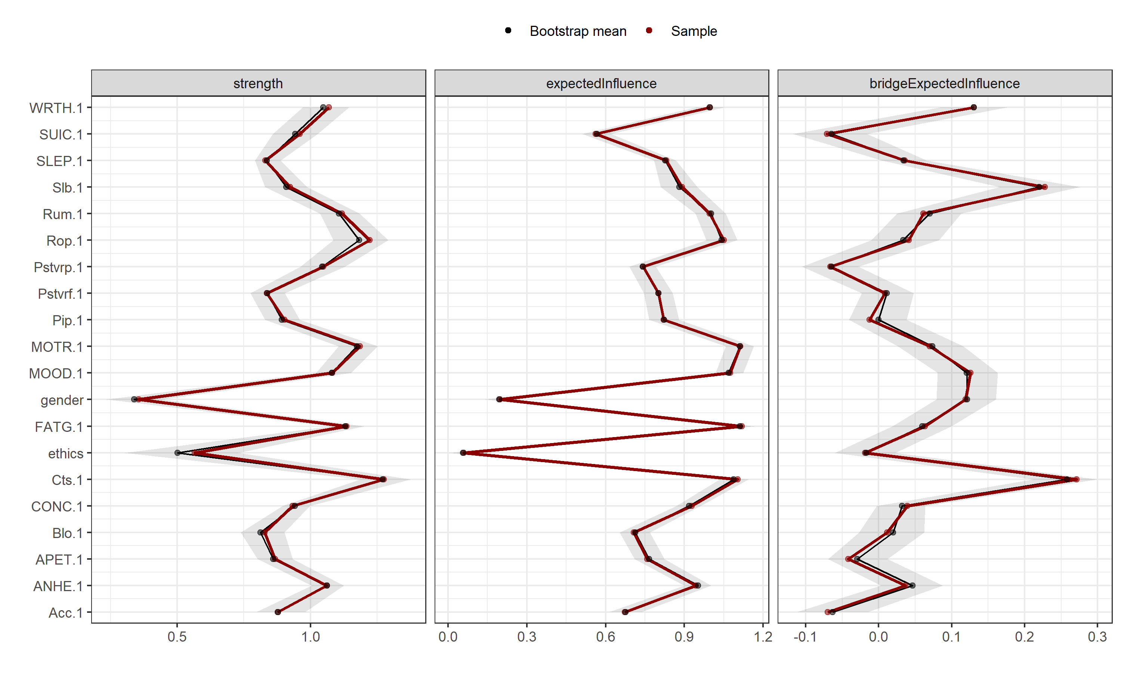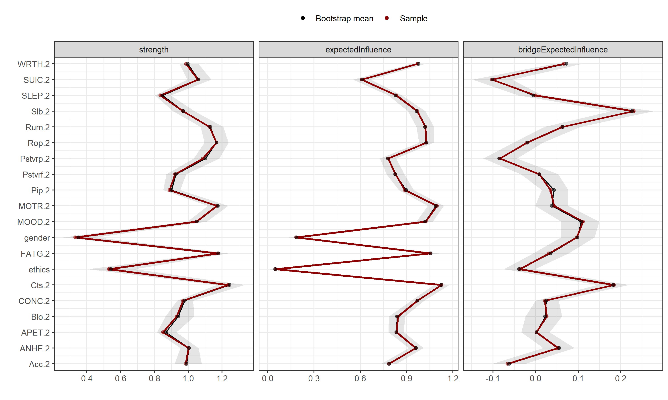
Figure S1. Bootstrapped 95% confidence intervals around each edge weight at W1 and W2.
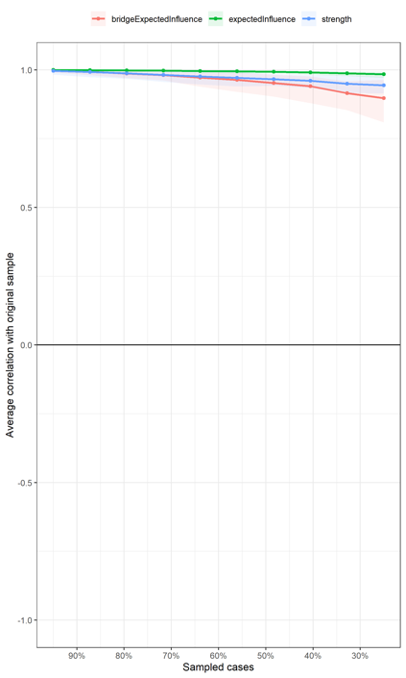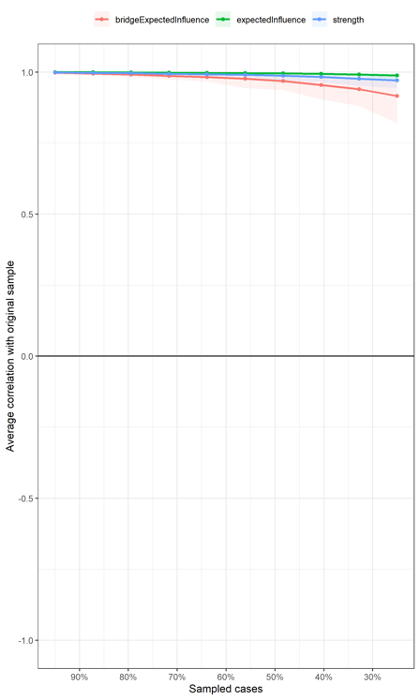
Figure S2. Stability of central indices at W1 and W2.

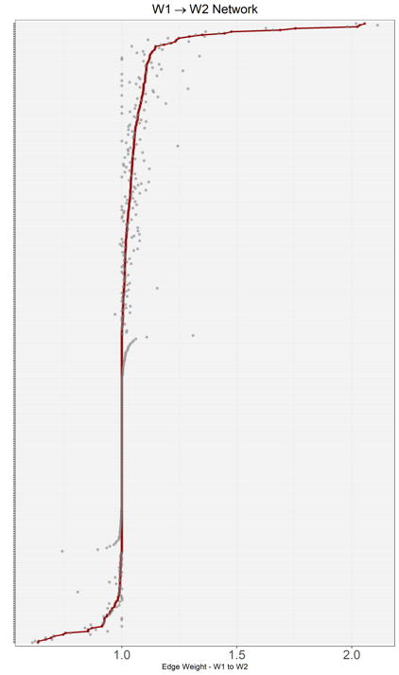
Figure S3. Bootstrapped 95% confidence intervals around each edge weight of the temporal network.

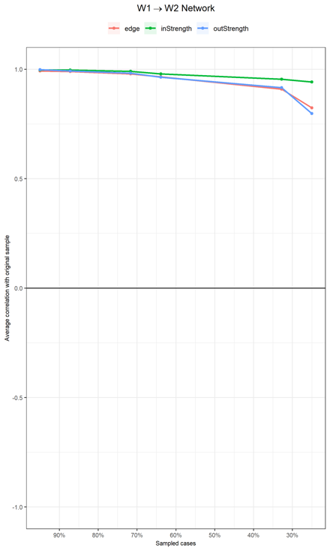
Figure S4. Stability of central indices of the temporal network.

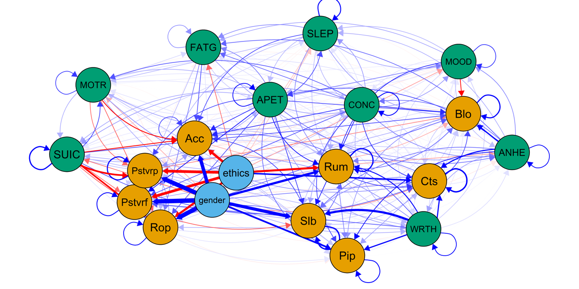
Figure S5. CLPN plots with both autoregressive and cross-lagged edges

 | ANHE | MOOD | SLEP | FATG | APET | WRTH | CONC | MOTR | SUIC | Slb | Acc
ANHE | 0.145 | 0.061 | 0.042 | 0.083 | 0.102 | 0.048 | 0.074 | 0.017 | 0.000 | 0.076 | 0.027
MOOD | 0.035 | 0.112 | 0.039 | 0.048 | 0.000 | 0.021 | 0.014 | 0.009 | 0.000 | 0.049 | 0.000
SLEP | 0.006 | 0.046 | 0.180 | 0.061 | 0.036 | 0.032 | 0.038 | 0.037 | 0.000 | 0.000 | 0.097
FATG | 0.051 | 0.013 | 0.007 | 0.058 | 0.027 | 0.008 | 0.000 | 0.000 | 0.000 | 0.000 | 0.095
APET | 0.077 | 0.070 | 0.096 | 0.067 | 0.143 | 0.053 | 0.052 | 0.044 | 0.046 | 0.110 | 0.115
WRTH | 0.017 | 0.025 | 0.006 | 0.004 | 0.001 | 0.138 | 0.022 | 0.014 | 0.000 | 0.369 | 0.086
CONC | 0.068 | 0.054 | 0.055 | 0.082 | 0.044 | 0.040 | 0.156 | 0.091 | 0.054 | 0.125 | 0.114
MOTR | 0.011 | 0.000 | 0.000 | 0.021 | 0.016 | 0.043 | 0.052 | 0.105 | 0.042 | -0.003 | -0.158
SUIC | 0.009 | 0.020 | 0.022 | 0.000 | 0.045 | 0.038 | 0.034 | 0.103 | 0.213 | -0.090 | -0.158
Slb | 0.004 | 0.012 | -0.002 | 0.003 | 0.000 | 0.005 | 0.000 | 0.000 | -0.006 | 0.236 | 0.102
Acc | 0.000 | -0.007 | -0.004 | 0.000 | 0.000 | -0.006 | 0.000 | -0.004 | 0.000 | -0.006 | 0.101
Rum | 0.004 | 0.012 | 0.013 | 0.007 | 0.006 | 0.013 | 0.012 | 0.015 | 0.006 | 0.035 | 0.038
Pstvrf | 0.000 | 0.000 | -0.005 | 0.000 | 0.000 | 0.000 | 0.000 | -0.003 | 0.000 | 0.000 | 0.004
Rop | 0.000 | 0.000 | -0.003 | 0.000 | 0.000 | 0.000 | 0.000 | 0.000 | 0.000 | 0.014 | 0.024
Pstvrp | -0.011 | -0.012 | -0.006 | -0.007 | -0.005 | -0.008 | -0.006 | -0.009 | -0.010 | 0.000 | 0.053
Pip | 0.001 | 0.000 | 0.000 | 0.000 | 0.005 | 0.000 | 0.004 | 0.000 | 0.002 | 0.025 | 0.032
Cts | 0.013 | 0.010 | 0.016 | 0.017 | 0.006 | 0.014 | 0.005 | 0.013 | 0.012 | 0.058 | 0.000
Blo | 0.000 | 0.000 | -0.005 | 0.000 | 0.000 | 0.000 | 0.000 | -0.006 | 0.000 | 0.004 | 0.000
sex | 0.000 | 0.014 | -0.032 | 0.013 | 0.000 | 0.000 | -0.008 | -0.045 | -0.080 | 0.524 | 0.563
ethics | -0.052 | -0.053 | -0.033 | -0.081 | -0.008 | 0.000 | 0.000 | 0.036 | 0.043 | 0.000 | -0.403
Table S1 Partial directed correlations (standardized beta coefficients) of temporal network.

Continued Table S1 Partial directed correlations (standardized beta coefficients) of temporal network.
 | Rum | Pstvrf | Rop | Pstvrp | Pip | Cts | Blo | sex | ethics
ANHE | 0.000 | 0.000 | 0.000 | -0.010 | 0.137 | 0.194 | 0.221 | 0.000 | 0.000
MOOD | 0.122 | 0.000 | 0.000 | 0.000 | 0.000 | 0.000 | -0.139 | 0.000 | 0.000
SLEP | 0.063 | 0.000 | 0.039 | 0.000 | 0.000 | 0.000 | 0.051 | 0.000 | 0.000
FATG | 0.018 | 0.037 | 0.072 | 0.000 | 0.000 | 0.000 | 0.000 | 0.000 | 0.000
APET | 0.133 | 0.135 | 0.090 | 0.101 | 0.079 | 0.031 | 0.099 | 0.000 | 0.000
WRTH | 0.168 | 0.090 | 0.040 | 0.057 | 0.213 | 0.209 | 0.029 | 0.000 | 0.000
CONC | 0.045 | 0.096 | 0.000 | 0.000 | 0.102 | 0.116 | 0.112 | 0.000 | 0.000
MOTR | 0.000 | 0.000 | -0.086 | -0.079 | 0.000 | 0.058 | 0.010 | 0.000 | 0.000
SUIC | 0.000 | -0.079 | -0.281 | -0.294 | 0.013 | 0.091 | 0.097 | 0.000 | 0.000
Slb | 0.083 | 0.041 | 0.087 | 0.036 | 0.023 | 0.036 | 0.023 | 0.000 | 0.000
Acc | -0.029 | 0.000 | 0.004 | 0.027 | 0.000 | -0.002 | -0.043 | 0.000 | 0.000
Rum | 0.222 | 0.047 | 0.019 | 0.000 | 0.067 | 0.107 | 0.080 | 0.000 | 0.000
Pstvrf | 0.000 | 0.164 | 0.018 | 0.020 | -0.010 | -0.016 | 0.016 | 0.000 | 0.000
Rop | 0.000 | 0.000 | 0.148 | 0.056 | 0.000 | 0.000 | 0.017 | 0.000 | 0.000
Pstvrp | 0.000 | 0.027 | 0.088 | 0.195 | -0.026 | -0.066 | -0.067 | 0.000 | 0.000
Pip | 0.000 | 0.001 | 0.000 | 0.000 | 0.157 | 0.000 | 0.011 | 0.000 | 0.000
Cts | 0.067 | 0.000 | 0.000 | -0.016 | 0.050 | 0.251 | 0.099 | 0.000 | 0.000
Blo | 0.017 | 0.008 | -0.018 | 0.000 | 0.056 | 0.028 | 0.210 | 0.000 | 0.000
sex | 0.390 | 0.721 | 0.710 | 0.705 | 0.300 | 0.068 | 0.090 | 0.000 | 0.000
ethics | -0.348 | -0.450 | -0.369 | -0.454 | 0.031 | 0.257 | 0.043 | 0.000 | 0.000
Note: The first column contains the independent variables, and the first row contains the dependent variables.

