Selection of a High-Affinity Nitrofurantoin-Specific Aptamer via GO-SELEX and Development of a Fluorescent Aptasensor for Environmental Water Monitoring

1. Figure

Figure S1 Recovery of sequences bound to NFT in GO-SELEX

Figure S2 Homologous tree analysis

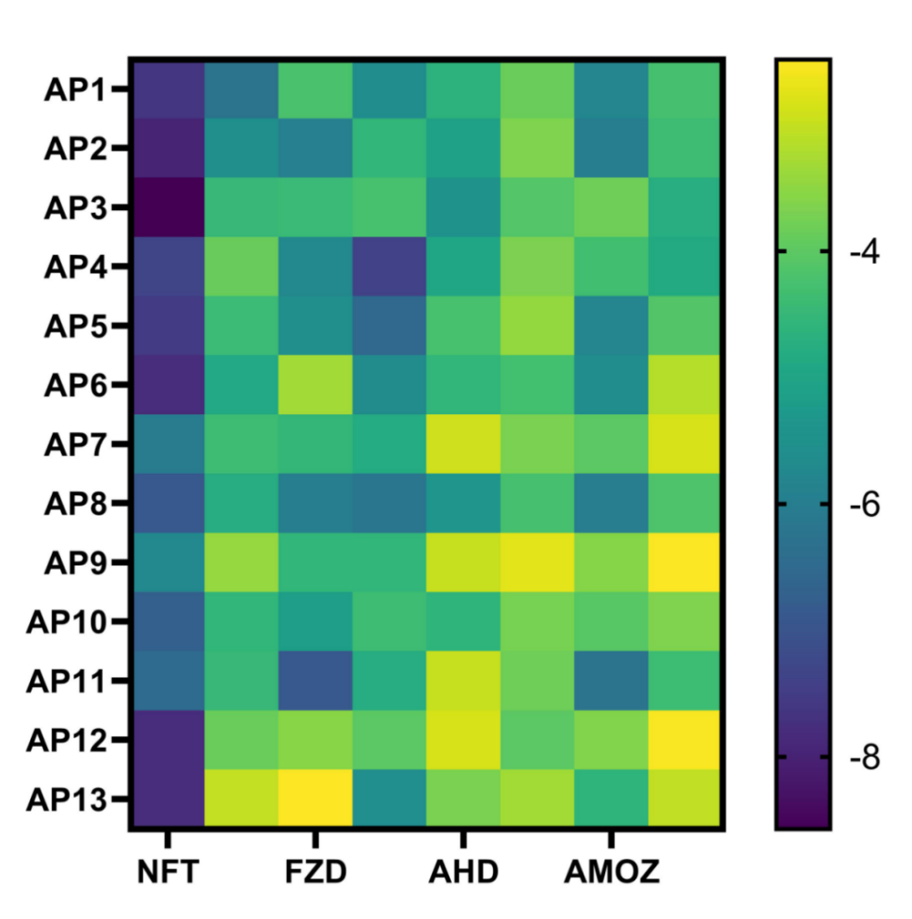
Figure S3 Molecular docking heatmaps of candidate aptamers from different families with NFT and its analogs

2.Table
Table S1 All oligonucleotide sequences
Name | Sequence
FAM-Random ssDNA library | 5’-FAM-CACCTAATACGACTCACTATAGCGGATCCGA-N40-CTGGCTCGAACAAGCTTGC-3’
FAM-Forward Primer | GGCTCGAACAAGCTTGC-3’
Reverse Primer | 5’-FAM-CACCTAATACGACTCACTATAGCGGA-3’
Reverse Primer | 5’-GCAAGCTTGTTCGAGCCAG-3’
Biotin ssDNA | 5’-biotin-GCAAGCTTGTTCGAGCCAG-3’

Table S2 PCR reaction condition
Components | Volume/µL
SSDNA | 5
25 nM reverse primer | 2
500 nM forword primer | 2
2×taq PCR MasterMix Ⅱ | 10
DdH₂O | 31

Table S3 PCR reaction program
Procedure | Temperature/℃ | Time/s
Denatured | 95 | 0.30
Renatured | 53.5 | 0.30
extended | 72 | 0.06

Table S4 Random sequence of aptamers
Aptamers | Random sequence (N40)
Seq-1 | ATCTACACCGGTAGGATTCGGTCTGGACCCTCCGCTCTCC
Seq-2 | AGTGCCCGGGGGTATTGCGAATACGCTGAGGATTTAGGGT
Seq-3 | GGCCTCGGCGTAGACCACCCGAGATCGCTTACGGAGGTGT
Seq-4 | TCTCTGATGGGTCTGGGGGTCCAAGCGATACTTTAGGTGA
Seq-5 | CGTCCGAGATCCACCATTCCGGGTCGGTAACTTATGAGG
Seq-6 | CGTCGATGTCGTTCGGTGTGCATTGGTCCTCATTCGATAT
Seq-7 | TGGCGAGACGACTCGGCTAACTGGGTCGCATCCCCTTTCC
Seq-8 | CTCTCCACAATTGATCCGATGTATTTTTCGTCCTGCGATC
Seq-9 | CCATCCCCGATGGTCAGGGTTTAGGGTGTGGTATCTTTCA
Seq-10 | GGCCCCGATTGACGATGGAACCATTCGCATGGGAGGGTCC
Seq-11 | GTTTCCGCAAAACCAGGACTGAGCGTCTGGTTTCCAACTA
Seq-12 | CCCCGCCGTACCTATGAGTTGATTACGCCCTTCAGGGGCA
Seq-13 | GACACCGAAACCGCGGAGACTCTGGCCATCTCTACTCCAA
Seq-14 | GTCCGATGGATTTATCGGGCCGAGTGTTGCGTATGGGATC
Seq-15 | TCCGCACACTCAGTGGTATGTGTTGTACCGCGTCAGAATC
Seq-16 | TGCCACACCGTGGGGAGAGGATTCGTGAGATCGTTAGTGT
Seq-17 | CCTCGGTGAACTAACGGGTTTGCTGCTGTGGTCTTCACCC
Seq-18 | TCAGCGTATATGTGTGGACCGCGCCTACATTCCGGCAGTT
Seq-19 | AGTGGTGAACGGTCCGCGAGAGGCGCCATTAGGCATGATC
Seq-20 | TGAATTTCCATTCGGTCTGCACATCGGGAGGTACTTGGTA
Seq-21 | AGGTGAATGCGACCTCAGAACTCTTGGGGCTTTATTGGTC
Seq-22 | CAACGACTTCGACTCTCGGTACATTTGTCTGGGCCCTAAC
Seq-23 | TCTGCACTGTTCATGCAGGCAACGGTGAGTACGTATTGGT
Seq-24 | TGGCCGCATAATGATCCTATAGGGAGAGCAGTCCTGTTTC
Seq-25 | CCTCGCCTCGACTATATTCGGGCTCTTCAGTACGTCTCCA
Seq-26 | CTTGACCCTGGGCTGTAATTGGTAATCTTCCTCGGAGTG
Seq-27 | TCCTGCCCGTGAGTACGGATAAGTCGTCTAGGTTCTTTTA
Seq-28 | CGCCCCGCCGGACCTTACCGCATTGGCTCCTAGTGGTTTC
Seq-29 | GGTCTGTCAACGGTGACGTCGTTCAAGGTGGTCCCATTG
Seq-30 | CTCTGGGTTTGACCTCTGTGTGTGGACTGACGTTTTAGTA
Seq-31 | CCCGAATGATCAGTGGGCACTGTAATCTCCGTGAGTTATA
Seq-32 | GGACTCAGCTGGGTATGCGGTGTGTGTGGGTTTTCACCTT
Seq-33 | ACTGTCGAACGGTCCCCCTAGATAGAACTCTGGTCGATAG
Seq-34 | AACGCATGTAAATGGGGAAAGCTCGAGTCGGTATTTCGGT
Seq-35 | AGAATGTCGGCAGGGAATTGATCCGCCCTCTTCCGTCGGA
Seq-36 | ACCCCAGGTTCGCATGAAGCCGTACGGGAGTTTTTGGGAT
Seq-37 | GCGGAGACGGCTTGGCACGCGGATCCCAAACACTTTCACC
Seq-38 | ACCGGTTGCTGAAGTGTATCGGCTAGCAGGATATTTCTCA
Seq-39 | TTATGCCTGTCGGATGTCATGGTATTGACCTGGTGATGTA
Seq-40 | TCAAAGTAGGATAGGCCTTGGTCATGGCGTGTGACGGTGT
Seq-41 | ACAATCGTGACGGAACTATGATAAGAGGGTCGCATTCGCT
Seq-42 | TTCGGTCGGCGATCGTGCGCGCTTCTGGTGGTTTTATACT
Seq-43 | GGACCGTAGGTACAGGAGCCGGCCATGGGAGTGATACTCA
Seq-44 | AGCTTGCCTCGATATCGCGACATGGGGGTATTGACGTGAA
Seq-45 | ACCGTGTGCTACGGTGTTTCGGCTTTTGTAACGTAATCGT
Seq-46 | ACTTCGGTATCCGATCCTCGTCGGGAGGAACTGGACATTT
Seq-47 | TGAACGGAGGGCTGATAAGTACAACAGTCGACGTAGTTTC

Table S5 Secondary structure free energy of candidate aptamers
Families | Sequence | Free energy of secondary structure (Kcal/mol)
 | Seq 1(AP1) | -15.43
Family 1 | Seq 16 | -11.23
 | Seq 26 | -5.80
 | Seq 20 | -11.79
 | Seq 29 | -11.54
Family 2 | Seq 35 | -14.03
 | Seq 40 | -8.73
 | Seq 43(AP2) | -19.08
 | Seq 4 | -12.90
Family 3 | Seq 23(AP3) | -17.49
 | Seq 47 | -13.05
 | Seq 37 | -13.03
 | Seq 2 | -11.09
Family 4 | Seq 42(AP4) | -13.31
 | Seq 34 | -11.11
 | Seq 5 | -10.39
 | Seq 12 | -14.33
 | Seq 17 | -10.15
Family 5 | Seq 25 | -9.33
 | Seq 36 | -11.76
 | Seq 38 | -10.17
 | Seq 45(AP5) | -14.35
 | Seq 8 | -11.77
Family 6 | Seq 9 | -13.86
 | Seq 14 | -12.98
 | Seq 27(AP6) | -16.72
 | Seq 15(AP7) | -13.62
Family 7 | Seq 31 | -11.25
 | Seq 39 | -11.50
 | Seq 11(AP8) | -16.08
Family 8 | Seq 13 | -9.83
 | Seq 18 | -9.99
 | Seq 32 | -9.06
 | Seq 30 | -7.85
Family 9 | Seq 46(AP9) | -15.30
 | Seq 41 | -10.46
 | Seq 3 | -13.49
Family 10 | Seq 19(AP10) | -17.25
 | Seq 33 | -8.93
 | Seq 6(AP11) | -11.79
Family 11 | Seq 21 | -9.37
 | Seq 28 | -11.02
 | Seq 44 | -11.36
Family 12 | Seq 10(AP12) | -12.35
 | Seq 22 | -9.22
Family 13 | Seq 7(AP13) | -13.68
 | Seq 24 | -12.07

3.Sample Pretreatment

Water Samples
A 200 mL water sample (measured accurately to 0.01 mL) was transferred to a 250 mL wide-mouth bottle and centrifuged at 15,000 rpm for 20 min to remove impurities. The supernatant was filtered through a 0.22 µm membrane. The filtrate was evaporated to dryness under a gentle nitrogen stream, after which the residue was redissolved in 5 mL of binding buffer and filtered again through a 0.22 µm membrane.

Soil Samples
Soil samples (5 g, weighed accurately to 0.01 g) were placed in a 50 mL centrifuge tube, vortex-mixed for 1 min, and extracted with 10 mL of formic acid-methanol solution for 15 min. The mixture was centrifuged at 15,000 rpm for 10 min, and the supernatant was transferred to a 50 mL pear-shaped flask. The residue was re-extracted with 10 mL of formic acid-methanol solution. The combined extracts were filtered through a 0.22 µm membrane, evaporated to dryness under a nitrogen stream, and reconstituted in 5 mL of binding buffer, followed by filtration through a 0.22 µm membrane prior to analysis.

