Appendix File

Table S1. Plasmids Constructed in This Study.
Plasmids | Description | source
pMD18-T | AmpR | Sangon  Biotech
pMD-slr0168 | AmpR, The upstream and downstream genes of slr0168 were cloned into the SphI/MluI and XbaI/KpnI sites of the pMD18-T vector. | This study
pMD-slr0168-Ω | SpR, The spectinomycin resistance gene was cloned into the XhoI/XbaI site of the pMD-slr0168 vector. | This study
pST407 | SpR, The PpsbA2s was cloned into the BamHI/SalI site of the pMD-slr0168-Ω vector, and the TrbcL was cloned into the SalI/HindIII site. | This study
pST407-TKS/OAC | SpR, The TKS/OAC gene was amplified, and the pST407 plasmid was double-digested with BglII/SacII. The fragments were then ligated and transformed into E. coli DH5α. | This study
pST02 | SpR, The AAE1 gene was amplified, and the pST407-TKS/OAC plasmid was digested with SacII. The fragments were then ligated and transformed into E. coli DH5α. | This study
pST408 | SpR, The Pcpc560 was cloned into the BamHI/SalI site of the pMD-slr0168-Ω vector, and the TrbcL was cloned into the SalI/HindIII site. | This study
pST408-TKS/OAC | SpR, The TKS/OAC gene was amplified, and the PJS408 plasmid was double-digested with BglII/SacII. The fragments were then ligated and transformed into E. coli DH5α. | This study
pST03 | SpR, The AAE1 gene was amplified, and the pST408-TKS/OAC plasmid was digested with SacII. The fragments were then ligated and transformed into E. coli DH5α. | This study
pMD-slr1176 | AmpR, The upstream and downstream genes of slr1176 were cloned into the SphI/MluI and XbaI/KpnI sites of the pMD18-T vector. | This study
pST04 | CmR, The chloramphenicol resistance gene was cloned into the XhoI/XbaI site of the pMD-slr1176 vector. | This study
pST503 | CmR, The Pcpc560 was cloned into the BamHI/SalI site of the pST04 vector, and the TrbcL was cloned into the SalI/HindIII site. | This study
pST05 | CmR, The maeB gene was amplified, and the pST503 plasmid was double-digested with BglII/PstI. The fragments were then ligated and transformed into E. coli DH5α. | This study

Table S2. Primers used in this study.
Primers | Sequence (5' to 3')
SP-F | CCACGCGTAAGCTTGGATCCGCTCACGCAACTGGTCCAGAA
SP-R | CGGGAGCTCGAATTCTAGAGTGCTTAGTGCATCTAACGC
TrbcL-F | CGCGTCGACCGGTGTTTGGATTGTCGGAGT
TrbcL-R | CCGACGCGTAAGCTTCCGGTAATTGGTAAATTGCTGTC
PpsbA2s-F | ATGGGGAAAAACTACAAAAGTTTAGATTCCGT
PpsbA2s-R | GTTGATTTTTGATTATACCCCCCGCAAATAA
TKS-F | AGTGAGTACCGGCCAAACCAT
TKS-R | ATGACCGCCAATGGTGCCTTC
AAE1-F | CTCCAACGGCTACTATCATGCC
AAE1-R | CATCCATCAACACGGTGCGCCA
slr0168Up-F | GGCATGCCGAGCGGCACCACGGGGCACCACCGC
slr0168Up-R | GACGCGTCGGCGCACAGCAGCGTGCGACGTGTG
slr0168Dw-F | CTCTAGAGTGCCACTACCTGGCGTGCCGCTACC
sIr0168Dw-R | GGGGTACCCCGCATGACCAGCTGCCGCCCCAGC
Pcpc-F | CGTCTAGAGGATCCCCTGTAGAGAAGAGTCCCTG
Pcpc-R | TTTCTCCTCTTTTGAATTAATCTCCTACTTGACTTTATGAG
TKS-qF | TCAACACGGTGCACCTCGAC
TKS-qR | GCGTCGCAGCCGGTGCGCCA
AAE1-qF | ATCAACACGGTGACGGTGCG
AAE1-qR | CGACGCGTAAGCCGTCCGGT
Cam-F | ACCGGCATGCGTTGATCGGCACGTAAGAGGT
Cam-R | CAACTGCAGTTACGCCCCGCCCTGCCACTCATC
slr1176Up-F | ACATGCATGCCAGTTAGCCTAGGCAGTGGTTC
slr1176Up-R | CGACGCGTCGACCGCCCCCTAAATCCCCCAATA
slr1176Dw-F | CTAGTCTAGAGTCGACCATTGCCGCAACGACACTG
slr1176Dw-R | CGAGCTCGGTACCACCAAAGAGTTATTGGCGGCTA
MaeB-F | AGGAGATTAATTCAAAAGAGGAGAAAATGGATGACCAGTTAAAACAAAGTGC
MaeB-R | ATCCAAACACCGGTCGACTGCAGTTACAGCGGTTGGGTTTGCGCT

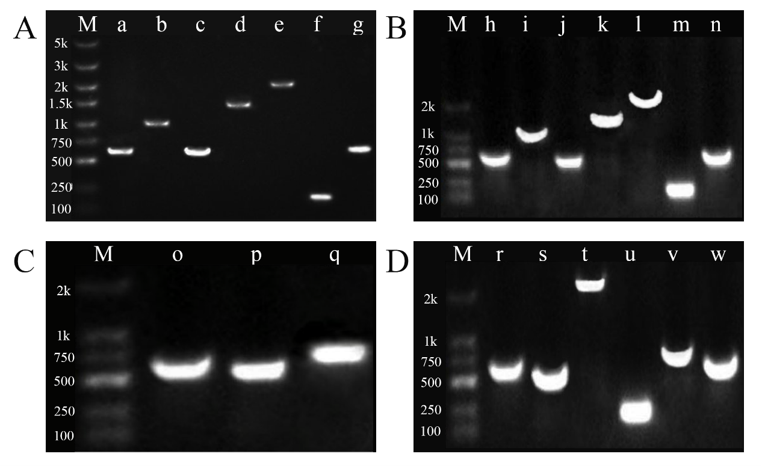
Fig. S1. PCR identification of the plasmids for transformation. A) Plasmid pST02, M: DNA Marker, a: Upstream homologous arm of slr0168 (600bp), b: Gentamicin resistance gene (1100bp), c: Promoter PpsbA2s (600bp), d: TKS/OAC gene (1500bp), e: AAE1 gene (2200bp), f: Terminator TrbcL (200bp), g: Downstream homologous arm of slr0168 (600bp); B) Plasmid pST03, M: DNA Marker, h: Upstream homologous arm of slr0168 (600bp), i: Gentamicin resistance gene (1100bp), j: Promoter Pcpc560 (500bp), k: TKS/OAC gene (1500bp), l: AAE1 gene (2200bp), m: Terminator TrbcL (200bp), n: Downstream homologous arm of slr0168 (600bp); C) Plasmid pST04, M: DNA Marker, o: Upstream homologous arm of slr1176 (600bp), p: Downstream homologous arm of slr1176 (600bp), q: Chloramphenicol resistance gene (750bp); D) Plasmid pST05, M: DNA Marker, r: Upstream homologous arm of slr1176 (600bp), s: Promoter Pcpc560 (500bp), t: maeB gene (2300bp), u: Terminator TrbcL (200bp), v: Chloramphenicol resistance gene (750bp), w: Downstream homologous arm of slr1176 (600bp).

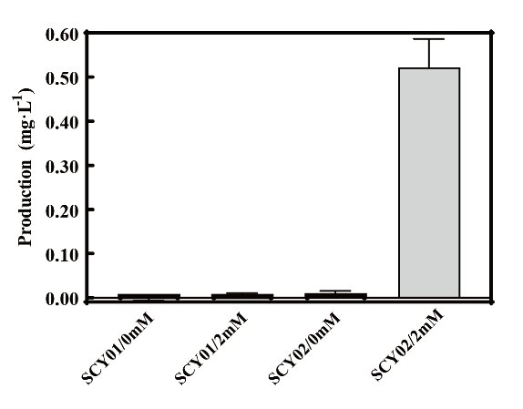
Fig. S2. OLA production of SCY01/SCY02 on day 14 under 0-2 mM sodium hexanoate.

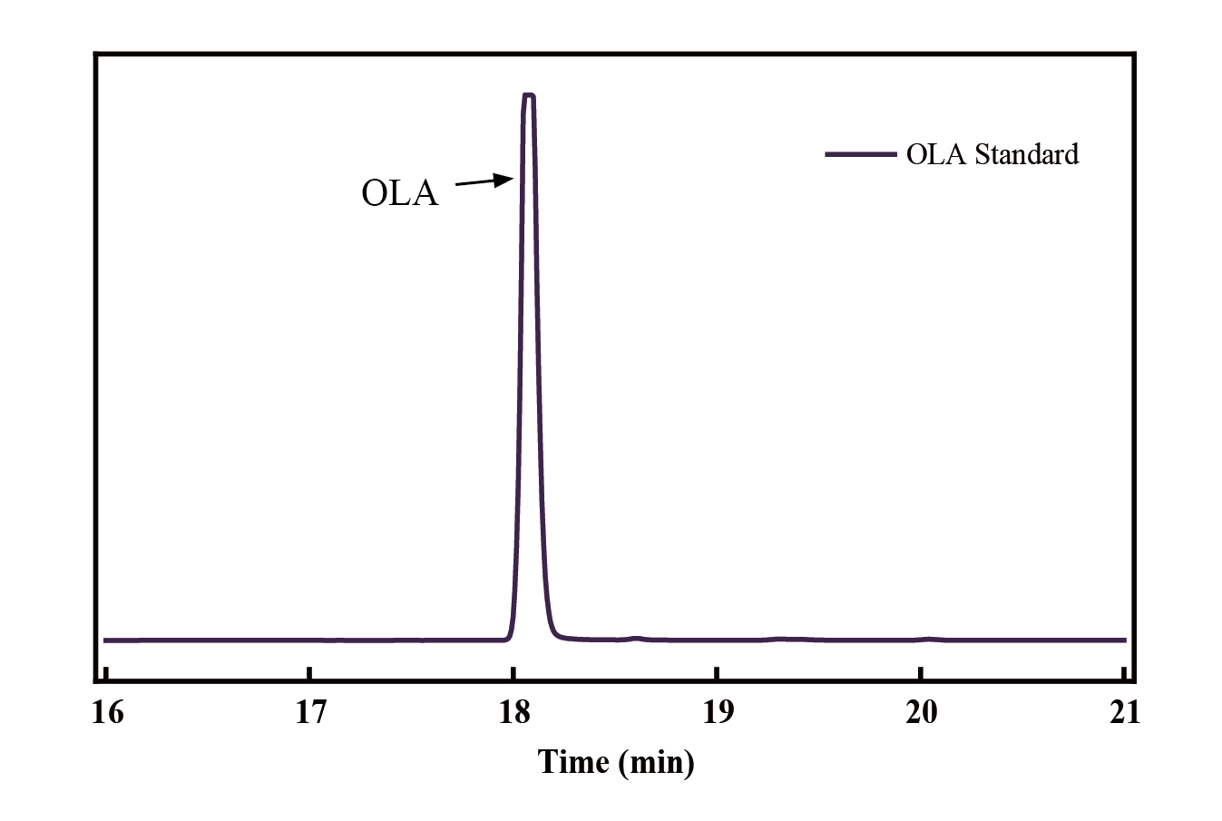
Fig. S3. HPLC chromatogram of olivetolic acid standard.

