Appendix 1 FMOLS Output 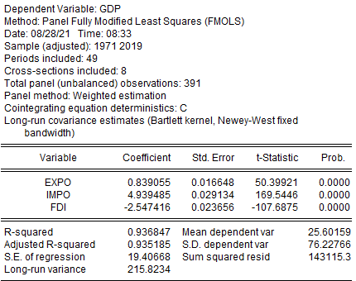

Appendix 2 DOLS Output

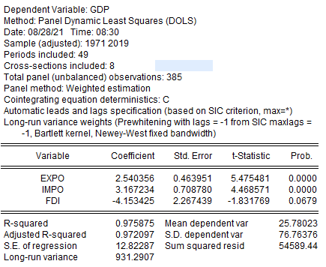

Appendix 3 Pairwise Dumitrescu-Hurlin Panel Causality Test Output 