Introduction
The idea is to evaluate 15 selected visuals from VABs. The visuals were chosen to try to reflect the main subjects and visuals in VABs in the last 15 years. If similar content is covered in more than one visual, it is because that subject material has often been included in VABs.

There is unrelated work underway to maximise the general accessibility (link to NZ government accessibility standards) of the VABs as part of a planned revamp of the GeoNet website. This is different from evaluating visuals in VABs, but if you have any comments related to how this might affect visuals, please provide those separately.

Evaluation
The intent of a visual should be to improve or clarify the most important messages in a VAB, and that is the focus of this evaluation. The main criteria to consider are:
- Clarity of message. Does the message of the VAB, or one of them if there are more than one, come across in the visual?
- Clarity of information or data shown. How clear is what is shown in the visual? If it claims to show a trend, is that trend obvious? If it is a photograph that claims to show something, is that clear to an inexperienced audience? Is something that needs to be highlighted labeled or otherwise identified?
- Does the visual have missing or unnecessary information or distractions? Is an important aspect of the visual not shown, or conversely, is there too much “chart clutter” – unnecessary elements that distract from information or data in the visual?

Colour
We tend to use colour without really thinking about it. There are three aspects this. You can comment of these separately, but it is also okay to include them as part of other comments, such as about distractions in a visual.

Colour Vision Deficiency friendly
Is the visual friendly to someone who has a colour vision deficiency, i.e. is “colour blind”? I have done this for you using https://bioapps.byu.edu/colorblind_image_tester. This is a “colour blind image tester” for moderate-to-severe, red-green colorblindness (deuteranopia), the most common type (affecting 1 in 12 men and 1 in 200 women). While we can’t test every visual for all varieties of colour blindness, ensuring a visual is friendly to the most common type of colour blindness is a fair goal.

Colour contrast
You can use https://www.siegemedia.com/contrast-ratio to check the contrast of text, symbols or lines in one colour against the background colour and determine if the contrast is sufficient. Low contrast text/symbols may be difficult to see for people that have degenerative eye conditions such as cataracts. You need to know the numeric value for the colours, which you can most easily do with a colour picker as a browser extension. In most cases, our VAB visuals are drawn against a white background so the contrast ratio is sufficient for most colours, but care needs to be taken when using light shades.

Sensible use of colours
Does a visual use colours in a way that adds clarity, perhaps to distinguish one set of data from another? Are colours used unnecessarily when greyscale would suffice? This can be related to whether a visual is colour vision deficiency friendly. Are colours that are used relevant to the data, what people expect, e.g. red-hot, blue cold?

Scoring
Qualitative, free text comments are more difficult to work with than quantitative data. A simple scoring system doesn’t replace considered and well written comments, but can be valuable in ranking visuals and helping prioritise recommendations. Score each visual as 1, 2, or 3. A score of:
- 1 means a visual failed to get across the intended information, because the information was not clear or was substantially diluted by other material.
- 2 means a visual achieved what it set out to do. A general audience could discern the information it contained, regardless of any issues it may have.
- 3 means a visual that achieved what it set out to do and did it in a way that made the information easy to understand, although it still might have some issues.

Example
I have provided an example of how I evaluated a visual. You don’t have to do it exactly how I have, but some consistency between evaluators will make it easier to understand your thoughts.

Thank you,
Steven Sherburn
2025-07-28

Example Visual Evaluation
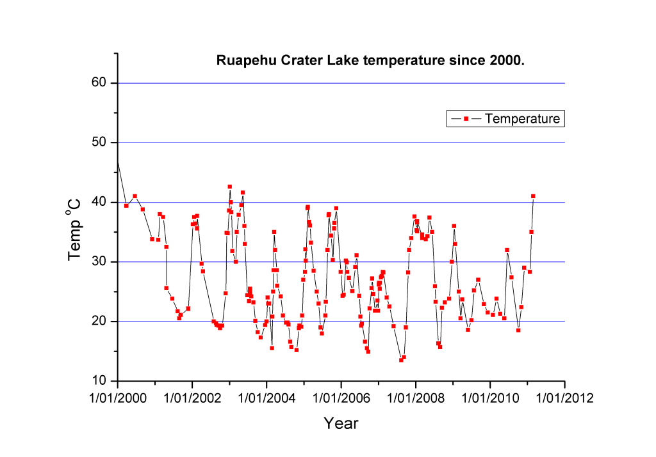 | VAB RUA-2011-01
VAB message
Crater Lake heating
Visual requirements
Should shown lake temperature increasing
 | Caption Ruapehu Crater Lake temperatures since 2000
 | Type time-series
 | Blue/green colourblind friendly yes

Clarity of message | Clarity of information/data | Missing or unnecessary information or distractions | Colour and accessibility | Score 1-3
Title and caption describe data, but not message | Data markers and lines are clear  Signal not identified | X-axis tick label better if only year  X-axis “Year” label unnecessary  Y-axis scale too high, could stop at 50  Grid lines unnecessary  Legend unnecessary | Colours have no special significance  Contrast sufficient | 2

Visual 1
VAB RUA-2011-01
VAB message
Crater Lake heating
Visual requirements
Should shown lake temperature increasing
Caption Ruapehu Crater Lake temperatures since 2000
Type time-series
Blue/green colourblind friendly yes

Clarity of message | Clarity of information/data | Missing or unnecessary information or distractions | Colour and accessibility | Score 1-3

Visual 2
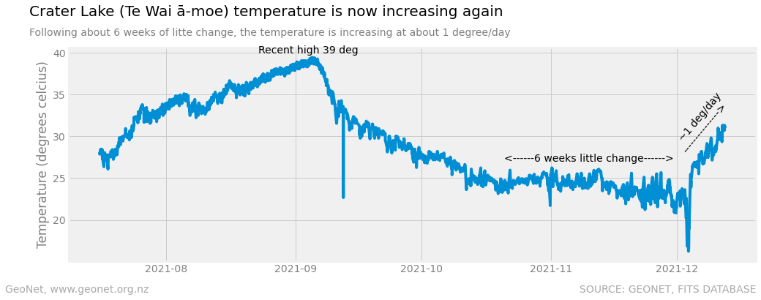 | VAB RUA-2021-06
VAB message
Crater Lake heating
Visual requirements
Should shown lake temperature increasing
 | Caption Plot of the daily average Crater Lake temperature as measured at the outlet since July 2021. Short duration spikes in the data are not necessarily representative of the whole lake
 | Type time-series
 | Blue/green colourblind friendly yes

Clarity of message | Clarity of information/data | Missing or unnecessary information or distractions | Colour and accessibility | Score 1-3

Visual 3
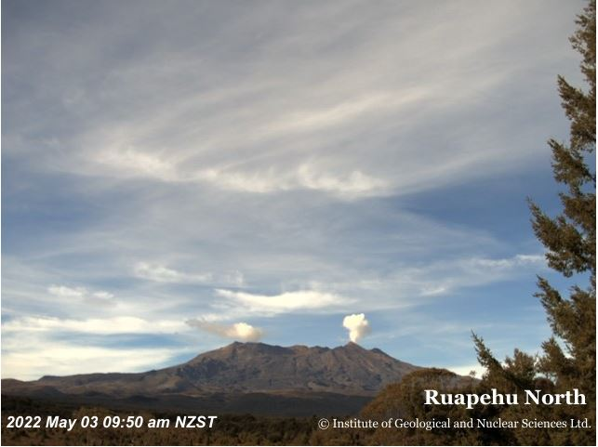 | VAB RUA-2022-09
VAB message
Steam plume visible at Mt Ruapehu, volcanic unrest continues

Visual requirements
Should show steam plume
 | Caption GeoNet image of Ruapehu from earlier this morning
 | Type photograph
 | Blue/green colourblind friendly not applicable

Clarity of message | Clarity of information/data | Missing or unnecessary information or distractions | Colour and accessibility | Score 1-3

Visual 4
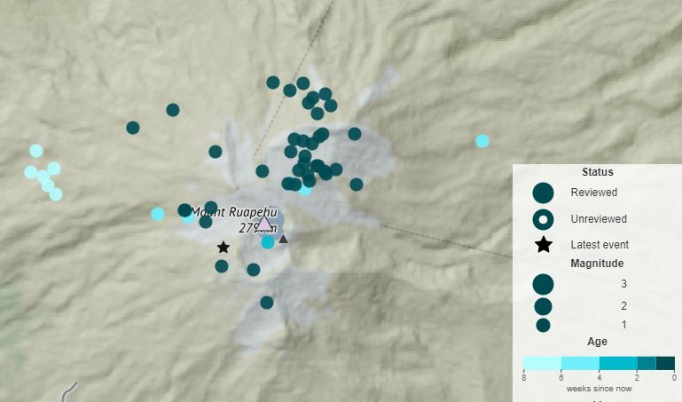 | VAB RUA-2023-06
VAB message
Earthquake activity recorded beneath Mt Ruapehu. Te Wai ā-moe (Crater Lake) slowly heating
Visual requirements
Should show earthquake activity
 | Caption Earthquake locations (circles) beneath Mt Ruapehu. Darker coloured circles show earthquakes during the past week. Lighter coloured circles show older earthquakes.
 | Type map
 | Blue/green colourblind friendly yes

Clarity of message | Clarity of information/data | Missing or unnecessary information or distractions | Colour and accessibility | Score 1-3

Visual 5
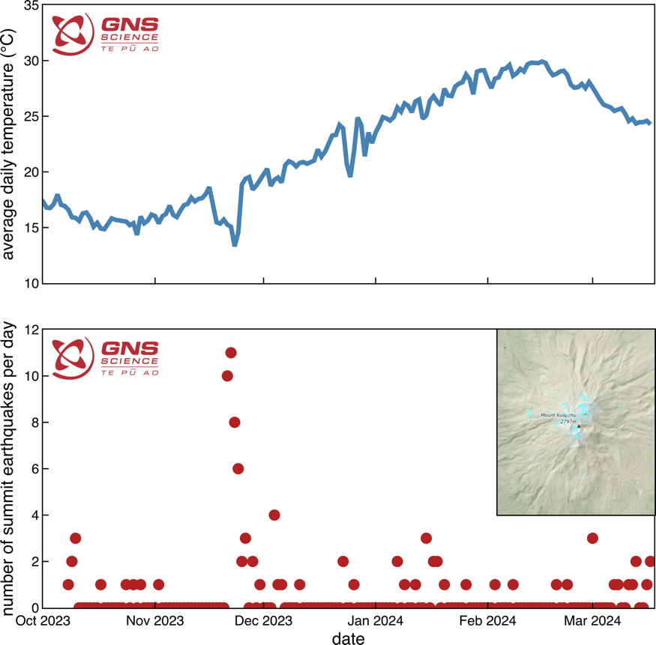 | VAB RUA-2024-02
VAB message
Te Wai ā-moe (Crater Lake) heating episode is over at Mt Ruapehu
Visual requirements
Should show heating has ended
 | Caption Plot of Te Wai ā-moe (Crater Lake) temperature (top) and number of earthquakes under the summit per day over time, from October 2023 to March 2024 (bottom – see inset for map of earthquake locations)
 | Type time-series and map
 | Blue/green colourblind friendly yes

Clarity of message | Clarity of information/data | Missing or unnecessary information or distractions | Colour and accessibility | Score 1-3

Visual 6
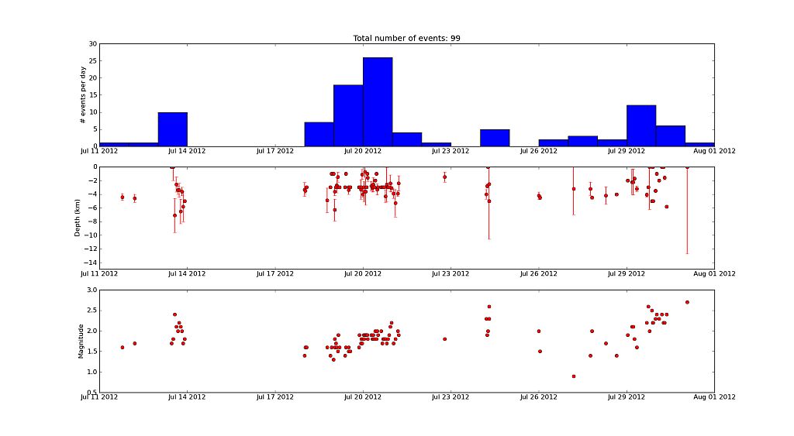 | VAB TON-2012-03
VAB message
Mt Tongariro update
Visual requirements
Should show that earthquakes have occurred
 | Caption Frequency of volcanic earthquakes recorded at Mount Tongariro
 | Type time-series
 | Blue/green colourblind friendly yes

Clarity of message | Clarity of information/data | Missing or unnecessary information or distractions | Colour and accessibility | Score 1-3

Visual 7
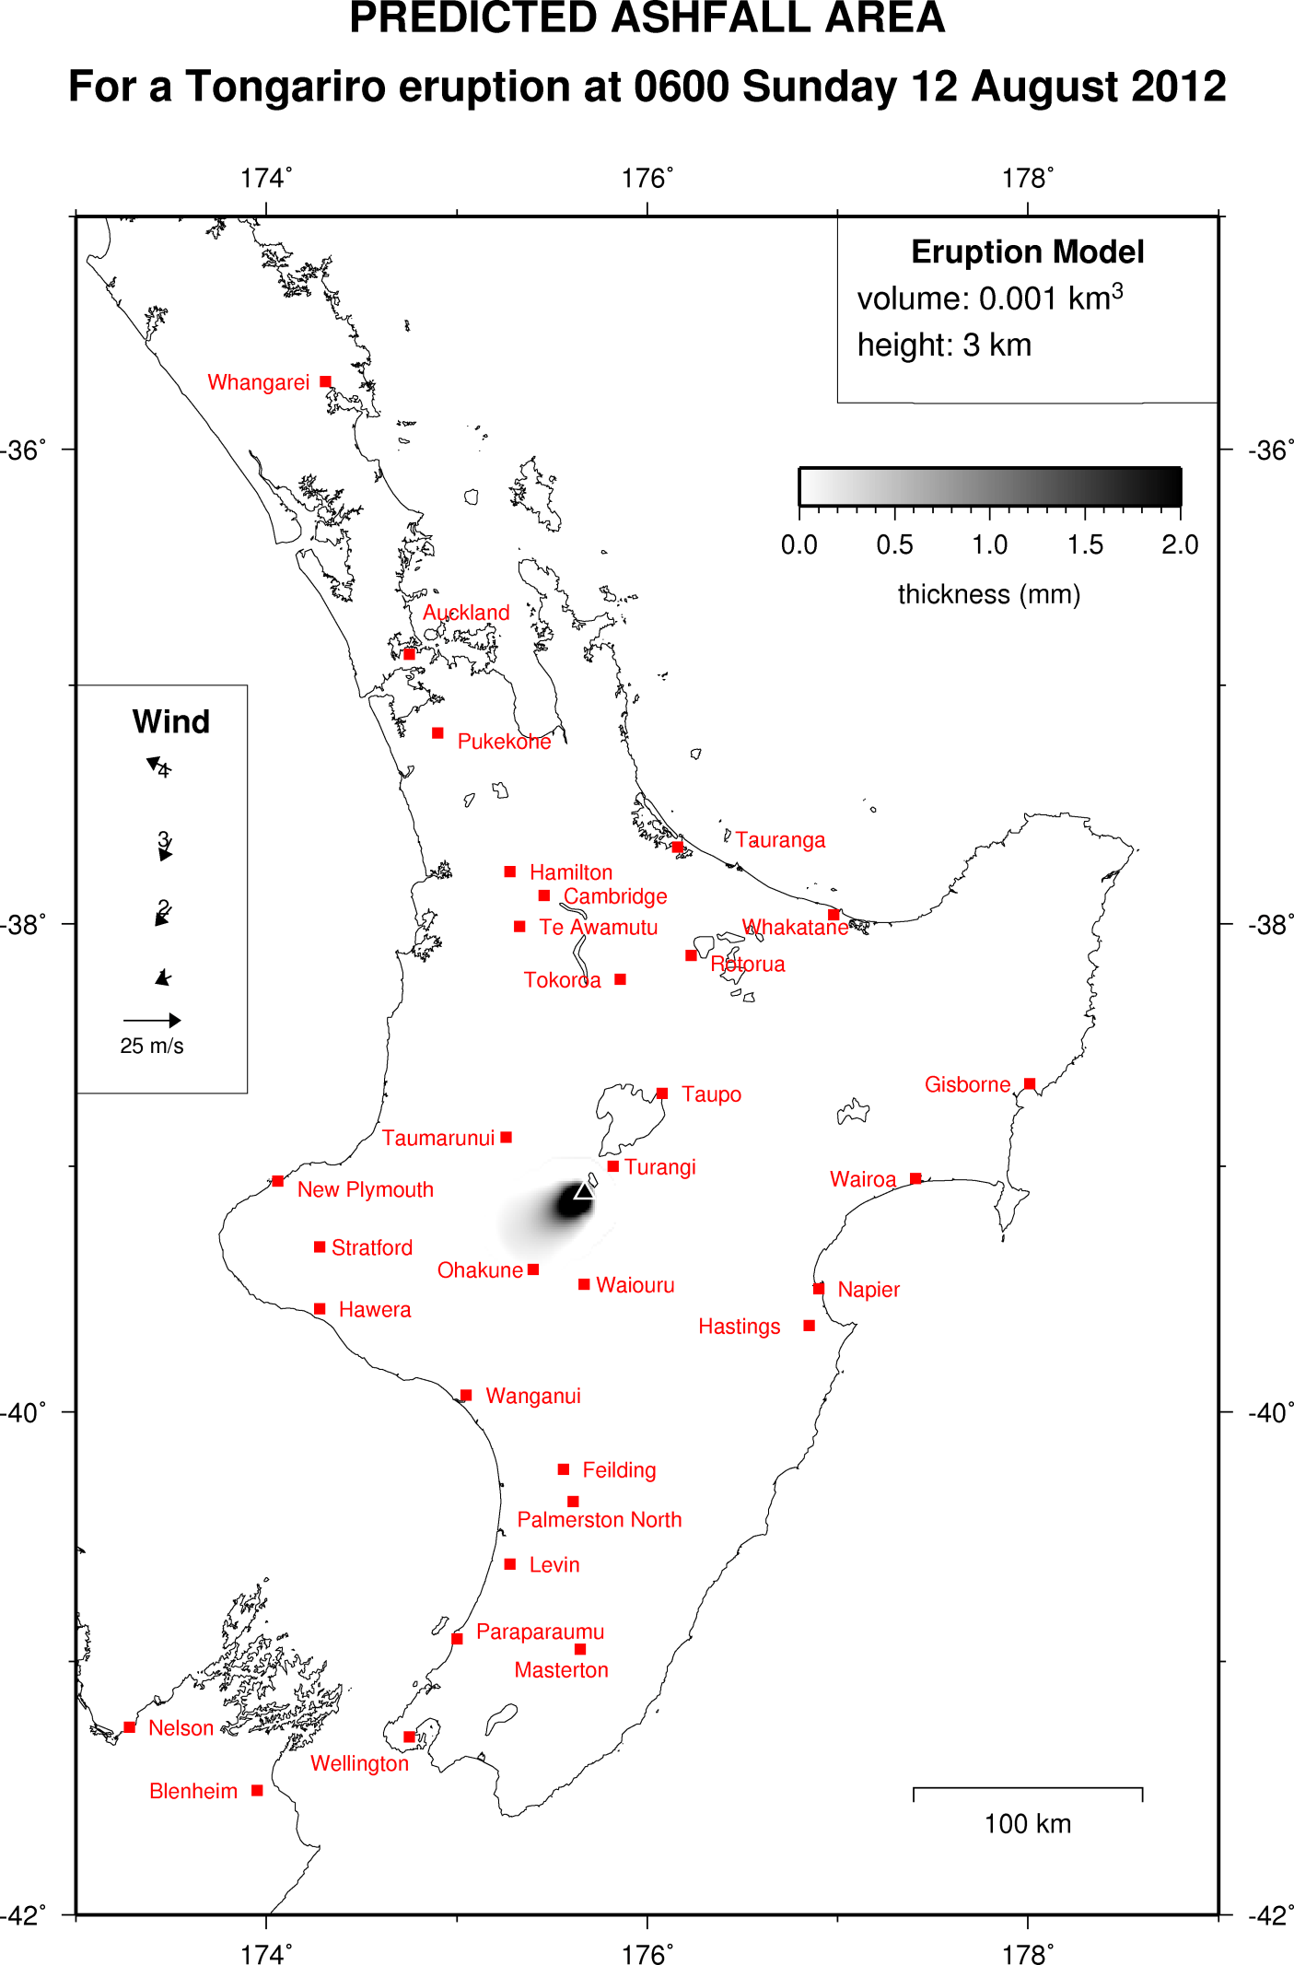 | VAB TON-2012-16
VAB message
Tongariro eruption update (ashfall map)
Visual requirements
Should show where ash may fall
 | Caption Predicted ashfall area for Tongariro
 | Type map
 | Blue/green colourblind friendly yes, map is greyscale

Clarity of message | Clarity of information/data | Missing or unnecessary information or distractions | Colour and accessibility | Score 1-3

Visual 8
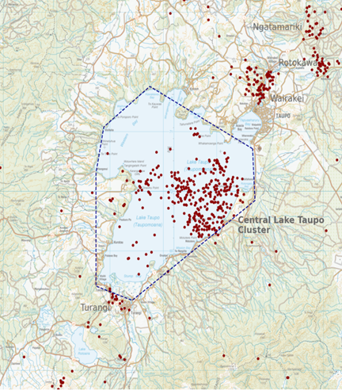 | VAB TP-2022-01
VAB message
Earthquake activity under Lake Taupō picks up
Visual requirements
Should show some aspect of earthquake activity having increased under the lake
 | Caption Earthquakes located by GeoNet in the Lake Taupō area from January 1 to July 21, 2022. All earthquakes shown here were located less than 30 km deep. There are just over 300 earthquakes shown on the map
 | Type map
 | Blue/green colourblind friendly yes

Clarity of message | Clarity of information/data | Missing or unnecessary information or distractions | Colour and accessibility | Score 1-3

Visual 9
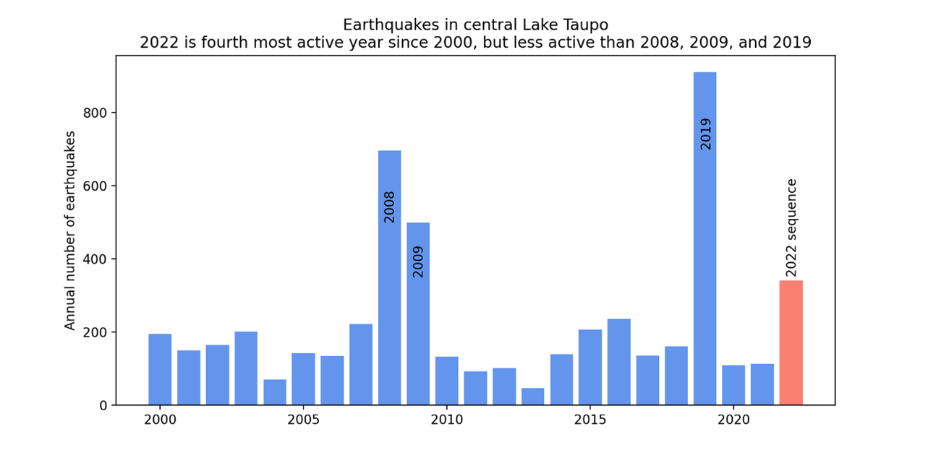 | VAB TP-2022-01
VAB message
Earthquake activity under Lake Taupō picks up
Visual requirements
Should show some aspect of earthquake activity having increased under the lake
 | Caption Earthquakes detected and located in the dashed area outlined in the map each year since 2000. The 2022 sequence of earthquakes stands out, but at this stage has fewer earthquakes than 2008, 2009, and 2019
 | Type time-series
 | Blue/green colourblind friendly yes

Clarity of message | Clarity of information/data | Missing or unnecessary information or distractions | Colour and accessibility | Score 1-3

Visual 10
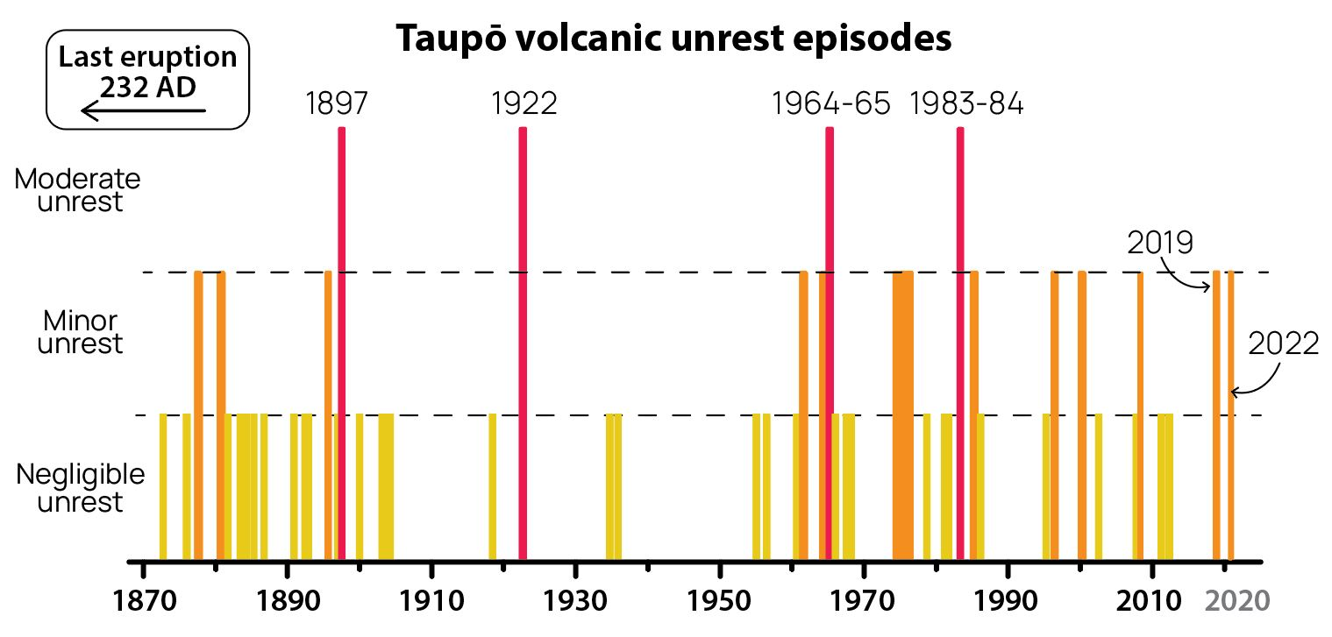 | VAB TP-2022-04
VAB message
Ongoing earthquakes and deformation indicating minor volcanic unrest
Visual requirements
Should show ongoing earthquakes or deformation, or some aspect of how this means volcanic unrest
 | Caption The magnitude of past unrest episodes at Taupō Volcano
 | Type time-series
 | Blue/green colourblind friendly yes

Clarity of message | Clarity of information/data | Missing or unnecessary information or distractions | Colour and accessibility | Score 1-3

Visual 11
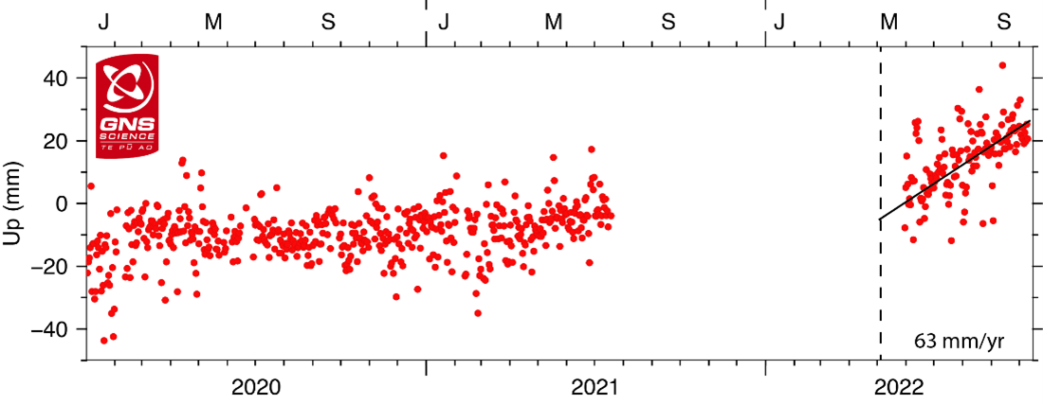 | VAB TP-2022-06
VAB message
Minor unrest ongoing at Taupō Volcano
Visual requirements
Should show some aspect of ongoing volcanic unrest
 | Caption GNSS ground uplift observed at Horomatangi Reef in central Lake Taupō since 2020. The observations represent daily elevations. The scatter in the observations reflects the uncertainty in the calculated daily elevations. The GNSS at Horomatangi Reef was not operating from mid-2021 to mid-2022
 | Type time-series
 | Blue/green colourblind friendly yes

Clarity of message | Clarity of information/data | Missing or unnecessary information or distractions | Colour and accessibility | Score 1-3

Visual 12
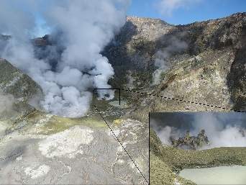 | VAB WI-2012-16
VAB message
Spiny Lava Dome – A New and Unusual Style of Eruptive Activity At White Island
Visual requirements
Should show the lava dome
 | Caption A compiled image showing the wide and close up views of the active crater area and the dome
 | Type photograph
 | Blue/green colourblind friendly not applicable

Clarity of message | Clarity of information/data | Missing or unnecessary information or distractions | Colour and accessibility | Score 1-3

Visual 13
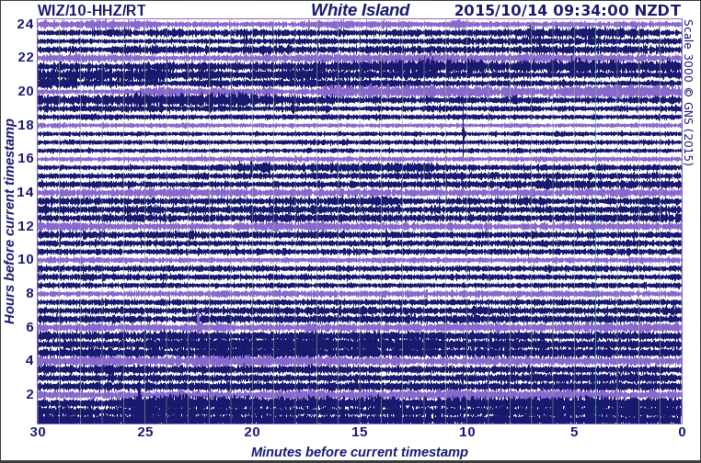 | VAB WI-2015-01
VAB message
Slight increase in volcanic unrest at White Island (Whakaari)
Visual requirements
Should show some aspect of increased unrest
 | Caption Seismic drum for White Island, note the 'banding' of the tremor
 | Type seismogram
 | Blue/green colourblind friendly yes

Clarity of message | Clarity of information/data | Missing or unnecessary information or distractions | Colour and accessibility | Score 1-3

Visual 14
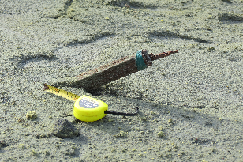 | VAB WI-2016-07
VAB message
Details of April 27 eruption unraveling
Visual requirements
Should show some aspect of the eruption
 | Caption Survey Peg D snapped off by blast
 | Type photograph
 | Blue/green colourblind friendly not applicable

Clarity of message | Clarity of information/data | Missing or unnecessary information or distractions | Colour and accessibility | Score 1-3

Visual 15
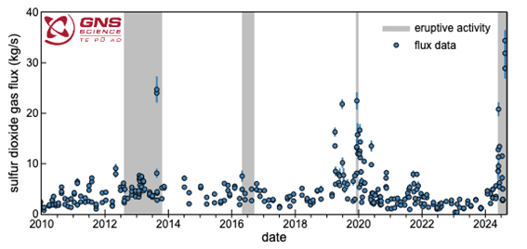 | VAB WI-2024-18
VAB message
Update from gas flight: volcanic gas emissions increase with minor ash emissions continuing
Visual requirements
Should show some aspect of gas or ash emissions
 | Caption Amount of sulphur dioxide (SO2) gas (blue circles) emitted since January 2010. Periods of eruptive activity are shown by grey bands in the background. SO2 emissions have increased since the volcanic activity increased at the end of May 2024 (grey region to the far right of the plot)
 | Type time-series
 | Blue/green colourblind friendly yes

Clarity of message | Clarity of information/data | Missing or unnecessary information or distractions | Colour and accessibility | Score 1-3

