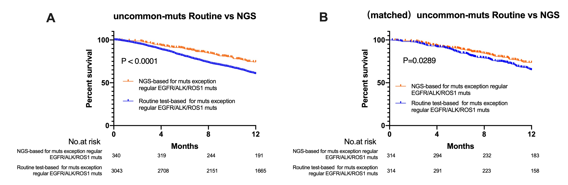
Supplementary Figure 1: Kaplan Meier estimates of overall survival (OS) according to NGS or Routine testing in uncommon mutated patients and used for a propensity score–matched survival analysis in the 12-month mortality (A) OS between patients with NGS or with Routine testing (unreached vs unreached, P＜0.0001); (B) matched OS between patients with NGS or with Routine testing (unreached vs unreached, P=0.0289).

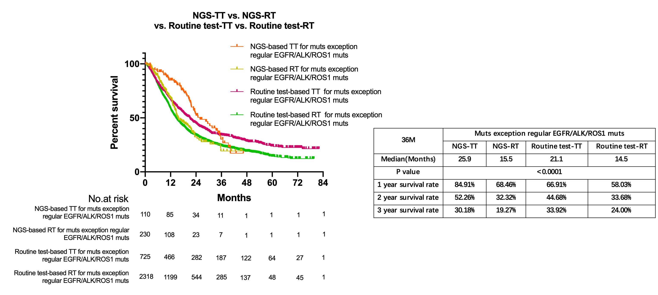
Supplementary Figure 2: Kaplan Meier estimates of overall survival (OS) according to NGS or Routine testing in uncommon mutated patients with targeted therapy (TT) or Routine therapy (RT). For four groups: the uncommon mutations patients with NGS or routine testing and with or without targeted therapies (25.9 months vs 15.5 months vs 21.1 months vs 14.5 months, P＜0.0001). Then according to 36-month mortality analysis: 12- and 24-month mortality of the groups of NGS testing were significantly higher than the group with routine testing.

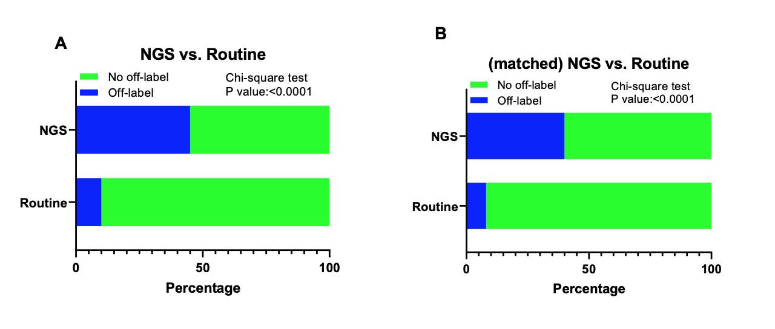
Supplementary Figure 3: The comparison of the ration of uncommon mutated patients that received off-label therapy according to NGS or Routine testing and used for a propensity score–matched survival analysis. The obviously higher ratio of the uncommon mutated patients received off-label drugs in NGS than that in Routine testing (45.4% vs. 9.6%; P <0.0001).

