Supplementary Figures and Tables

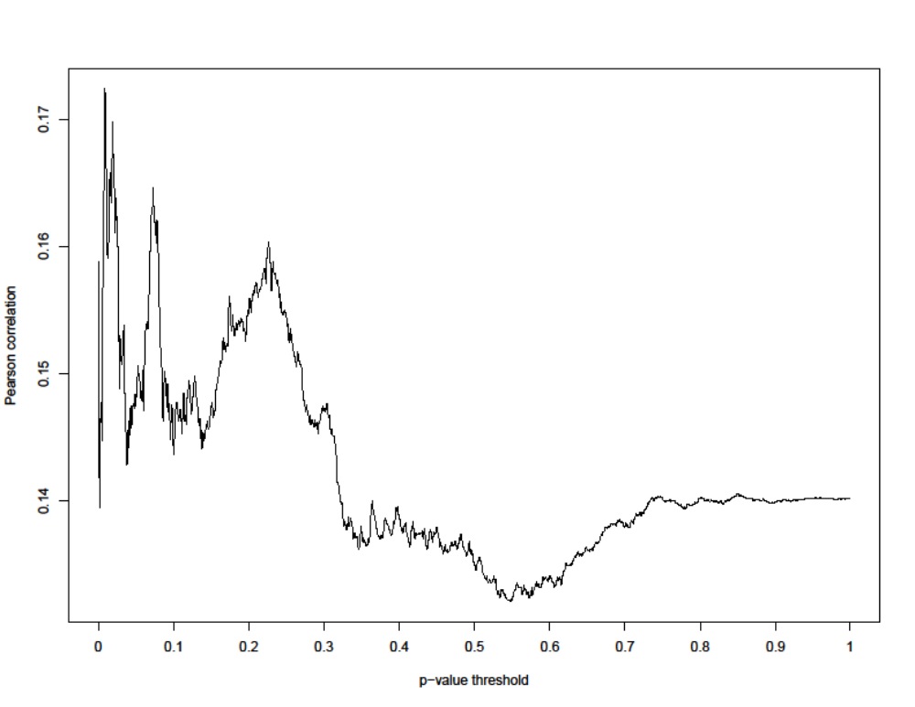
Supplementary Figure 1. Pearson correlations between measured adult BMI and PRS for BMI across multiple PRS p-value thresholds. All PRS were adjusted using linear regression for sex and residual effects of ancestry. The X-axis shows 1,000 PRS p-value thresholds from 0.001 to 1.0 at intervals of 0.001. The Y-axis shows the Pearson correlation between measured BMI and PRS for BMI. Noise at the low end of the p-value threshold is due to the small numbers of SNPs included in the PRS calculation at very low p-value thresholds.
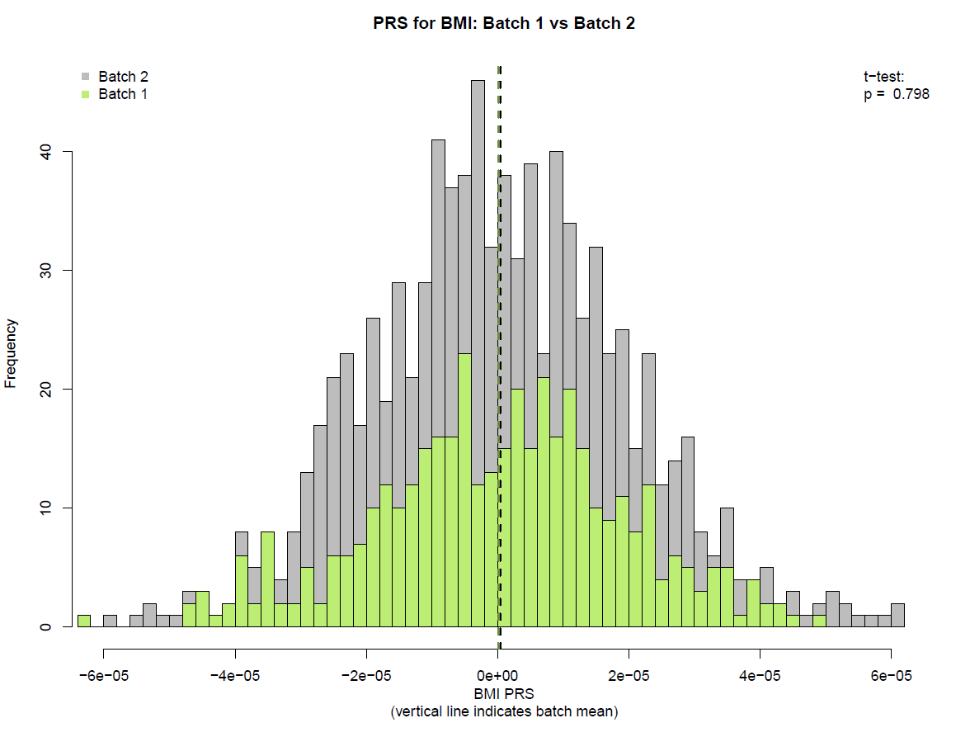

Supplementary Figure 2. In SSC families of European ancestry, PRS for BMI were calculated within WGS batch, adjusting for sex and for residual ancestry effects using linear regression. Batch 1 (hg37, n = 519 families) is shown in green and batch 2 (hg38, n = 1,132 families) is shown in grey. Using a t test, the mean PRS of the two batches were not significantly different (p = 0.80).

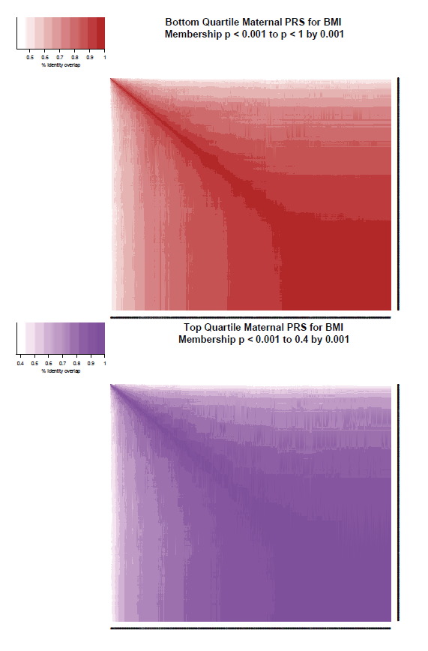Supplementary Figure 3. Correlation between quartile membership by SNP p-value threshold during calculation of PRS. The top panel represents the quartile of lowest maternal PRS for BMI. The bottom panel represents the highest quartile of maternal PRS for BMI. Fill color indicates overlap between different p-value thresholds, expressed as a percentage. PRS for BMI was calculated for 1,000 different p-value thresholds, from 0.001 to 1.0 in increments of 0.001.

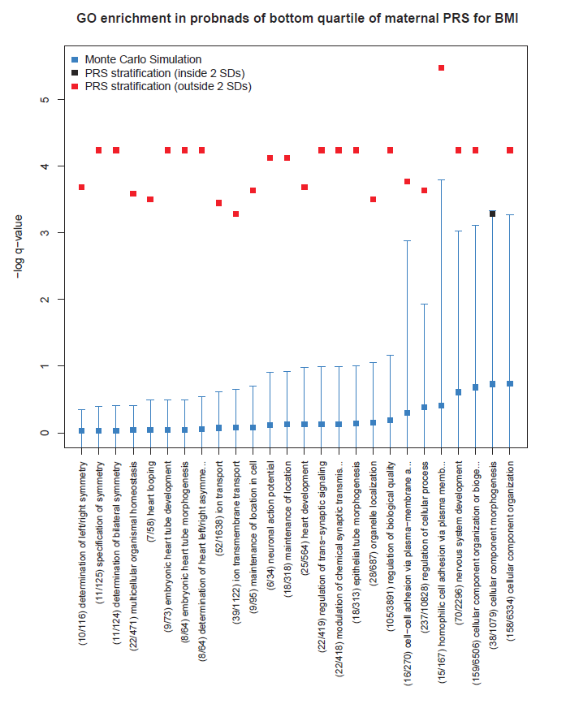
Supplementary Figure 4. Red squares indicate the observed GO pathway enrichment in probands who are offspring of mothers in the lowest BMI PRS quartile. Blue lines indicate the mean and two standard deviations of 10,000 random samplings of 325 European probands. Black squares indicate that the observed value is inside the expected range. The total number annotated genes and genes observed with medium or high impact de novo variants in these probands is shown by the GO pathway names along the x-axis. 26 significant pathways were found after FDR correction (q < 0.05, Supplementary Table 1). These pathways are involved in symmetry, heart development, and nervous system development.
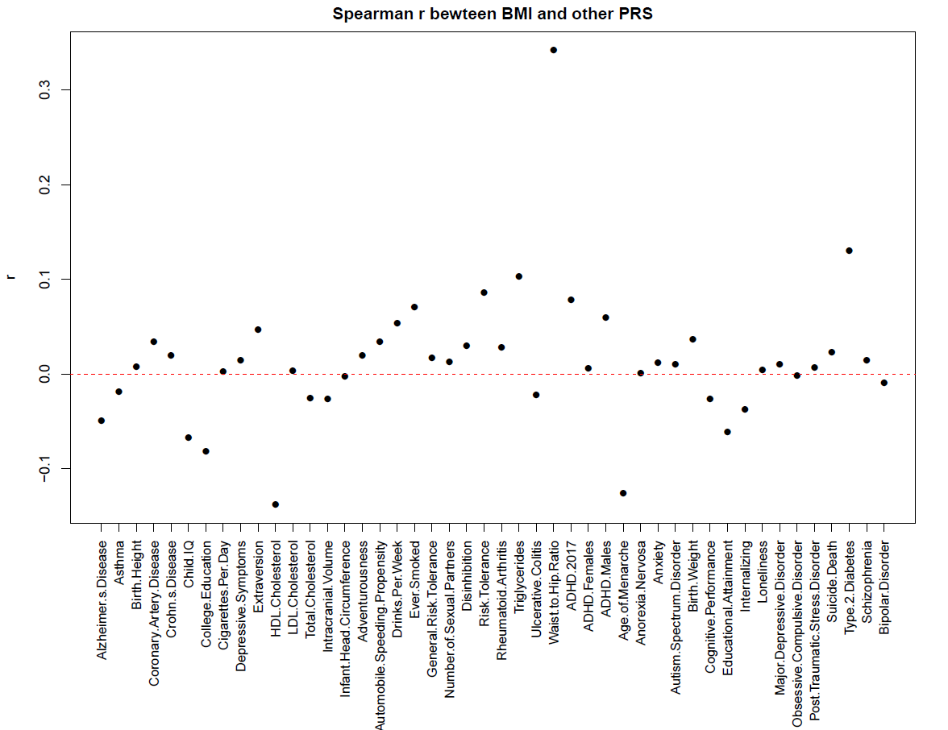
Supplementary Figure 5. Spearman correlations between maternal BMI PRS vs. maternal PRS for other traits. Traits are named on the X-axis. The red dashed line indicates r = 0. The strongest positive correlations are with maternal PRS for waist-to-hip ratio and type 2 diabetes. The strongest negative correlation is with maternal PRS for HDL cholesterol.
GO.ID | Pathway | Annotated | Significant | Expected | p-value | q-value
GO:0016569 | covalent chromatin modification | 470 | 26 | 8.39 | 3.7e-07 | 0.00256
GO:0016570 | histone modification | 456 | 25 | 8.14 | 7.4e-07 | 0.00256
GO:0016043 | cellular component organization | 6334 | 154 | 113.03 | 1.7e-06 | 0.00392
GO:0007017 | microtubule-based process | 723 | 32 | 12.9 | 2.3e-06 | 0.00398
GO:0071840 | cellular component organization or biogenesis | 6506 | 156 | 116.1 | 3.4e-06 | 0.00470
GO:0034968 | histone lysine methylation | 110 | 11 | 1.96 | 4.4e-06 | 0.00507
GO:0006325 | chromatin organization | 789 | 32 | 14.08 | 1.4e-05 | 0.0130
GO:0018022 | peptidyl-lysine methylation | 125 | 11 | 2.23 | 1.5e-05 | 0.0130
GO:0016571 | histone methylation | 135 | 11 | 2.41 | 3.1e-05 | 0.0238
GO:0006464 | cellular protein modification process | 4066 | 103 | 72.56 | 5.6e-05 | 0.0352
GO:0036211 | protein modification process | 4066 | 103 | 72.56 | 5.6e-05 | 0.0352
GO:0044260 | cellular macromolecule metabolic process | 8207 | 181 | 146.45 | 7.5e-05 | 0.0387
GO:0007010 | cytoskeleton organization | 1308 | 43 | 23.34 | 7.6e-05 | 0.0387
GO:0032886 | regulation of microtubule-based process | 204 | 13 | 3.64 | 8.0e-05 | 0.0387
GO:0051276 | chromosome organization | 1193 | 40 | 21.29 | 9.1e-05 | 0.0387
GO:0018205 | peptidyl-lysine modification | 361 | 18 | 6.44 | 9.3e-05 | 0.0387
GO:0043412 | macromolecule modification | 4269 | 106 | 76.18 | 9.5e-05 | 0.0387
GO:0006351 | transcription, DNA-templated | 3603 | 92 | 64.29 | 0.00013 | 0.0500

Supplementary Table 1. All GO pathways significantly enriched in probands of mothers in the top quartile of maternal PRS for BMI prior to elimination of pathways for tests of specificity. Columns indicate the GO ID, the name of the GO pathway, the number of genes in the GO pathway, the number of genes present in the quartile, the number expected by chance, the p-value for the Fisher’s exact test, and the FDR corrected q-value (6,917 tests). Two pathways eliminated in our test for specificity of high BMI vs. general metabolic dysfunction are shaded in blue. Four pathways eliminated in our tests for specificity of a maternal effect are shaded in yellow.

GO ID | Pathway | Annotated | Significant | Expected | p-value | q-value
GO:0007156 | homophilic cell adhesion via plasma membrane adhesion molecules. | 167 | 15 | 3.12 | 6.0e-07 | 0.00415
GO:0016043 | cellular component organization | 6334 | 158 | 118.51 | 6.1e-06 | 0.0144
GO:0035050 | embryonic heart tube development | 73 | 9 | 1.37 | 8.6e-06 | 0.0144
GO:0050804 | modulation of chemical synaptic transmission | 418 | 22 | 7.82 | 1.4e-05 | 0.0144
GO:0099177 | regulation of trans-synaptic signaling | 419 | 22 | 7.84 | 1.5e-05 | 0.0144
GO:0071840 | cellular component organization or biogenesis | 6506 | 159 | 121.73 | 2.0e-05 | 0.0144
GO:0009855 | determination of bilateral symmetry | 124 | 11 | 2.32 | 2.2e-05 | 0.0144
GO:0007399 | nervous system development | 2296 | 70 | 42.96 | 2.2e-05 | 0.0144
GO:0009799 | specification of symmetry | 125 | 11 | 2.34 | 2.3e-05 | 0.0144
GO:0003143 | embryonic heart tube morphogenesis | 64 | 8 | 1.2 | 2.5e-05 | 0.0144
GO:0061371 | determination of heart left/right asymmetry | 64 | 8 | 1.2 | 2.5e-05 | 0.0144
GO:0065008 | regulation of biological quality | 3891 | 105 | 72.8 | 2.6e-05 | 0.0144
GO:0060562 | epithelial tube morphogenesis | 313 | 18 | 5.86 | 2.7e-05 | 0.0144
GO:0051235 | maintenance of location | 318 | 18 | 5.95 | 3.3e-05 | 0.0161
GO:0019228 | neuronal action potential | 34 | 6 | 0.64 | 3.5e-05 | 0.0161
GO:0098742 | cell-cell adhesion via plasma-membrane adhesion molecules | 270 | 16 | 5.05 | 5.3e-05 | 0.0229
GO:0007368 | determination of left/right symmetry | 116 | 10 | 2.17 | 6.5e-05 | 0.0250
GO:0007507 | heart development | 564 | 25 | 10.55 | 6.5e-05 | 0.0250
GO:0051651 | maintenance of location in cell | 95 | 9 | 1.78 | 7.2e-05 | 0.0262
GO:0050794 | regulation of cellular process | 10828 | 237 | 202.59 | 7.6e-05 | 0.0263
GO:0048871 | multicellular organismal homeostasis | 471 | 22 | 8.81 | 8.4e-05 | 0.0277
GO:0001947 | heart looping | 58 | 7 | 1.09 | 0.00010 | 0.0301
GO:0051640 | organelle localization | 687 | 28 | 12.85 | 0.00010 | 0.0301
GO:0006811 | ion transport | 1638 | 52 | 30.65 | 0.00011 | 0.0317
GO:0032989 | cellular component morphogenesis | 1079 | 38 | 20.19 | 0.00014 | 0.0372
GO:0034220 | ion transmembrane transport | 1122 | 39 | 20.99 | 0.00014 | 0.0372

Supplementary Table 2. GO pathways that are significantly enriched in probands of mothers in the bottom quartile of maternal PRS for BMI. Columns indicate the GO ID, the name of the GO pathway, the number of genes in the GO pathway, the number of genes present in the quartile, the number expected by chance, the p-value for the Fisher’s exact test, and the FDR corrected q-value (6,917 tests). Two pathways eliminated in this test for specificity of high BMI vs. general metabolic dysfunction are shaded in blue.

