Graph abstract
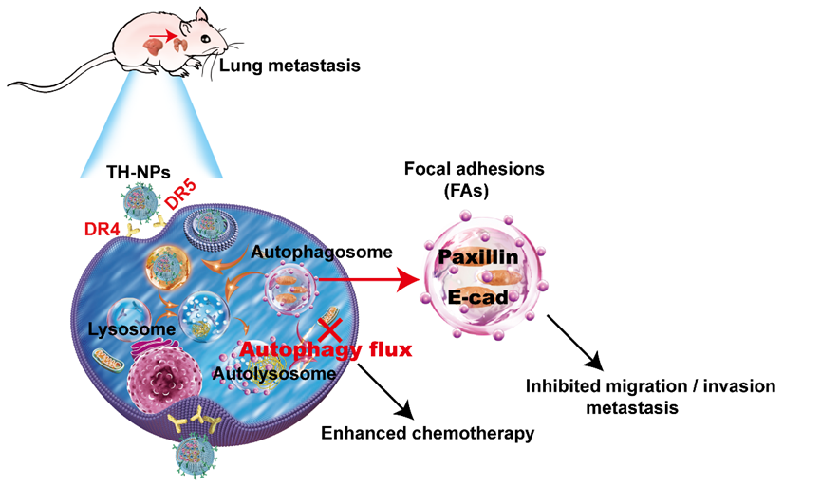
The targeted co-delivery biomimetic nanoparticles TH-NPs can block chemotherapy-induced autophagy-mediated focal adhesions disassembly or degradation, leading to tumor metastasis inhibition and excellent tumor growth suppression.

