Programmable Hybridization Assemble Nicked Displacement Amplification for Detecting Ricin

Yu Wangª, Yuan Pengª, JialeiBaiª, Shuang Liª, Dianpeng Hanª, Shuyue Renª, Kang Qinª, Sen Liª, Huanying Zhouª, Zhixian Gao^{a, *}

ª Tianjin Key Laboratory of Risk Assessment and Control Technology for Environment and Food Safety, Tianjin Institute of Environmental and Operational Medicine, Tianjin 300050, P.R. China.

* Corresponding author.
Tel./fax: +86 22 84655403.
E-mail address: gaozhx@163.com (Z. Gao).

EXPERIMENTAL SECTION
Materials
Klenow Fragment (3’-5’exo), Nt.BbvCI, dNTP and respective buffers were purchased from New England Biolabs (NEB). Anti-ricin monoclonal antibody was purchased from GeneTex. Ricin standards were from Beijing Hanpu Institute of Biomedicine. Chloroauric acid trihydrate were from SIGMA-Aldrich. The main instruments used in the experiment: thermostatic metal bath OSE-96 (Beijing Tiangen Biochemical Technology Co., Ltd., China), fluorescence spectrophotometer F97pro (Shanghai Lingguang Technology Co., Ltd., China), magnetic attraction frame (Life Company, USA), Gel imaging system ImageQuant350 (GE, USA).
Buffer preparation
(1) Hybridization buffer (pH = 7.5): 0.2423 g of Tris, 2.3376 g of NaCl and 0.1017 g of MgCl2 dissolved in 100 mL of ultrapure water.
(2) Salting buffer: 8.182 g of NaCl dissolved in 100 mL of 0.1 M PBS buffer.
(3) Stock buffer solution: 1 g PEG20000 and 1 g BSA dissolved in 0.1 M PBS.
Table S1. DNA sequence
Name | DNA sequence（5′-3′）
BarcodeDNA | SH-TTTTT TTTTT TGACTTCTCCGGATACTGGTTGATTCTATCC
L6S0H1 | CTCCGGATACTGGTTGATTCTATCCAGCTGAGGATAGAATCAACCAGTATCCGGAGAAGTCA
L6S0H2 | TCAGCTGGATAGAATCAACCAGTATCCGGAGTGACTTCTCCGGATACTGGTTGATTCTATCC
L6S0H1F | CTCCGGAT(6-FAM)ACTGGTTGATTCTATCCAGCTGAGGATAGAATC  AACCAGTAT(BHQ-1)CCGGAG AAGTCA
L10S0H1 | CTCTTTGGATAGAATCAACCAGTATCCGGAGTTCTTGACTTCTCCGGATACTGGTTGATTCTATCC
L10S0H2 | CTCCGGATACTGGTTGATTCTATCCAAAGAGCTGAGGATAGAATCAACCAGTATCCGGAGAAGTCA
L14S0H1 | CGCATTGGATAGAATCAACCAGTATCCGGAGTTGTCATTTGATTTCTCCGGATACTGGTTGATTCTATCC
L14S0H2 | CTCCGGATACTGGTTGATTCTATCCAATGCGAGAGCTGAGGATAGAATCAACCAGTATCCGGAGAAGTCA
L18S0H1 | AGCGTTGGATAGAATCAACCAGTATCCGGAGTTTTCAGTGTTCTGACTTCTCCGGATACTGGTTGATTCTATCC
L18S0H2 | CTCCGGATACTGGTTGATTCTATCCAACGCTCAAGAGAGCTGAGGATAGAATCAACCAGTATCCGGAGAAGTCA
L10S4H1 | CTCAGCGGATAGAATCAACCAGTATCCGGAGTTCTTGACTTCTCCGGATACTGGTTGATTCTATCC
L10S4H2 | CTCCGGATACTGGTTGATTCTATCCGCTGAGGTTTGGATAGAATCAACCAGTATCCGGAGAAGTCA
L14S8H1 | CTCAGCGGATAGAATCAACCAGTATCCGGAGCCGTCTTTTGACTTCTCCGGATACTGGTTGATTCTATCC
L14S8H2 | CTCCGGATACTGGTTGATTCTATCCGCTGAGGGATCATTGGATAGAATCAACCAGTATCCGGAGAAGTCA
L18S12H1 | CTCAGCGGATAGAATCAACCAGTATCCGGAGTTTTCAGTTTTCTGACTTCTCCGGATACTGGTTGATTCTATCC
L18S12H2 | CTCCGGATACTGGTTGATTCTATCCGCTGAGGTTTTCCTCTTTGGATAGAATCAACCAGTATCCGGAGAAGTCA
Report Probe F | C(6-FAM)TCCG GATACTGGTTGATTCTATCC
Report Probe Q | AATCAACCAGTATC CGGAG(BHQ-1)

HANDA
HANDA method
The hairpin probes needed to be denatured at 95°C for 5 minutes before use, and then slowly dropped to room temperature. The cooling annealing process lasted for 1 hour. In a 20 μL system, the final concentration of TH0 was 250 nM, and the final concentration of hairpin probes L6S0H1 and L6S0H2 was 1 μM. They were mixed and placed in 37°C for 45 min to hybridize to form a long HCR chain. Then KF (4 U) and dNTP (0.5U, 10 mM) were added. After 15 minutes of reaction, Nt.BbvCI (12U) was added, and the reaction was continued at 37°C for 2 hours.
Amplification kinetic analysis
In the experiment, the hairpin probe L6S0H1F labeled with a fluorescent group was hybridized with L6S0H2 for exploration. The experiment process was as follows:
(1) Mix L6S0H1F (10 μM, 5 μL), L6S0H2 (10 μM, 5 μL) with 190 μL hybridization buffer in the micro cuvette.
(2) Place the cuvette in the fluorescence spectrophotometer and start timing scanning (parameters: scanning speed 1 min/time, gain 800V, excitation wavelength 485 nm).
(3) After the fluorescence value stabilizes, add TH0 (10 μM, 5 μL), and record the fluorescence value change.
(4) After the fluorescence value is stable, add KF (4 U) and record the change of fluorescence value.
(5) After the fluorescence value is stable, add Nt.BbvCI (12 U) and Report Probe (10 μM, 3 μL), and record the change in fluorescence value.
Explore the amplification capabilities of different hairpin probes
The experiment used 12% PAGE electrophoresis and real-time fluorescence determination to characterize the amplification ability of different hairpins. Real-time fluorescence mainly monitored the fluorescence recovery of HANDA after adding the reporter probe. The speed of its fluorescence recovery and the intensity of the fluorescence value represented the ability of hairpin probe amplification. The hairpin probes (10 μM, 2 μL) were mixed with TH0 (1 μM, 5 μL) at 37°C for 45 min. Then KF (4 U) was added to polymerize for 15 min. Subsequently, Nt.BbvCI (12 U) and Report Probe (3 μL) were added. The fluorescence value was continuously monitored through real-time fluorescent PCR (instrument parameter setting: temperature was 37 ℃, the fluorescence value was detcted once every 10 s).
Barcode DNA-HANDA
Preparation of magnetic probe
Please refer to the instructions of Dynabead@ M-270 Magnetic Bead Kit.
(1) 5 mg of magnetic beads particles were shaken with 500 μL of C1 buffer for 10 minutes.
(2) Please separate the magnetic beads and discard the supernatant. ricin monoclonal antibody (1mg/mL, 60 μL) was mixed with PBS (190 μL, 0.01 mol/L), the activated magnetic beads, and 250 μL C2 solution at 37 ℃ for 20 h.
(3) The above magnetic beads were washed with HB solution.
(4) Washing with SB solution. Finally, the magnetic beads were resuspended in 500 µL of SB solution and placed at 4°C for later use.
Coupling rate of magnetic beads and ricin monoclonal antibody
The BCA protein quantification kit was used to determine the content of the monoclonal antibody in the supernatant collected by the magnetic separation, so as to indirectly measured the amount of the monoclonal antibody coupled to the magnetic beads and then calculated the coupling efficiency. The measurement method was as follows:
(1) Preparation of BSA standard dilutions (0 μg/mL, 0.05 μg/mL, 0.1 μg/mL, 0.2 μg/mL, 0.25 μg/mL, 0.5 μg/mL) for protein quantification standard curve backup.
(2) Preparation of working solution: mixing 5000 µL of BCA and 70 µL of Cu reagent (200 µL/well) and incubating at 37 ℃ for 30 min.
(3) Measuring the absorbance value at 570nm on the microplate reader and drawing a standard working curve to calculate the sample concentration and coupling rate.
Preparation of colloidal gold probe
This experiment used sodium citrate reduction method to prepare 15 nm colloidal gold [1]. 1% chloroauric acid solution was heated and stirred with 99 mL of ultrapure water. After boiling, 1% trisodium citrate (2 mL) was quickly added and kept the temperature for 15 min. After cooling to room temperature, the mixture was filtered with 0.45 µm cellulose acetate filter membrane (pH between 8.5-9.0). 1 mL of the above colloidal gold was mixed with anti-ricin polyclonal antibody (45 μg/mL, 100 μL) at room temperature for 1 h with shaking. The sulfhydryl modified Barcode DNA (20 μM) was added to the colloidal gold mixture and allowed to stand at 4 ℃ for 2 h. Then salting buffer was added to make the final salt concentration reach 0.14 mol/L at 4 ℃ for 2 h. The probe was blocked with 5% BSA for 1 h. Finally, the final product was centrifuged (2000 r/min, 10 min) at 4 ℃ and the pellet was discarded. The supernatant was centrifuged (13000 r/min, 20 min) and the pellet was collected. 800 μL of stock buffer was added to the pellet to store at 4 ℃ for later use.
Establishment of barcode DNA-HANDA detection method
- Magnetic probe (1 mg/mL, 10 μL) was blocked with 1% BSA for 1 h.
- The gold probe (50 μL) was added to the magnetic bead mixture and placed in a vertical mixer at 37 ℃ for 1 h to form a sandwich structure.
- DTT (5 mM, 50 μL) was added in (2). Then the mixture was placed in a vertical mixer at 37 ℃ for 80 min to elute the barcode DNA.
- After magnetic separation, supernatant was kept as primer DNA for amplification. the optimized hairpin L6S0H1 and L6S0H2 were selected, and performed HANDA according to the above method.
- The fluorescence value of the amplified product was measure twith a fluorescence spectrophotometer.
Actual sample detection
Commercially available milk and drinking water were selected as samples for spiked recovery determination. The pretreatment method mainly referred to the previous literature [2]. Milk pretreatment method: excess fat from the upper layer was removed by centrifugation (10000 rpm, 20 min). Then it was diluted ten times with PBS and added the corresponding concentration of ricin to make the final concentration 200, 100, 50, 5 ng/mL. Drinking water pretreatment method: it was directly added the corresponding concentration of ricin to make the final concentration 200, 100, 50, 5 ng/mL. Then barcode DNA-HANDA was used to determine the content of ricin in the samples, and each sample was subjected to three repeated experiments to determine the recovery rate of standard addition. Among them, the recovery rate of degreasing standard addition (%) = C_{after standard addition sample}/C_{standard product}, where C_{standard addition sample} refers to the detection concentration after adding ricin standard product, and C_{standard product} is the concentration of adding standard product.
Results and discussion
Determination of coupling rate of magnetic bead conjugated monoclonal antibody
The magnetic beads were covalently coupled to ricin monoclonal antibodies. The theoretical monoclonal antibody coupling amount of the magnetic beads was 12 µg/mg. However, during the coupling process, the monoclonal antibody could not be fully coupled to the surface of the magnetic beads. Therefore, it was necessary to determine the antibody content in the supernatant after coupling the magnetic beads and calculate the coupling efficiency of the magnetic beads to the monoclonal antibody. The BCA protein quantification kit was used to determine the antibody concentration in the supernatant. The standard curve of protein (Figure S1) established by BCA protein quantification kit was y=0.9324x+0.0954 (R²=0.998). The absorbance of the supernatant collected after magnetic separation at 562 nm was 0.13, and the antibody concentration in the supernatant was calculated to be 37.47 µg/mL, that is, the coupling rate of the magnetic bead-conjugated antibody was 37.53%.
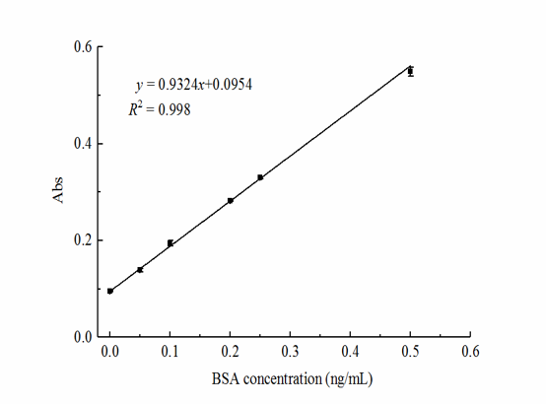
Figure S1. Protein quantification standard curve.
Optimization of experimental conditions
The elution time of DTT, the concentration of polymerase and the concentration of dicing enzyme were optimized respectively, so that the detection method could exert the best effect. The ordinate of the optimization process was △F (the difference between the fluorescence value of the target concentration and the negative value), so that the optimization conditions of the experiment could be determined intuitively.
1. Optimization of DTT elution time
The function of DTT is to break the gold-sulfur bond between barcode DNA and colloidal gold, so that the barcode DNA can be released into the solution [3]. Experiments have proved that the elution time is closely related to the DNA release effect. If the elution time is too short, the barcoded DNA cannot be completely eluted and released, making the detection fluorescence value low; long elution time increases the detection time. The concentration of DTT was fixed at 5mM, and the fluorescence value increased with the increase of elution time (Figure S2). When the elution time was 80 min, the change of fluorescence value tended to be stable. Therefore, 80 min was selected as the best time for DTT to elute barcoded DNA.
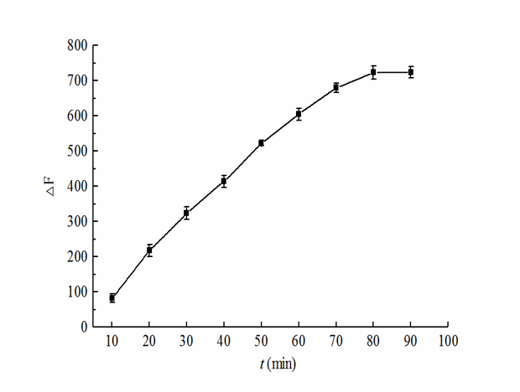
Figure S2. Optimization of DTT elution time.
2. Optimization of KF and Nt.BbvCI concentration
As shown in Figure S3, when the KF concentration was 0.25 U/μL, the detected fluorescence value had a larger inflection point. When the KF concentration was higher than 0.25 U/μL, the fluorescence value would not change significantly, and the curve tended to be stable. When the concentration of Nt.BbvCI was greater than 0.5 U/μL, the fluorescence value changes tended to be stable. Considering the overall cost, choose 0.25 U/μL and 0.5 U/μL as the optimal KF concentration and Nt.BbvCI concentration.
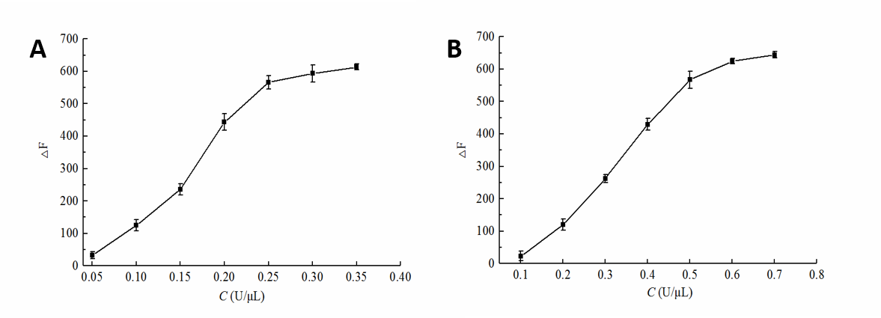
Figure S3. Optimization of KF polymerase (A) and Nt.BbvCI nicking enzyme (B) added.
Actual sample detection
In the experiment, commercially available milk and drinking water were selected as simulated pollution samples, and barcode DNA-HANDA was applied for detection. The test results show (Table S2) that the recovery rate of standard addition was between 84.6%-122%, and the relative standard deviation was between 2.191%-6.75%, indicating that this method had good application value.
Table S2 Recoveries of ricin toxin in food samples
Sample | Added  (ng/mL) | Found  (ng/mL) | Recovery (%) | RSD (%)
Drinking  water | 200 | 215 | 107.5 | 4.332
Drinking  water | 100 | 117.2 | 117.2 | 3.27
Drinking  water | 50 | 44.2 | 88.4 | 4.204
Drinking  water | 5 | 4.23 | 84.6 | 6.75
Milk | 200 | 173.8 | 86.9 | 3.315
Milk | 100 | 92.3 | 92.3 | 2.191
Milk | 50 | 52.2 | 104.4 | 5.624
Milk | 5 | 6.1 | 122 | 5.71

References:
1. Grabar KC, Brown KR, Keating CD, Stranick SJ, Tang SL, Natan MJ: Nanoscale characterization of gold colloid monolayers: a comparison of four techniques. Anal Chem 1997, 69:471-477.
2. Alenazi NA, Manthorpe JM, Lai EPC: Selective extraction of BPA in milk analysis by capillary electrophoresis using a chemically modified molecularly imprinted polymer. Food Control 2015, 50:778-783.
3. Tan F, Liu X, Quan X, Chen J, Li X, Zhao H: Selective detection of nanomolar Cr(vi) in aqueous solution based on 1,4-dithiothreitol functionalized gold nanoparticles. Analytical Methods 2011, 3:343-347.

