Explanation of Variable Selection in the Prediction Model
Through feature analysis of patients' test indicators, it was found that 13 variables (gender, NLR, SII, MLR, KL-6, WBC, NEUT, NEUT%, LYMPH%, MONO%, HCT, MCV, RDW-SD) were significantly correlated with the differential diagnosis of diseases (CTD vs. CTD-ILD). These test items were therefore selected as variables for constructing the prediction model. The model was established following the same methods and procedures described in the manuscript, and subsequent model interpretability analysis was performed, with the results shown in the figures below.
Figure (A) presents the SHAP summary plot of the prediction model, consisting of 12 features ranked by their impact on the occurrence of ILD in CTD patients. Figure (B) displays a bar plot of the mean absolute SHAP values for each feature, which quantifies the average impact of each feature on the model output. A longer blue bar indicates a greater average impact of the corresponding feature on predicting ILD occurrence in CTD patients.
Therefore, based on the correlation between each variable and the disease, the SHAP values in the prediction model, and medical professional perspectives, we ultimately identified four test items—RDW-SD, SII, WBC, and MCV—as the variables for constructing the disease prediction model.

Figure(A)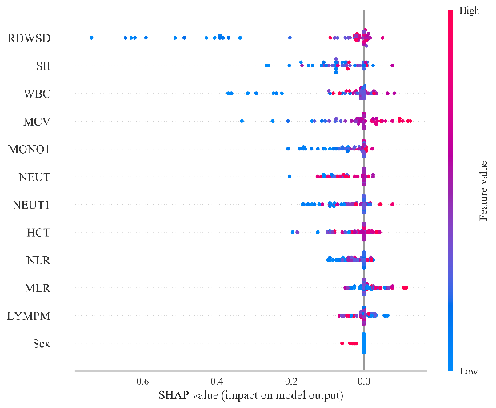
Figure(B)