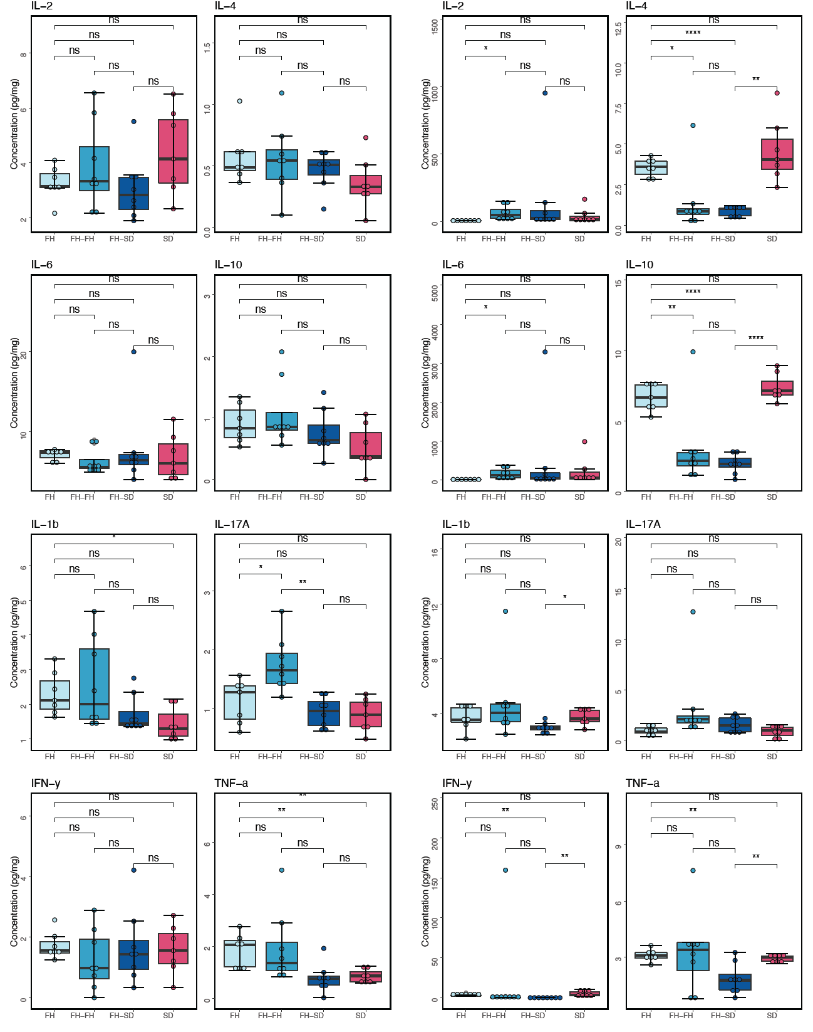
Figure S1. Boxplot showing the concentration of inflammatory cytokines in hippocampal tissues (left panel) and serum samples (right panel). The asterisks indicate as follows: ns, p > 0.05; *, p ≤ 0.05; **, p ≤ 0.01; ***, p ≤ 0.001; ****, p ≤0.0001 (t-test).

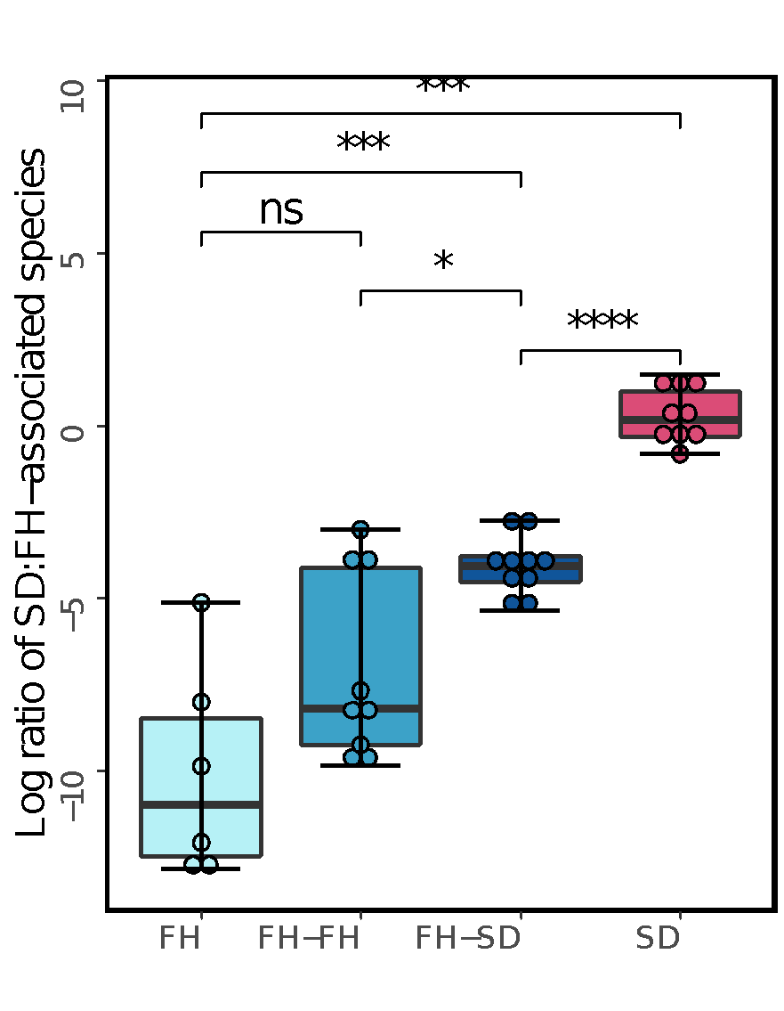
Figure S2. Box plot illustrating the log-ratios of SD:FH-associated species in experimental groups, where the asterisks indicate as follows: ns, p > 0.05; *, p ≤ 0.05; **, p ≤ 0.01; ***, p ≤ 0.001; ****, p ≤ 0.0001 (Mann-Whitney Wilcoxon test).
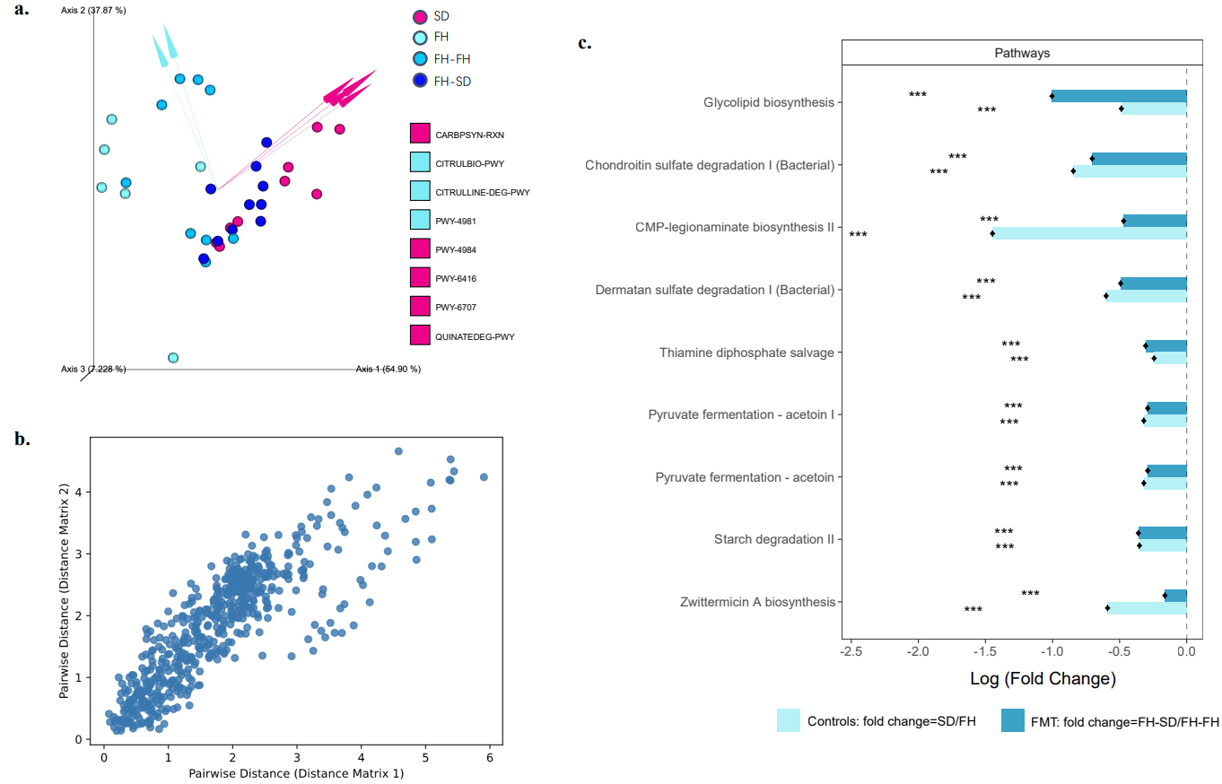Figure S3. Quantitative analysis of gut functional diversity and abundance in terms of MetaCyc pathways. (a) DEICODE (robust Aitchison PCA) generated biplot of MetaCyc pathways. CARBPSYN-RXN, carbamoyl phosphate synthesis; CITRULBIO-PWY, L-citrulline biosynthesis; CITRULLINE-DEG-PWY, L-citrulline degradation; PWY-4981, L-proline biosynthesis II (from arginine); PWY-4984, urea cycle; PWY-6416, quinate degradation II; PWY-6707, gallate biosynthesis; and QUINATEDEG-PWY, quinate degradation. (b) Mantel scatter plot between the MetaCyc-mapped enzymatic reactions and pathway assignments of robust-PCA-based distance matrices. (c) ANCOM-BC model-derived pairwise differential proportion analysis on metabolic pathways stratified by control and FMT groups, where the data is represented by effect size (log₂(fold change)) and 95% confidence interval bars (two-sided; Bonferroni adjusted). Diamonds on top of some bars indicate structural zeros. All effect sizes with adjusted p < 0.05 are indicated as follows: *, significant at 5% level of significance; **, significant at 1% level of significance; ***, significant at 0.1% level of significance.
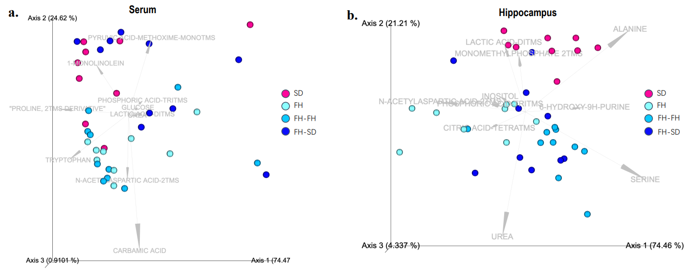
Figure S4. DEICODE-generated biplots of metabolomics in serum (a) and hippocampus (b). The data points represented individual rats and were colored by group. Metabolites driving the ordination space were exemplified by the vectors.

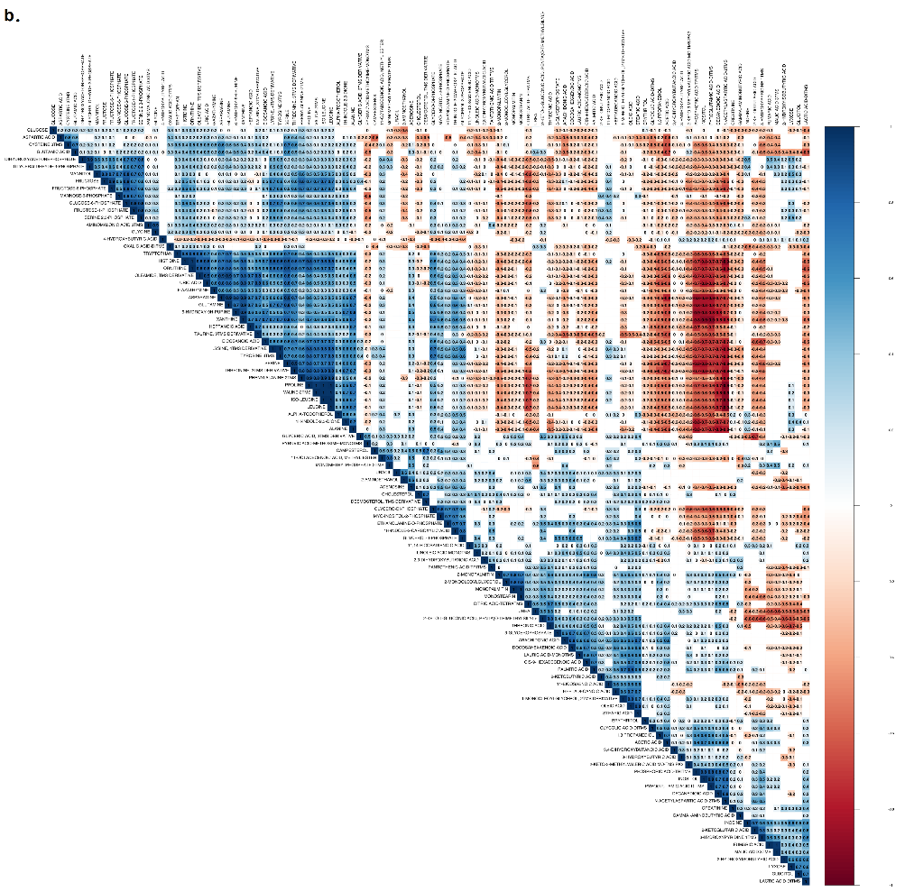
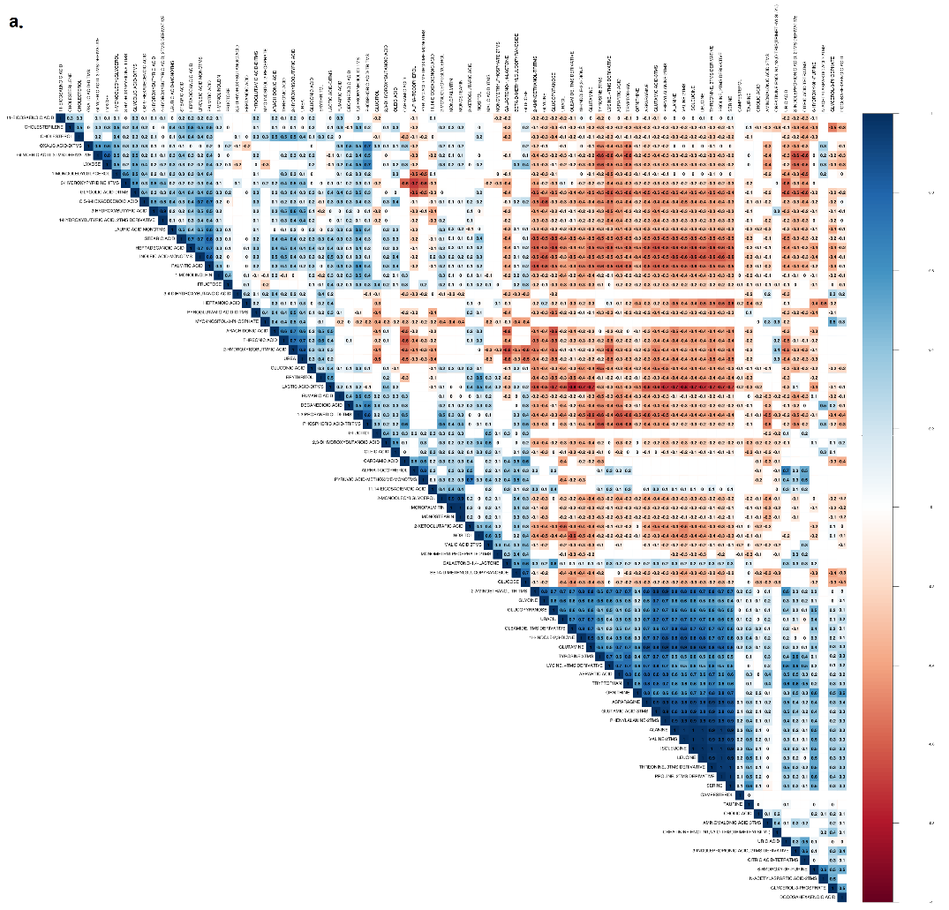
Figure S5. Correlation heatmaps of serum metabolites (a) and hippocampal metabolites (b). Blue color indicates positively significant association, red color indicates negatively significant association, white colored cells are the insignificant correlations (p>0.05).

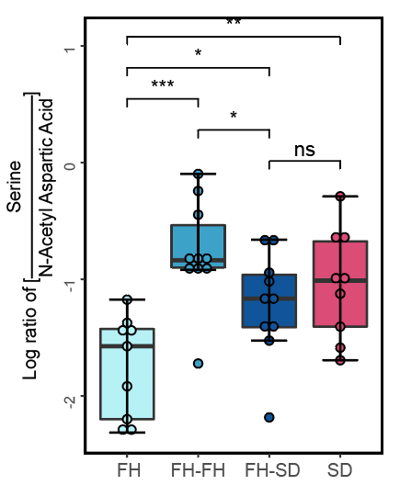
Figure S6. Boxplot showing the log-ratio of serine to N-acteyl-aspartate in hippocampal metabolomics. The asterisks indicate as follows: ns, p > 0.05; *, p ≤ 0.05; **, p ≤ 0.01; ***, p ≤ 0.001; ****, p ≤ 0.0001 (Wilcoxon-test).

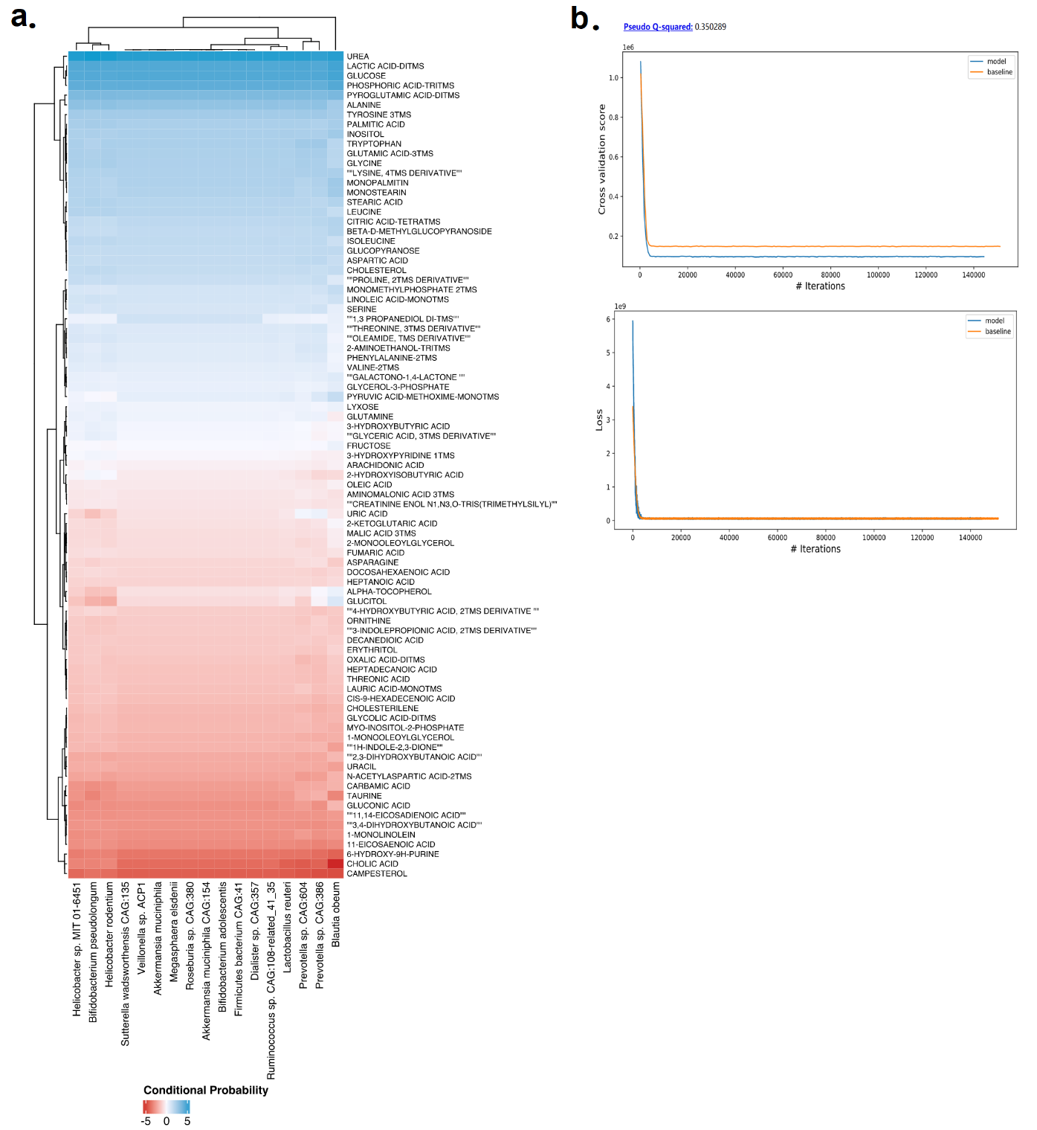
Figure S7. Microbe-metabolite co-occurrences amongst the group-associated features Clustered heatmap showing the log conditional probabilities between microbial species or functions and metabolites present in the serum along with convergence summary of the models.

