File S11. Supplemental Tables and Figures
Table S1. Loci excluded from the multi-QTL model for scab resistance.
Trait | QTL Chr@position bp (nearest PotatoMASH locus) ª | Chrom | Confidence interval (90%) in bp ^{b} | Model | PVE (%) (Single-QTL model)
Scab resistance | *Chr01@79610739 (C1_27) | 1 | n/a | Trigenic dominance | 10
Scab resistance | Chr04@1152376 (C4_1) | 4 | (1152376…2161512) | Quadrigenic dominance | 9
Scab resistance | Chr04@5418166 (C4_5) | 4 | (2104391…65073726) | Additive | 3
Scab resistance | Chr05@7266490 (C5_8) | 5 | (6204132…8055219) | Additive | 3
Scab resistance | *Chr08@39692268 (C8_9) | 8 | n/a | Trigenic dominance | 9
Scab resistance | Chr10@19301274 (C10_6) | 10 | (4098200…32300932) | Quadrigenic dominance | 14
a|b The distance in bp is based on DM v6.01 of the reference genome. When the QTL peak was at a “pseudo-marker” position, its cM position was converted to a physical coordinate by interpolation.
*CI (90%) was not estimated for QTL Chr01@79.6 Mb because the chromosome‑wide credible interval is centred on the main QTL peak and does not extend to cover smaller peaks. QTL Chr08@39.7 Mb lies within the 90% credible interval of QTL Chr08@53.9 Mb.

Table S2. Additive effects of parental haplotypes for scab resistance, plant maturity and tuber shape.
Trait | QTL ª | Désirée haplotypes |  |  |  | Electra haplotypes ^{b} |  |  |  | Picasso haplotypes
Trait | QTL ª | 1 | 2 | 3 | 4 | 1 | 2 | 3 | 4 | 1 | 2 | 3 | 4
Scab resistance | Chr01@1.1 | -0.056 | -0.002 | 0.034 | 0.009 | -0.014 | 0.012 | 0.036 | -0.005 | -0.008 | -0.032 | -0.016 | -0.064
Scab resistance | Chr03@4.4 | -0.004 | -0.082 | -0.001 | 0.091 | -0.051 | -0.023 | 0.076 | 0.019 | -0.024 | -0.062 | 0.012 | -0.031
Scab resistance | Chr08@53.9 | -0.182 | 0.017 | 0.035 | 0.018 | 0.017 | -0.016 | 0.095 | -0.001 | 0.017 | -0.021 | -0.012 | -0.019
Scab resistance | Chr10@57 | 0.035 | -0.019 | -0.019 | 0.020 | -0.207 | -0.015 | 0.164 | 0.051 | -0.044 | 0.010 | -0.020 | -0.014
Scab resistance | Chr12@1 | -0.013 | -0.041 | 0.075 | -0.006 | 0.053 | -0.042 | 0.034 | -0.010 | -0.055 | -0.225 | 0.065 | -0.021
Scab resistance | Chr01@79.6 | 0.012 | -0.002 | -0.016 | 0.001 | 0.036 | 0.026 | 0.061 | -0.017 | -0.028 | -0.004 | 0.007 | -0.075
Scab resistance | Chr04@1.2 | -0.009 | -0.019 | -0.021 | -0.009 | 0.006 | 0.019 | -0.038 | 0.191 | -0.053 | -0.022 | -0.002 | -0.043
Scab resistance | Chr04@5.4 | -0.045* | -0.059* | -0.046* | -0.034 | -0.034 | -0.036 | -0.050* | 0.496* | -0.049* | -0.046* | -0.047* | -0.046*
Scab resistance | Chr05@7.3 | -0.027 | -0.161* | -0.037 | 0.143 | -0.033 | -0.027 | 0.257* | 0.070 | -0.055 | -0.053 | 0.000 | -0.077*
Scab resistance | Chr08@39.7 | -0.002 | 0.008 | -0.008 | -0.018 | 0.034 | -0.001 | 0.036 | 0.007 | -0.012 | 0.003 | -0.018 | -0.030
Scab resistance | Chr10@19.3 | -0.002 | 0.005 | -0.054 | 0.008 | -0.001 | -0.043 | 0.162 | 0.042 | -0.041 | -0.003 | -0.074 | 0.001
Plant maturity | Chr05@4.5 | -0.150 | -0.061 | -0.146 | 0.563* | -0.145 | -0.176 | -0.018 | 0.157 | -0.193* | -0.236* | 0.206* | 0.199*
Tuber shape | Chr10@50.3 | 0.221* | -0.500* | 0.140 | 0.412* | -0.507* | 0.076 | 0.151 | 0.101 | -0.389* | 0.088 | 0.116 | 0.089
ª QTLs in bold were retained in the multi-QTL model for scab resistance, and their respective additive effects are shown. For other scab resistance QTLs, the additive effects are from single-QTL models. For plant maturity and tuber shape, the additive effects are from their respective multi-QTL models. The position after @ is indicated in Mb.
^{b} Electra haplotypes highlighted in different colours indicate the Picasso haplotype from which each region is inherited, based on phased haplotag profiles.
* The additive effects are significantly different than 0 at α = 0.1.

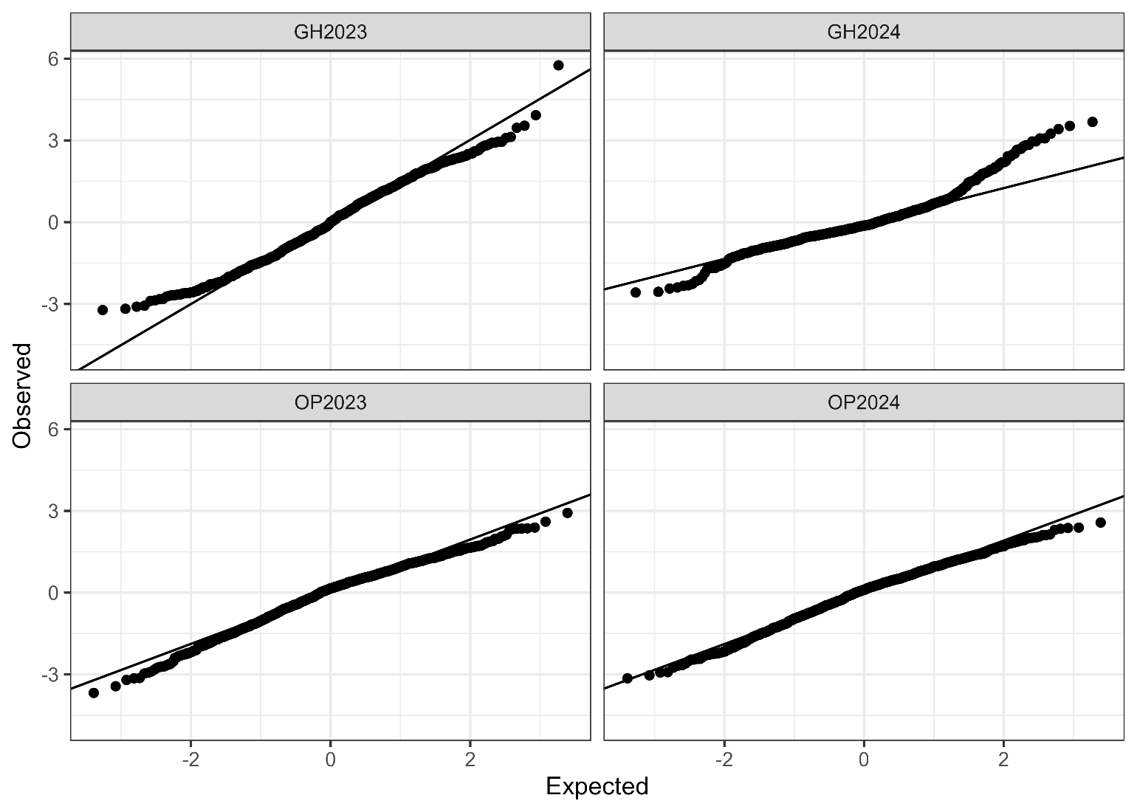
Figure S1. QQ-plots of model residuals for each environment (GH2023, GH2024, OP2023 and OP2024) for scab resistance trait.

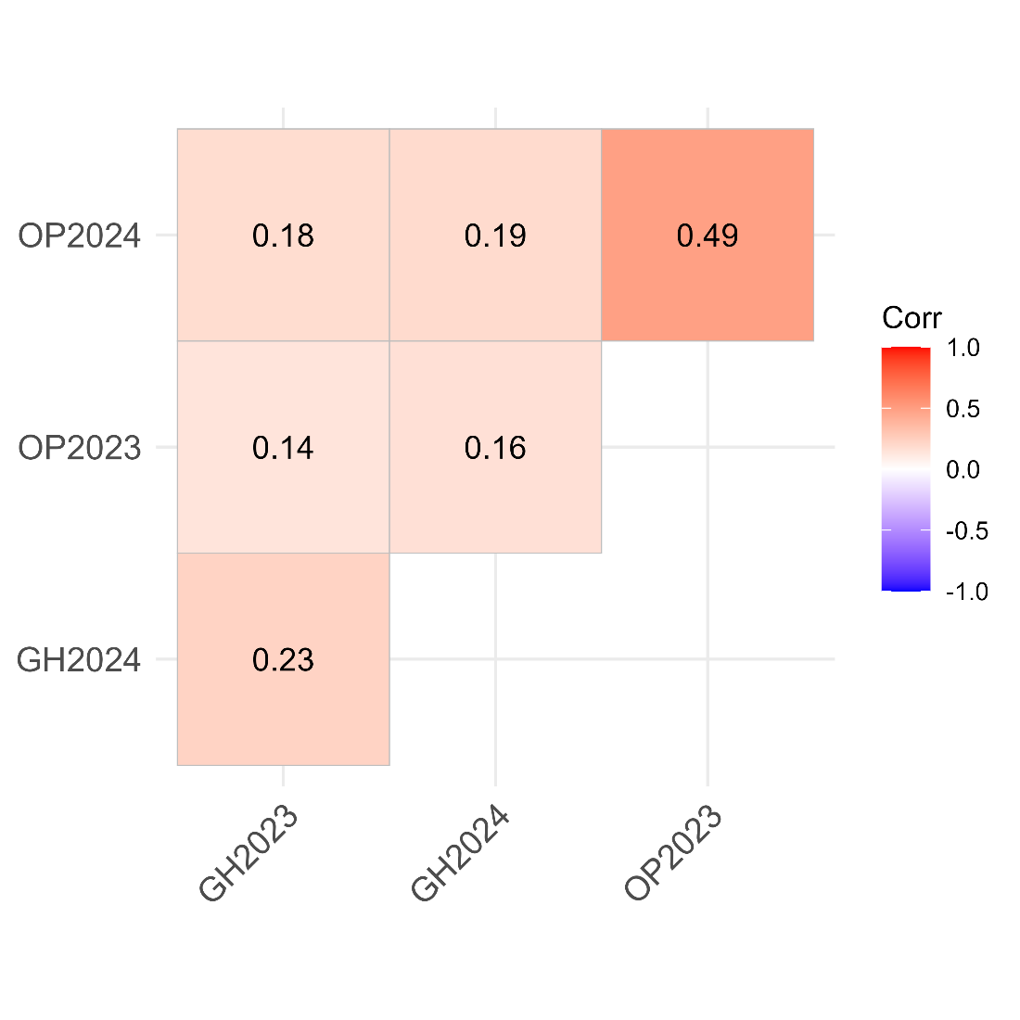
Figure S2. Pearson correlation matrix of scab resistance across different environments. Red indicates stronger positive correlations, and blue indicates weaker or negative correlations.

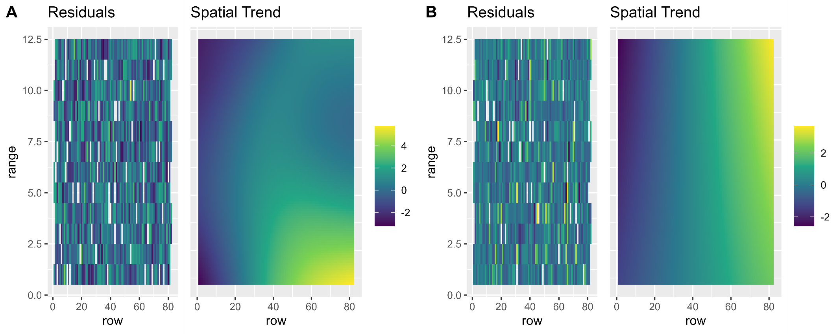
Figure S3.1. Residuals of the model overlaid on the trial layout and the spatial trend observed in GH2023 (A) and GH2024 (B). Regarding the spatial trend, yellow indicates low disease pressure, whereas deep blue indicates high disease pressure.

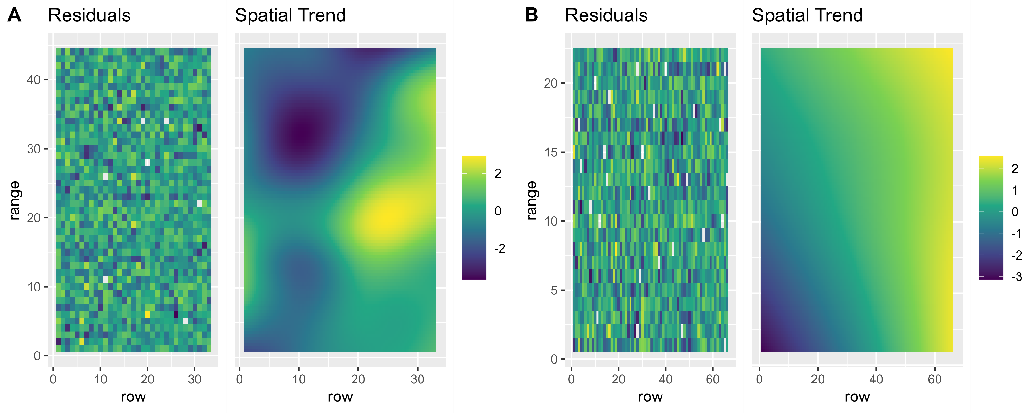
Figure S3.2. Residuals of the model overlaid on the trial layout and the spatial trend observed in OP2023 (A) and OP2024 (B). Regarding the spatial trend, yellow indicates low disease pressure, whereas deep blue indicates high disease pressure.

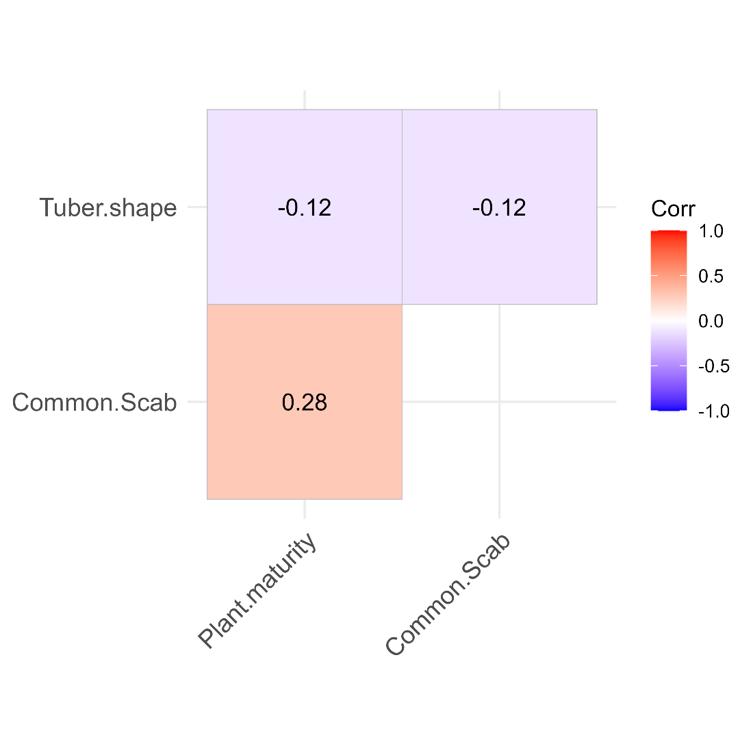
Figure S4. Pearson correlation matrix of scab resistance, plant maturity, and tuber shape in OP2024. Red indicates stronger positive correlations, and blue indicates weaker or negative correlations.

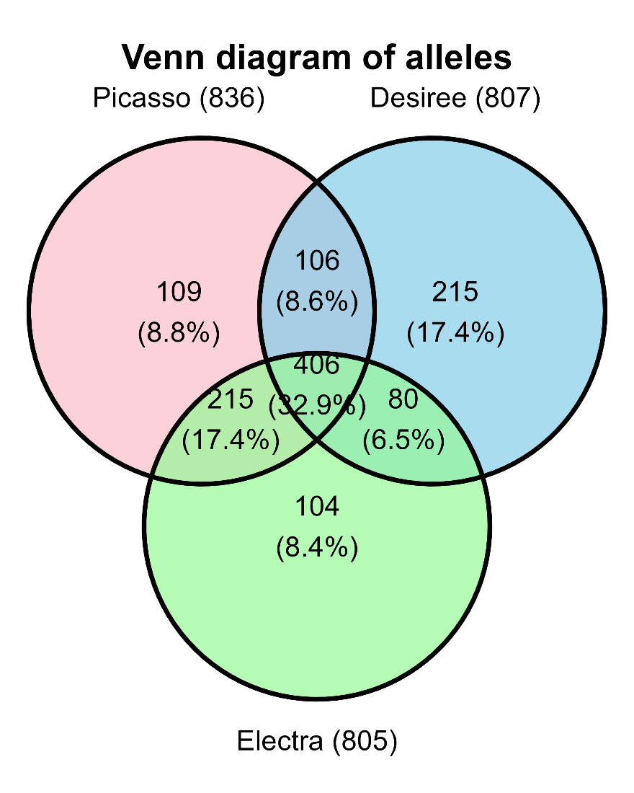
Figure S5. Venn diagram of alleles from the three parents Picasso (pink), Desiree (blue), and Electra (green), showing alleles unique to each parent, shared between pairs of parents, and shared among all three.

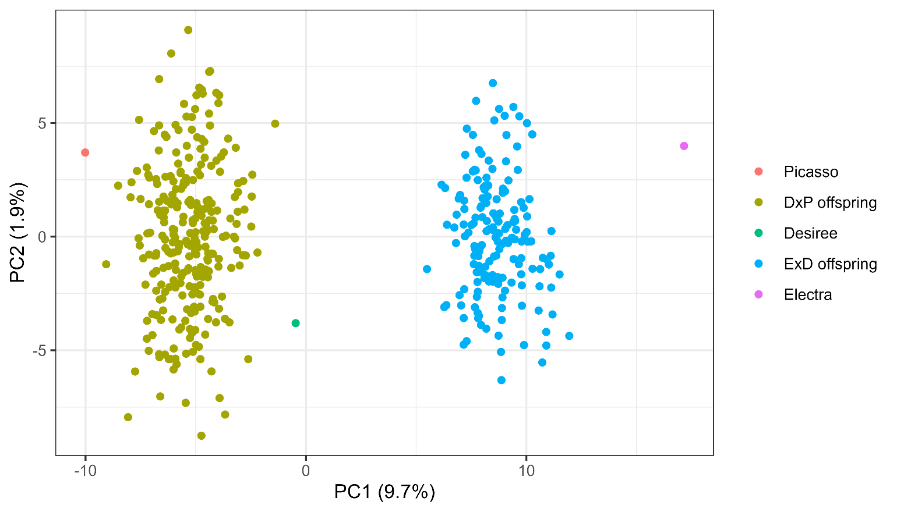
Figure S6. Principal component analysis (PCA) of genetic variation in both biparental populations. The PCA plot shows the population structure of the three parents, 270 Désirée × Picasso progeny, and 166 Electra × Désirée progeny, with colours distinguishing the parents and the two progeny populations.

Figure S7. Integrated chromosomal map of Electra, Désirée, and Picasso, with genetic distances expressed in cM.

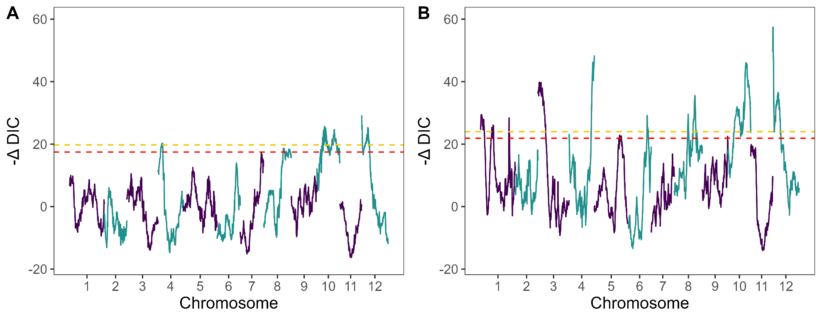
Figure S8. Genome discovery scans for scab resistance using additive (A) and digenic dominance (B) models. Dashed horizontal lines correspond to significance thresholds at α = 0.05 (gold) and α = 0.1 (red). Peaks exceeding the more stringent threshold (α = 0.05) were considered in the analysis.

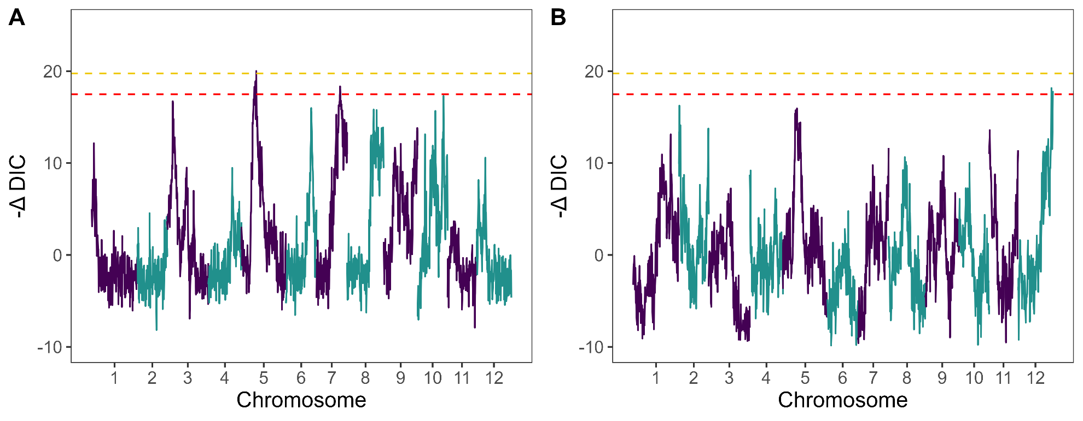
Figure S9. Composite interval mapping (CIM) scans for additive (A) and digenic dominance (B) models. Dashed horizontal lines correspond to significance thresholds at α = 0.05 (gold) and α = 0.1 (red). Peaks exceeding the more stringent threshold (α = 0.05) were considered in the analysis.

Figure S10. (A) Genome discovery scan for plant maturity using additive model. Dashed horizontal lines correspond to significance thresholds at α = 0.05 (gold) and α = 0.1 (red). Peaks exceeding the more stringent threshold (α = 0.05) were considered in the analysis. (B) Additive effects of parental haplotypes for the QTL for plant maturity in the multi-QTL model. Higher values indicate early maturity, and lower values indicate late maturity.

Figure S11. (A) Genome discovery scan for tuber shape using additive model. Dashed horizontal lines correspond to significance thresholds at α = 0.05 (gold) and α = 0.1 (red). Peaks exceeding the more stringent threshold (α = 0.05) were considered in the analysis. (B) Additive effects plot of parental haplotypes for the QTL for tuber shape in the multi-QTL model. Higher values indicate more oval tubers, and lower values indicate more round tubers.

Figure S12. Additive effects plot of parental haplotypes for the QTL for scab resistance on Chr04 (A) and Chr05 (B), excluded from the multi-QTL model. Higher values indicate more resistance, and lower values indicate more susceptibility.

