Supplementary Table S1. Parameters for displacement and functional ultrasound imaging, and electromyography recording
Category | Parameter | Value
Displacement imaging | Imaging array (frequency) | L22-14vX-LF (15.625 MHz)
Displacement imaging | Number of angles | 12
Displacement imaging | Maximum angle | ± 3°
Displacement imaging | Framerate | 16667 Hz
Displacement imaging | FUS pulse duration | 1-80 ms
fUS imaging | Imaging array (frequency) | L22-14vX-LF (15.625 MHz)
fUS imaging | Number of angles | 13
fUS imaging | Maximum angle | ± 7°
fUS imaging | Number of RF signals  averaged per angle | 3
fUS imaging | Number of compound frames | 150
fUS imaging | Framerate | 19500 Hz
fUS imaging | SVD cutoff | 30
fUS imaging | Framerate of power Doppler | 1 Hz
Electromyography | Electrodes | A pair of monopolar needle electrodes (polytetrafluorethylene-insulated stainless-steel)
 | Recording sites | Biceps femoris (hindlimb) and/or caudal (tail) muscle
 | Filter | 0.5 – 5 kHz bandpass filtering
 | Sampling frequency | 10 kHz
 | Gain factor | 2000

Supplementary Fig. S1. Electromyography (EMG) processing pipeline.
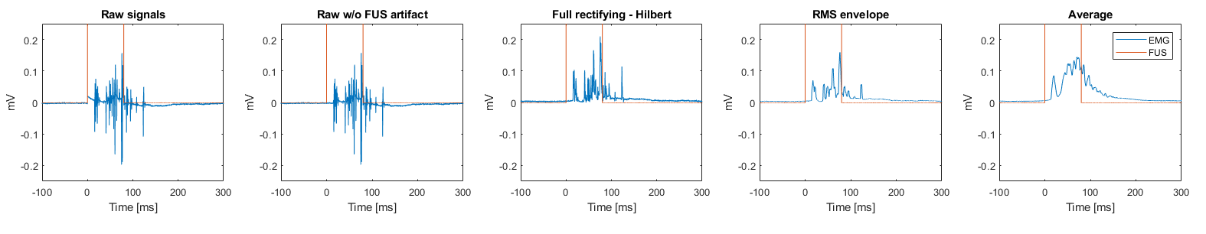

Supplementary Fig. S2. Dose-dependent group-averaged CBV responses with increasing pressure. (Left) Solid line and shadow represent mean and standard deviation, respectively (n = 4 animals, average of 7 stimulations each). (Right) Statistical result on peak amplitude of ∆CBV/CBV (Mean ± STD with data, n = 4 animals). One-way ANOVA with Tukey correction was performed for multiple comparisons. Any significance in the performed analyses is presented (* p < 0.05, ** p < 0.01, *** p < 0.001).
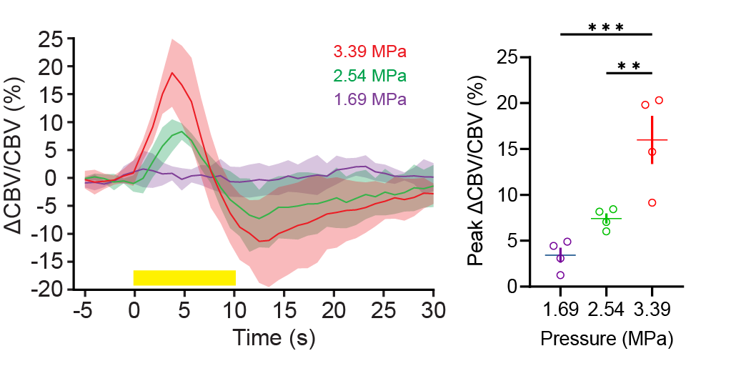

Supplementary Fig. S3. CBV response to electrical stimulation (1.5 mA, 7 ms, 4 Hz PRF, 20 s) that evokes toe twitch in the left hindpaw.
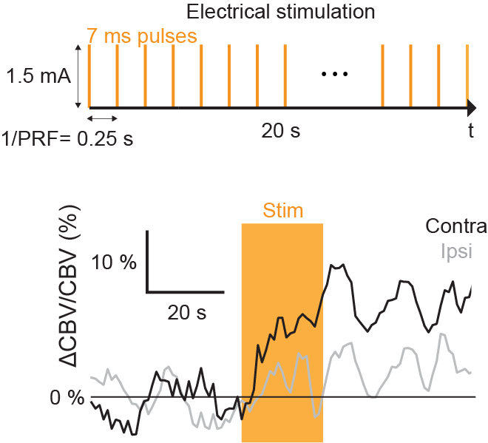

Supplementary Fig. S4. Histological analysis (H&E staining). Left hemisphere was sonicated and no significant tissue damages was observed in any of hemispheres.
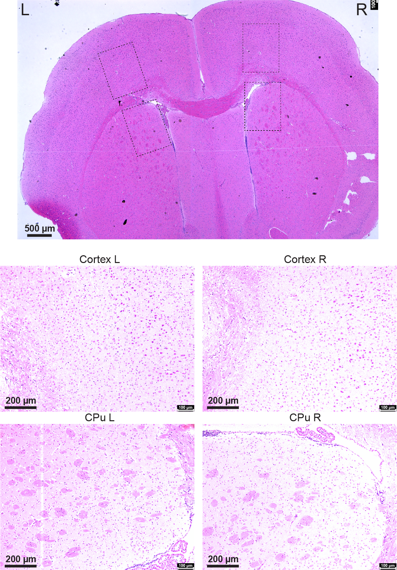

Supplementary Fig. S5. Thermocouple measurement of temperature increases by FUS (10 pulses at 3.39 MPa, 80 ms pulse duration, 1 Hz PRF). The left panel depicts a B-mode image of thermocouple needle inserted in the craniotomized brain. The right panel depicts temperature measurement with the fitting after correction of viscous heating artifact.
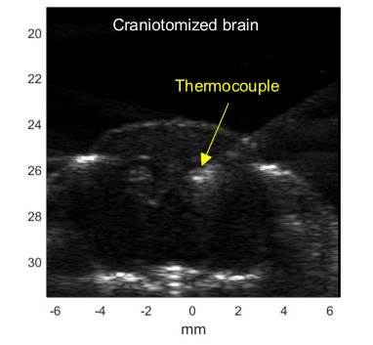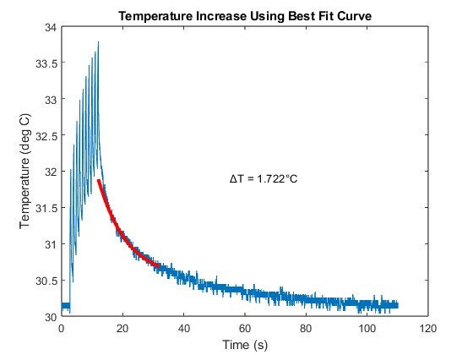

Supplementary Fig. S6. Simulated pressure-field distribution of H-204 single-element transducer at 1.68 MHz targeting the right hippocampus on a mouse configuration. (A, B) Coronal and sagittal planes, respectively, showing the pressure-field distribution normalized to the maximum pressure value in free-field (without the skull and brain), including the contours of transducer surface and mouse skull in a white continuous line; the target coordinate is marked with a white cross. (C, D, E) Zoom in of the coronal, axial and sagittal planes, respectively, showing the normalized pressure-field distribution inside the brain in detail, in addition to the reflections occurring at the skull surface; the target coordinate corresponding to the right hippocampus is marked with a white cross and indicated with a white arrow.
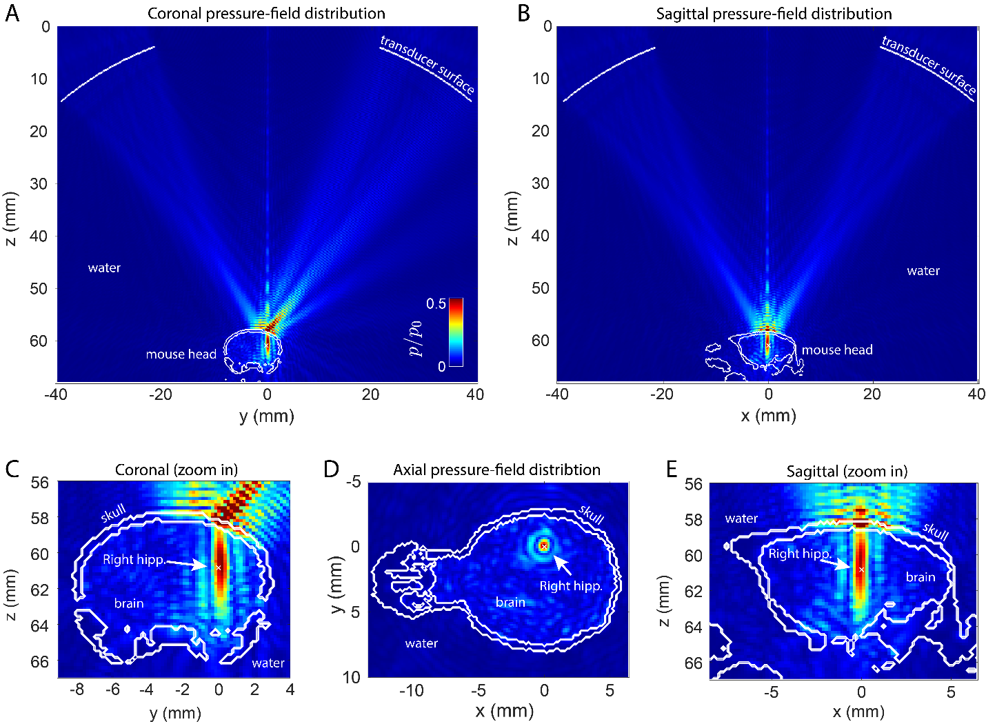

Supplementary Fig. S7. Transcranial resting-state functional connectivity measured in the sham and FUS-N groups.
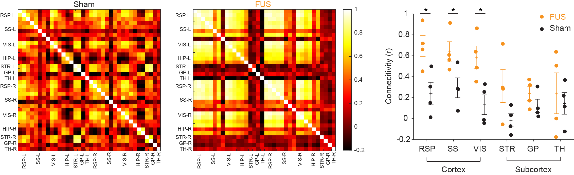

Supplementary Fig. S8. Preliminary results on whole-brain CBV responses to 1.5 MHz FUS (10 pulses at 0.8 Hz PRF with 300 ms pulse duration) delivered to the retrosplenial cortex in mice using 6.25 MHz row-column addressed array. The orthogonal plane wave compounding was employed with 42 plane waves (21 row Tx/col Rx + 21 col Tx/row Rx at angles evenly spaced between ± 5.5°), resulting in 310-Hz volume rate. Then, 160 beamformed and compounded RF volumes were SVD-filtered and accumulated to generate volumetric power Doppler. The panel shows significantly activated voxels registered onto the brain atlas. FUS pressure and the number of significantly activated voxels in response to FUS was denoted in the top left, demonstrating dose-dependent responses to FUS.
