Supplementary information

Table S1. GenBank ID (accession numbers) of the analyzed nucleotide and amino acid sequences.
Organism (species, strain) | Nucleotide sequence | Amino acid sequence
Agrobacterium rhizogenes A4, 15834, NCPPB1855 | NZ_CP073113.1, NZ_CP044124.1, NZ_JAAMEO010000030.1 | WP_142692216.1
Agrobacterium rhizogenes 1724 | KY000038.1 | ASK42899.1
Agrobacterium rhizogenes K599 (pRi2659) | EF433766.1 | ABS11825.1
Nicotiana tabacum | X91881.1 | CAA62988.1
Nicotiana glauca | X03432.1 | CAA27160.1
Nicotiana tomentosiformis 1 | KJ599826.1 | AIM40174.1
Nicotiana tomentosiformis 2 | KJ599826.1 | AIM40177.1
Linaria creticola 1 | MF997051.1 | AXO59181.1
Linaria creticola 2 | MF997052.1 | AXO59182.1
Linaria genistifolia | KC309424.1 | AGH15831.1
Linaria vulgaris 1 | EU735069.2 | AFA43818.1
Linaria vulgaris 2 | EU735069.2 | ACD81987.1
Agrobacterium vitis 6b | X77327.1 | CAA54541.1

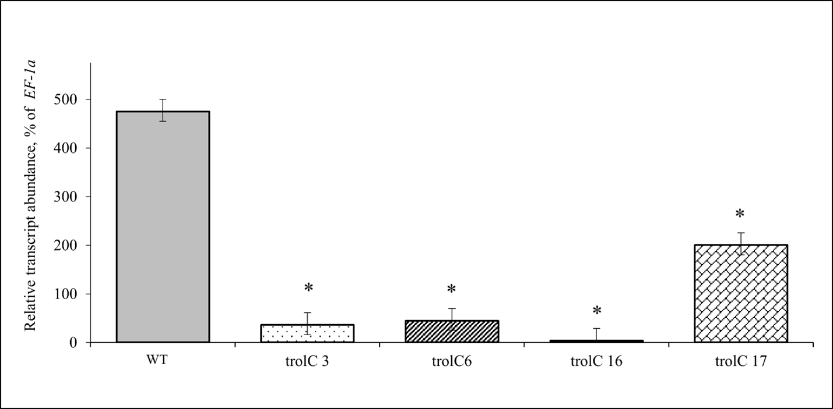
Fig. S1. Relative transcript abundance of the trolC gene in roots under normal conditions. n=3, * – p˂0.01
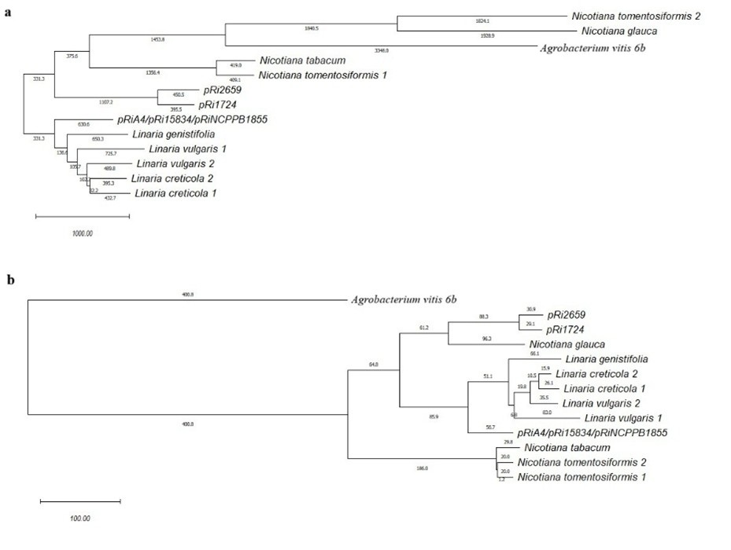
Fig. S2. a – phylogenetic trees of nucleotide sequences. b – phylogenetic trees of amino acid sequences of RolC-like proteins and the 6b protein of A. vitis.

