Supplementary Figures
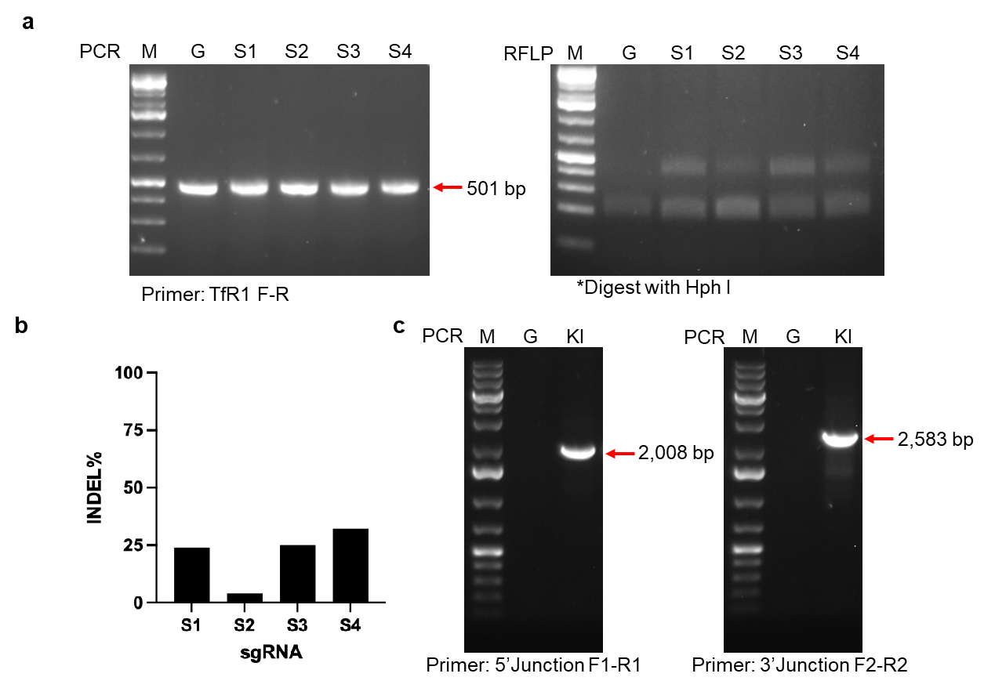
Supplementary Figure 1. Evaluation of sgRNA editing efficiency and validation of hTfR1 knock-in in BHK-21 cells. a PCR-RFLP analysis of sgRNA (sgRNA1-4) editing efficiency. sgRNAs/Cas9 were nucleofected into BHK-21 cells using P3 Primary Cell 4D-Nucleofector X Kit (Lonza) with program EN-150. Cells were harvested 48 h after nucleofection for PCR-RFLP and sequencing analysis. b The editing efficiency of sgRNAs was analyzed by EditCo. c PCR results confirmed successful KI of T2A-hTfR1 into BHK-21 cells. BHK-21 cells were transfected by P3 Primary Cell 4D-Nucleofector X Kit (Lonza) and with Program EN-150. Negative control plasmid pmaxGFP (3 μg) or sgRNA/Cas9 (3 μg/3 μg) with donor plasmid pKO2.1-T2A-hTfR1(3 μg) were nucleofected in a final volume of 100 μL in a 6-well plate. Cells were harvested 48 h after nucleofection for genomic DNA extraction. Junction primers F1-R1 and F2-R2, described in Fig. 2, were used to amplify the hTfR1 knock-in integration.
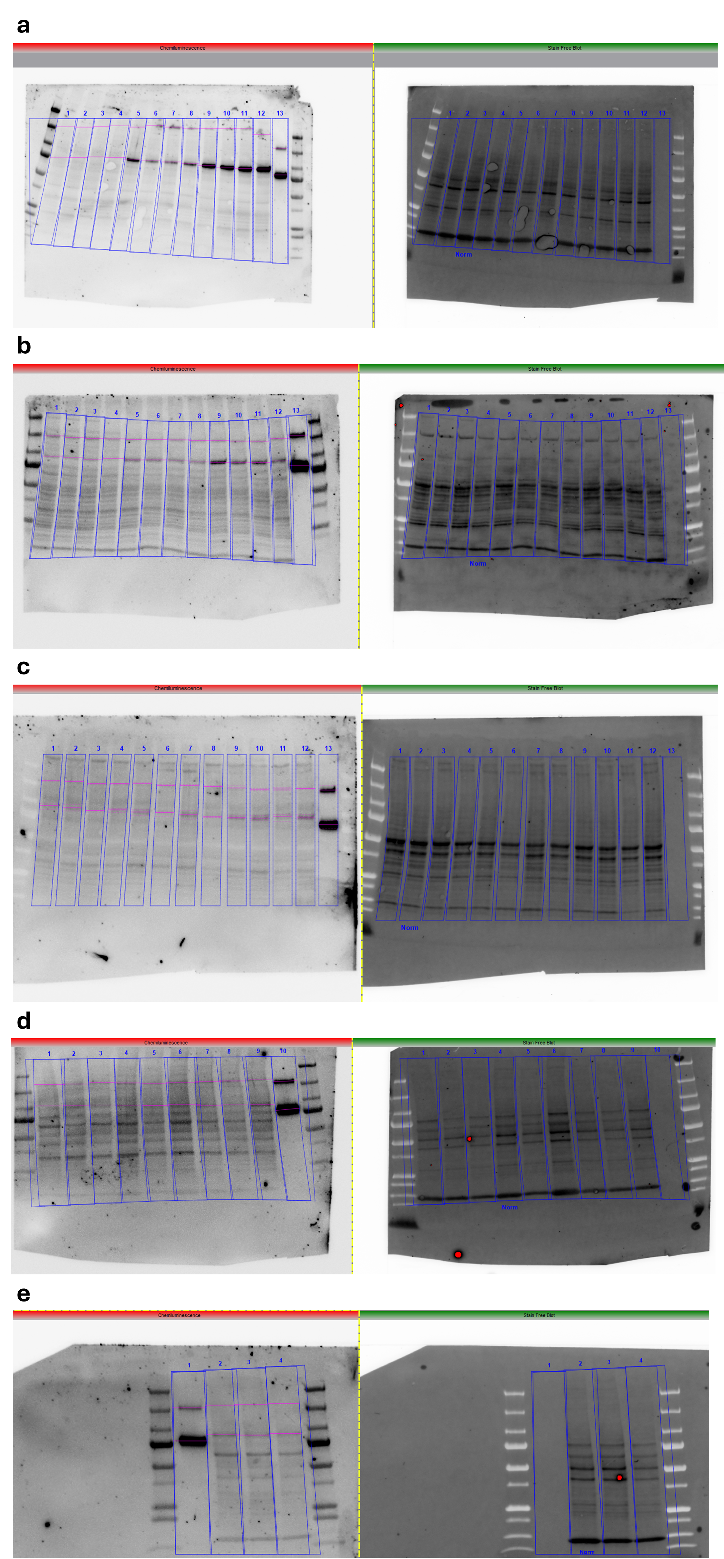
Supplementary Figure 2. Quantification of hTfR1 protein expression in hTfR1 hamsters by Western blot. Images showing Western blot and total protein from WT and HET and HOM hTfR1 hamster a spleen, b liver, c brain, and d,e lung samples. The left side images show chemiluminescence of gels stained with ch128.1/IgG1, followed by an HRP-conjugated secondary antibody, and developed with Clarity Max ECL Western Blotting Substrate. The right-side images show the total protein detected in each gel prior to antibody staining. The quantitative Western blot analysis (Figure 3b) was based on total protein normalization of lanes outlined in blue. For gels a-c, wells were loaded in the following pattern from left to right: 1-4: WT hamsters (2 male, 2 female), 5-8: HET hTfR1 hamsters (2 male, 2 female), 9-12: HOM hTfR1 hamsters (2 male, 2 female), 13: 12.5 ng positive control soluble hTfR1. Lung tissue was run on two 12-well gels run in parallel. Lung gel 1 (d) was loaded in the following pattern: 1-4: WT hamsters (2 male, 2 female), 5-8: HET hTfR1 hamsters (2 male, 2 female), 9: HOM hTfR1 hamster (1 male), 10: 12.5 ng soluble hTfR1. Lung gel 2 (e) was loaded with 1: 12.5 ng soluble hTfR1, 2-4: HOM hTfR1 hamsters (1 male 2, 2 female). Protein m.w. markers were included on the far left and right lanes in each analysis.

