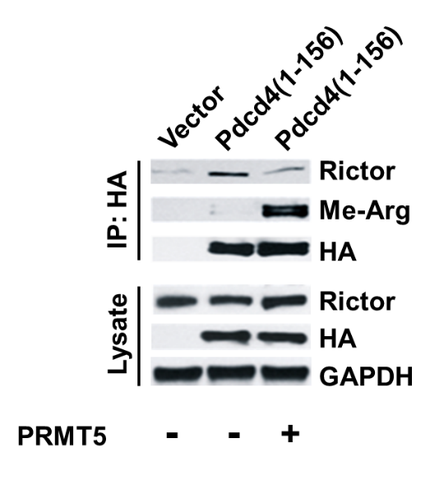

Supplementary Figure 1. Methylation of Pdcd4 abolishes Pdcd4-Rictor binding. HEK293 cells were transfected with empty vector, Pdcd4(1-156) expressing plasmid, or Pdcd4(1-156) plus PRMT5 expressing plasmids. The Pdcd4-Rictor complex was precipitated using HA conjugated magnetic beads, followed by Western blot analysis using the indicated antibodies.

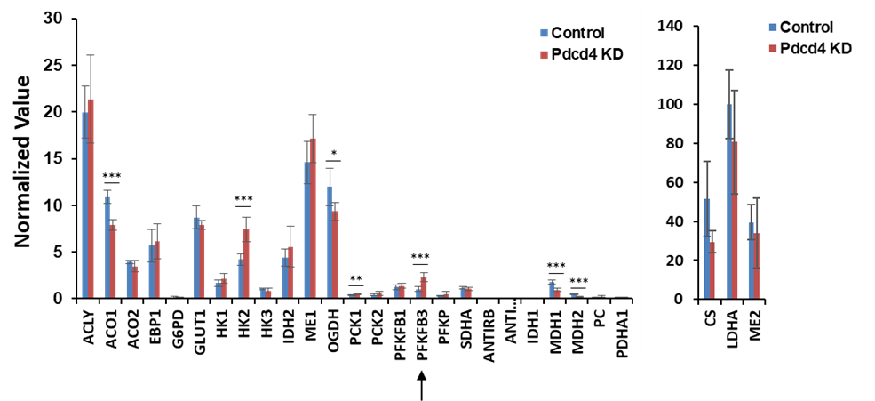

Supplementary Figure 2. RPPA analysis of the expressions of proteins involved in glycolysis and TCA cycle. The nitrocellulose membrane containing the control and Pdcd4 knockdown spots were incubated with primary antibody listed above, and followed by incubation with fluorescent secondary antibodies. Protein fluorescence and immunofluorescence for the same protein spot were quantified using Innopsys Mapix software. Both fluorescence intensities were background-corrected prior to normalization of immunofluorescence intensity to protein fluorescence intensity. The normalized values for each enzyme from control and Pdcd4 knockdown samples (n=6) were analyzed using a two-sample t test (mean±SD); *p < 0.05; **p < 0.01; ***p <0.001. PFKFB3 is indicated by an arrow.

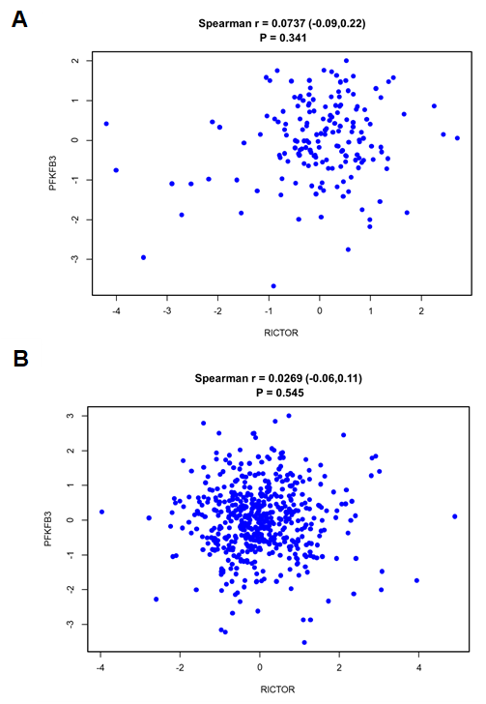

Supplementary Figure 3. There is no correlation between rictor mRNA and pfkfb3 mRNA in both (A) OncoSG-LUAD and (B) TCGA-PAN-LUAD datasets. The normalized values (log-transformed mRNA expression z-scores) of rictor and pfkfb3 were quantified by Spearman's correlation coefficient.

Supplementary Table I
Patients and Tumor Characteristics (n=87)
Age (year) 42-82
Smoking status
Never smoker 5
Cigarette smoker 76
Unknown 6

Histology
Adenocarcinoma 45
Squamous carcinoma 42

UICC Stage
I 24
II 27
III 32
IV 5

Grade
Well differentiated 5
Moderately differentiated 31
Poorly differentiated 44
Undifferentiated 2
Unknown 5

