Supplemental materials:

A Virtual Reality Framework for Studying Affective Modulation of Route-Based Spatial Navigation
Kammler-Sücker, K., Riemer, M., Turturo, V., & Bublatzky, F.

Perceived Threat
Table S1: Model estimates for perceived threat.

 | β | Std. error | df (num.) | df (denom.) | F | p (KR) | ES | p (PB)
(Intercept) | 1.12 | 0.23
Condition  (threat - safety) | 0.15 | 0.08 | 1 | 99 | 3.66 | .059 | 0.09 | .069
Anxiety (centered) | 0.03 | 0.02 | 1 | 33 | 1.68 | .204 | 0.19 | .193
Task  (repeat - retrace) | 0.00 | 0.08 | 1 | 99 | 0.00 | 1.000 | 0.00 | 1.000
Locomotion  (rolling - stepwise) | 0.32 | 0.23 | 1 | 33 | 1.95 | .172 | 0.19 | .186
Condition × Anxiety (c) |  |  | 1 | 99 | 1.96 | .165 |  | .161
Condition × Task |  |  | 1 | 99 | 0.00 | 1.000 |  | 1.000
Anxiety (c) × Task |  |  | 1 | 99 | 0.00 | 1.000 |  | 1.000
Condition × Locomotion |  |  | 1 | 99 | 7.65 | .007 ** |  | .013 *
Anxiety (c) × Locomotion |  |  | 1 | 33 | 2.22 | .146 |  | .149
Task × Locomotion |  |  | 1 | 99 | 0.00 | 1.000 |  | 1.000
Condition × Anxiety (c) × Task |  |  | 1 | 99 | 0.00 | 1.000 |  | 1.000
Condition × Anxiety (c) × Locomotion |  |  | 1 | 99 | 1.53 | .219 |  | .231
Condition × Task × Locomotion |  |  | 1 | 99 | 0.00 | 1.000 |  | 1.000
Anxiety (c) × Task × Locomotion |  |  | 1 | 99 | 0.00 | 1.000 |  | 1.000
Condition × Anxiety (c) × Task × Locomotion |  |  | 1 | 99 | 0.00 | 1.000 |  | 1.000
Notes: Reported are the model estimates for LME models and the ANOVA-like significance tests, based on the Kenward-Roger (KR) method. Effect sizes (ES) are based on model refits with standardized data. Estimated p values were corroborated with parametric bootstrapping (PB).

Arousal
Table S2: Model estimates for self-reported arousal.

 | β | Std. error | df (num.) | df (denom.) | F | p (KR) | ES | p (PB)
(Intercept) | 3.34 | 0.30
Condition  (threat - safety) | 0.42 | 0.09 | 1 | 96 | 22.22 | < .000 *** | 0.21 | < .001 ***
Anxiety (centered) | 0.02 | 0.03 | 1 | 32 | 0.93 | .342 | 0.15 | .351
Task  (repeat - retrace) | 0.00 | 0.09 | 1 | 96 | 0.00 | 1.000 | 0.00 | 1.000
Locomotion  (rolling - stepwise) | 0.35 | 0.30 | 1 | 32 | 1.37 | .250 | 0.18 | .247
Condition × Anxiety (c) |  |  | 1 | 96 | 0.17 | .677 |  | .673
Condition × Task |  |  | 1 | 96 | 0.00 | 1.000 |  | 1.000
Anxiety (c) × Task |  |  | 1 | 96 | 0.00 | 1.000 |  | 1.000
Condition × Locomotion |  |  | 1 | 96 | 12.92 | < .001 *** |  | < .001 ***
Anxiety (c) × Locomotion |  |  | 1 | 32 | 0.91 | .347 |  | .356
Task × Locomotion |  |  | 1 | 96 | 0.00 | 1.000 |  | 1.000
Condition × Anxiety (c) × Task |  |  | 1 | 96 | 0.00 | 1.000 |  | 1.000
Condition × Anxiety (c) × Locomotion |  |  | 1 | 96 | 0.01 | .917 |  | .914
Condition × Task × Locomotion |  |  | 1 | 96 | 0.00 | 1.000 |  | 1.000
Anxiety (c) × Task × Locomotion |  |  | 1 | 96 | 0.00 | 1.000 |  | 1.000
Condition × Anxiety (c) × Task × Locomotion |  |  | 1 | 96 | 0.00 | 1.000 |  | 1.000

Valence
Table S3: Model estimates for self-reported valence.

 | β | Std. error | df (num.) | df (denom.) | F | p (KR) | ES | p (PB)
(Intercept) | 4.19 | 0.25
Condition  (threat - safety) | 0.00 | 0.08 | 1 | 99 | 0.00 | .971 | 0.00 | .974
Anxiety (centered) | 0.01 | 0.02 | 1 | 33 | 0.23 | .635 | 0.07 | .638
Task  (repeat - retrace) | 0.00 | 0.08 | 1 | 99 | 0.00 | 1.000 | 0.00 | 1.000
Locomotion  (rolling - stepwise) | -0.17 | 0.25 | 1 | 33 | 0.49 | .490 | -0.10 | .489
Condition × Anxiety (c) |  |  | 1 | 99 | 6.77 | .011 * |  | .009 **
Condition × Task |  |  | 1 | 99 | 0.00 | 1.000 |  | 1.000
Anxiety (c) × Task |  |  | 1 | 99 | 0.00 | 1.000 |  | 1.000
Condition × Locomotion |  |  | 1 | 99 | 3.11 | .081 |  | .082
Anxiety (c) × Locomotion |  |  | 1 | 33 | 8.10 | .008 ** |  | .013 *
Task × Locomotion |  |  | 1 | 99 | 0.00 | 1.000 |  | 1.000
Condition × Anxiety (c) × Task |  |  | 1 | 99 | 0.00 | 1.000 |  | 1.000
Condition × Anxiety (c) × Locomotion |  |  | 1 | 99 | 1.40 | .239 |  | .240
Condition × Task × Locomotion |  |  | 1 | 99 | 0.00 | 1.000 |  | 1.000
Anxiety (c) × Task × Locomotion |  |  | 1 | 99 | 0.00 | 1.000 |  | 1.000
Condition × Anxiety (c) × Task × Locomotion |  |  | 1 | 99 | 0.00 | 1.000 |  | 1.000

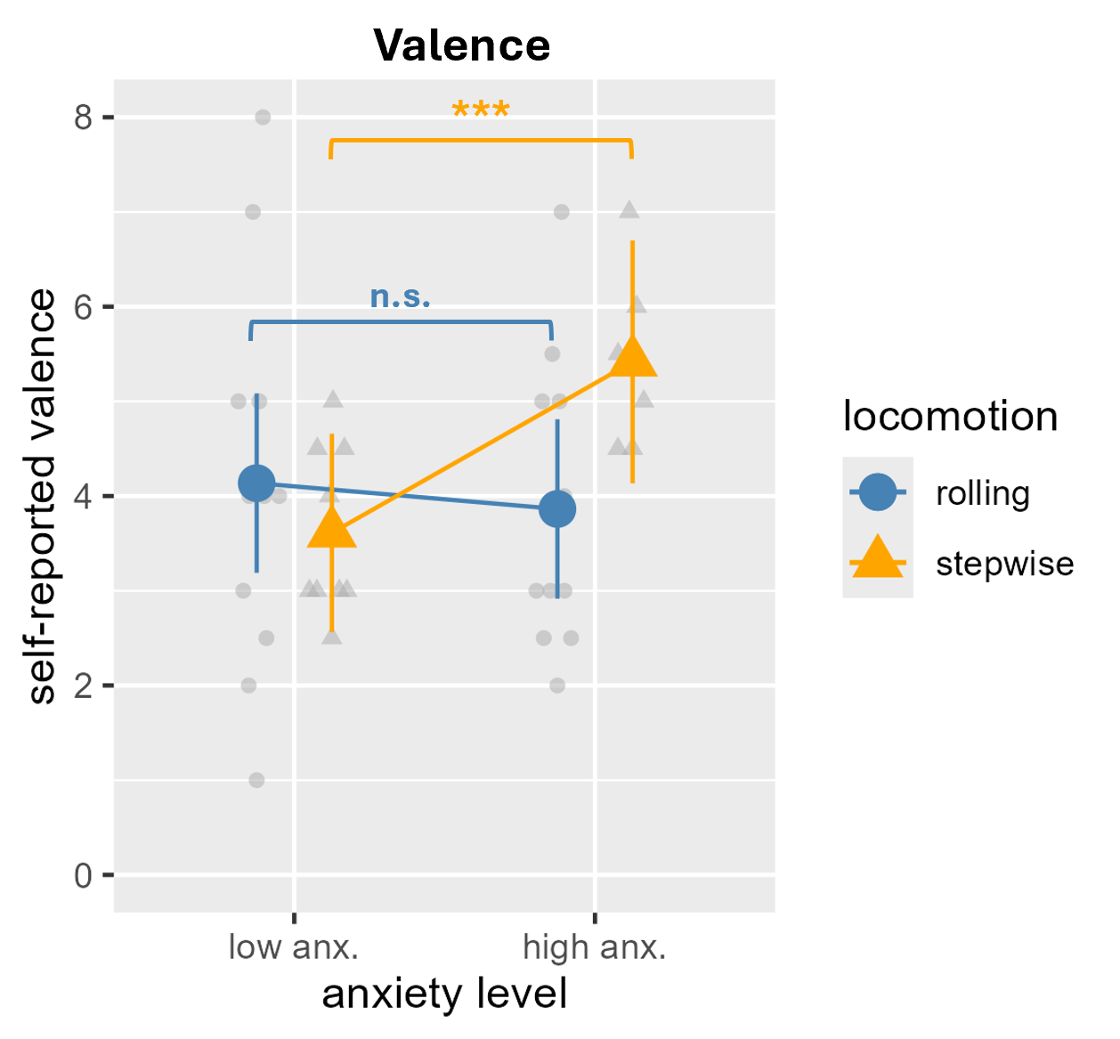
Figure S1: Post-hoc contrasts for interaction effect Locomotion × Anxiety on decision times.

Accuracy Rates
Table S4: Model estimates for accuracy rates.

 | β | Std. error | df (num.) | df (denom.) | F | p (KR) | ES | p (PB)
(Intercept) | 0.94 | 0.01
Condition  (threat - safety) | 0.01 | 0.01 | 1 | 99 | 1.23 | .271 | 0.08 | .285
Anxiety (centered) | 0.00 | 0.00 | 1 | 33 | 0.26 | .614 | -0.06 | .623
Task  (repeat - retrace) | 0.02 | 0.01 | 1 | 99 | 13.53 | < .001 *** | 0.25 | < .001 ***
Locomotion  (rolling - stepwise) | 0.00 | 0.01 | 1 | 33 | 0.04 | .849 | 0.02 | .850
Condition × Anxiety (c) |  |  | 1 | 99 | 0.00 | .972 |  | .969
Condition × Task |  |  | 1 | 99 | 0.00 | .960 |  | .967
Anxiety (c) × Task |  |  | 1 | 99 | 0.10 | .752 |  | .753
Condition × Locomotion |  |  | 1 | 99 | 4.86 | .030 * |  | .029 *
Anxiety (c) × Locomotion |  |  | 1 | 33 | 1.38 | .248 |  | .269
Task × Locomotion |  |  | 1 | 99 | 1.76 | .188 |  | .199
Condition × Anxiety (c) × Task |  |  | 1 | 99 | 0.01 | .904 |  | .917
Condition × Anxiety (c) × Locomotion |  |  | 1 | 99 | 1.74 | .191 |  | .223
Condition × Task × Locomotion |  |  | 1 | 99 | 0.13 | .716 |  | .732
Anxiety (c) × Task × Locomotion |  |  | 1 | 99 | 0.30 | .586 |  | .602
Condition × Anxiety (c) × Task × Locomotion |  |  | 1 | 99 | 1.62 | .206 |  | .215
Notes: Reported are the model estimates for LME models and the ANOVA-like significance tests, based on the Kenward-Roger (KR) method. Effect sizes (ES) are based on model refits with standardized data. Estimated p values were corroborated with parametric bootstrapping (PB).

Decision Times

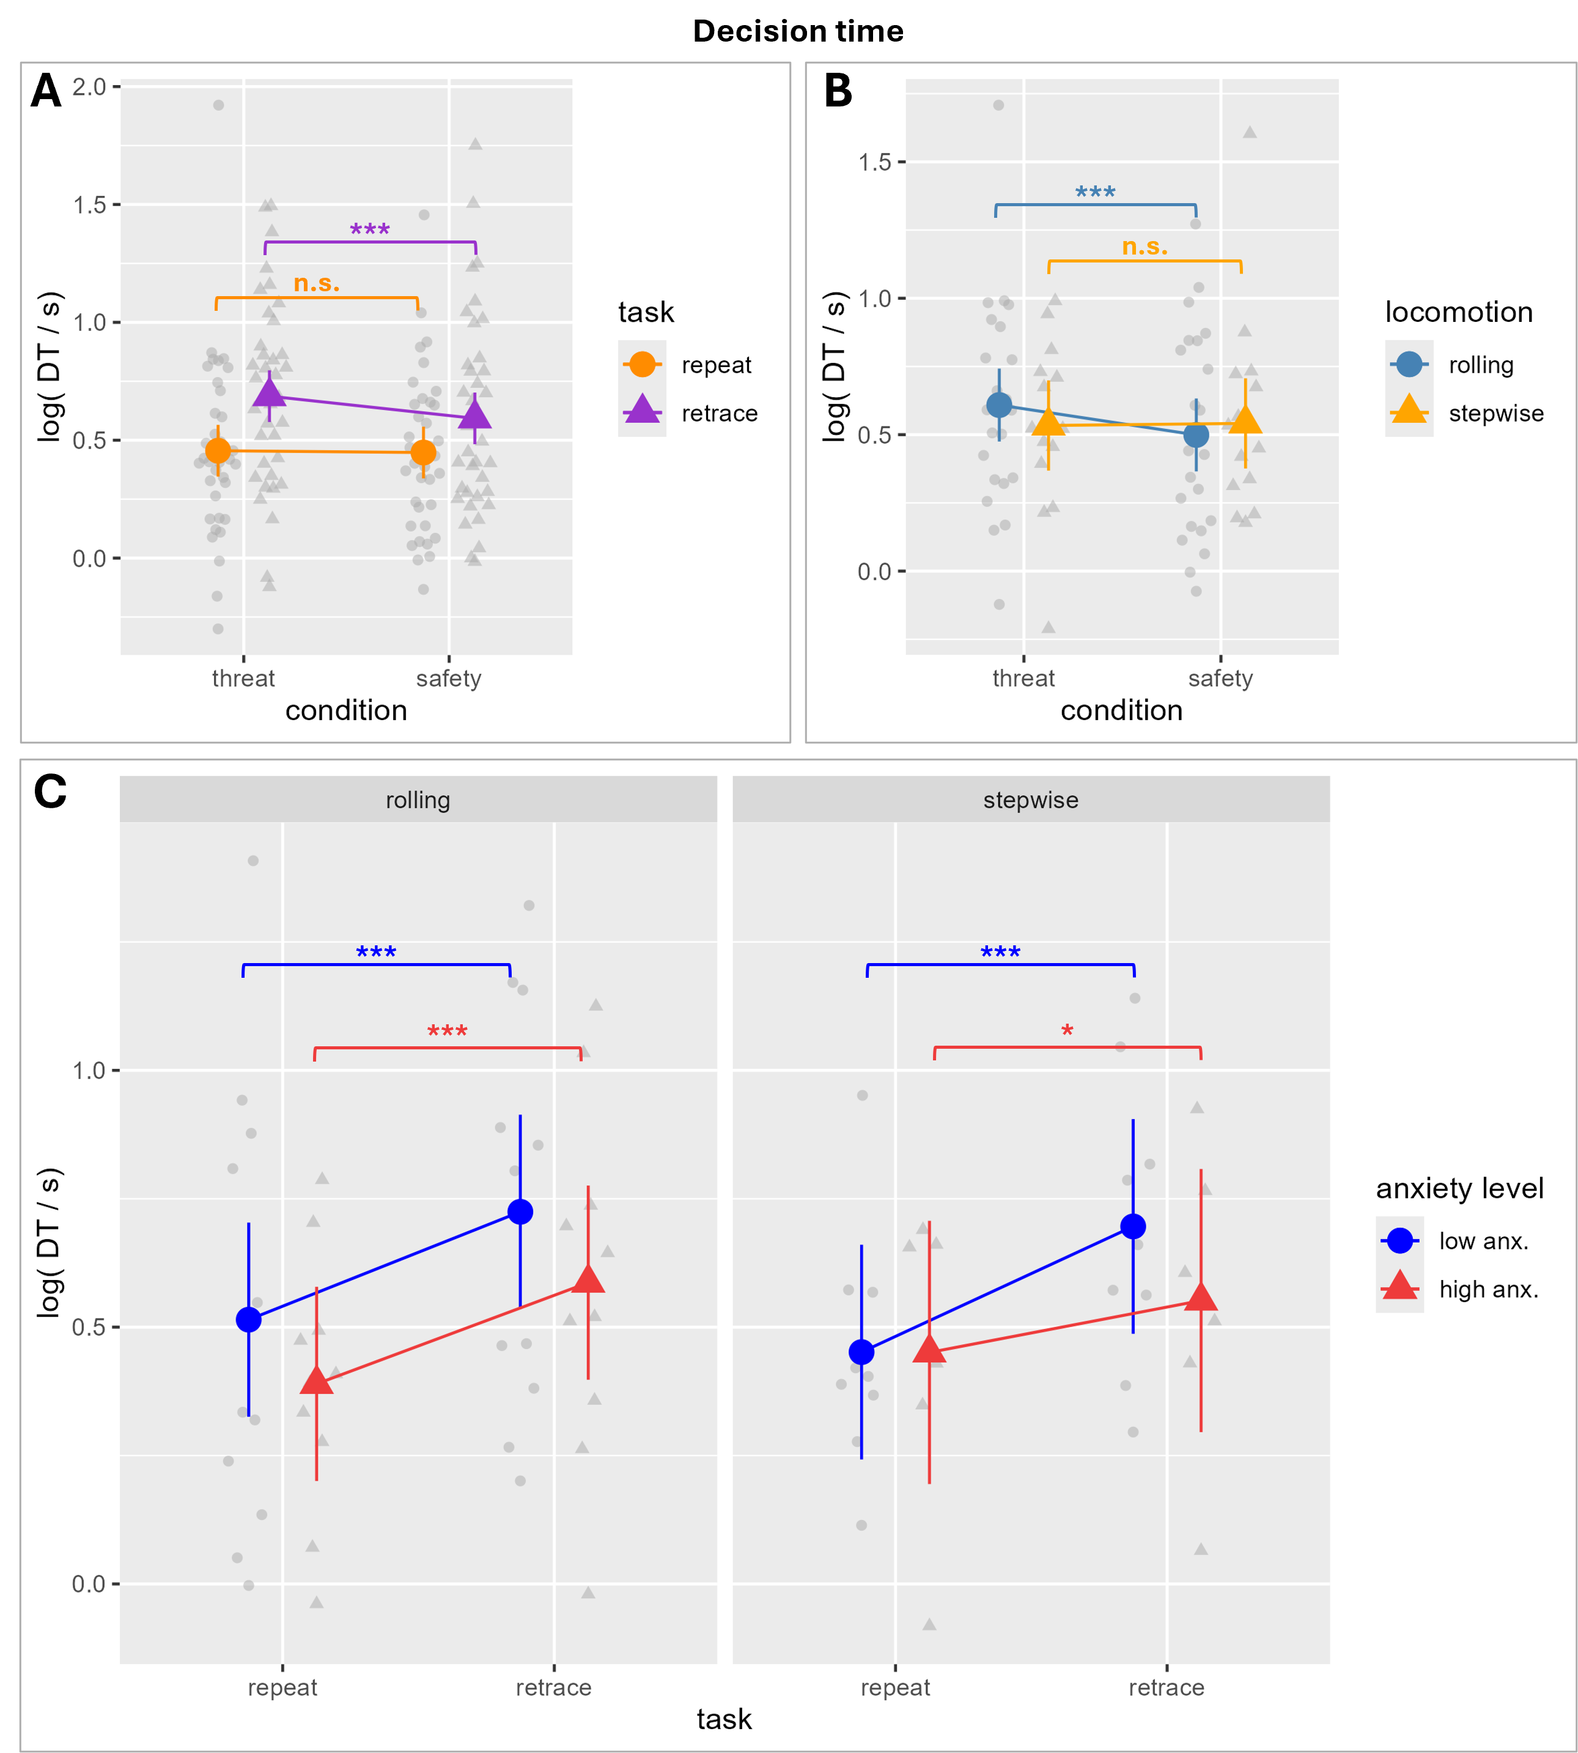
Figure S2: Post-hoc contrasts for those interaction effects for decision times that were not discussed in detail in the main text.

