Supplementary Information

Melanoma Detection by AFM Indentation of Histological Specimens

ByoungJun Jeon^{1,‡}, Hyo Gi Jung^{2,3,‡}, Sang Won Lee^{2,‡}, Gyudo Lee⁴, Jung Hee Shim⁵, Mi Ok Kim⁶, Byung Jun Kim⁶, Sang-Hyon Kim,⁷ Hyungbeen Lee,⁸ Sang Woo Lee,⁸ Dae Sung Yoon,^{2,3} Seong Jin Jo,^{9*} Tae Hyun Choi,^{6*} and Wonseok Lee^{10*}
¹Interdisciplinary Program for Bioengineering, Seoul National University, Seoul 08826, Korea
²School of Biomedical Engineering, Korea University, Seoul 02841, Korea
³ Interdisciplinary Program in Precision Public Health, Korea University, Seoul 02841, South Korea
⁴Department of Biotechnology and Bioinformatics, Korea University, Sejong, 30019, South Korea
⁵Department of Plastic and Reconstructive Surgery, Research Services, Seoul National University Bundang Hospital, Seongnam 13620, Korea
⁶Department of Plastic and Reconstructive Surgery, Institute of Human Environment Interface Biology, Seoul National University College of Medicine, Seoul 03087, Korea
⁷Department of Internal Medicine, Keimyung University Dongsan Medical Center, Daegu 41931, Korea
⁸Department of Biomedical Engineering, Yonsei University, Wonju 26493, Korea
⁹Department of Dermatology, Seoul National University College of Medicine, Seoul 03087, Korea
¹⁰Department of Electrical Engineering, Korea National University of Transportation, Chungju, 27469, South Korea

*Corresponding author: Seong Jin Jo (E-mail: ayin76@hanmail.net) Tae Hyun Choi (E-mail: psthchoi@snu.ac.kr) and Wonseok Lee (E-mail: wslee@ut.ac.kr)
‡These authors contributed equally to this work.

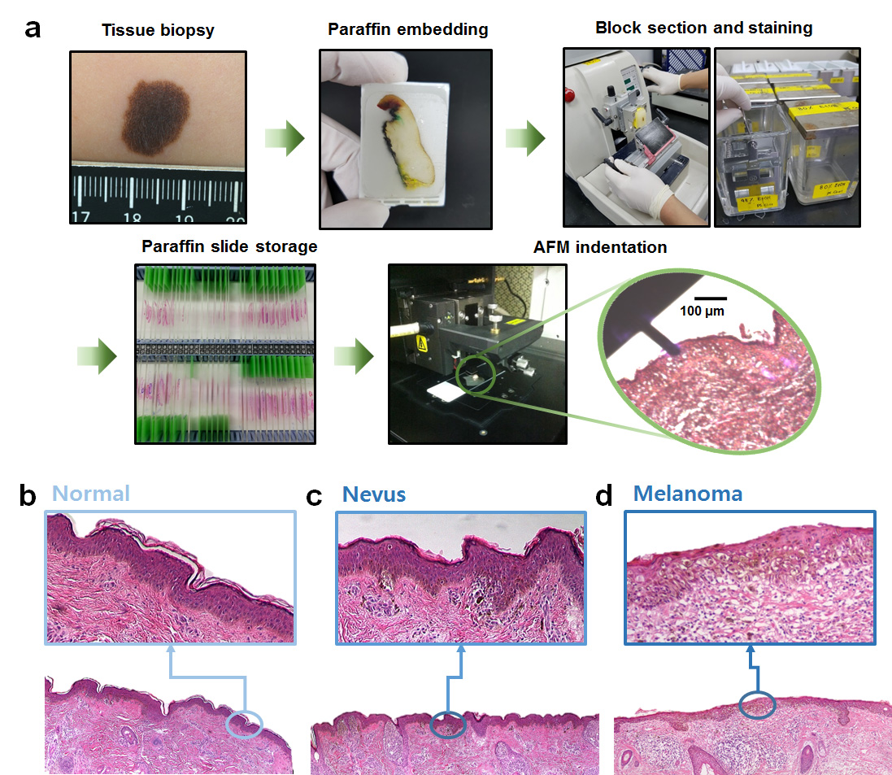
Fig. S1 (a) Preparation process of histological specimens and magnified optical images of H&E stained specimens of (b) normal, (c) benign nevus, and (d) melanoma.

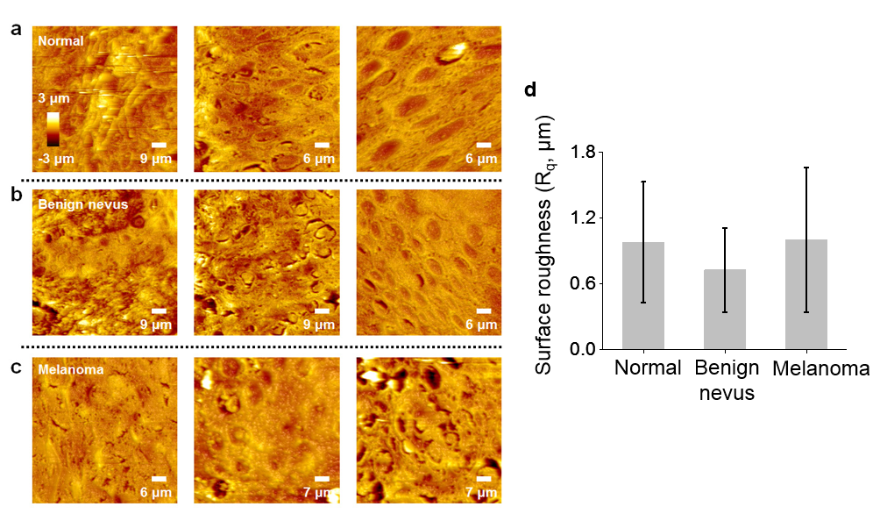
Fig. S2 AFM topographic images of (a) normal, (b) benign nevus, and (c) melanoma tissue specimen. AFM image size was 3,600–8,100 μm² depending on lesion sample. (d) The surface roughness (R_{q}) of normal, benign nevus, and melanoma sample, which was calculated by the following equation: $R_{q}=\sqrt{\frac{1}{n}\sum_{i=1}^{n}{{y_{i}}^{2}}}$.

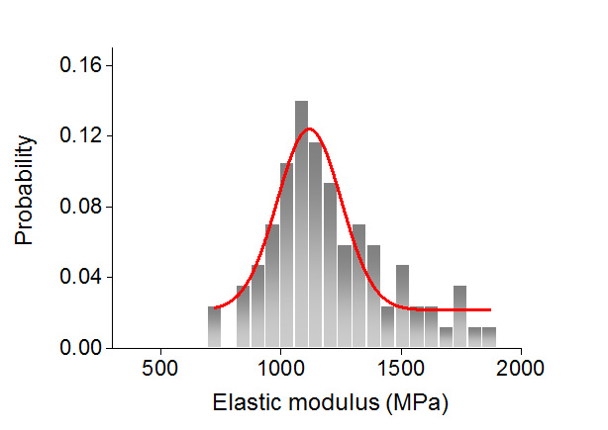
Fig. S3 Histogram of elasticity distribution of a glass substrate on which tissue specimens are placed. Elasticity was measured to be 1.1 ± 0.1 GPa. Note that the measured mechanical properties of glass substrate are not indicative of the intrinsic characteristic. Despite the fact, we came to know that the glass is always relatively more rigid than the sample.

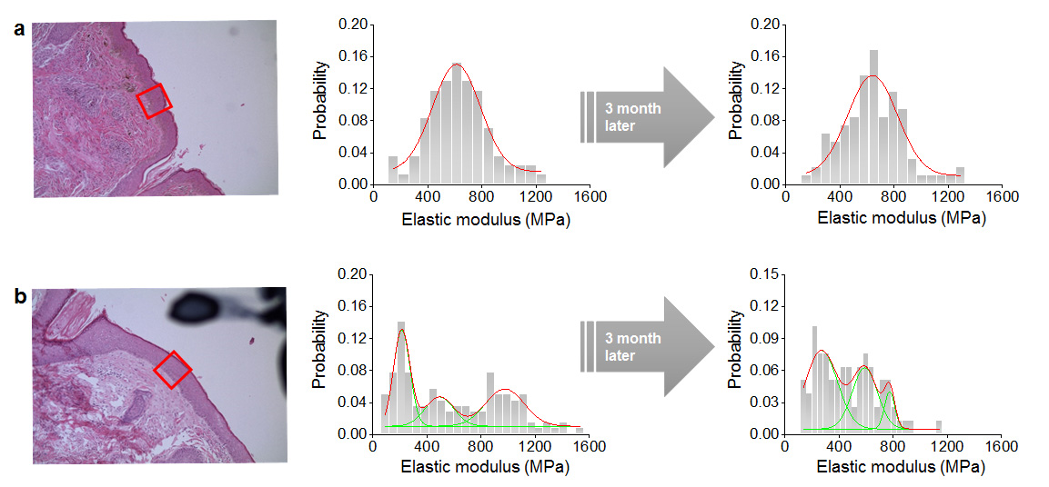
Fig. S4 Reproducibility of histological specimens for AFM indentation-based melanoma detection. The same lesion of each (a) benign nevus and (b) melanoma tissue specimen was probed after three months, showing that biomechanical signatures remained, even though it was hard to find the same exact spot that we probed three months ago.

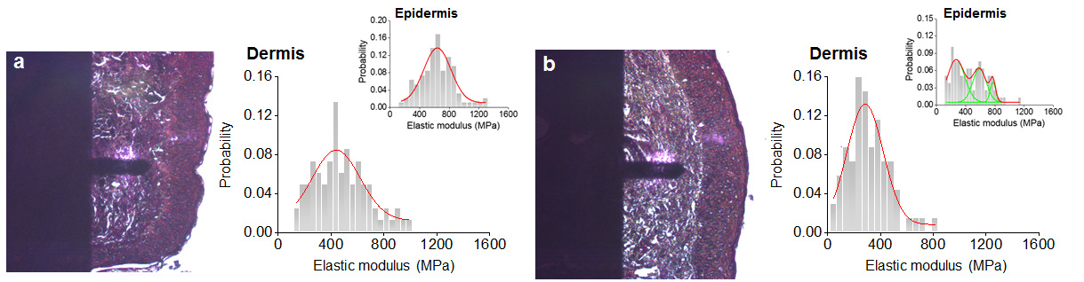
Fig. S5 Elasticity of histological specimen on dermis. Optical image and corresponding histogram of elasticity distribution of the lesion on (a) benign nevus and (b) melanoma in dermis. The inset histograms are results of the epidermis, showing difference from those of dermis.

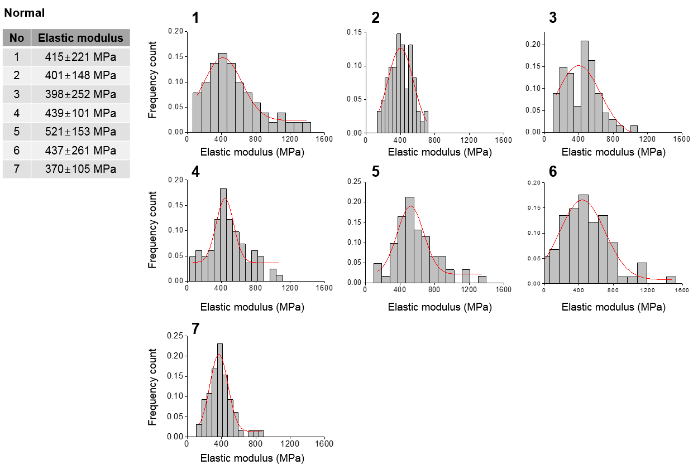
Fig. S6 Biomechanical signatures of healthy epidermal skin tissues characterized by unimodal distribution with average single-peak stiffness from 398 to 521 MPa.

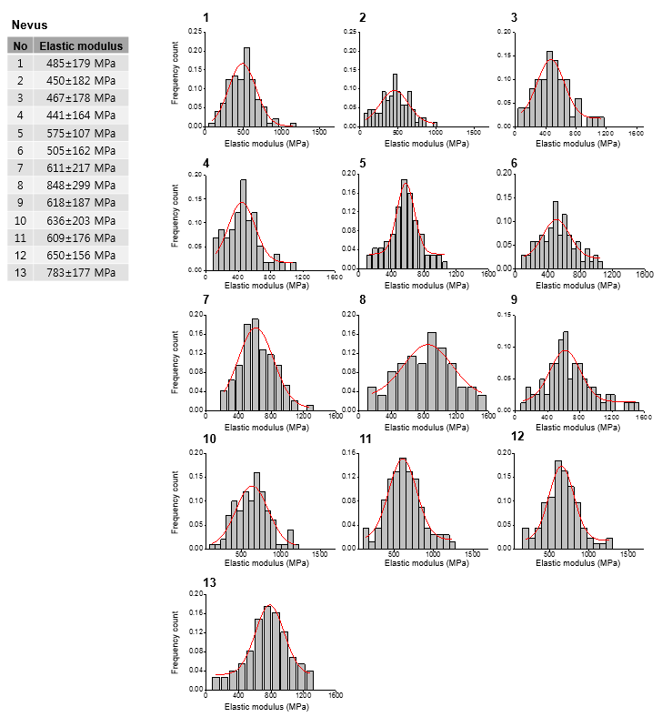
Fig. S7 Benign nevi tissues with different biomechanical signatures. All histograms of elasticity distributions exhibited single-peak distribution. Elasticities of cases 1 to 6 were similar to those of normal tissues, whereas elasticities of the cases 7 to 13 were generally 100 MPa higher than those of cases 1 to 6 (see Table 1 in the text).

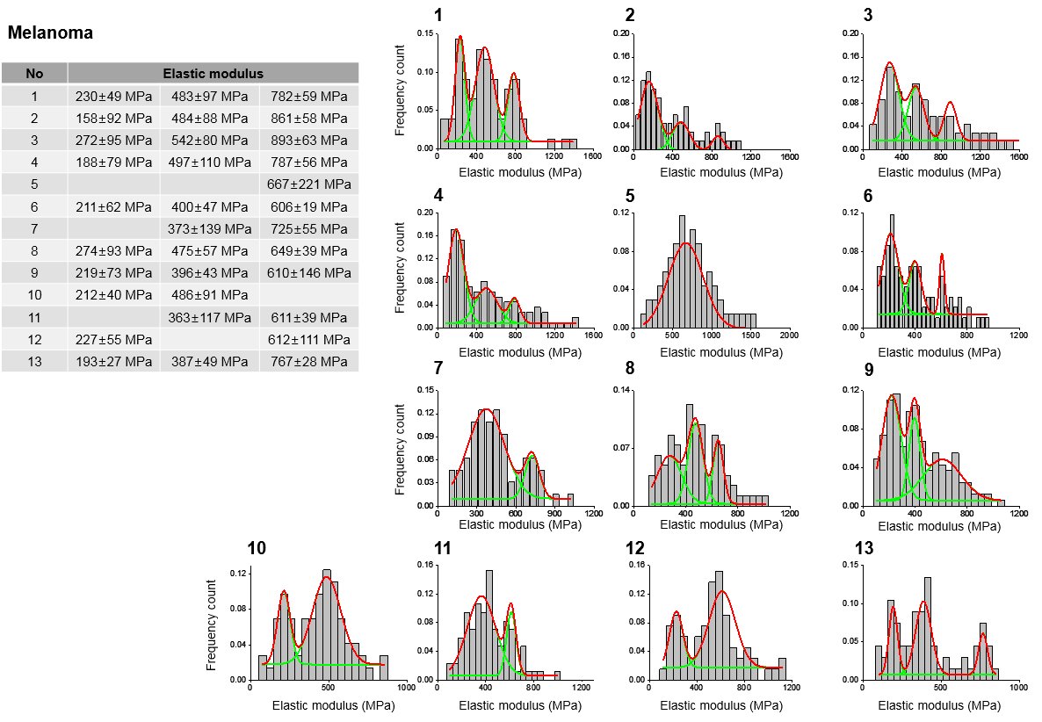
Fig. S8 Stiffness profiles of melanoma tissues revealing distinct phenotype in biomechanical properties. Histograms exhibited three multi-peak distributions ranging from the 1st to the 3rd peak region in the melanoma tissues, particularly in early melanoma tissues (Clark level I). However, this phenomenon was found to be occasionally unsustainable depending on cancer stage. The soft tissue properties in cases 5, 7, and 11 disappeared whereas such rigid properties rarely disappeared in cases 10. Case 5 showed single-peak distribution characteristics in elasticity. The complexity is attributed to heterogeneities of melanoma tissues.

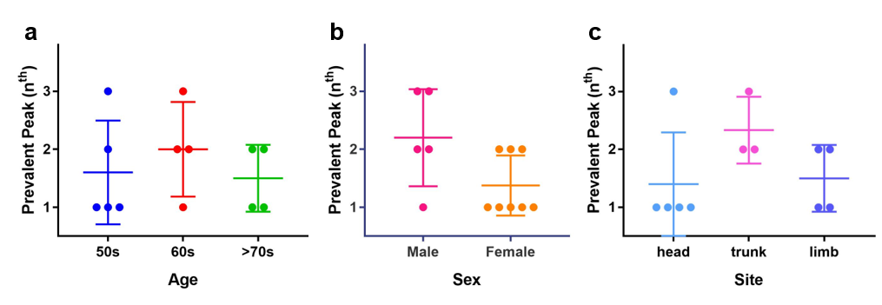
Fig. S9 The most prevalent peak (P_{m}) — one with the highest population — among multiple peaks on melanoma tissues depending on age (a), sex (b), and site (c). For all items in each graph, Student’s t-test results did not show significant difference (P-value> 0.05).

