Transient Pseudo-Random Binary Sequence Measurements for the Rapid Determination of Elementary Rate Constants for Heterogeneous Catalytic Reactions

Z. Weber^{1,‡}, A. Javanmard^{1,‡}, R. Wang^{1,‡}, M. J. Janik^{1,*}, A. Armaou^{2,1,*}, R. M. Rioux^{1,3,*}
¹Department of Chemical Engineering, The Pennsylvania State University, University Park, PA 16802
²Department of Chemical Engineering, University of Patras, Rio 26504, Greece
³Department of Chemistry, The Pennsylvania State University, University Park, PA 16802

‡Authors contributed equally.

S1. Transient PRBS Reactor

S1.1. PRBS Reactor Dynamics
A to-scale schematic of the transient PRBS reactor is shown in Extended Data Figure 1a, starting from the fast-pulsing valve. A detailed schematic of the valve itself is provided in Extended Data Figure 1b. The parts of the reactor upstream to the pulsing gas injection point do not need to be optimized to remove dead volume. The PRBS reactor is optimized from the injection point to the mass spectrometer sampling point to reduce dead volume and eliminate dispersion as much as possible.
PRBS reactor dynamics are minimized to obtain ideal pulses (as close to a square pulse as possible) and to minimize the response time. The modified fast-acting valve is placed just above the glass tube to minimize dead volume at the reactor entrance. The residence time of the reactor is reduced by using a 1/4” OD glass tube for the reactor and 1/8” OD tubing post-reactor up to the mass spectrometer. An extended capillary was installed on the Hiden HPR-20 QIC mass spectrometer to reduce “dead volume” associated with the reactor outlet. In this configuration, the MS capillary protrudes beyond the standard head capillary tubing and extends directly into the reactor effluent stream, allowing the product gases to be sampled immediately upon exiting the reactor, thus minimizing the effect of dispersion in the effluent from the reactor.
A known method of reducing residence time is to increase carrier flow. For all PRBS reactions, a total constant carrier flow is set to 100 mL/min. A reduction in the residence time of the reactor had a significant impact on the full width half max (FWHM) of a step-change input. A residence time of 10 s leads to a FWHM of 13.5 s for a 5 s pulse from the valve. Reducing the residence time down to 1 s reduced the FWHM to 5.8 s. A small amount of peak spreading still occurs in the reactor, likely occurring in the 0.9 m capillary of the mass spectrometer. Eliminating all reactor dynamics is unrealistic but minimizing them allows for faster response times and more ideal pulses. Simplified reactor dynamics enables easier kinetic extraction from the data through microkinetic and reactor modeling.
Remaining non-idealities arising from reactor and instrument dynamics are accounted for using an inert tracer gas in the pulsed feed. Argon was used as the tracer for CO. Since argon does not interact with the catalyst, it passes through the reactor without chemical interaction with the catalyst bed and directly reflects the temporal response of the fast-acting valve. As a result, the argon signal captures the true shape of the inlet pulses after transport through the reactor and sampling line. Although the mass spectrometer measures only the reactor outlet composition, the argon signal enables reconstruction of the inlet concentration profile for the pulsed gas through mass balance relationships. Decoupling transport effects from intrinsic kinetics in this manner is essential for accurate kinetic analysis. Without a tracer, the fitted rate constants would conflate catalytic kinetics with reactor and detection dynamics.

S1.2. Maintaining Isothermal Conditions
Temperature gradients within reactors must be minimized to collect reliable kinetic data. During transient experiments, thermal excursions are likely due to the highly exothermic nature of CO oxidation. Maintaining bed temperature within 1 °C is essential for collecting rate constants at a given temperature. If the bed temperature cannot be maintained isothermal along the length of bed, modeling would have to include an energy balance leading to additional complexity within an already computationally expensive model.
A traditional packed bed using silicon carbide cannot be used in the PRBS reactor, as it leads to significant temperature excursions upon introduction of the reactant gas even at lower temperature (~160 °C), as shown in Figure S1a. The geometric characteristics of the bed design is presented in Figure S1d (a). The high concentration of the catalyst at a narrow band is difficult to control due to transport limitations. Glass wool was also tried as a diluent for the catalyst bed because of its low density and inertness. A significant amount of glass wool can be packed into the reactor compared to silicon carbide used in the traditional packed bed. An improvement was seen compared to the traditional bed, but an increase in temperature was still observed over the course of a sequence (Figure S1b). A “geometric” reason for this is the spatial dispersion of the catalyst particles which allows for better transport, as can be seen in Figure S1d (b).
Based on the better results with glass wool, aluminum wool was chosen as a potential diluent. Aluminum wool is similar to the glass wool in terms of packing characteristics, but aluminum wool has a thermal conductivity of 237 W/m-K,¹ while glass wool has a thermal conductivity of 0.023-0.040 W/m-K.² The two orders of magnitude increase in thermal conductivity allows for heat to be conducted away from catalyst particles and into the bulk diluent. Aluminum wool was found to successfully maintain isothermal conditions even at higher temperature (~210 °C) within the catalyst bed (Figure S1c). Small spikes in the temperature are observed, but they are well within error of a K-type thermocouple. The design of the bed is similar to the glass wool one and is presented in Figure S1d (c). Figure S1d are pictures and the schematic of the 3 packed bed materials used in this study.

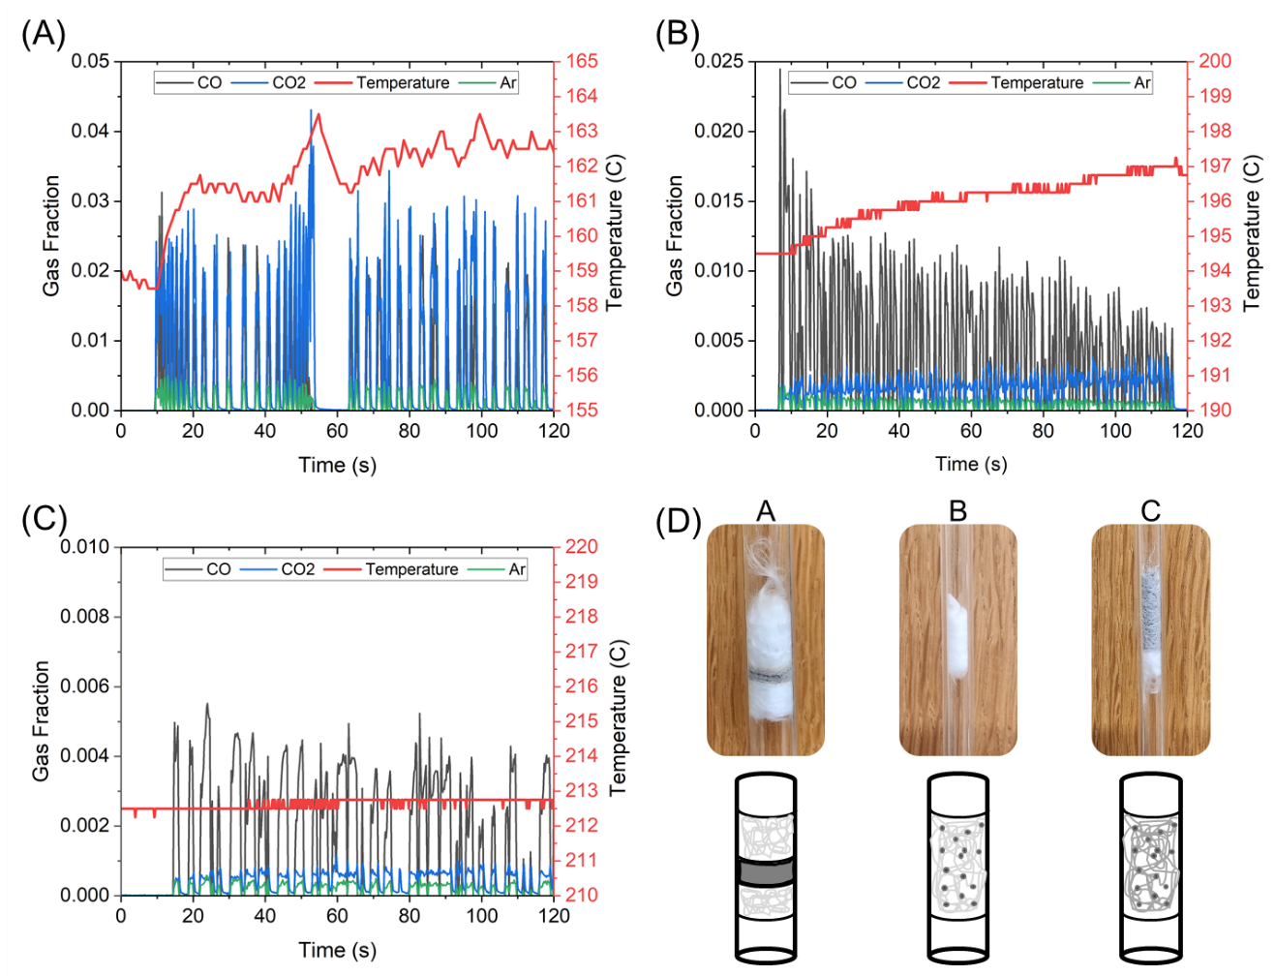
Figure S1. Results from using different packing materials to achieve an isothermal catalyst bed during CO oxidation on Pd/SiO₂. Panels A-C are mass spectrometer and temperature data. (A) Data collected on a traditional packed bed. During a PRBS sequence, a larger temperature excursion is experienced. (B) Glass wool bed made with only glass wool and catalyst. The temperature excursion is reduced, and the reactor can be operated at higher temperatures with a lower conversion indicating a more isothermal local environment. (C) Bed made with aluminum wool. The reactor remains isothermal during the entire PRBS sequence. (D) Pictures and schematic of the three beds used in this study. The A-C labels located above the images indicate which panel corresponds to the bed pictured.

S1.3. Properly Tuned PRBS Sequence
A PRBS sequence needs to be properly tuned to obtain meaningful kinetic parameters. A sequence that pushes the instrumentation to its limits can lead to poor data. Figure S2a demonstrates a rapid CO pulsing sequence with a maximum on-time (the duration for which the valve remains open) and off-time (the duration for which the valve remains closed between pulses) of 1 s. When pulsing is too rapid, the signal for CO (pulsed reactant) and CO₂ (product) resemble noise. The most likely reasons for the signals appearing noisy around a constant value are inadequate data acquisition rate. A pulse must be properly sampled by the mass spectrometer to accurately capture the shape of a pulse. This can only be accomplished with a faster data acquisition rate (dictated by instrument limitations) or increasing the on-time and off-time for the pulse. If the pulse frequency is too fast, the signal becomes noisy with no resolvable features, indicating the response is dominated by instrument effects rather than the kinetics of the reaction.
A sequence with appropriate time scales leads to a signal with more distinguishable features. Increasing the on-time and off-time to a max time of 3 s is shown in Figure S2b. A significant improvement is seen compared to the sequence with a max on-time and off-time of 1 s. Most features in the signal become more defined, but very fast pulses with maximum on-time and off-time below 1 s still lead to perturbations that are not sufficiently sampled by the mass spectrometer. Figure S2c shows a PRBS sequence with on-time and off-time bounds of 1 s to 6 s, yielding transient features that are fully resolved and sufficiently sampled by the mass spectrometer. These sequence bounds are used to create the sequence for all CO pulsing experiments.
On-time and off-time can also be too long. Figure S2d shows a PRBS sequence with on-time and off-time of 12s. Long on-times lead to the formation of pseudo steady-state plateaus during the pulse, as illustrated by the CO₂ trace. Long off-times allows the reactor to fully relax back to its ground state, which provides no additional kinetic information. Although acceptable fits can still be obtained using long pulses if the random timestep is sufficiently small, this approach requires substantially more pulses and increases both experimental and computational cost. Therefore, on-time and off-time bounds must be tuned to the reaction kinetics, reactor hydrodynamics and measurement dynamics to maximize information content while minimizing unnecessary data collection.
Key factors influencing PRBS sequence tuning include the reactor (dead volume), the mass spectrometer response, the fast-pulsing valve, and the reaction kinetics being studied. The minimum bounds on on-time and off-time are primarily dictated by the reactor and the instrument associated with collecting the transient data (mass spectrometer in this case). For reactions with slow kinetics, very short on-time and off-time may not be required leading to the kinetics dictating the lower bound. For all cases the upper bound will be set by the reaction kinetics. The upper bound for on-time should be long enough to approach a pseudo steady-state product signal, while the upper bound for off-time is set based on the reactant or product desorbing from the catalyst indicated by the signals return to the baseline.
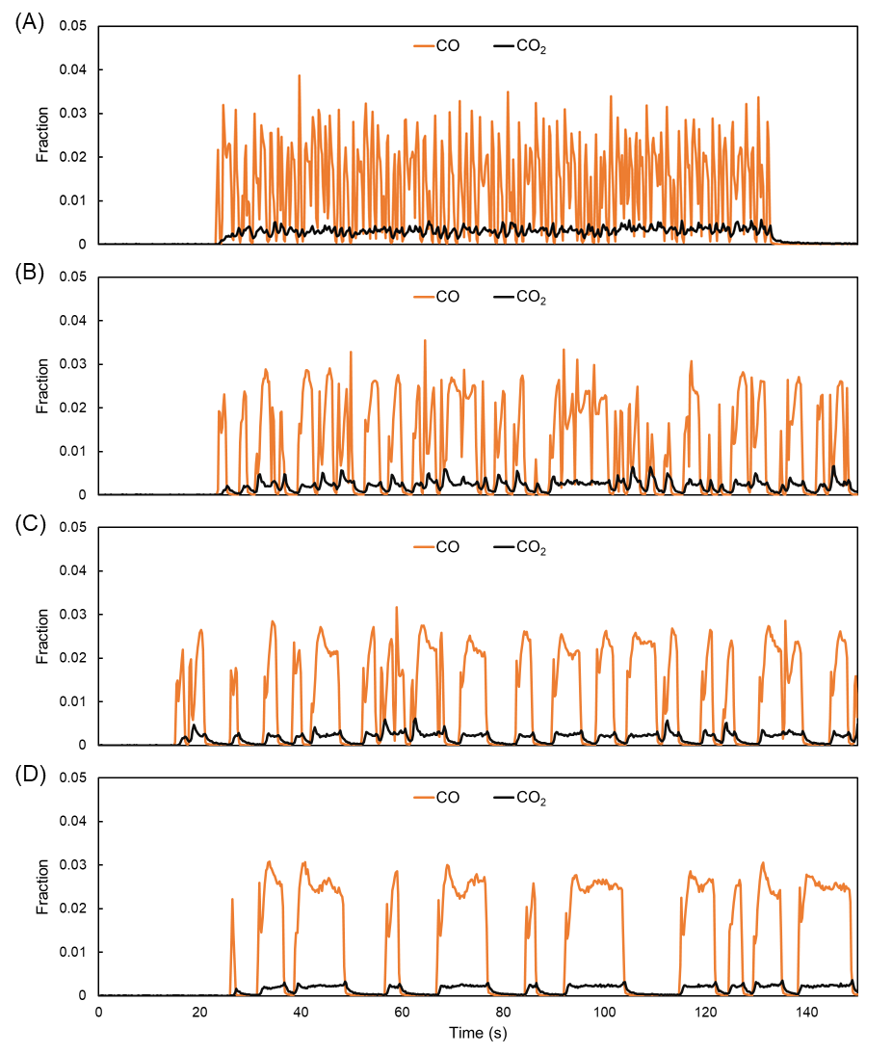
Figure S2. PRBS sequences with varying timescales. (A) PRBS sequence with maximum on-time and off-time of 1 s. (B) PRBS sequence with maximum on-time and off-time of 3 s. (C) PRBS sequence with on-time and off-time bounds of 1 s to 6 s. (D) PRBS sequence with maximum on-time and off-time of 12 s.

S2. PRBS Reactor Model
An isothermal axial dispersion model^{3, 4} based on material balances assuming ideal gas behavior of all species is built to simulate the experimental PRBS reactor. General forms of the mass balance equations for the reactor are demonstrated in Eqs. (S1)-(S6). The superficial gas velocity in the reactor, u_{s}, is estimated by mass balance of the inert component present in the inlet stream (Eqs. (S7)-(S8)). The axial dispersion coefficient, D_{L}, is calculated according to Ruthven’s correlation^{3, 5}. Diffusivities predicted by Fairbanks and Wilke’s⁶ and Fuller et al.’s⁷ equations are assumed for CO, O₂, CO₂ and He. Internal and external mass transfer resistances of the catalyst were determined to be small, the overall effectiveness factors for all reactions are equal to unity. The rate expressions for each elementary step in Table 1 are used to calculate a surface reaction rate, r_{sur}. The reactor model’s partial differential equations are discretized into ordinary differential equations (ODEs) on 101 spatial mesh points using a finite difference approximation in upwind form. The resultant stiff system of ODEs is solved using function ode15s in MatLab, a variable-step, variable-order solver, with a relative tolerance of 10⁻⁵.
$\frac{∂C_{i}}{∂t}=D_{L,i}\frac{∂^{2}C_{i}}{∂x^{2}}-\frac{1}{ε}\frac{∂u_{s}C_{i}}{∂x}-\frac{1}{ε}ρ_{b}r_{sur}(k,T,C_{i},θ_{m})$ (S1)
$\frac{∂θ_{m}}{∂t}=\frac{r_{sur}(k,T,C_{i},θ_{m})}{C_{t}}$ (S2)
where i = CO, O₂; m = CO, O₂, CO₂, O. Initial conditions used are
$C_{i}\left(x,0\right)=0,x≠0$ (S3)
$θ_{m}\left(x,0\right)=0$ (S4)
while the boundary conditions employed are:
$C_{i}\left(0,t\right)=C_{in,i}\left(t\right)$ (S5)
$\frac{∂C_{i}}{∂x}(L_{b},t)=0$ (S6)
The superficial velocity at any time or point in the reactor is:
$u_{s}=\frac{u_{s,0}C_{T}(1-y_{{CO}_{2},0}-\frac{y_{CO,0}}{f_{CO,P}}-y_{O_{2},0})}{(C_{T}-C_{{CO}_{2}}-\frac{C_{CO}}{f_{CO,P}}-C_{O_{2}})}$ (S7)
$u_{s,0}=\frac{Q_{C}+Q_{P,0}}{A}$ (S8)
The thermodynamic equilibrium constant for the overall reaction is fixed at the reactor temperature. Parameter k₋₄ is determined according to the rate constants in Eqs. (S9) and (S10), respectively. The standard Gibbs free energy, $∆G_{r}^{°}$, applied in Eq. (S9) is set to the value for CO oxidation at 1 bar.⁸
$K_{r}=\frac{K^{°}}{P^{°}}=\frac{1}{P^{°}}exp⁡(-\frac{∆G_{r}^{°}}{RT})$ (S9)
$k_{-4}=\frac{k_{1}k_{5}k_{4}}{k_{-1}k_{-5}}{(\frac{k_{2}k_{3}}{k_{-2}k_{-3}K_{r}})}^{\frac{1}{2}}$ (S10)
The parameter fitting is considered complete when the weighted objective function is minimized. The least squares objective function is presented in Eq. (S11), with the factor for weighting error, $W_{i}$, presented in Eq. (S12). The initial time-varying reactor outlet profiles (of approximately 300 sampling points) are first fitted using a global optimizer, which searches from multiple initial guesses using a trust-region-reflective local optimizer (function multistart and lsqnonlin in MatLab). The fitted rate constants then become the initial guesses for the entire profile fitting by the same local optimizer to maintain rate constant estimation accuracy and avoid extremely long computational time. Rate constant k₁, k₂ and k₋₅ are normalized by factors of 10⁵ during the fitting process to harmonize their initial guess magnitude to other parameters because of P~10⁵ Pa and θ (surface coverage) ~ 1.
$\min{f}=\sum_{i}{\sum_{j}^{n_{t}}{W_{i}}{(C_{exp,i,j}-C_{pred,i,j})}^{2};}i=CO,O_{2},CO_{2}$ (S11)
$W_{i}={(\frac{C_{max,all}}{C_{max,i}})}^{2};C_{max,{i}}=\max{(}C_{exp,i});C_{max,{a}ll}=\max\left(\max\left(C_{exp,i}\right)\right)$ (S12)
Since the reactor outlet only is measured as a function of time during an experiment, the inlet profile for all species is needed to properly model the data. The inlet profile of all species can be determined using a tracer gas (Ar is included in the CO cylinder for this purpose). Using the mass spectrometer, the tracer fraction at the outlet of the reactor (y_{tracer, out}) is measured as a function of time. The Peclet numbers of all reactants are approximately 10, indicating convection-dominated operation. Therefore, the data is directly shifted backward in time by the residence time (τ) to obtain the tracer fraction at the reactor inlet (y_{tracer,in}) at time t. MATLAB function pchip (piecewise cubic Hermite interpolating polynomials with the Fritsch–Carlson monotone cubic interpolation slope-selection algorithm) is used to interpolate the tracer fraction data; any negative values calculated during interpolation are set equal to 0 to yield y’_{tracer,in}. The time varying pulsed gas flowrate ($Q_{P,0}$) is calculated using Eq. (S13), which is the result of the mole balance between the final tracer concentration at the inlet to the pulsing flowrate and gas cylinder fraction of tracer in the pulsing gas (f_{tracer,P}, 10%).
$\left(Q_{P}+Q_{C}\right){y^{'}}_{tracer,in}=f_{tracer,P}Q_{P}$ (S13)
Total volumetric flowrate ($Q_{T}$) is the sum of the constant gas (O₂ + He) volumetric flowrate ($Q_{C}$) and the time varying pulses added to the flow. Combining the definition for $Q_{T}$ and Eq. (S13) yields Eq. (S14).
$Q_{T}=Q_{C}\frac{{y'}_{tracer,in}}{f_{tracer,P}-{y'}_{tracer,in}}$ (S14)
The inlet fraction of the pulsed reactant (y’_{reactant,in}) can be determined using y’_{tracer,in} and the relative ratio of the two components in the pulsing gas cylinder as Eq. (S15).
${y'}_{reactant,in}={y'}_{tracer,in}\frac{f_{CO,P}}{f_{Ar,P}}$ (S15)
The inlet profile for a species of interest in the steady-state gas flow can be determined using Eq. (S16).
$y_{i,C}=f_{i,C}\frac{Q_{C}}{Q_{T}}$ (S16)
The determination of inlet profiles is essential for deconvoluting transport dynamics from the kinetics of interest. Through the inclusion of a tracer gas, inlet profiles can be derived from measured outlet profiles eliminating the need to also measure the reactor inlet as a function of time.
S3. Mass Spectrometer

S3.1. Scan Tree for Masses Monitored During CO Oxidation Using the Hiden HPR-20 QIC Mass Spectrometer
The mass spectrometer has its own dynamics associated with standard operation. To accurately measure mass signals, data must be shifted by a constant time delay for each mass. In these experiments, five signals were monitored by the mass spectrometer: CO (m/z = 28), O⁺ (m/z = 16), CO₂ (m/z = 44), Ar (m/z = 40), and the total pressure (Torr). A full scan of these five channels required approximately 280 ms, resulting in an effective temporal resolution of about 56 ms per mass channel. An example of the scan sequence and associated timing is shown in Figure S3. To ensure accurate time alignment, all signals were shifted to reflect the actual time at which each mass was measured. Such time correction is essential for resolving fast transient events and for reliably extracting kinetic parameters from the coupled reactor and microkinetic models.

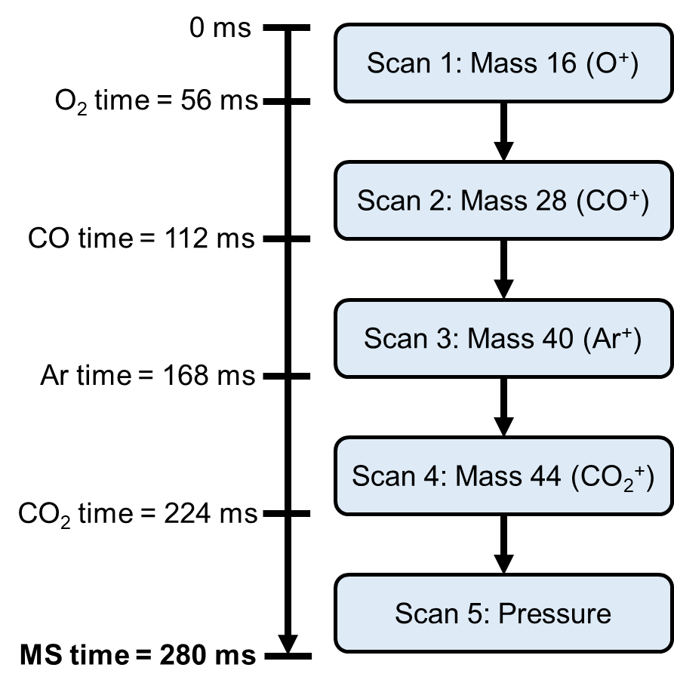
Figure S3. Scan tree for the masses scanned for a CO oxidation experiment with Ar tracer. The mass spectrometer (MS) time is the only timestamp output from the instrument. The time must be adjusted for each mass to obtain an accurate time stamp for each species scanned in a single scan.

S3.2. “Experiment-like” calibration to eliminate mass spectrometer dynamics
A methodology was developed to make the calibration method mimic the PRBS experiments. By ensuring the calibration is conducted more closely to the experiment methodology, mass spectrometer (MS) complexities should be minimized and removed from the data as much as possible. The method will be referred to as an “experiment-like” calibration. This calibration methodology is implemented to determine the mole fraction of species in the gas phase during PRBS experiments. All modeled experimental data shown in this work utilize this calibration method.
To calibrate CO and Ar, variable flows of CO (50% CO/5% Ar /He, 99.999% purity, Linde, 0-10 ml/min) is injected into a steady-state flow of 20 mL/min O₂ (99.93%, Linde) and 80 mL/min He (99.999%, Linde). This approach ensures that the MS response to CO and Ar is measured in the presence of the same steady-state gases used during PRBS experiments. When CO is introduced, the pressure inside the mass spectrometer increases slightly. The same pressure increase occurs during PRBS experiments, and accounting for this change during calibration ensures that the dynamic response of the MS is properly represented. Under these conditions, both CO and Ar exhibit simple linear relationships between MS counts and gas-phase mole fraction (Figure S4a and b). This confirms that, when calibrated under experiment-like conditions, both CO and Ar can be quantified using simple linear calibration curves.
Calibration of O₂ requires additional consideration because O₂ signal intensity depends on total MS pressure. Two equivalent calibration approaches were evaluated. In the first approach, O₂ counts are fitted as a function of both pressure and mole fraction using a three-dimensional plane. In the second approach, O₂ counts are normalized by the measured pressure at each calibration point and then fitted using a simple linear relationship. Normalizing by pressure eliminates the need for multidimensional fitting while producing identical results. For this reason, the pressure-normalized linear calibration was adopted for all data analysis as shown in Figure S4.
CO₂ calibration is performed in a similar manner by injecting a flow of CO₂ (10% CO/10% Ar /He, 99.999% purity, Linde, 0-12 ml/min) into a steady-state flow of 20 mL/min O₂ and 80 mL/min He. The calibration range for CO₂ and Ar is between mole fractions of 0 and 0.01, which corresponds to the concentration range encountered during PRBS experiments. Although Ar is calibrated over this range, this calibration is not used for data analysis, since Ar calibration obtained from the CO mixture is more relevant to the experiments. Introducing CO₂ into the MS causes only a small change in pressure, always less than 5%. Even with this small pressure variation, CO₂ counts maintain a linear relationship with mole fraction. Calibration results for CO, Ar, CO₂, and pressure-normalized O₂ are shown in Figure S4.
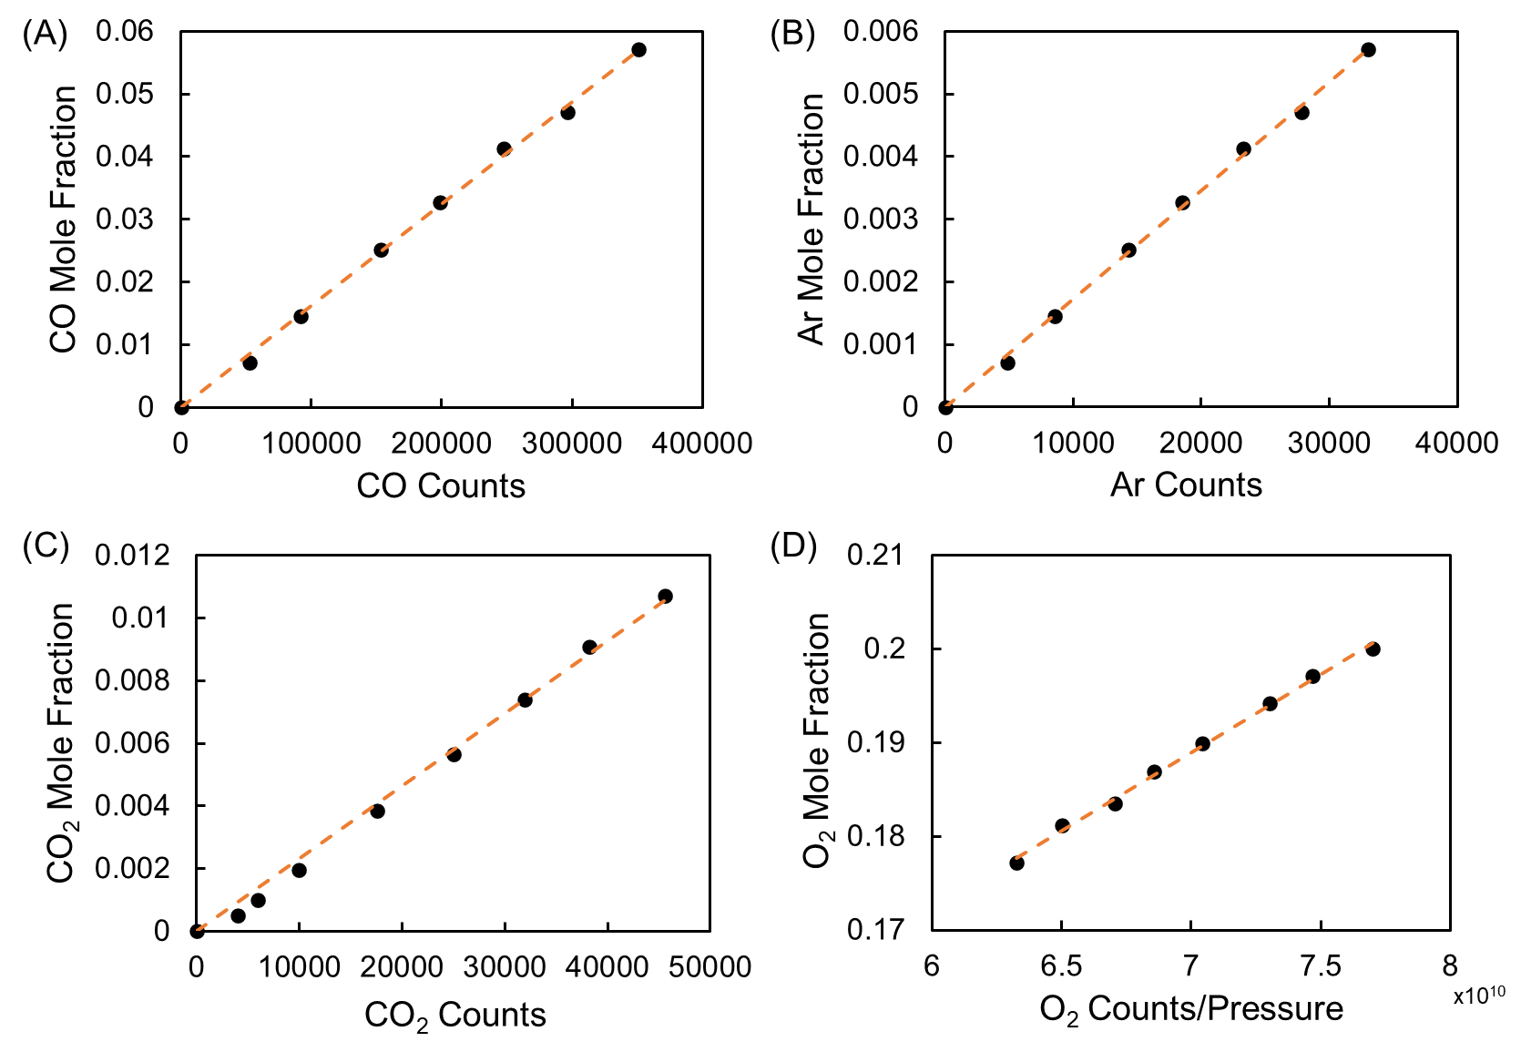
Figure S4. Calibration curves collected using the “experiment-like” calibration methodology. The calibration curves shown are used for CO oxidation PRBS experiments with CO as the pulsing gas. Similar curves are obtained when the pulsing gas is swapped. (A) CO calibration curve (B) Ar calibration curve (C) CO₂ calibration curve (D) O₂ calibration curve when O₂ counts are normalized to pressure.

Although pressure changes during CO₂ calibration are small, CO₂ counts are further corrected by normalizing them to the base MS pressure measured during steady 20 ml/min O₂ and 80 ml/min He flow. A typical base pressure is ~0.8 μTorr. During PRBS experiments, the MS pressure rises slightly during CO pulses. To account for this effect, CO₂ counts measured at elevated pressures are scaled back to the base calibration pressure. For example, if pressure increases by 5% during a pulse, the corresponding CO₂ counts are reduced by 5% before applying the calibration curve. This correction is valid over the small pressure range encountered in these experiments. In practice, pressure variations during PRBS experiments are kept below ~10%. The change in pressure is minimized by keeping injector flow low (5-10 mL/min).
Additional corrections are required to obtain accurate mole fractions from raw MS counts. When CO is pulsed, a small amount of CO₂ is detected even in the absence of reaction. This background CO₂ likely originates from trace CO₂ impurities in the CO cylinder and from oxidation of residual O₂ on the heated carbonyl trap in the CO line. To remove this contribution, a calibration curve is generated that relates CO₂ counts to CO counts during CO calibration pulses. This relationship is later used to subtract background CO₂ associated with the CO pulse. An example of this calibration is shown in Figure S5a.
A final correction is required to account for fragmentation (cracking patterns) that occur during ionization in the mass spectrometer. Fragmentation leads to overlap between signals from different species. For CO oxidation experiments, the primary masses monitored are CO (m/z = 28), O⁺ (m/z = 16), CO₂ (m/z = 44), and Ar (m/z = 40). For CO, the main fragments are CO⁺, C⁺, and O⁺. For CO₂, the main fragments are CO₂⁺, CO⁺, C⁺, and O⁺. Carbon fragments are not tracked and are therefore ignored. Since CO⁺ (m/z = 28) and O⁺ (m/z = 16) signals can originate from more than one species, their contributions must be corrected using measured cracking patterns.
Fragmentation ratios were determined directly on the instrument used in this work, since cracking patterns depend on instrument settings and can vary between spectrometers. The parent peak for each species was normalized to a value of 1, and fragment peaks were expressed relative to the parent peak (the primary signal for CO₂ and CO is the parent or unfragmented peak). The measured split ratios were as follows: for CO₂, CO⁺/ CO₂⁺ = 0.088 and O⁺/ CO₂⁺= 0.121; for CO, O⁺/CO⁺ = 0.006. The measured cracking patterns are shown in Figure S5b.

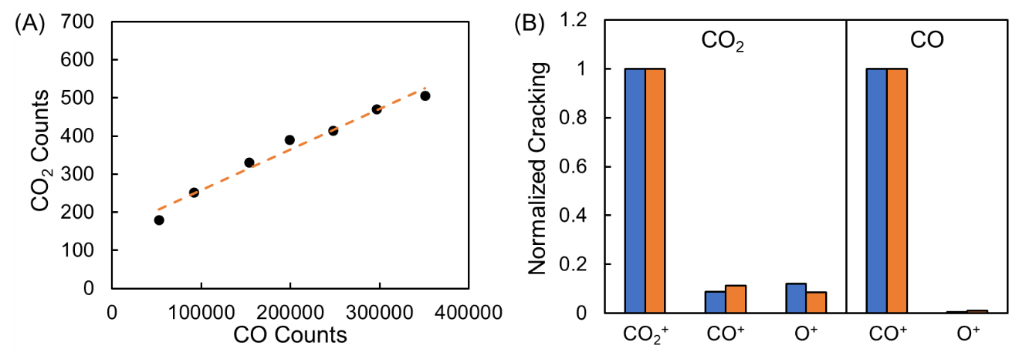
Figure S5. Calibrations used for further correction of counts obtained from the mass spectrometer for a given species. (A) CO₂ counts as a function of CO counts during the CO calibration. This calibration is used to subtract of trace amounts of CO₂ from the CO line. (B) Normalized cracking pattern for CO₂ and CO in the mass spectrometer. Measured values are shown in blue and values from the Hiden website are shown in orange. Cracking pattern is dependent on mass spectrometer operating settings which gives rise to the small discrepancies between the two values reported.

The complete correction procedure used to process MS data for CO oxidation is summarized below. For each scan, signals at m/z = 16, 28, 40, and 44 are recorded along with the MS pressure. Raw CO counts are first corrected for fragmentation originating from CO₂ according to Eq. (S17):
${CO}_{Corrected}={CO}_{raw}-\left({CO}_{2,raw}×{{CO}^{+}}_{CO2 split}\right)$ (S17)
In Eq. (S17), CO_{Corrected} is the adjusted CO counts, CO_{raw} is CO counts obtained directly from the mass spectrometer data, CO_{2,raw} is CO₂ counts obtained from the mass spectrometer, and CO⁺_{CO2 split} is the split fraction obtained from the fragmentation calibration (with value 0.088). No additional corrections are required for CO before applying the linear CO calibration curve.
Raw oxygen counts must be corrected for fragmentation contributions from both CO and CO₂. This correction is performed using Eq. (S18):
$O_{Corrected}=O_{raw}-\left({CO}_{Corrected}×{O^{+}}_{CO split}\right)-\left({CO}_{2,raw}×{O^{+}}_{CO2 split}\right)$ (S18)
The equation for correcting O is similar to CO, but fragmentation from two species is considered. In Eq. (S18), O_{Corrected} is the adjusted oxygen counts, O_{raw} is the mass spectrometer raw signal at m/z = 16, CO_{Corrected} is the corrected CO counts obtained from Eq. (S17), O⁺_{CO split} is the fragmentation split for O⁺ from CO (with value of 0.006), and O⁺_{CO2 split} is the fragmentation split for O⁺ from CO₂ (with value of 0.121). The adjusted CO counts are used in this equation to ensure the fragmentation from CO₂ is not accounted for twice.
The CO₂ counts also needed adjusted before being input into the calibration. The CO₂ signal does not require fragmentation correction, but instead a correction based on pressure change and the amount of CO₂ that enters the reactor system during a pulse of CO. Eq. (S19) is used to correct CO₂ counts. The correction leads to negative values prior to an experiment starting when the system is at baseline. For all negative values, counts are set to 0 using the ReLU function ($ReLU(x)=max(0,x)$).
${CO}_{2, Corrected}=ReLU({CO}_{2, raw}-{CO}_{2, raw}×\left(\frac{P-P_{0}}{P_{0}}\right)-\left(m×{CO}_{raw}+b\right))$ (S19)
In Eq. (S19), CO_{2, Corrected} is the adjusted CO₂ counts, P is the pressure for any given scan, P₀ is the base calibration pressure the CO₂ calibration curve is adjusted to, m is the slope obtained from the calibration in Figure S5a, and b is the intercept obtained from the calibration in Figure S5b.
Once Eqs. (S17)–(S19) are applied, the corrected counts for CO, O₂, and CO₂ are converted to mole fractions using their respective calibration curves (Figure S4). Following this procedure yields transient mole-fraction data suitable for quantitative kinetic modeling.

S4. PRBS calibrated MS and fitted dataset collected during CO oxidation over Pd/SiO₂
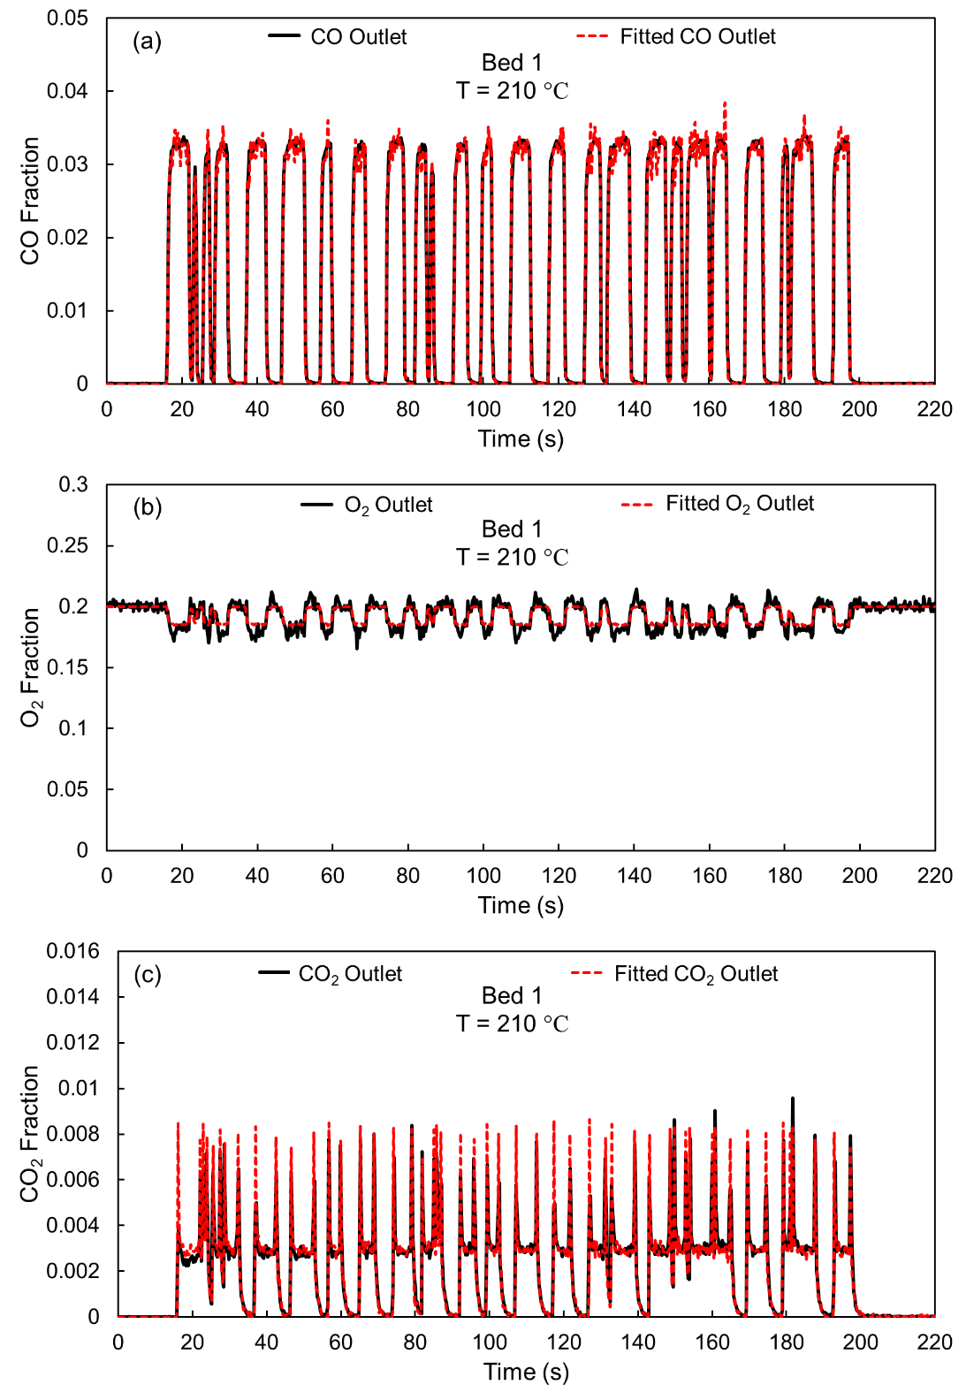
Figure S6. Fitted PRBS data for CO oxidation over Pd/SiO₂ at 210 °C in Bed 1. (a) CO. (b) O₂. (c) CO₂.
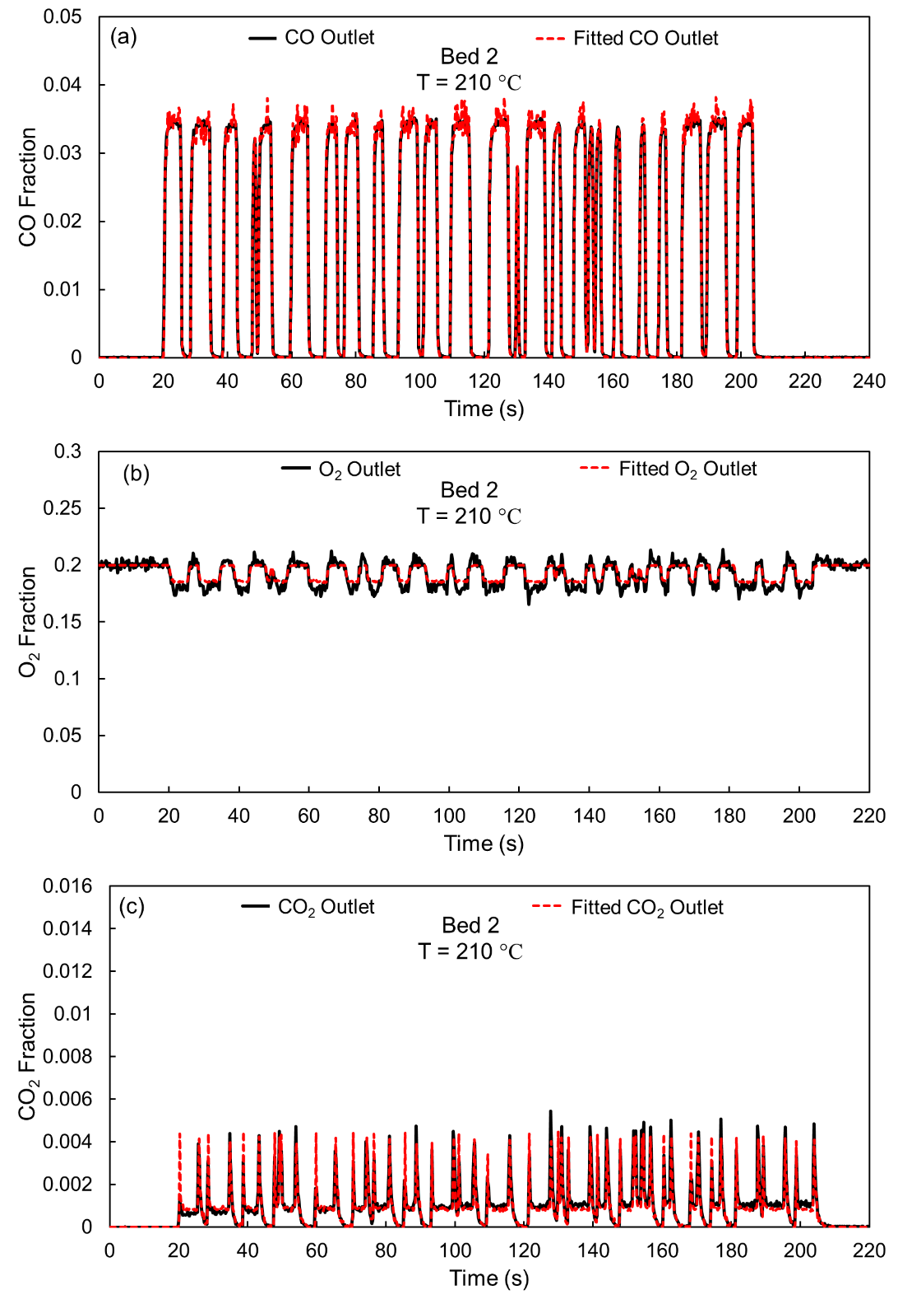
Figure S7. Fitted PRBS data for CO oxidation over Pd/SiO₂ at 210 °C in Bed 2. (a) CO. (b) O₂. (c) CO₂.

S5. Degree of Rate Control Analysis
Campbell⁹ introduced the degree of rate control (DRC) for elementary steps to quantify the influence of an elementary step in the microkinetic model on the overall reaction rate. In the main text, the steady-state degrees of rate control ($X_{SRC,i}$) for each elementary step i of the microkinetic model in Table 1, were calculated from Eq. (S20), where r denotes the overall reaction rate in the reactor at the steady state.
$X_{SRC,i}={\left(\frac{∂\ln{r_{sur}} }{∂\ln{k_{i}}}\right)}_{k_{j}≠k_{i},K_{i}}$ (S20)
Foley et al.¹⁰ calculated non-steady-state (transient) DRC for elementary steps of microkinetic models in batch reactors. In the main text, a dynamic axial-dispersion reactor model was built for the mass balances of the reactor, resulting in spatial non-homogeneous transient DRC along the reactor. Therefore, a spatially averaged transient DRC for each elementary step of the Langmuir–Hinshelwood microkinetic mechanism was calculated, as shown in Eq. (S21). Therefore, in the main text, a spatially averaged transient degree of rate control ($X_{TRC,i}$) for elementary step i of the microkinetic model in Table 1 was calculated as Eq. (S21). When the reaction rate was zero, calculating the DRC for individual elementary step was meaningless. Therefore, when the overall product formation rate in the microkinetic model, $r_{5}$, in the reactor was at the baseline noise level, the spatially averaged transient DRC for all elementary steps were set to zero.
$X_{TRC,i}=\frac{\int_{0}^{L_{b}}{{\left(\frac{∂\ln{r_{5}\left(t\right)}}{∂\ln{k_{i}}}\right)}_{k_{j}≠k_{i},K_{i}}}dx }{L_{b}}$ (S21)
Both $X_{TRC,i}$ and $X_{SRC,i}$ are not necessarily positive nor constrained to a maximum or a summation of unity. A larger absolute value indicated a more significant influence of the corresponding elementary step on the overall reaction rate. Therefore, the analysis in the main text focused on the absolute values of the $X_{TRC,i}$ and $X_{SRC,i}$.

S6. PRBS calibrated MS and fitted dataset collected at 180-220 °C
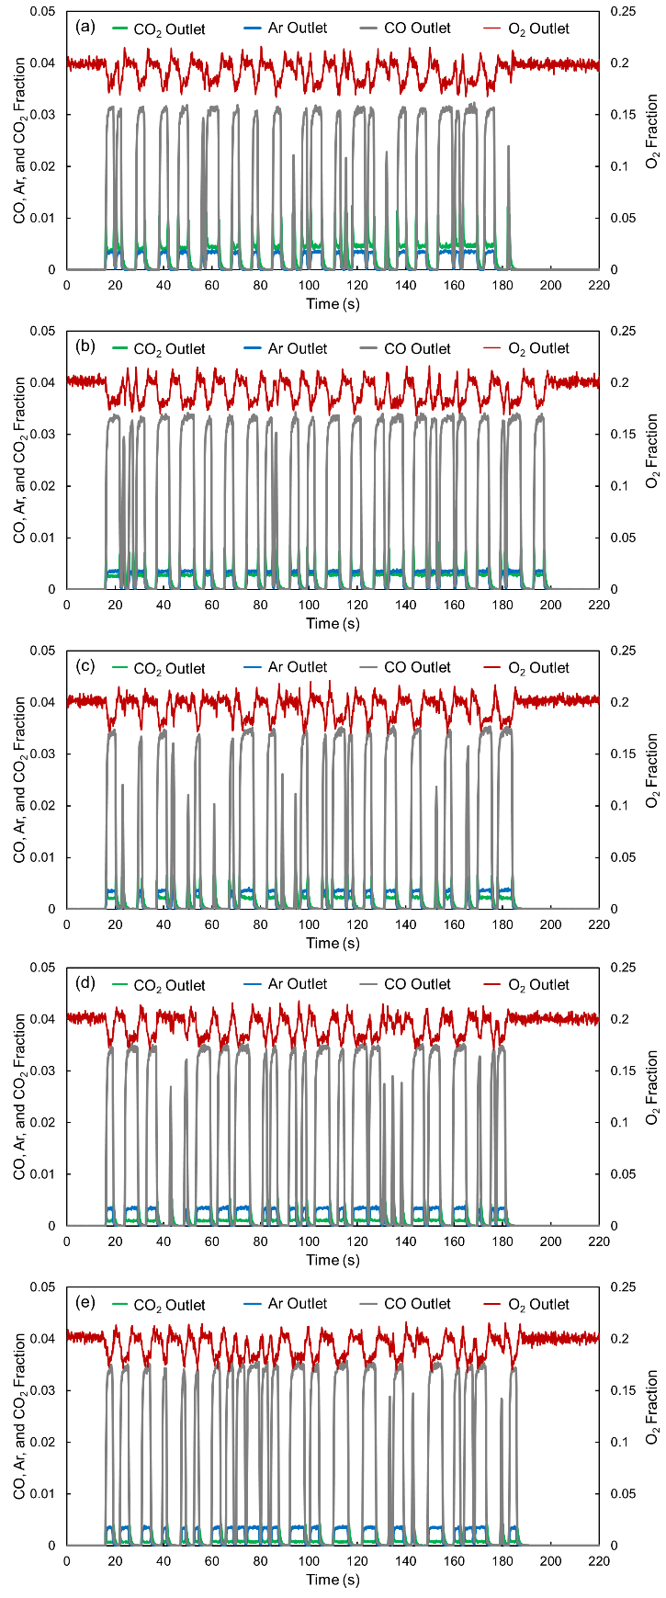
Figure S8. PRBS Reactor outlet mole fractions of CO₂, Ar (tracer), CO, and O₂ measured during PRBS perturbations in Bed 1 using different pulse sequences at different temperatures: (a) 220 °C, (b) 210 °C, (c) 200 °C, (d) 190 °C, and (e) 180 °C.

S7. Algorithm of Bayesian linear regression for Arrhenius activation energy in the forward and reverse directions of elementary steps
The Bayesian linear regression of the Arrhenius plots was performed using the Metropolis–Hastings algorithm¹¹ to estimate the activation energies of each elementary step. The slope ($a$) and intercept ($b$) of the linear regression of $\ln{k}$ vs $\frac{1}{T}$ were treated as the parameters to be identified in the Markov chain Monte Carlo (MCMC) Bayesian regression. The corresponding results obtained using the regress function in MatLab (realization of ordinary least squares algorithm) were used as the initial values for the MCMC chains. The variance, $σ_{m}$, was calculated independently at each temperature $T_{m}$ using Eq. (S22), where $n_{m}$ denotes the number of experiments conducted at $T_{m}$. Parameter $k_{m,l}$ is the rate constant fitted at l^{th} experiment conducted at $T_{m}$. When only one experiment was conducted at a given temperature, the variance was approximated using the maximum variance estimated for the other temperatures. A total of 10,000,000 MCMC iterations were performed, and the first 2,000,000 iterations were discarded as burn-in phase. The proposal width was adjusted to achieve a final acceptance rate between 0.3 and 0.4.
$σ_{m}=\sqrt{\frac{\sum_{l}{{(\ln{k_{m,l}}-\frac{a}{T_{m}}-b)}^{2}}}{n_{m}-1}}$ (S22)

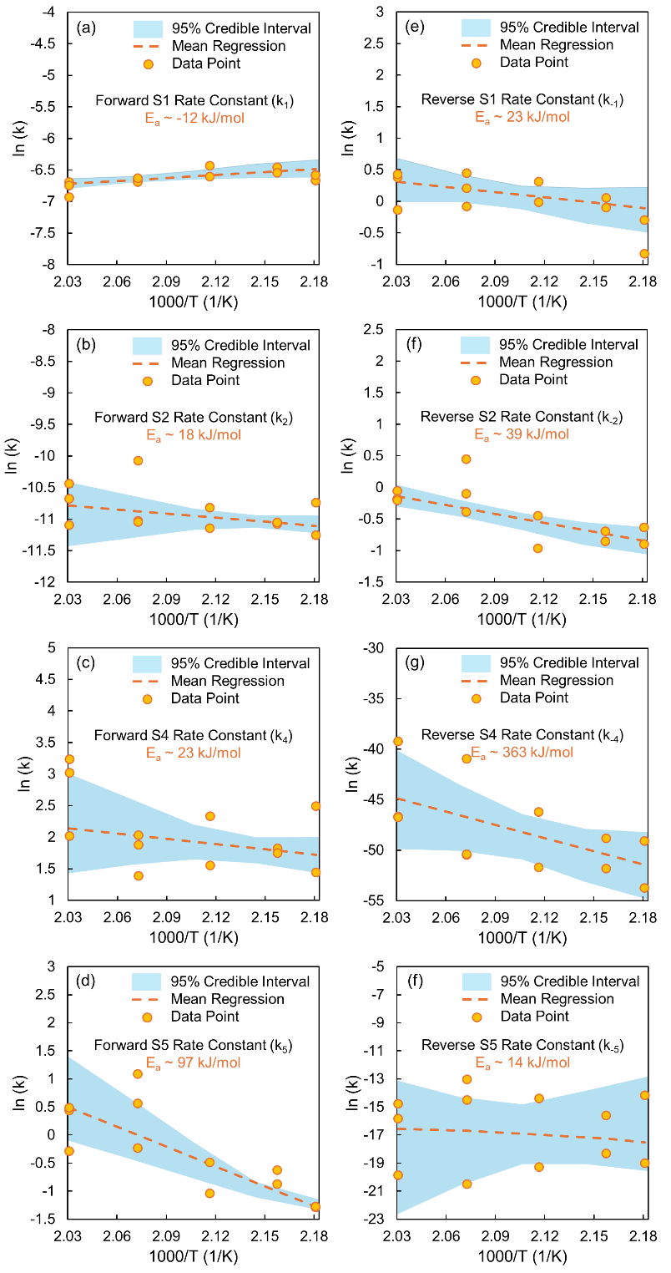
Figure S9. Arrhenius plots of the fitted rate constants for the forward ((a–d)) and reverse ((e–h)) directions of elementary steps S1, S2, S4, and S5.

S8. Steady-State Kinetic Measurements of CO Oxidation in a Fixed-Bed Reactor
Kinetic measurements were conducted in an in-house down-flow fixed-bed reactor. Catalyst beds were prepared by grinding by grinding 1-3 mg of catalysts with silicon carbide (#70 Mesh, Kramer Industries, Inc, Buffalo Grove, IL) with a mortar and pestle for a total weight of 150 mg. Silicon carbide was used to prevent local temperature increase due to the exothermicity of the CO oxidation reaction. The catalyst bed was loaded into a quartz tube (1/2” O.D.) supported by glass wool and placed into a furnace where a K-type thermocouple inserted from the bottom of the reactor made direct contact with the glass wool. The reactor was heated up (5 °C/min) in 30 mL/min of O₂/N₂ (20% O₂) to the target reaction temperature. Once the temperature was stable, the gas flow was switched to CO/O₂/N₂ at the same total flow rate to initiate the reaction.
The effluent gas was analyzed with a Nexis GC-2030 (Shimadzu) equipped with a flame ionization detector (FID) and In-Jet Methanizer (Shimadzu) to detect low concentrations of CO and CO₂. The effluent stream from the reactor was injected using a 6-way valve and separated with a Q-Bond capillary column (Shimadzu) using N₂ as the carrier gas. The apparent activation energy of CO oxidation was determined from an Arrhenius plot comprised of five different temperatures, while CO and O₂ reaction orders were determined from a plot comprised of five different partial pressures of CO and O₂ respectively. Temperatures and partial pressures were varied randomly to eliminate systemic measurement errors. Two points for each plot were repeated to check for catalytic deactivation. Each condition was held for 100 min, with the last 30 min used to calculate the steady-state rate. CO conversion was limited to less than 10% for all reaction conditions and all reported rates were calculated assuming differential reactor behavior.
Steady-state kinetic data for the synthesized Pd-SiO₂ catalyst are shown in Figure S10. The apparent kinetics resemble that of previous work done by other groups for CO oxidation on Pd nanoparticles on an irreducible support¹²⁻¹⁵. Under the conditions used for the steady-state measurements, lean conditions, CO acts as a poison due to the strong bonding affinity of CO to Pd resulting in a negative order. The reaction has a strong positive dependence on the partial pressure of O₂. This results from weak binding of O₂ and the strong binding of CO leading to a surface covered primarily by CO¹⁶.

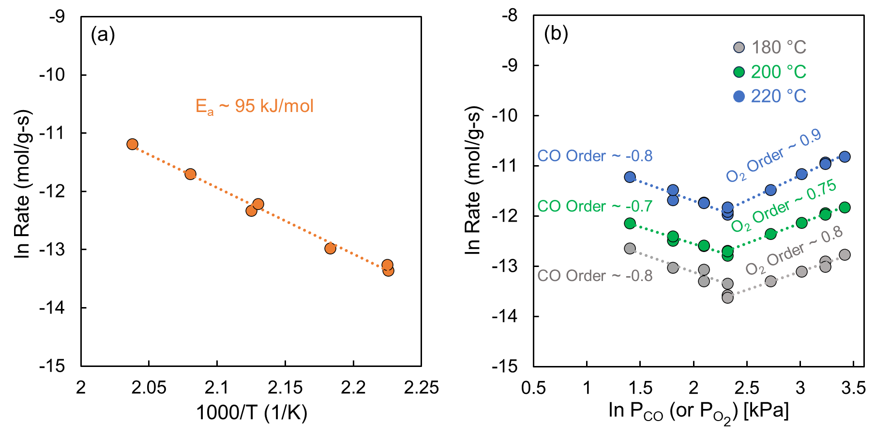
Figure S10. Steady-state kinetics for CO oxidation over Pd-SiO₂. (a) Arrhenius plot between 180-220 °C. The apparent activation energy is calculated to be ~ 95 kJ/mol. (b) Reaction order plot demonstrating CO orders and O₂ orders at 180 °C, 200 °C, and 220 °C.

S9. Determination of Active Site Concentration
The active site concentration for a catalyst can be determined by fitting the data to the microkinetic model, but reducing unknown variables in the model leads to results with narrower confidence intervals. The concentration of active sites can be estimated using CO chemisorption at 25°C. The CO adsorption isotherms for Pd/SiO₂ are shown in Figure S11. To estimate active site concentration, the linear portion of the 1st and repeat isotherms are subtracted from one another. The 1st isotherm represents both physical and chemical adsorption of CO, while the repeat isotherm, collected after evacuating the sample room temperature, represents physisorbed CO. The difference between the two isotherms is the quantity of chemisorbed CO at a given pressure. The intercept of the difference isotherm is the total amount of chemisorbed CO at 0 mmHg. The isotherms, including the difference isotherm are shown in Figure S11. The quantity determined from the intercept is also the concentration of active sites if a 1:1 Pd:CO adsorption ratio is assumed. The concentration of active sites for the 0.5 wt% Pd/SiO₂ catalyst is estimated to be 6.4 μmol/g, corresponding to a Pd dispersion of 13.6%.

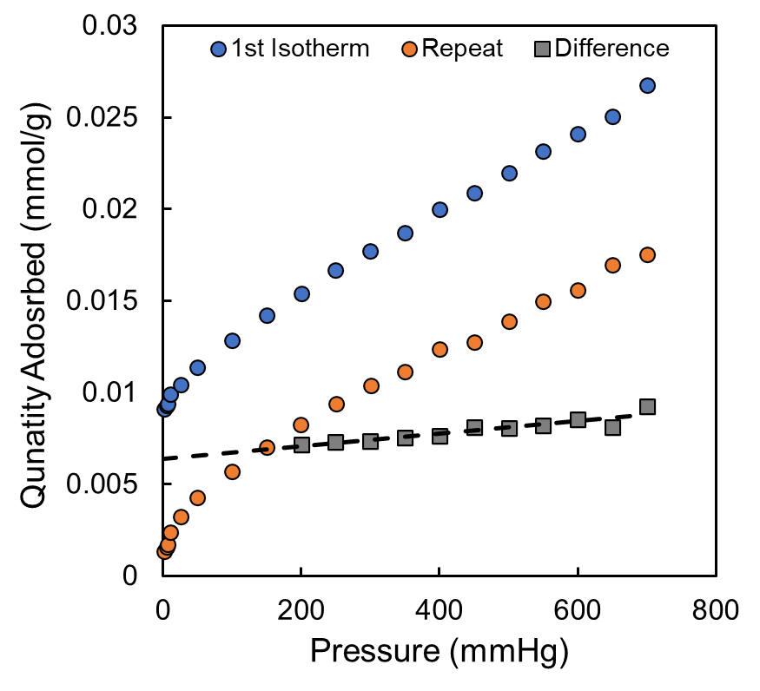
Figure S11. CO adsorption isotherms for the 0.5 wt% Pd/SiO₂ catalyst at 298 K. The 1st isotherm (blue) and repeat isotherm (orange) are subtracted in the 200-700 mmHg range to determine the difference isotherm. The intercept of the difference isotherm is taken to be the estimated concentration of active sites (*) on the catalyst. A 1:1 Pd to CO adsorption ratio is assumed in this analysis.

Nomenclature
A = cross-sectional area of reactor tube (m²)
a=slope in Bayesian regression
$b$=intercept in Bayesian regression
C_{exp,i} = measured experimental gas concentration of species i (mol∙m⁻³)
C_{i} = gas concentration of species i (mol∙m⁻³)
C_{max,all} = max concentration of any gas during the experiment (mol∙m⁻³)
C_{max,i} = max concentration of species i (mol∙m⁻³)
C_{pred,i} = outlet gas concentration of species i predicted by the model (mol∙m⁻³)
C_{in},_{I} = inlet gas concentration of species i (mol∙m⁻³)
C_{T} = total concentration of all gases (mol∙m⁻³)
C_{t} = total concentration of sites (mol∙kg⁻¹)
D_{L,i} = Axial dispersion coefficient of species i (m²∙s⁻¹)
f_{i},_{C} = fraction of species i in the constant gas as determined by the cylinder
f_{i},_{P} = fraction of species i in the pulsing gas cylinder
f = objective function
∆G_{r}° = standard Gibbs free energy of overall reaction (J∙mol⁻¹)
K_{i} = equilibrium constant of i^{th} elementary reaction
K_{r} = equilibrium constant of overall reaction (Pa⁻¹)
K° = standard equilibrium constant of overall reaction
k, k₁, k₋₁, k₂, k₋₂, k₃, k₋₃, k₄, k₋₄, k₅, k₋₅ = rate constants
L_{b} = length of packed bed (m)
$n_{m}$= number of experiments conducted at temperature $T_{m}$
P° = standard pressure (Pa)
Q_{C} = constant steady-state gas volumetric flowrate
Q_{P,0} = pulsing gas volumetric flowrate
Q_{T} = total volumetric flowrate
R = universal gas constant (J∙mol⁻¹∙K⁻¹)
r_{i} = reaction rate of i^{th} reaction (mol∙kg⁻¹∙s⁻¹)
r_{sur} = surface reaction rate (mol∙kg⁻¹∙s⁻¹)
T = temperature (K)
t = time (s)
u_{s} = superficial gas velocity (m∙s⁻¹)
u_{s,0} = superficial gas velocity when a pulse is started (m∙s⁻¹)
W_{i} = weight of species i in objective function
$X_{SRC,i}$=steady state degree of rate control for i^{th} elementary step
$X_{TRC,i}$= transient degree of rate control for i^{th} elementary step
x = axial coordinate (m)
y_{i,0} = fraction of species i in total flow when a pulse reaches the maximum
y_{tracer,out} = tracer gas (Ar) mole fraction at the outlet of the reactor
y_{tracer,in} ,y’_{tracer,in}= tracer gas (Ar) mole fraction at the inlet of the reactor
y’_{reactant,in} = calculated inlet fraction of pulsed reactant gas
y_{i,C} = fraction of species i at the reactor inlet

Greek Letters
ε = void fraction of packed bed
θ_{m} = surface coverage of m species
ρ_{b} = density of packed bed (kg∙m⁻³)
τ = reactor residence time (s)
$σ_{m}$=variance of ln k at temperature $T_{m}$

References

(1) ToolBox, T. E. Thermal Conductivity of Metals and Alloys: Data Table & Reference Guide. The Engineering ToolBox, 2005. https://www.engineeringtoolbox.com/thermal-conductivity-metals-d_858.html (accessed 2025 04/16/2025).
(2) ToolBox, T. E. Thermal Conductivity of Common Materials - Solids, Liquids and Gases. The Engineering ToolBox, 2003. https://www.engineeringtoolbox.com/thermal-conductivity-d_429.html (accessed 2025 04/16/2025).
(3) Yang, M.; Wang, L.; Kamali Shahri, S. M.; Rioux, R. M.; Armaou, A. Investigation of CO2 Sorption Mechanisms in Isothermal Columns via Transient Material and Energy Balance PDE Models. Ind Eng Chem Res 2018, 57 (31), 10303-10314. DOI: 10.1021/acs.iecr.8b02176.
(4) Wang, R.; Weber, Z.; Janik, M. J.; Rioux, R. M.; Armaou, A. Identifying Elementary Reaction Kinetics of Heterogeneous Catalytic Mechanisms Using Pseudorandom Binary Sequence-Induced Transients. ACS Catalysis 2025, 2677-2689. DOI: 10.1021/acscatal.4c05157.
(5) Ruthven, D. M. Principles of adsorption and adsorption processes; John Wiley & Sons, 1984.
(6) Fairbanks, D.; Wilke, C. Diffusion coefficients in multicomponent gas mixtures. Industrial & Engineering Chemistry 1950, 42 (3), 471-475.
(7) Fuller, E. N.; Schettler, P. D.; Giddings, J. C. New method for prediction of binary gas-phase diffusion coefficients. Industrial & Engineering Chemistry 1966, 58 (5), 18-27.
(8) Chase, M. W.; Organization, N. I. S. NIST-JANAF thermochemical tables; American Chemical Society Washington, DC, 1998.
(9) Campbell, C. T. The Degree of Rate Control: A Powerful Tool for Catalysis Research. Acs Catal 2017, 7 (4), 2770-2779. DOI: 10.1021/acscatal.7b00115.
(10) Foley, B. L.; Bhan, A. Degrees of Rate Control at Non(pseudo)steady-State Conditions. ACS Catalysis 2020, 10 (4), 2556-2564. DOI: 10.1021/acscatal.9b04910.
(11) Chen, M.-H.; Shao, Q.-M.; Ibrahim, J. G. Monte Carlo methods in Bayesian computation; Springer Science & Business Media, 2012.
(12) Baddour, R. F.; Modell, M.; Heusser, U. K. Simultaneous kinetic and infrared spectral studies of carbon monoxide oxidation on palladium under steady-state conditions. The Journal of Physical Chemistry 1968, 72 (10), 3621-3629. DOI: 10.1021/j100856a045.
(13) Berlowitz, P. J.; Peden, C. H. F.; Goodman, D. W. Kinetics of Co Oxidation on Single-Crystal Pd, Pt, and Ir. J Phys Chem-Us 1988, 92 (18), 5213-5221. DOI: DOI 10.1021/j100329a030.
(14) Cant, N. W.; Hicks, P. C.; Lennon, B. S. Steady-State Oxidation of Carbon-Monoxide over Supported Noble-Metals with Particular Reference to Platinum. J Catal 1978, 54 (3), 372-383. DOI: Doi 10.1016/0021-9517(78)90085-4.
(15) Kieken, L.; Boudart, M. Rate of Oxidation of Co on Pd at Pressure between 10(-1) and 10(2) Mbar. Catal Lett 1993, 17 (1-2), 1-10. DOI: Doi 10.1007/Bf00763921.
(16) Engel, T.; Ertl, G. Elementary Steps in the Catalytic Oxidation of Carbon Monoxide on Platinum Metals. In Advances in Catalysis, Eley, D. D., Pines, H., Weez, P. B. Eds.; Vol. 28; Academic Press, 1979; pp 1-78.

