Setting of Initial Diagnosis |  | n (%)
Physician’s Offices  Outpatient Hospitals |  | 21,030; (89.21%)  1,272; (5.40%)
Urgent Care Facilities |  | 297; (1.26%)
Inpatient Hospital |  | 33; (0.14%)
Rural Health Clinic  Unassigned/Unknown |  | 26; (0.11%)  915; (3.88%)

Table 2. Initial Setting of Diagnosis in Patients with Medial Epicondylitis, within the Humana Database.

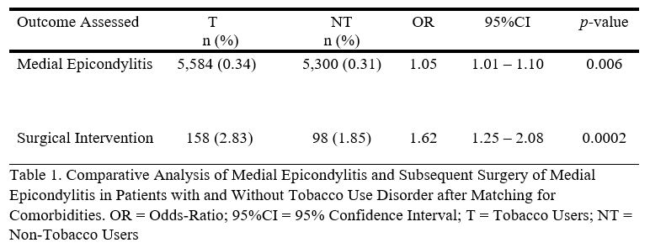

Demographics |  | n (%)
SEX  Male  Female  AGE |  | 283 (53.91)  242 (46.09)
10-19 |  | N/A
20-29 |  | N/A
30-39 |  | 43 (8.20)
40-49 |  | 150 (28.57)
50-59 |  | 192 (36.57)
60-69 |  | 94 (17.90)
70-79 |  | 46 (8.76)
80-89 |  | N/A
90 and over  COMORBIDITIES  Alcohol Abuse  Diabetes Mellitus  Hyperlipidemia  Hypertension  Obesity (BMI >30kg/m²)  Tobacco Use |  | N/A  23 (4.38)  116 (22.10)  278 (52.95)  265 (50.48)  77 (14.67)  158 (30.10)
Table 3. Demographics of Age, Gender, and Comorbidities of Patients with Medial Epicondylitis within the Humana Population who Underwent Surgical Intervention. BMI = Body Mass Index

Demographics |  | SI  n (%) | TP  n (%) | p-value
Alcohol Abuse  Diabetes Mellitus  Hyperlipidemia  Hypertension  Obesity (BMI >30kg/m²)  Tobacco Use |  | 23 (4.38)  116 (22.10)  278 (52.95)  265 (50.48)  77 (14.67)  158 (30.10) | 692 (2.93)  6,182 (26.22)  13,431 (56.98)  13,829 (58.66)  3,906 (16.57)  5,584 (23.69) | 0.063  0.097  0.328  0.048  0.321  0.009
Table 4. Comparative Analysis of Comorbidities in Patients with Medial Epicondylitis who Underwent Surgical Intervention vs the Total Population of Patients with Medial Epicondylitis in the Humana Population Database. SI = Surgical Intervention; TP = Total Population of patients with Medial Epicondylitis; BMI = Body Mass Index. P-values less than 0.05 are Considered Significant and written in bold.

