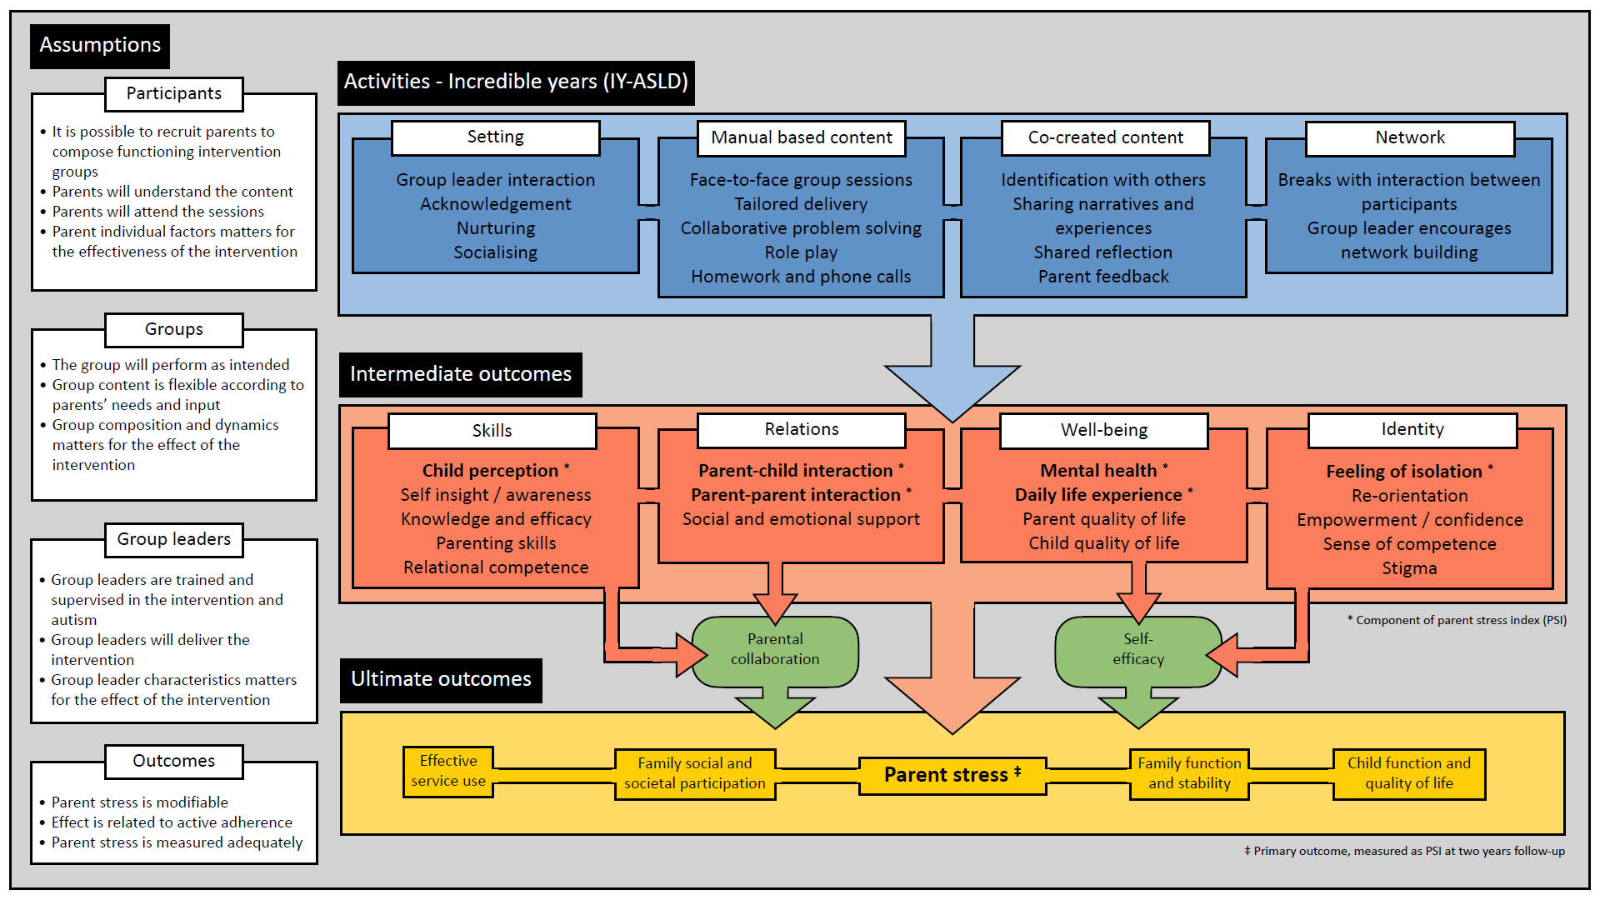

ENACT logic model
The primary outcome of the ENACT trial is reduced parental stress. Our theory of change to get to this outcome involve the implementation of the IY-ASLD program. We posit that by implementing this intervention as our primary project activity, several key components will come together to trigger a process of change for study participants.
The intervention includes four key components:
- the non-specific aspects of the intervention setting, including the group leaders, acknowledgment of the need of the parents, and the nurturing atmosphere of the group and the group leaders themselves.
- Manual-based content, which include the face-to-face nature of the sessions, the specific material covered, including tailored coaching, a collaborative problem-solving method and role play, the homework exercises, and the check-in phone calls from the practitioner. The IY is built around a collaborative approach and teaches a social developmental child-centred pragmatic model. Important components are child-directed play, Enhancing communication, language, social and emotional regulation skills, seeing and understanding the child’s need to be able to provide developmentally adapted support and interaction. IY also has an explicit processual model of change where work over time is necessary produce lasting changes.
- The Co-created content, which reflects the impact of the intra-group processes shown to be a key component of group-based interventions. Important elements include identifying with others, sharing narratives and experiences, parent feedback, and reflection scaffolded by the group leaders. The co-created content is encouraged and fostered in the IY framework to ensure relevance, as well as providing opportunities for collaborative problem-solving, engagement and encouraging active processes and team-building.
- The Network component includes the opportunity for parents to establish or become part of a network of other parents dealing with similar challenges. The break times within the group sessions as well as the active encouragement from the practitioner to build networks are key elements here, in addition to the co-created content, group discussions, and the role-play exercises.

Intermediate outcomes
By ensuring these components are included in the delivery of the intervention, and with the given assumptions (as detailed on the left of the diagram), it is proposed that a set of intermediate outcomes can be achieved and evidenced with final end point data.
- Skills: These include the parent’s improved perception of their child*, improved self-insight / awareness, improved knowledge and efficacy as a parent, improved parenting skills, and improved relational competence.

- Relations: These include an improved quality of parent-child and parent-parent interactions* (as reported by parents) and improved social and emotional support.

- Wellbeing: This includes improved parental mental health*, daily life experiences*, quality of life, and improved child quality of life.

- Identity: This includes an improvement in any feelings of isolation*, emotional re-orientation, increased empowerment / confidence, increased sense of competence, and reduced sense of stigma.
*These elements are measured directly by the PSI.

Ultimate outcomes
Finally, assuming the conditions outlined above, we propose that the ultimate outcomes for participants and their families will include:
- more effective use of support services;
- greater social and societal participation;
- reduced parental stress (as measured by the PSI);
- improved family functioning and stability;
- improved child functioning and quality of life.
We anticipate measuring each of these ultimate outcomes within the life of the project, but also expect that they will continue to develop over an extended time period.

