Effect of Driving Pressure–Guided PEEP Titration on the Incidence of Elevated Driving Pressure During Pneumoperitoneum in Laparoscopic Bariatric Surgery: A Randomized Superiority Trial

Electronic Supplementary Material

Table of contents
Supplementary Files | Tables and Figure Captions | Page
Supplementary Figure 1. | Schematic diagram of study protocol and interventions for all groups. Abbreviations - PACU: Post-anesthesia care unit; PEEP: Positive End-Expiratory Pressure; V_{T}: Tidal volume; VCV: Volume-controlled ventilation; PCV: Pressure-controlled ventilation; P: Pneumoperitoneum; RM: Recruitment maneuver. | 3
Supplementary Figure 2. | Sample Size Estimation for One-Way ANOVA (X-Y plot for a range of values). | 4
Supplementary Table 1. | Ventilatory parameters at each timepoint (Static compliance and Dynamic compliance). | 5
Supplementary Table 2. | Mixed-effects model for repeatedly measured ventilatory parameters (driving pressure, peak pressure, plateau pressure, static and dynamic compliance). | 6
Supplementary Figure 3. | Ventilatory parameters across timepoints – Static Compliance (A), Dynamic Compliance (B). A mixed-effects model for repeated measures data was performed to detect differences between different timepoints (at the same PEEP strategy), and to evaluate the interaction between PEEP strategies and timepoints. Interaction PEEP strategies vs. timepoints for all ventilatory parameters: P<0.05. *P<0.05 compared Before PN vs. During PN before RM. †P<0.05 compared During PN before RM vs. During PN after RM. ‡P<0.05 compared During PN after RM vs. After PN before RM. §P<0.05 After PN before RM vs. After PN after RM. Abbreviations: RMTP: Recruitment maneuver and PEEP titration; RMFP: Recruitment maneuver and fixed PEEP; NRMFP: No recruitment maneuver and fixed PEEP; PN: Pneumoperitoneum; RM: Recruitment maneuver. | 8
Supplementary Figure 4. | Line graph of difference between time points: ANOVA for repeated measures followed by a Tukey post-hoc test if the P-value was <0.05. The upper and lower whiskers represent the SD. Mean±SD: Before PN (11.08±2.67); During PN After RM (15.38±3.29); After PN After RM (11.23±2.78). *P<0.05 Before PN vs. During PN after RM. † P<0.05 compared During PN after RM vs. After PN after RM. Abbreviations: RMTP = Recruitment Maneuver and Titrated PEEP titration; RMFP = Recruitment Maneuver and Fixed PEEP; NRMFP = No Recruitment Maneuver and Fixed PEEP; PN = Pneumoperitoneum; RM = Recruitment Maneuver. | 9
Supplementary Table 3. | Intention-to-Treat Analysis of the Primary Endpoint Under Extreme-Case Imputation (Missing Outcomes Imputed as Driving Pressure >15 cmH₂O). | 10
Supplementary Table 4. | Percentage of patients with driving pressure >15 cmH₂O per group at studied timepoints. | 11
Supplementary Figure 5. | Percentage of patients with driving pressure >15 cmH₂O per group at studied timepoints. Pearson’s χ² test; significant overall results (P<0.05) were further explored by χ² partitioning with Bonferroni correction to identify specific group differences. Abbreviations: RMTP: Recruitment maneuver and Positive End-Expiratory Pressure (PEEP) titration; RMFP: Recruitment maneuver and fixed PEEP; NRMFP: No recruitment maneuver and fixed PEEP; PN: Pneumoperitoneum; RM: Recruitment maneuver. | 12
Supplementary Table 5. | Univariable and Multivariable Logistic Regression Analysis of Factors Associated with Driving Pressure >15 cmH₂O During Pneumoperitoneum Before Recruitment Maneuver. | 13
Supplementary Table 6. | Univariable and Multivariable Logistic Regression Analysis of Factors Associated with Driving Pressure >15 cmH₂O During Pneumoperitoneum Before Recruitment Maneuver. | 14
Supplementary Table 7. | Respiratory and hemodynamic variables. | 15
Supplementary Table 8. | Anesthetic management in PACU. | 16
 | CONSORT 2025 checklist item description | 17

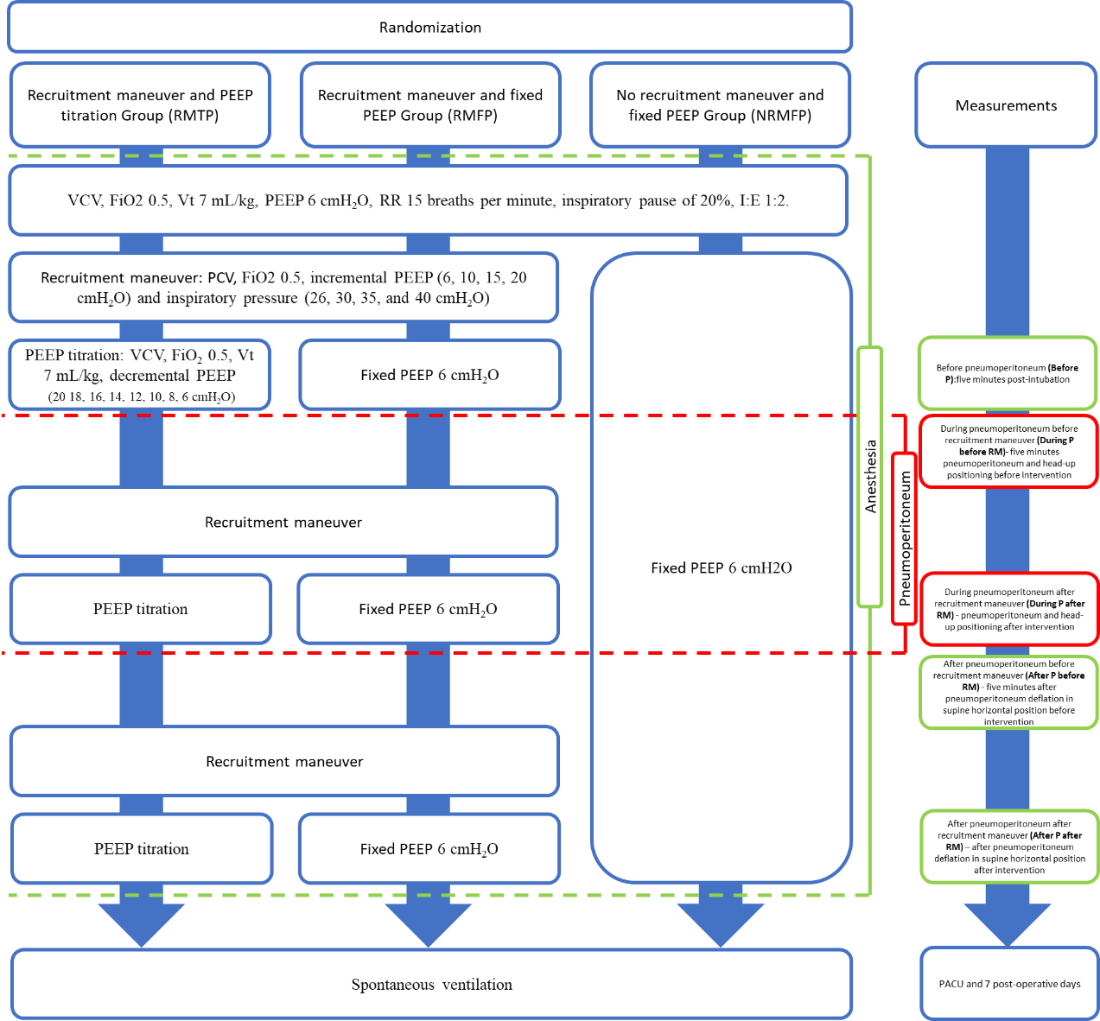
Supplementary Figure 1. Schematic diagram of study protocol and interventions for all groups. Abbreviations - PACU: Post-anesthesia care unit; PEEP: Positive End-Expiratory Pressure; V_{T}: Tidal volume; VCV: Volume-controlled ventilation; PCV: Pressure-controlled ventilation; P: Pneumoperitoneum; RM: Recruitment maneuver.

Supplementary Figure 2. Sample Size Estimation for One-Way ANOVA (X-Y plot for a range of values).
The sample size for this study was calculated using G*Power¹, based on previously collected data reporting the mean intraoperative driving pressures². For the ANOVA (Fixed effects, omnibus, one-way) analysis, the input parameters included an effect size f of 0.38, an alpha error probability (α) of 0.05, and a desired power of 0.80 (1 - β). With three groups considered, the power analysis output yielded a noncentrality parameter (λ) of 10.25 and a critical F-value of 3.13. Based on these inputs, the total sample size required to achieve the desired power and significance level was calculated to be 69 participants, corresponding to an actual power of 0.806. The omnibus F-test was used to assess the overall effect of the intervention (Fixed PEEP of 4-5 cmH₂O [18.8±4.1, n = 44]; Fixed PEEP of 12 cmH₂O [14.4±5.1, n = 25]; and individualized PEEP [9.8±1.4, n = 21]) on the dependent variable (intraoperative driving pressure, cmH₂O) across all three groups, in accordance with the findings of Simon P et al². The effect size used for the sample size calculation was based on the difference between the group means. To account for potential dropout, the estimated sample size was adjusted to 78 participants (26 per group), considering a 10% expected dropout rate. References: 1) Faul F, Erdfelder E, Lang AG, Buchner A. G*Power 3: a flexible statistical power analysis program for the social, behavioral, and biomedical sciences. Behav Res Methods. 2007;39(2):175-191.
(https://www.psychologie.hhu.de/arbeitsgruppen/allgemeine-psychologie-und-arbeitspsychologie/gpower);
2) Simon P, Girrbach F, Petroff D, et al. Individualized versus Fixed Positive End-expiratory Pressure for Intraoperative Mechanical Ventilation in Obese Patients: A Secondary Analysis. Anesthesiology. 2021;134(6):887-900.

Supplementary Table 1. Ventilatory parameters at each timepoint (Static compliance and Dynamic compliance).
Ventilatory parameters | Group |  |  | P-value | Post-hoc analysis
Ventilatory parameters | RMTP  (n=26) | RMFP  (n=25) | NRMFP  (n=25) | P-value | Post-hoc analysis
Before Pneumoperitoneum
Static compliance ¹ (cmH₂O) | 65.00 ± 12.54 | 48.75 ± 11.13 | 40.00 ± 8.78 | < 0.001 | RMPT>RMFP (p = 0.005); RMPT>NRFP (p < 0.001); RMFP>NRFP (p = 0.003)
Dynamic compliance¹ (cmH₂O) | 42.55 ± 6.61 | 35.45 ± 6.30 | 30.71 ± 5.19 | < 0.001 | RMPT>RMFP (p = 0.01); RMPT>NRFP (p < 0.001); RMFP>NRFP (p = 0.01)
During Pneumoperitoneum Before Recruitment Maneuvers
Static compliance ¹ (cmH₂O) | 36.23 ± 6.46 | 30.00 ± 5.81 | 28.57 ± 5.69 | < 0.001 | RMPT>RMFP (p = 0.01); RMPT>NRFP (p < 0.001);
Dynamic compliance¹ (cmH₂O) | 28.81 ± 5.08 | 24.44 ± 4.03 | 23.17 ± 3.88 | < 0.001 | RMPT>RMFP (p = 0.008); RMPT>NRFP (p < 0.001)
During Pneumoperitoneum After Recruitment Maneuvers
Static compliance²  (cmH₂O) | 45.90  [41.77 - 49.46] | 31.65  [29.33 - 36.60] | 28.57  [27.50 - 31.25] | < 0.001 | RMPT>RMFP (p < 0.001); RMPT>NRFP (p < 0.001)
Dynamic compliance¹ (cmH₂O) | 33.18 ± 4.15 | 24.61 ± 4.62 | 23.17 ± 3.88 | < 0.001 | RMPT>RMFP (p < 0.001); RMPT>NRFP (p < 0.001)
After Pneumoperitoneum Before Recruitment Maneuver
Static compliance² (cmH₂O) | 50.00  [46.25 - 55.93] | 38.60  [34.08 - 42.50] | 37.91  [32.50 - 41.70] | < 0.001 | RMPT>RMFP (p < 0.001); RMPT>NRFP (p < 0.001)
Dynamic compliance² (cmH₂O) | 35.14  [31.17 - 38.59] | 30.00  [26.00 - 32.00] | 29.23  [25.56 - 31.54] | < 0.001 | RMPT>RMFP (p = 0.01); RMPT>NRFP (p < 0.001)
After Pneumoperitoneum After Recruitment Maneuver
Static compliance² (cmH₂O) | 65.48  [60.00 - 71.50] | 53.75  [47.50 - 58.18] | 37.91  [32.50 - 41.70] | < 0.001 | RMPT>RMFP (p = 0.003); RMPT>NRFP (p < 0.001); RMFP>NRFP (p < 0.001)
Dynamic compliance¹ (cmH₂O) | 42.87 ± 5.49 | 36.92 ± 6.03 | 29.23 ± 4.57 | < 0.001 | RMPT>RMFP (p = 0.03); RMPT>NRFP (p < 0.001); RMFP>NRFP (p < 0.001)
¹Data expressed as mean±standard deviation, One-way ANOVA test followed by a Tukey post-hoc test if the P-value was <0.05.² Data expressed as median (IQ [interquartile range]), Kruskal Wallis test followed by a Dunn post-hoc test if the P-value was <0.05.

Supplementary Table 2. Mixed-effects model for repeatedly measured ventilatory parameters (driving pressure, peak pressure, plateau pressure, static and dynamic compliance) (Post-hoc pairwise comparisons).
Driving pressure | RMTP Group (P<0.001)
Timepoints | Before PN | During PN before RM | During PN after RM | After PN before RM
During PN before RM | <0.001
During PN after RM | <0.001 | 0.007
After PN before RM | 0.002 | 0.001 | 0.98
After PN after RM | 0.99 | <0.001 | <0.001 | <0.001
 | RMFP Group (P<0.001)
Timepoints | Before PN | During PN before RM | During PN after RM | After PN before RM
During PN before RM | <0.001
During PN after RM | <0.001 | 0.60
After PN before RM | 0.02 | 0.001 | 0.11
After PN after RM | 0.92 | <0.001 | <0.001 | 0.001
 | NRMFP Group (P<0.001)
Timepoints | Before PN | During PN before RM | During PN after RM | After PN before RM
During PN before RM | <0.001
During PN after RM | <0.001 | 1
After PN before RM | 0.35 | <0.001 | <0.001
After PN after RM | 0.35 | <0.001 | <0.001 | 1
Peak pressure | RMTP Group (P<0.001)
Timepoints | Before PN | During PN before RM | During PN after RM | After PN before RM
During PN before RM | < 0.001
During PN after RM | < 0.001 | 0.65
After PN before RM | < 0.001 | 0.88 | 0.99
After PN after RM | 0.99 | < 0.001 | < 0.001 | < 0.001
 | RMFP Group (P<0.001)
Timepoints | Before PN | During PN before RM | During PN after RM | After PN before RM
During PN before RM | <0.001
During PN after RM | <0.001 | 0.77
After PN before RM | 0.06 | 0.001 | 0.04
After PN after RM | 0.74 | <0.001 | <0.001 | 0.001
 | NRMFP Group (P<0.001)
Timepoints | Before PN | During PN before RM | During PN after RM | After PN before RM
During PN before RM | <0.001
During PN after RM | <0.001 | 1.00
After PN before RM | 0.30 | <0.001 | <0.001
After PN after RM | 0.30 | <0.001 | <0.001 | 1.00
Plateau pressure | RMTP Group (P<0.001)
Timepoints | Before PN | During PN before RM | During PN after RM | After PN before RM
During PN before RM | <0.001
During PN after RM | <0.001 | 0.83
After PN before RM | <0.001 | 0.98 | 0.97
After PN after RM | 0.99 | <0.001 | <0.001 | <0.001
 | RMFP Group (P<0.001)
Timepoints | Before PN | During PN before RM | During PN after RM | After PN before RM
During PN before RM | <0.001
During PN after RM | <0.001 | 0.60
After PN before RM | 0.02 | 0.001 | 0.01
After PN after RM | 0.92 | <0.001 | <0.001 | 0.001
 | NRMFP Group (P<0.001)
Timepoints | Before PN | During PN before RM | During PN after RM | After PN before RM
During PN before RM | <0.001
During PN after RM | <0.001 | 1.00
After PN before RM | 0.32 | <0.001 | <0.001
After PN after RM | 0.23 | <0.001 | <0.001 | 0.99
Static compliance | RMTP Group (P<0.001)
Timepoints | Before PN | During PN before RM | During PN after RM | After PN before RM
During PN before RM | <0.001
During PN after RM | <0.001 | 0.007
After PN before RM | 0.002 | 0.001 | 0.98
After PN after RM | 0.99 | <0.001 | <0.001 | <0.001
 | RMFP Group (P<0.001)
Timepoints | Before PN | During PN before RM | During PN after RM | After PN before RM
During PN before RM | <0.001
During PN after RM | <0.001 | 0.60
After PN before RM | 0.02 | 0.001 | 0.11
After PN after RM | 0.92 | <0.001 | <0.001 | 0.001
 | NRMFP Group (P<0.001)
Timepoints | Before PN | During PN before RM | During PN after RM | After PN before RM
During PN before RM | <0.001
During PN after RM | <0.001 | 1.00
After PN before RM | 0.35 | <0.001 | <0.001
After PN after RM | 0.35 | <0.001 | <0.001 | 1.00
Dynamic compliance | RMTP Group (P<0.001)
Timepoints | Before PN | During PN before RM | During PN after RM | After PN before RM
During PN before RM | <0.001
During PN after RM | 0.002 | 0.04
After PN before RM | 0.007 | 0.02 | 0.99
After PN after RM | 0.97 | <0.001 | <0.001 | <0.001
 | RMFP Group (P<0.001)
Timepoints | Before PN | During PN before RM | During PN after RM | After PN before RM
During PN before RM | <0.001
During PN after RM | <0.001 | 0.72
After PN before RM | 0.08 | 0.001 | 0.08
After PN after RM | 0.72 | <0.001 | <0.001 | 0.001
 | NRMFP Group (P<0.001)
Timepoints | Before PN | During PN before RM | During PN after RM | After PN before RM
During PN before RM | <0.001
During PN after RM | <0.001 | 1.00
After PN before RM | 0.30 | <0.001 | <0.001
After PN after RM | 0.30 | <0.001 | <0.001 | 1.00
Abbreviations: RMTP: Recruitment maneuver and titrated positive end-expiratory pressure (PEEP); RMFP: Recruitment maneuver and fixed PEEP; NRMFP: No recruitment maneuver and fixed PEEP; PN: Pneumoperitoneum; RM: Recruitment maneuver. Mixed-effects models were fit by restricted maximum likelihood estimation to investigate temporal trends within each group. Both random intercepts and random slopes for time were specified to capture subject-specific trajectories of intraoperative ventilatory parameters, and an autoregressive correlation structure was imposed to account for within-subject dependence. B-splines (cubic basis, three interior knots) were employed to flexibly model non-linear relationships over time. Fixed effects comprised group assignment, assessment timepoint, and their interaction. Post-hoc pairwise comparisons of estimated marginal means were performed at timepoints showing a significant interaction, with P-values adjusted using the Tukey-Kramer method.
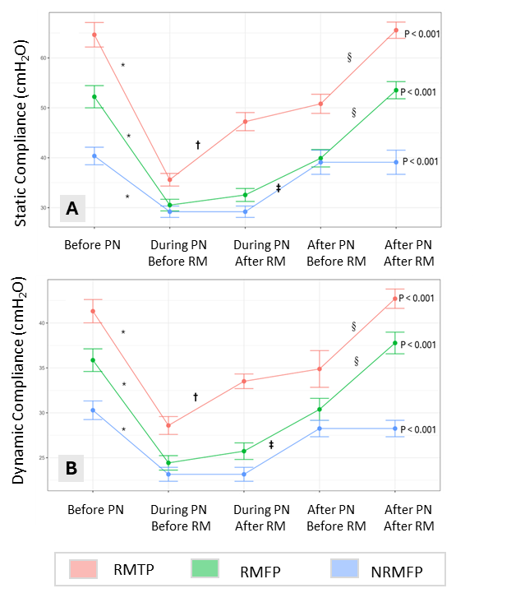
Supplementary Figure 3. Ventilatory parameters across timepoints – Static Compliance (A), Dynamic Compliance (B). A mixed-effects model for repeated measures data was performed to detect differences between different timepoints (at the same PEEP strategy), and to evaluate the interaction between PEEP strategies and timepoints. Interaction PEEP strategies vs. timepoints for all ventilatory parameters: P<0.05. *P<0.05 compared Before PN vs. During PN before RM. †P<0.05 compared During PN before RM vs. During PN after RM. ‡P<0.05 compared During PN after RM vs. After PN before RM. §P<0.05 After PN before RM vs. After PN after RM. Abbreviations: RMTP: Recruitment maneuver and PEEP titration; RMFP: Recruitment maneuver and fixed PEEP; NRMFP: No recruitment maneuver and fixed PEEP; PN: Pneumoperitoneum; RM: Recruitment maneuver.

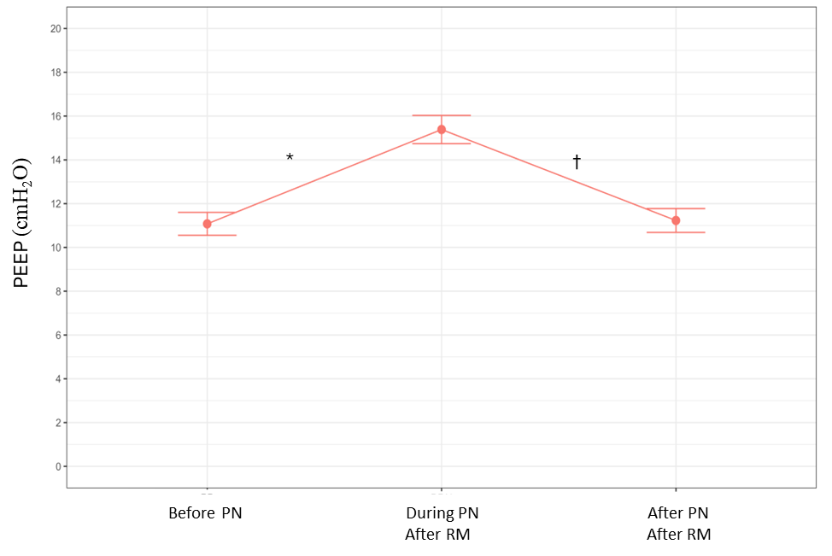
Supplementary Figure 4. Line graph of difference between time points: ANOVA for repeated measures followed by a Tukey post-hoc test if the P-value was <0.05. The upper and lower whiskers represent the SD. Mean±SD: Before PN (11.08±2.67); During PN After RM (15.38±3.29); After PN After RM (11.23±2.78). *P<0.05 Before PN vs. During PN after RM. † P<0.05 compared During PN after RM vs. After PN after RM. Abbreviations: RMTP = Recruitment Maneuver and Titrated PEEP titration; RMFP = Recruitment Maneuver and Fixed PEEP; NRMFP = No Recruitment Maneuver and Fixed PEEP; PN = Pneumoperitoneum; RM = Recruitment Maneuver.

Timepoint | Group | Events / Total | Risk, n/N (%) | Relative Risk (95% CI) | Risk Difference* | P-value**
Before PN | RMTP | 0 / 26 | 0.0 | Reference | – | –
Before PN | RMFP | 1 / 26 | 3.8 | 3.00 (0.13 – 70.42) | 3.8 (−6.4 - 15.5) | 0.49
Before PN | NRMFP | 2 / 26 | 7.7 | 5.00 (0.25 – 99.35) | 7.7 (−3.9 - 20.6) | 0.29
During PN Before RM | RMTP | 2 / 26 | 7.7 | Reference | – | –
During PN Before RM | RMFP | 12 / 26 | 46.2 | 6.00 (1.49 – 24.20) | 38.5 (14.2 - 60.5) | 0.01
During PN Before RM | NRMFP | 12 / 26 | 46.2 | 6.00 (1.49 – 24.20) | 38.5 (14.2 - 60.5) | 0.01
During PN After RM | RMTP | 1 / 26 | 3.8 | Reference | – | –
During PN After RM | RMFP | 8 / 26 | 30.8 | 8.00 (1.08 – 59.50) | 26.9 (6.1 - 46.3) | 0.04
During PN After RM | NRMFP | 12 / 26 | 46.2 | 12.00 (1.68 – 85.73) | 42.3 (20.7 - 61.2) | 0.01
After PN Before RM | RMTP | 0 / 26 | 0.0 | Reference | – | –
After PN Before RM | RMFP | 2 / 26 | 7.7 | 5.00 (0.25 – 99.35) | 7.7 (−3.9 - 20.6) | 0.29
After PN Before RM | NRMFP | 3 / 26 | 11.5 | 7.00 (0.38 – 129.12) | 11.5 (−1.- 25.6) | 0.19
After PN After RM | RMTP | 0 / 26 | 0.0 | Reference | – | –
After PN After RM | RMFP | 1 / 26 | 3.8 | 3.00 (0.13 – 70.42) | 3.8 (−6.4 - 15.5) | 0.49
After PN After RM | NRMFP | 3 / 26 | 11.5 | 7.00 (0.38 – 129.12) | 11.5 (−1.7 - 25.6) | 0.19
Supplementary Table 3. Intention-to-Treat Analysis of the Primary Endpoint Under Extreme-Case Imputation (Missing Outcomes Imputed as Driving Pressure >15 cmH₂O).
Data are presented as number of events/total and percentage. Relative risks (RRs) and 95% confidence intervals (CIs) were calculated using the RMTP group as the reference category. In this extreme-case scenario, missing primary outcome data (n=2) were imputed as driving pressure >15 cmH₂O. Abbreviations: RMTP: Recruitment maneuver and Positive End-Expiratory Pressure (PEEP) titration; RMFP: Recruitment maneuver and fixed PEEP; NRMFP: No recruitment maneuver and fixed PEEP; PN: Pneumoperitoneum; RM: Recruitment maneuver. *Risk difference represents the absolute difference in incidence between each intervention group and the RMTP reference group at the same timepoint. Risk differences and 95% CIs were calculated using the Newcombe method without continuity correction. **P values were derived from Fisher’s exact test due to sparse event counts.

Supplementary Table 4. Percentage of patients with driving pressure >15 cmH₂O per group at studied timepoints.
Primary outcome -  Driving pressure >15 (cmH₂O) per time point | Group |  |  |  |  |  | P-value¹ | Difference between groups  Post-hoc analysis¹
 | RMTP  (n=26) |  | RMFP  (n=25) |  | NRMFP  (n=25) |  | P-value¹ | Difference between groups  Post-hoc analysis¹
Before PN |  |  |  |  |  |  | 0.35
No | 26 | 100 | 25 | 100 | 24 | 96.0
Yes | 0 | 0 | 0 | 0 | 1 | 4.0
During PN Before RM |  |  |  |  |  |  | 0.005 | RMTP < RMFP (p<0.01) RMTP < NRMFP (p<0.001)
No | 24 | 92.3 | 14 | 56.0 | 14 | 56.0
Yes | 2 | 7.7 | 11 | 44.0 | 11 | 44.0
During PN After RM |  |  |  |  |  |  | 0.003 | RMTP < RMFP (p<0.01) RMTP < NRMFP (p<0.001)
No | 25 | 96.1 | 18 | 72.0 | 14 | 56.0
Yes | 1 | 3.9 | 7 | 28.0 | 11 | 44.0
After PN Before RM |  |  |  |  |  |  | 0.34
No | 26 | 100.0 | 24 | 96.0 | 23 | 92.0
Yes | 0 | 0 | 1 | 4.0 | 2 | 8.0
After PN After RM |  |  |  |  |  |  | 0.12
No | 26 | 100.0 | 25 | 100.0 | 23 | 92.0
Yes | 0 | 0 | 0 | 0 | 2 | 8.0
P-value² | 0.20 |  | 0.10 |  | 0.18

Data expressed as n (%). (1) χ² partition test (Difference between groups); (2) Cochran's Q test (Difference between timepoints per group), used to assess within-group changes over time when dealing with categorical variables and repeated measures. Abbreviations: RMTP: Recruitment maneuver and Positive End-Expiratory Pressure (PEEP) titration; RMFP: Recruitment maneuver and fixed PEEP; NRMFP: No recruitment maneuver and fixed PEEP; PN: Pneumoperitoneum; RM: Recruitment maneuver. PN: Pneumoperitoneum; RM: Recruitment maneuver.

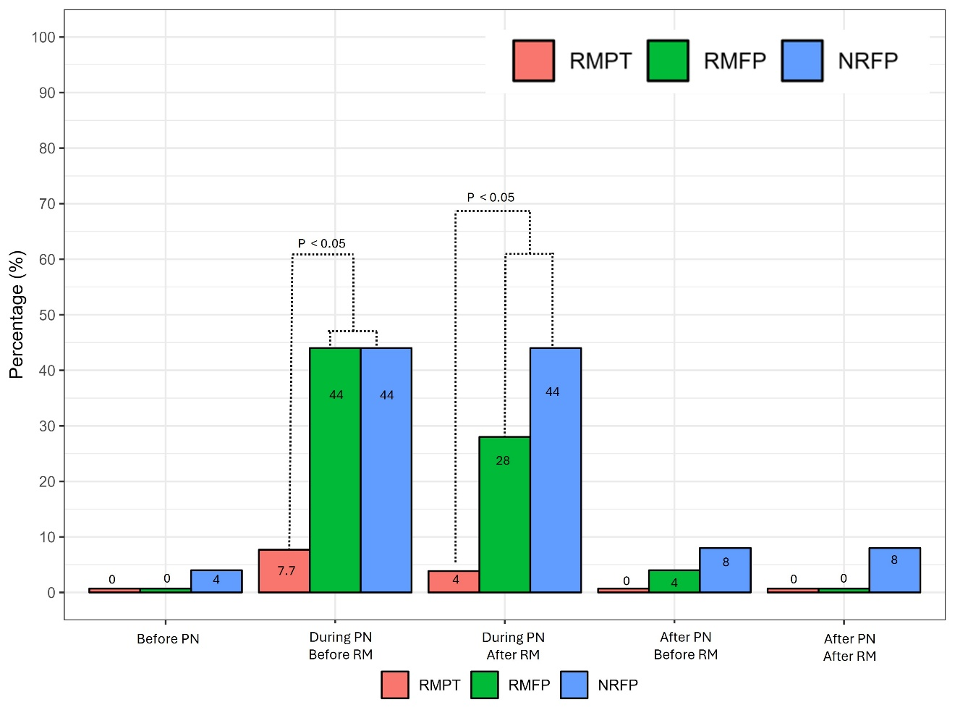
Suppl. Figure 5. Percentage of patients with driving pressure >15 cmH₂O per group at studied timepoints. Pearson’s χ² test; significant overall results (P<0.05) were further explored by χ² partitioning with Bonferroni correction to identify specific group differences. Abbreviations: RMTP: Recruitment maneuver and Positive End-Expiratory Pressure (PEEP) titration; RMFP: Recruitment maneuver and fixed PEEP; NRMFP: No recruitment maneuver and fixed PEEP; PN: Pneumoperitoneum; RM: Recruitment maneuver.

Supplementary Table 5. Univariable and Multivariable Logistic Regression Analysis of Factors Associated with Driving Pressure >15 cmH₂O During Pneumoperitoneum Before Recruitment Maneuver.
Variable | Crude OR | 95% CI | P-value | Adjusted OR | 95% CI | P-value
RMTP | 1 |  |  | 1
RMFP | 11.41 | 1.99-117.8 | 0.01 | 10.29 | 2.37-72.61 | 0.005
NRMFP | 16.58 | 2.85-181.58 | 0.005 | 14.28 | 4.95-152.32 | 0.005
BMI | 1.06 | 0.89-1.27 | 0.50 | 1.09 | 0.95-1.25 | 0.21
Type of surgery¹ | 0.46 | 0.05-2.97 | 0.44 | 0.46 | 0.07-2.01 | 0.34
ARISCAT score² | 1.18 | 1.05-1.37 | 0.01 | 1.13 | 1.03-1.26 | 0.01
STOP-BANG score³ | 1.64 | 1.11-2.56 | 0.01 | 1.68 | 1.22-2.41 | 0.002
Prior diagnosis of obstructive sleep apnoea | 0.53 | 0.08-2.74 | 0.46 | 0.76 | 0.19-2.58 | 0.67
Crude ORs represent univariable logistic regression estimates. Adjusted ORs were obtained from multivariable logistic regression including all prespecified covariates entered simultaneously. The RMTP group was used as the reference category. Analyses were conducted under the primary intention-to-treat scenario, in which missing primary outcome data were imputed as driving pressure ≤15 cmH₂O. Odds ratios (ORs) are presented with 95% confidence intervals (CIs). The outcome variable was driving pressure >15 cmH₂O. BMI = body mass index; 1Gastric bypass and
Gastric sleeve. 2 ARISCAT = Assess Respiratory Risk in Surgical Patients in Catalonia score; 3 STOP-BANG = Snoring, Tiredness, Observed apnea, high blood Pressure, Body mass index, Age, Neck circumference, Gender questionnaire. RMTP: Recruitment maneuver and Positive End-Expiratory Pressure (PEEP) titration; RMFP: Recruitment maneuver and fixed PEEP; NRMFP: No recruitment maneuver and fixed PEEP; PN: Pneumoperitoneum; RM: Recruitment maneuver. PN: Pneumoperitoneum; RM: Recruitment maneuver.

Supplementary Table 6. Univariable and Multivariable Logistic Regression Analysis of Factors Associated with Driving Pressure >15 cmH₂O During Pneumoperitoneum After Recruitment Maneuver.
Variable | Crude OR | 95% CI | P-value | Adjusted OR | 95% CI | P-value
RMTP | 11.54 | 1.45-275.3 | 0.04 | 11.11 | 1.81-215.7 | 0.02
RMFP | 34.16 | 4.5-841.55 | 0.004 | 21.43 | 3.65-411.55 | 0.005
NRMFP | 1.04 | 0.86-1.24 | 0.68 | 0.92-1.23 | 0.95-1.25 | 0.40
BMI | 0.71 | 0.09-4.27 | 0.71 | 0.64 | 0.09-2.87 | 0.59
Type of surgery¹ | 1.16 | 1.04-1.33 | 0.01 | 1.11 | 1.02-1.22 | 0.02
ARISCAT score² | 1.36 | 0.93-2.05 | 0.12 | 1.48 | 1.08-2.09 | 0.01
STOP-BANG score³ | 0.97 | 0.16-5.22 | 0.96 | 1.11 | 0.27-3.81 | 0.87
Prior diagnosis of obstructive sleep apnoea | 11.54 | 1.45-275.3 | 0.04 | 11.11 | 1.81-215.7 | 0.02
Crude ORs represent univariable logistic regression estimates. Adjusted ORs were obtained from multivariable logistic regression including all prespecified covariates entered simultaneously. The RMTP group was used as the reference category. Analyses were conducted under the primary intention-to-treat scenario, in which missing primary outcome data were imputed as driving pressure ≤15 cmH₂O. Odds ratios (ORs) are presented with 95% confidence intervals (CIs). The outcome variable was driving pressure >15 cmH₂O. BMI = body mass index; 1Gastric bypass and
Gastric sleeve. 2 ARISCAT = Assess Respiratory Risk in Surgical Patients in Catalonia score; 3 STOP-BANG = Snoring, Tiredness, Observed apnea, high blood Pressure, Body mass index, Age, Neck circumference, Gender questionnaire. RMTP: Recruitment maneuver and Positive End-Expiratory Pressure (PEEP) titration; RMFP: Recruitment maneuver and fixed PEEP; NRMFP: No recruitment maneuver and fixed PEEP; PN: Pneumoperitoneum; RM: Recruitment maneuver. PN: Pneumoperitoneum; RM: Recruitment maneuver.

Supplementary Table 7. Respiratory and hemodynamic variables.
 | Groups
Variables | RMTP(n=26) |  | RMFP(n=25) |  | NRMFP(n=25) |  | P-value | Post hoc analysis
Initial
Systolic pressure¹ (mmHg) | 133.1 | ±14.3 | 138.2 | ±18.3 | 131.2 | ±16.5 | 0.29
Diastolic pressure¹ (mmHg) | 78.5 | ±13.4 | 79.7 | ±12.2 | 77.4 | ±11.7 | 0.81
Mean arterial pressure¹ (mmHg) | 96.7 | ±12.4 | 99.2 | ±12.9 | 95.4 | ±12 | 0.53
Heart rate¹ (bpm) | 78.2 | ±16.2 | 86.2 | ±13.9 | 79.2 | ±15.9 | 0.14
SatO₂% ² | 99 | [97-100] | 99 | [97-100] | 98 | [98-100] | 0.94
SatO₂/FiO₂ ratio ² | 471.4 | [461.9-476.2] | 471.4 | [461.9-476.2] | 466.7 | [466.7-476.2] | 0.94
Before Pneumoperitoneum
Systolic pressure² (mmHg) | 94.5 | [88.3-100.8] | 96 | [85-102] | 92 | [85-102] | 0.80
Diastolic pressure² (mmHg) | 54.5 | [50.3-58.6] | 52 | [50- 58] | 51 | [49- 54] | 0.25
Mean arterial pressure² (mmHg) | 67 | [62.3-73.7] | 67.3 | [61-72.7] | 65.7 | [62.3 - 68.7] | 0.70
Heart rate² (bpm) | 59.5 | [52-66.8] | 72 | [63- 80] | 68 | [64- 76] | 0.06
SatO₂% ² | 100 | [99-100] | 100 | [100-100] | 99 | [98-100.0] | 0.02 | RMFP>NRMFP  (p=0.007)
During Pneumoperitoneum After Recruitment Maneuver
IAP (During PN) (mmHg) ² | 15.5 | [15-17] | 15 | [15-17] | 15 | [15-17] | 0.35
Systolic pressure² (mmHg) | 101.5 | [89.8-110.8] | 103.0 | [91-139] | 103 | [87- 108] | 0.33
Diastolic pressure¹ (mmHg) | 62.6 | ±12.5 | 70.5 | ±21 | 61.2 | ±12.9 | 0.08
Mean arterial pressure² (mmHg) | 73.8 | [68.7-83.5] | 76.00 | [67-108] | 74 | [64.3-82.7] | 0.34
Heart rate¹ (bpm) | 72.4 | ±14.7 | 74.9 | ±15.3 | 72.8 | ±14.9 | 0.81
SatO₂% ² | 99.5 | [97-100] | 99 | [97-100] | 98 | [97-99] | 0.38
SatO₂/FiO₂ ratio² | 210.6 | [192.7-217.7] | 208.9 | [185-232] | 210.6 | [194-222.7] | 0.97
FiO₂ ¹ | 0.49 | ±0.1 | 0.5 | ±0.9 | 0.5 | ±0.1 | 0.81
ETCO₂ ¹ (mmHg) | 38.5 | ±7 | 33.2 | ±5.1 | 36.8 | ±5 | 0.005 | RMTP>RMFP  (p = 0.002); RMFP<NRMFP  (p = 0.03)
After Pneumoperitoneum After Recruitment Maneuver
Systolic pressure¹ (mmHg) | 105.6 | ± 10.8 | 100.4 | ±13.6 | 105.1 | ±13.7 | 0.28
Diastolic pressure² (mmHg) | 59 | [55.3-62.8] | 56 | [51-63] | 56 | [54-65] | 0.38
Mean arterial pressure¹ (mmHg) | 75.1 | ±7.5 | 71.2 | ±8.9 | 73.8 | ±9.2 | 0.25
Heart rate¹ (bpm) | 64.3 | ±14.7 | 70.9 | ±12.6 | 68.5 | ±11.5 | 0.19
SatO₂% ² | 99 | [97.2-100] | 99 | [98-100] | 98 | [97-99] | 0.004 | RMTP<NRMFP  (p=0.006); RMFP>NRMFP  (p=0.006)
SatO₂ ≥ 90% ³ | 26 | (100) | 24 | (96) | 25 | (100) | 0.35
SatO₂% ≥ 92% ³ | 26 | (100) | 24 | (96) | 25 | (100) | 0.35
SatO₂/FiO₂ ratio² | 198 | [181.8-222.2] | 206.3 | [190.4-235.7] | 210.6 | [194-223.8] | 0.61
FiO₂ ² | 0.5 | [0.4-0.5] | 0.5 | [0.4-0.5] | 0.5 | [0.4-0.5] | 0.66
ETCO₂¹ (mmHg) | 41 | [37.3-43] | 35 | [33-38] | 41 | [39-44] | <0.001 | RMTP>RMFP  (p<0.001); RMFP<NRMFP  (p<0.001)
Abbreviations: IAP: Intraabdominal pressure. RMTP: Recruitment maneuver and titrated positive end-expiratory pressure (PEEP); RMFP: Recruitment maneuver and fixed PEEP; NRMFP: No recruitment maneuver and fixed PEEP; PN: Pneumoperitoneum; RM: Recruitment maneuver. ¹Data expressed as mean±standard deviation, One-way ANOVA test followed by a Tukey post-hoc test if the P-value was <0.05.²Data expressed as median (IQ [interquartile range]), Kruskal Wallis test followed by a Dunn post-hoc test if the P-value was <0.05. ³Values expressed as n (%), χ2 test.

Supplementary Table 8. Anesthetic management in PACU.
Variable | Group |  |  |  |  |  | P-value
Variable | RMTP  (n=26) |  | RMFP  (n=25) |  | NRMFP  (n=25) |  | P-value
Maximum pain score in the PACU¹ (VNS) | 3.5 | [0-5.8] | 5.0 | [0-7] | 6 | [0-8] | 0.37
Need of rescue analgesia² | 13 | (50) | 14 | (56) | 16 | (64) | 0.59
Rescue dose of morphine¹ (mg) | 10 | [5-10] | 10.0 | [5-10] | 8 | [5-10] | 0.90
Nausea and vomiting in PACU² | 4 | (15.4) | 2 | (8) | 3 | (12) | 0.71
Abbreviations: VNS: Verbal Numeric Scale; PACU: Post-anesthesia care unit; RMTP: Recruitment maneuver and PEEP titration; RMFP: Recruitment maneuver and fixed PEEP; NRMFP: No recruitment maneuver and fixed PEEP. ¹Values expressed as median (IQ [interquartile range]). ¹Data expressed as median (IQ [interquartile range]), Kruskal Wallis test followed by a Dunn post-hoc test if the P-value was <0.05. ²Values expressed as n (%), χ2 test.

 | Section/topic | No | CONSORT 2025 checklist item description | Reported on page no.
 | Title and abstract
 | Title and structured abstract | 1a | Identification as a randomised trial | 1
 | Title and structured abstract | 1b | Structured summary of the trial design, methods, results, and conclusions | 3
 | Open science
 | Trial registration | 2 | Name of trial registry, identifying number (with URL) and date of registration | 6
 | Protocol and statistical analysis plan | 3 | Where the trial protocol and statistical analysis plan can be accessed | 6
 | Data sharing | 4 | Where and how the individual de-identified participant data (including data dictionary), statistical code and any other materials can be accessed | 6-7
 | Funding and conflicts of interest | 5a | Sources of funding and other support (eg, supply of drugs), and role of funders in the design, conduct, analysis and reporting of the trial | 6-8
 | Funding and conflicts of interest | 5b | Financial and other conflicts of interest of the manuscript authors | 1
 | Introduction
 | Background and rationale | 6 | Scientific background and rationale | 5
 | Objectives | 7 | Specific objectives related to benefits and harms | 5-6
 | Methods
 | Patient and public involvement | 8 | Details of patient or public involvement in the design, conduct and reporting of the trial | 7
 | Trial design | 9 | Description of trial design including type of trial (eg, parallel group, crossover), allocation ratio, and framework (eg, superiority, equivalence, non-inferiority, exploratory) | 8-9
 | Changes to trial protocol | 10 | Important changes to the trial after it commenced including any outcomes or analyses that were not prespecified, with reason | 8-9
 | Trial setting | 11 | Settings (eg, community, hospital) and locations (eg, countries, sites) where the trial was conducted | 6
 | Eligibility criteria | 12a | Eligibility criteria for participants | 6-8
 | Eligibility criteria | 12b | If applicable, eligibility criteria for sites and for individuals delivering the interventions (eg, surgeons, physiotherapists) | 6-8
 | Intervention and comparator | 13 | Intervention and comparator with sufficient details to allow replication. If relevant, where additional materials describing the intervention and comparator (eg, intervention manual) can be accessed | 6-9
 | Outcomes | 14 | Prespecified primary and secondary outcomes, including the specific measurement variable (eg, systolic blood pressure), analysis metric (eg, change from baseline, final value, time to event), method of aggregation (eg, median, proportion), and time point for each outcome | 6-9
 | Harms | 15 | How harms were defined and assessed (eg, systematically, non-systematically) | 6-9
 | Sample size | 16a | How sample size was determined, including all assumptions supporting the sample size calculation | 6-9
 | Sample size | 16b | Explanation of any interim analyses and stopping guidelines | 6-9
 | Randomisation: |  |  | 6-9
 | Sequence generation | 17a | Who generated the random allocation sequence and the method used | 6-9
 | Sequence generation | 17b | Type of randomisation and details of any restriction (eg, stratification, blocking and block size) | 6-9
 |  |  |  | 6-9
 | Allocation concealment mechanism | 18 | Mechanism used to implement the random allocation sequence (eg, central computer/telephone; sequentially numbered, opaque, sealed containers), describing any steps to conceal the sequence until interventions were assigned | 6-9
 | Implementation | 19 | Whether the personnel who enrolled and those who assigned participants to the interventions had access to the random allocation sequence | 6-9
 | Blinding | 20a | Who was blinded after assignment to interventions (eg, participants, care providers, outcome assessors, data analysts) | 6-9
 | Blinding | 20b | If blinded, how blinding was achieved and description of the similarity of interventions | 6-9
 | Statistical methods | 21a | Statistical methods used to compare groups for primary and secondary outcomes, including harms | 6-9
 | Statistical methods | 21b | Definition of who is included in each analysis (eg, all randomised participants), and in which group | 6-9
 | Statistical methods | 21c | How missing data were handled in the analysis | 6-9
 | Statistical methods | 21d | Methods for any additional analyses (eg, subgroup and sensitivity analyses), distinguishing prespecified from post hoc | 12
 | Results
 | Participant flow, including flow diagram | 22a | For each group, the numbers of participants who were randomly assigned, received intended intervention, and were analysed for the primary outcome | 12
 | Participant flow, including flow diagram | 22b | For each group, losses and exclusions after randomisation, together with reasons | 12-12
 | Recruitment | 23a | Dates defining the periods of recruitment and follow-up for outcomes of benefits and harms | 14
 | Recruitment | 23b | If relevant, why the trial ended or was stopped | 12-14
 | Intervention and comparator delivery | 24a | Intervention and comparator as they were actually administered (eg, where appropriate, who delivered the intervention/comparator, how participants adhered, whether they were delivered as intended (fidelity)) | 10-12
 | Intervention and comparator delivery | 24b | Concomitant care received during the trial for each group | 10-12
 | Baseline data | 25 | A table showing baseline demographic and clinical characteristics for each group | Table 1
 | Numbers analysed,  outcomes and estimation | 26 | For each primary and secondary outcome, by group:  ● the number of participants included in the analysis  ● the number of participants with available data at the outcome time point  ● result for each group, and the estimated effect size and its precision (such as 95% confidence interval)  ● for binary outcomes, presentation of both absolute and relative effect size
 | Harms | 27 | All harms or unintended events in each group | 13-14
 | Ancillary analyses | 28 | Any other analyses performed, including subgroup and sensitivity analyses, distinguishing pre-specified from post hoc | 13-15
 | Discussion |  |  | 17
 | Interpretation | 29 | Interpretation consistent with results, balancing benefits and harms, and considering other relevant evidence | 17
 | Limitations | 30 | Trial limitations, addressing sources of potential bias, imprecision, generalisability, and, if relevant, multiplicity of analyses

Citation: Hopewell S, Chan AW, Collins GS, Hróbjartsson A, Moher D, Schulz KF, et al. CONSORT 2025 Statement: updated guideline for reporting randomised trials. BMJ. 2025; 388:e081123. https://dx.doi.org/10.1136/bmj-2024-081123
© 2025 Hopewell et al. This is an Open Access article distributed under the terms of the Creative Commons Attribution License (https://creativecommons.org/licenses/by/4.0/), which permits unrestricted use, distribution, and reproduction in any medium, provided the original work is properly cited.
*We strongly recommend reading this statement in conjunction with the CONSORT 2025 Explanation and Elaboration and/or the CONSORT 2025 Expanded Checklist for important clarifications on all the items. We also recommend reading relevant CONSORT extensions. See www.consort-spirit.org.

