Supporting Information Figures and Tables
(Spectrophotometric vs. HPLC based Quantification of Vicine and Convicine in Faba Bean)
Figure S1: External calibration of purified vicine and convicine standards measured as spectrophotometric extinction at 273 nm. Over the tested concentration range (0–15 g·100 g⁻¹), extinction increased linearly, corresponding to absorbance values between 0.0 and 1.4. Solid lines represent linear regression fits (R² = 0.9999 for vicine; R² = 0.9973 for convicine), and the grey shaded areas indicate the 95 % confidence intervals. Points represent mean extinction values; vertical error bars denote the standard deviation (SD) of replicate measurements.

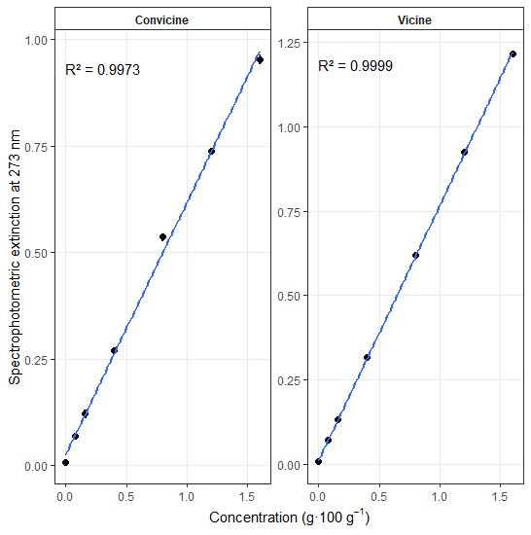
Figure S2: Chromatographic separation of convicine (retention time: 2.78 min), vicine (retention time: 3.25 min) and uridine (retention time: 3.84 min) using an HPLC-PDA at a wavelength of 273 nm

Figure S3: Linear regression between spectrophotometric extinction values and total vicine and convicine content (VC) as determined by HPLC-PDA from 301 faba bean seed samples. Regression analysis yielded R² = 0.77 and dashed lines indicate 95 % confidence intervals.

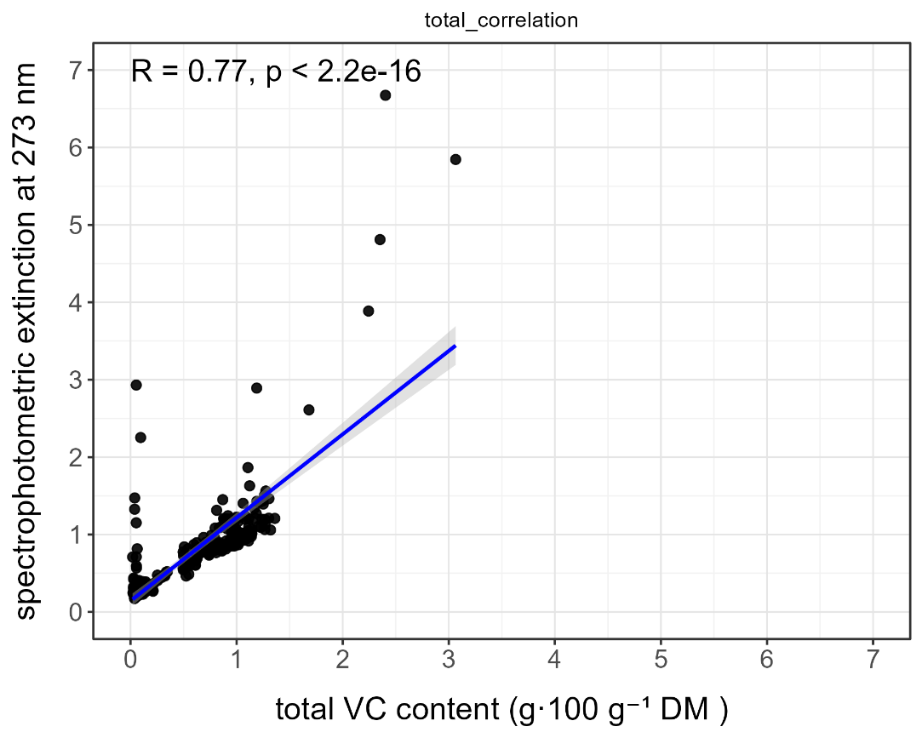
Figure S4: Relationship between spectrophotometric extinction measured at 273 nm and total vicine and convicine (VC) content quantified by HPLC-PDA shown separately for five experimental datasets. Panels represent (A) multi-year and multi-location variety comparisons using mature seed material, (B) drought stress versus control conditions, (C) seed developmental stages during maturation, (D) tissue-specific samples (seed coat and cotyledon), and (E) different post-harvest drying procedures. Each point represents one sample. Solid lines indicate linear regression fits with shaded areas showing 95 % confidence intervals. Pearson correlation coefficients (R) and corresponding p-values are indicated in each panel
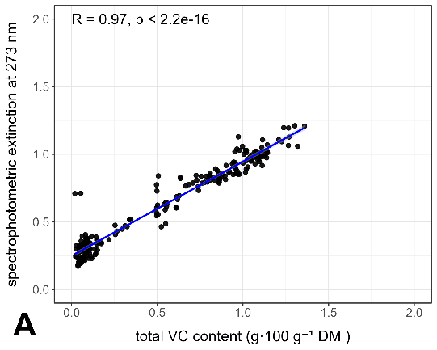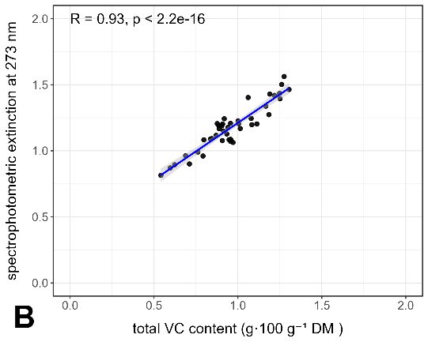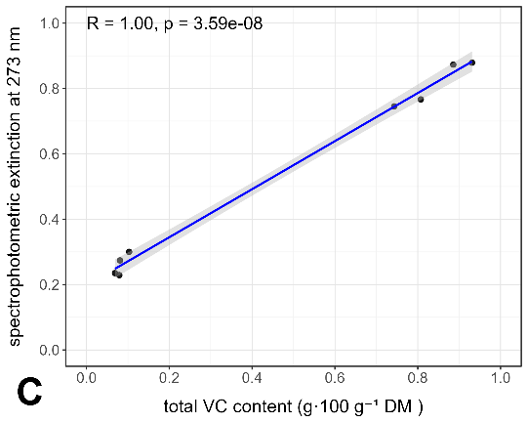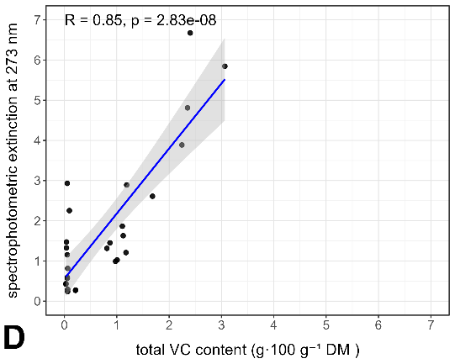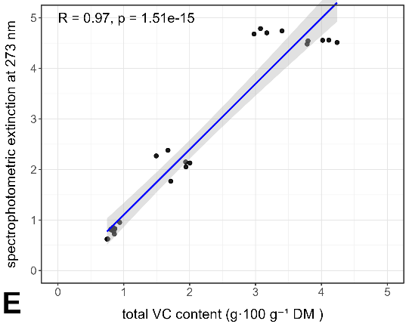

Table S1. Recovery rates, linearity parameters, Limit of Detection (LOD) and Limit of Quantification (LOQ) for vicine and convicine standards used in HPLC-PDA calibration. Results are expressed as mean ± standard deviation (n as indicated)

Parameter | Vicine (Mean ± SD) | Convicine (Mean ± SD) | n
Recovery [%] | 99.7 ± 0.8 | 99.8 ± 0.5 | 3
Linearity [µg·g⁻¹] | 5 – 160 | 1 – 36 | 6
Correlation coefficient (r²) | 0.9990 – 0.9998 | 0.9991 – 0.9999 | 7
LOD [µg·g⁻¹] | 3.66 ± 0.24 | 0.66 ± 0.95 | 10
LOQ [µg·g⁻¹] | 5.33 ± 0.15 | 1.33 ± 0.19 | 10
QC 1 (cv. ‘Fuego’) [g·100 g⁻¹] | 0.749 ± 0.012 | 0.310 ± 0.025 | 20
QC 2 (cv. ‘Tiffany’) [g·100 g⁻¹] | 0.200 ± 0.105 | 0.033 ± 0.016 | 20

Table S2-1: Untargeted LC–MS/MS analysis of aqueous extracts obtained from samples subjected to spectrophotometric VC determination. The table lists detected molecular features with retention time (RT), compound annotation, molecular formula, annotation confidence based on predicted compositions, calculated molecular weight (Calc. MW), and maximum peak area observed across all analyzed samples. Vicine and convicine are included for reference alongside co-extracted metabolites detected under the same analytical conditions.

RT [min] | Name | Formula | Annot. Source: Predicted Compositions | Calc. MW | Area (Max.)
0.74 | Phytic acid | C6 H18 O24 P6 | No results | 659.86213 | 11530065.02
0.74 | myo-Inositol 1,3,4,5,6-pentakisphosphate | C6 H17 O21 P5 | No results | 579.89596 | 7016665.887
0.97 | Muramic acid | C9 H17 N O7 | Full match | 251.10068 | 344662080.1
1.04 | Spectinomycin | C14 H24 N2 O7 | Full match | 332.15862 | 119414885.7
1.06 | Protirelin | C16 H22 N6 O4 | Not the top hit | 362.16918 | 70653764.53
1.25 | 2-[4-(3-Amino-2-hydroxypropoxy)phenyl]acetamide | C11 H16 N2 O3 | Full match | 224.1163 | 6386768.382
1.28 | α-Lactose | C12 H22 O11 | Full match | 342.11639 | 222731732.6
1.36 | N3,N4-Dimethyl-L-arginine | C8 H18 N4 O2 | Full match | 202.14334 | 19051495.46
1.38 | Cytidine 5'-monophosphate (hydrate) | C9 H14 N3 O8 P | Full match | 323.0522 | 4909588.297
1.72 | Amobarbital | C11 H18 N2 O3 | Full match | 226.13222 | 33453769.7
1.87 | Dihydrouridine | C9 H14 N2 O6 | Full match | 246.08571 | 4788766.109
2.17 | Acetylarginine | C8 H16 N4 O3 | Full match | 216.12254 | 9340039.508
2.29 | Cytidine | C9 H13 N3 O5 | Full match | 243.08582 | 146090676
2.32 | (2S)-3-Hydroxy-2-({[(3S,4S,5R)-2,3,4-trihydroxy-5-(hydroxymethyl)tetrahydro-2-furanyl]methyl}amino)butanoic acid (non-preferred name) | C10 H19 N O8 | Full match | 281.11133 | 6594403.84
2.43 | Convicine | C10 H15 N3 O8 | Full match | 305.08613 | 223034059.5
2.50 | Adenosine 5'-monophosphate | C10 H14 N5 O7 P | Full match | 347.06335 | 11016774.49
2.57 | Vicine | C10 H16 N4 O7 | Full match | 304.10208 | 919719258.5
2.70 | N-Acetyl-L-tyrosine | C11 H13 N O4 | Full match | 223.08486 | 77351038.92
3.39 | Tyrosylalanine | C12 H16 N2 O4 | Full match | 252.11142 | 5824921.622
3.47 | (−)-(α)-Kainic Acid | C10 H15 N O4 | Full match | 213.10057 | 4338871.215
3.56 | N-Acetyl-L-tyrosine | C11 H13 N O4 | Full match | 223.08486 | 28352771.28
3.62 | N6-Me-Adenosine | C11 H15 N5 O4 | Full match | 281.11285 | 8135451.864
3.73 | (DL)-3-O-Methyldopa | C10 H13 N O4 | Full match | 211.08498 | 32338042.15
3.84 | Epirizole | C11 H14 N4 O2 | Full match | 234.11203 | 4349971.324
4.08 | N-Acetyl-L-tyrosine | C11 H13 N O4 | Full match | 223.08496 | 11972354.14
4.23 | Guanosine | C10 H13 N5 O5 | Full match | 283.09222 | 114267471.8
4.41 | Adenosine | C10 H13 N5 O4 | Full match | 267.09723 | 256136836.5
4.51 | 2'-Deoxyadenosine | C10 H13 N5 O3 | Full match | 251.10254 | 6578912.097
4.66 | 1-(2-methoxy-4-nitrophenyl)pyrrolidine | C11 H14 N2 O3 | Full match | 222.10109 | 12679718.51
4.94 | 2'-O-Methyladenosine | C11 H15 N5 O4 | Full match | 281.11321 | 17921641.01
4.94 | 1-(4-nitrophenyl)piperidine | C11 H14 N2 O2 | Full match | 206.1059 | 3575262.368
5.16 | 1,4:3,6-Dianhydro-2-deoxy-5-O-(ethylcarbamoyl)-2-[(phenylcarbamoyl)amino]-D-glucitol | C16 H21 N3 O5 | Full match | 335.14899 | 8076431.398
5.43 | 1-morpholino-3-(4-nitrophenoxy)propan-2-ol | C13 H18 N2 O5 | Full match | 282.1224 | 6555224.141
5.52 | DL-Tryptophan | C11 H12 N2 O2 | Full match | 204.09064 | 9496706.074
5.59 | 3-[1-(2-Carboxyethyl)-1H-benzo[d]imidazol-2-yl]propanoic acid | C13 H14 N2 O4 | Full match | 262.09615 | 3654450.843
5.92 | Levodropropizine | C13 H20 N2 O2 | Full match | 236.15329 | 61197526.89
6.62 | 5-Methoxyindoleacetic acid | C11 H11 N O3 | Full match | 205.07463 | 5604494.538
6.67 | 5,7-Dihydroxy-2-(4-hydroxyphenyl)-6,8-bis[3,4,5-trihydroxy-6-(hydroxymethyl)tetrahydro-2H-pyran-2-yl]-4H-chromen-4-one | C27 H30 O15 | No match | 594.16043 | 78054640.53
7.08 | Corymboside | C26 H28 O14 | Not the top hit | 564.14984 | 40211159.14
7.19 | Carteolol | C16 H24 N2 O3 | Full match | 292.17964 | 5639873.92
7.29 | Indole-3-acetyl-L-aspartic acid | C14 H14 N2 O5 | Full match | 290.09113 | 7250288.904

Table S2-2: Relative peak areas of selected LC–MS/MS features detected in aqueous spectrophotometric extracts, shown separately for different genotypes and developmental stages. Grouped peak areas are reported for immature seeds sampled four and eight weeks after flowering (Bioro, Melody, Tiffany) and for mature seed material (Alexia, Emilia). Values represent group-wise signal intensities used for comparative assessment of matrix composition across sample types

RT [min] | Group Area: Bioro, 4 wochen | Group Area: Bioro, 8 wochen | Group Area: Melody, 4 wochen | Group Area: Melody, 8 wochen | Group Area: Tiffany, 4 wochen | Group Area: Tiffany, 8 wochen | Group Area: Alexia, reif | Group Area: Emilia, reif
0.74 | 5539.946001 | 1242283.883 | 5384.341041 | 4926.571286 | 5624.653163 | 11530065.02 | 53530.08207 | 5090.837836
0.74 | 5352.622228 | 4256019.648 | 5202.278783 | 4759.987727 | 5434.465163 | 7016665.887 | 88203.8118 | 4918.699885
0.97 | 260568163.7 | 8239764.161 | 344662080.1 | 1953755.949 | 279515494.1 | 36944357.16 | 462245.2712 | 481321.3759
1.04 | 95399730.34 | 128104.0769 | 119414885.7 | 11428.5712 | 109544439.3 | 2479503.096 | 5426.930941 | 5086.025707
1.06 | 50062759.26 | 140954.804 | 70653764.53 | 10292.89068 | 47718599.36 | 3316985.528 | 4887.6457 | 4263.013353
1.25 | 2844384.464 | 94105.59146 | 6097682.648 | 18850.54307 | 6386768.382 | 607237.6908 | 10602.11341 | 7524.611883
1.28 | 183266173.3 | 77009278.95 | 222731732.6 | 181157731.4 | 158190969.7 | 88384166.91 | 57946937.77 | 23329055.4
1.36 | 11544720.05 | 15681042.08 | 9411655.529 | 19051495.46 | 13442426.4 | 11820424 | 1094117.71 | 411842.2778
1.38 | 908090.997 | 1042343.873 | 605248.6731 | 414762.8864 | 806164.8903 | 4909588.297 | 38266.47104 | 5623.050718
1.72 | 33453769.7 | 49904.73471 | 3479198.023 | 24671.04212 | 2683896.396 | 365355.8371 | 29137.31299 | 25741.60913
1.87 | 4788766.109 | 69892.18051 | 1994142.63 | 27916.51304 | 540590.3125 | 4947.758469 | 20016.43621 | 7696.567297
2.17 | 5028070.446 | 7592280.028 | 3097698.451 | 3420270.696 | 1162257.093 | 9340039.508 | 50230.66372 | 34274.4546
2.29 | 15434475.4 | 485975.8718 | 69983816.63 | 206984.2719 | 146090676 | 2457146.689 | 451677.545 | 691795.9576
2.32 | 6594403.84 | 15776.6657 | 5954169.908 | 4725.686559 | 3312543.301 | 31256.05853 | 4117.237529 | 8318.643129
2.43 | 119489629.8 | 118174086.3 | 223034059.5 | 81371142.75 | 42631119.46 | 56595105.36 | 31429457.96 | 2620877.18
2.50 | 1640850.576 | 5164032.918 | 447849.334 | 11016774.49 | 1506186.025 | 5825431.755 | 2101213.408 | 434262.7601
2.57 | 352423590.9 | 536970963.1 | 919719258.5 | 350220399.3 | 178536971.9 | 344793024.4 | 195306991.7 | 103481569.4
2.70 | 59666052.81 | 38871441.12 | 46405223.68 | 17623503.84 | 77351038.92 | 27485434.06 | 11209752.98 | 5241614.03
3.39 | 2512857.703 | 19404.6296 | 5399318.26 | 5582.289368 | 5824921.622 | 407191.8112 | 4661.386997 | 5023.221928
3.47 | 4338871.215 | 15859.7864 | 802413.2642 | 16275.03838 | 608951.1665 | 229776.977 | 3090.76496 | 3014.452654
3.56 | 28352771.28 | 15468360.87 | 21272917.45 | 6236009.699 | 27788079.87 | 12398844.88 | 3864384.082 | 1918298.804
3.62 | 3219847.891 | 198457.5966 | 7153092.709 | 88614.34098 | 8135451.864 | 1171541.644 | 26371.26416 | 10147.70503
3.73 | 12532646.65 | 981259.145 | 25840454.41 | 189370.652 | 32338042.15 | 3604809.932 | 38318.9137 | 27250.50504
3.84 | 2822023.782 | 896807.9687 | 3545815.398 | 839257.559 | 4349971.324 | 2027988.446 | 79707.4702 | 46147.81925
4.08 | 1000322.587 | 410547.5735 | 2329039.304 | 346037.8646 | 11972354.14 | 601948.822 | 72228.30644 | 536081.0229
4.23 | 72079855.17 | 14005309.71 | 107346309.3 | 4754631.587 | 114267471.8 | 47911334.32 | 1060111.482 | 718811.7211
4.41 | 126155851.4 | 38147743.65 | 179271777.9 | 36466774.37 | 256136836.5 | 96569704.65 | 1889093.53 | 2534395.758
4.51 | 2285264.165 | 53325.99557 | 2771787.917 | 16659.00691 | 6578912.097 | 54513.28282 | 3049.69607 | 3391.973541
4.66 | 1485177.055 | 11999.29431 | 6719865.399 | 5613.918875 | 12679718.51 | 101418.0952 | 4434.580323 | 3952.492769
4.94 | 9436425.656 | 716364.2075 | 14674135.83 | 101584.1635 | 17921641.01 | 6271246.472 | 71554.29411 | 78245.96123
4.94 | 766568.1086 | 5943.936857 | 1187189.314 | 3367.620831 | 3575262.368 | 25393.12961 | 3679.488059 | 3989.982445
5.16 | 4124804.549 | 34896.57006 | 6364970.696 | 19217.01679 | 8076431.398 | 44141.74866 | 3478.481791 | 4023.101275
5.43 | 1789702.058 | 969084.8791 | 4402102.242 | 128711.0764 | 6555224.141 | 2730744.68 | 15517.38054 | 7970.935501
5.52 | 5453694.318 | 1673350.023 | 9496706.074 | 2026228.774 | 9144239.71 | 1553296.61 | 575227.2288 | 350708.1105
5.59 | 1329112.036 | 6141.97001 | 1385189.059 | 3742.818146 | 3654450.843 | 22054.44822 | 4230.243649 | 3945.901751
5.92 | 61197526.89 | 4977.642235 | 1585076.51 | 5139.341385 | 3200197.361 | 69092.38776 | 6135.376923 | 3764.023925
6.62 | 2810658.27 | 12444.11473 | 5604494.538 | 7789.340921 | 5366654.352 | 187942.6982 | 11988.70745 | 11561.05011
6.67 | 59660091.45 | 2600529.146 | 48801868.94 | 2584968.448 | 78054640.53 | 3695688.48 | 17063670.7 | 13380535.48
7.08 | 8054365.99 | 953269.0413 | 40211159.14 | 67776.16439 | 3315221.965 | 6184.279489 | 7266.97917 | 143968.1382
7.19 | 440496.662 | 26909.65901 | 1693013.338 | 34068.41657 | 5639873.92 | 19205.27635 | 30042.81497 | 16285.46719
7.29 | 1028930.65 | 69486.07274 | 7250288.904 | 22458.1748 | 4515331.605 | 8805.325391 | 72662.27714 | 48595.14311

