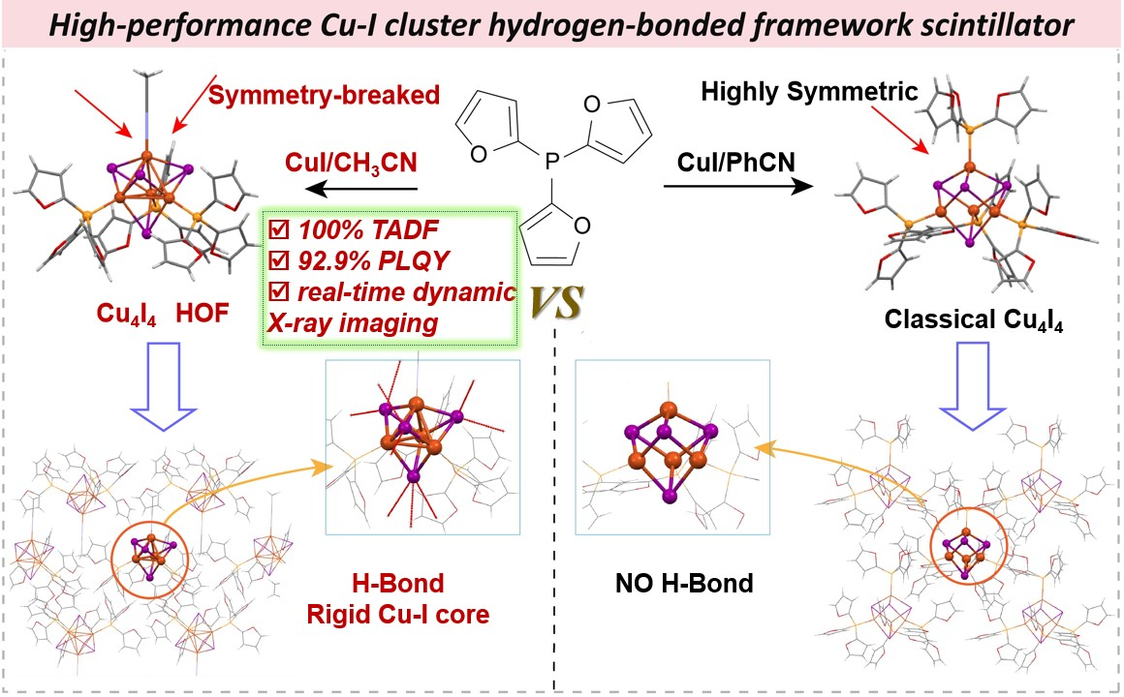
Symmetry-broken cubane exhibits a near-unity PLQY of 92.9% and a single-exponential lifetime of 3.77 μs, delivering a remarkable radioluminescence (RL) light yield of 59819 photons MeV⁻¹ and a low detection limit of 51.2 nGy s⁻¹. This concept is compatible with scalable processing, as evidenced by the formation of flexible microcrystal-based screens that maintain high imaging fidelity under static, tomographic, and dynamic operating modes.

