Supporting Information

Rigidifying Symmetry-Broken Cu₄I₄ Clusters with Hydrogen-Bonded Frameworks Enables Fast and High Light Yield Scintillation for Real-Time Dynamic X-ray Imaging and 3D Tomographic Reconstruction
Mengzhu Wang,¹ Siwen Zou,¹ Ning Ding,¹ Yongjing Deng,¹ Feiyang Li,³ Pengfei She,^{1,2}* Jiangang Li,¹ Yongkang Zhu,¹ Yun Ma^{1,2}* and Qiang Zhao¹*

Table S1. Detailed Single crystal X-ray data of Cu₄I₄(TFP)₄ and Cu₄I₄(TFP)₃CH₃CN.

Complex | Cu₄I₄(TFP)₄ | Cu₄I₄(TFP)₃CH₃CN
Formula Weight | 1690.41 | 1499.30
CCDC Number | 2482226 | 2482227
Crystal System | Cubic | Trigonal
Space Group | F-43c | P -3c1
a (Å) | 22.3779(5) | 13.5636(5)
b (Å) | 22.3779(5) | 13.5636(5)
c (Å) | c=22.3779(5) | 31.4440(12)
α (º) | 90 | 90
β (º) | 90 | 90
γ (º) | 90 | 120
V (Å³ ) | 11206.2(8) | 5009.8(4)
Z value | 8 | 4
D(calcd) (g cm⁻³) | 2.004 | 1.988
Temperature (K) | 193 | 273
F(000) | 6464.0 | 2840.0
μ (mm⁻¹) | 3.872 | 4.283
R₁/wR₂  [I>2σ(I)] | R₁ = 0.0564  wR₂ = 0.1625 | R₁ = 0.0567  wR₂ = 0.1626
R₁/wR₂  [all data] | R₁ = 0.0931  wR₂ = 0.1806 | R₁ = 0.0938  wR₂ = 0.1894
GOF | 1.064 | 1.033

Figure S1. Comparison of experimental (black trace) and simulated (red trace) PXRD patterns for Cu₄I₄(TFP)_{4.}

Figure S2. Comparison of experimental (black trace) and simulated (red trace) PXRD patterns for Cu₄I₄(TFP)₃CH₃CN.

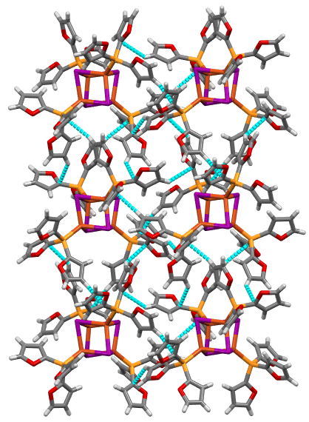

Figure S3. C-H···π stacking in Cu₄I₄(TFP)₄.

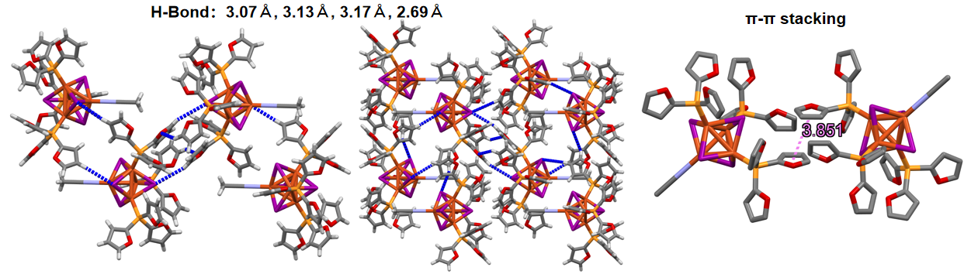
Figure S4. H-Bond and π···π stacking in Cu₄I₄(TFP)₃CH₃CN.

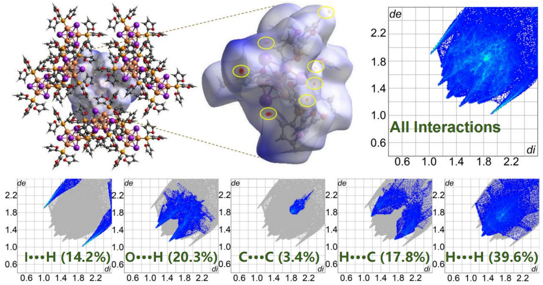
Figure S5. Hirshfeld surfaces of Cu₄I₄(TFP)₃CH₃CN: Simulation of a Hirshfeld surface of one building block; 2D fingerprint plot generated by Hirshfeld surface; and relative contributions of various intermolecular interactions to the Hirshfeld surface ratio.

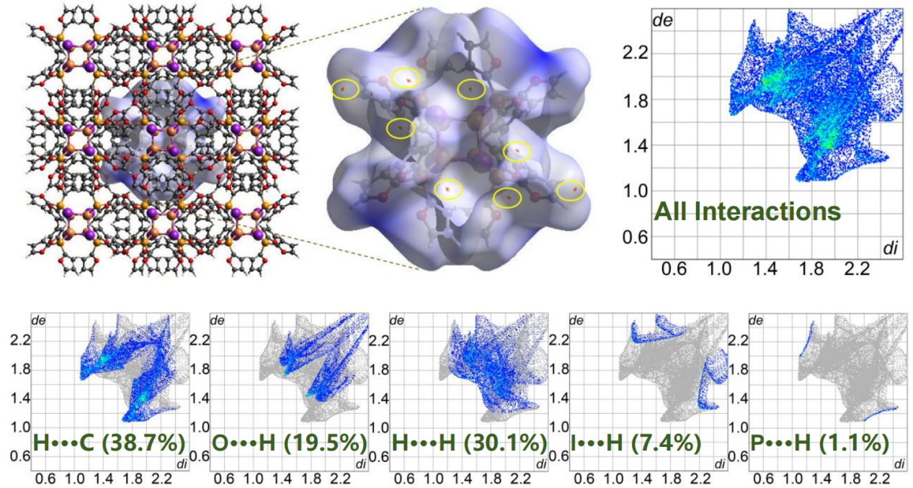
Figure S6. Hirshfeld surfaces of Cu₄I₄(TFP)₄: Simulation of a Hirshfeld surface of one building block; 2D fingerprint plot generated by Hirshfeld surface; and relative contributions of various intermolecular interactions to the Hirshfeld surface ratio.
.

Table S2 Summary of photophysical of Cu₄I₄(TFP)₃CH₃CN and Cu₄I₄(TFP)₄.
Compound | Λ_{77K} _{(delay)} (nm) | λ_{300K} (nm) | ∆E_{ST} (eV)
Cu₄I₄(TFP)₃CH₃CN | 540 | 555 | 0.0624
Cu₄I₄(TFP)₄ | 535 | 562 | 0.112

PLQY = 92.9%
Figure S7. PLQY of Cu₄I₄(TFP)₃CH₃CN.

Figure S8. The Emission spectra of Cu₄I₄(TFP)₃CH₃CN crystals at 77 K and 300 K.

Figure S9 Time-resolved PL (TRPL) of Cu₄I₄(TFP)₄ at 77K.

77 K
τ = 76.1 ㎲
Figure S10 Time-resolved PL (TRPL) of Cu₄I₄(TFP)₃CH₃CN at 77K.

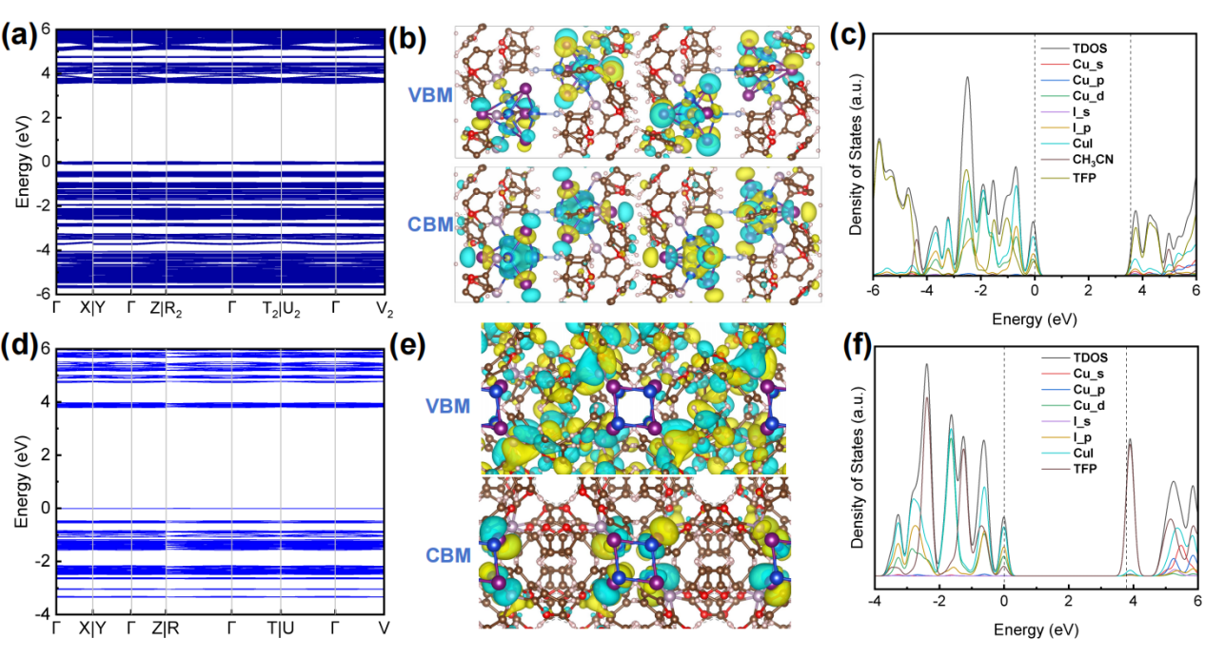

Figure S11. Calculated electronic band structure along high-symmetry k-point paths, indicating a band gap, VBM/CBM and calculated total and partial DOS for (a–c) Cu₄I₄(TFP)₃CH₃CN and (d–f) Cu₄I₄(TFP)₄.

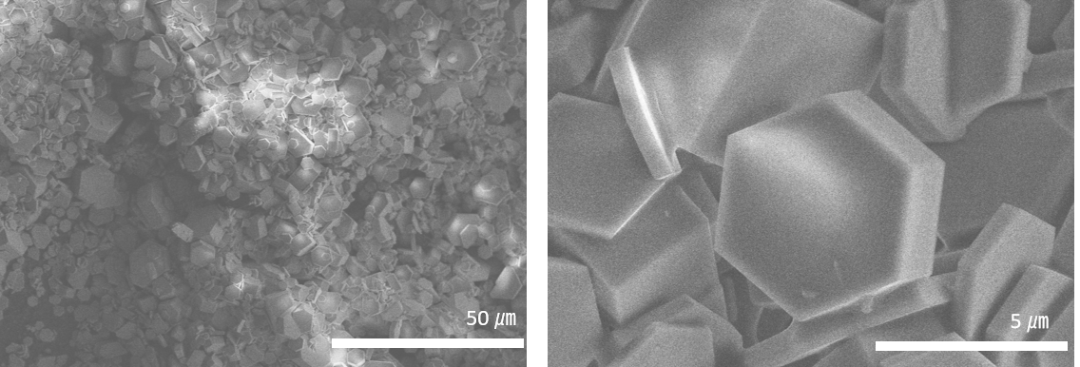
Figure S12. SEM images of Cu₄I₄(TFP)₃CH₃CN microcrystals.

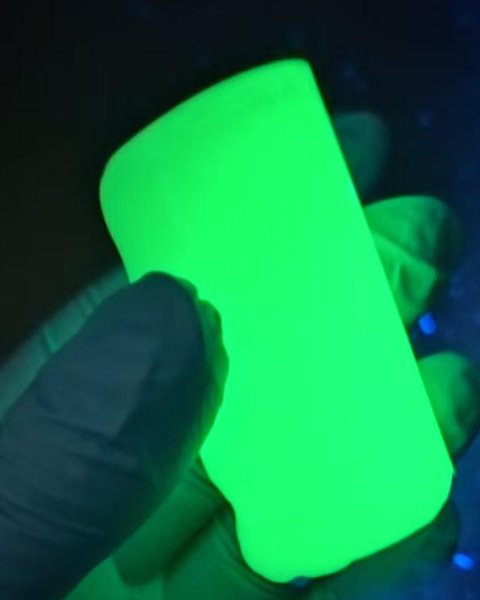
Figure S13. Under ultraviolet (UV) light, the Cu₄I₄(TFP)₃CH₃CN microcrystals scintillation screen emitted bright green light.

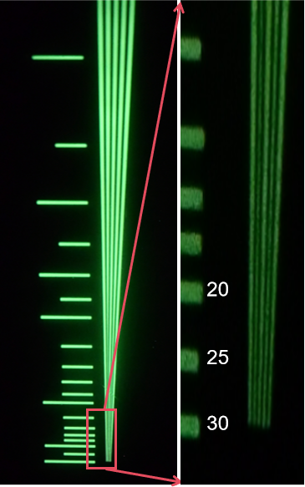
Figure S14. X-ray images of a standard resolution test pattern plate based on the Cu₄I₄(TFP)₃CH₃CN microcrystals scintillation screen.

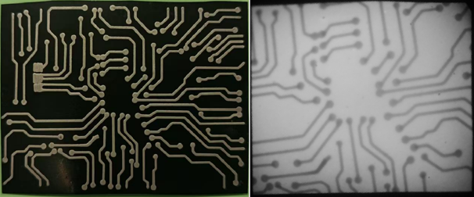
Figure S15. X-ray radiograph of an electronic chip obtained using a scintillator screen fabricated from Cu₄I₄(TFP)₃CH₃CN microcrystals.
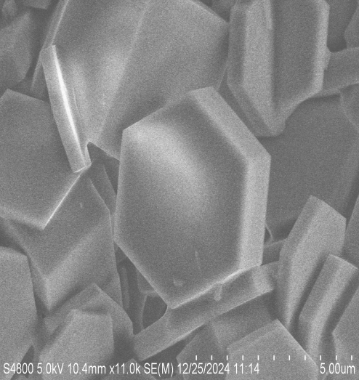
5 ㎛

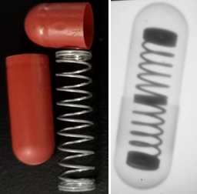
Figure S16. A photo of the metal spring and capsule (left) and X-ray image (right).

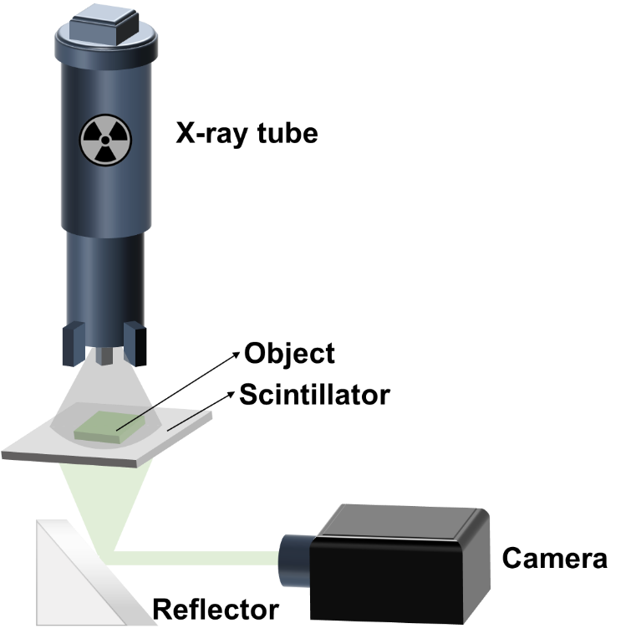

Figure S17. The spatial distribution diagram of optical imaging system.

References

S1. Ju, D.; Zhou, M.; Ran, P.; Li, H.; Yang, Y. M.; Jiang, T. Melt-Processable and Thermally Driven Self-Healing Luminescent Cu(I) Hybrid Metal Halides. ACS Mater. Lett. 2023, 5, 2978-2986.
S2. Zhao, W.; Wang, Y.; Guo, Y.; Suh, Y. D.; Liu, X. Color-Tunable and Stable Copper Iodide Cluster Scintillators for Efficient X-Ray Imaging. Adv. Sci. 2022, 10, 2205526.
S3. Li, B.; Jin, J.; Liu, X.; Yin, M.; Zhang, X.; Xia, Z.; Xu, Y. Multiphase Transformation in Hybrid Copper(I)-Based Halides Enable Improved X-ray Scintillation and Real-Time Imaging. ACS Mater. Lett. 2024, 6, 1542-1548.
S4. Zink, D. M.; Volz, D.; Baumann, T.; Mydlak, M.; Flügge, H.; Friedrichs, J.; Nieger, M.; Bräse, S. Heteroleptic, Dinuclear Copper(I) Complexes for Application in Organic Light-Emitting Diodes. Chem. Mater. 2013, 25, 4471-4486.
S5. Zink, D. M.; Bächle, M.; Baumann, T.; Nieger, M.; Kühn, M.; Wang, C.; Klopper, W.; Monkowius, U.; Hofbeck, T.; Yersin, H.; Bräse, S. Synthesis, Structure, and Characterization of Dinuclear Copper(I) Halide Complexes with P̂N Ligands Featuring Exciting Photoluminescence Properties. Inorg. Chem. 2013, 52, 2292-2305.

