Supplementary Material
- Supplementary Information
  - Supplementary Methods
S1 Effect size definition and computation
The primary effect measure was Hedges’ g, which is less biased than Cohen’s d in small samples. Similar to Cohen’s d, Hedge’s g quantifies effect sizes by categorizing them into distinct levels: small (0 to 0.2), small-to-medium (0.2 to 0.5), medium-to-large (0.5 to 0.8), and large effects (greater than 0.8). We prioritized change-from-baseline data; if unavailable, we used posttest data. For two-group designs, Hedges’ g was computed as $g=J×\frac{Δμ_{I}-Δμ_{C}}{S_{p}}$, where$S_{p}=\sqrt{\frac{(n_{I}-1)s_{I}^{2}+(n_{C}-1)s_{C}^{2}}{n_{I}+n_{C}-2}}$. Here, $Δμ$ and $S$ denote the mean and SD of change scores (or posttest values when change scores were not available). The small-sample correction was $J=1-\frac{3}{4(n_{I}+n_{C}-2)-1}$. When only Cohen’s d was reported, we applied the bias correction $g=J×d$; when only F-statistics or similar were available, we converted them to g using standard transformations.

S2 Variance estimation and handling missing information
For change-score analyses, when the SD of change was missing, we imputed it using the Cochrane-recommended formula:
$$SD_{change}=\sqrt{SD_{baseline}^{2}+SD_{final}^{2}-2×Corr×SD_{baseline}×SD_{final}}$$
The within-group correlation (Corr) was derived from studies reporting SD change by back-calculation in each arm and then averaged for use with the same measure. When only SEs, CIs, or quantiles were available, we applied standard conversions. Prior to synthesis we harmonized the direction of benefit (e.g., reversing the sign for scales where higher scores indicate worse cognition such as ADAS-Cog).

S3 Software
Analyses were conducted in R version 4.4.2 using the metafor, meta, and esc packages: metafor was used to compute Hedges’ g and its variance, fit REML random-effects models, and generate forest and funnel plots; esc converted t/F/η² and related statistics to SMD where required; multilevel/multivariate models were fitted with rma.mv in metafor.

  - Supplementary Results

S4 Subgroup analyses for processing speed
Only 7 studies contributed to processing speed. In subgroup analyses, higher intensity (>10 points) showed a statistically significant pooled effect [0.49 (0.17 to 0.80)], whereas the ≤10 points subgroup was imprecise [0.51 (-1.09 to 2.11)]; the subgroup difference did not reach statistical significance (p for subgroup difference = 0.066). Given high heterogeneity and limited study numbers, these findings should be interpreted cautiously.

S5 Subgroup analyses for verbal fluency and visuospatial ability
Subgroup analyses for verbal fluency (k=13) indicated larger pooled effects in community-recruited trials than clinic-recruited trials [0.57 (0.24 to 0.91) vs 0.25 (0.08 to 0.42); p for subgroup difference = 0.002)] and for lower intensity (≤10 points) than >10 points [0.62 (0.09 to 1.15) vs 0.39 (0.17 to 0.62); p = 0.002]. For visuospatial ability (k=5), subgroup analyses by settings and intensity were not estimable because all studies were clinic-recruited and >10 points; a delivery-mode comparison (structured vs mixed) was not statistically significant (p = 0.776). Prediction intervals included the null for verbal fluency and visuospatial ability, suggesting that effects may vary across trial characteristics.

- Supplementary Figures
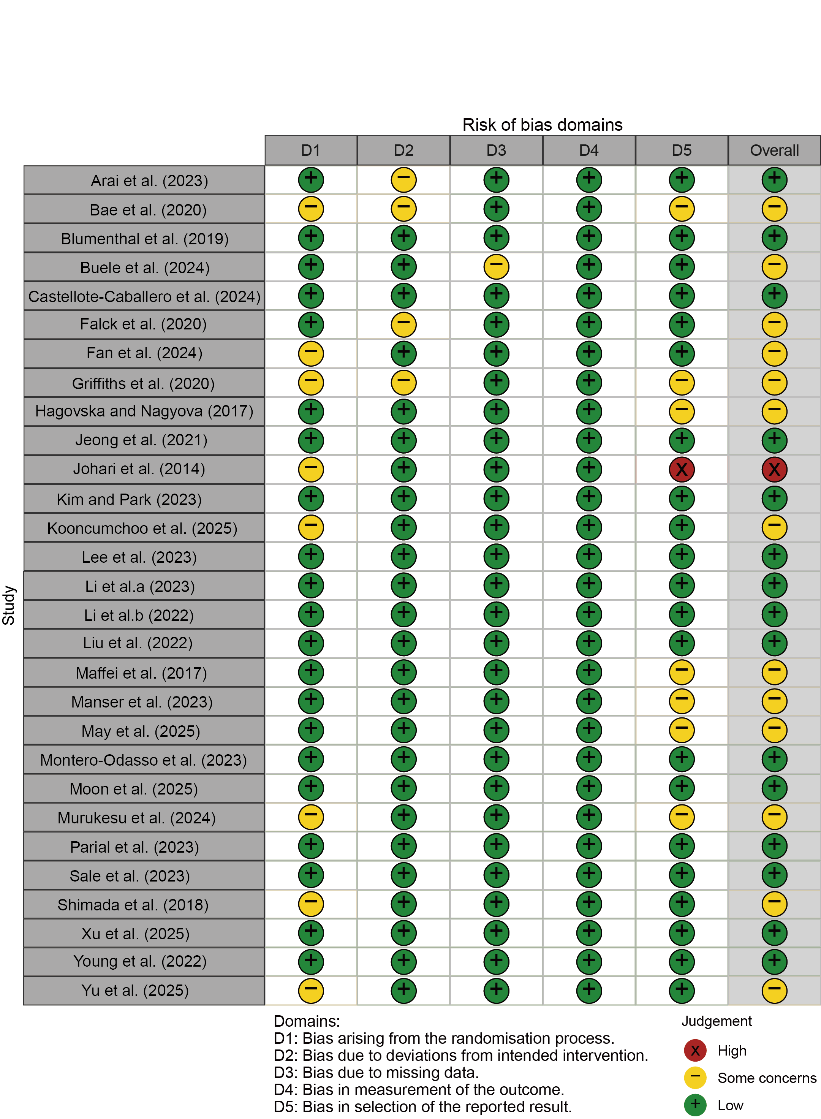
Fig. S1. Risk of bias traffic plot of the included studies.

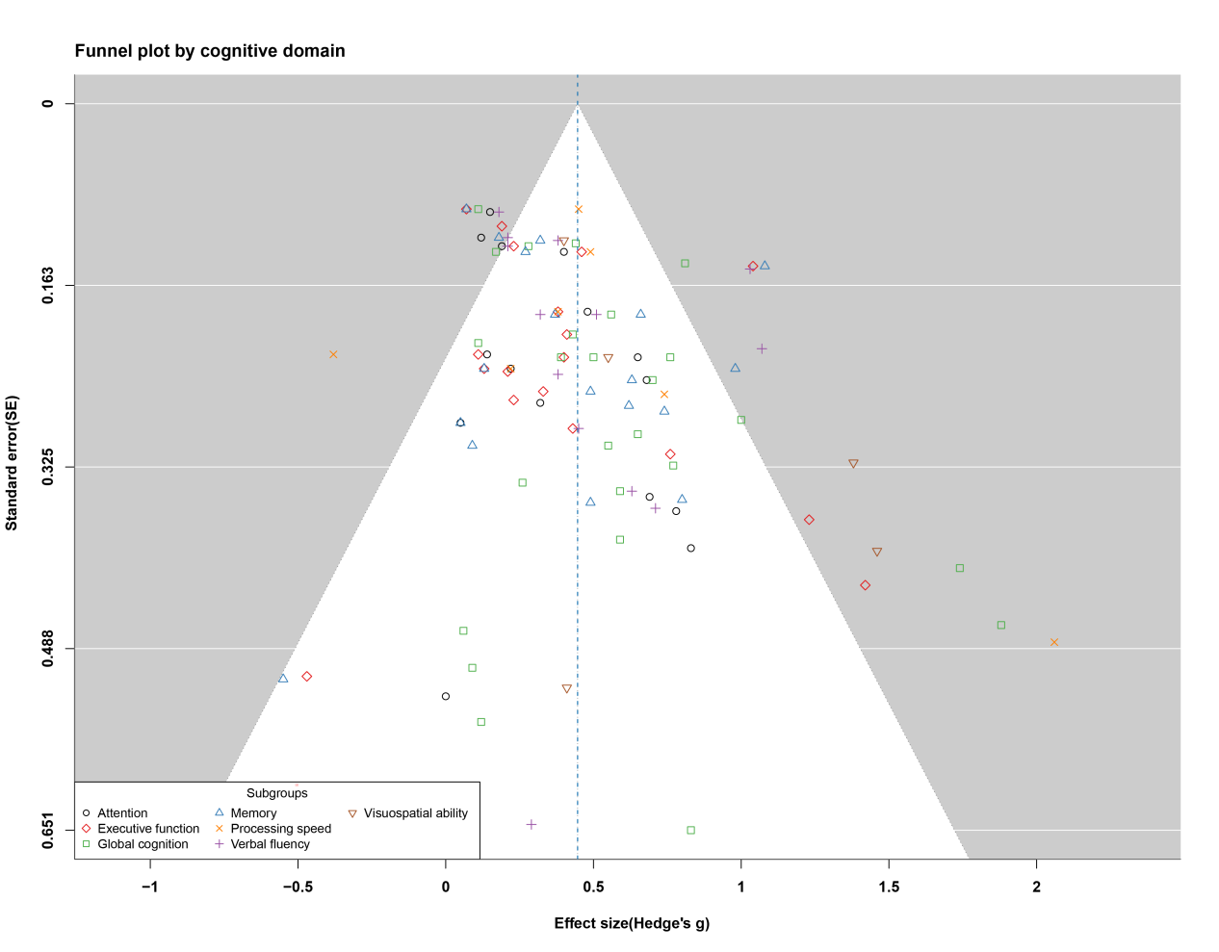
Fig. S2. Funnel plot for global cognition, attention, executive function, memory, processing speed, verbal fluency, and visuospatial ability.

- Supplementary Tables
Table S1
Search strategy used in the current systematic review and results from each database. (a) PubMed, (b) Web of Science, (c) Embase, (d) Cochrane, (e) PsycINFO, (f) CINAHL.
(a) PubMed (date: 11/07/2025 )
Set # | Search strategy | Results
1 | "cognitive dysfunction"[MeSH Terms] OR mild cognitive impairment[MeSH Terms] OR "cognitive declin*"[Title/Abstract] OR "cognitive disord*"[Title/Abstract] OR "cognitive deteriorat*"[Title/Abstract] OR "cognitive disabilit*"[Title/Abstract] OR "cognitive defic*"[Title/Abstract] OR "memory impair*"[Title/Abstract] OR "memory disord*"[Title/Abstract] OR "mental deterioration"[Title/Abstract] OR "neurocognitive disord*"[Title/Abstract] OR "incipient dementia"[Title/Abstract] OR "dementia prodrome"[Title/Abstract] | 140,203
2 | "aged"[MeSH Terms] OR "geriatrics"[MeSH Terms] OR "aging"[MeSH Terms] OR "old"[Title/Abstract] OR "old age"[Title/Abstract] OR "older population"[Title/Abstract] OR "older individual"[Title/Abstract] OR "older person"[Title/Abstract] OR "older people"[Title/Abstract] OR "older adult*"[Title/Abstract] OR "older patient"[Title/Abstract] OR "older group*"[Title/Abstract] OR "aged population"[Title/Abstract] OR "aged individual"[Title/Abstract] OR "aged person"[Title/Abstract] OR "aged people"[Title/Abstract] OR "aged adult*"[Title/Abstract] OR "aged patient"[Title/Abstract] OR "aged group*"[Title/Abstract]OR "gerontolog*"[Title/Abstract] OR "senior*"[Title/Abstract] OR "retire*"[Title/Abstract] OR "centenarian*"[Title/Abstract] OR "elder*"[Title/Abstract] | 5,343,892
3 | "combin*"[Title/Abstract] OR "multi*"[Title/Abstract] OR " comprehensiv*"[Title/Abstract] OR "mix"[Title/Abstract] OR "integrat*"[Title/Abstract] OR "two"[Title/Abstract] OR "dual*"[Title/Abstract] | 12,463,641
4 | "intervent*"[Title/Abstract] OR "train*"[Title/Abstract] OR "modal*"[Title/Abstract] OR "model*"[Title/Abstract] OR "program*"[Title/Abstract] OR "therap*"[Title/Abstract] OR "treatment*"[Title/Abstract] OR "rehabilitat*"[Title/Abstract] OR "task*"[Title/Abstract] OR "exercis*"[Title/Abstract] | 14,315,116
5 | #1 AND #2 AND #3 AND #4 | 18,786
6 | #5 AND (randomized controlled trial[Filter]) | 1404

(b) Web of Science (date: 11/07/2025 )
Set # | Search strategy | Results
1 | TI=(cognitive dysfunction) OR TI=(mild cognitive impairment) OR TI=(cognitive declin*) OR TI=(cognitive disord*) OR TI=(cognitive deteriorat*) OR TI=(cognitive disabilit*) OR TI=(cognitive defic*) OR TI=(memory impair*) OR TI=(memory disord*) OR TI=(mental deterioration) OR TI=(neurocognitive disord*) OR TI=(incipient dementia) OR TI=(dementia prodrome) OR AB=(cognitive dysfunction) OR AB=(mild cognitive impairment) OR AB=(cognitive declin*) OR AB=(cognitive disord*) OR AB=(cognitive deteriorat*) OR AB=(cognitive disabilit*) OR AB=(cognitive defic*) OR AB=(memory impair*) OR AB=(memory disord*) OR AB=(mental deterioration) OR AB=(neurocognitive disord*) OR AB=(incipient dementia) OR AB=(dementia prodrome) | 281,226
2 | TI=(aged) OR TI=(geriatrics) OR TI=(aging) OR TI=(old age) OR TI=(older population) OR TI=(older individual) OR TI=(older person) OR TI=(older people) OR TI=(older adult*) OR TI=(older patient) OR TI=(older group*) OR TI=(aged population) OR TI=(aged individual) OR TI=(aged person) OR TI=(aged people) OR TI=(aged adult*) OR TI=(aged patient) OR TI=(aged group*) OR TI=(gerontolog*) OR TI=(senior*) OR TI=(retire*) OR TI=(centenarian) OR TI=(elder*) OR AB=(aged) OR AB=(geriatrics) OR AB=(aging) OR AB=(old age) OR AB=(older population) OR AB=(older individual) OR AB=(older person) OR AB=(older people) OR AB=(older adult*) OR AB=(older patient) OR AB=(older group*) OR AB=(aged population) OR AB=(aged individual) OR AB=(aged person) OR AB=(aged people) OR AB=(aged adult*) OR AB=(aged patient) OR AB=(aged group*) OR AB=(gerontolog*) OR AB=(senior*) OR AB=(retire*) OR AB=(centenarian) OR AB=(elder*) | 3,610,455
3 | TI=(combin*) OR TI=(multi*) OR TI=(comprehensiv*) OR TI=(mix) OR TI=(integrat*) OR TI=(two) OR TI=(dual*) OR AB=(combin*) OR AB=(multi*) OR AB=(comprehensiv*) OR AB=(mix) OR AB=(integrat*) OR AB=(two) OR AB=(dual*) | 16,334,436
4 | TI=(intervent*) OR TI=(train*) OR TI=(modal*) OR TI=(model*) OR TI=(program*) OR TI=(therap*) OR TI=(treatment*) OR TI=(rehabilitat*) OR TI=(task*) OR TI=(exercis*) OR AB=(intervent*) OR AB=(train*) OR AB=(modal*) OR AB=(model*) OR AB=(program*) OR AB=(therap*) OR AB=(treatment*) OR AB=(rehabilitat*) OR AB=(task*) OR AB=(exercis*) | 5,440,267
5 | DT=(Randomized Controlled Trial) OR DT=(Controlled Clinical Trial) OR TI=(randomized) OR TI=(randomly) OR TS=(placebo) | 354,2627
6 | #1 AND #2 AND #3 AND #4 AND #5 | 1,952

(c) Embase (date: 11/07/2025 )
Set # | Search strategy | Results
1 | 'cognitive defect'/exp/mj OR 'mild cognitive impairment'/exp/mj OR 'cognitive dysfunction':ab,ti OR 'cognitive declin*':ab,ti OR 'cognitive disord*':ab,ti OR 'cognitive deteriorat*':ab,ti OR 'cognitive disabili*':ab,ti OR 'cognitive defici*':ab,ti OR 'memory impair*':ab,ti OR 'memory disord*':ab,ti OR 'mental deterioration':ab,ti OR 'neurocognitive disord*':ab,ti OR 'isolated memory impair*':ab,ti OR 'incipient dementia':ab,ti OR 'dementia prodrome':ab,ti | 506,782
2 | 'aged'/exp/mj OR 'geriatrics'/exp/mj OR 'aging'/exp OR 'senescence'/exp OR 'older adults'/exp OR 'older people'/exp OR 'older adult'/exp OR 'very elderly'/exp OR 'old age':ab,ti OR 'older population':ab,ti OR 'older individual':ab,ti OR 'older person':ab,ti OR 'older patient':ab,ti OR 'older group*':ab,ti OR 'aged population':ab,ti OR 'aged individual':ab,ti OR 'aged adult*':ab,ti OR 'aged group*':ab,ti OR gerontolog*:ab,ti OR senior*:ab,ti OR retire*:ab,ti OR centenarian:ab,ti OR elder*:ab,ti | 1,388,786
3 | 'combin*':ab,ti OR multi*:ab,ti OR comprehensiv*:ab,ti OR mix:ab,ti OR integrat*:ab,ti OR two:ab,ti OR dual*:ab,ti | 16,133,410
4 | intervent*:ab,ti OR 'train*':ab,ti OR 'modal*':ab,ti OR 'model*':ab,ti OR 'program*':ab,ti OR 'therap*':ab,ti OR 'treatment*':ab,ti OR 'rehabilitat*':ab,ti OR 'exercis*':ab,ti | 18,800,429
5 | 'randomized controlled trial'/exp OR 'controlled clinical trial'/exp OR randomized:ti OR randomly:ti OR placebo:ti | 1,433,074
6 | #1 AND #2 AND #3 AND #4 AND #5 | 2,176

(d) Cochrane (date: 11/07/2025 )
Set # | Search strategy | Results
1 | MeSH descriptor:[Cognitive Dysfunction] explode all trees OR (mild cognitive impairment):ti,ab,kw OR (cognitive declin*):ti,ab,kw OR (cognitive disord*):ti,ab,kw OR (cognitive deteriorat*):ti,ab,kw OR (cognitive disabilit*):ti,ab,kw OR (cognitive defic*):ti,ab,kw OR (memory impair*):ti,ab,kw OR (memory disord*):ti,ab,kw OR (mental deterioration):ti,ab,kw OR (neurocognitive disord*):ti,ab,kw OR (incipient dementia):ti,ab,kw OR (dementia prodrome):ti,ab,kw | 69,348
2 | MeSH descriptor:[Aged] explode all trees OR MeSH descriptor:[Geriatrics] explode all trees OR (aging) OR (old age):ti,ab,kw OR (old* population):ti,ab,kw OR (old* individual):ti,ab,kw OR (old* person):ti,ab,kw OR (old* people):ti,ab,kw OR (old* adult*):ti,ab,kw OR (old* patient):ti,ab,kw OR (old* group*):ti,ab,kw OR (aged population):ti,ab,kw OR (aged individual):ti,ab,kw OR (aged person):ti,ab,kw OR (aged people):ti,ab,kw OR (aged adult*):ti,ab,kw OR (aged patient):ti,ab,kw OR (aged group*):ti,ab,kw OR (gerontolog*):ti,ab,kw OR (senior*):ti,ab,kw OR (retire*):ti,ab,kw OR (centenarian*):ti,ab,kw OR (elder*):ti,ab,kw | 789,625
3 | (combin*":ti,ab,kw OR (multi*":ti,ab,kw OR (comprehensiv*":ti,ab,kw OR (mix":ti,ab,kw OR (integrat*":ti,ab,kw OR (two":ti,ab,kw OR (dual*":ti,ab,kw | 275,815
4 | (intervent*):ti,ab,kw OR (train*):ti,ab,kw OR (modal*):ti,ab,kw OR (model*):ti,ab,kw OR (program*):ti,ab,kw OR (therap*):ti,ab,kw OR (treatment*):ti,ab,kw OR (rehabilitat*):ti,ab,kw OR (task*):ti,ab,kw OR (exercis*):ti,ab,kw | 695,955
5 | (randomized controlled trial):ti,ab,kw OR (controlled clinical trial):ti,ab,kw OR (randomized):ti,ab,kw OR (randomly):ti,ab,kw OR (placebo):ti,ab,kw | 548,021
6 | #1 AND #2 AND #3 AND #4 AND #5 | 1,196

(e) PsycINFO (date: 11/07/2025 )
Set # | Search strategy | Results
1 | (TI (cognitive dysfunction) OR TI (mild cognitive impairment) OR TI (cognitive declin*) OR TI (cognitive disord*) OR TI (cognitive deteriorat*) OR TI (cognitive disabilit*) OR TI (cognitive defic*) OR TI (memory impair*) OR TI (memory disord*) OR TI (mental deterioration) OR TI (neurocognitive disord*) OR TI (incipient dementia) OR TI (dementia prodrome)) OR (AB (cognitive dysfunction) OR AB (mild cognitive impairment) OR AB (cognitive declin*) OR AB (cognitive disord*) OR AB (cognitive deteriorat*) OR AB (cognitive disabilit*) OR AB (cognitive defic*) OR AB (memory impair*) OR AB (memory disord*) OR AB (mental deterioration) OR AB (neurocognitive disord*) OR AB (incipient dementia) OR AB (dementia prodrome)) | 72,276
2 | (TI (aged) OR TI (geriatrics) OR TI (aging) OR TI (old age) OR TI (older population) OR TI (older individual) OR TI (older person) OR TI (older people) OR TI (older adult*) OR TI (older patient) OR TI (older group*) OR TI (aged population) OR TI (aged individual) OR TI (aged person) OR TI (aged people) OR TI (aged adult*) OR TI (aged patient) OR TI (aged group*) OR TI (gerontolog*) OR TI (senior*) OR TI (retire*) OR TI (centenarian) OR TI (elder*)) OR (AB (aged) OR AB (geriatrics) OR AB (aging) OR AB (old age) OR AB (older population) OR AB (older individual) OR AB (older person) OR AB (older people) OR AB (older adult*) OR AB (older patient) OR AB (older group*) OR AB (aged population) OR AB (aged individual) OR AB (aged person) OR AB (aged people) OR AB (aged adult*) OR AB (aged patient) OR AB (aged group*) OR AB (gerontolog*) OR AB (senior*) OR AB (retire*) OR AB (centenarian) OR AB (elder*)) | 518,179
3 | (TI (combin*) OR TI (multi*) OR TI (comprehensiv*) OR TI (mix) OR TI (integrat*) OR TI (two) OR TI (dual*)) OR (AB (combin*) OR AB (multi*) OR AB (comprehensiv*) OR AB (mix) OR AB (integrat*) OR AB (two) OR AB (dual*)) N5 (TI (intervent*) OR TI (train*) OR TI (modal*) OR TI (model*) OR TI (program*) OR TI (therap*) OR TI (treatment*) OR TI (rehabilitat*) OR TI (task*) OR TI (exercis*)) OR (AB (intervent*) OR AB (train*) OR AB (modal*) OR AB (model*) OR AB (program*) OR AB (therap*) OR AB (treatment*) OR AB (rehabilitat*) OR AB (task*) OR AB (exercis*)) | 2,864,084
4 | TI (randomized controlled trial) OR TI (controlled clinical trial) OR TI (randomized) OR TI (randomly) OR TI (placebo) | 46,519
5 | #1 AND #2 AND #3 AND #4 | 424

(f) CINAHL (date: 11/07/2025 )
Set # | Search strategy | Results
1 | (TI (cognitive dysfunction) OR TI (mild cognitive impairment) OR TI (cognitive declin*) OR TI (cognitive disord*) OR TI (cognitive deteriorat*) OR TI (cognitive disabilit*) OR TI (cognitive defic*) OR TI (memory impair*) OR TI (memory disord*) OR TI (mental deterioration) OR TI (neurocognitive disord*) OR TI (incipient dementia) OR TI (dementia prodrome)) OR (AB (cognitive dysfunction) OR AB (mild cognitive impairment) OR AB (cognitive declin*) OR AB (cognitive disord*) OR AB (cognitive deteriorat*) OR AB (cognitive disabilit*) OR AB (cognitive defic*) OR AB (memory impair*) OR AB (memory disord*) OR AB (mental deterioration) OR AB (neurocognitive disord*) OR AB (incipient dementia) OR AB (dementia prodrome)) | 38,113
2 | (TI (aged) OR TI (geriatrics) OR TI (aging) OR TI (old age) OR TI (older population) OR TI (older individual) OR TI (older person) OR TI (older people) OR TI (older adult*) OR TI (older patient) OR TI (older group*) OR TI (aged population) OR TI (aged individual) OR TI (aged person) OR TI (aged people) OR TI (aged adult*) OR TI (aged patient) OR TI (aged group*) OR TI (gerontolog*) OR TI (senior*) OR TI (retire*) OR TI (centenarian) OR TI (elder*)) OR (AB (aged) OR AB (geriatrics) OR AB (aging) OR AB (old age) OR AB (older population) OR AB (older individual) OR AB (older person) OR AB (older people) OR AB (older adult*) OR AB (older patient) OR AB (older group*) OR AB (aged population) OR AB (aged individual) OR AB (aged person) OR AB (aged people) OR AB (aged adult*) OR AB (aged patient) OR AB (aged group*) OR AB (gerontolog*) OR AB (senior*) OR AB (retire*) OR AB (centenarian) OR AB (elder*)) | 566,233
3 | (TI (combin*) OR TI (multi*) OR TI (comprehensiv*) OR TI (mix) OR TI (integrat*) OR TI (two) OR TI (dual*)) OR (AB (combin*) OR AB (multi*) OR AB (comprehensiv*) OR AB (mix) OR AB (integrat*) OR AB (two) OR AB (dual*)) N5 (TI (intervent*) OR TI (train*) OR TI (modal*) OR TI (model*) OR TI (program*) OR TI (therap*) OR TI (treatment*) OR TI (rehabilitat*) OR TI (task*) OR TI (exercis*)) OR (AB (intervent*) OR AB (train*) OR AB (modal*) OR AB (model*) OR AB (program*) OR AB (therap*) OR AB (treatment*) OR AB (rehabilitat*) OR AB (task*) OR AB (exercis*)) | 2,728,465
4 | TI (randomized controlled trial) OR TI (controlled clinical trial) OR TI (randomized) OR TI (randomly) OR TI (placebo) | 173,836
5 | #1 AND #2 AND #3 AND #4 | 572

Table S2
The eligibility criteria conducted in accordance with the PICOS.
PICOS | Eligibility criteria
Population | Older adults with mild cognitive impairment (MCI) patients aged ≥50 years, diagnosed by clinicians according to Peterson criteria(Petersen et al., 1999), Albert criteria(Albert et al., 2013), and/or equivalent standards, requiring: (a) subjective cognitive concern; (b) objective cognitive deficits relative to age-normed performance on neuropsychological testing, such as Clinical Dementia Rating (CDR), the Mini-Mental State Examination (MMSE), or Montreal Cognitive Assessment (MoCA); (c) essentially preserved functional independence; and (d) absence of dementia.
Intervention | Any interventions were considered multidomain if they included 2 or more nonpharmacological components, including but not limited to cognitive training and/or stimulation, physical exercise, different medications, management of vascular risk factors, social interaction exercise, dietary supplementations, and sleep intervention, as well as their combinations. No restrictions were placed on dose, length, duration, intensity, intervention format, or setting.
Comparison | Eligible comparators included placebo, usual care, no treatment, health education, wait-list or attention controls, single-domain interventions, or any other intervention with the intervention type different from that of other groups.
Outcome | Primary outcome: change in global cognitive function assessed with standardized neuropsychological measures. Secondary outcomes: changes in domain-specific cognitive functions.
Study design | Only Randomized controlled trials (RCTs) with two or more arms were included in the review, without imposing any restrictions on the inclusion of cohort studies, longitudinal studies, or crossover designs.
Additional exclusion criteria | (1) studies without peer-reviewed full texts; (2) studies not published in English; (3) trials using the same type of intervention in both the intervention and control groups; (4) protocols, reviews, editorials, conference abstracts; and (5) studies whose primary focus was MCI with a co-occurring condition that independently affects cognition, unless MCI-only outcomes were reported separately.

Table S3
Summarizes pooled random-effects estimates for global cognition and domain-specific outcomes. Positive Hedges’ g indicates better cognition in the multidomain intervention group.
Outcome | Studies (k) | Hedges’ g | 95% CI | I² (%) | Prediction interval | p value
Global cognition | 25 | 0.51 | 0.36 to 0.67 | 58.4 | 0.00 to 1.02 | <0.001
Attention | 15 | 0.31 | 0.18 to 0.43 | 21.6 | 0.05 to 0.56 | <0.001
Executive function | 18 | 0.39 | 0.21 to 0.57 | 68.3 | -0.18 to 0.96 | <0.001
Memory | 18 | 0.43 | 0.25 to 0.61 | 70.7 | -0.17 to 1.04 | <0.001
Processing speed | 7 | 0.48 | -0.12 to 1.08 | 77.7 | -0.90 to 1.87 | 0.0967
Verbal fluency | 13 | 0.47 | 0.28 to 0.66 | 69.3 | -0.13 to 1.08 | <0.001
Visuospatial ability | 5 | 0.80 | 0.16 to 1.44 | 69.9 | -0.54 to 2.14 | 0.026

Table S4
Subgroup analyses for global cognition
Moderator | Category | Hedges’ g (95% CI) | p for subgroup difference
Settings | Community | 0.53 (0.29 to 0.78) | 0.248
Settings | Clinic | 0.50 (0.27 to 0.74)
Intensity | ≤10 points | 0.68 (0.45 to 0.91) | 0.002
Intensity | >10 points | 0.50 (0.29 to 0.71)

Table S5
Subgroup analyses for attention.
Moderator | Category | Hedges’ g (95% CI) | p for subgroup difference
Settings | Community | 0.33 (0.16 to 0.49) | 0.313
Settings | Clinic | 0.33 (0.06 to 0.59)
Intensity | ≤10 points | 0.35 (0.05 to 0.65) | 0.465
Intensity | >10 points | 0.31 (0.13 to 0.49)

Table S6
Subgroup analyses for executive function.
Moderator | Category | Hedges’ g (95% CI) | p for subgroup difference
Settings | Community | 0.38 (0.20 to 0.56) | 0.093
Settings | Clinic | 0.50 (-0.19 to 1.19)
Intensity | ≤10 points | 0.48 (0.11 to 0.86) | 0.043
Intensity | >10 points | 0.32 (0.11 to 0.53)

Table S7
Subgroup analyses for memory.
Moderator | Category | Hedges’ g (95% CI) | p for subgroup difference
Settings | Community | 0.54 (0.31 to 0.78) | <0.001
Settings | Clinic | 0.30 (-0.00 to 0.60)
Intensity | ≤10 points | 0.60 (0.24 to 0.96) | <0.001
Intensity | >10 points | 0.33 (0.12 to 0.54)

Reference
Albert, M.S., DeKosky, S.T., Dickson, D., Dubois, B., Feldman, H.H., Fox, N.C., Gamst, A., Holtzman, D.M., Jagust, W.J., Petersen, R.C., Snyder, P.J., Carrillo, M.C., Thies, B., Phelps, C.H., 2013. The diagnosis of mild cognitive impairment due to alzheimer’s disease: Recommendations from the national institute on aging-alzheimer’s association workgroups on diagnostic guidelines for alzheimer’s disease. FOCUS. https://doi.org/10.1176/appi.focus.11.1.96
Petersen, R.C., Smith, G.E., Waring, S.C., Ivnik, R.J., Tangalos, E.G., Kokmen, E., 1999. Mild cognitive impairment: Clinical characterization and outcome. Arch Neurol 56, 303–308. https://doi.org/10.1001/archneur.56.3.303

