Figure S1: The Preferred Reporting Items for Systematic Reviews and Meta-Analyses (PRISMA) flow chart
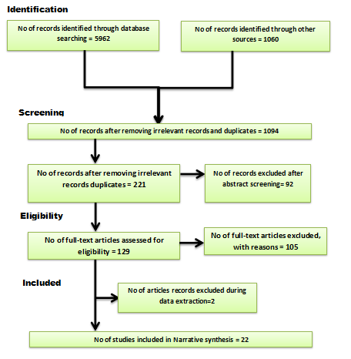

Figure S2: Table of Included Study Characteristics
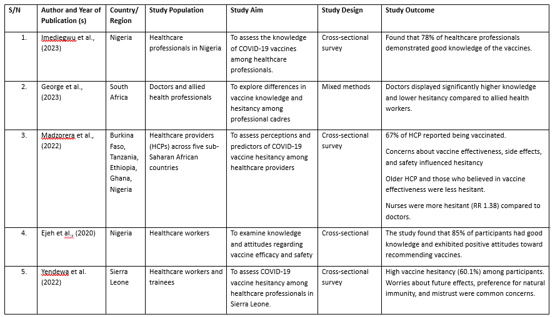
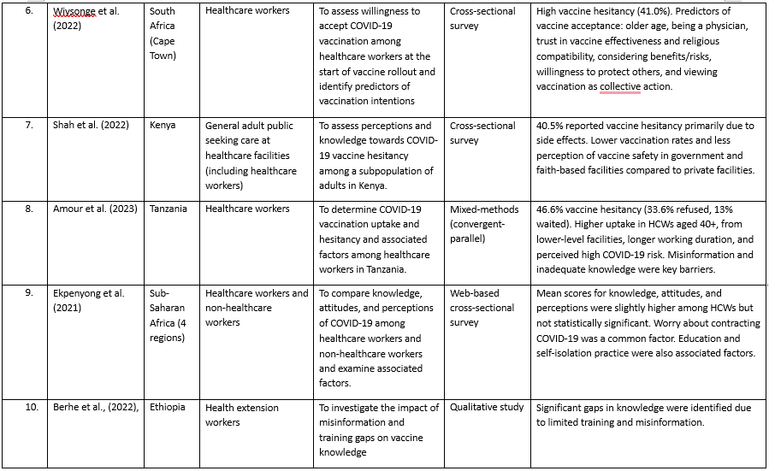
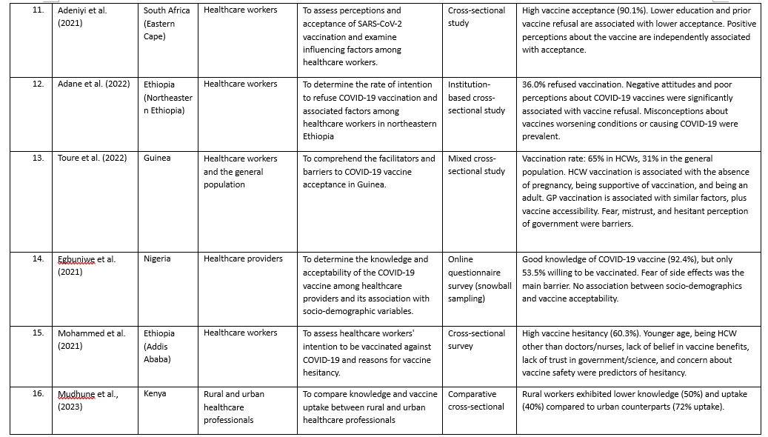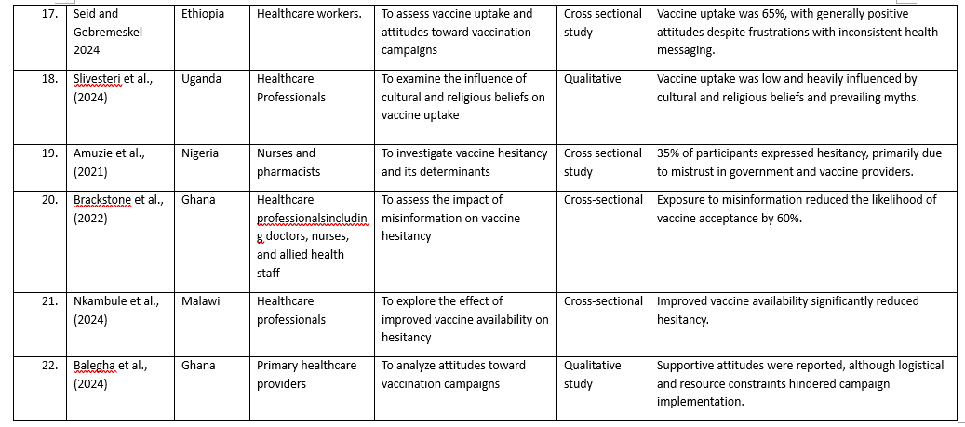
Appendices
Appendix 1
 | First Screening (Full-text Screening Outcome)
S/N |  | Author (s) | Population | exposure | Type of study (qualitative and quantitative) |  | Outcome | Decision  (yes, unsure, no)
 |  | Imediegwu et al., 2023. | Y | Y |  | Y | Y | Y
 |  | George et al., 2023 | N | Y |  | Y | Y | Y
 |  | Ejeh et al., 2020 | Y | Y |  | Y | Y | Y
 |  | Berhe et al., 2022 | Y | Y |  | Y | Y | Y
 |  | Mudhune et al., 2023 | Y | Y |  | Y | Y | Y
 |  | Seid and Gebremeskel 2024 | Y | Y |  | Y | Y | Y
 |  | Slivesteri et al., 2024 | Y | Y |  | Y | Y | Y
 |  | Amuzie et al., 2021 | Y | Y |  | Y | Y | Y
 |  | Brackstone et al., 2022 | Y | Y |  | Y | Y | Y
 |  | Nkambule et al., 2024 | Y | Y |  | N | Y | Y
 |  | Balegha et al., 2024 | Y | Y |  | Y | Y | Y
 |  | Madzorera et al., 2022 | Y | Y |  | Y | Y | Y
 |  | Yendewa et al. 2022 | Y | Y |  | Y | Y | Y
 |  | Wiysonge et al. (2022) | Y | Y |  | Y | Y | Y
 |  | Shah et al. (2022) | Y | Y |  | Y | Y | Y
 |  | Amour et al. (2023) | Y | Y |  | Y | Y | Y
 |  | Ekpenyong et al. (2021) | Y | Y |  | Y | Y | Y
 |  | Mohammed et al. (2021) | Y | Y |  | Y | Y | Y
 |  | Egbuniwe et al. (2021) | Y | Y |  | Y | Y | Y
 |  | Toure et al. (2022) | Y | Y |  | Y | Y | Y
 |  | Adane et al. (2022) | Y | Y |  | Y | Y | Y
 |  | Adeniyi et al. (2021) | Y | Y |  | Y | Y | Y
 |  | Kigongo et al., 2023 | N | Y |  | Y | N | N
 |  | Osuagwu et al., 2023 | N | Y |  | Y | Y | N
 |  | Gudayu and Mengistie 2023 | N | N |  | Y | N | N
 |  | Naidoo et al., 2023 | N | Y |  | Y | N | N
 |  | Mudenda et al., 2024 | N | N |  | Y | N | N
 |  | Balegha et al., 2024 | Y | N |  | Y | Y | N
 |  | Ajonina-Ekoti et al., 2022 | Y | N |  | Y | Y | N
 |  | Ahiakpa et al., 2022 | N | Y |  | N | N | N
 |  | Kabakama et al., 2022 | Y | Y |  | N | Y | N
 |  | Mbele et al., 2024 | N | Y |  | Y | N | N
 |  | Nzaji et al., 2024 | N | N |  | Y | N | N
 |  | Ackah et al., 2022 | Y | N |  | Y | Y | N
 |  | Anjorin et al., 2021 | Y | Y |  | N | N | N
 |  | Mashoto et al., 2024 | Y | Y |  | N | Y | N
 |  | Nasimiyu et al., 2022 | N | Y |  | Y | N | N
 |  | Faye et al., 2022 | N | N |  | Y | N | N
 |  | Chutiyami et al., 2022 | Y | N |  | Y | Y | N
 |  | Njoga et al., 2022 | Y | Y |  | N | N | N
 |  | Azanaw et al., 2023 | N | N |  | Y | N | N
 |  | Chiamaka et al., 2022 | Y | N |  | Y | Y | N
 |  | Msuya et al., 2023 | Y | Y |  | N | Y | N
 |  | Kanyanda et al., 2021 | N | Y |  | Y | N | N
 |  | Aseneh et al., 2023 | N | N |  | Y | N | N
 |  | Tolossa et al., 2022 | Y | Y |  | N | Y | N
 |  | Ntimani, 2023 | N | Y |  | Y | N | N
 |  | Abay et al., 2022 | Y | Y |  | N | Y | N
 |  | Wang et al., 2022 | N | Y |  | Y | N | N
 |  | Osuagwu et al., 2022 | N | N |  | Y | N | N
 |  | Sallam, 2021 | Y | N |  | Y | Y | N
 |  | Miner et al., 2023 | Y | Y |  | N | Y | N
 |  | Ngangue et al., 2022 | N | N |  | Y | N | N
 |  | Ogunbosi et al., 2022 | Y | N |  | Y | Y | N
 |  | Carcelen et al., 2022 | Y | Y |  | N | Y | N
 |  | Alalawi et al., 2024 | N | Y |  | Y | N | N
 |  | Alhassan et al., 2022 | N | N |  | Y | N | N
 |  | Mudenda et al., 2023 | Y | N |  | Y | Y | N
 |  | Alobwede et al., 2022 | Y | Y |  | N | N | N
 |  | Wake, 2021 | Y | N |  | Y | Y | N
 |  | Ibekwe et al., 2024 | N | Y |  | N | N | N
 |  | Gabriel et al., 2024 | Y | Y |  | N | Y | N
 |  | Fokom et al., 2024 | Y | Y |  | N | Y | N
 |  | George et al., 2024 | N | Y |  | Y | N | N
 |  | Iliyasu et al., 2022 | N | N |  | Y | N | N
 |  | Sogbesan et al., 2024 | Y | N |  | Y | Y | N
 |  | Emmanuel et al., 2024 | Y | Y |  | N | N | N
 |  | Atongu et al., 2024 | Y | Y |  | N | Y | N
 |  | de Figueiredo et al., 2023 | N | Y |  | Y | N | N
 |  | Alimohamed et al., 2024 | Y | Y |  | N | Y | N
 |  | Dinga et al., 2021 | N | Y |  | Y | N | N
 |  | Alie et al., 2024 | N | N |  | Y | N | N
 |  | Ajeigbe et al., 2022 | Y | N |  | Y | Y | N
 |  | Omayo et al., 2023 | Y | Y |  | N | N | N
 |  | Chilongola et al., 2022 | Y | Y |  | N | Y | N
 |  | Baral et al., 2023 | N | Y |  | Y | N | N
 |  | Dzomo et al., 2023 | N | N |  | Y | N | N
 |  | Oladapo et al., 2024 | Y | Y |  | N | Y | N
 |  | Ciswaka et al., 2024 | N | N |  | Y | N | N
 |  | Ekezie et al., 2024 | Y | N |  | Y | Y | N
 |  | Isah et al., 2023 | Y | Y |  | N | N | N
 |  | Kalu et al., 2022 | Y | Y |  | N | Y | N
 |  | Chikezie et al., 2023 | N | Y |  | Y | N | N
 |  | Muchangi et al., 2023 | N | N |  | Y | N | N
 |  | Omotoso et al., 2022 | Y | Y |  | N | Y | N
 |  | Alhassan et al., 2021 | Y | Y |  | N | Y | N
 |  | Toure et al., 2022 | N | Y |  | Y | N | N
 |  | Ghazy et al., 2024 | N | N |  | Y | N | N
 |  | Adeagbo et al., 2022 | Y | Y |  | N | Y | N
 |  | Cheuyem et al., 2024 | N | Y |  | Y | N | N
 |  | Solís Arce et al., 2021 | N | N |  | Y | N | N
 |  | Wanyonyi et al., 2022 | Y | N |  | Y | Y | N
 |  | Adeyanju, 2022 | Y | Y |  | N | N | N
 |  | Gezahegn, 2023 | N | N |  | Y | N | N
 |  | Konje et al., 2022 | Y | Y |  | N | Y | N
 |  | Allan et al., 2023 | N | Y |  | Y | N | N
 |  | Ogunyinka et al., 2024 | Y | Y |  | N | Y | N
 |  | Mohammed et al., 2023 | N | Y |  | Y | N | N
 |  | Eberhardt and Ling, 2024 | N | N |  | Y | N | N
 |  | Kiptoo et al., 2024 | Y | N |  | Y | Y | N
 |  | Amponsah-Tabi et al., 2023 | Y | Y |  | N | N | N
 |  | Akrong et al., 2024 | N | N |  | Y | N | N
 |  | Al-Aghbari et al., 2023 | Y | N |  | Y | Y | N
 |  | Masele and Daud, 2022 | Y | Y |  | N | Y | N
 |  | Kutz et al., 2023 | Y | Y |  | N | Y | N
 |  | Nyamuryekung’e et al., 2023 | N | Y |  | Y | N | N
 |  | Mtei et al., 2023 | Y | Y |  | N | Y | N
 |  | Mudenda et al., 2022 | N | Y |  | Y | N | N
 |  | Jairoun et al., 2022 | Y | Y |  | N | Y | N
 |  | Yilma et al., 2022 | N | Y |  | Y | N | N
 |  | Sulaiman et al., 2023 | Y | N |  | Y | N | N
 |  | Eze et al., 2021 | Y | N |  | Y | Y | N
 |  | Rice et al., 2022 | Y | Y |  | N | N | N
 |  | Ayieko et al., 2024 | N | N |  | Y | N | N
 |  | Wollburg et al., 2022 | Y | N |  | Y | Y | N
 |  | Bamgbade et al., 2024 | N | Y |  | N | N | N
 |  | Agha et al., 2021 | Y | Y |  | N | Y | N
 |  | Sialubanje et al., 2022 | Y | Y |  | N | Y | N
 |  | Otiti-Sengeri et al., 2022 | N | Y |  | Y | N | N
 |  | Amwoma et al., 2023 | N | N |  | Y | N | N
 |  | Dzinamarira et al., 2021 | Y | N |  | Y | Y | N
 |  | Ajose et al., 2023 | Y | Y |  | N | Y | N
 |  | Cummings et al., 2023 | N | Y |  | Y | N | N
 |  | Bello et al., 2024 | N | N |  | Y | N | N
 |  | Patwary et al., 2022 | Y | N |  | Y | Y | N
 |  | Ndejjo et al., 2024 | Y | Y |  | N | N | N
 |  | Zakari et al., 2023 | N | N |  | Y | N | N
 |  | Dirie et al., 2024 | Y | N |  | Y | Y | N
 |  | Mose et al., 2022 | N | Y |  | N | N | N

Second Screening (Full-text Screening Outcome)
S/N | Author (s) | Population | exposure | Type of study (qualitative and quantitative) | Outcome | Decision  (yes, unsure, no)
 | Imediegwu et al., 2023. | Y | Y | Y | Y | Y
 | George et al., 2023 | Y | Y | Y | Y | Y
 | Ejeh et al., 2020 | Y | Y | Y | Y | Y
 | Berhe et al., 2022 | Y | Y | Y | Y | Y
 | Mudhune et al., 2023 | Y | Y | Y | Y | Y
 | Seid and Gebremeskel 2024 | Y | Y | Y | Y | Y
 | Slivesteri et al., 2024 | Y | Y | Y | Y | Y
 | Amuzie et al., 2021 | Y | Y | Y | Y | Y
 | Madzorera et al., 2022 | Y | Y | Y | Y | Y
 | Brackstone et al., 2022 | Y | Y | Y | Y | Y
 | Nkambule et al., 2024 | Y | Y | Y | Y | Y
 | Balegha et al., 2024 | Y | Y | Y | Y | Y
 | Yendewa et al. 2022 | Y | Y | Y | Y | Y
 | Wiysonge et al. (2022) | Y | Y | Y | Y | Y
 | Shah et al. (2022) | Y | Y | Y | Y | Y
 | Amour et al. (2023) | Y | Y | Y | Y | Y
 | Ekpenyong et al. (2021) | Y | Y | Y | Y | Y
 | Mohammed et al. (2021) | Y | Y | Y | Y | Y
 | Egbuniwe et al. (2021) | Y | Y | Y | Y | Y
 | Toure et al. (2022) | Y | Y | Y | Y | Y
 | Adane et al. (2022) | Y | Y | Y | Y | Y
 | Adeniyi et al. (2021) | Y | Y | Y | Y | Y

Appendix 2
Search Strategy
The search string in PubMed was: ("COVID-19 Vaccines"[MeSH] OR "SARS-CoV-2 vaccine") AND ("vaccine hesitancy" OR "vaccine uptake") AND ("healthcare professionals" OR "health workers") AND ("Sub-Saharan Africa" OR "Africa South of the Sahara").
In Google Scholar, the keywords were not necessarily MeSH; the keywords used to serve for relevant articles involved "COVID-19 vaccines," "vaccine hesitancy," "healthcare professionals," and "Sub-Saharan Africa." The search string used was: ("COVID-19 vaccines" OR "SARS-CoV-2 vaccine") AND ("vaccine hesitancy" OR "vaccine uptake") AND ("healthcare professionals" OR "health workers") AND ("Sub-Saharan Africa").
AJOL has more region-specific search parameters. The keywords used included "COVID-19 vaccines," "vaccine hesitancy," "healthcare professionals," and "Sub-Saharan Africa." The Boolean string used was as shown: ("COVID-19 vaccines" OR "SARS-CoV-2 vaccine") AND ("vaccine hesitancy" OR "vaccine uptake") AND ("healthcare professionals" OR "health workers") AND ("Sub-Saharan Africa").
CINAHL searches were refined using controlled vocabulary, including CINAHL Headings and Boolean operators. Relevant search terms included "COVID-19 Vaccines"[MeSH], "vaccine hesitancy," "healthcare professionals," and "Sub-Saharan Africa." The detailed search strategy was: ("COVID-19 Vaccines"[MeSH] OR "SARS-CoV-2 vaccine") AND ("vaccine hesitancy" OR "vaccine uptake") AND ("healthcare professionals" OR "health workers") AND ("Sub-Saharan Africa"). While the last database search in Scopus also combined predefined keywords with Boolean operators, which is a uniform strategy to ensure coverage across disciplines, as was done in other databases. Search key terms like “COVID-19 vaccines”, “vaccine hesitancy”, “healthcare professionals”, and “sub-Saharan Africa” were used in combination with “OR” and “AND” to form MeSH as seen in Table 1. The search design was designed to be comprehensive and uniform for all the databases so that it can be transparent and reproducible by other researchers.

