Supplementary Information of Revealing Seismic Sequence Characteristics in the South-eastern Alps and the Western Dinarides by clustering analysis and refined location
Brondi P.¹*, Picozzi M.¹, De Landro G.², Iaccarino A. G.², Lomax A.³, Magrin A. ¹ Zampa L.¹, Michele M.⁴
*Corresponding author. Email: pbrondi@ogs.it
¹National Institute of Oceanography and Applied Geophysics – OGS, Trieste, Italy.
²University of Naples “Federico II”, Naples, Italy.
³ALomax Scientific, Mouans-Sartoux, France
⁴ Istituto Nazionale di Geofisica e Vulcanologia – INGV, Rome, Italy

Figures S1, S2, S3, S4 and Table S1 are included in this supplementary material.
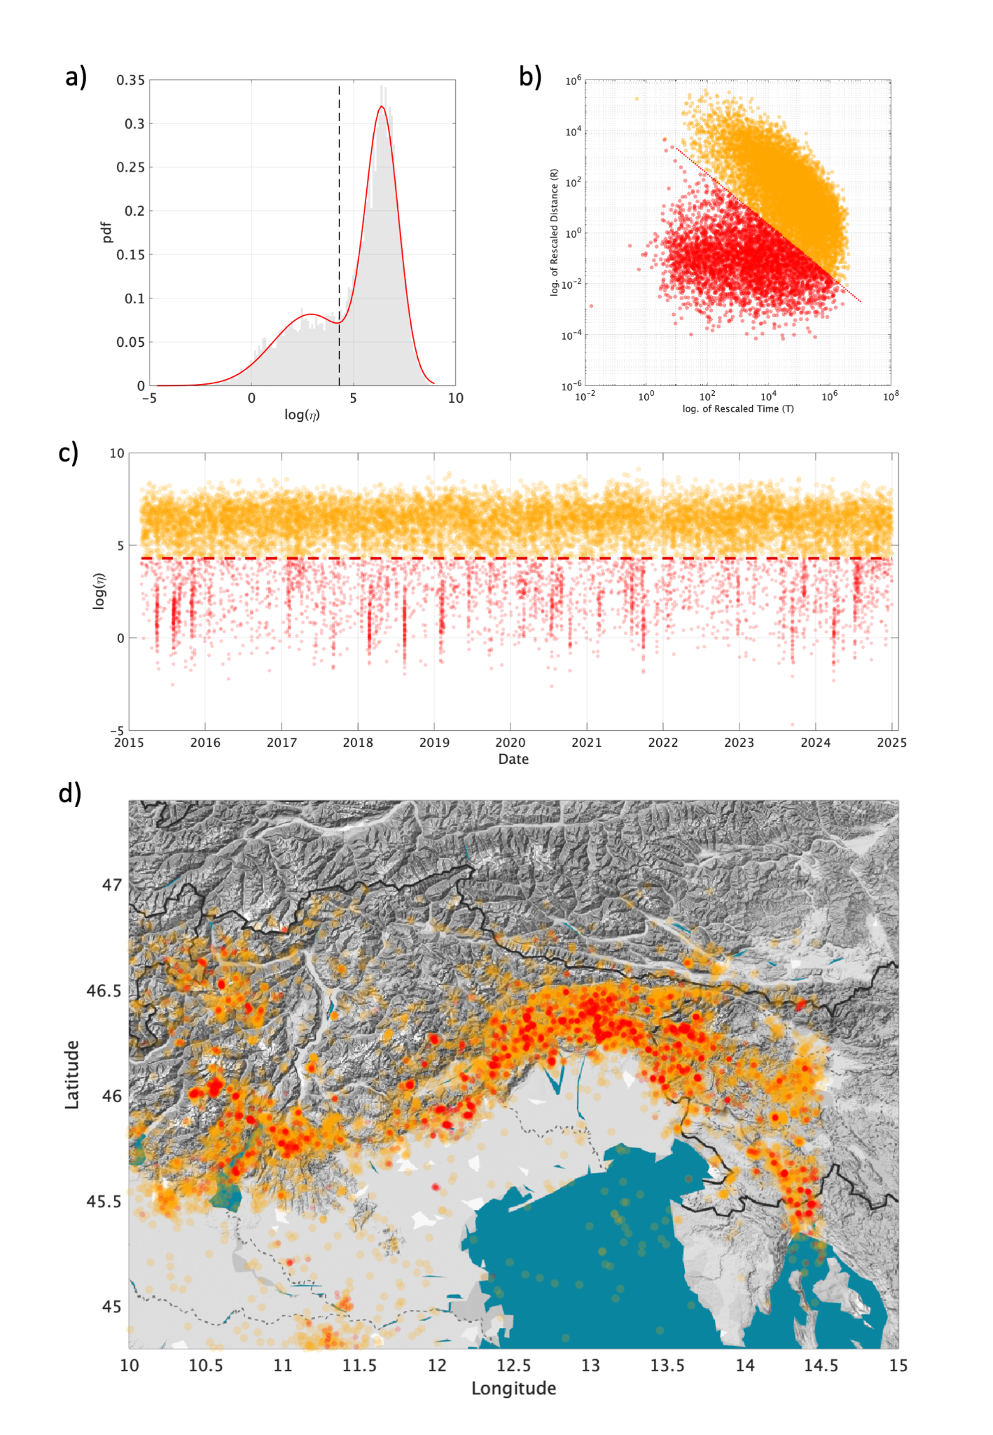
Figure S1: cluster identification with Zaliapin et al. (2008) method for the OGS catalog relocated using NLL-SSST: a) Separation between background seismicity and clustered seismicity based on the probability density function of log(η). b) The same separation between background seismicity (yellow) and clustered seismicity (red), shown as a plot of rescaled distance versus rescaled time. c) The trend of log(η) as a function of time. d) Epicenter location.

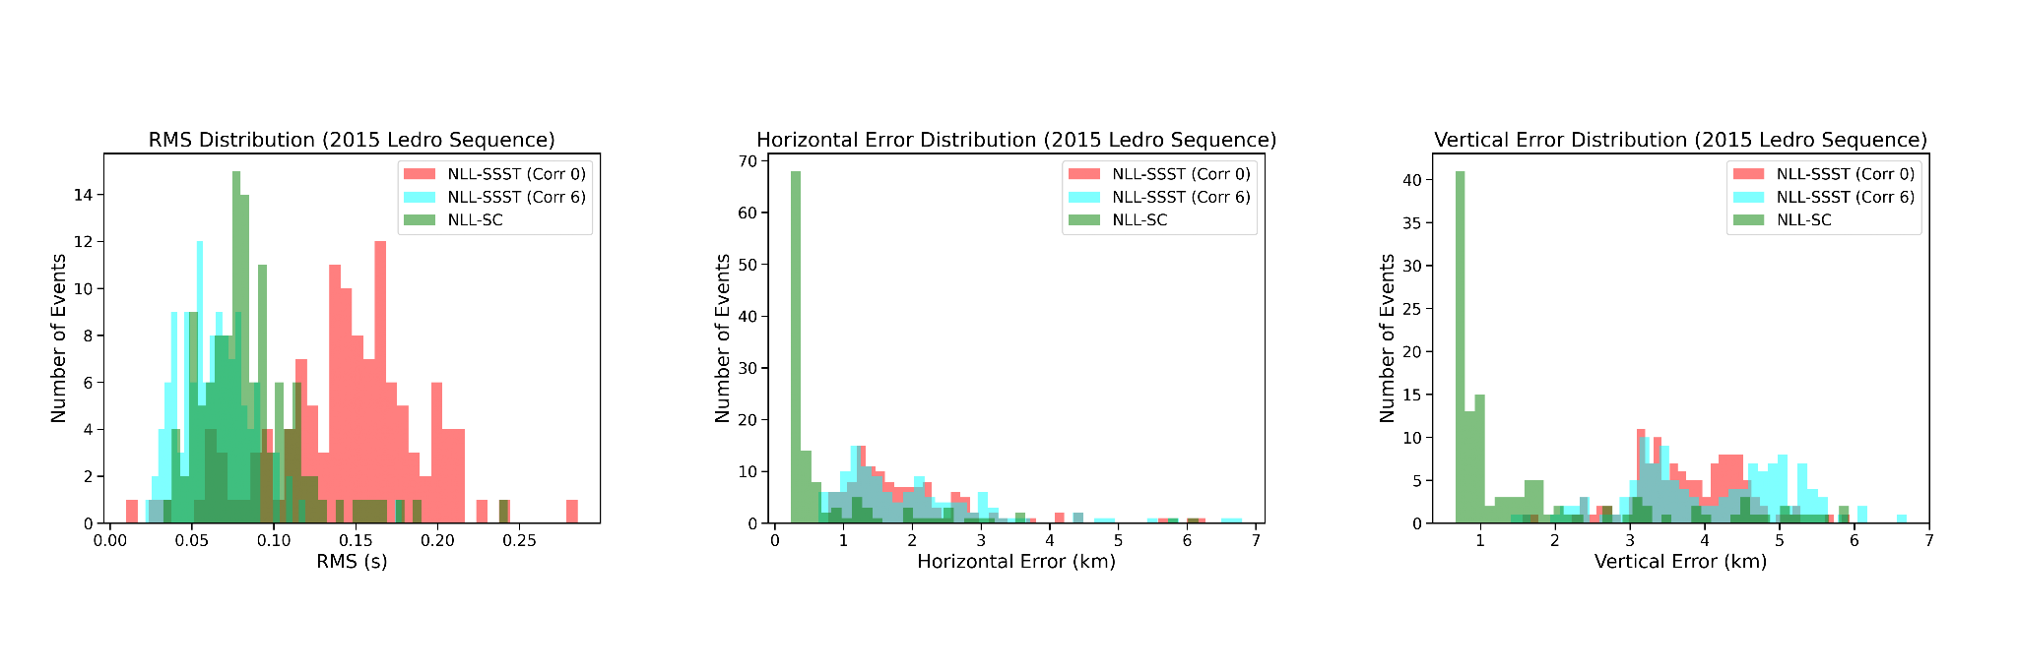
- b) c)
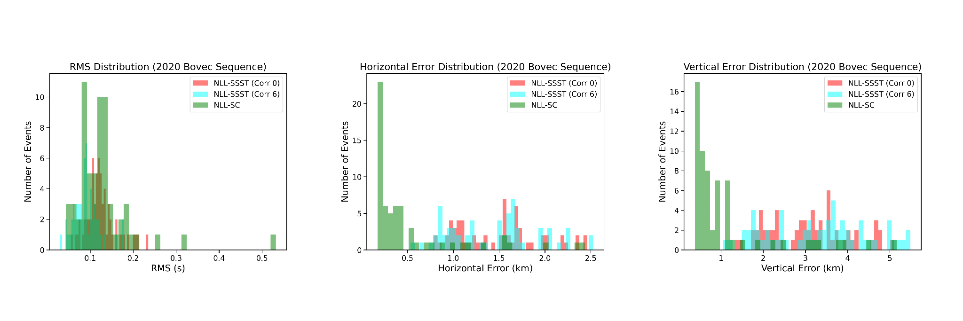
d) e) f)
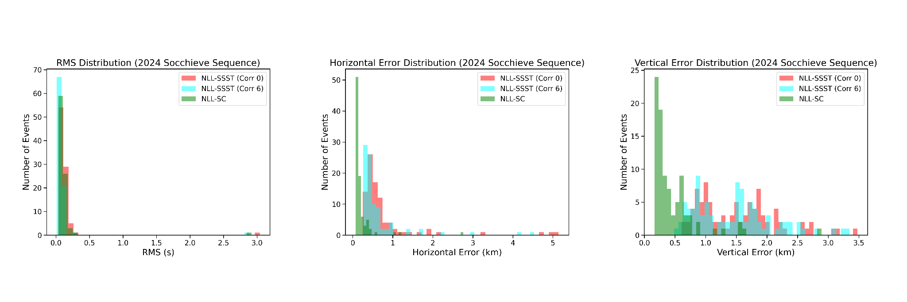
g) h) i)

Figure S2: RMS, Horizontal Error and Vertical Error obtained for initial iteration of NLL-SSST (red), last iteration of NLL-SSST (cyan) and NLL-SC (green) in the case of 2015 Ledro (a,b,c), 2020 Bovec (d,e,f) and 2024 Socchieve (g, h, i) sequences.

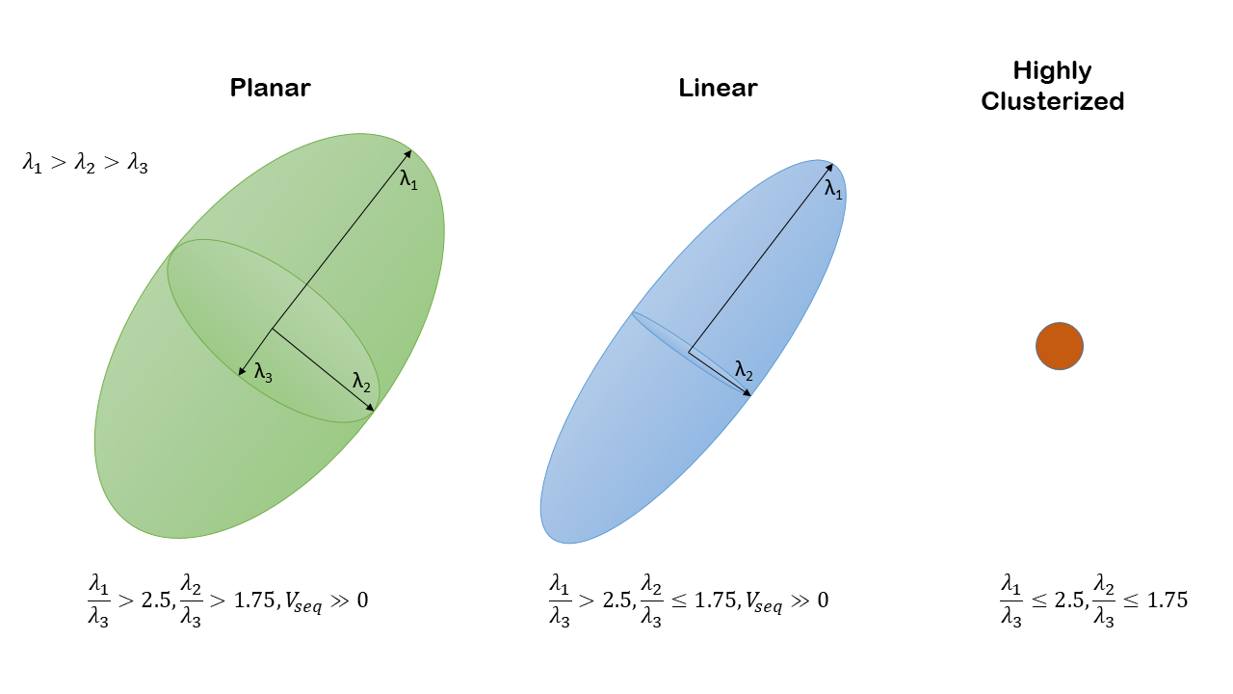
Figure S3: Classification of the sequence geometry based on PCA

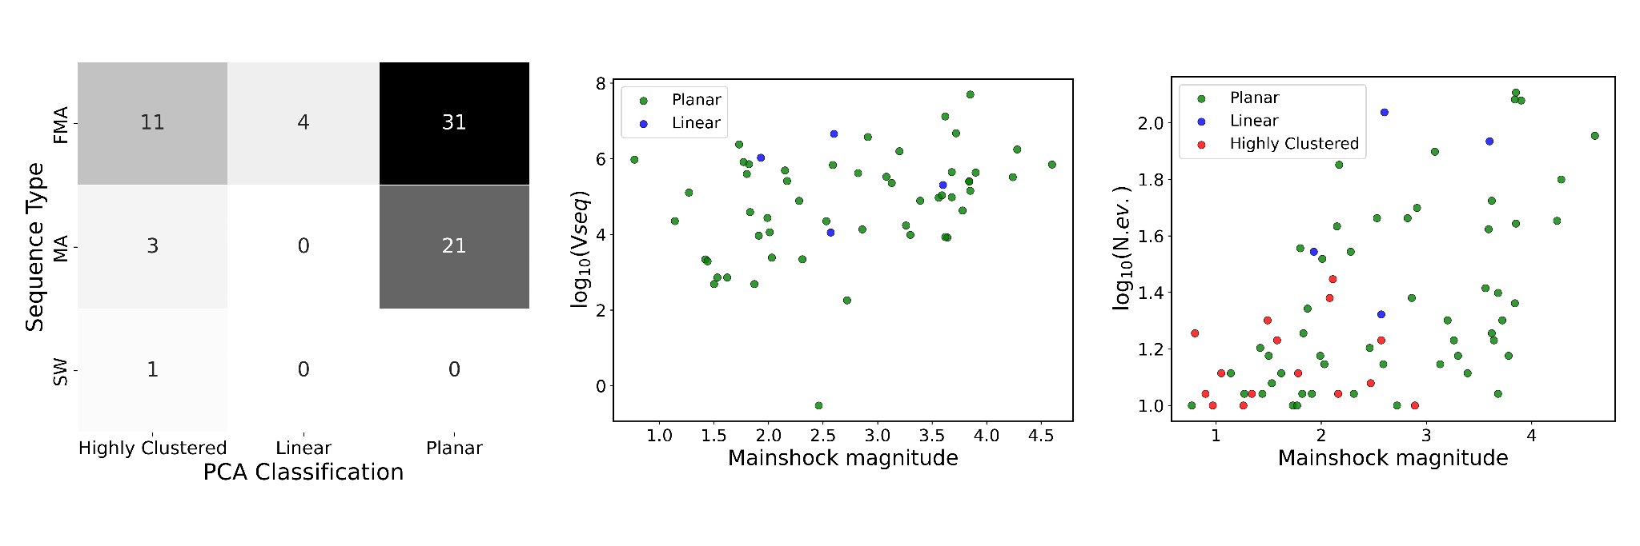

- b) c)

Figure S4: Characteristics of PCA classification typologies: a) Highly Clustered, Linear and Planar sequences as function of the sequence type b) Logarithm of V_{seq} for Planar and Linear sequences as function of the mainshock magnitude c) Logarithm of the number of events as function of mainshock magnitude for Planar, Linear and Highly Clustered sequences

N. Seq. | Origin Time Main. | ML Main. | Lon. Main. | Lat. Main. | N. ev. | N. for. | N. aft. | Seq. Type | Duration (days) | Location Main. | Area
1 | 2015-05-15  05:35:47.101 | 3.6 | 12.06 | 45.86 | 86 | 24 | 61 | FMA | 32.71 | Vidor (Veneto) | CS
2 | 2015-08-01  20:47:52.123 | 3.8 | 10.78 | 45.89 | 121 | 0 | 120 | MA | 31.85 | Ledro (Trentino) | WS
3 | 2015-08-12  07:09:54.981 | 1.9 | 13.05 | 46.30 | 22 | 0 | 21 | MA | 18.18 | Trasaghis (Friuli) | CS
4 | 2015-08-18  20:10:02.592 | 3.7 | 11.92 | 45.88 | 11 | 0 | 10 | MA | 27.62 | Alano di Piave (Veneto) | CS
5 | 2015-08-29  18:47:04.054 | 4.2 | 13.61 | 46.31 | 45 | 0 | 44 | MA | 49.37 | Bovec (Slovenia) | ES
6 | 2015-10-28  14:08:10.353 | 1.6 | 10.69 | 45.65 | 17 | 6 | 10 | FMA | 13.45 | Gargnano (Lombardia) | WS
7 | 2015-11-01  20:20:42.254 | 3.1 | 10.78 | 45.89 | 79 | 47 | 31 | FMA | 42.97 | Ledro (Trentino) | WS
8 | 2015-11-11  19:46:38.725 | 3.3 | 12.84 | 46.49 | 17 | 1 | 15 | FMA | 6.75 | Ovaro (Friuli) | CS
9 | 2016-01-19  14:44:52.211 | 1.1 | 13.08 | 46.28 | 13 | 4 | 8 | FMA | 6.29 | Trasaghis (Friuli) | CS
10 | 2016-03-15  02:47:23.848 | 1.7 | 11.99 | 45.57 | 10 | 6 | 3 | FMA | 0.03 | Loreggia (Veneto) | CS
11 | 2016-04-23  10:27:36.980 | 2.9 | 11.92 | 46.15 | 10 | 7 | 2 | FMA | 24.19 | Sagron Mis (Veneto) | CS
12 | 2016-08-10  04:52:48.000 | 3.1 | 12.94 | 46.39 | 14 | 3 | 10 | FMA | 47.02 | Villa Santina (Friuli) | CS
13 | 2017-02-02  03:16:43.609 | 2.3 | 12.37 | 46.14 | 35 | 4 | 30 | FMA | 98.11 | Alpago (Veneto) | CS
14 | 2017-01-29  18:49:55.109 | 1.5 | 13.21 | 46.34 | 15 | 9 | 5 | FMA | 6.60 | Venzone (Friuli) | CS
15 | 2017-02-07  00:49:14.227 | 2.1 | 12.21 | 45.95 | 24 | 14 | 9 | FMA | 7.49 | Tarzo (Veneto) | CS
16 | 2017-03-26  00:11:24.404 | 1.3 | 12.37 | 46.14 | 11 | 3 | 7 | FMA | 88.18 | Alpago (Veneto) | CS
17 | 2017-06-13  22:46:56.201 | 2.5 | 12.37 | 46.15 | 46 | 10 | 35 | FMA | 179.58 | Alpago (Veneto) | CS
18 | 2017-06-04  18:00:57.159 | 3.8 | 10.70 | 45.63 | 15 | 0 | 14 | MA | 48.41 | San Zeno di Montagna (Veneto) | WS
19 | 2017-09-06  12:22:30.262 | 3.6 | 11.98 | 46.27 | 26 | 0 | 25 | MA | 30.63 | Voltago Agordino (Veneto) | CS
20 | 2017-10-24  14:21:40.443 | 1.8 | 12.36 | 46.15 | 13 | 5 | 7 | FMA | 76.37 | Alpago (Veneto) | CS
21 | 2018-01-17  10:22:20.552 | 3.8 | 13.59 | 46.32 | 23 | 0 | 22 | MA | 39.55 | Bovec (Slovenia) | ES
22 | 2018-02-25  08:16:30.073 | 3.9 | 12.59 | 46.37 | 128 | 0 | 127 | MA | 88.57 | Forni di Sopra (Friuli) | CS
23 | 2018-03-30  02:16:54.072 | 0.9 | 13.59 | 46.12 | 11 | 6 | 4 | SW | 0.07 | Stregna (Friuli) | ES
24 | 2018-04-19  07:53:28.061 | 1.8 | 12.16 | 46.24 | 11 | 0 | 10 | MA | 1.42 | La Valle Agordina (Veneto) | CS
25 | 2018-05-09  21:48:02.864 | 3.6 | 13.11 | 46.29 | 17 | 1 | 15 | FMA | 53.08 | Bordano (Friuli) | CS
26 | 2018-07-02  19:14:24.050 | 2.5 | 12.58 | 46.28 | 16 | 3 | 12 | FMA | 9.44 | Claut (Friuli) | CS
27 | 2018-08-11  03:30:39.616 | 3.9 | 13.04 | 46.33 | 120 | 6 | 113 | FMA | 21.44 | Cavazzo Carnico (Friuli) | CS
28 | 2019-02-01  08:18:23.672 | 0.8 | 12.68 | 46.27 | 10 | 6 | 3 | FMA | 1.48 | Frisanco (Friuli) | CS
29 | 2019-02-15  04:24:07.057 | 2.2 | 14.26 | 45.64 | 71 | 64 | 6 | FMA | 55.13 | Pivka (Slovenia) | ES
30 | 2019-02-15  20:37:29.242 | 1.9 | 10.60 | 46.53 | 35 | 29 | 5 | FMA | 45.46 | Stelvio (Trentino) | WS
31 | 2019-04-03  01:51:35.256 | 2.3 | 13.28 | 46.30 | 11 | 7 | 3 | FMA | 2.54 | Lusevera (Friuli) | CS
32 | 2019-06-14  13:57:24.164 | 3.9 | 12.99 | 46.39 | 44 | 0 | 43 | MA | 25.56 | Verzegnis (Friuli) | CS
33 | 2019-07-22  11:58:43.216 | 1.8 | 12.20 | 46.08 | 10 | 1 | 8 | FMA | 4.15 | Limana (Veneto) | CS
34 | 2019-09-22  12:58:43.205 | 3.7 | 13.00 | 46.45 | 20 | 0 | 19 | MA | 46.03 | Zuglio (Friuli) | CS
35 | 2019-09-26  04:59:41.413 | 0.8 | 12.44 | 46.33 | 18 | 10 | 7 | FMA | 1.84 | Cimolais (Friuli) | CS
36 | 2020-01-10  13:31:09.402 | 1.5 | 13.28 | 46.30 | 20 | 0 | 19 | MA | 51.80 | Lusevera (Friuli) | CS
37 | 2020-03-06  19:21:18.717 | 2.8 | 11.82 | 46.05 | 46 | 9 | 36 | FMA | 52.42 | Sovramonte (Veneto) | CS
38 | 2020-04-28  22:59:53.139 | 1.6 | 13.25 | 46.34 | 13 | 1 | 11 | FMA | 0.32 | Resia (Friuli) | CS
39 | 2020-05-17  15:09:05.614 | 1.3 | 13.57 | 46.24 | 11 | 7 | 3 | FMA | 6.75 | Kobarid (Slovenia) | ES
40 | 2020-06-02  08:46:53.227 | 1.5 | 13.25 | 46.34 | 12 | 11 | 0 | FMA | 0.15 | Resia (Friuli) | CS
41 | 2020-07-13  12:06:54.489 | 3.7 | 12.63 | 46.33 | 25 | 0 | 24 | MA | 22.23 | Forni di Sotto (Friuli) | CS
42 | 2020-07-17  02:50:57.814 | 4.3 | 13.54 | 46.31 | 63 | 0 | 62 | MA | 41.06 | Bovec (Slovenia) | ES
43 | 2020-09-01  03:25:52.593 | 1.8 | 13.46 | 46.08 | 36 | 7 | 28 | FMA | 2.36 | Cividale del Friuli (Friuli) | CS
44 | 2020-10-13  05:00:12.079 | 2.0 | 13.37 | 46.22 | 33 | 8 | 24 | FMA | 10.87 | Taipana (Friuli) | CS
45 | 2021-02-22  12:04:06.744 | 3.6 | 10.99 | 45.77 | 18 | 0 | 17 | MA | 55.46 | Ala (Trentino) | WS
46 | 2021-03-05  09:15:18.253 | 2.1 | 13.12 | 46.46 | 28 | 25 | 2 | FMA | 2.87 | Zuglio (Friuli) | CS
47 | 2021-07-01  10:50:02.625 | 2.2 | 13.89 | 45.98 | 11 | 0 | 10 | MA | 2.83 | Cepovan (Slovenia) | ES
48 | 2021-07-31  23:44:21.602 | 1.4 | 13.04 | 46.37 | 16 | 9 | 6 | FMA | 46.30 | Cavazzo Carnico (Friuli) | CS
49 | 2021-08-03  19:05:16.322 | 2.1 | 12.20 | 45.91 | 43 | 18 | 24 | FMA | 25.52 | Refrontolo (Veneto) | CS
50 | 2021-08-10  15:21:30.648 | 2.6 | 13.40 | 46.08 | 21 | 3 | 17 | FMA | 21.06 | Cividale del Friuli (Friuli) | CS
51 | 2021-09-22  18:29:57.783 | 1.8 | 12.75 | 46.16 | 18 | 13 | 4 | FMA | 9.30 | Fanna (Friuli) | CS
52 | 2021-09-28  00:45:55.442 | 3.6 | 12.01 | 45.94 | 53 | 1 | 51 | FMA | 5.04 | Valdobbiadene (Veneto) | CS
53 | 2022-06-29  17:35:44.876 | 1.4 | 13.68 | 46.37 | 11 | 4 | 6 | FMA | 157.48 | Soca (Slovenia) | ES
54 | 2022-05-03  08:33:59.884 | 2.7 | 12.87 | 46.35 | 10 | 0 | 9 | MA | 30.66 | Preone (Friuli) | CS
55 | 2022-12-19  03:41:54.021 | 2.9 | 12.59 | 46.32 | 24 | 0 | 23 | MA | 11.30 | Claut (Friuli) | CS
56 | 2022-12-24  07:14:27.404 | 2.6 | 14.41 | 45.54 | 17 | 4 | 12 | FMA | 1.17 | Ilirska Bristrica (Slovenia) | ES
57 | 2023-03-11  02:56:31.785 | 3.3 | 12.91 | 46.36 | 15 | 0 | 14 | MA | 10.17 | Preone (Friuli) | CS
58 | 2023-07-17  19:11:20.118 | 1.3 | 12.75 | 46.17 | 10 | 1 | 8 | FMA | 3.06 | Fanna (Friuli) | CS
59 | 2023-07-30  06:29:49.845 | 2.0 | 13.72 | 46.18 | 14 | 0 | 13 | MA | 2.90 | Tolmin (Slovenia) | ES
60 | 2023-09-10  21:50:18.565 | 1.1 | 13.03 | 46.41 | 13 | 5 | 7 | FMA | 0.50 | Tolmezzo (Friuli) | CS
61 | 2023-09-11  13:21:25.789 | 3.6 | 13.69 | 46.08 | 42 | 0 | 41 | MA | 43.08 | Kad nad Kanalom (Slovenia) | ES
62 | 2023-11-05  23:01:01.406 | 2.9 | 13.60 | 46.34 | 50 | 18 | 31 | FMA | 18.05 | Bovec (Slovenia) | ES
63 | 2023-12-25  12:22:11.186 | 2.5 | 12.68 | 46.28 | 12 | 0 | 11 | MA | 9.12 | Tramonti di Sotto (Friuli) | CS
64 | 2024-01-09  00:02:26.378 | 3.4 | 14.36 | 46.43 | 13 | 1 | 11 | FMA | 45.98 | Tržič (Slovenia) | ES
65 | 2024-03-27  21:19:37.383 | 4.6 | 12.81 | 46.35 | 90 | 0 | 89 | MA | 63.05 | Socchieve (Friuli) | CS
66 | 2024-05-11  00:12:00.229 | 1.9 | 12.39 | 46.17 | 11 | 0 | 10 | MA | 3.01 | Alpago (Veneto) | CS
67 | 2024-07-06  07:15:41.664 | 2.6 | 10.55 | 46.02 | 109 | 22 | 86 | FMA | 73.33 | Saviore dell’Adamello (Lombardia) | WS
68 | 2024-07-30  20:20:00.229 | 2.6 | 10.41 | 46.00 | 14 | 6 | 7 | FMA | 24.84 | Paspardo (Lombardia) | WS
69 | 2024-08-24  21:58:40.558 | 1.0 | 11.02 | 45.83 | 10 | 6 | 3 | FMA | 0.83 | Mori (Trentino) | WS
70 | 2024-09-23  12:53:13.168 | 3.2 | 10.43 | 46.01 | 20 | 2 | 17 | FMA | 63.22 | Paspardo (Lombardia) | WS
71 | 2024-10-18  19:50:57.756 | 2.0 | 10.55 | 46.05 | 15 | 3 | 11 | FMA | 53.56 | Tione di Trento (Trentino) | WS

Table S1: Information on identified sequences includes origin time, magnitude and epicenter location of the mainshock, along with the total number of events, number of foreshocks, number of aftershocks, type, and reference location for the sequence.

