Molecularly imprinted electrochemical sensors based on mesoporous silica films for the detection of Deoxynivalenol in grain
Ke Wang ª, Sidi Zhang ª, Daokun Xu ^{b}, Songsong Jiang ^{c}, Lifeng Wang ^{a*}, Donglei Jiang ^{a*}
^{a.} College of Food Science and Engineering, Collaborative Innovation Center for Modern Grain Circulation and Safety, Key Laboratory of Grains and Oils Quality Control and Processing, Nanjing University of Finance and Economics, Nanjing, Jiangsu 210023, PR China
^{b.} Nanjing Institute for Food and Drug Control, Nanjing, Jiangsu, 211198, PR China
^{c.} College of Tourism and Culinary Science, Yangzhou University, Yangzhou, Jiangsu 225127, PR China

*Corresponding author*:
E-mail addresses: dljiang@nufe.edu.cn,wanglifeng 8@163.com
Tel/Fax：86-025- 86718520

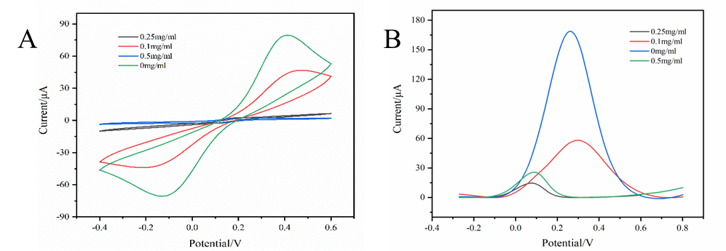
Figure S1. (A) CV curves of GO at different concentrations (B) DPV curves of GO at different concentrations.

Figure S2. Sensor specificity (A) and repeatability (B)

Table S1. Analytical performances of other methods for DON
Method | Linear range | LOD | Ref.
DNA fluorescent aptasensor biosensor | 0.1-50 ng/mL | 0.033 ng/mL | [1]
Immunofluorescence probe | 0-16 ng/mL | 0.25 ng/mL | [2]
Aptasensor biosensor | 0.1-100 ng/mL | 0.08 ng/mL | [3]
Immunochromatographic strip | 50-10000 μg/kg | 28.16 μg/kg | [4]
Molecularly imprinted biosensors | 0.1-500 ng/mL | 0.028 ng/mL | This work

Table S2. Determination of DON in wheat flour sample using Arg-MIP/rGO/VMSF/SPCE with the method of standard additions (n =3).
Sample | Added (ng/mL) | Founded(ng/mL) | Recovery (%) | RSD (%)
Wheat | 10 | 9.57±0.19 | 95.73±1.86 | 1.98
Wheat | 50 | 48.97±0.88 | 97.93±1.78 | 1.79
Wheat | 100 | 100.52±0.59 | 100.52±0.59 | 0.59

Reference
[1] J. Meng, R. Li, X. Chen, X. Wang, Q. Huang, D. Nie, D. Guo, Z. Zhao, Z. Han, Magnetic beads-based double-stranded DNA fluorescent aptasensor biosensor for deoxynivalenol detection, Food Chemistry 473 (2025) 143042. https://doi.org/10.1016/j.foodchem.2025.143042.
[2] C. Dong, Y. Li, X. Sun, X. Yang, T. Wei, A Highly Sensitive Silicon-Core Quantum Dot Fluorescent Probe for Vomitoxin Detection in Cereals, Foods 14 (2025) 1545. https://doi.org/10.3390/foods14091545.
[3] W. Yu, X. Lin, N. Duan, Z. Wang, S. Wu, A fluorescence and surface-enhanced Raman scattering dual-mode aptasensor for sensitive detection of deoxynivalenol based on gold nanoclusters and silver nanoparticles modified metal-polydopamine framework, Analytica Chimica Acta 1244 (2023) 340846. https://doi.org/10.1016/j.aca.2023.340846.
[4] J. Wang, L. Wang, H. Zhang, X. Mei, L. Qiu, J. Liu, Y. Zhou, Development of a time-resolved immunochromatographic strip for rapid and quantitative determination of deoxynivalenol, Front. Vet. Sci. 10 (2023). https://doi.org/10.3389/fvets.2023.1142820.

