Supplementary Data

Table S1. The primers used in this study for qRT-PCR assays
Genes | Forward primer (5’-3’) | Reverse primer (5’-3’)
qRT-PCR assay
NFATc1 | GTCAGAGCGAGACTCAGAGG | TCCTTACTACAGGTCGGCCA
GAPDH | TGCACCACCAACTGCTTAGC | GGCATGGACTGTGGTCATGAG
SNAI1 | TCTCTGAGGCCAAGGATCTC | ATTCCATGGCAGTGACAAGG
ZEB1 | AGACATGTGACGCAGTCTGGG | CACTTAAATTGATACTTATGG
E-cadherin | ACAGCCCCGCCTTATGATTCTC | AAGCGATTGCCCCATTCGTT
Vimentin | CCTTGAACGCAAAGTGGAATC | GACATGCTGTTCCTGAATCTGAG
Twist1 | CCGTGGACAGTGATTCCCAG | CCTTTCAGTGGCTGATTGGC
SLUG | ACGCCTCCAAAAAGCCAAAC | ACTCACTCGCCCCAAAGATG
ZEB2 | AGCCTCTGTAGATGGTCCAGT | GGTCAGCAGTTGGGCAAAAG
TCF3 | GCACTGGCCTCGATCTACTC | GGCCTCGTTAATATCCCGCA
FOXC2 | TTCATCATGGACCGCTTCCC | CGCTCTTGATCACCACCTTCT
GRHL2 | TTGGGCTGATGGCAACTGTAA | TGGTGTAGGCTCTTCGGGTA

Table S2. The primers used in this study for luciferase reporter plasmid construction
Constructs | Position | Forward primer (5’-3’) | Reverse primer (5’-3’)
pGL3-SLUG-Luc | -1571/+32 | CAGGTTCCAGTTTGTGTGTGG | CACCCGGCTCCTTTACGAAC
pGL3-SLUG-Luc | -1455/+40 | AGAACCAGGGGAGGACGATT | AGAAGAACCACTCGCTAGGC
 | -1451/-860 | CCAGGGGAGGACGATTTTGT | TATCAAGGGAAAAGGCCCGAG
 | -1064/-541 | ACTCTAACCAGGTCCCTCCTC | TGAAATGCCACGGCCTTTTTG
 | -558/+43 | AAAGGCCGTGGCATTTCAAG | CGCAGAAGAACCACTCGCTA

Table S3. qPCR primers used in this study for ChIP assay
Genes | Position | Forward primer (5’-3’) | Reverse primer (5’-3’)
SNAI1 | negative control | TGAAAAGGGGCCCTCAACTC | GCCCTCTACACACATCATTGC
 | F1:-548/-260 | GCATTTCAAGCCGCCGAG | GGACGTCGAGCGAAGCGA
 | F2:-283/-8 | GAGGCCTCGCTTCGCTC | GCCGCCAACTCCCTTAAGTA

Table S4. The ARRIVE Guidelines Checklist.

 | ITEM
Title | 1 | Expression of NFATc1 promotes liver and lung metastasis in mice
Abstract | 2 | BACKGROUND AND PURPOSE: Colorectal cancer is a leading cause of cancer-related deaths in the world. Our aim was to determine whether overexpression of NFATc1 transcription factor increase the liver and lung metastasis in mice and whether FK506, a selective inhibitor of classic Ca2+/calcineurin-NFAT could inhibit SW480 cells metastasis in vivo.  EXPERIMENTAL APPROACH: Shown in Experimental procedures.
INTRODUCTION
Background | 3a | Colorectal cancer (CRC) is a leading cause of cancer-related deaths in the world, which is responsible for around 881 000 deaths worldwide each year (www.WHO.int). Although CRC patients benefit from conventional and advanced therapies such as surgical resection, chemotherapy, radiotherapy and immunotherapy; there are still 20-30% of patients who suffer from metastasis and (or) recurrence, particularly in patients with stage II, III, or IV disease. Thus, a better understanding of how key molecular and cellular regulators drive cancer cells’ escape from the primary tumor and invasion into distant organs is necessary.
 | 3b | To delineate the effect of NFATc1 in CRC metastasis, we established the stable overexpressed SW480 cell lines which have metastatic potential. As we know, the most common site of metastases for colon cancer is the liver, and colon cancer cells may also spread to the lungs. We established lung and liver metastasis model in female BALB/c nude mice.
Objectives | 4 | Therefore, the objectives of this study were to determine whether overexpression of NFATc1 transcription factor increase the liver and lung metastasis in mice and whether FK506, a selective inhibitor of classic Ca2+/calcineurin-NFAT could inhibit SW480 cells metastasis in vivo.
METHODS
Ethical statement | 5 | All experimental procedures involving animals were conducted in accordance with Institution Guide lines and were approved by the Laboratory Animal Center of Xi’an Jiaotong University (Xi’an, P.R. China).  Animal experiments complied with the ARRIVE guidelines, and were carried out in accordance with the National Institutes of Health guidelines for the care and use of laboratory animals.
Study design | 6 | Two groups of 10 mice each and two groups of 8 mice each were studied: A. Control SW480 B. Overexpression-NFATc1-SW480 C. Overexpression-NFATc1-SW480 + PBS treatment D. Overexpression-NFATc1-SW480 + FK506 treatment  Animals were randomized into control group and overexpression-NFATc1 group. Animals were randomized into PBS treatment group and FK506 group.
Experimental procedures | 7 | Mice were anesthetized by isoflurane (25% w/v isoflurane in propylene glycol) (Route: nose cone).  To establish lung and liver metastasis model, 1X10⁶ NFATc1-overexpressing SW480 colon cancer cells or their control cells were injected into the tail vein of nude mice using a 27G needle. Then an 8mm left subcostal incision was made and the spleen was confirmed to be under the peritoneum. Next the peritoneum was opened for about 7mm to expose spleen over the peritoneum and the cell suspension of 2X10⁶/50ul of SW480 cells was injected into the spleen using an insulin syringe. Finally, the spleen was returned to the abdominal cavity, the peritoneum was sutured with one stitch and the wound was closed with a clip.  Mice were treated by FK506 ((0.1mg/kg)) or PBS by intraperitoneal injection for 21 days.  All experiments were conducted in the light phase.  Mice were euthanatized by carbon dioxide (CO2).
Experimental animals | 8 | Female BALB/c nude mice, aged 8 weeks, were included (n=36).  Mice were obtained from the Animal Center of Xi’an Jiaotong University and housed under specific pathogen-free (SPF) conditions.
Housing and husbandry | 9 | Mice were housed with an inverse 12 hours day-night cycle with lights on at 8:30 pm in a temperature (23⁰C) and humidity (55%) controlled room.  Mice were housed under specific pathogen-free (SPF) conditions.  Mice were allowed free access to water and a normal maintenance diet.
Sample size | 10 | Thirty-six healthy mice were divided into four groups of double ten mice per group and double eight mice per group (Table 1).
Allocating animals to experimental group | 11 | All surgeries were operated by same operators: Tianli Shen and Yunhua Wu.
Experimental outcomes | 12 | Shown in Table 1 and Figure 5.
Statistical methods | 13 | The number of metastatic nodules was tested by Mann-Whitney test.  The volume of tumor in spleen was tested by Mann-Whitney test.  The number of positive Vimentin SW480 cell was tested by Mann-Whitney test.
RESULT
Baseline data | 14 | The mice were free of all viral, bacterial, and parasitic pathogens.
Numbers analysed | 15 | Shown in Table 1.
Outcomes and estimation | 16 | Shown in Table 1.
Adverse events | 17 | None
DISCUSSION
Interpretation/scientific implications | 18 | The aim of our study was to verify if overexpression of NFATc1 could promote SW480 cells metastasis in mice and application of FK506 could reduce metastasis in vivo.  A limitation of this study is the fact that we just carried out the experiment in nude mice. Next, we will verify this conclusion in murine colon cancer cells such as MC38.  We innovatively established a live-lung double metastasis model in a mouse, which greatly reduced the sacrifice of the mouse.
Generalisability/translation | 19 | None
Funding | 20 | This project was sponsored by the National Nature Science Foundation of China (81972720), by the Science and Technology Project of Shaanxi Province (2019SF-066).

Figure S1 Western blot analysis of NFATc1 expression in 8 monoclonal NFATc1-KO HCT116 cells.

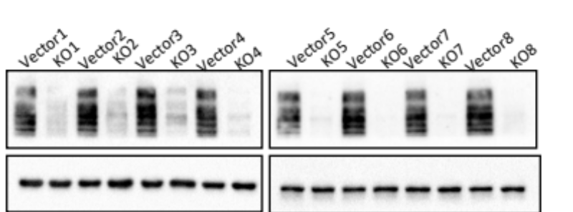

Figure S2 Overexpression of NFATc1 in SW480 and SW620 was confirmed by real-time PCR.

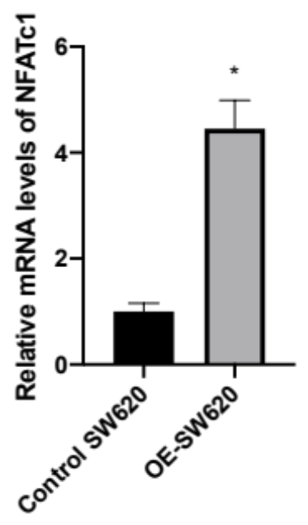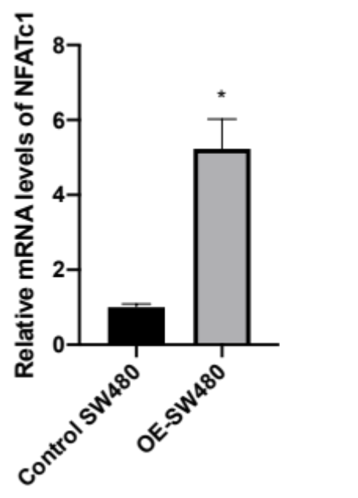

Figure S3 Real-time PCR analysis of EMT related transcription factors: Snai1, Twist1, Slug, Zeb1, Zeb2, GRHL2, FOXC2 and TCF3 in SW480 cells transfected with lentivirus overexpressing NFATc1 or vector control (Mann Whitney test). Results are expressed as the mean ± S.D. of three independent experiments. *P<0.05

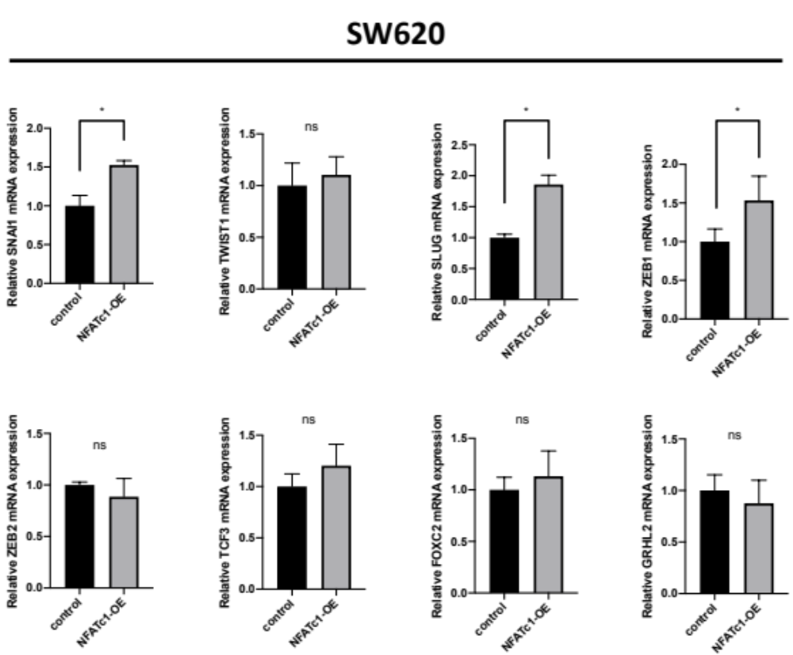

Figure S4 SW480 cells stably expressing NFATc1 and control cells were transfected with pGL-Basic plasmids containing the expand promoter region of Slug (-3000/+32) genes.

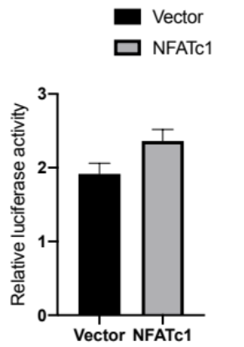

Figure S5 The mice were awake during anesthesia that underwent the lung and liver metastasis surgery.

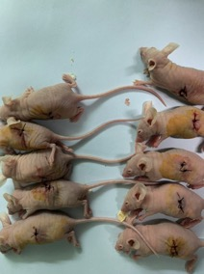

Figure S6

Uncropped Western blots

Figure 1G

Loading order: SW480, SW620, HCT116, LoVo, Caco-2, DLD-1
Antibody: NFATc1

Loading order: SW480, SW620, HCT116, LoVo, Caco-2, DLD-1
Antibody: GAPDH

Figure 3A

Wrong Loading

HCT116,
Loading order: Ctrl, KO1, Wrong loading, Ctrl, KO5
Antibody: NFATc1

HCT116,
Loading order: Ctrl, KO1, Wrong loading, Ctrl, KO5
Antibody: GAPDH

SW480, SW620
Loading order: SW480-Ctrl, SW480-OE, SW620-Ctrl, SW620-OE
Antibody: NFATc1

SW480, SW620
Loading order: SW480-Ctrl, SW480-OE, SW620-Ctrl, SW620-OE
Antibody: GAPDH

HCT116,
Loading order: Ctrl, KO1, Ctrl, KO5
Antibody: E-cadherin

SW480, SW620
Loading order: SW480-Ctrl, SW480-OE, SW620-Ctrl, SW620-OE
Antibody: E-cadherin

HCT116,
Loading order: Ctrl, KO1, Ctrl, KO5
Antibody: Vimentin

SW480, SW620
Loading order: SW480-Ctrl, SW480-OE, SW620-Ctrl, SW620-OE
Antibody: Vimentin

HCT116,
Loading order: Ctrl, KO1, Ctrl, KO5
Antibody: GAPDH

SW480, SW620
Loading order: SW480-Ctrl, SW480-OE, SW620-Ctrl, SW620-OE
Antibody: GAPDH

HCT116,
Loading order: Ctrl, KO1, Ctrl, KO5
Antibody: Snai1

HCT116,
Loading order: Ctrl, KO1, Ctrl, KO5
Antibody: β-tubulin

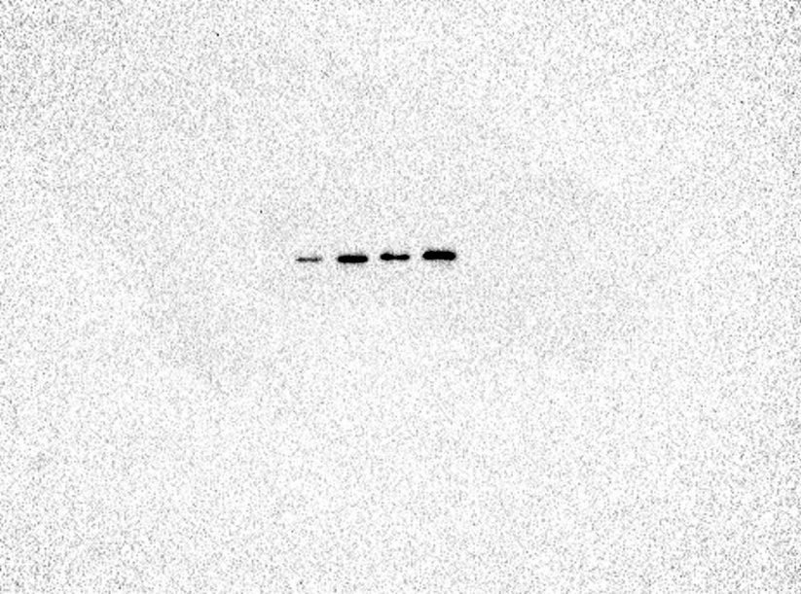

SW480, SW620
Loading order: SW480-Ctrl, SW480-OE, SW620-Ctrl, SW620-OE
Antibody: Snai1

SW480, SW620
Loading order: SW480-Ctrl, SW480-OE, SW620-Ctrl, SW620-OE
Antibody: β-tubulin

SW480, SW620
Loading order: SW480-Ctrl, SW480-OE, SW620-Ctrl, SW620-OE
Antibody: Slug

SW480, SW620
Loading order: SW480-Ctrl, SW480-OE, SW620-Ctrl, SW620-OE
Antibody: β-tubulin

SW480, SW620
Loading order: SW480-Ctrl, SW480-OE, SW620-Ctrl, SW620-OE
Antibody: Slug

SW480, SW620
Loading order: SW480-Ctrl, SW480-OE, SW620-Ctrl, SW620-OE
Antibody: β-tubulin

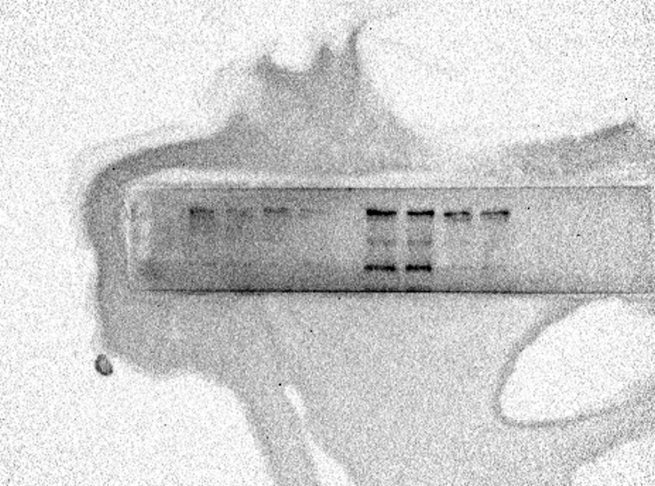

HCT116, SW480, SW620
Loading order: Ctrl, KO1, Ctrl, KO5, SW480-Ctrl, SW480-OE, SW620-Ctrl, SW620-OE
Antibody: ZO-1

HCT116, SW480, SW620
Loading order: Ctrl, KO1, Ctrl, KO5, SW480-Ctrl, SW480-OE, SW620-Ctrl, SW620-OE
Antibody: GAPDH

Figure 4J

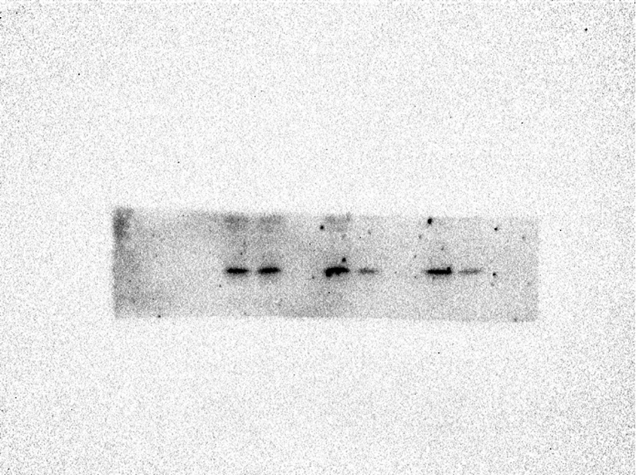

Stable NFATc1-overexpressed SW480 cells
Loading order: siCon, siSnai1, siCon, siSlug, siCon, siSnai1 and Slug
Antibody: Slug

Stable NFATc1-overexpressed SW480 cells
Loading order: siCon, siSnai1, siCon, siSlug, siCon, siSnai1 and Slug
Antibody: β-Tubulin

Stable NFATc1-overexpressed SW480 cells
Loading order: siCon, siSnai1, siCon, siSlug, siCon, siSnai1 and Slug
Antibody: Snai1

Stable NFATc1-overexpressed SW480 cells
Loading order: siCon, siSnai1, siCon, siSlug, siCon, siSnai1 and Slug
Antibody: β-Tubulin

Stable NFATc1-overexpressed SW480 cells
Loading order: siCon, siSnai1, siCon, siSlug, siCon, siSnai1 and Slug
Antibody: E-cadherin

Stable NFATc1-overexpressed SW480 cells
Loading order: siCon, siSnai1, siCon, siSlug, siCon, siSnai1 and Slug
Antibody: Vimentin

Stable NFATc1-overexpressed SW480 cells
Loading order: siCon, siSnai1, siCon, siSlug, siCon, siSnai1 and Slug
Antibody: GAPDH

Figure 4H (Exogenous Co-IP)

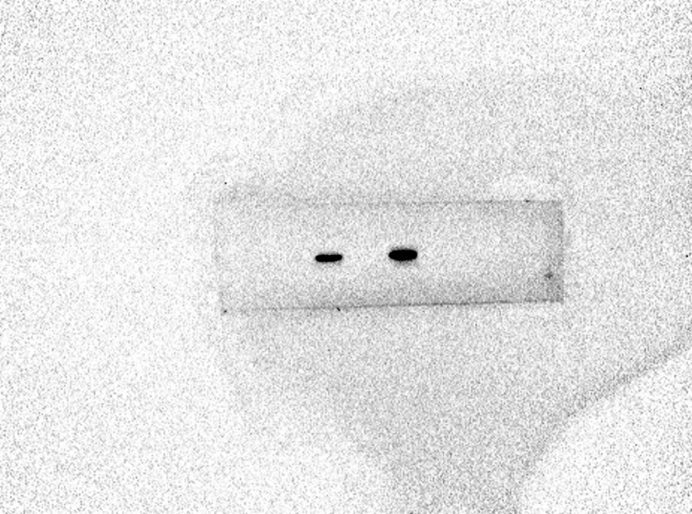


Figure 4I (Endogenous Co-IP)

