Supplementary Material
Angle-Resolved Magnetic Chirality Control in a Dy₃ Single Molecule Toroic
Sagar Paul,^{1,#} Zhenhua Zhu,^{2,3#}* Shuting Liu,² Appu Sunil¹, Eufemio Moreno-Pineda,^{4,5}* Jinkui Tang^{2,3}*and Wolfgang Wernsdorfer^{1,5,}*
¹ Physikalisches Institut, Karlsruhe Institute of Technology, D-76131 Karlsruhe, Germany.
²State Key Laboratory of Rare Earth Resource Utilization, Changchun Institute of Applied Chemistry, Chinese Academy of Sciences, Changchun 130022, P. R. China.
³School of Chemistry and Chemical Engineering, Beijing Institute of Technology, Beijing 102488, P. R. China.
⁴ Universidad de Panamá, Facultad de Ciencias Naturales, Exactas y Tecnología, Depto. de Química-Física, 0824 Panamá, Panamá.
⁵ Institute of Quantum Materials and Technologies (IQMT), Karlsruhe Institute of Technology (KIT), Hermann-von-Helmholtz-Platz 1, D-76344, Eggenstein-Leopoldshafen, Germany.
#These authors contributed equally to this work.
Contact authors: zhuzh@ciac.ac.cn; eufemio.moreno-pineda@kit.edu; tang@ciac.ac.cn; wolfgang.wernsdorfer@kit.edu

Contents:
1. Sample sythesis & basic characterization S2
2. Crystallographic details S4
3. Experimental details S8
3.1. Proton nuclear magnetic resonance S8
3.2. Infrared spectrum S8
3.3. X-ray diffraction S8
3.4. Magnetic (SQUID) measurements S8
3.5. μSQUID measurements S8
4. SQUID measurements S9
5. Supporting μSQUID measurements S14

- Sample syntheses and characterization:
All reactions and manipulations were carried out under aerobic conditions. Reagents were purchased from commercial sources and were used without further purification. 2-hydroxy-3-methoxybenzohydrazide was prepared via a previously published method.¹

Scheme S1. Synthesis of ligand HL
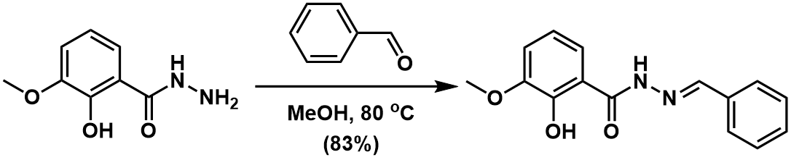

To a solution of benzaldehyde (1.17 g, 11 mmol) in MeOH (40 mL) was added 2-hydroxy-3-methoxybenzohydrazide (2.00 g, 11 mmol) and the mixture was heated to reflux for 24 h. The reaction mixture was concentrated via rotary evaporation. The solid was collected by filtration, washed with cold MeOH and Et₂O, dried under vacuum to give product as white solid (2.47 g, 9.1 mmol) in 83% yield. ¹H NMR (400 MHz, d₆-DMSO, 298 K) δ (ppm) 11.86 (s, 1H), 11.82 (s, 1H), 8.47 (s, 1H), 7.75 (d, J = 4.8 Hz, 2H), 7.47 (d, J = 4.5 Hz, 4H), 7.17 (d, J = 7.9 Hz, 1H), 6.90 (t, J = 7.9 Hz, 1H), 3.82 (s, 3H).

Scheme S2. Synthesis of complex Dy₃-Ph
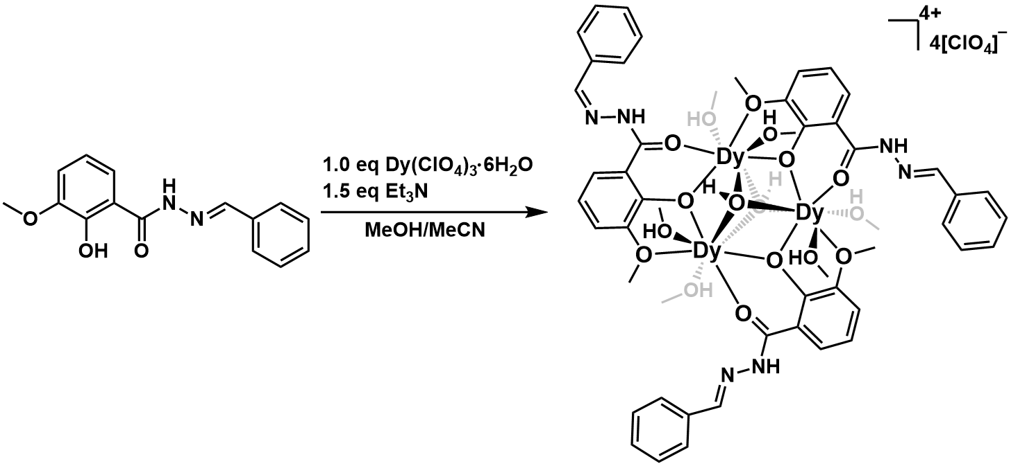

A solution of Dy(ClO₄)₃·6H₂O (0.1 mmol, 0.0569 g) in methanol (10 mL) was added to a solution of HL (0.1 mmol, 0.0270 g) in acetonitrile (5 mL). The mixture was stirred for 5 min, then Et₃N (0.15 mmol, 21 μL) was added. After stirring for 3 h at room temperature, the mixture was filtered to give a clear pale-yellow solution. Colorless hexagonal block crystals suitable for single crystal diffraction were obtained after slow diffusion of diethyl ether into this filtrate for several days (Yield: 22 mg, 11%, based on dysprosium). Selected IR (cm⁻¹): 3425 (br), 3317 (br), 3085 (w), 2957 (w), 2851 (w), 2592 (w), 1617 (w), 1594 (s), 1552 (s), 1493 (m), 1449 (w), 1439 (s), 1372 (m), 1312 (s), 1237 (s), 1211 (w), 1082 (s), 1062 (s), 1037 (s), 955 (m), 928 (w), 853 (s), 796 (s), 735 (m), 690 (m), 648 (w), 616 (m).

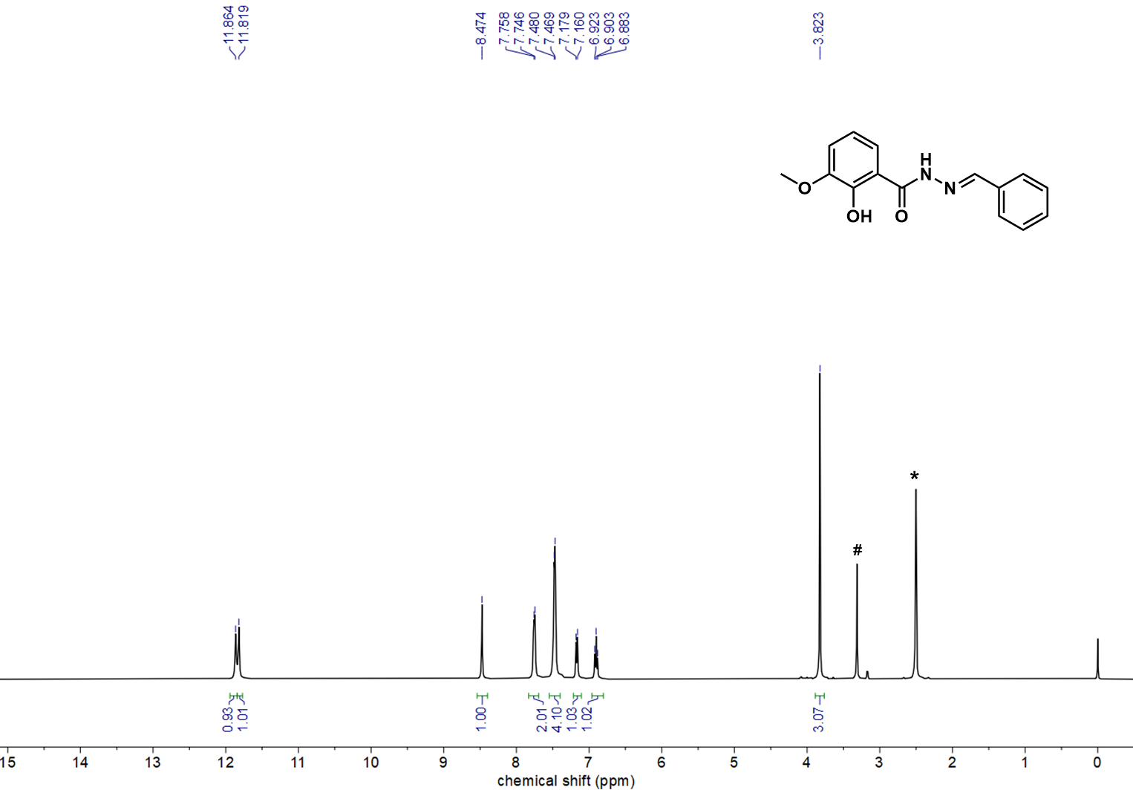
Figure S1. ¹H NMR (400 MHz, 298K) spectrum of HL in d₆-DMSO. *d₆-DMSO, #H₂O.

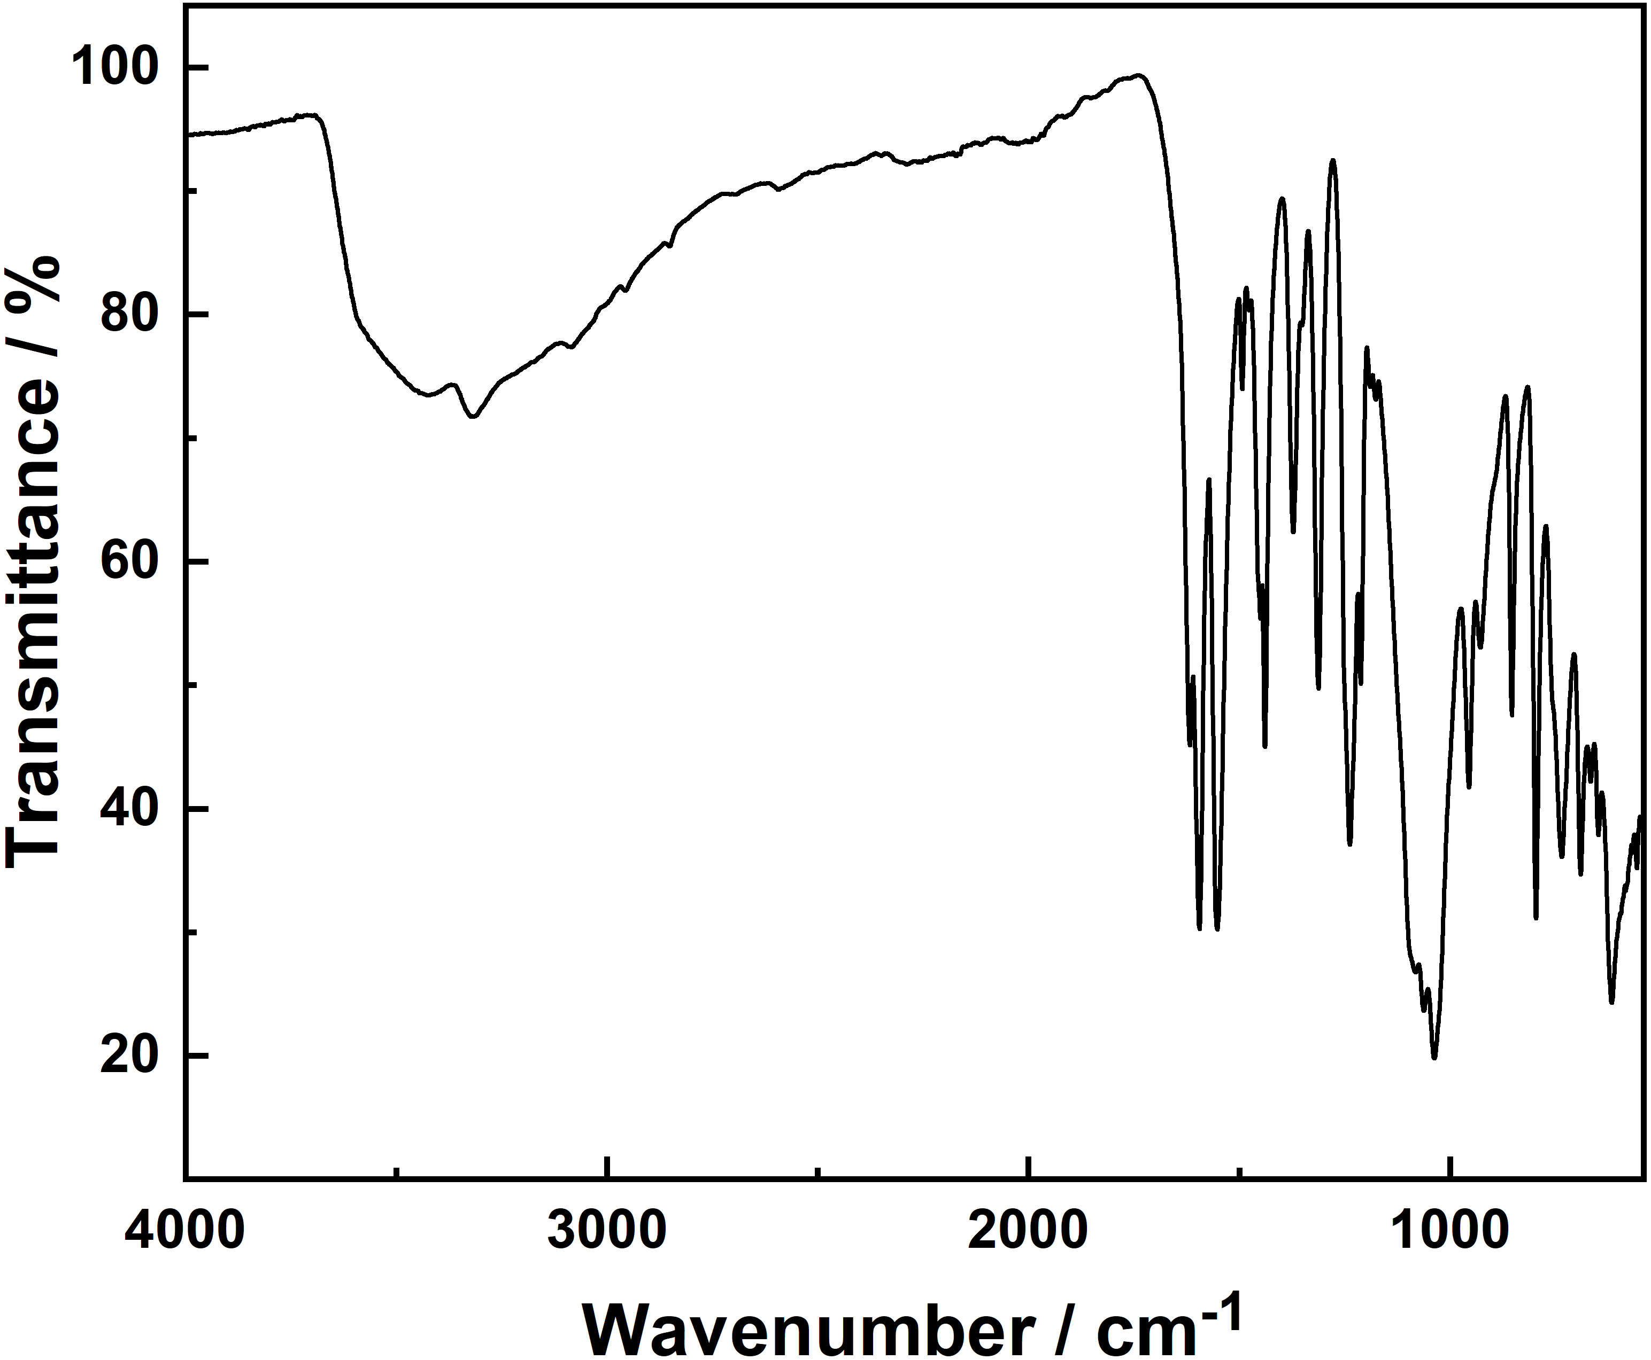
Figure S2. IR spectrum of Dy₃-Ph.

- Crystallographic Details:

Table S1. Crystal data and structure refinement for Dy₃-Ph.
Identification code | Dy₃-Ph
Empirical formula | C₅₁H₆₇Cl₄Dy₃N₆O₃₄
Formula weight | 1937.40
Temperature/K | 180.0
Crystal system | trigonal
Space group | R-3
a/Å | 16.7769(6)
b/Å | 16.7769(6)
c/Å | 47.197(3)
α/° | 90
β/° | 90
γ/° | 120
Volume/Å³ | 11504.4(11)
Z | 6
ρ_{calc}/g/cm³ | 1.678
μ/mm^{‑1} | 3.117
F(000) | 5718.0
Crystal size/mm³ | 0.26 × 0.16 × 0.06
Radiation | MoKα (λ = 0.71073)
2Θ range for data collection/° | 4.856 to 50.046
Index ranges | -19 ≤ h ≤ 19, -19 ≤ k ≤ 19, -56 ≤ l ≤ 56
Reflections collected | 52704
Independent reflections | 4511 [R_{int} = 0.0876, R_{sigma} = 0.0374]
Data/restraints/parameters | 4511/249/409
Goodness-of-fit on F² | 1.054
Final R indexes [I>=2σ (I)] | R₁ = 0.0738, wR₂ = 0.1933
Final R indexes [all data] | R₁ = 0.0912, wR₂ = 0.2067
Largest diff. peak/hole / e Å⁻³ | 2.20/-1.69
CCDC number | 2442450

Table S2. Selected bond distances [Å] and angles [°] for Dy₃-Ph.
Dy1-O1 | 2.366(7) | Dy1-O4² | 2.311(8)
Dy1-O2 | 2.3566(5) | Dy1-O5 | 2.267(7)
Dy1-O3² | 2.496(8) | Dy1-O6 | 2.385(11)
Dy1-O4 | 2.331(8) | Dy1-O7 | 2.364(10)
O4²-Dy1-O4 | 141.0(3) | O2-Dy1-O6 | 137.5(3)
O4²-Dy1-O2 | 72.46(19) | O5-Dy1-O4 | 73.2(3)
O4-Dy1-O2 | 72.1(2) | O5-Dy1-O4² | 145.1(3)
O4-Dy1-O3² | 154.3(3) | O5-Dy1-O2 | 132.1(2)
O4²-Dy1-O3² | 64.6(3) | O5-Dy1-O3² | 81.3(3)
O4²-Dy1-O1 | 74.7(2) | O5-Dy1-O1 | 135.8(3)
O4-Dy1-O1 | 74.4(2) | O5-Dy1-O7 | 77.4(4)
O4-Dy1-O7 | 99.4(4) | O5-Dy1-O6 | 77.5(4)
O4²-Dy1-O7 | 87.8(3) | O1-Dy1-O3² | 124.9(3)
O4²-Dy1-O6 | 99.8(4) | O1-Dy1-O6 | 76.5(4)
O4-Dy1-O6 | 95.4(4) | O7-Dy1-O3² | 77.7(4)
O2-Dy1-O3² | 130.3(2) | O7-Dy1-O1 | 137.5(4)
O2-Dy1-O1 | 61.1(3) | O7-Dy1-O6 | 145.6(4)
O2-Dy1-O7 | 76.8(3) | O6-Dy1-O3² | 75.6(4)
Symmetry codes: ¹1+Y-X, 2-X, +Z; ²2-Y, 1+X-Y, +Z.

Table S3. The CShM values calculated by SHAPE 2.1 program for Dy₃-Ph.²⁻⁴
Central atom | Shape | CShM
Dy | Octagon (D_{8h}) | 31.004
Dy | Heptagonal pyramid (C_{7v}) | 22.449
Dy | Hexagonal bipyramid (D_{6h}) | 16.153
Dy | Cube (O_{h}) | 10.112
Dy | Square antiprism (D_{4d}) | 2.345
Dy | Triangular dodecahedron (D_{2d}) | 0.657
Dy | Johnson - Gyrobifastigium (J26) (D_{2d}) | 14.298
Dy | Johnson - Elongated triangular bipyramid (J14) (D_{3h}) | 29.649
Dy | Johnson - Biaugmented trigonal prism (J50) (C_{2v}) | 3.069
Dy | Biaugmented trigonal prism (C_{2v}) | 2.250
Dy | Snub disphenoid (J84) (D_{2d}) | 3.050
Dy | Triakis tetrahedron (T_{d}) | 10.917
Dy | Elongated trigonal bipyramid (D_{3h}) | 23.412

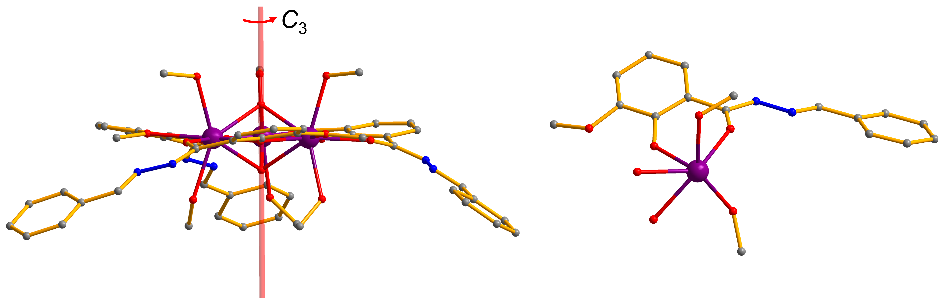
Figure S3. Orientation of the molecular C₃ axis (left) and asymmetric unit (right) in the crystal of Dy₃-Ph. Dy, violet; N, blue; O, red; C, gray. For clarity, hydrogen atoms and ClO₄⁻ anions are omitted.

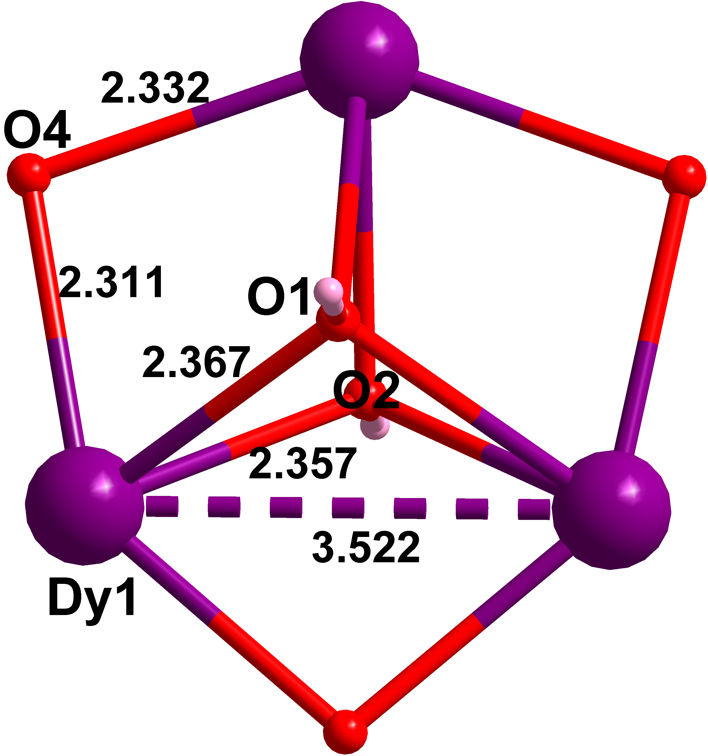
Figure S4. Central core of Dy₃-Ph.

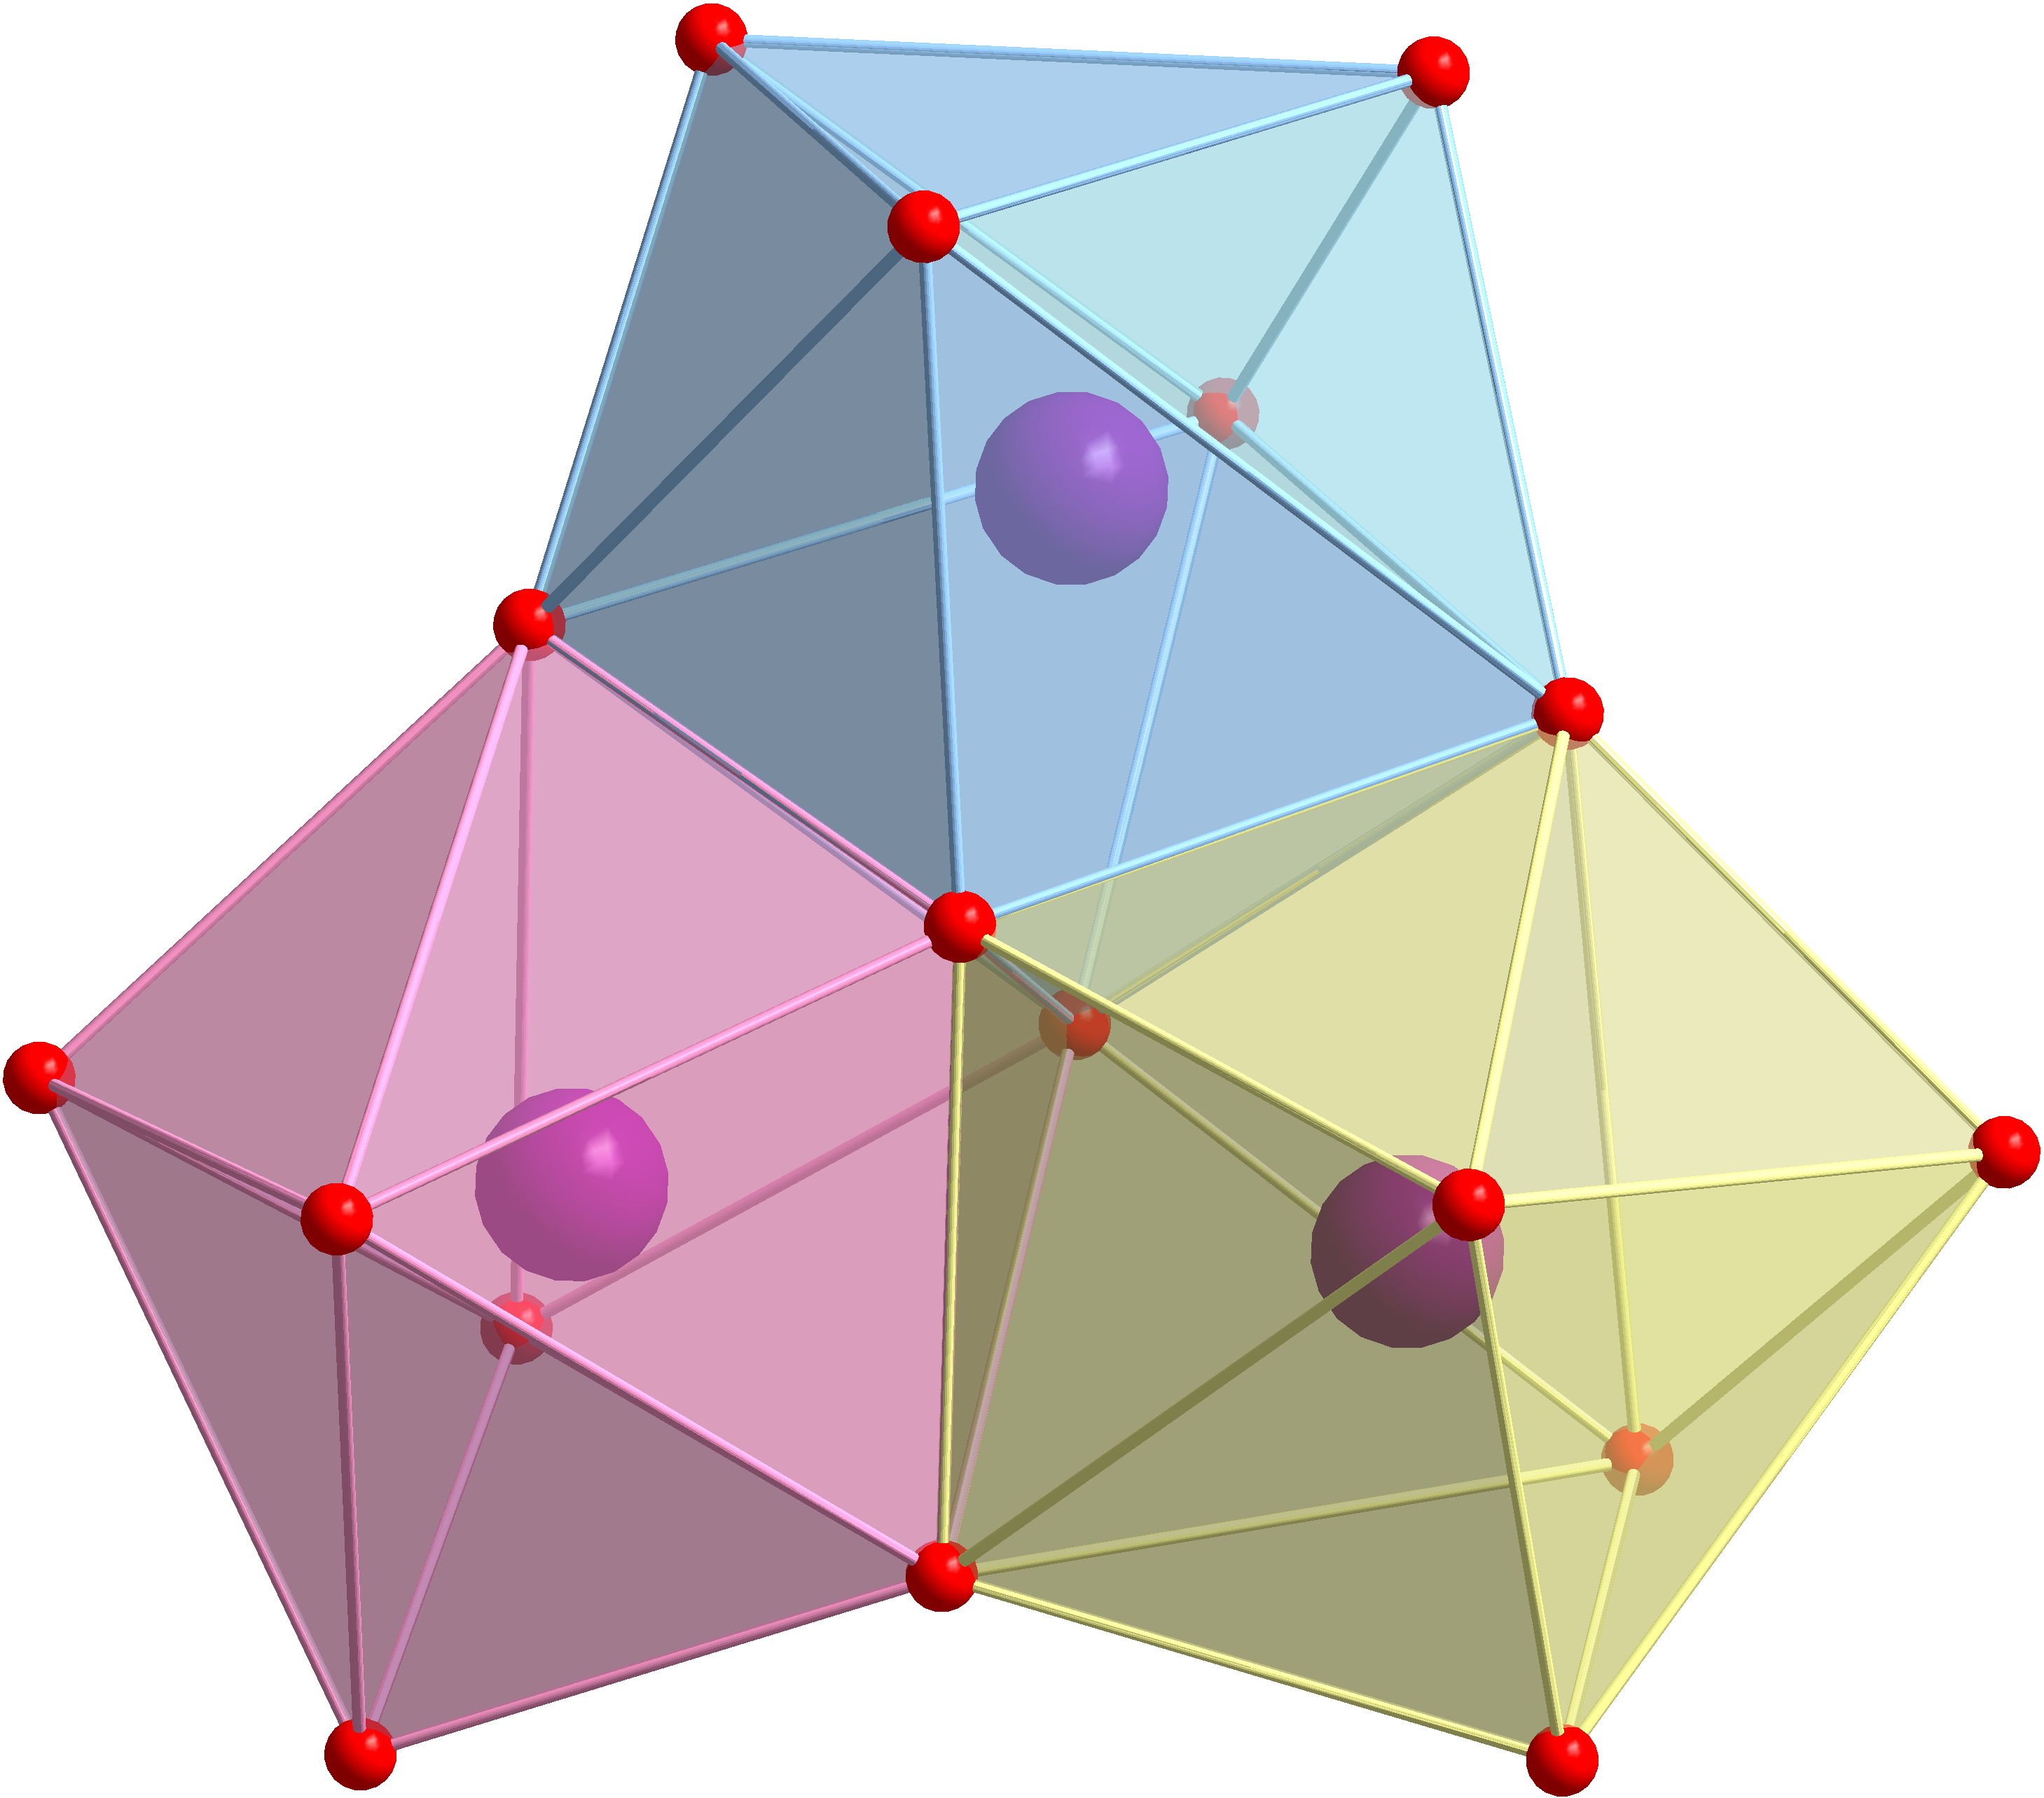
Figure S5. Coordination polyhedra of Dy₃-Ph.

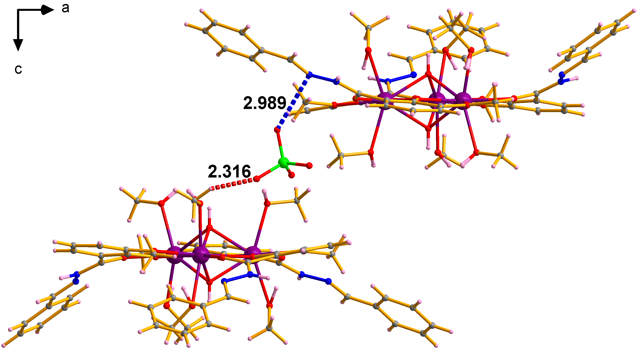
Figure S6. Intermolecular C-H···O (red dashed line) interaction with 2.316 Å and Cl-O···N (blue dashed line) interaction with 2.989 Å of Dy₃-Ph viewed along b axis. Dy, violet; N, blue; O, red; C, gray; H rose.

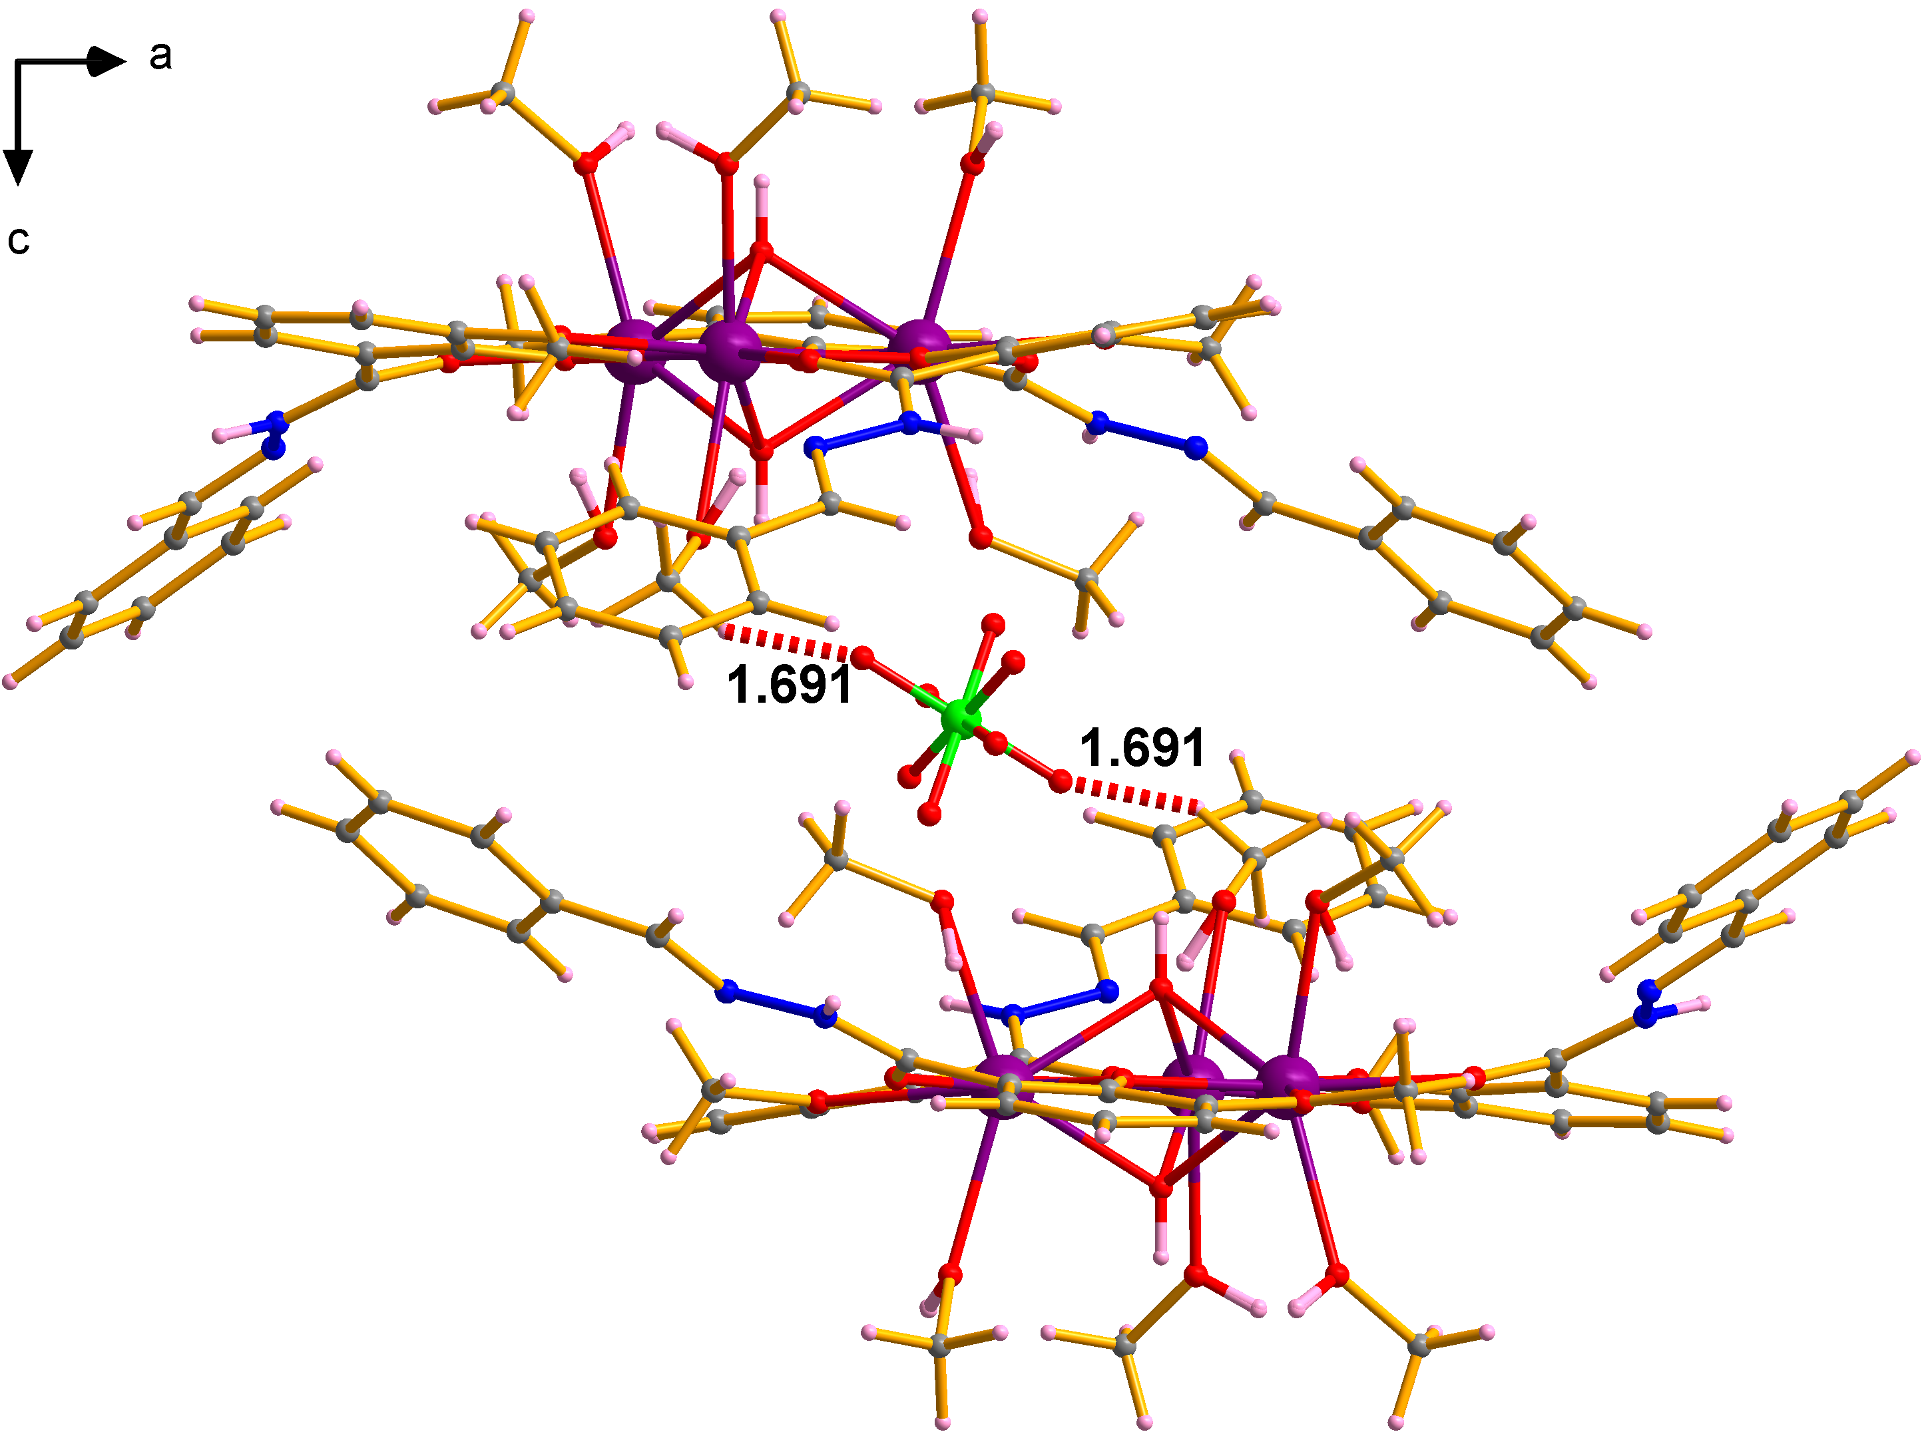
Figure S7. Intermolecular C-H···O (red dashed lines) interactions with 1.691 Å of Dy₃-Ph viewed along b axis. Dy, violet; N, blue; O, red; C, gray; H rose.

3. Experimental Details:
3.1. Proton nuclear magnetic resonance (¹H NMR) spectrum was recorded on Bruker AV400 MHz instrument and calibrated using TMS (0.00 ppm) as an internal reference. The following abbreviations were used to explain the multiplicities: s = singlet, d = doublet, t = triplet.
3.2. Fourier transform infrared spectrum (FT-IR) was recorded on a Nicolet 6700 Flex FTIR spectrometer equipped with a smart iTR attenuated total reflectance (ATR) sampling accessory and labeled according to their relative intensities with br (broad), s (strong), m (medium), and w (weak).
3.3. Single-crystal X-ray diffraction (SCXRD) measurement was performed on a Bruker D8 Venture CCD diffractometer with graphite-monochromated Mo Kα radiation ( = 0.71073 Å). The crystal was measured at 180 K. The program APEX3 was used to integrate the data, which was thereafter corrected for absorption using multi-scan method. The structure was solved by intrinsic phasing methods and refined by full-matrix least-squares methods on F² with anisotropic thermal parameters for all non-hydrogen atoms by using the SHELXT⁵ (intrinsic phasing methods) and refined by SHELXL⁶ (full matrix least-squares techniques) in the Olex2⁷ package. All non-hydrogen atoms were refined with anisotropic displacement parameters. The hydrogen atoms were introduced in calculated positions and refined with a fixed geometry with respect to their carrier atoms. Crystallographic data, refinement details and CCDC number are given in Table S1.
3.4. Magnetic (SQUID) measurements:
Magnetic measurements (powder sample) down to 2 K temperature were performed using a Quantum Design MPMS-XL7 SQUID magnetometer. Variable-temperature direct current (dc) magnetic susceptibility data were collected with an external magnetic field of 1000 Oe in the temperature range of 2–300 K and variable field magnetization data from ±7 T were collected. Alternating current (ac) magnetic susceptibility data were collected in zero applied field using a 3.0 Oe ac oscillating field. The experimental magnetic data were corrected for the diamagnetism estimated from Pascal’s constants⁸ and sample holder calibration.

3.5. μSQUID measurements:
Magnetization measurements over the temperature range 0.03–5.0 K were performed on single crystals of the compound using µSQUID magnetometry. A single crystal of approximately 50 µm in length (arm-length of triangular crystals) was positioned adjacent to a µSQUID array on the chip, leaving only a few micrometers between the crystal edge and the nearest µSQUID loop to maximize magnetic coupling. The crystal was thermalized with Apiezon™ grease and cooled to 30 mK in a dilution refrigerator. A three-axis vector magnet enabled precise orientation of the magnetic field within the plane of the SQUID (H_{x,y}), with an angular accuracy better than 0.1°. Low-temperature M(H) curves were recorded at sweep rates between 0.001 and 0.128 T/s with a time-resolution of approximately 1 ms.
The well-defined triangular shape of the single micro-crystals allows the measurement plane (H_{x,y}) to be aligned with the Dy₃ molecular plane. Owing to the nearly equilateral geometry, orienting one in-plane field component (e.g., H_{x}) parallel to a crystal edge places the external field along one of the Dy easy axes. Conversely, directing H_{x} from the midpoint of one edge toward the opposing vertex aligns the field along a corner of the switching-field hexagon, as established by the angular-dependent magnetization maps presented in the main text. This geometric correspondence between the micro-crystal shape and the molecular magnetic anisotropy enables a highly reproducible and symmetry-selective control of field orientation. Eventually the vector-control of field-direction is crucial for a precise alignment in the measurement plane (H_{x,y}) to a direction of choice, such as along the arm-center or the corner of the switching-field hexagon. For measurements requiring access to out-of-plane orientations (see section 5), selected crystals were mounted vertically with respect to the in-plane measurement axes (H_{x,y}). Owing to the large aspect ratio of the thin triangular micro-crystals, achieving stable vertical alignment is challenging and often requires the use of fine plastic-thread supports to hold the crystal securely.

- SQUID Measurements

Table S4 Relaxation fitting parameters for Dy₃-Ph in the temperature range of 1.9 to 3 K.⁹
T  (K) | χ_{S,Total}  (cm³/mol) | Δχ₁  (cm³/mol) | τ₁  (s) | α₁ | Δχ₂  (cm³/mol) | τ₂  (s) | α₂ | Residual
1.9 | 0.16159 | 0.80682 | 0.00203 | 0.4138 | 0.17104 | 0.26712 | 1.2E-16 | 5.38536E-5
2.2 | 0.15864 | 1.16161 | 0.00175 | 0.40961 | 0.1433 | 0.2025 | 1.2E-17 | 1.18879E-4
2.5 | 0.26571 | 1.49832 | 0.00151 | 0.38885 | 0.12143 | 0.15475 | 1.2E-16 | 4.09062E-4
3 | 0.21238 | 2.01588 | 0.00119 | 0.35075 | 0.10256 | 0.11009 | 1.9E-12 | 5.83564E-4

Table S5 Relaxation fitting parameters for Dy₃-Ph in the temperature range of 3.5 to 13 K.¹⁰⁻¹²
T  (K) | χ_{S}  (cm³/mol) | χ_{T}  (cm³/mol) | τ  (s) | a | Residual
3.5 | 0.21344 | 2.82337 | 9.26232E-4 | 0.37983 | 0.00973
4 | 0.29991 | 3.19904 | 7.55784E-4 | 0.36235 | 0.00478
4.5 | 0.36083 | 3.44977 | 6.44125E-4 | 0.35464 | 0.00716
5 | 0.38201 | 3.60184 | 5.26389E-4 | 0.35132 | 0.00619
6 | 0.51848 | 3.69757 | 4.04838E-4 | 0.33485 | 0.00577
7 | 0.44416 | 3.63361 | 2.82805E-4 | 0.32478 | 0.00608
8 | 0.50759 | 3.49231 | 2.17396E-4 | 0.30601 | 0.00627
9 | 0.49872 | 3.33049 | 1.62235E-4 | 0.29665 | 0.00704
10 | 0.65042 | 3.15157 | 1.35859E-4 | 0.25863 | 0.00179
11 | 0.69899 | 2.98759 | 9.89002E-5 | 0.26012 | 0.00529
12 | 0.81624 | 2.83017 | 7.54335E-5 | 0.23401 | 0.00602
13 | 0.60459 | 2.68092 | 6.06293E-5 | 0.21267 | 0.00377

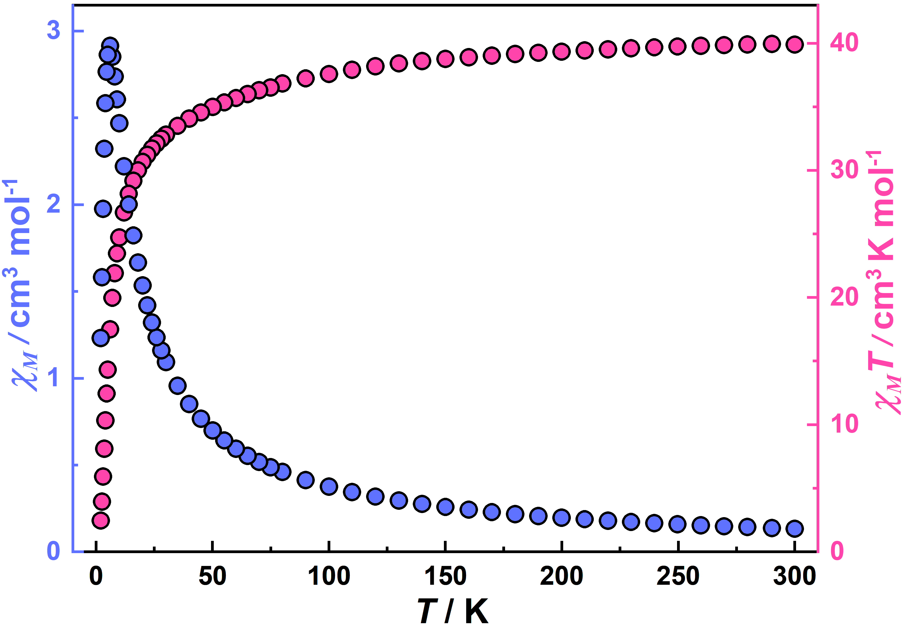
Figure S8. Temperature-dependent χ_{M}(T) (left y-axis, blue circles) and χ_{M}T(T) (right y-axis, pink circles) plots for Dy₃-Ph under an applied field 1000 Oe.

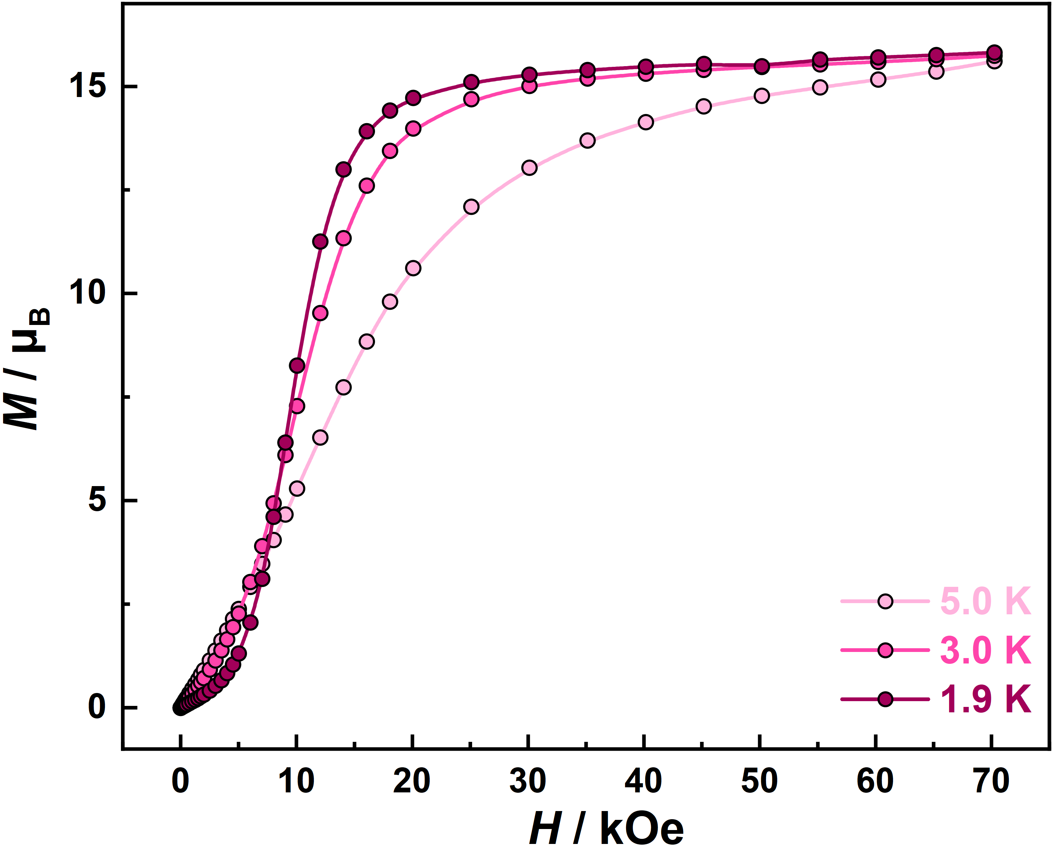
Figure S9. Field dependence of the magnetization at 1.9, 3.0 and 5.0 K for Dy₃-Ph.

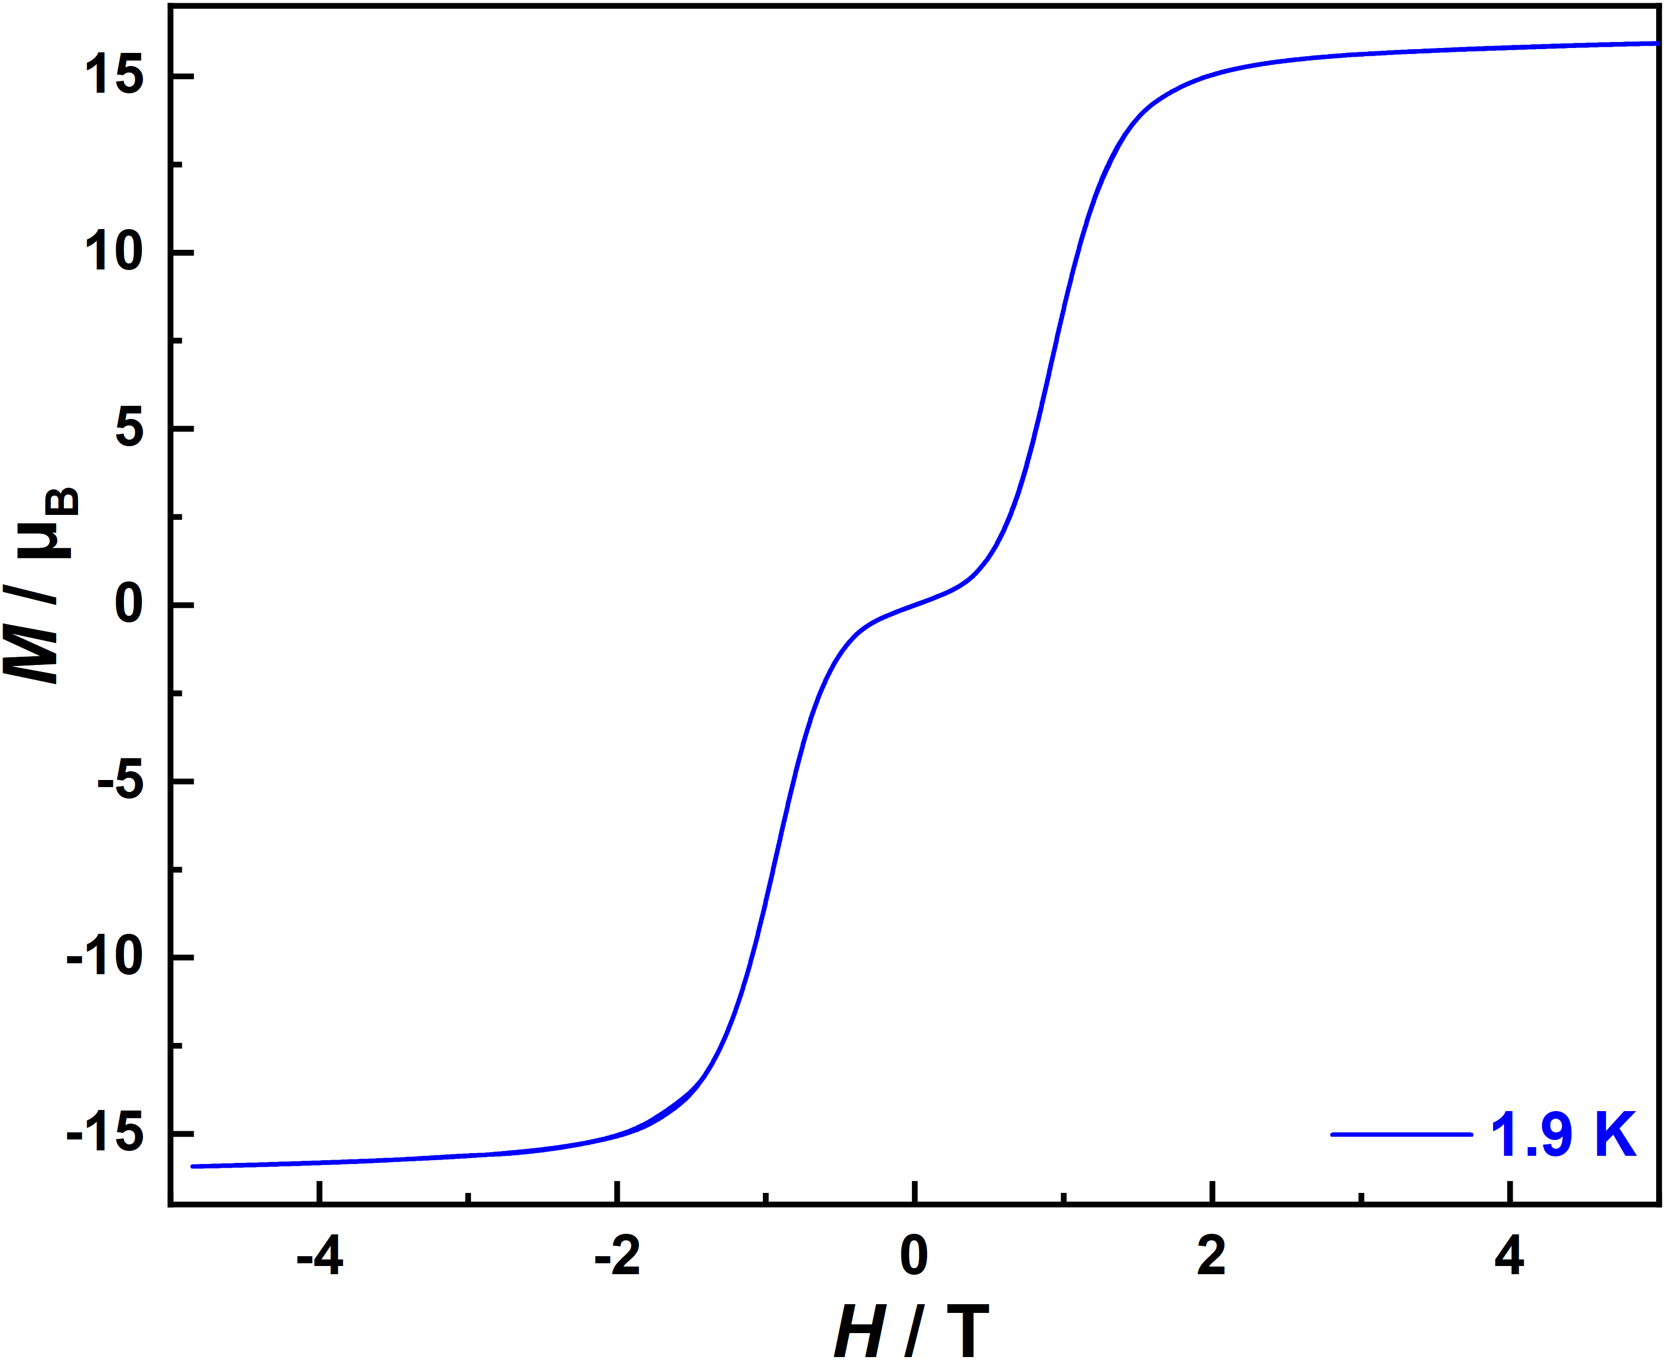
Figure S10. Magnetic hysteresis measurement at 1.9 K for Dy₃-Ph.

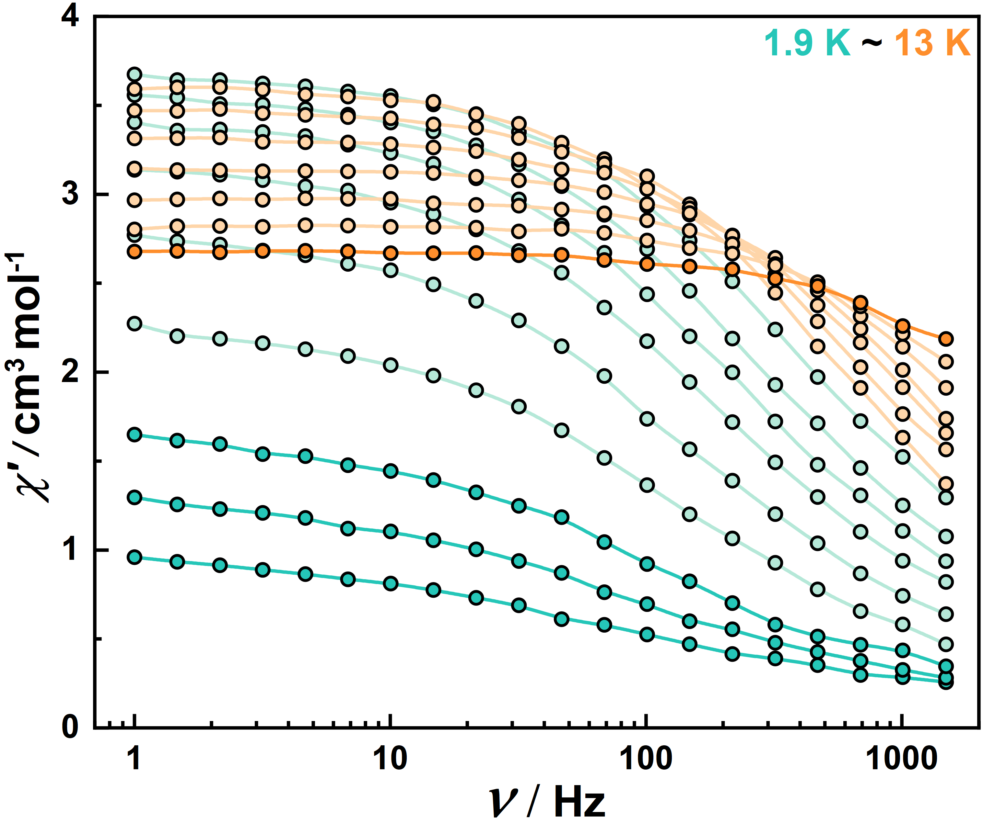
Figure S11. Frequency dependence of the in-phase component of the ac susceptibility for Dy₃-Ph at the temperatures shown. Data were collected in an ac field of 3 Oe and a zero-dc field. The colored lines are guides for the eye.

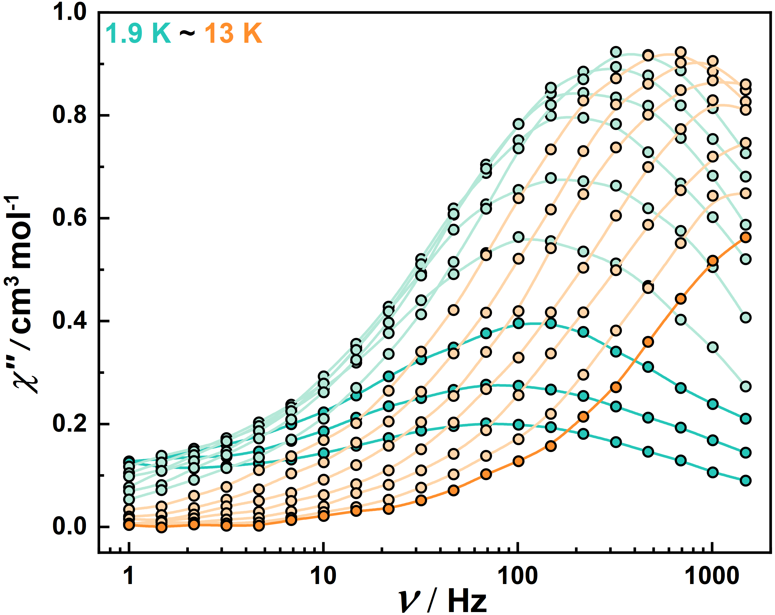
Figure S12. Frequency dependence of the out-of-phase component of the ac susceptibility for Dy₃-Ph at the temperatures shown. Data were collected in an ac field of 3 Oe and a zero-dc field. The colored lines are guides for the eye.

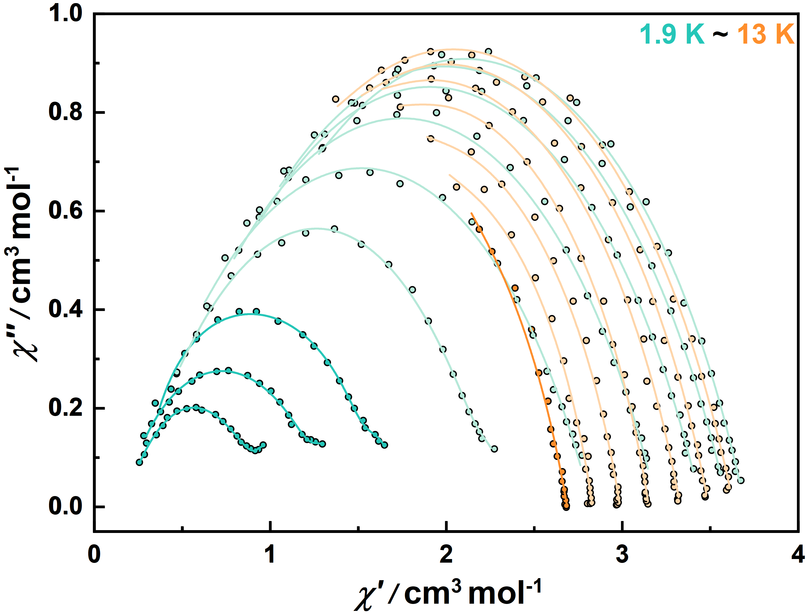
Figure S13. Cole-Cole plots for the ac susceptibility in zero-dc field for Dy₃-Ph from 1.9–13 K. Solid lines represent the fits to the data using the parameters described in the text.

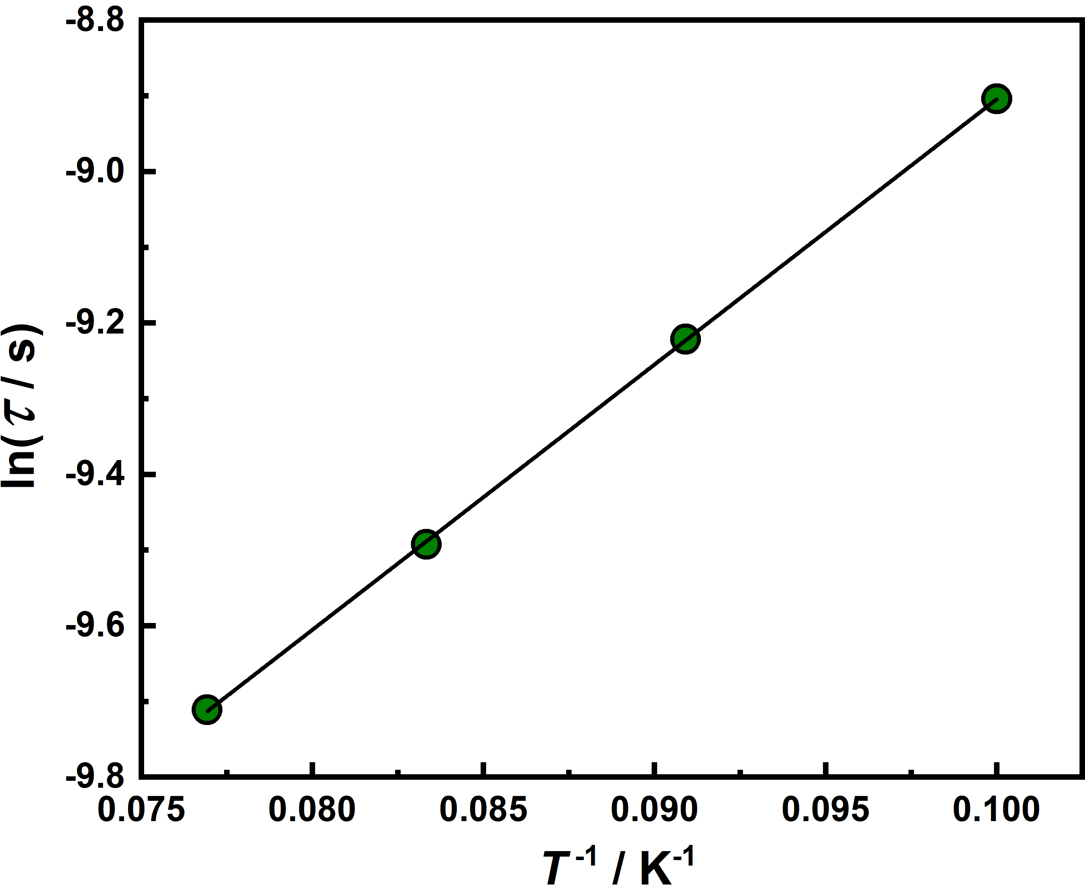
Figure S14. Temperature dependence of the magnetic relaxation times for Dy₃-Ph plotted as ln(τ) versus T⁻¹. The black line represents the fit to Arrhenius equation ln(τ) = -ln[τ₀⁻¹ exp(-U_{eff}/k_{B}T)], giving U_{eff} = 35.1(3) K and τ₀ = 4.1(1) × 10⁻⁶ s.

- Supporting μSQUID Measurements:

Figure S15. (a)-(c) M(H_{x}) loops for single crystal of Dy₃-ph at different temperatures (0.03 K – 5.0 K) with field-sweep rate = 16 mT/s, for three different crystal-orientations with respect to the applied field (H_{x}). These measurements correspond to the crystal orientations in Figure 4 (a)-(c) in the main text.
Figure S16. (a)-(d) Field-angle dependent derivative maps (dm/dh = $\frac{1}{µ_{0}M_{s}}$dM/dH) reproduced in four other crystals (#s1-4) of the same sample. All four measurements represent ‘in-plane’ variation of vector magnetic field (H_{x,y}). (a), (c) had H_{x} nearly aligned with a Dy easy axis (i.e. along the ‘hexagon-arm’ or φ ~ 0°), while (b), (d) had H_{x} nearly aligned with ‘hexagon-corner’ (φ ~ 30°).

Figure S17. (a), (b) Field-angle dependent derivative maps (dm/dh = $\frac{1}{µ_{0}M_{s}}$dM/dH) in vertically mounted crystals (#s5-6) to show in-plane to out-of-plane variation of magnetic field. As the dominant anisotropy axis lie within a plane, the magnetic reversal (switching) of individual Dy spins is impossible (at such low temperatures) along out-of-plane direction, hence the parallel lines are observed as the field is varied in-plane to out-of-plane. This leads to a 3D switching-field-anisotropy surface that corresponds to a hexagonal prism, with the extended arms of the hexagon extruded along the z (out-of-plane) direction. Depending on the in-plane field orientation, the spacing between the parallel features in the derivative maps increases or decreases accordingly.

- Ab-initio calculations
ab initio calculations using the CASSCF/SO-RASSI/SINGLE_ANISO approach implemented in OpenMolcas^{13,14} were carried out. For the calculations, the crystal structure was employed without further optimizations, and the atoms were described using the standard basis sets from the ANO-RCC library^{15,16}. Due to the presence of a single Dy(III) ions in the asymmetric unit, the dilution method was employed, where the Dy(III) ion of interest was investigated while the remaining Dy(III) were swapped with Y(III) for the computations. A basis set of VTZP quality was employed for the Dy(III) ions, while VDZP quality was employed for atoms directly bound to the Dy(III) ions, and VDZ quality for the remaining atoms, using the second-order DKH transformation. Optimization of the molecular orbitals (MOs) was achieved by state-averaged CASSCF calculations. The active space of Dy(III) was defined by the nine 4f electrons in the seven 4f orbitals. Three calculations were carried out (RASSCF routine) with 21, 224, and 490 states for S = 5/2, S = 3/2, and S = ½, respectively. The CASSCF wavefunctions were subsequently mixed by spin-orbit coupling, employing the RASSI¹⁷ routine with all 21 states for S = 5/2 being included, while 128 and 130 states were included for S = 3/2 and S = 1/2. Lastly, the crystal field decomposition of the ground J = 15/2 multiplet of the ⁶H_{15/2} term was executed with the SINGLE_ANISO module^{18,19}.

Table 6. Computed energy levels (the ground state is set at zero), composition of the g-tensor (g_{x}, g_{y}, g_{z}), and the main components (>10%) of the wavefunction for each m_{J} state of the ground-state multiplet ⁶H_{15/2} for the Dy(1) in Dy₂, at the CASSCF level.
ab initio energy (cm^{–1}) | g_{x} | g_{y} | g_{z} | Wavefunction
0 | 0.00332 | 0.00505 | 19.66075 | 96.4% ±15/2
179.707 | 0.17737 | 0.23156 | 16.76134 | 79.2% ±13/2 + 13.4% ±9/2
288.968 | 1.41804 | 1.81768 | 13.01442 | 44.2% ±11/2 + 25.0% ±7/2 + 11.1% ±9/2 + 10.1% ±13/2
352.918 | 4.77945 | 6.08485 | 8.81968 | 25.1% ±5/2 + 20.6% ±1/2 + 16.3% ±3/2 + 14.4% ±11/2 + 13.5% ±9/2
398.794 | 0.24508 | 2.077 | 12.82739 | 27.9% ±3/2 + 25.5% ±1/2 + 15.0% ±5/2 + 14.2% ±9/2
444.23 | 0.84528 | 0.94639 | 17.59626 | 26.6% ±7/2 + 26.0% ±5/2 + 18.8% ±9/2 + 14.1% ±3/2
471.741 | 0.11785 | 0.21777 | 18.9505 | 45.4% ±1/2 + 31.6% ±3/2 + 12.8% ±5/2
583.877 | 0.00268 | 0.00548 | 19.67684 | 25.9% ±7/2 + 25.8% ±9/2 + 16.5% ±5/2 + 15.3% ±11/2

Table 7. Crystal field Hamiltonian is given as ${\hat{H}}_{CF}=\sum_{k,q}{B_{k}^{q}O_{k}^{q}}$, and the extended Stevens operator coefficients $B_{k}^{q}$ are extracted from CASSCF calculations for Dy₃ system.
 |  | $$B_{k}^{q}$$
k | q | Dy
2 | -2 | -1.19666
2 | -1 | -2.24162
2 | 0 | -0.0587
2 | 1 | 5.25765
2 | 2 | -2.29151
4 | -4 | -5.32023
4 | -3 | -2.60953
4 | -2 | -4.90206
4 | -1 | 0.88142
4 | 0 | -2.70179
4 | 1 | -9.45501E-4
4 | 2 | 0.01014
4 | 3 | 0.03088
4 | 4 | -0.08181
6 | -6 | -0.02599
6 | -5 | -0.01015
6 | -4 | 0.0037
6 | -3 | 0.01308
6 | -2 | -0.00518
6 | -1 | -0.03468
6 | 0 | 0.00796
6 | 1 | 0.05107
6 | 2 | -5.03022E-4
6 | 3 | -0.17276
6 | 4 | -0.00359
6 | 5 | 0.16999
6 | 6 | -0.0084

Supplementary References

1 Pearl, I. A. & Beyer, D. L. Reactions of Vanillin and its Derived Compounds. XXV. Hydrazides of Vanillic and Related Acids. J. Am. Chem. Soc. 77, 3660-3662 (1955). https://doi.org/10.1021/ja01618a078
2 Pinsky, M. & Avnir, D. Continuous Symmetry Measures. 5. The Classical Polyhedra. Inorg. Chem. 37, 5575-5582 (1998). https://doi.org/10.1021/ic9804925
3 Casanova, D. et al. Minimal Distortion Pathways in Polyhedral Rearrangements. J. Am. Chem. Soc. 126, 1755-1763 (2004). https://doi.org/10.1021/ja036479n
4 Casanova, D., Llunell, M., Alemany, P. & Alvarez, S. The Rich Stereochemistry of Eight-Vertex Polyhedra: A Continuous Shape Measures Study. Chem. Eur. J. 11, 1479-1494 (2005). https://doi.org/10.1002/chem.200400799
5 Sheldrick, G. M. SHELXT - Integrated space-group and crystal-structure determination. Acta Cryst. A 71, 3-8 (2015). https://doi.org/10.1107/s2053273314026370
6 Sheldrick, G. M. A short history of SHELX. Acta Cryst. A 64, 112-122 (2008). https://doi.org/10.1107/s0108767307043930
7 Dolomanov, O. V., Bourhis, L. J., Gildea, R. J., Howard, J. A. K. & Puschmann, H. OLEX2: a complete structure solution, refinement and analysis program. J. Appl. Crystallogr. 42, 339-341 (2009). https://doi.org/10.1107/s0021889808042726
8 Bain, G. A. & Berry, J. F. Diamagnetic Corrections and Pascal's Constants. J. Chem. Educ. 85, 532-536 (2008). https://doi.org/10.1021/ed085p532
9 Guo, Y.-N. et al. Two-Step Relaxation in a Linear Tetranuclear Dysprosium(III) Aggregate Showing Single-Molecule Magnet Behavior. J. Am. Chem. Soc. 132, 8538-8539 (2010). https://doi.org/10.1021/ja103018m
10 Reta, D. & Chilton, N. F. Uncertainty estimates for magnetic relaxation times and magnetic relaxation parameters. Phys. Chem. Chem. Phys. 21, 23567-23575 (2019). https://doi.org/10.1039/C9CP04301B
11 Blackmore, W. J. A. et al. Characterisation of magnetic relaxation on extremely long timescales. Phys. Chem. Chem. Phys. 25, 16735-16744 (2023). https://doi.org/10.1039/D3CP01278F
12 Cole, K. S. & Cole, R. H. Dispersion and Absorption in Dielectrics I. Alternating Current Characteristics. J. Chem. Phys. 9, 341-351 (1941). https://doi.org/10.1063/1.1750906
13 Li Manni, G. et al. The OpenMolcas Web: A Community-Driven Approach to Advancing Computational Chemistry. Journal of Chemical Theory and Computation 19, 6933-6991 (2023). https://doi.org/10.1021/acs.jctc.3c00182
14 Fdez. Galván, I. et al. OpenMolcas: From Source Code to Insight. Journal of Chemical Theory and Computation 15, 5925-5964 (2019). https://doi.org/10.1021/acs.jctc.9b00532
15 Roos, B. O. & Malmqvist, P.-Å. in A Tribute Volume in Honor of Professor Osvaldo Goscinski Advances in Quantum Chemistry 37-49 (2004).
16 Zobel, J. P., Widmark, P. O. & Veryazov, V. The ANO-R Basis Set. J Chem Theory Comput 16, 278-294 (2020). https://doi.org/10.1021/acs.jctc.9b00873
17 Malmqvist, P. Å., Roos, B. O. & Schimmelpfennig, B. The restricted active space (RAS) state interaction approach with spin–orbit coupling. Chem. Phys. Lett. 357, 230-240 (2002). https://doi.org/10.1016/s0009-2614(02)00498-0
18 Chibotaru, L. F. & Ungur, L. Ab initio calculation of anisotropic magnetic properties of complexes. I. Unique definition of pseudospin Hamiltonians and their derivation. J. Chem. Phys. 137, 064112 (2012). https://doi.org/10.1063/1.4739763
19 Ungur, L. & Chibotaru, L. F. Ab Initio Crystal Field for Lanthanides. Chem-Eur J 23, 3708-3718 (2017). https://doi.org/10.1002/chem.201605102

