Supplementary
Transmission dynamic of respiratory multi-pathogen co-infection in a Chinese megacity: A modelling study based on Wuhan Big Data Center
Jiahui Li et al.
Correspondence: Tianmu Chen, chentianmu@xmu.edu.cn.

This file includes:
Figures S1 to S4
Tables S1 to S4
SI References 1-3
Model Fitting Parameters and Goodness-of-Fit
Table S1. The mean of the fitting parameters in different single-pathogen infections. (Week⁻¹)
Single-pathogen | Mean of $β_{0i}$ | Mean of $a_{i}$ | Mean Generation Interval | Generation Interval Variance
AdV | 1.54e-03 | 1.13e-02 | 2.66 | 1.39
CoxsV | 2.22e-03 | 6.00e-02 | 2.52 | 1.22
Cpn | 1.16e-03 | 6.35e-02 | 2.74 | 1.47
Flu_A | 1.47e-03 | 1.22e-02 | 2.27 | 1.04
Flu_B | 2.23e-03 | 1.18e-01 | 2.60 | 1.32
HPIVs | 2.23e-03 | 6.33e-02 | 2.64 | 1.36
Mp | 2.93e-03 | 6.40e-02 | 2.69 | 1.42
RSV | 3.63e-05 | 5.87e-02 | 2.62 | 1.34
RhV | 5.30e-06 | 6.15e-02 | 2.59 | 1.31
SARS-CoV-2 | 4.46e-03 | 1.39e-02 | 2.45 | 1.25

Table S2. The R² and P-value comparing the fitted curve to the actual data in different single-pathogen infections.
Pathogen | R² | P-value
AdV | 0.8794 | <0.0001
CoxsV | 0.8032 | <0.0001
Cpn | 0.9006 | <0.0001
Flu_A | 0.8478 | <0.0001
Flu_B | 0.9694 | <0.0001
HPIVs | 0.8725 | <0.0001
Mp | 0.9100 | <0.0001
RSV | 0.8616 | <0.0001
RhV | 0.8220 | <0.0001
SARS-CoV-2 | 0.7103 | <0.0001
Table S3. The mean of the fitting parameters in different dual-pathogen coinfections. (Week⁻¹)
Dual-pathogen | Mean of $β_{0i}$ | Mean of $a_{i}$ | Mean of $σ_{1}$ | Mean of $σ_{2}$ | Mean of $ε_{1}$ | Mean of $ε_{2}$ | Mean Generation Interval | Generation Interval Variance
AdV+Mp | 2.24e-03 | 4.00e-02 | 0.2359 | 0.0732 | 2.4890 | 0.3386 | 2.55 | 1.29
AdV+RhV | 1.45e-03 | 3.27e-02 | 0.1446 | 0.1449 | 0.9982 | 0.2783 | 2.67 | 1.39
AdV+RSV | 5.57e-04 | 2.27e-02 | 0.7185 | 0.2537 | 0.6878 | 1.0401 | 2.62 | 1.38
CoxsV+Mp | 1.67e-03 | 4.82e-02 | 0.0103 | 0.0109 | 0.9890 | 0.1851 | 2.62 | 1.34
Cpn+Mp | 2.22e-03 | 3.45e-02 | 0.3004 | 0.3015 | 0.9088 | 0.9639 | 3.23 | 1.60
Flu_A+Flu_B | 3.34e-03 | 5.06e-02 | 0.0825 | 0.0825 | 3.4428 | 0.0825 | 2.60 | 1.32
Flu_A+Mp | 2.86e-03 | 4.83e-02 | 0.1711 | 0.1715 | 2.4349 | 0.3413 | 2.38 | 1.10
Flu_A+SARS-CoV-2 | 2.73e-03 | 5.60e-02 | 0.1037 | 0.0952 | 1.8676 | 1.8189 | 2.22 | 1.03
Flu_B+Mp | 4.76e-05 | 9.74e-02 | 0.1020 | 0.1020 | 0.4075 | 0.4075 | 2.61 | 1.33
HPIVs+Mp | 1.11e-03 | 3.99e-02 | 0.0552 | 0.0553 | 0.2284 | 0.2243 | 2.59 | 1.32
RSV+Mp | 1.01e-03 | 2.63e-02 | 0.1356 | 0.2410 | 0.7684 | 0.8826 | 2.68 | 1.41
RhV+Mp | 1.51e-03 | 2.23e-02 | 0.1983 | 0.1379 | 0.2769 | 1.0228 | 2.54 | 1.27
SARS-CoV-2+Mp | 2.70e-03 | 3.29e-02 | 0.1981 | 0.0383 | 0.5660 | 0.6160 | 3.71 | 2.14

Table S4. The R² and P-value of the fitted curve compared to the actual data in different dual-pathogen coinfections.
Pathogen | R² | P-value
AdV+Mp | 0.6051 | <0.0001
AdV+RhV | 0.3708 | <0.0001
AdV+RSV | 0.3039 | <0.0001
CoxsV+Mp | 0.6976 | <0.0001
Cpn+Mp | 0.7917 | <0.0001
Flu_A+Flu_B | 0.7162 | <0.0001
Flu_A+Mp | 0.4926 | <0.0001
Flu_A+SARS-CoV-2 | 0.2911 | <0.0001
Flu_B+Mp | 0.9210 | <0.0001
HPIVs+Mp | 0.6740 | <0.0001
RSV+Mp | 0.8562 | <0.0001
RhV+Mp | 0.5251 | <0.0001
SARS-CoV-2+Mp | 0.7507 | <0.0001

Parameter Sensitivity Analysis
The sensitivity index (1) is an important indicator for quantifying the sensitivity of model variables to parameter changes. If the partial derivative of variable $u$ with respect to parameter $p$ exists, then the sensitivity index of this variable with respect to parameter $p$ is
$$Υ_{p}^{u}=\frac{∂u}{∂p}×\frac{p}{u}.$$
According to the definition of the sensitivity index, a sensitivity analysis of the model's basic reproduction number $R_{0}$ and its related parameters was conducted using latin hypercube sampling combined (LHS) with the partial rank correlation coefficient (PRCC) method, with the results shown in Fig. S1. This method employs a hierarchical random sampling strategy to ensure efficient exploration of the parameter space and utilizes PRCC to quantitatively assess the nonlinear dependency between parameters and $R_{0}$ (2-3). The magnitude of the absolute value of PRCC indicates the strength of the influence, while the sign indicates a positive or negative mechanism of action.
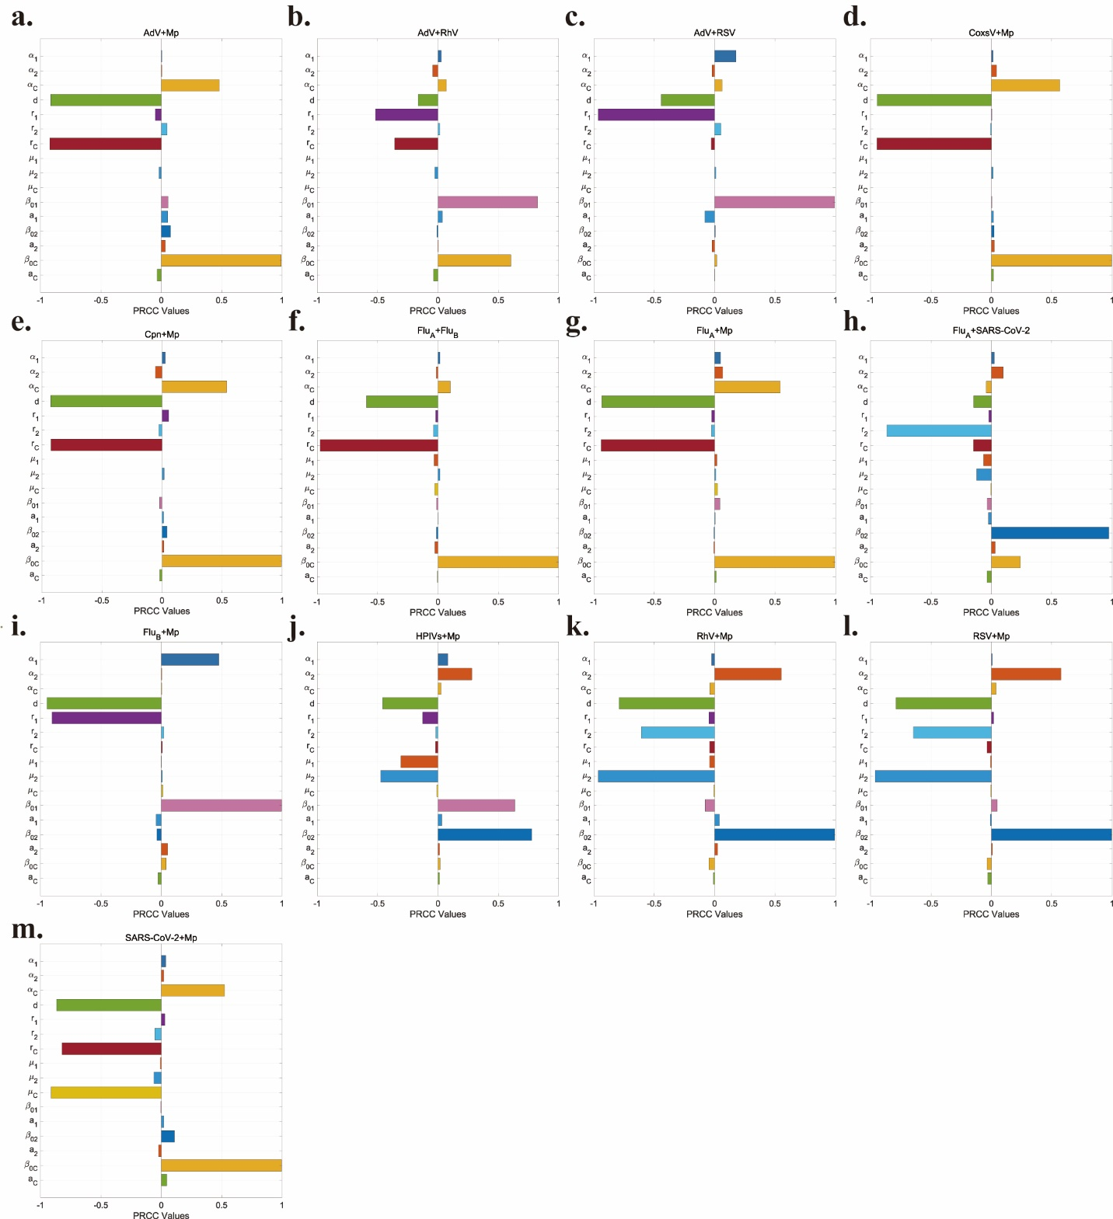
Fig. S1 Sensitivity plot of the basic reproduction number $R_{0}$.

Time-dependent Reproduction Numbers for Single and Co-infecting Pathogens
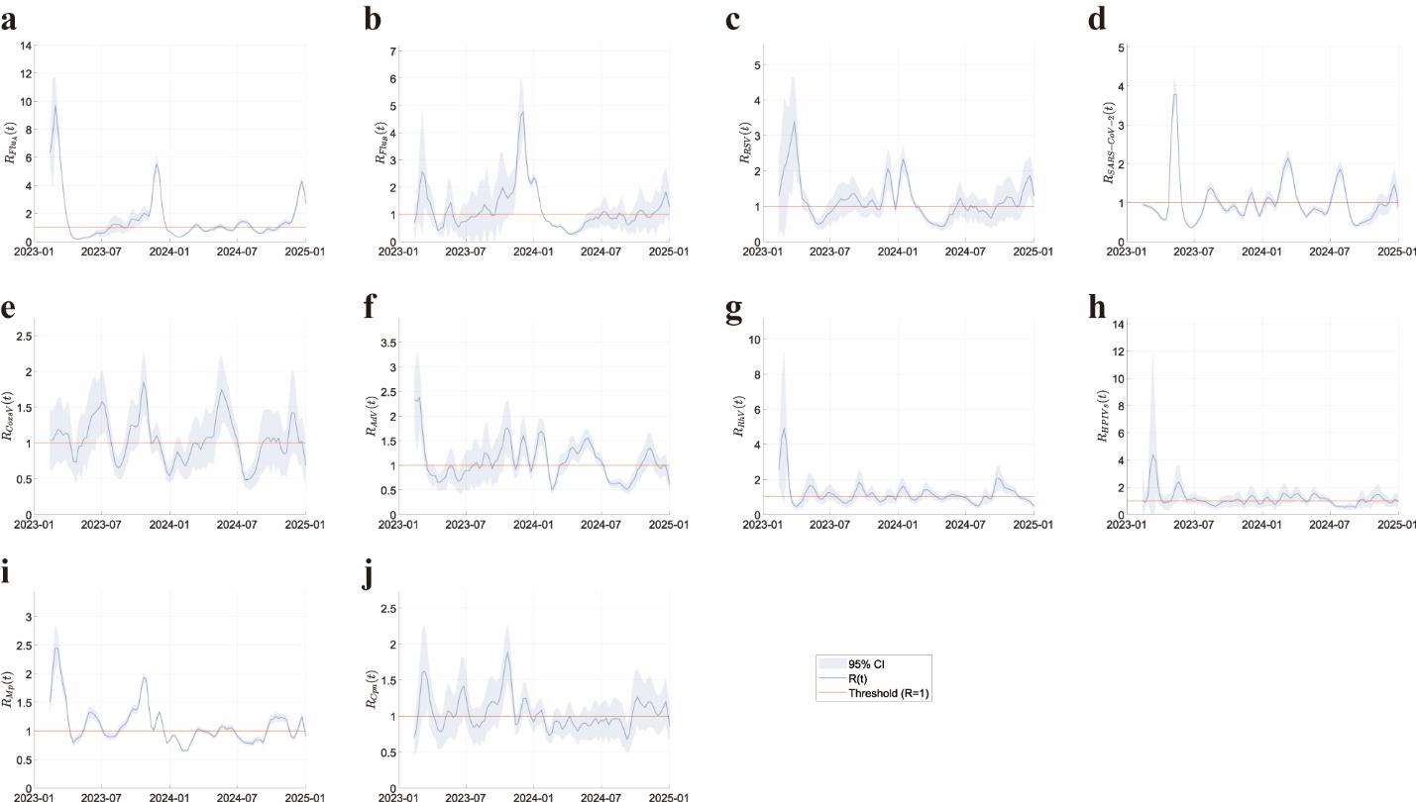
Fig. S2 Time-dependent reproduction numbers for single-pathogen infections.
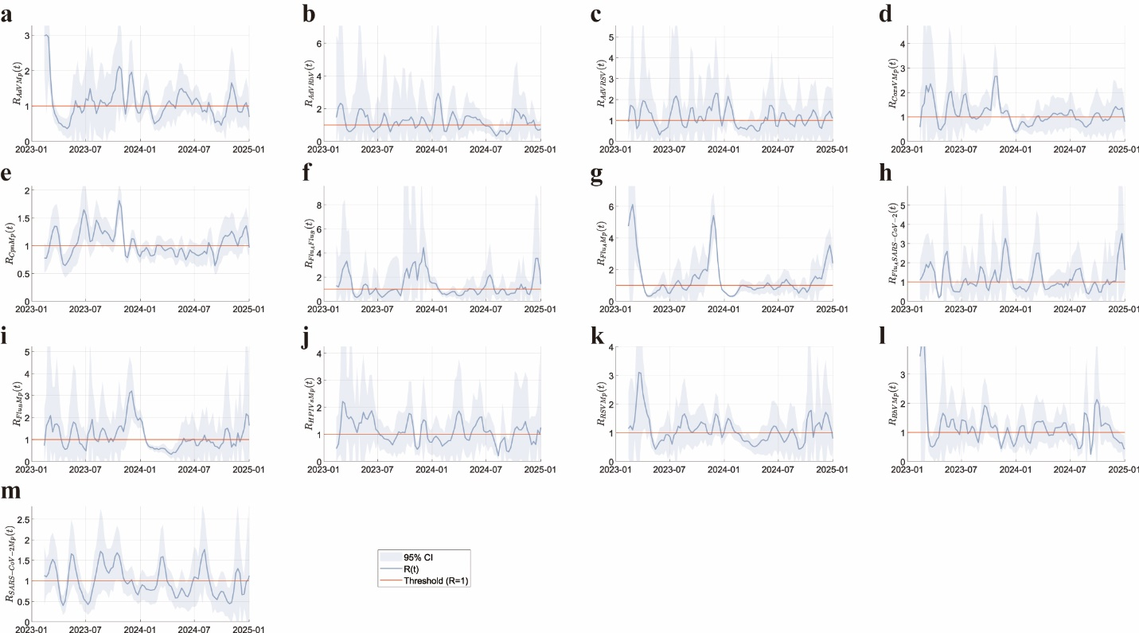
Fig. S3 Time-dependent reproduction numbers for co-infecting pathogens.
Detailed calculation process for the basic reproduction number
The simplified single-pathogen infection model based on model (1) is shown in Fig. S4. The three models a, b, and c in the figure have similar structures. We only discussed model a, as the other two models have similar properties. The differential equation system for model a is given by equation (2). Assuming that the DFE of the model (2) is $E_{01}=\left(S_{0},0,0,0\right)$.
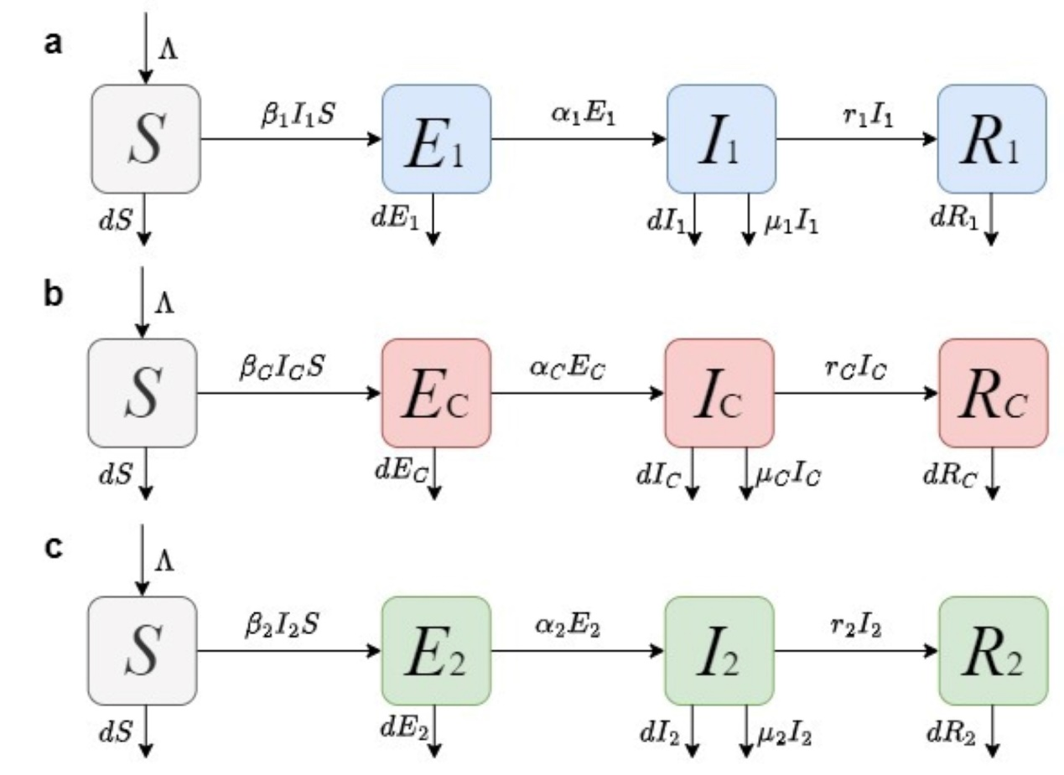
Fig. S4 Single-path infection transmission dynamics model. The three models in the figure are simplified single-pathogen infection models obtained by completely blocking all cross-infection pathways between pathogens. (a) represents the left column of model (1), where transmission is entirely dominated by Pathogen 1. (b) represents the middle column of model (1), where cross-infection between pathogens is completely ignored, and all co-infected individuals are infected solely by the co-infected individuals themselves. (c) represents the right column of model (1), where transmission is entirely dominated by pathogen 2.
$\left\{\begin{aligned}\frac{dS}{dt}=Λ-β_{1}I_{1}S-dS, \\ \frac{dE_{1}}{dt}=β_{1}I_{1}S-α_{1}E_{1}-dE_{1}, \\ \frac{dI_{1}}{dt}=α_{1}E_{1}-r_{1}I_{1}-μ_{1}I_{1}-dI_{1}, \\ \frac{dR_{1}}{dt}=r_{1}I_{1}-dR_{1}.\end{aligned}\right.$(2)
Taking the partial derivatives with respect to each infectious compartment $E_{1},I_{1}$, we obtain the Jacobian matrices of $F$ and $V$ at DFE $E_{01}$ as follows:
$$F\left(E_{01}\right)=\left(\begin{matrix}0 & β_{1}S_{0} \\ 0 & 0\end{matrix}\right),$$
$$V\left(E_{01}\right)=\left(\begin{matrix}α_{1}+d & 0 \\ -α_{1} & r_{1}+μ_{1}+d\end{matrix}\right).$$
Further solving for the inverse matrix of $V\left(E_{0}\right)$ yields:
$${V\left(E_{0}\right)}^{-1}=\left(\begin{matrix}\frac{1}{α_{1}+d} & 0 \\ \frac{α_{1}}{\left(α_{1}+d\right)\left(r_{1}+μ_{1}+d\right)} & \frac{1}{r_{1}+μ_{1}+d}\end{matrix}\right).$$
Then, the basic reproduction number $R_{01}$ of model (2) is the spectral radius of the next generation matrix ${FV\left(E_{01}\right)}^{-1}$. Direct calculation gives
$${FV\left(E_{01}\right)}^{-1}=\left(\begin{matrix}\frac{α_{1}{β_{1}S}_{0}}{\left(α_{1}+d\right)\left(r_{1}+μ_{1}+d\right)} & \frac{β_{1}S_{0}}{r_{1}+μ_{1}+d} \\ 0 & 0\end{matrix}\right),$$
$$\begin{aligned}\left|λE-{FV\left(E_{01}\right)}^{-1}\right|&=\left|\begin{matrix}λ-\frac{α_{1}{β_{1}S}_{0}}{\left(α_{1}+d\right)\left(r_{1}+μ_{1}+d\right)} & -\frac{β_{1}S_{0}}{r_{1}+μ_{1}+d} \\ 0 & λ\end{matrix}\right| \\ &=λ\left[λ-\frac{α_{1}{β_{1}S}_{0}}{\left(α_{1}+d\right)\left(r_{1}+μ_{1}+d\right)}\right]=0.\end{aligned}$$
Solving the above formula, we obtain the eigenvalues of the matrix ${FV\left(E_{01}\right)}^{-1}$ as $λ_{1}=0$, $λ_{2}=\frac{α_{1}{β_{1}S}_{0}}{\left(α_{1}+d\right)\left(r_{1}+μ_{1}+d\right)}$. Based on the biological significance of the model parameters, the parameters $α_{1}, β_{1}, d, r_{1}, μ_{1},$ and $S_{0}$ are all greater than or equal to 0, so $λ_{2}≥λ_{1}$. Therefore, the maximum eigenvalue of ${FV\left(E_{01}\right)}^{-1}$ is $\frac{α_{1}{β_{1}S}_{0}}{\left(α_{1}+d\right)\left(r_{1}+μ_{1}+d\right)}$, i.e., the spectral radius is $\frac{α_{1}{β_{1}S}_{0}}{\left(α_{1}+d\right)\left(r_{1}+μ_{1}+d\right)}$. Therefore, the basic reproduction number of the model is
$$R_{01}=ρ\left({FV\left(E_{01}\right)}^{-1}\right)=\frac{α_{1}{β_{1}S}_{0}}{\left(α_{1}+d\right)\left(r_{1}+μ_{1}+d\right)}.$$
Similarly,
$$R_{02}=ρ\left({FV\left(E_{02}\right)}^{-1}\right)=\frac{α_{2}{β_{2}S}_{0}}{\left(α_{2}+d\right)\left(r_{2}+μ_{2}+d\right)},$$
$$R_{0C}=ρ\left({FV\left(E_{0C}\right)}^{-1}\right)=\frac{α_{C}{β_{C}S}_{0}}{\left(α_{C}+d\right)\left(r_{C}+μ_{C}+d\right)}.$$
Further supplement the spectral radius calculation method of model (1). First, calculate and obtain:
$${FV\left(E_{0}\right)}^{-1}=\left(\begin{matrix}\frac{α_{1}β_{1}S_{0}}{p_{1}q_{1}} & \frac{α_{C}β_{1}ε_{1}S_{0}}{p_{C}q_{C}} & 0 & \frac{β_{1}S_{0}}{q_{1}} & \frac{β_{1}ε_{1}S_{0}}{q_{C}} & 0 \\ 0 & \frac{α_{C}β_{C}S_{0}}{p_{C}q_{C}} & 0 & 0 & \frac{β_{C}S_{0}}{q_{C}} & 0 \\ 0 & \frac{α_{C}β_{2}ε_{2}S_{0}}{p_{C}q_{C}} & \frac{α_{2}β_{2}S_{0}}{p_{2}q_{2}} & 0 & \frac{β_{2}ε_{2}S_{0}}{q_{C}} & \frac{β_{2}S_{0}}{q_{2}} \\ 0 & 0 & 0 & 0 & 0 & 0 \\ 0 & 0 & 0 & 0 & 0 & 0 \\ 0 & 0 & 0 & 0 & 0 & 0\end{matrix}\right),$$
$$\left|λE-{FV\left(E_{0}\right)}^{-1}\right|=\left|\begin{matrix}λ-\frac{α_{1}β_{1}S_{0}}{p_{1}q_{1}} & -\frac{α_{C}β_{1}ε_{1}S_{0}}{p_{C}q_{C}} & 0 & -\frac{β_{1}S_{0}}{q_{1}} & -\frac{β_{1}ε_{1}S_{0}}{q_{C}} & 0 \\ 0 & λ-\frac{α_{C}β_{C}S_{0}}{p_{C}q_{C}} & 0 & 0 & -\frac{β_{C}S_{0}}{q_{C}} & 0 \\ 0 & -\frac{α_{C}β_{2}ε_{2}S_{0}}{p_{C}q_{C}} & λ-\frac{α_{2}β_{2}S_{0}}{p_{2}q_{2}} & 0 & -\frac{β_{2}ε_{2}S_{0}}{q_{C}} & -\frac{β_{2}S_{0}}{q_{2}} \\ 0 & 0 & 0 & λ & 0 & 0 \\ 0 & 0 & 0 & 0 & λ & 0 \\ 0 & 0 & 0 & 0 & 0 & λ\end{matrix}\right|=λ^{3}\left[λ-\frac{α_{1}β_{1}S_{0}}{p_{1}q_{1}}\right]\left[λ-\frac{α_{C}β_{C}S_{0}}{p_{C}q_{C}}\right]\left[λ-\frac{α_{2}β_{2}S_{0}}{p_{2}q_{2}}\right]=0,$$
Among them, $p_{i}=α_{i}+d, q_{i}=r_{i}+μ_{i}+d, \left(i=1, 2, C\right).$ Solving the above formula, we obtain the eigenvalues of the matrix ${FV\left(E_{0}\right)}^{-1}$ as
$$λ_{1}=λ_{2}=λ_{3}=0,$$
$$λ_{4}=\frac{α_{1}β_{1}\left(t\right)S_{0}}{\left(α_{1}+d\right)\left(r_{1}+μ_{1}+d\right)},$$
$$λ_{5}=\frac{α_{C}β_{C}\left(t\right)S_{0}}{\left(α_{C}+d\right)\left(r_{C}+μ_{C}+d\right)},$$
$$λ_{6}=\frac{α_{2}β_{2}\left(t\right)S_{0}}{\left(α_{2}+d\right)\left(r_{2}+μ_{2}+d\right)}.$$
Based on the biological significance of the model parameters, all parameters are greater than or equal to 0. Therefore, $λ_{4},λ_{5},λ_{6}≥λ_{1}=λ_{2}=λ_{3}$. Consequently, the maximum eigenvalue of the matrix ${FV\left(E_{0}\right)}^{-1}$ is the maximum value of $λ_{4}$, $λ_{5}$, and $λ_{6}$, i.e., the spectral radius is the maximum value of $λ_{4}$, $λ_{5}$, and $λ_{6}$. Thus, the fundamental reproduction number of the entire system is
$$\begin{aligned}R_{0}&=ρ\left({FV\left(E_{0}\right)}^{-1}\right) \\ &=max\left\{\frac{α_{1}β_{1}\left(t\right)S_{0}}{\left(α_{1}+d\right)\left(r_{1}+μ_{1}+d\right)},\frac{α_{C}β_{C}\left(t\right)S_{0}}{\left(α_{C}+d\right)\left(r_{C}+μ_{C}+d\right)},\frac{α_{2}β_{2}\left(t\right)S_{0}}{\left(α_{2}+d\right)\left(r_{2}+μ_{2}+d\right)}\right\} \\ &=max\left\{R_{01},R_{02},R_{0C}\right\}.\end{aligned}$$
This is the maximum value of the basic reproduction number for the three simplified models.
SI References
- Silva, C. J. & Torres, D. Modeling and optimal control of HIV/AIDS prevention through PrEP. Discrete Contin. Dyn. Syst. Ser. S. 11, 119–141 (2018).
- Taylor, R. Interpretation of the correlation coefficient: a basic review. J. Diagn. Med. Sonogr. 6, 35–39 (1990).
- Blower, S. M., Hartel, D. & Dowlatabadi, H., er al. Drugs, sex and HIV: a mathematical model for New York City. Philos. Trans. R. Soc. Lond. B Biol. Sci. 331, 171–187 (1991).

