Supplemental material

Table S1 List of 40 genotypes grown in the initial experiment under white and R/ B LEDs
These plants were grown in different light conditions to select contrasting genotypes as parents of the RIL populations. Included are also genotypes from the companies Nunhems and Bejo Zaden that are given with their company code.
Accession name
Bejo Zaden-HB1
Bejo Zaden-HB2
Bejo Zaden-OL1
Solanum galapagense
Nunhems-9008
Nunhems-9098
Nunhems-FM001
Moneymaker
TR00026
TR00027
All Round
Momotaro
Rote Beere
Ailsa Craig
Lycopersicon esculentum Mill.
EA000915/ ABC Potato Leaf
PI 129097/EA04710
EA05721
EA05779 Morne a L’Eau
PI 272654 / EA05170
Cal J TM VF
Black Cherry
Garderners Delight
Tiffen Mennonite
Rutgers
ES58 Heinz' Lycopersicon esculentum Mill. Convar. Infiniens Lehm. Var. Pluriloculare
S. pimpinellifolium /EA03058/ T 495
S. pimpinellifolium LYC 2798 /EA02994
LA1578
S. arcanum LA2157
Katinka Cherry
S. habrochaites LYC 4
S. pennellii LA716/EA00585
Brandywine
Giant Belgium
Kentucky Beefsteak
Marmande VFA
Watermelon Beefsteak
Callanzo
Capriccia

Table S2: Average environmental conditions per experiment.
Average humidity, temperature and incoming solar light are given per experiment with a 2*standard error. For relative humidity and temperature inside the greenhouse two values are shown, the first one is the average over the time periods when the supplemental lights were off and the second when they were on. Solar light was measured on top of the greenhouse and, with a correction factor for light-reduction by the greenhouse, an estimate of the incident light at the plant level was calculated. The values are averages over a period starting when the first batch of plants was transferred to HPS and LED supplemental lighting until the last batch of plants was sampled for the destructive measurements. The number of data points for the first and fifth experiment were approximately N= 3000 for the lights off and ca. N= 6000 for the lights on, for the consecutive experiments (#2 to #4) ca. N= 2300 data points for the lights off and ca. N= 4700 for the lights on were used.
Supplemental lighting type | HPS | LED | HPS | LED | HPS | LED | HPS | LED | HPS | LED
Experiment | 1 | 1 | 2 | 2 | 3 | 3 | 4 | 4 | 5  (mature plants) | 5  (mature plants)
Relative humidity  (%) | 70.2±0.1/ 70.2 ±0.1 | 72.5±0.2/ 70.6±0.1 | 69.8±0.1/ 69.2±0.1 | 68.9±0.1/ 68.2±0.1 | 68.9±0.1/ 68.2±0.1 | 69.2±0.1/ 67.6±0.1 | 69.5±0.1/ 58.5±0.3 | 69.9±0.2/ 58.2±0.2 | 57.1±0.2/  66.2±0.3 | 62.5±0.3/  64.8±0.3
Temperature (°C) | 19±0.03/ 22.9±0.04 | 19.3±0.03/ 22.6±0.02 | 19.1±0.04/ 23.1±0.03 | 19.2±0.03/ 22.6±0.02 | 19.3±0.04/ 23.1±0.03 | 19.4±0.04/ 23.3±0.03 | 19.5±0.04/ 24.8±0.07 | 19.5±0.04/ 24.8±0.06 | 20.0±0.04/  22.2±0.03 | 19.6±0.04  22.5±0.03
Solar light estimates at plant height  (µmol*m⁻²*s⁻¹) | 37.5 ±1.1 |  | 15.8±0.7 |  | 40.7±1.4 |  | 60.8±1.3 |  | 64.7±1.0
Average solar light hours per day (h) | 9.5 |  | 8 |  | 11 |  | 13.7 |  | 9.4

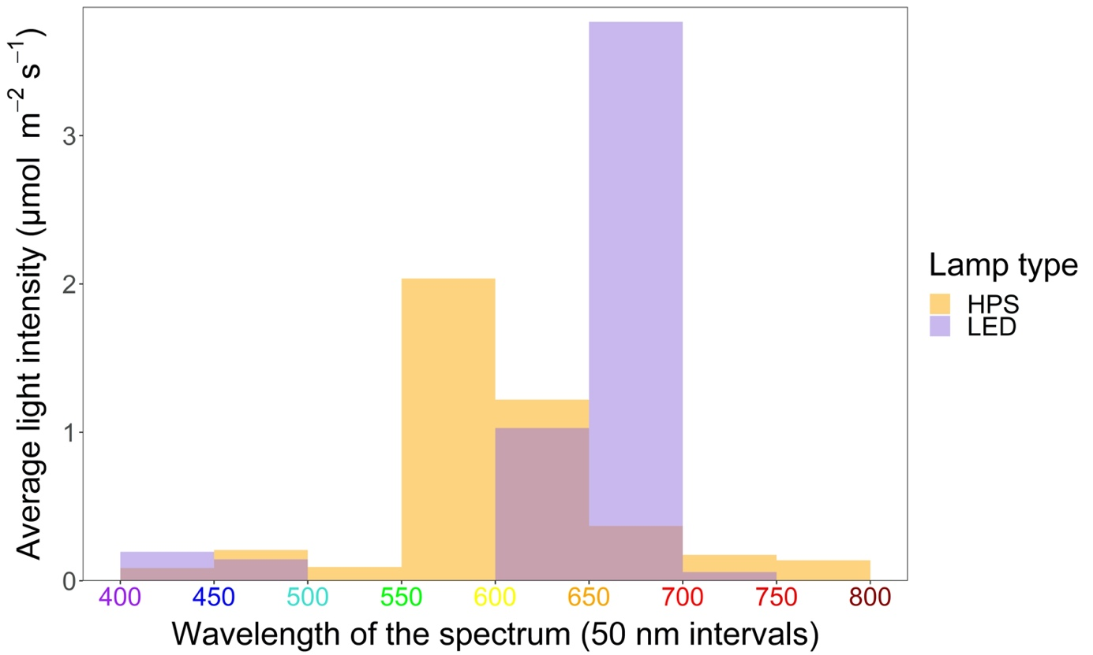
Figure S1. Light spectrum of HPS and R/ B LED lights
The average light intensity (in µmol m⁻² s⁻¹) within a 50 nm wavelength range in the spectral region from 400 nm to 800 nm is shown for the R/ B LED toplights (lilac) and the HPS lamps (orange) used in this experiment. The data were kindly provided by Tijmen Kerstens.

- 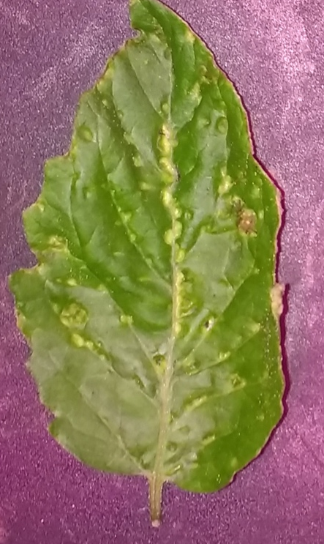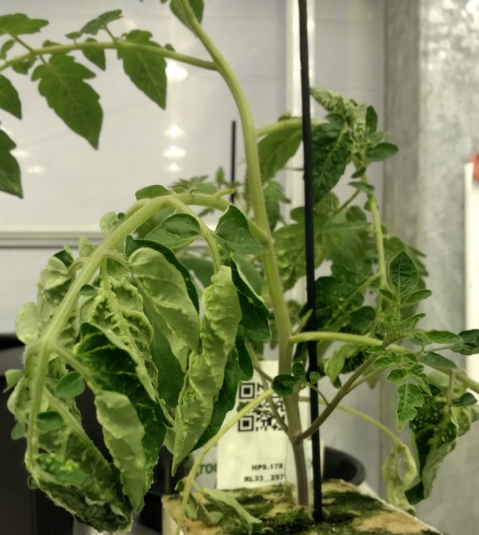
- 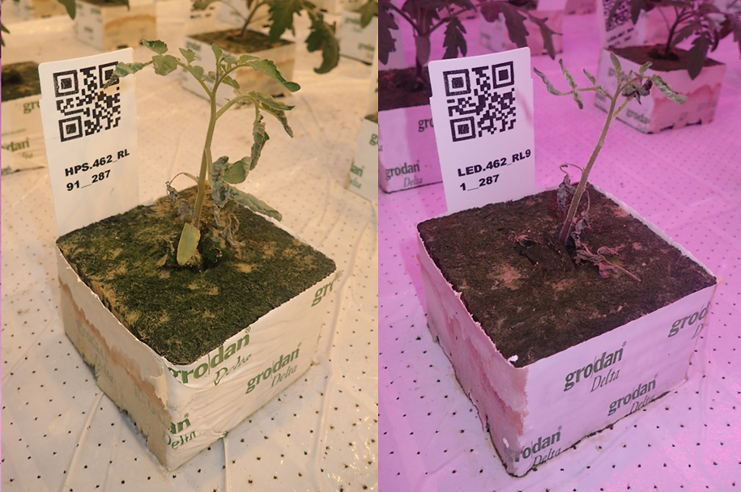
Figure S2. Plants with intumescence
A) Close up of a leaf with intumescence and curled up leaves of a plant with medium severe phenotype. B) Identical genotypes of the population R ~ L with a severe form of intumescence in HPS and LED lighting. The plants were approximately three weeks old.

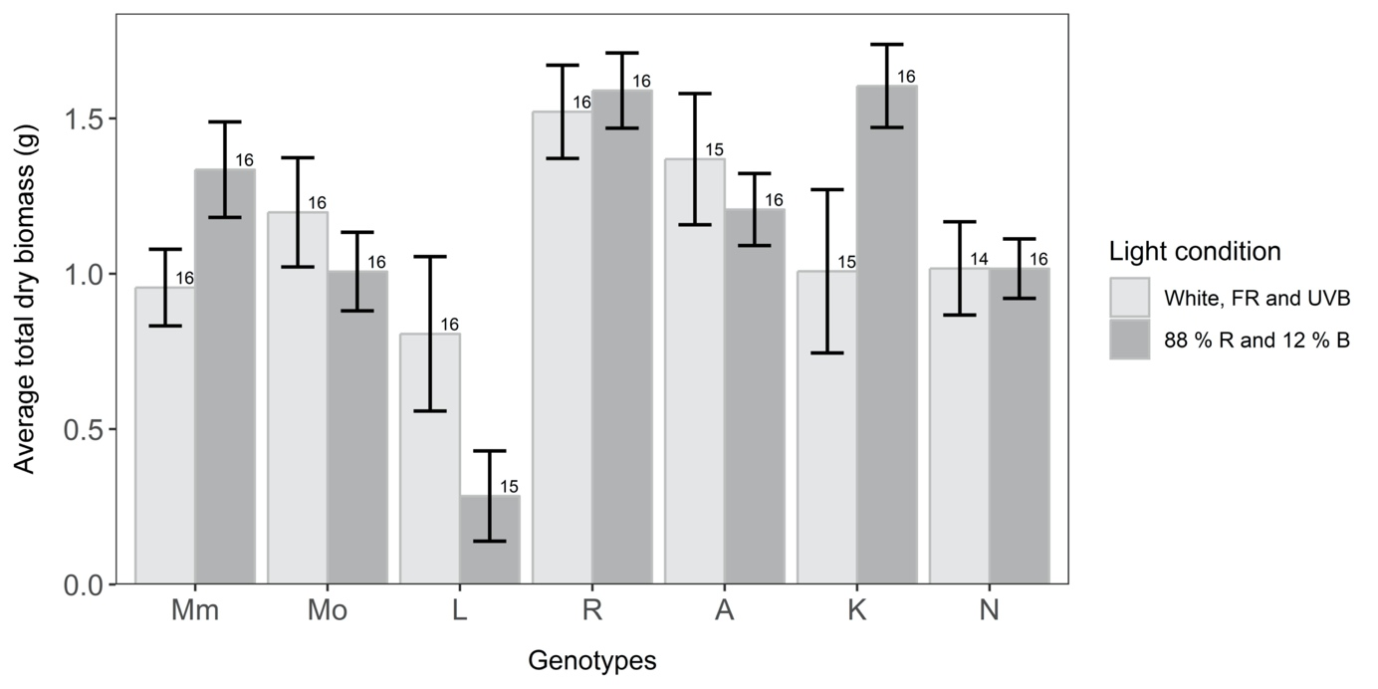Figure S3. Average biomass in two light conditions of the seven genotypes that were used as parents for the RIL populations.
The average total (roots, stems and leaves) dry biomass per genotype was determined for plants growing under either white LEDs (with additional FR and UVB; “White, FR and UVB”) or R/ B LEDs (“88% R and 12% B”). The genotypes selected for crosses to build RIL populations are: Moneymaker (“Mm”), Momotaro (“Mo”), LA1578 (“L”), Rutgers (“R”), Ailsa Craig (“A”), Kentucky Beefsteak (“K”) and Nunhems-FM001 (“N”). The bar-height represents the average biomass per genotype and condition, the error bars are two times the standard error, and the number of assessed replicates is given on the top right of each bar.
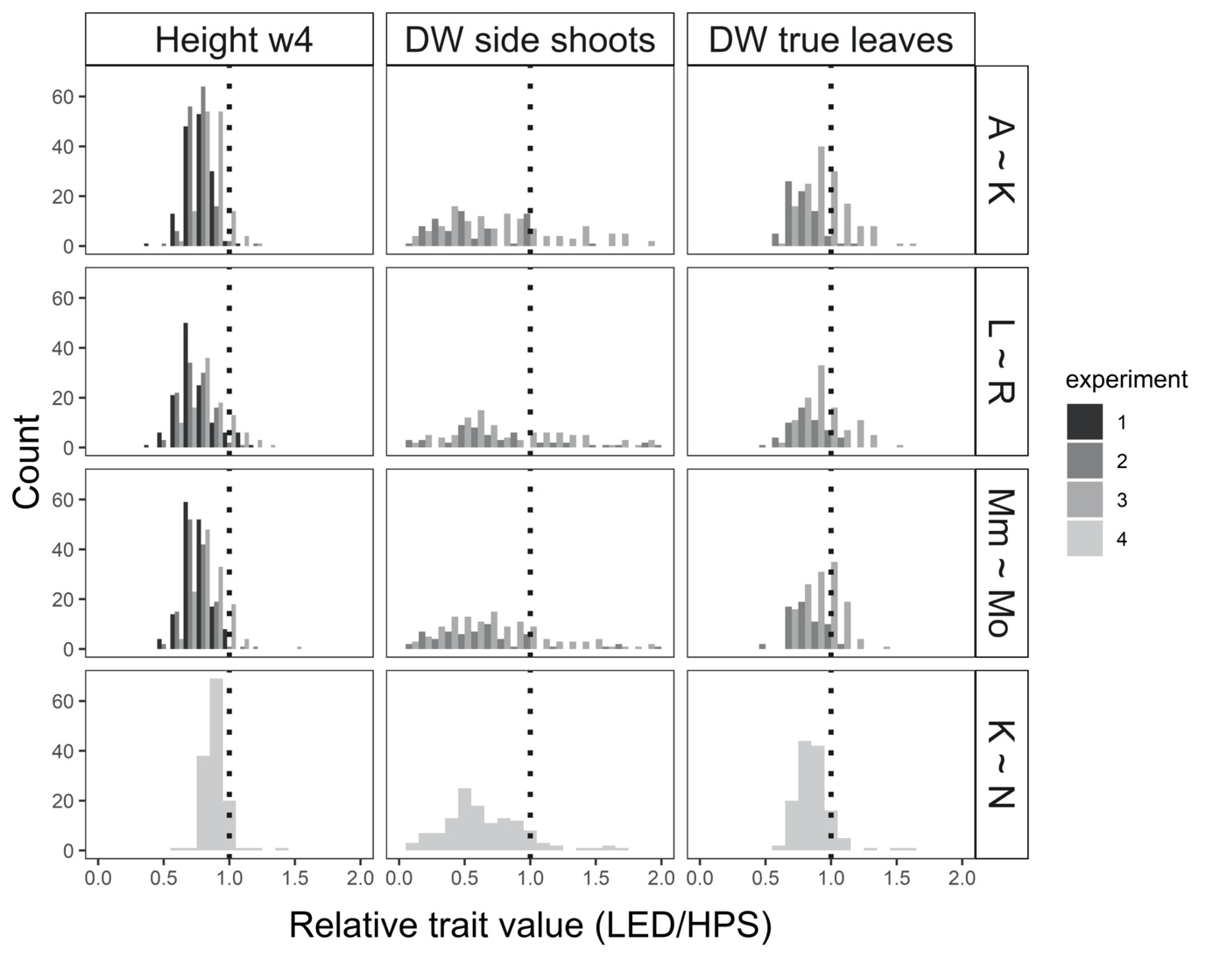
Figure S4. Histograms for the traits plant height at week 4 and dry weight of side shoots and true leaves of young plants.
The histograms of the relative trait values, the ratio of the trait value in LED light compared to that in HPS light, is shown for each population (A ~ K, L ~ R, Mn ~ Mo and K ~ N) and colour coded per experiment. The ratio 1 is indicated as dotted line in each histogram, at this point the trait value in HPS and LED light is identical, if the value is above 1, the value is higher in LED light, below 1 in HPS light grown plants. The dry weight (DW) of the two leaf types was not determined in the first experiment. The histograms are only displayed until a relative trait value of 2, for DW of the side shoots individual RILs show ratios until 24.

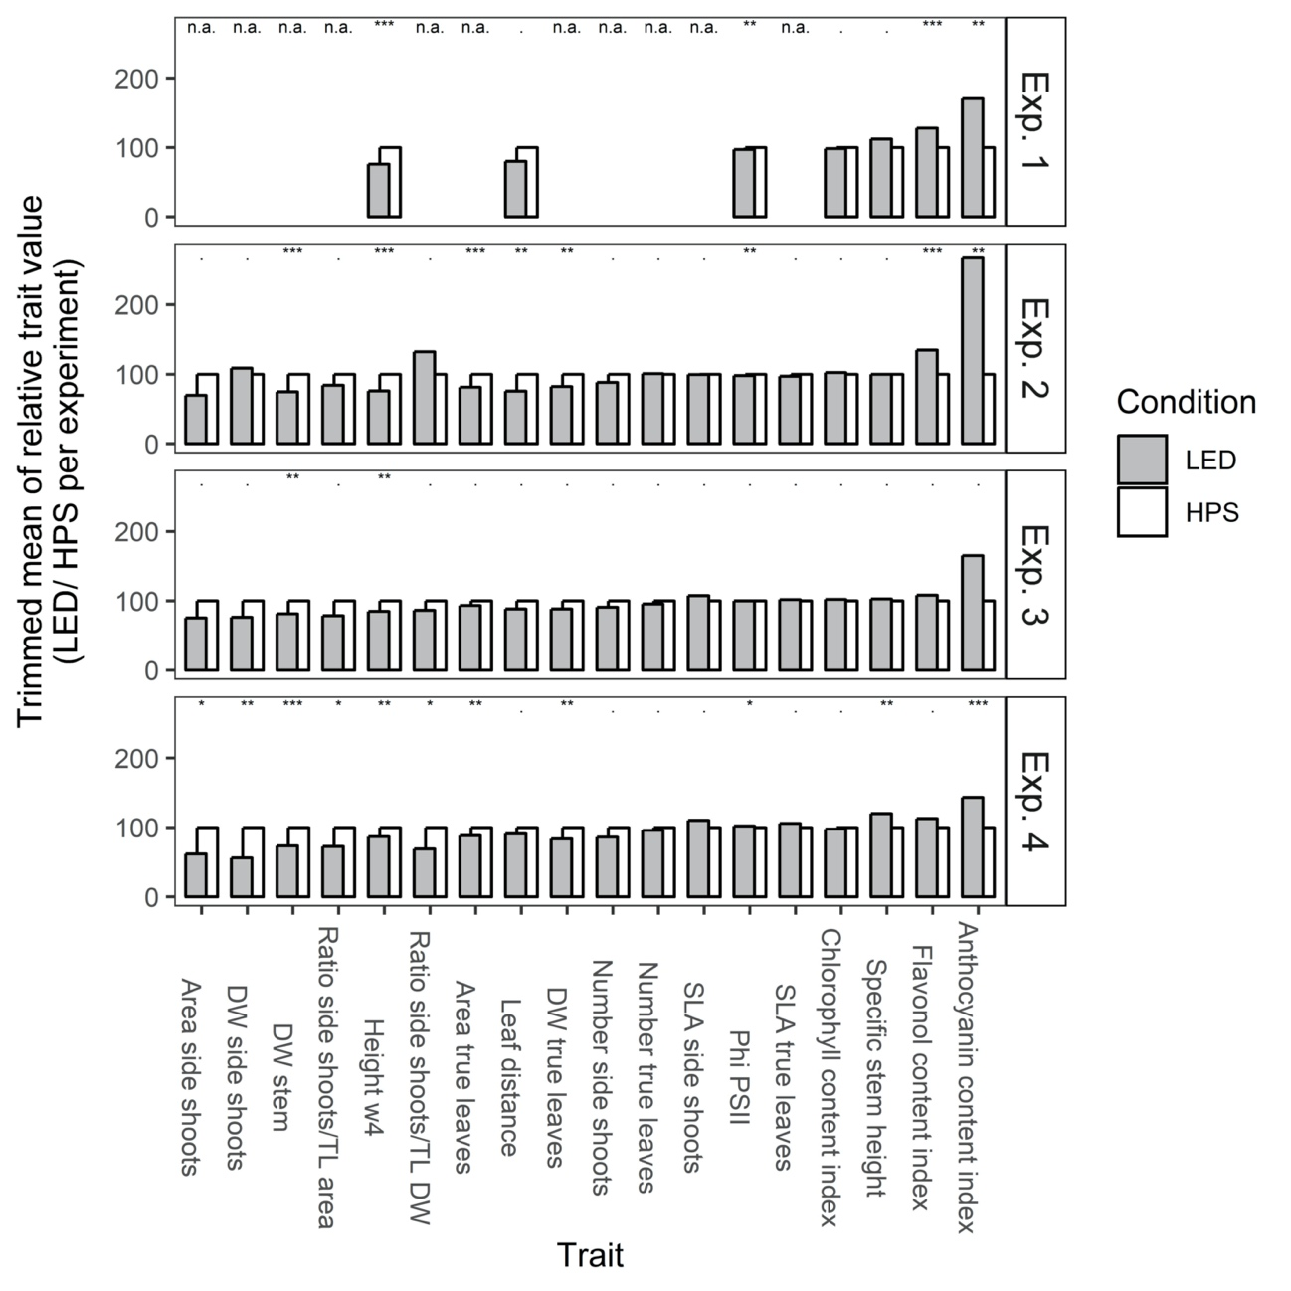
Figure S5. Relative trait value of all parental genotypes over the 4 experiments of young plants
All seven parental genotypes of the 4 RIL-populations were grown in each experiment with ca. 4 replicates per condition. The average trait value of each genotype under HPS-supplemental lighting is set to be 100% and the trait value in LED-supplemental lighting is compared to that value. For each experiment the trimmed mean (trim at 10%) of all genotypes is depicted. A Wilcoxon rank sum test on the untransformed, individual plant data was used to determine if there is a difference in trait value between the light treatments (HPS vs. LED supplemental lighting).

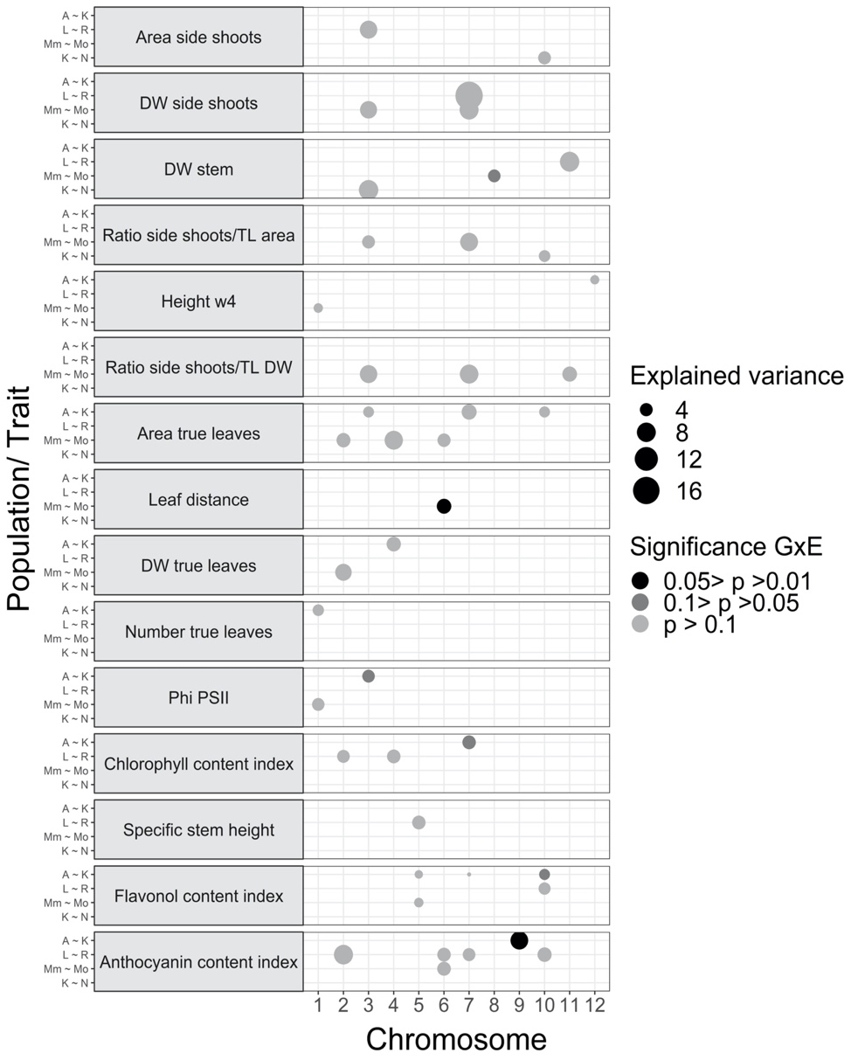
Figure S6. Explained variance (%) of LED specific QTL
The QTL that were only identified under LED conditions are presented as circles that represent by their size the explained variance of the respective QTL. The colour of the circles indicates the significance of the genotype by environment (G x E) interaction of the peak marker of those QTL between HPS and LED light, determined by an ANOVA analysis. The significance is the p-value of the marker by environment interaction and in case this interaction has a p-value between 0.1 and 0.05 the circles representing the QTL are dark grey and in case the p-value is between 0.05 and 0.01 the circles are black. All QTL with a tested G x E interaction with a p-value above 0.1 are displayed in light grey. The QTL are shown per chromosome (x axis) and per population and trait (y axis). The QTL intervals are shown in Suppl. File 2.

Figure S7. QTL mapping of the relative difference in trait value per genotype for the two light environments, using the expression (x_{LED} – x_{HPS}) / x_{HPS .}
Only one QTL was detected at the beginning of ch06 for distance between leaves, which is the internode length.

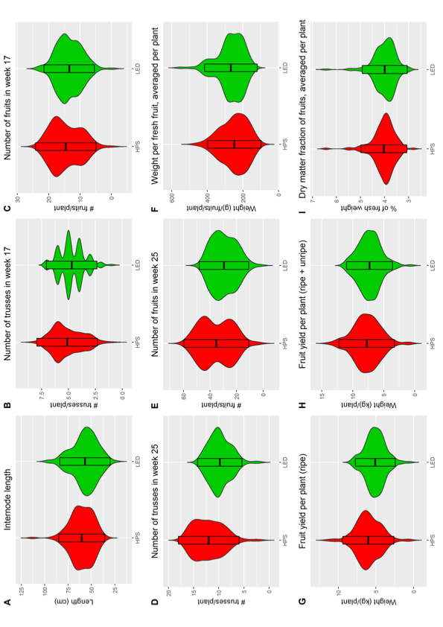
Figure S8. Violin plots for all evaluated fruit traits, comparing between the two lighting systems. The HPS system is shown in red and the LED system in green. In the middle of the violin plots, box-plots are shown. The box-plots show mean ± standard deviation of the mean.

