Facile one-pot synthesis of ultra-thin defect rich Pd metallenes for efficient oxygen evolution reaction

Chaudhry Muhammad Subhan ^{a, c}, Meysam Amini ^{b} *, Dilawar Hassan ^{c}, Muhammad Humza Javed ^{d}

ª PMAS Arid Agriculture University, Rawalpindi, 46300, Pakistan.
^{b} School of Materials Science and Engineering, University of New South Wales, Sydney, NSW, 2052, Australia.
^{c} UNESCO-UNISA Africa Chair in Nanoscience and Nanotechnology, College of Graduate Studies, University of South Africa, Muckleneuk Ridge, Pretoria, P.O. Box 392, South Africa.
^{d} Department of Biomedical Engineering, University of Calgary, 2500 University Drive NW, Calgary, Alberta, T2N 1N4, Canada.
*Corresponding author: m.amini@unsw.edu.au

Electrochemical Measurements
The electrochemical surface area (ECSA) was evaluated in terms of the double-layer capacitance (C_{dl}). The equation for ESCA measurements is: ECSA = C_{dl}/Cs, where Cs is the specific capacitance, which is assumed to be 0.040 mF/cm² in 1 M KOH solution,^{[1]} based on values previously reported for metal oxide catalysts. Cdl was calculated as half of the slope of the plot of capacitive current in a non-faradaic double-layer region against the scan rate. Electrochemical impedance spectroscopy (EIS) measurements were performed in 1.0 M KOH with an applied potential of 1.3V from 100 kHz to 0.01 Hz with an amplitude of 5 mV.
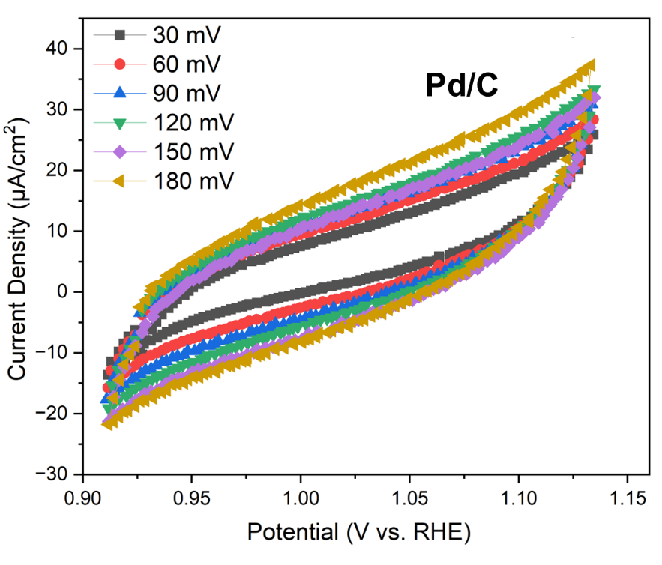
Figure S1. Non-faradaic region CV curves of Pd/C at different scan rate from 30 to 180 mV.
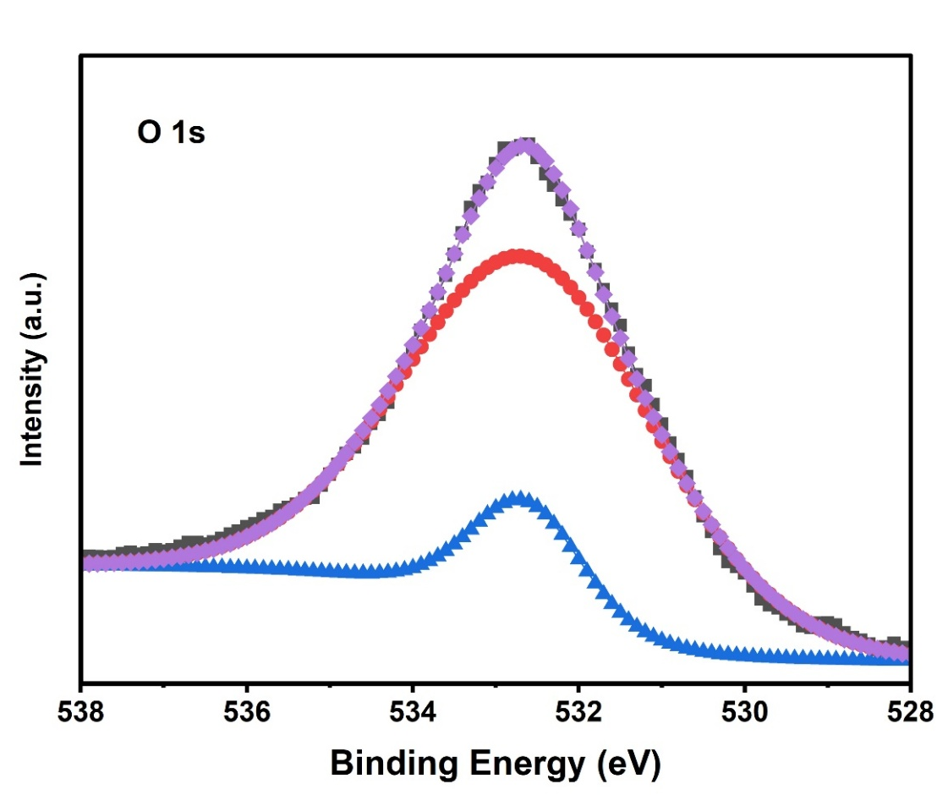
Figure S2. XPS spectra of O-1s

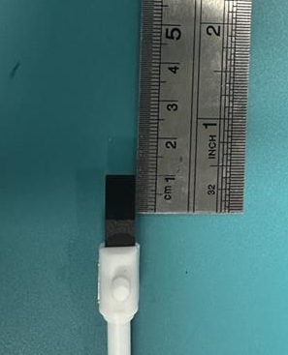
Figure S3. Photograph of deposited electrode on carbon fibre paper.

[1] Song, M. et al. (2024). Corrosion Engineering of Part-Per-Million Single Atom Pt1/Ni(OH)2 Electrocatalyst for PET Upcycling at Ampere-Level Current Density. Advanced Materials. https://doi.org/10.1002/adma.202403234.

