Appendix

Model description
Interconnection capacities with neighboring countries are maintained at current levels as reported by Statnett, the Norwegian Transmission System Operator (TSO), due to absence of 2050 capacity projections [11]. Cross-border interconnections are assumed to operate at one-quarter of their rated capacity based on historical utilization patterns [61]. Internal transmission infrastructure between Norwegian regions can be expanded above current capacities to facilitate inter-regional balancing, with expansion costs included in the optimization.
Hydropower and pumped storage capacities are fixed at current levels based on Norwegian Water Resources and Energy Directorate (NVE) data, reflecting limited expansion potential and ecosystem protection priorities [58]. The existing 5 GW of installed onshore wind capacity is excluded from the model, assuming full replacement by 2050 due to operational lifespan limits [26]. This allows highRES to endogenously determine whether redevelopment at these sites is optimal under scenario-specific constraints; sites remain available if not excluded by scenario criteria in Table A1. Available land area for each technology is converted to capacity potential using assumed power densities in MW/km² [62].

Exclusions for solar PV and offshore wind remain consistent across all scenarios. For solar PV, excluded areas include terrain slopes exceeding 6.3°, elevations above 2000 m, all protected areas (IUCN categories Ia-V) based on WDPA [45], and different land cover types (forest, agriculture, physical infrastructures) according to Ref. [26,58,63]. For offshore wind, excluded areas comprise protected marine zones and waters deeper than 70 m for bottom-mounted wind turbines. Onshore wind faces scenario-specific biodiversity and infrastructure exclusions detailed in Table A1 (Section 2.2), supplemented by terrain slopes exceeding 15° and physical infrastructure buffers (military installations, airports, urban areas) applied uniformly across all scenarios.

Weather data for variable RE generation is processed using the ‘atlite’ geospatial toolbox (version 0.2.13) [57], which converts ERA5 weather reanalysis into hourly capacity factor time series at 30 km × 30 km resolution [64] . We employ 2010 weather data due to its challenging conditions—characterized by exceptional cold and reduced precipitation—resulting in elevated electricity demand and diminished hydropower production, thereby stress-testing system adequacy under adverse meteorological conditions [65]. To exclude poorly performing locations that would not be commercially viable, grid cells with average annual capacity factors below 0.09 (solar PV), 0.15 (onshore wind), and 0.20 (offshore wind) are removed from the available deployment area [26,58,63]. The scenario-specific onshore wind availability rasters from Section 2.2 are integrated with these technical and meteorological constraints within atlite, which aggregates available capacity potential to the regional resolution.

Electricity demand projections for 2050 are based on Statnett forecasts indicating maximum annual consumption of 260 TWh, distributed spatially across regions and temporally to hourly resolution using methods detailed in [26,58]. A system-wide carbon emission constraint of 0 gCO₂/kWh enforces complete decarbonization of the electricity sector by 2050, precluding fossil fuel generation including carbon capture and storage technologies. Technology cost parameters (capital expenditures, fixed and variable operation and maintenance costs, lifetimes) are sourced from [26,58,63,66]. While investment costs for existing infrastructure (hydropower, pumped storage, transmission) are excluded, fixed and variable operation and maintenance costs are included to accurately represent operational expenditures.

The workflow management system Snakemake [67] automates data preparation, model execution, and output processing. The model is solved using the CPLEX optimization solver. Model formulation, input datasets, processing scripts, and instructions for replicating results are openly available in the associated GitHub repository.

Table A1. Scenarios for balancing ecological and economic siting for wind farms.
Scenario | Development focus | Siting strategy | Costs  (LCOE map) | Biodiversity (richness maps) | Area footprint (infrastructure index map) | Protected areas/redlist species
Production maximization (PM) | Economy | Share | < | --- | --- | Ib, II
Production co-location (PC) | Economy | Spare | < | --- | < 5 km from infrastructure | Ia, Ib, V
Collision sensitivity avoidance (CA) | Ecology | Share | --- | < [bats, raptors, gulls] - avoid classes 3-5 | --- | Ia, Ib, IV+redlist
Ecological footprint minimization (EF) | Ecology | Spare | --- | < [all species] - avoid classes 3-5 | < 1 km from infrastructure | Ia, Ib, II, IV+redlist
Sensitive development (SD) | Balanced | Share | < | < [bats, raptors, gulls] - avoid classes 4-5 | --- | Ia, Ib, IV+redlist
Sustainable co-location (SC) | Balanced | Spare | < | < [all species] - avoid classes 4-5 | < 3 km from infrastructure | Ia, Ib + redlist
Sustainable development (SO1) | Balanced | Balanced | < | < geometric mean[all species]+infrastructure  < avoid classes 3-5 |  | Ia, Ib + redlist
Sustainable development (SO2) | Balanced | Balanced | < | < geometric mean[all species]+infrastructure  < avoid classes 4-5 |  | Ia, Ib + redlist

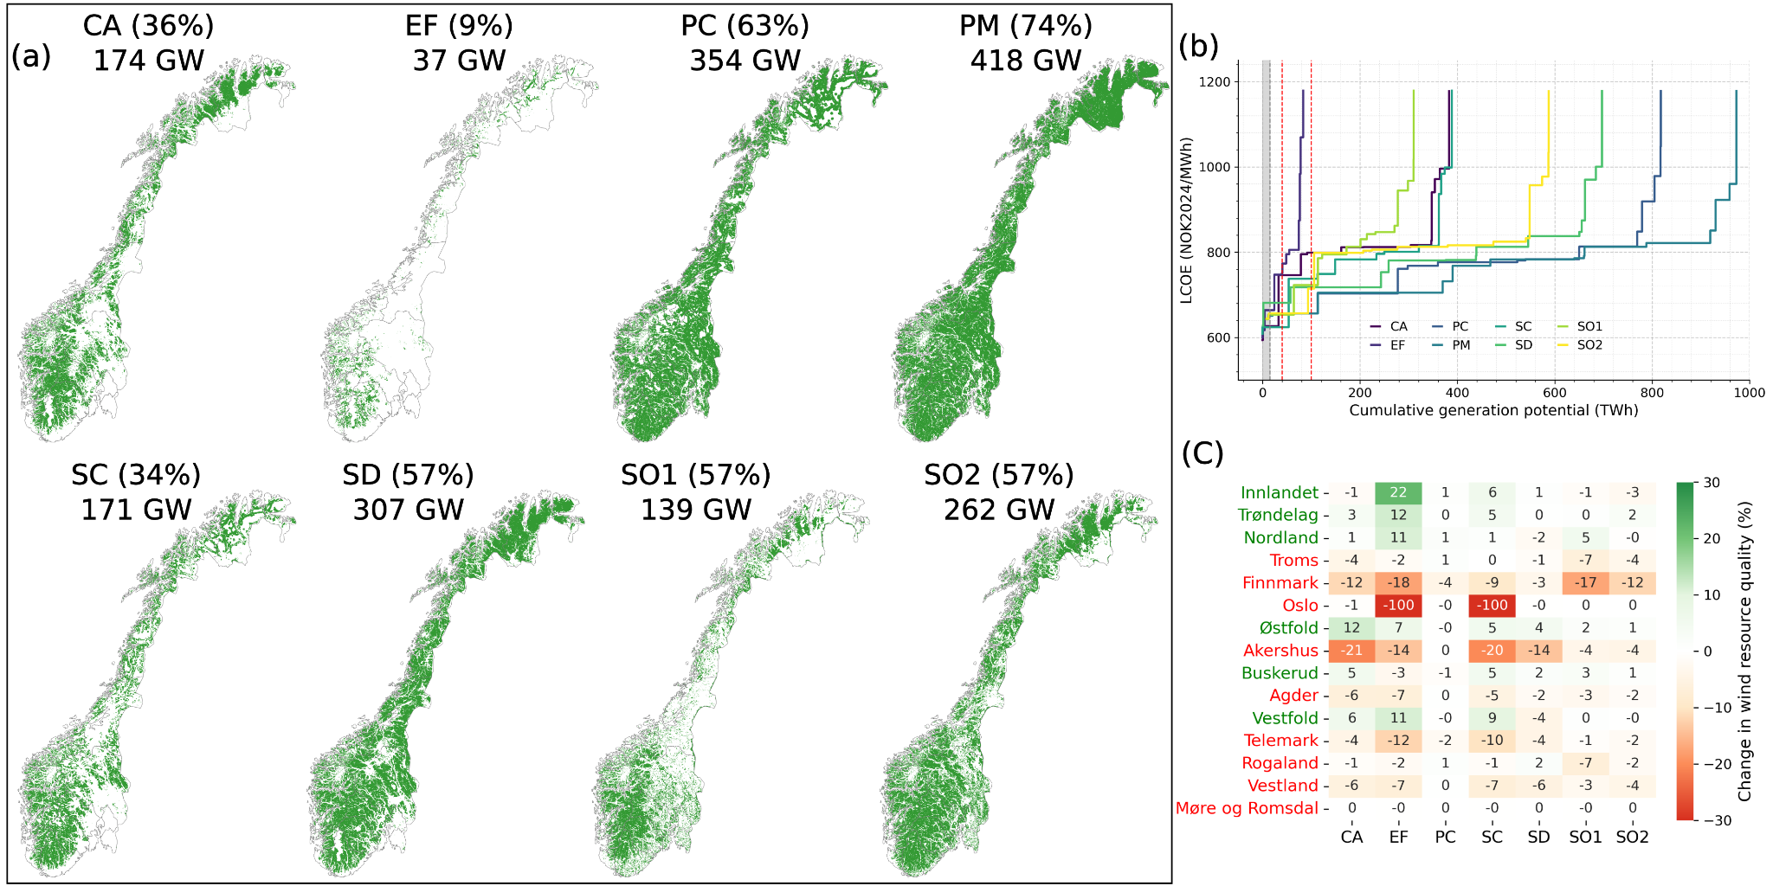

Fig. A1 Impact of ecological restrictions and proximity to infrastructure criteria. (a) Spatial distribution of areas available for onshore wind development under each scenario, shown in green. Scenario names include the percentage of total Norwegian land area available and total capacity potential in GW. (b) Supply curves showing cumulative onshore wind generation potential as a function of levelized cost of electricity (LCOE) for each scenario, with each step corresponding to a region. Vertical red dashed lines indicate total projected increase in Norwegian electricity demand by 2050 [11], and the filled grey area shows onshore wind electricity generation in Norway in 2024. (c) Regional heatmap showing percentage change in mean onshore wind capacity factor relative to PM baseline scenario. Green cells indicate restrictions improve mean wind quality, while red cells indicate degradation. County names with green generally experience a mean increase in capacity factors, while counties named with red exhibit a decline (Related to Fig. 1).
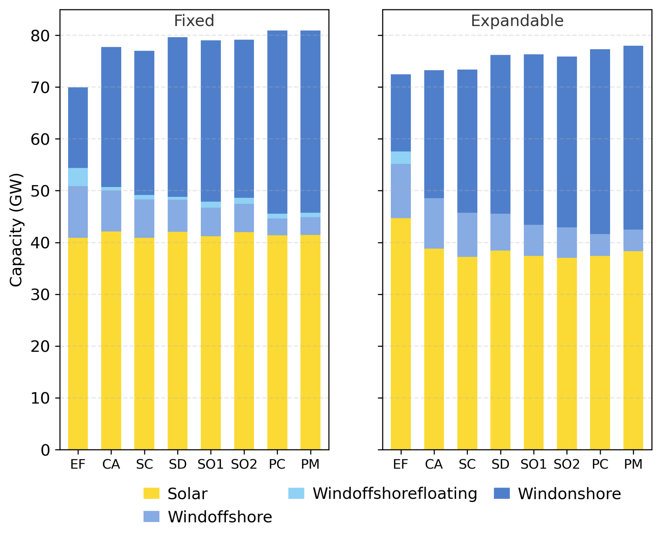
Fig. A2 Total installed generation capacity. The left panel shows fixed transmission configuration; the right panel shows expandable transmission configuration. Stacked bars represent technology-specific capacity contributions. Solar capacity ranges between 37-45 GW across scenarios, while onshore wind exhibits the large variabilities (15-38 GW), directly responding to ecological restrictions. Hydropower capacity (not shown) remains fixed at current levels across all scenarios (Related to Fig. 4).

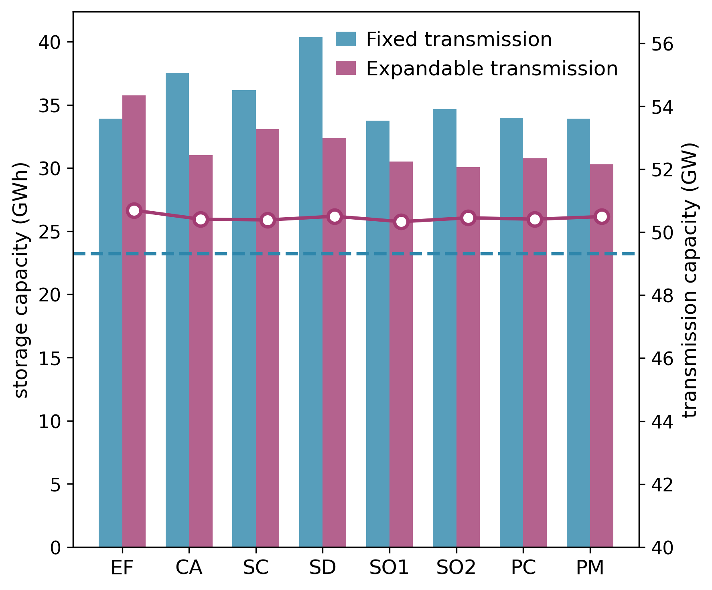
Fig. A3 Storage capacity deployment and transmission expansion across scenarios. Bars show total installed storage capacity (left y-axis, GWh). Solid line indicates optimal total transmission capacity for expandable transmission scenarios while dashed line represents existing transmission. The figure illustrates how spare-share siting frameworks alter the economics of spatial versus temporal balancing (Related to Fig. 4).

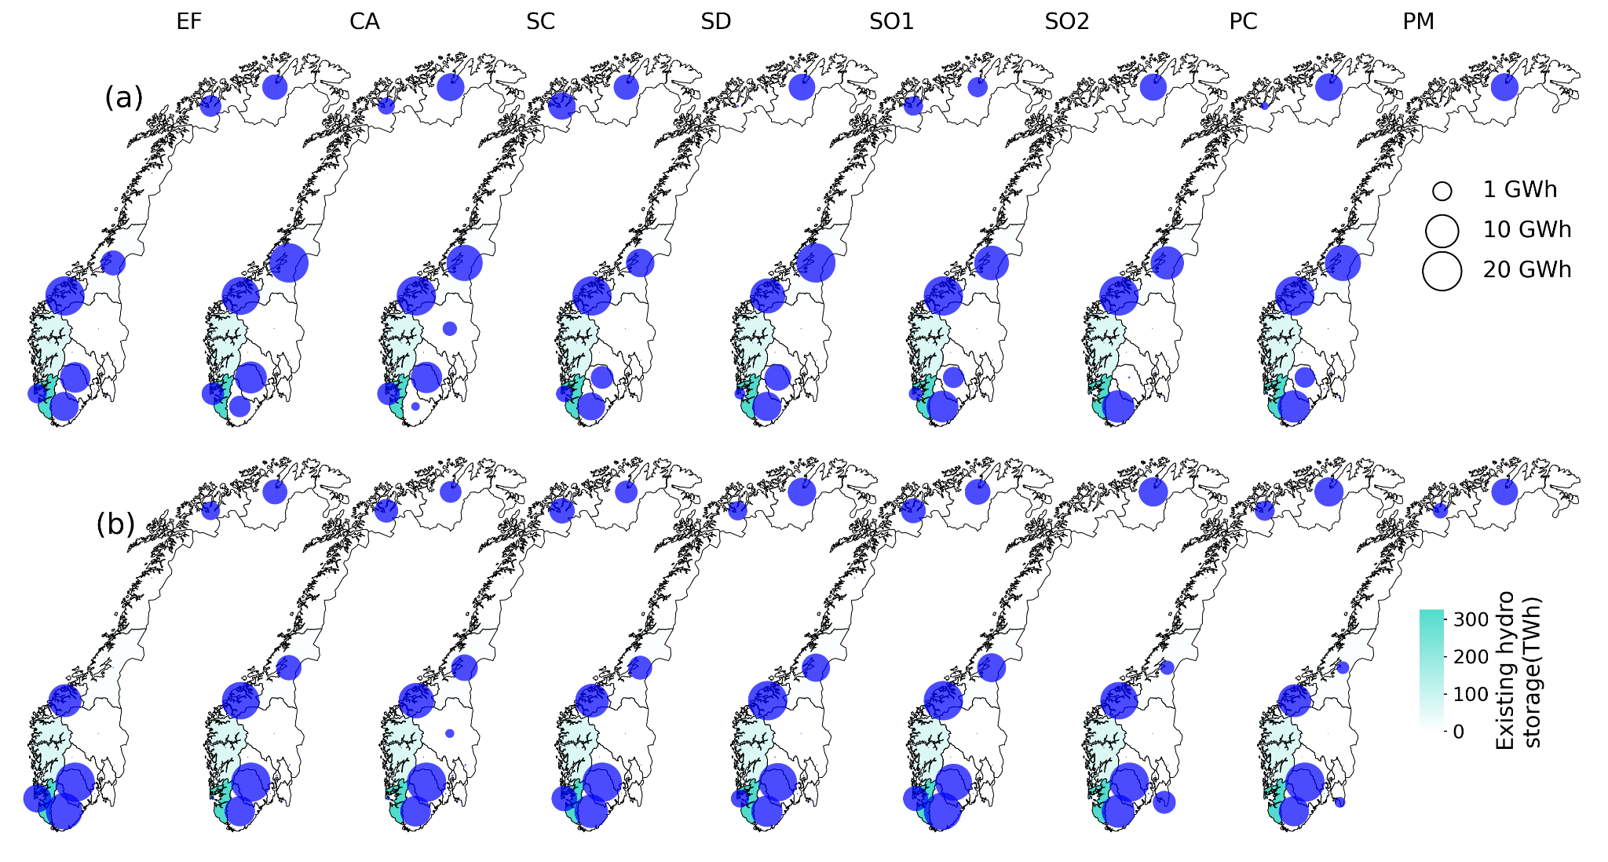
Fig. A4 Regional distribution of new storage capacity deployment. (a) Fixed (b) Expandable transmission. Circle sizes represent installed storage capacity with color bars indicating existing hydropower storage availability (TWh) in each county. Western regions deploy negligible new storage across all scenarios due to existing hydropower storage capacity. Northern regions remain with minimum new storage capacity, relying instead on transmission to southern demand centers (Related to Fig. 5).

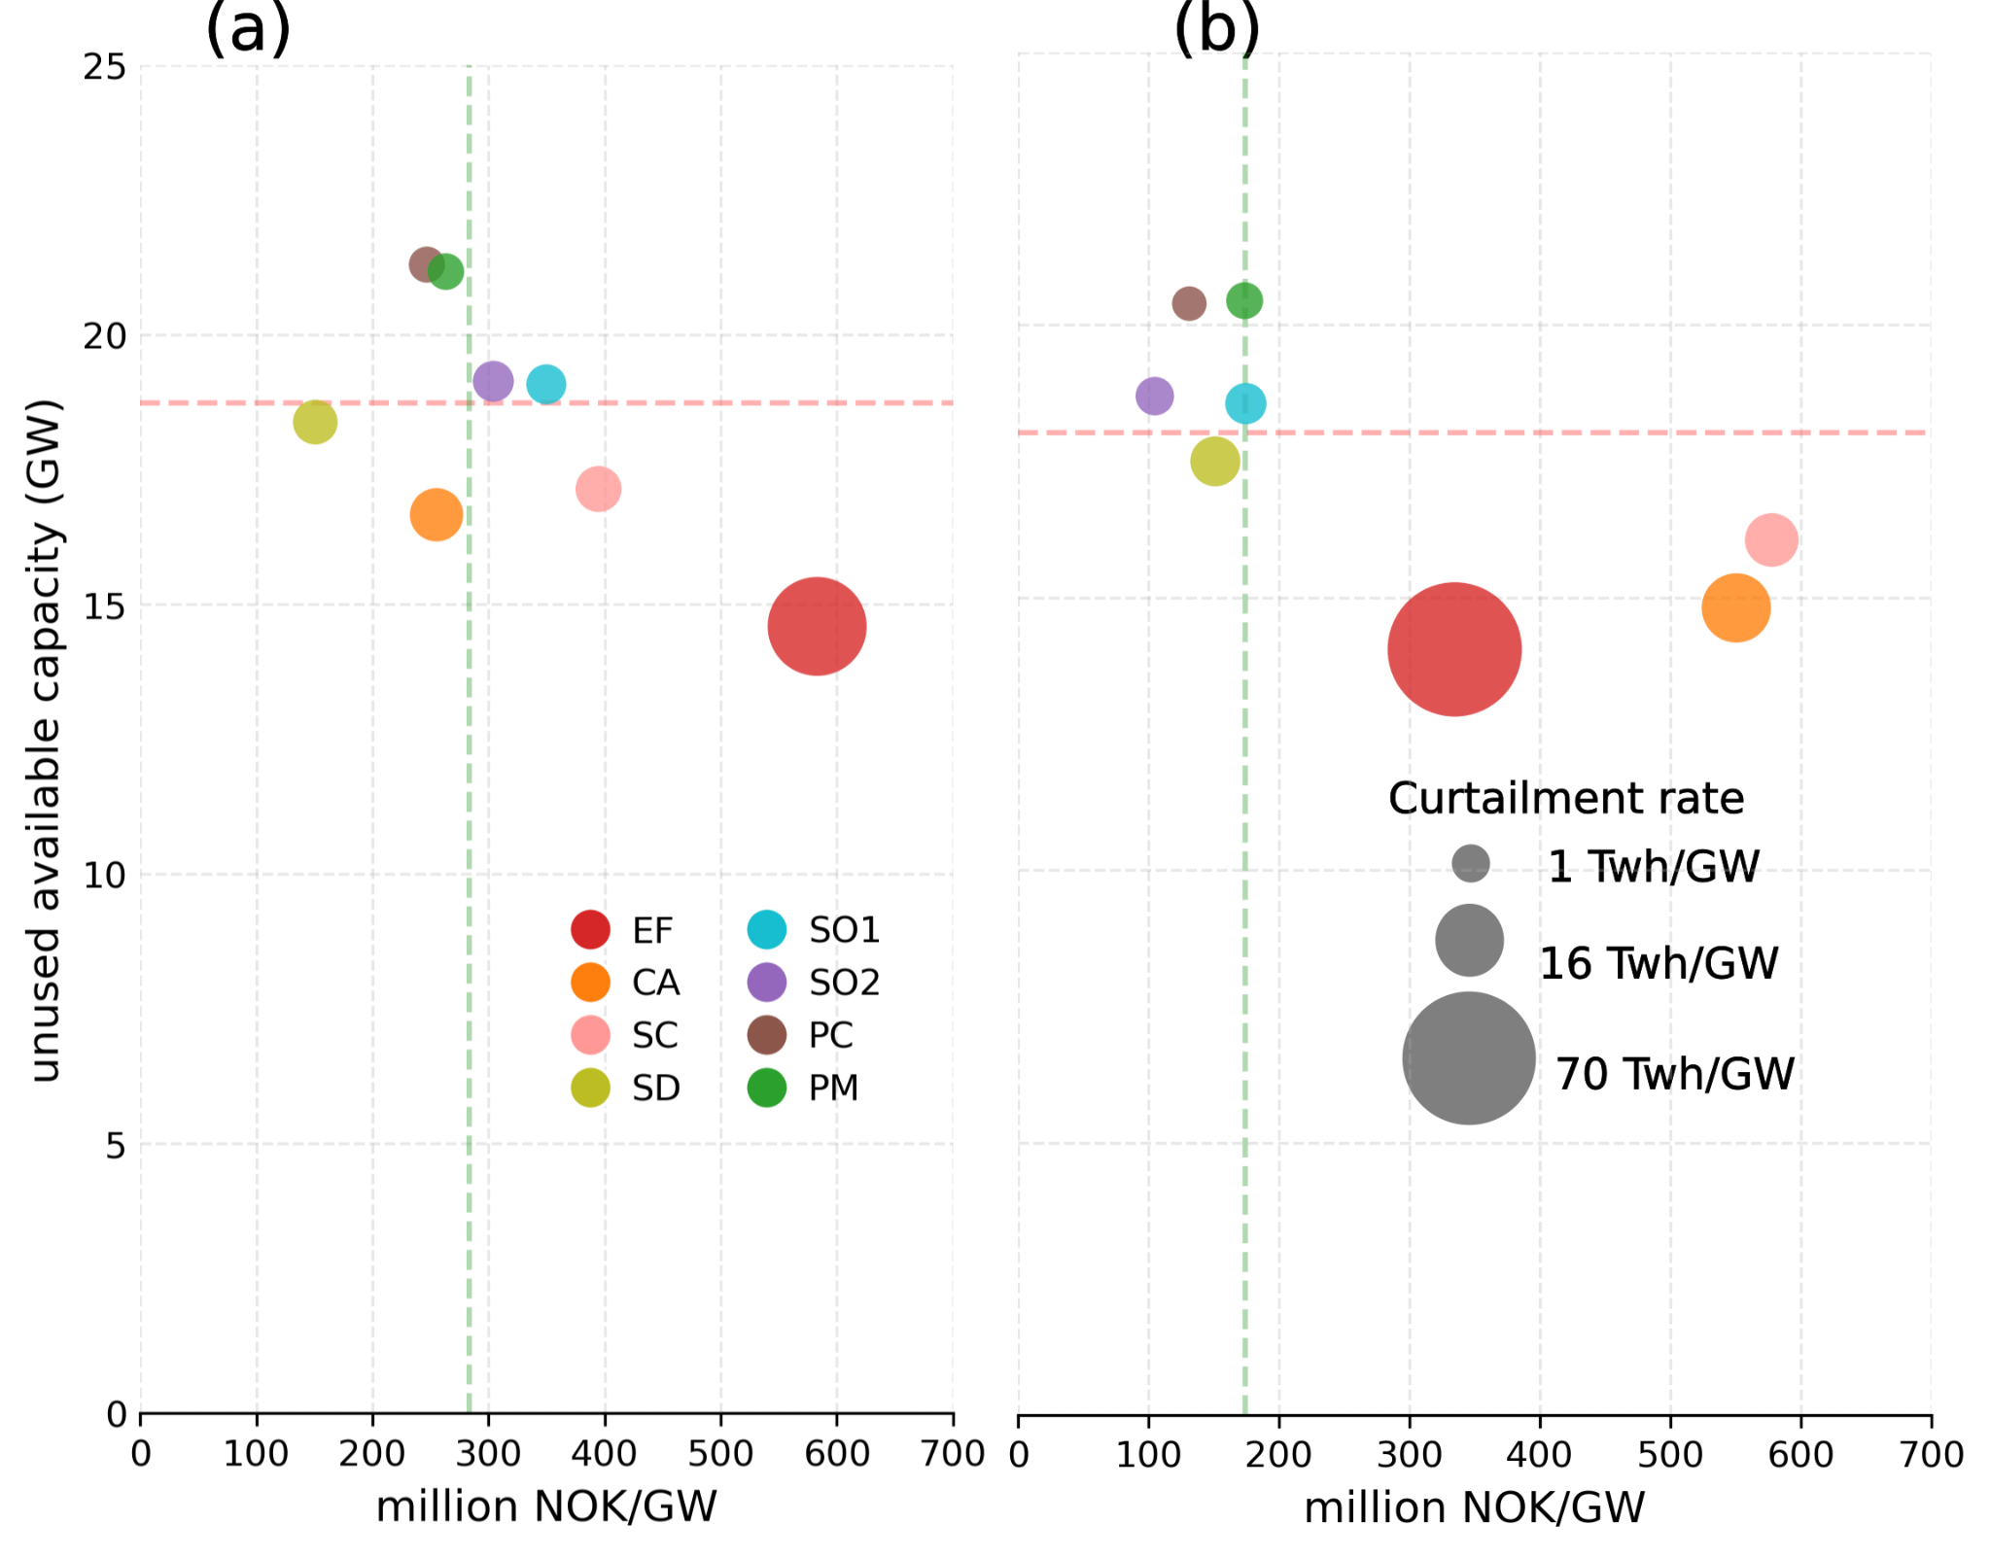
Fig. A5 Economic opportunity cost and system efficiency for offshore wind. (a) Fixed (b) expandable transmission showing the relationship between economic opportunity cost (million NOK/GW, x-axis) and unused available offshore capacity (GW, y-axis). Circle size represents curtailment rate (TWh/GW). Economic opportunity cost represents the marginal economic value for offshore wind of relaxing land-based area constraints at the current optimum. Green and red dashed lines indicate median value (Related to Fig. 5).

