Supplementary Materials
DeePAW: A universal machine learning model for orbital-free ab initio calculations
Tianhao Su¹, Shunbo Hu², Yue Wu¹, Runhai Oyang¹, Xitao Wang¹, Musen Li^{1†}, Jeffrey Reimers^{3,†}, Tong-Yi Zhang^{1,4,†}
¹ Materials Genome Institute, Shanghai Engineering Research Center for Integrated Circuits and Advanced Display Materials, Shanghai Frontier Science Center of Mechan informatics, State Key Laboratory of Materials for Advanced Nuclear Energy, Shanghai University, Shanghai 200444, China
² Institute for the Conservation of Cultural Heritage, Key Laboratory of Silicate Cultural Relics Conservation (Ministry of Education), Shanghai University, Shanghai 200444, China
³ School of Mathematical and Physical Sciences, University of Technology Sydney, Ultimo, New South Wales 2007, Australia
⁴ Guangzhou Municipal Key Laboratory of Materials Informatics, Sustainable Energy and Environment Thrust, Advanced Materials Thrust, Hong Kong University of Science and Technology (Guangzhou), Guangzhou 511400, Guangdong, China

Contents
Supplementary Section 1 Projector Augmented-Wave (PAW) method 3
Supplementary Section 2 Orbital-Free Density Functional Theory 3
Supplementary Section 2.1 Basic Theory of Orbital-Free Density Functional Theory 4
Supplementary Section 2.2 Time Dependent-Orbital Free Density Functional Theory 5
Supplementary Section 2.3 Mathematical Formulation of DORI and λ₂ Descriptors 7
Supplementary Section 2.4 Grid Sampling Method 8
Supplementary Section 3. Theoretical Framework of the Model 9
Supplementary Section 3.1 Euclidean Neural Networks 9
Supplementary Section 3.2 Message Passing Neural Networks 10
Supplementary Section 3.3 Graph Attention Networks 11
Supplementary Section 3.4 Kolmogorov Arnold Networks (KANs) 12
Supplementary Section 4. The Network Output Heads 14
Supplementary Section 4.1 MLP Output Head 14
Section 4.2 KAN Output Head 15
Supplementary Section 4.3 GAT Output Head 16
Supplementary Section 5. Sequential Training Strategy 17
Supplementary Section 6. DeePAW Performance on the MP Database 18
Supplementary Section 6.1 DeePAW Performance against Space Group (SG) 18
Supplementary Section 6.2 DeePAW Performance against Elements 25
Supplementary Section 6.3 DeePAW performance on Formation Energy 28
Supplementary Section 7. Detailed Analysis of Catalytic Scenarios 28
References 32

Supplementary Section 1 Projector Augmented-Wave (PAW) method
Electronic wavefunctions in solids and molecules exhibit significant spatial variations, especially with great fluctuation at the region near an atomic nucleus, called the local region, and with smooth variations in the other region, called the non-local region. The PAW method generalizes both the pseudopotential method and the linear augmented-plane-wave method in a natural way, thereby allows high-quality KSDFT calculations to be performed using the original fictitious Lagrangian approach. The augmentation procedure of PAW is generalized in that partial-wave expansions are by the overlap with localized projector functions and the pseudopotential approach based on generalized separable pseudopotentials can be regained by a simple approximation. The PAW method ingeniously combines the advantages of pseudopotential and all-electron methods through the construction of an operator $\hat{T}$. The operator $\hat{T}$ maps computationally tractable pseudo wavefunctions $\left|\tilde{ψ}\right\rangle$ to their corresponding all-electron wavefunctions $\left|ψ\right\rangle =\hat{T}\left|\tilde{ψ}\right\rangle$, which more accurately represent true electronic states.
T=1+i​n​|ϕin⟩-|ϕin⟩)⟨pin| #1a
where $ϕ_{in}$, $\left|{\tilde{ϕ}}_{in}\right\rangle$ and $\left\langle {\tilde{p}}_{in}\right|$ denote the local basis functions of the all-electron wavefunctions, the pseudo wavefunctions, and the projector functions, respectively.
The fundamental concept of the $\hat{T}$ operator lies in its spatial partitioning strategy: it adopts distinct wavefunction description protocols in different regions to balance computational efficiency with physical accuracy. In non-local regions for smooth electronic wavefunctions, the operator preserves the pseudo wavefunctions characteristics through the approximation:
$$\begin{aligned}\left|ψ\right\rangle =\hat{T}\left|\tilde{ψ}\right\rangle ≈\left|\tilde{ψ}\right\rangle \#\left(1b\right)\end{aligned}$$
In local regions proximal to atomic nuclei, the operator performs rigorous wavefunction reconstruction through:
ψ=Tψ=ψ+n​(|ϕin⟩-|ϕin⟩)⟨pin|ψ⟩#1c

Supplementary Section 2 Orbital-Free Density Functional Theory

Supplementary Section 2.1 Basic Theory of Orbital-Free Density Functional Theory
Shao et al.¹, developed DFTpy as an efficient and object-oriented platform for OFDFT simulations, where electron density $ρ\left(r\right)$ is directly utilized as the fundamental variable for energy variation and optimization. In contrast to conventional Kohn-Sham DFT (KSDFT), OFDFT circumvents the requirement to directly calculate numerous orbitals, thereby achieving substantially reduced computational complexity ($O\left(N\right)$). This characteristic renders OFDFT particularly advantageous for investigating large-scale systems comprising tens of thousands to millions of atoms. Within the OFDFT framework, the total energy of a system is expressed as a functional of electron density $ρ\left(r\right)$, with the ground state determined through application of the variational principle. This energy functional incorporates multiple physical components:
$$\begin{aligned}E\left[ρ\right]=T_{s}\left[ρ\right]+E_{H}\left[ρ\right]+E_{xc}\left[ρ\right]+∫v_{ext}\left(r\right)ρ\left(r\right)dr \#(2.1)\end{aligned}$$
In Eq. (2.1), $T_{s}\left[ρ\right]$ represents the kinetic energy functional of the system, $E_{H}\left[ρ\right]$ denotes the Hartree energy, $E_{xc}\left[ρ\right]$ corresponds to the exchange-correlation energy, and the final term involving the integral of external potential $v_{ext}\left(r\right)$ describes the coupling between nuclear potential fields or other external potentials with electron density. $E_{H}\left[ρ\right]$ and $E_{xc}\left[ρ\right]$ give the corresponding potentials $v_{H}\left[ρ\right]$ and $v_{xc}\left[ρ\right]$. Within this framework, the kinetic energy functional $T_{s}\left[ρ\right]$ serves a dual role: primarily, it dominates energy scaling, particularly in metallic systems; secondarily, it expresses the sensitive components of electronic structure, where essential differences such as localized chemical bonding characteristics and metal/semiconductor transitions must be captured through gradient corrections or non-local correlations in $T_{s}\left[ρ\right]$. In DFTpy, the kinetic energy functional $T_{s}\left[ρ\right]$ consists of three terms, the classis Thomas-Fermi (TF) kinetic energy functional $T_{TF}\left[ρ\right]∝∫ρ^{\frac{5}{3}}\left(r\right)dr$, the von Weizsäcker functional $T_{vW}\left[ρ\right]∝∫\sqrt{ρ\left(r\right)}\left(-\frac{1}{2}∇^{2}\right)\sqrt{ρ\left(r\right)}dr$ and physically meaningful non-local kinetic energy functional², which is given by
$$\begin{aligned}T_{NL}\left[ρ\right]=∫ρ^{α}\left(r\right)ω_{NL}\left[ρ\right]\left(r,r^{'}\right)ρ^{β}\left(r^{'}\right)drdr^{'}.\#（2.2）\end{aligned}$$
Eq. (2.2) introduces a kernel function $ω_{NL}\left(r,r^{'}\right)$ to characterize non-local correlation effects between charge distributions at different spatial points, and the parameters $α$ and $β$ represent the density scaling exponent and non-local density coupling exponent, respectively, controlling the weighting of local density $ρ\left(r\right)$ contributions to kinetic energy and the sensitivity of the non-local kernel $ω_{NL}\left(r,r^{'}\right)$ to remote density $ρ\left(r^{'}\right)$. The kernel function $ω_{NL}$ achieves high-precision modeling of charge distributions, circumventing the requirement in KSDFT to solve individually for each orbital and thereby dramatically reducing computational expenditure. OFDFT exhibits distinctive advantages in large-scale light-matter coupling investigations, simultaneously avoiding the high-dimensional eigenvalue calculations associated with Kohn-Sham orbitals while preserving the capacity for electron characterization of condensed matters.

Supplementary Section 2.2 Time Dependent-Orbital Free Density Functional Theory
Electron density plays an extremely role in the development of Time Dependent-DFT (TD-DFT). The Runge-Gross theorem³ states that that there is a one-to-one correspondence between the TD-scalar potential $v\left(r,t\right)$ and the TD-probability density $ρ\left(r,t\right)$. van Leeuwen⁴ proposed the equation of motion to construct the time-dependent potential for a given initial electron density⁵. DFTpy implements TD-OFDFT by considering a single Bosonic wavefunction and solving the following initial-value equation,
$i\frac{∂}{∂t}ϕ_{B}=\left[-\frac{∇^{2}}{2}+v_{B}\left(r,t\right)\right]ϕ_{B}\left(r,t\right)$, (2.3)
where $ϕ_{B}\left(r,t\right)$ is the normalized bosonic wavefunction. The bosonic system yields the following density-wave-function relationship,
$ρ\left(r,t\right)=N_{e}{\left|ϕ_{B}\left(r,t\right)\right|}^{2}$, (2.4)
where $N_{e}$ is the number of electrons in the system. The time-dependent effective potential is given by
$v_{B}\left(r,t\right)=v_{\text{s}}\left(r,t\right)+v_{\text{P}}\left(r,t\right)$, (2.5)
where $v_{\text{s}}\left(r,t\right)=v_{ext}(r,t)+v_{H}[ρ(t)](r,t)+v_{xc}[ρ(t)](r,t)$ is the widely used potential based on the adiabatic approximation with the TD Hartree potential $v_{\text{H}}\left(r,t\right)=\int{dr}'\frac{ρ\left(r',t\right)}{\left\lceil r-r'\right\rceil }$ and the exchange-correlation (xc) potential, $v_{\text{xc}}(r,t)$, and $v_{\text{P}}\left(r,t\right)$ is the Pauli potential. The typical initial condition associated with Eq. (2.3) is given by
$ϕ_{B}\left(r,t_{0}\right)=\frac{1}{\sqrt{N_{e}}}\sqrt{ρ_{0}\left(r\right)}e^{ik∙r}$, (2.6)
where the exponential term $e^{ik∙r}$ effectively donates momentum of strength k = |k| along the direction of vector k to the electronic system. The Pauli potential involves both adiabatic and nonadiabatic contributions,
$v_{P}(r,t)=v_{P}^{ad}(r,t)+v_{P}^{nad}(r,t)$. (2.7)
The adiabatic Pauli potential is defined by is defined as a functional derivative of the Pauli kinetic energy $T_{P}\left[ρ\right]=T_{s}\left[ρ\right]-T_{vW}\left[ρ\right],$viz.,
$v_{P}^{ad}(r,t)={\left.\frac{∂T_{P}\left[ρ\right]}{∂ρ\left(r\right)}\right|}_{ρ_{0}\left(r\right)→ρ\left(r,t\right)}$. (2.8)
DFTpy employs the nonadiabatic Pauli potential⁶
$v_{P}^{nad}(r,t)=-\frac{π^{3}}{12}\left(\frac{6}{k_{F}^{2}(r,t)}F^{-1}\left\{iq⋅j(q,t)\frac{1}{q}\right\}+\frac{1}{k_{F}^{4}(r,t)}F^{-1}\left\{iq⋅j(q,t) q\right\}\right)$ (2.9)
where $j$ and $q$ are the electronic current density and the reciprocal space vector, respectively. The current density is determined by the standard equation $j(r)=\frac{1}{2i}[ϕ_{B}^{*}(r)∇ϕ_{B}(r)-ϕ_{B}^{*}(r)∇ϕ_{B}^{*}(r)]$. $F$ stands for Fourier transform and $k_{F}(r,t)=[3π^{2}ρ(r,t)]^{1/3}$ is the Fermi wavevector function of the local electron density. Then, the Pauli potential is completely determined, which leads to the TD Hamiltonian $\hat{H}=\left[-\frac{∇^{2}}{2}+v_{B}\left(r,t\right)\right]$. DFTpy numerically solves the TD-OFDFT in a recursive manner with the following iterative function⁷⁻⁹
$\left(1-i\frac{dt}{2}\hat{H}\right)ϕ_{B}\left(r,t+1\right)=\left(1+i\frac{dt}{2}\hat{H}\right)ϕ_{B}\left(r,t\right)$. (2.10)
Using the electron density provided by DeePAW, the TD-OFDFT is calculated by using the open code DFTpy (https://gitlab.com/pavanello-research-group/dftpy), which workflow is shown in Supplementary Figure 1.
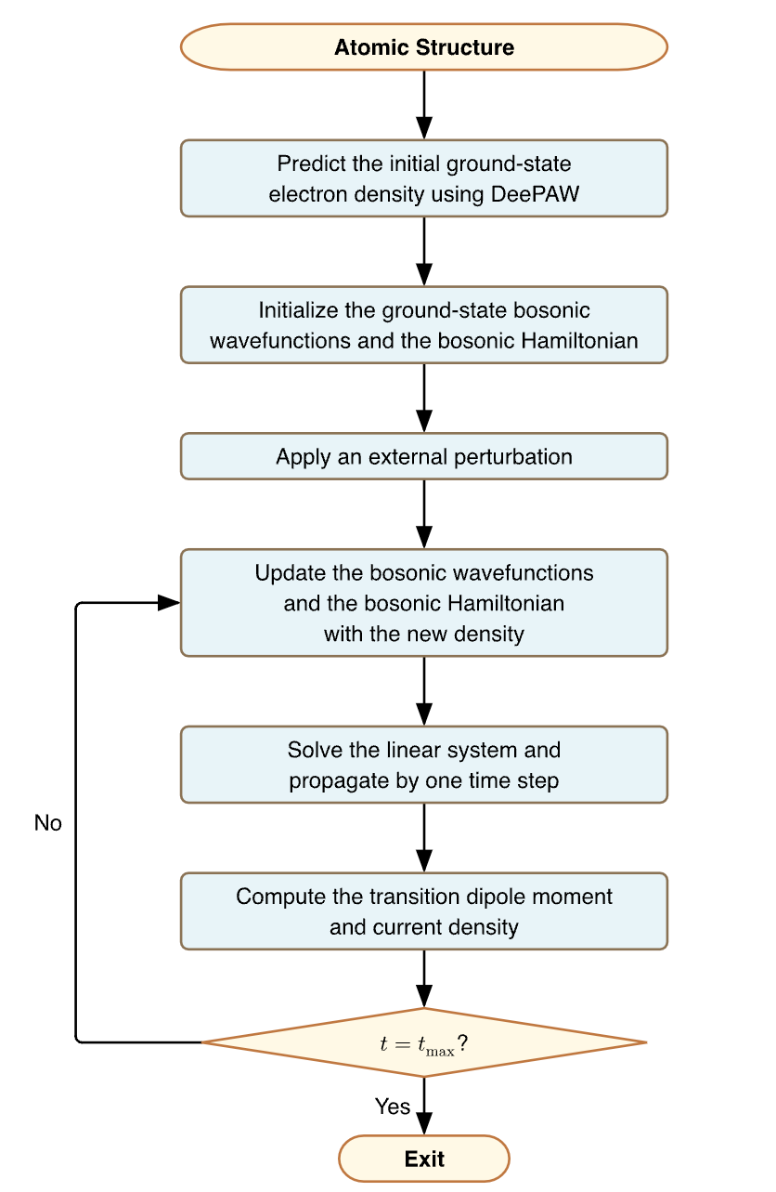
Supplementary Figure 1. The DFTpy workflow of TD-OFDFT, where the electron density is provided by DeePAW.

Supplementary Section 2.3 Mathematical Formulation of DORI and λ₂ Descriptors
DORI (Density Overlap Region Indicator)¹⁰ was developed as a scalar field for revealing both covalent and non-covalent interactions in molecular systems. DORI values range from 0 to 1. Regions with DORI close to 1 indicate areas where electron density overlaps significantly, corresponding to bonding regions (both covalent and non-covalent). The advantage of DORI is its ability to reveal the full spectrum of interactions within a unified framework.
The λ₂ analysis originates from the NCI (Non-Covalent Interaction) method¹¹ and the λ₂ value is the intermediate (second) eigenvalue of the electron density Hessian matrix $H(ρ)$. The sign of λ₂ distinguishes the nature of interactions:
- λ₂ < 0: Attractive interactions (bonding, hydrogen bonds)
- λ₂ > 0: Repulsive interactions (steric clashes)
- λ₂ ≈ 0: Weak van der Waals interactions
By combining DORI isosurfaces colored by λ₂ values, one can visualize and distinguish different types of interactions. This approach provides a comprehensive picture of the electron density distribution landscape.

Supplementary Section 2.4 Grid Sampling Method
The kinetic energy cutoff ($ENCUT$) was set to 520 eV, corresponding to $1.3×$the default $ENMAX$of oxygen (400 eV), in accordance with the Materials Project compatibility standard. A uniform cutoff across all calculations ensures basis set completeness for describing wavefunctions near the ion cores and enables direct energy comparison between different chemical environments. Fixing $ENCUT$also mitigates Pulay stress during variable-cell relaxation, as the number of basis functions remains constant despite volume changes, independent of the defaults inferred from the PREC tag. The Fast Fourier Transform (FFT) grid discretization follows the Nyquist-Shannon sampling theorem. The grid density is controlled by the scaling factor $C_{PREC}$, which sets the maximum wavevector represented on the grid relative to the basis set cutoff. Because the electron density $ρ(r)$arises from a convolution of wavefunctions in reciprocal space, its frequency spectrum extends to $2G_{cut}$. To avoid aliasing (wrap-around errors), PREC = Accurate uses a sampling factor of:
$$\begin{aligned}C_{PREC}=2.0\left(\text{satisfying }NG_{x,y,z}≥2×G_{cut}\right)\#\left(2.12\right)\end{aligned}$$
where the cutoff wavevector is:
$$\begin{aligned}G_{cut}=\frac{\sqrt{2m⋅ENCUT}}{ℏ}\#\left(2.13\right)\end{aligned}$$
This eliminates spurious dependence of the total energy on atomic positions relative to the FFT grid. By contrast, PREC = Normal or Medium uses a reduced sampling density of $C_{PREC}=1.5$, which introduces small aliasing errors that are negligible for standard bulk properties but require validation for high-precision force calculations.
The augmentation charges in the Projector Augmented Wave (PAW) method require a dual-grid strategy. For PREC = Accurate and Normal, a fine grid resolves the rapid variations of the compensation charges near the nucleus:
$$\begin{aligned}NGF_{x,y,z}≈2×NG_{x,y,z}\#\left(2.14\right)\end{aligned}$$
This double-grid approach provides accurate integration of the non-linear core corrections. In PREC = Single mode, augmentation charges are mapped onto the coarser soft-potential grid. This reduces memory usage but truncates the high-frequency components of the augmentation charge, which can produce Fourier ringing (Gibbs oscillations) in the vacuum region; this mode is therefore suitable only for systems where vacuum precision is not required.

Supplementary Section 3. Theoretical Framework of the Model

Supplementary Section 3.1 Euclidean Neural Networks
Geiger and Smidt¹² developed a generalized framework of Euclidean neural networks to treat E(3) equivariant functions and the e3nn library (https://e3nn.org/). e3nn includes the equivariant operations of 3D rotations, translations, and inversion, all together called the Euclidean Group. The data types of e3nn are the irreducible representations (irreps) of 3D orthogonal group $O\left(3\right)=\left\{A∈R^{3×3} | A^{T}A=I\right\}$ and 3D rotation group $SO\left(3\right)=\left\{A∈O(3) | det\left(A\right)=1\right\}$ is normalized and orthogonal, where A is one operator in the group. Any finite dimensional representation of O(3) can be factorized into the irreps of SO(3), which are indexed by the integers l=0, 1, 2, ⋯ and the l-irrep is of dimension $2l+1$, e.g., $l=0$, $l=1$, and $l=2$ correspond to scalars, vectors and rank 2 tensors, respectively. For example, a symmetric 3×3 Cartesian tensor, like a mechanical strain, can be expressed as 1x0e $⊕$ 1x2e in e3nn notation, where 1x means there is one time the irrep, $⊕$ denotes a direct sum (concatenation) of irreps and e denotes the even parity (o denotes the odd parity).
For Euclidean neural networks, all individual network operations are required to obey the equivariance where the group $G = E(3)$ is the Euclidean group in 3 dimensions. The equivariance is defined by $f\left(D_{x}\left(g\right)x\right)=D_{y}\left(g\right)f\left(x\right), ∀g∈G,x∈X$, where $D_{x}\left(g\right)$ (resp. $D_{y}\left(g\right)$) is the representation of the group element g acting on the vector space X (resp. Y), meaning that acting with the group on the inputs or the outputs of the function will get the same answer. The tensor product is the equivariant multiplication operation for two representations. It satisfies the two conditions: bilinear and equivariant. In the case of two vectors, the tensor product can be decomposed into a scalar (corresponding to the scalar product), a pseudovector (the cross product) and 5 components transforming according to the even irrep of $l = 2.$
The gate component in e3nn contains scalar activation functions and gate activation functions to carry out nonlinear activation functions and preserve E(3) equivariance, thereby named the gating mechanism. The inputs of scalar activation functions are odd scalar irreps, which go through activation functions, and the outputs are also scalar irreps. The gate activation is a direct sum of two sets of irreps. The first set of irreps is irreps_scalars, $x_{i}$, passed through activation functions act_scalars, $ϕ_{i}$. The second set of irreps is irreps_gated, $ϕ_{j}$, multiplied by the scalars irreps_gates $g_{j}$ passed through activation functions act_gates $y_{j}$. Mathematically, this can be written as: $\left(⊕ϕ_{i}\left(x_{i}\right)\right)⊕\left(⊕ϕ_{j}\left(g_{j}\right)y_{j}\right)$. Since scalar multiplication with a vector yields a vector, and scalar multiplication with any irrep preserves its transformation properties, the gate operation maintains E(3) equivariance.

Supplementary Section 3.2 Message Passing Neural Networks
Gilmer et al.¹³ reformulated several existing spatial-based ConvGNNs into a single common framework and named it Message Passing Neural Networks (MPNNs). MPNNs treat graph convolutions as a message-passing process in which information can be passed from one node to another along edges directly and message-passing iterations propagate information further. The forward process in MPNNs includes two phases, a message passing phase and a readout phase. The message passing phase has L layers and L is a hyperparameter. In the $\left(l\right)th$ layer $\left(l=1,⋯,L\right)$ there are a message function $M_{l}$ and a vertex feature update function $U_{l}$. The $\left(l\right)th$ layer receives the embeddings $h_{i}^{\left(l-1\right)}$ $\left(i=1,⋯,n\right)$ of a node, the embeddings $h_{j}^{\left(l-1\right)}$ $\left(j∈N_{i}, j=1,⋯,J\right)$ of neighbors of the node i, and the embeddings of edges connecting the node and its neighbors. The functions $M_{l}$ and $U_{l}$ implement the convolution and update the node embeddings accordingly. Mathematically, we have
$m_{i}^{\left(l\right)}=\sum_{j∈N_{i}}{M_{l}\left(h_{i}^{\left(l-1\right)},h_{j}^{\left(l-1\right)},e_{ij}\right)}$, (3.1a)
$h_{i}^{\left(l\right)}=U_{l}\left(h_{i}^{\left(l-1\right)},m_{i}^{\left(l\right)}\right)$ $\left(i=1,⋯,n\right)$, (3.1b)
where $n$ is the number of nodes in a graph and $h_{i}^{\left(0\right)}=X_{i}$ is the input feature vector of node i. Since the neighbor embeddings are the same as the node embeddings, but might be arranged differently, the neighbor embeddings are updated also. Following the message passing phase is the readout phase, which computes a feature vector for the whole graph using some readout function R. For regression at the graph level, the readout phase, like output layer, is expressed by
${\hat{y}}_{G}=R\left(h_{i}^{\left(L\right)} | i∈G\right)$. (3.2)
Since R operates on the set of node states and it must be invariant to permutations of the node states in order for the MPNN to be invariant to graph isomorphism. There are trainable latent variables (weights and biases) in each of the message functions $M_{l}$, vertex update functions $U_{l}$, and readout function R and these functions are all learned differentiable functions. The backpropagation method is used to train these involved latent variables with designed loss functions.

Supplementary Section 3.3 Graph Attention Networks
Veličković et al.¹⁴ proposed the Graph Attention networks (GAT) by using a single graph attentional layer. The input is a set of node features, $h=\left\{h_{1},⋯,h_{N}\right\}$ and $h_{i}∈R^{F}$, where N is the number of nodes, and F denotes the dimension of features in each node. The layer produces a new set of node features $h'=\left\{{h'}_{1},⋯,{h'}_{N}\right\}$ with ${h'}_{i}∈R^{F'}$ as its output with a shared linear transformation, parametrized by a weight matrix, W$∈R^{F'×F}$ on every node. An operator a, linear or nonlinear, is parametrized by a weight vector $a∈R^{2F'}$, which is used to compute scalar attention coefficients $e_{ij}=a\left(Wh_{i},Wh_{j}\right)$. Although node j can be any other nodes in the graph, usually, $j∈N\left(i\right)$ are only the nodes of neighborhood of node i. As in transformer, the attention coefficients are normalized by softmax and denoted by
$\begin{aligned}α_{ij}=\frac{exp\left(a^{T}\left(Wh_{i}∥Wh_{j}\right)\right)}{\sum_{ j∈N\left(i\right)}{exp\left(a^{T}\left(Wh_{i}∥Wh_{j}\right)\right)}} \#\left(3.3\right)\end{aligned}$.
where the operator is parametrized by a weight vector $a∈R^{2F'}$ and $∥$ denotes the concatenation operation. GAT also applies the LeakyReLU nonlinearity (with negative input slope α = 0:2) to revise Eq.(4a) to
$$\begin{aligned}α_{ij}=\frac{exp\left(LeakyReLU\left(a^{T}\left(Wh_{i}∥Wh_{j}\right)\right)\right)}{\sum_{ j∈N\left(i\right)}{exp\left(LeakyReLU\left(a^{T}\left(Wh_{i}∥Wh_{j}\right)\right)\right)}} \#\left(3.4\right)\end{aligned}$$
The final output features for every node are given by
$$\begin{aligned}{h^{'}}_{i}=σ\left(\sum_{ j∈N\left(i\right)}{α_{ij}}Wh_{j}\right) \#\left(3.5\right)\end{aligned}$$
where $σ\left(∙\right)$ is an activation function.
The multi-head GAT employs multi- weight matrix $W^{\left(k\right)}\left(k=1,⋯,K\right)$ and can deliver the concatenated output
$$\begin{aligned}{h^{'}}_{i}=σ\left(\sum_{ j∈N\left(i\right)}{α_{ij}^{\left(1\right)}}W^{\left(1\right)}h_{j}\right)∥⋯∥σ\left(\sum_{ j∈N\left(i\right)}{α_{ij}^{\left(K\right)}}W^{\left(K\right)}h_{j}\right) \#\left(3.6\right)\end{aligned}$$
where $α_{ij}^{\left(k\right)}$ is calculated by $a^{\left(k\right)}\left(k=1,⋯,K\right)$. Alternately, GAT takes the average first and then applies the activation function so that the updated features are
$$\begin{aligned}{h^{'}}_{i}=σ\left(\frac{1}{K}\sum_{k=1}^{K}{\sum_{ j∈N\left(i\right)}{α_{ij}^{\left(K\right)}}W^{\left(K\right)}h_{j}}\right) \#\left(3.7\right)\end{aligned}$$

Supplementary Section 3.4 Kolmogorov Arnold Networks (KANs)
Inspired by the Kolmogorov-Arnold representation theorem, Liu et al.¹⁵ developed Kolmogorov Arnold Networks (KANs), where each neuron (node) in a layer has its representations and the edges link nodes between layers are installed activation functions. KANs are inspired by the Kolmogorov superposition theory (KST)¹⁶, which is called the Kolmogorov-Arnold representation theorem. The KST theory states that a multivariate continuous function $f\left(x\right)=f\left(x_{1},⋯,x_{n}\right)$ on a bounded domain, usually ${\left[0,1\right]}^{n}$, can be decomposed by n inner nonlinear univariable continuous functions and $\left(2n+1\right)$ outer nonlinear functions with additive operation, viz.,
$$\begin{aligned}f\left(x\right)=f\left(x_{1},⋯,x_{n}\right)=\sum_{q=1}^{2n+1}{Φ_{q}\left(\sum_{p=1}^{n}{ϕ_{q,p}}\left(x_{p}\right)\right) }\#\left(3.8\right)\end{aligned}$$
where $ϕ_{q,p}\left(x_{p}\right)\left(p=1,⋯,n\right)$ denotes the n inner nonlinear univariable continuous functions and their sum is the variables of the $\left(2n+1\right)$ outer nonlinear functions $Φ_{q}\left(∙\right)\left(q=1,⋯,2n+1\right)$. Inspired by the Kolmogorov-Arnold representation theorem and in analogy with MLPs, KANs define a layer with $n_{in}$ dimensional inputs and $n_{out}$ dimensional outputs and stack more layers, thereby generalizing the network to arbitrary widths and depths. Obviously, the Kolmogorov-Arnold theorem corresponds to a two-layer KAN, where the first layer takes $n_{in}=n$ dimensional input and delivers the $n_{out}=2n+1$ dimensional outputs, and the second layer takes $n_{in}=2n+1$ dimensional input and $n_{out}=1$ dimensional output, as shown in Eq.(5a). KANs stack $L+1$ layers and in the lth layer $\left(l=0,1, ⋯,L\right)$ there are $n_{l}$ nodes and set $n_{0}=n_{1}=⋯=n_{L}=N$ in practice. The ith neuron (node) in the lth layer is denoted by (l, i) and its value (activation value is denoted by $x_{l,i}$. Like in MLP, each node in the lth layer links to every node in the $\left(l+1\right)$th layer so that there are $n_{l}n_{l+1}$ edges. On each edge, there is an activation function $ϕ_{l,j,i}\left(l=0,1, ⋯,L-1\right)\left(i=1, ⋯,n_{l}\right)$ $\left(j=1, ⋯,n_{l+1}\right)$. The pre- and post-activation of $ϕ_{l,j,i}$ are $x_{l,j}$ and $x_{l+1,i}$, respectively, and takes the following matrix form
$$\begin{aligned}x_{l+1}=\left(\begin{matrix}ϕ_{l,1,1} & ⋯ & ϕ_{l,1,n_{l}} \\ ⋮ & ⋱ & ⋮ \\ ϕ_{l,n_{l+1},1} & ⋯ & ϕ_{l,n_{l+1},n_{l}}\end{matrix}\right)x_{l} \#\left(3.9\right)\end{aligned}$$

The matrix $\left(\begin{matrix}ϕ_{l,1,1} & ⋯ & ϕ_{l,1,n_{l}} \\ ⋮ & ⋱ & ⋮ \\ ϕ_{l,n_{l+1},1} & ⋯ & ϕ_{l,n_{l+1},n_{l}}\end{matrix}\right)$ is the function $Φ_{l}$ for the lth layer. Thus, the KAN output is given by
$$\begin{aligned}KAN\left(x\right)=\left(Φ_{L-1}∘Φ_{L-2}∘⋯Φ_{1}∘Φ_{0}\right)x \#\left(3.10\right)\end{aligned}$$
or $f\left(x\right)=\sum_{i_{L-1}=1}^{n_{L-1}}{ϕ_{L-1,i_{L},i_{L-1}}}\left(\sum_{i_{L-2}=1}^{n_{L-2}}{ϕ_{L-1,i_{L-1},i_{L-2}}}\left(⋯\sum_{i_{1}=1}^{n_{1}}{ϕ_{L-1,i_{2},i_{1}}}\left(\sum_{i_{0}=1}^{n_{0}}{ϕ_{L-1,i_{1},i_{0}}}\right)\right)\right)x_{0}$. (3.11)

Similar to ResNet, KANs employ residual activation functions for $ϕ\left(x\right)$, viz.,
$$\begin{aligned}ϕ\left(x\right)=w_{b}b\left(x\right)+w_{s}spline\left(x\right) \#\left(3.12\right)\end{aligned}$$
In Eq.(5e), $w_{b}$ and $w_{s}$ are corresponding weights, $b\left(x\right)$ is a SiLU function given by
$$\begin{aligned}b\left(x\right)=SiLU\left(x\right)=\frac{x}{1+e^{-x}} \#\left(3.13\right)\end{aligned}$$
and $spline\left(x\right)$ is a linear combination of B-splines
$$\begin{aligned}spline\left(x\right)=\sum_{i}^{n_{l}}{c_{i}B_{i}^{k}\left(x\right)} \#\left(3.14\right)\end{aligned}$$
with each spline of order k (usually k = 3) on G intervals (for G + 1 grid points) and trainable weights $c_{i}$. KANs take the following initialization scales. Each activation function is initialized to have $w_{s}$ = 1 and $c_{i}$ is randomly selected from $N\left(0,σ^{2}={0.1}^{2}\right)$. $w_{b}$ is initialized according to the Xavier initialization¹⁷, also called Glorot initialization, which is a weight initialization method designed to keep the variance of activations and gradients consistent across layers, reducing the risk of vanishing or exploding gradients during training. The spline grids are updated on the fly to address the issue that splines are defined on bounded regions, but activation values can evolve out of the fixed region during training.
Noorizadegan et al.¹⁸ provided practitioner guide to KANs. Particularly, they provide a practical “Choose–Your–KAN” guide (https://github.com/AmirNoori68/kan-review), including various basic functions $ϕ_{q,p}\left(x_{p}\right)$ and outline open research challenges and future directions.

Supplementary Section 4. The Network Output Heads
The DeePAW model employs a dual-head architecture of MLP and KAN output heads for electron density prediction and GAT output head for formation energy. The design of dual-head architecture is inspired by the PAW method, where the electron density is partitioned into smooth and fluctuating components. The MLP head learns the smoothly varied electron density profile analogous to pseudo wavefunctions, while the KAN block captures the rapid local fluctuations analogous to all-electron wavefunctions in the classical PAW formalism.

Supplementary Section 4.1 MLP Output Head
The MLP head receives node embeddings from all $N_{L}$ layers of the electron density (ED) MPNN and delivers the smoothly varied electron density profile. Given the node embeddings ${\tilde{h}}_{i}^{n}(r_{i})∈R^{d}$ at grid point $r_{i}$ from layer $n$, the MLP output is formulated as
$$\begin{aligned}{\tilde{ρ}}^{MLP}\left(r_{i}\right)=\text{MLP}\left(Θ_{MLP},{\tilde{h}}_{i}^{n}\left(r_{i}\right)\right) \left(n=1,⋯,N_{L}\right)\#\left(4.1\right)\end{aligned}$$
The node embeddings from the ED MPNN are represented as irreducible representations (irreps) of the $O(3)$ group, decomposed into components of different angular momenta:
$$\begin{aligned}\tilde{h}={\tilde{h}}^{\left(0,e\right)}⊕{\tilde{h}}^{\left(0,o\right)}⊕{\tilde{h}}^{\left(1,e\right)}⊕⋯⊕{\tilde{h}}^{\left(l_{max},o\right)} \#\left(4.2\right)\end{aligned}$$
where ${\tilde{h}}^{(l,p)}$ denotes the component with angular momentum $l$ and parity $p$ (even $e$ or odd $o$), and $⊕$ represents the direct sum. To preserve rotational invariance, the MLP head employs the e3nn equivariant Linear layer that maps the irreps features to a scalar output. To explicitly elucidate the internal mechanism concealed within the notation $\text{MLP}(Θ_{MLP},⋅)$ and its connection to the final linear readout, the process can be decomposed into three sequential stages: Invariant Extraction, Non-linear Channel Mixing, and Equivariant Projection.
Stage 1: Invariant Feature Extraction
The MLP head first isolates the scalar components from the incoming irreps features $\tilde{h}$ provided by the EDMPNN. Since the target electron density is a scalar quantity, higher-order tensors ($l>0$) are filtered out to strictly enforce the physical symmetry constraints. Let $x^{\left(0\right)}∈R^{d_{in}}$ denote the extracted raw scalar features:
$$\begin{aligned}x^{\left(0\right)}={\text{Extract}}_{l=0,p=e}\left(\tilde{h}\right) \#\left(4.3\right)\end{aligned}$$
Stage 2: Non-linear Channel Mixing
The core expressivity of the model lies in this stage, where $Θ_{MLP}$(comprising weights $W$ and biases $b$) facilitate deep interaction between feature channels. Through a series of hidden layers, the model captures high-order physical dependencies. Assuming a network depth of $K$ layers (this work $K =2$) in the MLP output head and all neurons with activation function $σ$ (SiLU), the feature propagation is formulated as:
$$\begin{aligned}x^{\left(k\right)}=σ\left(W^{\left(k\right)}x^{\left(k-1\right)} + b^{\left(k\right)}\right),k=1,…,K-1 \#\left(4.4\right)\end{aligned}$$
Stage 3: Equivariant Linear Readout
The final feature vector $x^{\left(K-1\right)}$, which represents the highly processed scalar features derived from the ${\tilde{h}}^{\left(0 , e\right)}$component, is ready for projection. The final layer acts as a structured linear map that collapses the high-dimensional features into a single density value $\tilde{ρ}$:
$$\begin{aligned}{\tilde{ρ}}^{MLP}=\sum_{i=1}^{m_{0}}{{\left( w_{out}\right)}_{i}{\left(x^{\left(K-1\right)}\right)}_{i }}\#\left(4.5\right)\end{aligned}$$
Here, $\left(w_{out})_{i}\right.$and $(x^{\left(K-1\right)})_{i}$denote the $i$-th elements of the weight and feature vectors, respectively, and $m_{0}$ represents the multiplicity (number of channels) of the $l=0$ scalar features. This design inherently guarantees rotational invariance, since the $l=0$ and $p=e$ components are invariant under rotations so that the output electron density satisfies
$$\begin{aligned}ρ\left(Rr\right)=ρ\left(r\right), ∀R∈SO\left(3\right)\#\left(4.6\right)\end{aligned}$$

Section 4.2 KAN Output Head
The KAN head receives only node embeddings exclusively from the last layer ($N_{L}$) of the ED MPNN and calculates the residual electron density at all grid points:
$$\begin{aligned}Δ\tilde{ρ}\left(r_{i}\right)=\text{KAN}\left(Θ_{KAN},{\tilde{h}}_{i}^{N_{L}}\left(r_{i}\right)\right)\#\left(4.7\right)\end{aligned}$$
To accelerate the convergence of KAN training, a linear projection layer first reduces the high-dimensional node representation to a compact 32-dimensional space:
$$\begin{aligned}h=W_{proj}{\tilde{h}}_{i}^{N_{L}}+b_{proj}\#\left(4.8\right)\end{aligned}$$
where $W_{proj}∈R^{32×d}$ and $b_{proj}∈R^{32}$. Following the KAN formulation in Section 3.4, the forward propagation takes the matrix form as in Eq. (5b), and the KAN output is given by Eq. (5d). In the DeePAW implementation, the KAN network has layer widths $[32,6,1]$, grid size $G=8$, and spline order $k=3$ (cubic splines). The complete forward propagation through the two-layer KAN is:
KAN Layer 1 ($n_{0}=32→n_{1}=6$):
$$\begin{aligned}x_{1,j}=\sum_{i=1}^{32}{ϕ_{0,j,i}}\left(h_{i}\right), j=1,2,…,6 \#\left(4.9\right)\end{aligned}$$
KAN Layer 2 ($n_{1}=6→n_{2}=1$):
$$\begin{aligned}δ=\sum_{i=1}^{6}{ϕ_{1,1,i}}\left(x_{1,i}\right)\#\left(4.10\right)\end{aligned}$$
The residual activation functions $ϕ_{l,j,i}$ follow Section 3.4.

Supplementary Section 4.3 GAT Output Head
The GAT output head employs a multi-head attention mechanism as described in Section 3.3. For each GAT layer, the attention coefficients $α_{ij}$ are computed following Eq. (4b), with the LeakyReLU nonlinearity $σ(⋅)$ applied to the concatenated node features. The node features are then updated according to Eq. (4c) with the activation function $σ(⋅)$. The DeePAW implementation adopts the multi-head variant given by Eq. (4e), where the outputs from $K$ attention heads are averaged before applying the activation function.
After $N_{L}=3$ layers of GAT message passing with edge updates and residual connections, a global mean pooling aggregates the node representations into a graph-level embedding:
$$\begin{aligned}h_{graph}=\frac{1}{N_{a}}\sum_{i=1}^{N_{a}}{h_{i}^{\left(N_{L}\right)}}\#\left(4.11\right)\end{aligned}$$
The graph-level embedding is then processed by a three-layer MLP to predict the formation energy following the workflow,
$$\begin{aligned}z_{1}=\text{Dropout}\left(\text{SiLU}\left(\text{LayerNorm}\left(W_{1}h_{graph}+b_{1}\right)\right)\right)\#\left(4.12a\right)\end{aligned}$$
$$\begin{aligned}z_{2}=\text{Dropout}\left(\text{SiLU}\left(\text{LayerNorm}\left(W_{2}z_{1}+b_{2}\right)\right)\right)\#\left(4.12b\right)\end{aligned}$$
$$\begin{aligned}E=W_{3}z_{2}+b_{3}\#\left(4.13\right)\end{aligned}$$
where $W_{1}∈R^{d×d}$, $W_{2}∈R^{d/2×d}$, $W_{3}∈R^{1×d/2}$ are weight matrices, and $d=128$ is the hidden dimension.

Supplementary Section 5. Sequential Training Strategy
The sequential training strategy is designed to train DeePAW head-by-head due to the distinct tasks of the three output heads. The MLP and KAN heads both adopt the MAE loss function and work jointly for the common objective of predicting electron density distribution. Specifically, the MLP head and the double MPNNs are trained first, and then the KAN head and the double MPNNs are trained. After that, the optimal learnable parameters in the double MPNNs, containing all the information of electron density, are fixed during the training of GAT head for the prediction of formation energy, where MAE loss function is used in the GAT head. Minibatch gradient descent is used to train all three heads. The minibatch sizes are configured as $8×8×200=12,800$ (batch size$×$GPUs$×$sampling points) for MLP and KAN heads and $32×1=32$ (batch size $×$GPU) for GAT head. We employ Decoupled Relative Learning Rate Schedules¹⁹, which assign separate learning rate trajectories to different output heads. A linear warm-up strategy (${10}^{-6}→{10}^{-3}$) of learning rate is implemented over 1 epoch during initialization of the MLP head and the double MPNN backbone training and followed by a cosine annealing learning rate scheduler with the initial maximal learning rate of ${10}^{-3}$ and the final minimal learning rate of ${10}^{-5}$. After that, the training of KAN head and the double MPNN backbone takes the parameter decoupling strategy of learning rate to operate at a lower base rate (${10}^{-4}$) while sharing the same scheduler framework¹⁵. Then, the GAT head is trained with freezing trainable parameters in the double MPNNs, the decoupled weight decay regulation method of weight decay $1×{10}^{-5}$ to avoid overfitting²⁰, the gradient clipping method, and the early stopping mechanism. The training of GAT head is automatically terminated if the validation MAE does not improve over 10 epochs. The sequential optimization strategy acknowledges the distinct dynamics of the three output heads, enables the learning procedure to focus on specific modules and facilitates a more targeted and efficient optimization process. In the parameter decoupling strategy, the optimization configuration employs the AdamW optimizer ($β=\left(0.9, 0.999\right)$) with global gradient clipping ($threshold=10$) to prevent gradient explosion and enhance training efficiency. Distributed parallel training is conducted on an 8×NVIDIA RTX 4090 (24GB) GPU cluster, integrating critical technologies through the HuggingFace Accelerate library²¹: bfloat16 automatic mixed precision training accelerates computation, NCCL (NVIDIA Collective Communications Library)²² communication backend optimizes gradient synchronization efficiency, and dynamic batch partitioning enhances memory utilization. Since the GAT output head is trained with the fixed trainable parameters in the atomic MPNN, containing the implicit and coherent information of electron density, the graph level prediction of formation energy can be achieved much easier and more accurate.

Supplementary Section 6. DeePAW Performance on the MP Database
The DeePAW performance on the MP database is provided here in more details.

Supplementary Section 6.1 DeePAW Performance against Space Group (SG)
Supplementary Table 2 lists the DeePAW average performance against space group (SG) with the matric NMAPE (%) for electron density and MAE (eV/atom) for formation energy, where space group and its symbol are listed in the column SG and account denotes the average sampling number of grid points in the column electron density or structures in the column of formation energy. The results listed in Supplementary Table 2 show that statistically, space group (98, I4₁22) has the minimal prediction error NMAPE=0.19% for electron density and space group (178, P6₁22) has the minimal prediction error MAE=0.0197 (eV/atom), while space group (23, I222) has the maximal prediction error NMAPE=3.00% for electron density and space group (23, I222) has the maximal prediction error MAE=2.8007 (eV/atom).
Supplementary Table 2 DeePAW Average Performance against Space Group (SG)

SG | Formation Energy |  | Formation Energy
SG | Count | NMAPE(%) | Count | MAE(eV/atom)
1, $P1$ | 112900 | 0.51 | 277 | 0.095087
2, $P\overline{1}$ | 73300 | 0.55 | 125 | 0.046973
3, $P2$ | 2200 | 0.51 | 3 | 0.046973
4, $P2₁$ | 15700 | 0.4 | 25 | 0.046973
5, $C2$ | 13100 | 0.56 | 123 | 0.177113
6, $Pm$ | 15900 | 0.41 | 23 | 0.095087
7, $Pc$ | 8200 | 0.46 | 23 | 0.046973
8, $Cm$ | 28200 | 0.52 | 55 | 0.046973
9, $Cc$ | 9800 | 0.51 | 11 | 0.046973
10, $P2/m$ | 4100 | 0.51 | 12 | 0.046973
11, $P2₁/m$ | 17100 | 0.45 | 30 | 0.046973
12, $C2/m$ | 41000 | 0.58 | 4188 | 0.095087
13, $P2/c$ | 5900 | 0.42 | 8 | 0.046973
14, $P2₁/c$ | 73900 | 0.44 | 119 | 0.046973
15, $C2/c$ | 35200 | 0.47 | 85 | 0.095087
16, $P222$ | 200 | 1.14 | 1 | 1.48209
17, $P222₁$ | 200 | 0.56 | 1 | 0.097566
18, $P2₁2₁2$ | 1200 | 0.38 | 3 | 0.042868
19, $P2₁2₁2₁$ | 7300 | 0.39 | 16 | 0.097566
20, $C222₁$ | 2100 | 0.32 | 3 | 0.092408
21, $C222$ | 400 | 0.42 | 1 | 0.063177
22, $F222$ | 300 | 0.33 | 1 | 0.101834
23, $I222$ | 200 | 3 | 1 | 2.800688
24, $I2₁2₁2₁$ | 700 | 0.31 | 1 | 0.042868
25, $Pmm2$ | 4400 | 0.42 | 11 | 0.088661
26, $Pmc2₁$ | 3100 | 0.46 | 1 | 0.043538
28, $Pma2$ | 200 | 0.62 | 1 | 0.063259
29, $Pca2₁$ | 1800 | 0.35 | 3 | 0.088031
31, $Pmn2₁$ | 3900 | 0.45 | 6 | 0.0522
32, $Pba2$ | 200 | 0.29 | 1 | 0.07172
33, $Pna2₁$ | 7700 | 0.46 | 17 | 0.076832
34, $Pnn2$ | 300 | 0.96 | 1 | 0.07172
35, $Cmm2$ | 1400 | 0.49 | 3 | 0.069902
36, $Cmc2₁$ | 6300 | 0.51 | 12 | 0.040182
37, $Ccc2$ | 400 | 0.2 | 1 | 0.040182
38, $Amm2$ | 13200 | 0.5 | 27 | 0.069902
39, $Aem2$ | 200 | 0.37 | 1 | 0.100914
40, $Ama2$ | 1100 | 0.41 | 3 | 0.069902
41, $Aea2$ | 400 | 0.72 | 1 | 0.114389
42, $Fmm2$ | 1200 | 0.48 | 3 | 0.05814
43, $Fdd2$ | 1800 | 0.51 | 5 | 0.062095
44, $Imm2$ | 5300 | 0.51 | 13 | 0.069902
46, $Ima2$ | 2100 | 0.36 | 5 | 0.040182
47, $Pmmm$ | 2800 | 0.34 | 6 | 0.117056
49, $Pccm$ | 100 | 0.34 | 1 | 0.061763
51, $Pmma$ | 2600 | 0.39 | 7 | 0.076832
52, $Pnna$ | 1400 | 0.4 | 2 | 0.082717
53, $Pmna$ | 300 | 0.31 | 1 | 0.076832
54, $Pcca$ | 400 | 0.71 | 1 | 0.082717
55, $Pbam$ | 4500 | 0.49 | 9 | 0.068296
56, $Pccn$ | 500 | 0.24 | 1 | 0.082717
57, $Pbcm$ | 2900 | 0.42 | 5 | 0.065406
58, $Pnnm$ | 4000 | 0.54 | 12 | 0.068296
59, $Pmmn$ | 5500 | 0.46 | 16 | 0.076832
60, $Pbcn$ | 3900 | 0.33 | 9 | 0.082717
61, $Pbca$ | 7000 | 0.45 | 15 | 0.082717
62, $Pnma$ | 51100 | 0.43 | 133 | 0.084866
63, $Cmcm$ | 25100 | 0.5 | 88 | 0.040182
64, $Cmce$ | 4800 | 0.57 | 14 | 0.080516
65, $Cmmm$ | 7700 | 0.56 | 23 | 0.069902
66, $Cccm$ | 900 | 0.47 | 3 | 0.069695
67, $Cmme$ | 300 | 0.28 | 1 | 0.05814
68, $Ccce$ | 100 | 0.3 | 1 | 0.069695
69, $Fmmm$ | 2400 | 0.38 | 6 | 0.05814
70, $Fddd$ | 2500 | 0.54 | 5 | 0.062095
71, $Immm$ | 23900 | 0.89 | 65 | 0.069902
72, $Ibam$ | 3500 | 0.45 | 9 | 0.068296
73, $Ibca$ | 500 | 0.33 | 1 | 0.082717
74, $Imma$ | 7800 | 0.44 | 25 | 0.069902
75, $P4$ | 300 | 1.17 | 1 | 0.095087
76, $P4₁$ | 100 | 0.25 | 1 | 0.0526
79, $I4$ | 300 | 0.31 | 1 | 0.095087
81, $P\overline{4}$ | 400 | 0.53 | 1 | 0.177113
82, $I\overline{4}$ | 4900 | 0.46 | 16 | 0.046973
83, $P4/m$ | 400 | 0.34 | 1 | 0.095087
84, $P4₂/m$ | 300 | 0.46 | 1 | 0.095087
85, $P4/n$ | 800 | 0.55 | 2 | 0.177113
86, $P4₂/n$ | 800 | 0.4 | 2 | 0.177113
87, $I4/m$ | 3100 | 0.42 | 10 | 0.046973
88, $I4₁/a$ | 2800 | 0.42 | 6 | 0.046973
91, $P4₁22$ | 300 | 0.28 | 1 | 0.092408
92, $P4₁2₁2$ | 500 | 0.37 | 2 | 0.092408
93, $P4₂22$ | 100 | 0.72 | 1 | 0.101834
95, $P4₃22$ | 200 | 0.49 | 1 | 0.101834
96, $P4₃2₁2$ | 800 | 0.36 | 3 | 0.092408
97, $I422$ | 300 | 0.91 | 1 | 0.180436
98, $I4₁22$ | 100 | 0.19 | 1 | 0.067306
99, $P4mm$ | 2500 | 0.41 | 6 | 0.05063
100, $P4bm$ | 900 | 0.36 | 3 | 0.05063
102, $P4₂nm$ | 500 | 0.36 | 1 | 0.05063
105, $P4₂mc$ | 100 | 0.31 | 1 | 0.063177
107, $I4mm$ | 3300 | 0.51 | 8 | 0.038575
108, $I4cm$ | 200 | 0.42 | 1 | 0.043538
109, $I4₁md$ | 1200 | 0.4 | 4 | 0.038575
110, $I4₁cd$ | 100 | 0.65 | 1 | 0.126421
111, $P\overline{4}2m$ | 100 | 0.23 | 1 | 0.07172
113, $P\overline{4}2₁m$ | 1100 | 0.4 | 3 | 0.07172
114, $P\overline{4}2₁c$ | 200 | 0.3 | 1 | 0.07172
115, $P\overline{4}m2$ | 3600 | 0.43 | 11 | 0.07172
116, $P\overline{4}c2$ | 100 | 0.83 | 1 | 0.088031
117, $P\overline{4}b2$ | 100 | 1.43 | 1 | 0.088031
118, $P\overline{4}n2$ | 400 | 0.56 | 1 | 0.07172
119, $I\overline{4}m2$ | 3200 | 0.6 | 9 | 0.07172
120, $I\overline{4}c2$ | 100 | 2.12 | 1 | 0.088031
121, $I\overline{4}2m$ | 1000 | 0.43 | 4 | 0.07172
122, $I\overline{4}2d$ | 5000 | 0.58 | 13 | 0.043538
123, $P4/mmm$ | 29200 | 0.45 | 148 | 0.05063
125, $P4/nbm$ | 300 | 0.45 | 1 | 0.05063
126, $P4/nnc$ | 200 | 0.8 | 1 | 0.05063
127, $P4/mbm$ | 5500 | 0.54 | 13 | 0.05063
128, $P4/mnc$ | 900 | 0.38 | 2 | 0.05063
129, $P4/nmm$ | 9200 | 0.49 | 25 | 0.05063
130, $P4/ncc$ | 900 | 0.4 | 2 | 0.05063
131, $P4₂/mmc$ | 200 | 0.31 | 1 | 0.040182
132, $P4₂/mcm$ | 100 | 0.59 | 1 | 0.069902
133, $P4₂/nbc$ | 100 | 0.24 | 1 | 0.05063
135, $P4₂/mbc$ | 200 | 0.26 | 1 | 0.05063
136, $P4₂/mnm$ | 3900 | 0.35 | 11 | 0.05063
137, $P4₂/nmc$ | 1300 | 0.58 | 5 | 0.05063
139, $I4/mmm$ | 29600 | 0.51 | 105 | 0.038575
140, $I4/mcm$ | 7500 | 0.53 | 21 | 0.038575
141, $I4₁/amd$ | 4700 | 0.53 | 17 | 0.038575
142, $I4₁/acd$ | 1500 | 0.39 | 4 | 0.0522
143, $P3$ | 1400 | 0.5 | 5 | 0.043183
144, $P3₁$ | 400 | 0.27 | 2 | 0.03713
145, $P3₂$ | 500 | 0.46 | 2 | 0.03713
146, $R3$ | 6000 | 0.37 | 18 | 0.085449
147, $P\overline{3}$ | 1400 | 0.38 | 4 | 0.043183
148, $R\overline{3}$ | 10000 | 0.46 | 23 | 0.085449
149, $P312$ | 400 | 0.28 | 1 | 0.03713
150, $P321$ | 1100 | 0.52 | 3 | 0.03713
152, $P3₁21$ | 1400 | 0.37 | 4 | 0.03713
153, $P3₂12$ | 100 | 0.31 | 1 | 0.041699
154, $P3₂21$ | 200 | 0.41 | 1 | 0.03713
155, $R32$ | 1900 | 0.5 | 6 | 0.165181
156, $P3m1$ | 13300 | 0.31 | 35 | 0.042502
157, $P31m$ | 600 | 0.44 | 2 | 0.042502
158, $P3c1$ | 100 | 0.28 | 1 | 0.04856
159, $P31c$ | 400 | 0.42 | 1 | 0.04856
160, $R3m$ | 9300 | 0.4 | 25 | 0.042502
161, $R3c$ | 1800 | 0.51 | 5 | 0.04856
162, $P\overline{3}1m$ | 1500 | 0.47 | 4 | 0.043183
163, $P\overline{3}1c$ | 1200 | 0.35 | 3 | 0.056048
164, $P\overline{3}m1$ | 13500 | 0.4 | 31 | 0.043183
165, $P\overline{3}c1$ | 1100 | 0.46 | 3 | 0.056048
166, $R\overline{3}m$ | 22700 | 0.42 | 55 | 0.085449
167, $R\overline{3}c$ | 4200 | 0.39 | 12 | 0.085449
173, $P6₃$ | 3200 | 0.45 | 10 | 0.024823
174, $P\overline{6}$ | 1800 | 0.36 | 6 | 0.033503
175, $P6/m$ | 100 | 0.46 | 1 | 0.033503
176, $P6₃/m$ | 3700 | 0.55 | 11 | 0.033503
178, $P6₁22$ | 100 | 0.39 | 1 | 0.019702
180, $P6₂22$ | 300 | 0.42 | 1 | 0.024823
181, $P6₄22$ | 100 | 0.21 | 1 | 0.022981
182, $P6₃22$ | 800 | 0.42 | 2 | 0.024823
183, $P6mm$ | 300 | 0.48 | 1 | 0.033177
185, $P6₃cm$ | 1500 | 0.3 | 5 | 0.028682
186, $P6₃mc$ | 7700 | 0.46 | 22 | 0.033177
187, $P\overline{6}m2$ | 9500 | 0.45 | 29 | 0.026723
188, $P\overline{6}c2$ | 500 | 0.27 | 2 | 0.033005
189, $P\overline{6}2m$ | 8500 | 0.42 | 21 | 0.026723
190, $P\overline{6}2c$ | 500 | 0.48 | 2 | 0.033005
191, $P6/mmm$ | 6300 | 0.4 | 19 | 0.033503
193, $P6₃/mcm$ | 5200 | 0.56 | 14 | 0.033503
194, $P6₃/mmc$ | 31800 | 0.44 | 102 | 0.033503
197, $I23$ | 200 | 0.57 | 1 | 0.066506
198, $P2₁3$ | 1400 | 0.37 | 4 | 0.066506
199, $I2₁3$ | 800 | 0.57 | 2 | 0.066506
200, $Pm\overline{3}$ | 800 | 0.57 | 2 | 0.045
201, $Pn\overline{3}$ | 300 | 0.36 | 1 | 0.045
202, $Fm\overline{3}$ | 200 | 0.32 | 1 | 0.045
203, $Fd\overline{3}$ | 800 | 0.48 | 2 | 0.045
204, $Im\overline{3}$ | 1400 | 0.35 | 4 | 0.045
205, $Pa\overline{3}$ | 1500 | 0.37 | 4 | 0.045
206, $Ia\overline{3}$ | 1600 | 0.4 | 4 | 0.045
211, $I432$ | 100 | 1.25 | 1 | 0.060155
212, $P4₃32$ | 700 | 0.59 | 2 | 0.033785
213, $P4₁32$ | 400 | 0.35 | 1 | 0.033785
214, $I4₁32$ | 100 | 0.69 | 1 | -
215, $P\overline{4}3m$ | 2100 | 0.33 | 5 | 0.030588
216, $F\overline{4}3m$ | 16700 | 0.42 | 51 | 0.030588
217, $I\overline{4}3m$ | 3500 | 0.47 | 11 | 0.030588
218, $P\overline{4}3n$ | 600 | 0.26 | 2 | 0.030588
219, $F\overline{4}3c$ | 100 | 0.26 | 1 | 0.030588
220, $I\overline{4}3d$ | 1600 | 0.53 | 4 | 0.030588
221, $Pm\overline{3}m$ | 29600 | 0.4 | 122 | 0.045
223, $Pm\overline{3}n$ | 1800 | 0.32 | 5 | 0.045
224, $Pn\overline{3}m$ | 500 | 0.5 | 2 | 0.045
225, $Fm\overline{3}m$ | 87300 | 0.33 | 245 | 0.045
226, $Fm\overline{3}c$ | 200 | 1.38 | 1 | 0.045
227, $Fd\overline{3}m$ | 12200 | 0.45 | 36 | 0.045
229, $Im\overline{3}m$ | 3300 | 0.47 | 11 | 0.045
230, $Ia\overline{3}d$ | 2300 | 0.37 | 6 | 0.045

Supplementary Section 6.2 DeePAW Performance against Elements
Figure 2a in the main text shows the general performance for each of the 88 elements and Supplementary Table 3 lists the detailed information. The results listed in Supplementary Table 3 show that statistically, element In has the minimal prediction error NMAPE=0.1522% for electron density and element H has the minimal prediction error MAE=0.000701 (eV/atom), while element He has the maximal prediction error NMAPE=11.551% for electron density and element Pu has the maximal prediction error MAE=0.011679 (eV/atom). It is worth noting that the results for noble gases, specifically He, Kr, and Xe, may lack statistical representativeness due to their extremely limited sample sizes (Count < 30). The significantly higher error observed for He is largely attributed to this data scarcity, and these elements are listed here primarily for the sake of completeness.

Supplementary Table 3. DeePAW Performance against Elements

Element | Electron density |  | Formation energy
Element | Count | NMAPE(%) | Count | MAE (eV/atom)
H | 10086 | 0.4403 | 10326 | 0.000701
He | 12 | 11.551 | 8 | 0.00753
Li | 10652 | 0.354 | 21483 | 0.001086
Be | 993 | 0.7197 | 1170 | 0.002425
B | 5070 | 0.4189 | 6275 | 0.001365
C | 4569 | 0.5601 | 8986 | 0.001434
N | 8504 | 0.5609 | 11347 | 0.001851
O | 102070 | 0.3368 | 81094 | 0.000978
F | 14288 | 0.2989 | 11985 | 0.00156
Na | 3450 | 0.2644 | 12715 | 0.000736
Mg | 6446 | 0.2007 | 18846 | 0.001328
Al | 4096 | 0.4483 | 7664 | 0.001404
Si | 6542 | 0.4219 | 12617 | 0.0011
P | 7453 | 0.3669 | 16716 | 0.000887
S | 9490 | 0.4432 | 15133 | 0.001349
Cl | 3976 | 0.4483 | 6323 | 0.002073
K | 2558 | 0.3049 | 7946 | 0.001724
Ca | 2900 | 0.3199 | 8347 | 0.001617
Sc | 1214 | 0.3197 | 2674 | 0.002229
Ti | 3405 | 0.4476 | 7637 | 0.001834
V | 3896 | 0.7353 | 9650 | 0.001465
Cr | 2418 | 0.503 | 6739 | 0.001986
Mn | 5577 | 0.325 | 13892 | 0.001543
Fe | 6499 | 0.4463 | 12792 | 0.001587
Co | 5568 | 1.0001 | 10960 | 0.001701
Ni | 4874 | 0.3383 | 8176 | 0.00204
Cu | 4759 | 0.2987 | 9735 | 0.002213
Zn | 2908 | 0.2177 | 6813 | 0.001547
Ga | 2861 | 0.1901 | 4966 | 0.001848
Ge | 3095 | 0.303 | 5325 | 0.001735
As | 2104 | 0.4756 | 3851 | 0.002175
Se | 4249 | 0.4578 | 6402 | 0.002031
Br | 2144 | 0.4892 | 2986 | 0.002306
Kr | 7 | 0.5534 | 15 | 0.003214
Rb | 1458 | 0.3181 | 4556 | 0.002196
Sr | 2468 | 0.3217 | 7207 | 0.002106
Y | 1932 | 0.3103 | 4974 | 0.002019
Zr | 1683 | 0.3746 | 3810 | 0.002146
Nb | 1793 | 0.463 | 5417 | 0.001716
Mo | 2159 | 0.4426 | 5361 | 0.001834
Tc | 564 | 0.3402 | 693 | 0.007189
Ru | 1278 | 0.321 | 2410 | 0.003139
Rh | 1867 | 0.2609 | 2439 | 0.003489
Pd | 2178 | 0.3604 | 2883 | 0.003392
Ag | 1832 | 0.2708 | 4029 | 0.002635
Cd | 1427 | 0.2415 | 3323 | 0.002156
In | 1744 | 0.1522 | 4306 | 0.002453
Sn | 2145 | 0.1997 | 6071 | 0.001995
Sb | 2356 | 0.461 | 5691 | 0.002387
Te | 2593 | 0.4426 | 4931 | 0.002429
I | 1651 | 0.5138 | 2983 | 0.001717
Xe | 28 | 0.4195 | 157 | 0.00091
Cs | 1307 | 0.3337 | 4030 | 0.002292
Ba | 2302 | 0.3456 | 8204 | 0.001843
La | 1863 | 0.4626 | 5550 | 0.001706
Ce | 1224 | 1.4058 | 3229 | 0.002802
Pr | 1323 | 0.287 | 2848 | 0.002094
Nd | 1216 | 0.261 | 3190 | 0.001911
Pm | 463 | 0.2326 | 525 | 0.005455
Sm | 1247 | 0.3236 | 2862 | 0.00243
Eu | 888 | 0.2893 | 2364 | 0.003447
Gd | 730 | 0.2099 | 1636 | 0.004629
Tb | 863 | 0.3068 | 2198 | 0.001957
Dy | 1084 | 0.2748 | 2288 | 0.001895
Ho | 1333 | 0.2742 | 2144 | 0.002189
Er | 1045 | 0.2582 | 2186 | 0.001923
Tm | 1147 | 0.2877 | 1734 | 0.002122
Lu | 1015 | 0.307 | 1617 | 0.002333
Hf | 1340 | 0.3174 | 2714 | 0.002187
Ta | 1021 | 0.399 | 3388 | 0.00209
W | 1639 | 0.5015 | 5074 | 0.002224
Re | 755 | 0.4989 | 1457 | 0.002907
Os | 722 | 0.4465 | 1214 | 0.003729
Ir | 1434 | 0.5861 | 2020 | 0.003705
Pt | 1781 | 0.4001 | 2377 | 0.003939
Au | 1847 | 0.3527 | 2436 | 0.003758
Hg | 1331 | 0.2145 | 2292 | 0.002919
Tl | 1401 | 0.2733 | 2958 | 0.003002
Pb | 1344 | 0.2275 | 2966 | 0.002317
Bi | 1838 | 0.526 | 4873 | 0.001859
Ac | 149 | 0.4022 | 290 | 0.009217
Th | 550 | 0.6533 | 1050 | 0.003742
Pa | 144 | 1.1648 | 277 | 0.009239
U | 834 | 1.6642 | 2417 | 0.003429
Np | 312 | 1.2401 | 406 | 0.006882
Pu | 381 | 0.8865 | 460 | 0.011679

Supplementary Section 6.3 DeePAW performance on Formation Energy
As described in the Methods, the MP dataset is divided into training and testing sets at the ratio of 9:1, and nine-fold cross-validation is conducted and the model with the best validation performance is selected as the final model of DeePAW. Supplementary Figure 2 shows the DeePAW performance on the validation set and the test set, where the validation and test sets contain 15,234 and 15,236 crystals, respectively. DeePAW performance on both validation and test sets is excellent, with the same $R^{2}$ =0.9922and MAE=0.0681 eV/atom on both sets.
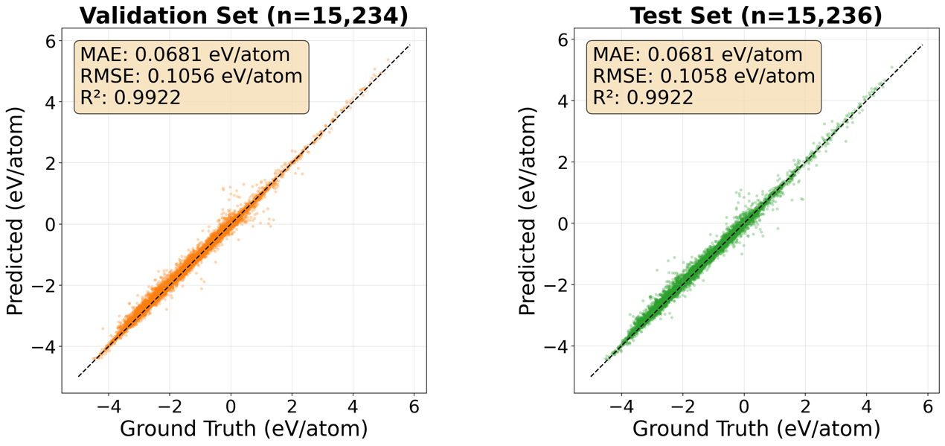
Supplementary Figure 2 The plots of formation energy predicted by DeePAW versus the true formation energy, (a) on the validation set and (b) on the test set, showing that DeePAW exhibits robust generalization power on the test set, achieving MAE=68.1 meV/atom and $R^{2}=0.9922$.

Supplementary Section 7. Detailed Analysis of Catalytic Scenarios
Rutile RuO₂ crystal has the space group (136, P42/mnm). For the calculations, a 2x2x2 supercell of RuO₂ is constructed, as shown in Fig. S2a and Na atoms are embedded into the octahedral interstitial sites of oxygen in accordance with the specific composition of NaRuO₂. A 0.25 $π$Å⁻¹ k-spacing is used for all calculations. The convergence criteria of structure optimization were chosen as the maximum force on each atom less than 0.02 eV/Ǻ with an energy change less than 1 × 10⁻⁶ eV. Since RuO₂ is antiferromagnetic, the initial magnetic moments of Ru atoms were set to 2 and -2, respectively. The initial magnetic moments of O and Na atoms were set the same to 0. Subsequently, superlattice relaxation is carried out to reach the stable structure. All possible interstitial sites are searched, and the optimal configuration is shown in Fig. S2b, which gives the distorted rutile structure with lattice constants a=10.83 Å, b=10.45 Å, c=5.67 Å. After that, a slab model of (110) surfaces of distorted rutile NaRuO₂ superlattice with the thickness of 11 (110) layers and the periodic boundary conditions along the [001] and [1$\overline{1}0]$ directions. The bottom 5 (110) layers are fixed to simulate the semi-infinite crystal, while the top 6 (110) layers are allowed to relax. The vacuum layers are set to >15 Å for the slab model, as shown in Fig. S2d.
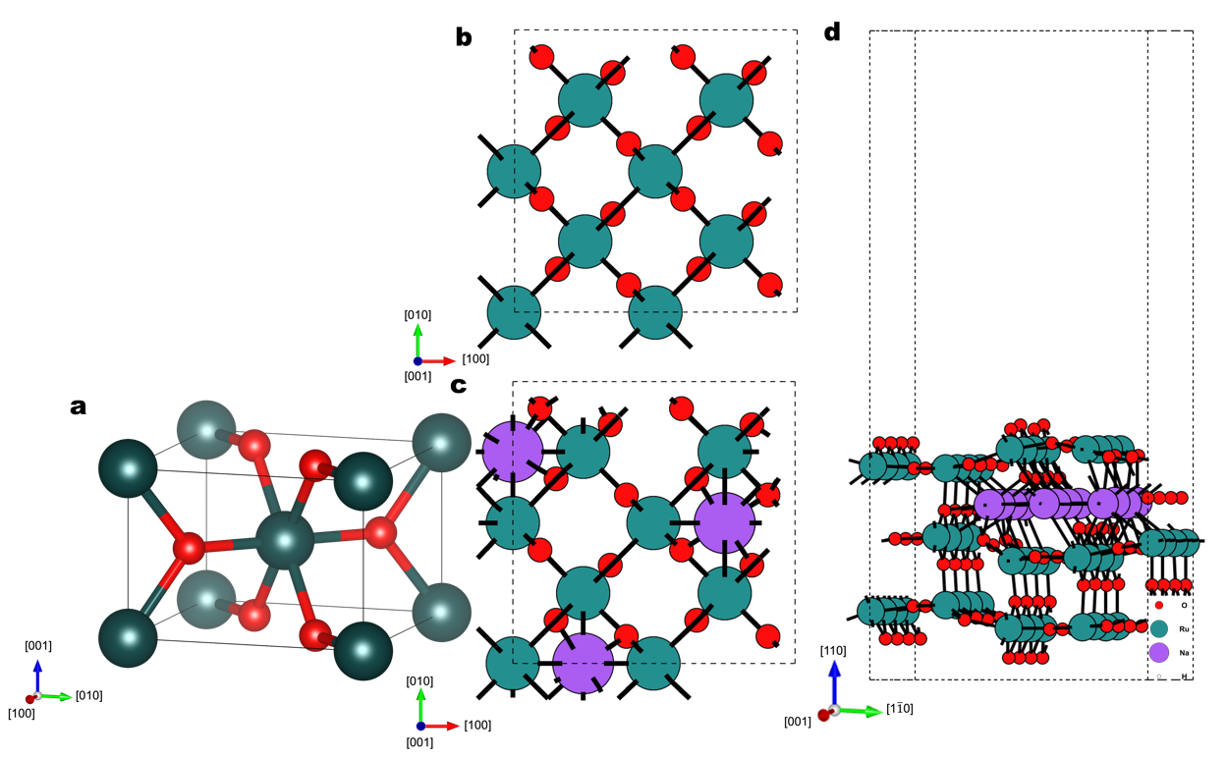
Supplementary Figure 3. a unit cell of virgin rutile RuO₂ superlattice, b RuO₂ superlattice, c the distorted rutile structure of NaRuO₂ superlattice, and d a half slab model of (110) surfaces of distorted rutile NaRuO₂ superlattice.
When a water molecule H₂O is contacted with the catalyst, the oxygen evolution reaction (OER) will go through four elementary steps (*+2H₂O→*OH→*O→*OOH→O₂), where * denotes the active state and Ru atoms are the active sites. Thermodynamically, the Gibbs free energy changes of four elementary steps are calculated by following the following equations,
$$\begin{aligned}ΔG1= G\left(OH*\right)+\frac{1}{2}G\left(H_{2}\right)-G\left(H_{2}O\right)-G*-eU\#\left(7a\right)\end{aligned}$$
$$\begin{aligned}ΔG2= G\left(O*\right)+\frac{1}{2}G\left(H_{2}\right)-G\left(OH*\right)-eU\#\left(7b\right)\end{aligned}$$
$$\begin{aligned}ΔG3= G\left(OOH*\right)+\frac{1}{2}G\left(H_{2}\right)-G\left(H_{2}O\right)-G\left(O*\right)-eU\#\left(7c\right)\end{aligned}$$
$$\begin{aligned}ΔG4= G*+G\left(O2\right)+\frac{1}{2}G\left(H_{2}\right)-G\left(OOH*\right)-eU\#\left(7d\right)\end{aligned}$$
where U is the applied potential taking the normal hydrogen electrode as the reference. In general, the Gibbs free energy change (ΔG) for each elemental step is defined by
$$\begin{aligned}ΔG=ΔE+ΔZPE-TΔS+ΔG_{U}+ΔG_{pH},\#\left(7e\right)\end{aligned}$$
where ΔE and ΔZPE are the adsorption energy and the zero-point energy correction, respectively, according to the standard hydrogen electrode energy, T, ΔS, U, and ΔG_{pH} represent the temperature, the entropy change, the applied electrode potential, and the free energy correction of the pH, respectively. Supplementary Figure 5 shows the charge density distribution of the O* and OOH* absorbed on the (110) surface of NaRuO₂, illustrating obvious overlap of electron cloud of the H atom of OOH* and the dangling O atom of NaRuO₂ with charge density 0.133 e⁻¹ Bohr³ in the center of the “bond” formed by the H atom of OOH* and the dangling O atom. Therefore, the dangling O atoms on the distorted surface are activated as a proton acceptor by Na doping. The H atom in OOH* can be more firmly bonded to the dangling O atom to stabilize the OOH*, resulting in a considerable improvement in the catalytic activity. The charge change is analyzed with the Atomic Simulation Environment code²¹ and shown in Supplementary Figure 5.
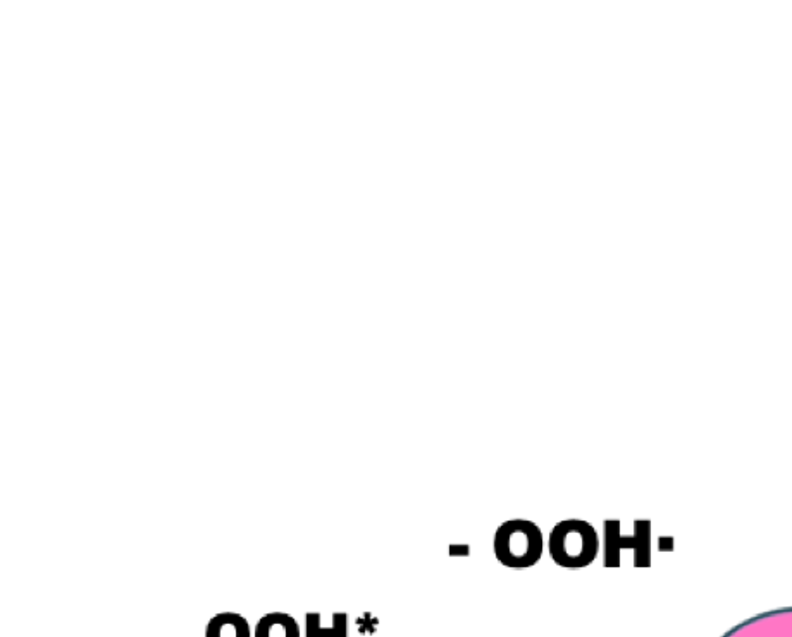
Supplementary Figure 4. The KSDFT-optimized structures of NaRuO₂ [110] surface slab and adsorption energies (E_{a}) of the oxo-intermediates.
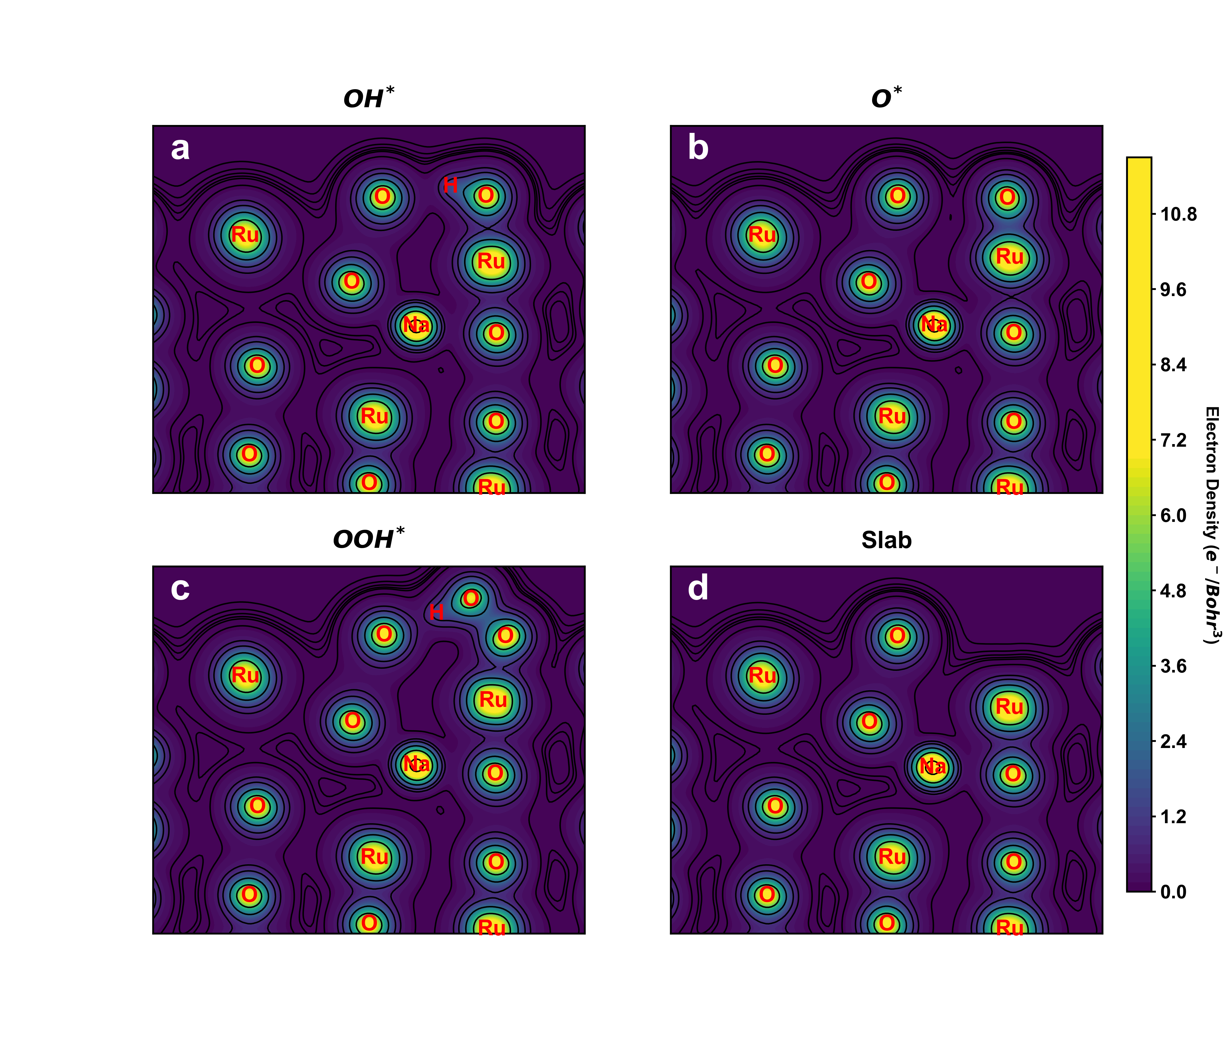
Supplementary Figure 5. The charge density distributions at the four elementary steps.

References
1 Shao, X., Jiang, K., Mi, W., Genova, A. & Pavanello, M. DFTpy: An efficient and object‐oriented platform for orbital‐free DFT simulations. Wiley Interdisciplinary Reviews: Computational Molecular Science 11, e1482 (2021).
2 Wang, Y. A., Govind, N. & Carter, E. A. Orbital-free kinetic-energy density functionals with a density-dependent kernel. Physical Review B 60, 16350-16358, doi:10.1103/PhysRevB.60.16350 (1999).
3 Runge, E. & Gross, E. K. U. Density-Functional Theory for Time-Dependent Systems. Physical Review Letters 52, 997-1000, doi:10.1103/PhysRevLett.52.997 (1984).
4 van Leeuwen, R. Mapping from Densities to Potentials in Time-Dependent Density-Functional Theory. Physical Review Letters 82, 3863-3866, doi:10.1103/PhysRevLett.82.3863 (1999).
5 White, A. J., Certik, O., Ding, Y. H., Hu, S. X. & Collins, L. A. Time-dependent orbital-free density functional theory for electronic stopping power: Comparison to the Mermin-Kohn-Sham theory at high temperatures. Physical Review B 98, 144302, doi:10.1103/PhysRevB.98.144302 (2018).
6 Jiang, K. & Pavanello, M. Time-dependent orbital-free density functional theory: Background and Pauli kernel approximations. Physical Review B 103, 245102 (2021).
7 Kuhn, W. Über die Gesamtstärke der von einem Zustande ausgehenden Absorptionslinien. Zeitschrift für Physik 33, 408-412 (1925).
8 Reiche, F. & Thomas, W. Über die Zahl der Dispersionselektronen, die einem stationären Zustand zugeordnet sind. Zeitschrift für Physik 34, 510-525 (1925).
9 Thomas, W. Über die Zahl der Dispersionselektronen, die einem stationären Zustande zugeordnet sind. (Vorläufige Mitteilung). Naturwissenschaften 13, 627-627, doi:10.1007/BF01558908 (1925).
10 De Silva, P. & Corminboeuf, C. Simultaneous visualization of covalent and noncovalent interactions using regions of density overlap. Journal of chemical theory and computation 10, 3745-3756 (2014).
11 Johnson, E. R. et al. Revealing noncovalent interactions. Journal of the American Chemical Society 132, 6498-6506 (2010).
12 Smidt, T. E., Geiger, M. & Miller, B. K. Finding symmetry breaking order parameters with euclidean neural networks. Physical Review Research 3, L012002 (2021).
13 Gilmer, J., Schoenholz, S. S., Riley, P. F., Vinyals, O. & Dahl, G. E. in International conference on machine learning. 1263-1272 (Pmlr).
14 Veličković, P. et al. in International conference on learning representations. 2 (Ithaca).
15 Liu, Z. et al. Kan: Kolmogorov-arnold networks. arXiv preprint arXiv:2404.19756 (2024).
16 Kolmogorov, A. N. in Dokl. Akad. Nauk USSR. 953-956.
17 Glorot, X. & Bengio, Y. in Proceedings of the thirteenth international conference on artificial intelligence and statistics. 249-256 (JMLR Workshop and Conference Proceedings).
18 Noorizadegan, A., Wang, S., Ling, L. & Dominguez-Morales, J. P. A Practitioner's Guide to Kolmogorov-Arnold Networks. arXiv preprint arXiv:2510.25781 (2025).
19 Ludziejewski, J. et al. Decoupled Relative Learning Rate Schedules. arXiv preprint arXiv:2507.03526 (2025).
20 Loshchilov, I. & Hutter, F. Decoupled weight decay regularization. arXiv preprint arXiv:1711.05101 (2017).
21 Hjorth Larsen, A. et al. The atomic simulation environment—a Python library for working with atoms. Journal of Physics: Condensed Matter 29, 273002 (2017).

