EXTENDED DATA FIGURE/TABLE LEGENDS
Extended Data Table 1. Summary statistics of the study sample included in the 2019 World Risk Poll. Projection weights were used to estimate the proportion of the population that experienced or anticipated drinking water harm.

Country | World Bank income classification | Sample |  | Experienced drinking water harm (%) | Anticipated drinking water harm (%)
Country | World Bank income classification | N | Female (%) | Experienced drinking water harm (%) | Anticipated drinking water harm (%)
Afghanistan | Low income | 1127 | 50.49 | 29.59 | 54.44
Albania | Upper middle income | 1080 | 62.41 | 20.60 | 69.93
Algeria | Upper middle income | 1100 | 52.27 | 22.79 | 66.18
Argentina | Upper middle income | 1060 | 58.96 | 12.60 | 53.08
Armenia | Upper middle income | 1080 | 65.46 | 11.55 | 41.56
Australia | High income | 1003 | 57.23 | 3.73 | 21.87
Austria | High income | 1000 | 49.30 | 5.07 | 24.39
Azerbaijan | Upper middle income | 1080 | 50.46 | 8.33 | 59.24
Bahrain | High income | 1011 | 34.92 | 17.48 | 52.57
Bangladesh | Lower middle income | 1072 | 56.34 | 8.42 | 54.71
Belarus | Upper middle income | 1128 | 57.71 | 5.53 | 45.50
Belgium | High income | 1000 | 51.70 | 3.73 | 33.70
Benin | Low income | 1000 | 40.90 | 28.14 | 66.56
Bolivia | Lower middle income | 1000 | 55.60 | 15.92 | 63.94
Bosnia Herzegovina | Upper middle income | 1080 | 59.26 | 4.70 | 40.93
Botswana | Upper middle income | 1114 | 62.75 | 17.11 | 47.46
Brazil | Upper middle income | 1080 | 60.74 | 14.81 | 70.25
Bulgaria | Upper middle income | 1080 | 56.48 | 4.47 | 44.60
Burkina Faso | Low income | 1000 | 39.40 | 20.08 | 59.37
Cambodia | Lower middle income | 1000 | 68.00 | 7.00 | 53.77
Cameroon | Lower middle income | 1000 | 46.80 | 41.24 | 66.71
Canada | High income | 1026 | 49.03 | 5.93 | 25.35
Chad | Low income | 1111 | 34.02 | 40.46 | 71.00
Chile | High income | 1060 | 62.55 | 13.83 | 73.43
China | Upper middle income | 3709 | 55.35 | 5.24 | 50.45
Colombia | Upper middle income | 1000 | 62.00 | 16.98 | 62.39
Congo Brazzaville | Lower middle income | 1090 | 45.87 | 44.81 | 65.23
Costa Rica | Upper middle income | 1000 | 60.50 | 10.42 | 51.11
Croatia | High income | 1080 | 50.09 | 4.44 | 47.27
Cyprus | High income | 1009 | 51.73 | 10.01 | 62.89
Denmark | High income | 1000 | 50.50 | 1.13 | 11.35
Dominican Republic | Upper middle income | 1078 | 60.20 | 19.12 | 53.31
Ecuador | Upper middle income | 1000 | 60.10 | 15.19 | 69.90
Egypt | Lower middle income | 1070 | 51.40 | 19.06 | 67.35
El Salvador | Lower middle income | 1080 | 62.96 | 22.89 | 62.85
Estonia | High income | 1080 | 59.35 | 3.26 | 22.31
Eswatini | Lower middle income | 1110 | 57.57 | 24.88 | 62.09
Ethiopia | Low income | 1121 | 56.56 | 27.32 | 56.71
Finland | High income | 1000 | 50.30 | 3.37 | 9.14
France | High income | 1000 | 52.30 | 4.43 | 40.11
Gabon | Upper middle income | 1070 | 52.90 | 46.05 | 74.40
Gambia | Low income | 1120 | 56.79 | 15.79 | 36.76
Georgia | Upper middle income | 1080 | 69.72 | 10.65 | 51.56
Germany | High income | 1000 | 51.20 | 5.06 | 27.04
Ghana | Lower middle income | 1010 | 40.20 | 27.44 | 65.42
Greece | High income | 1080 | 54.81 | 4.65 | 58.93
Guatemala | Upper middle income | 1100 | 60.64 | 31.91 | 61.92
Guinea | Low income | 1140 | 45.70 | 24.49 | 61.16
Honduras | Lower middle income | 1000 | 57.90 | 21.27 | 49.75
Hong Kong | High income | 1002 | 55.39 | 3.86 | 54.57
Hungary | High income | 1080 | 59.26 | 2.51 | 26.46
India | Lower middle income | 3377 | 42.40 | 21.33 | 56.31
Indonesia | Lower middle income | 1094 | 59.60 | 18.93 | 53.49
Iran | Upper middle income | 1005 | 50.55 | 21.29 | 51.75
Iraq | Upper middle income | 1097 | 46.95 | 40.30 | 64.07
Ireland | High income | 1000 | 48.10 | 7.54 | 38.03
Israel | High income | 1095 | 52.79 | 10.72 | 32.26
Italy | High income | 1000 | 50.30 | 4.92 | 44.59
Ivory Coast | Lower middle income | 1000 | 33.60 | 25.98 | 66.39
Jamaica | Upper middle income | 501 | 58.68 | 15.67 | 58.92
Japan | High income | 1012 | 43.28 | 1.45 | 43.27
Jordan | Upper middle income | 1001 | 48.65 | 19.47 | 54.11
Kazakhstan | Upper middle income | 1080 | 56.67 | 9.96 | 50.81
Kenya | Lower middle income | 1001 | 50.05 | 43.63 | 60.89
Kosovo | Upper middle income | 1088 | 55.42 | 9.23 | 52.89
Kuwait | High income | 1030 | 22.91 | 10.81 | -
Kyrgyzstan | Lower middle income | 1080 | 62.41 | 6.58 | 48.48
Laos | Lower middle income | 1070 | 60.28 | 13.13 | 44.30
Latvia | High income | 1080 | 62.50 | 2.06 | 33.96
Lebanon | Upper middle income | 1040 | 48.85 | 12.75 | 78.31
Lesotho | Lower middle income | 1000 | 61.40 | 33.83 | 70.48
Liberia | Low income | 1000 | 60.60 | 47.76 | 59.11
Libya | Upper middle income | 1000 | 27.70 | 19.43 | 42.92
Lithuania | High income | 1080 | 58.43 | 7.25 | 18.82
Luxembourg | High income | 1000 | 50.90 | 7.46 | 47.34
Madagascar | Low income | 1000 | 57.10 | 35.68 | 59.20
Malawi | Low income | 1000 | 57.60 | 33.59 | 60.82
Malaysia | Upper middle income | 1060 | 55.00 | 27.40 | 67.62
Mali | Low income | 1130 | 45.84 | 19.49 | 61.24
Malta | High income | 1000 | 53.70 | 5.13 | 39.64
Mauritania | Lower middle income | 1100 | 47.18 | 21.63 | 61.00
Mauritius | Upper middle income | 1000 | 50.00 | 14.20 | 56.60
Mexico | Upper middle income | 1001 | 56.94 | 13.65 | 62.36
Moldova | Lower middle income | 1080 | 50.28 | 11.64 | 57.04
Mongolia | Lower middle income | 1070 | 60.09 | 4.86 | 66.03
Montenegro | Upper middle income | 1080 | 54.63 | 16.14 | 54.21
Morocco | Lower middle income | 1015 | 62.66 | 19.86 | 48.90
Mozambique | Low income | 1000 | 48.80 | 51.99 | 71.92
Myanmar | Lower middle income | 1100 | 61.73 | 4.82 | 35.34
Namibia | Upper middle income | 1002 | 55.49 | 25.65 | 49.72
Nepal | Low income | 1095 | 56.62 | 22.58 | 46.51
Netherlands | High income | 1001 | 48.05 | 1.78 | 18.80
New Zealand | High income | 1006 | 57.36 | 5.84 | 29.15
Nicaragua | Lower middle income | 1080 | 62.50 | 16.30 | 45.33
Niger | Low income | 1000 | 45.20 | 26.02 | 46.37
Nigeria | Lower middle income | 1000 | 44.50 | 16.04 | 40.86
North Macedonia | Upper middle income | 1080 | 57.87 | 13.35 | 68.22
Norway | High income | 1000 | 45.90 | 2.49 | 20.25
Pakistan | Lower middle income | 1091 | 50.14 | 36.50 | 71.22
Palestine | Low income | 1090 | 59.54 | 18.51 | 58.05
Panama | High income | 1080 | 59.07 | 24.64 | 65.74
Paraguay | Upper middle income | 1079 | 58.39 | 14.03 | 47.63
Peru | Upper middle income | 1000 | 55.80 | 21.43 | 73.55
Philippines | Lower middle income | 1090 | 56.88 | 29.40 | 68.13
Poland | High income | 1080 | 57.59 | 2.23 | 29.90
Portugal | High income | 1001 | 53.75 | 8.11 | 50.03
Romania | Upper middle income | 1080 | 57.87 | 6.76 | 44.45
Russia | Upper middle income | 2168 | 61.44 | 10.52 | 54.02
Rwanda | Low income | 1000 | 66.50 | 34.38 | 59.22
Saudi Arabia | High income | 1000 | 44.90 | 10.84 | 37.93
Senegal | Lower middle income | 1000 | 50.50 | 27.99 | 68.68
Serbia | Upper middle income | 1080 | 57.78 | 5.73 | 38.98
Sierra Leone | Low income | 1133 | 55.08 | 39.28 | 57.97
Singapore | High income | 1040 | 50.38 | 0.89 | 12.71
Slovakia | High income | 1080 | 56.02 | 4.55 | 37.12
Slovenia | High income | 1001 | 49.75 | 5.34 | 44.52
South Africa | Upper middle income | 1060 | 63.68 | 25.36 | 57.32
South Korea | High income | 1007 | 36.54 | 4.57 | 47.04
Spain | High income | 1000 | 52.00 | 8.78 | 45.78
Sri Lanka | Upper middle income | 1083 | 65.00 | 9.68 | 53.90
Sweden | High income | 1000 | 51.70 | 1.18 | 7.95
Switzerland | High income | 1000 | 52.50 | 5.91 | 23.76
Taiwan | High income | 1000 | 54.00 | 2.80 | 55.56
Tajikistan | Low income | 1080 | 55.00 | 12.37 | 40.54
Tanzania | Low income | 1000 | 60.00 | 28.66 | 52.91
Thailand | Upper middle income | 1000 | 63.20 | 6.32 | 50.13
Togo | Low income | 1130 | 42.48 | 30.36 | 68.27
Tunisia | Lower middle income | 1000 | 50.90 | 27.36 | 57.68
Turkey | Upper middle income | 1059 | 37.87 | 10.13 | 63.48
Turkmenistan | Upper middle income | 1089 | 53.08 | 4.66 | 42.76
Uganda | Low income | 1000 | 53.20 | 38.63 | 62.41
Ukraine | Lower middle income | 1080 | 64.17 | 5.34 | 56.64
United Arab Emirates | High income | 1004 | 34.96 | 12.49 | 36.12
United Kingdom | High income | 1000 | 47.60 | 3.51 | 17.84
United States | High income | 1014 | 46.35 | 7.91 | 39.26
Uruguay | High income | 1080 | 59.17 | 7.83 | 49.44
Uzbekistan | Lower middle income | 1080 | 63.52 | 4.10 | 22.36
Venezuela | Upper middle income | 1080 | 59.91 | 29.20 | 73.44
Vietnam | Lower middle income | 1002 | 57.49 | 7.28 | 55.32
Yemen | Low income | 1140 | 50.00 | 37.21 | 52.27
Zambia | Lower middle income | 1000 | 54.50 | 54.26 | 66.43
Zimbabwe | Lower middle income | 1082 | 54.81 | 26.84 | 57.13
Total | - | 154195 | 53.55 | 14.26 | 52.31

Extended Data Table 2. Coefficients and 95% confidence intervals for linear regression models presented in Figure 2.
 | Knew someone or personally experienced harm from drinking water |  |  | Anticipate personally experiencing harm from drinking water
 | B | 95% CI | Adjusted R² | B | 95% CI | Adjusted R²
Log renewable freshwater resources per capita | -0.19 | -1.33, 0.96 | 0.00 | 0.30 | -1.13, 1.73 | 0.00
Proportion of population with basic drinking water service level | -0.59 | -0.70, -0.49 | 0.47 | – | – | –
>95% of population with basic drinking water service level (ref: ≤95%) | – | – | – | -15.47 | -20.32, -10.62 | 0.22
≥1% of deaths attributable to unsafe water (ref: <1%) | 17.53 | 14.29, 20.78 | 0.45 | 11.85 | 6.54, 17.17 | 0.12
Log GDP per capita | -6.06 | -7.12, -5.00 | 0.48 | -6.49 | -8.04, -4.94 | 0.33
Corruption Perception Index score (range: 0-100) | -0.38 | -0.47, -0.29 | 0.32 | -0.53 | -0.64, -0.42 | 0.38

Extended Data Table 3. Multivariable linear regression models of experienced and anticipated drinking water harm.
 | Knew someone or personally experienced harm from drinking water |  | Anticipate personally experiencing harm from drinking water
 | B | 95% CI | B | 95% CI
Log renewable freshwater resources per capita | 0.12 | -0.64, 0.89 | 0.58 | -0.51, 1.67
Proportion of population with basic drinking water service level | -0.29 | -0.48, -0.11 | – | –
>95% of population with basic drinking water service level (ref: ≤95%) | – | – | -5.78 | -12.35, 0.79
≥1% of deaths attributable to unsafe water (ref: <1%) | 7.39 | 2.34, 12.44 | -3.11 | -10.16, 3.95
Log GDP per capita | -0.30 | -2.91, 2.30 | -0.95 | -4.31, 2.41
Corruption Perception Index score (range: 0-100) | -0.15 | -0.29, -0.02 | -0.45 | -0.64, -0.26

Extended Data Table 4. Prevalence of experienced and anticipated harm from drinking water, by country income status and respondent sociodemographic characteristics. Point estimates and 95% confidence intervals were calculated using generalized linear models with binomial distributions and identity link functions.
 |  | Experienced harm in prior two years
 |  | Low income |  |  |  |  |  | Lower middle income |  |  |  |  |  | Upper middle income |  |  |  |  |  | High income
 |  | P |  | PD |  | 95% CI |  | P |  | PD |  | 95% CI |  | P |  | PD |  | 95% CI |  | P |  | PD |  | 95% CI
Respondent gender
Male |  |  | 33.0 |  |  |  |  |  | 21.4 |  |  |  |  |  | 10.0 |  |  |  |  |  | 4.9
Female |  |  | 29.3 |  | -3.8 |  | -5.8, -1.8 |  | 20.8 |  | -0.6 |  | -2.4, 1.3 |  | 10.2 |  | 0.2 |  | -0.9, 1.3 |  | 6.2 |  | 1.3 |  | 0.0, 2.6
Household location
Urban |  |  | 30.9 |  |  |  |  |  | 21.5 |  | 0.5 |  |  |  | 11.3 |  |  |  |  |  | 6.3
Rural |  |  | 31.1 |  | 0.2 |  | -2.2, 2.7 |  | 21.0 |  | -0.5 |  | -2.5, 1.6 |  | 9.5 |  | -1.8 |  | -2.9, -0.6 |  | 4.8 |  | -1.6 |  | -2.8, -0.3
 |  |  | Anticipate harm in next two years
 |  |  | Low income |  |  |  |  |  | Lower middle income |  |  |  |  |  | Upper middle income |  |  |  |  |  | High income
 |  |  | P |  | PD |  | 95% CI |  | P |  | PD |  | 95% CI |  | P |  | PD |  | 95% CI |  | P |  | PD |  | 95% CI
Respondent gender
Male |  |  | 60.0 |  |  |  |  |  | 59.8 |  |  |  |  |  | 52.8 |  |  |  |  |  | 32.0
Female |  |  | 58.9 |  | -1.1 |  | -3.3, 1.1 |  | 58.6 |  | -1.2 |  | -3.4, 1.1 |  | 61.4 |  | 8.6 |  | 6.3, 10.9 |  | 43.0 |  | 11.0 |  | 8.5, 13.5
Household location
Urban |  |  | 60.3 |  |  |  |  |  | 64.7 |  |  |  |  |  | 63.6 |  |  |  |  |  | 38.8
Rural |  |  | 59.3 |  | -1.0 |  | -3.7, 1.6 |  | 57.4 |  | -7.3 |  | -9.8, -4.8 |  | 53.9 |  | -9.7 |  | -12.0, -7.4 |  | 36.1 |  | -2.6 |  | -5.2, -0.0
 | P = prevalence, PD = prevalence difference, 95% CI = 95% confidence interval

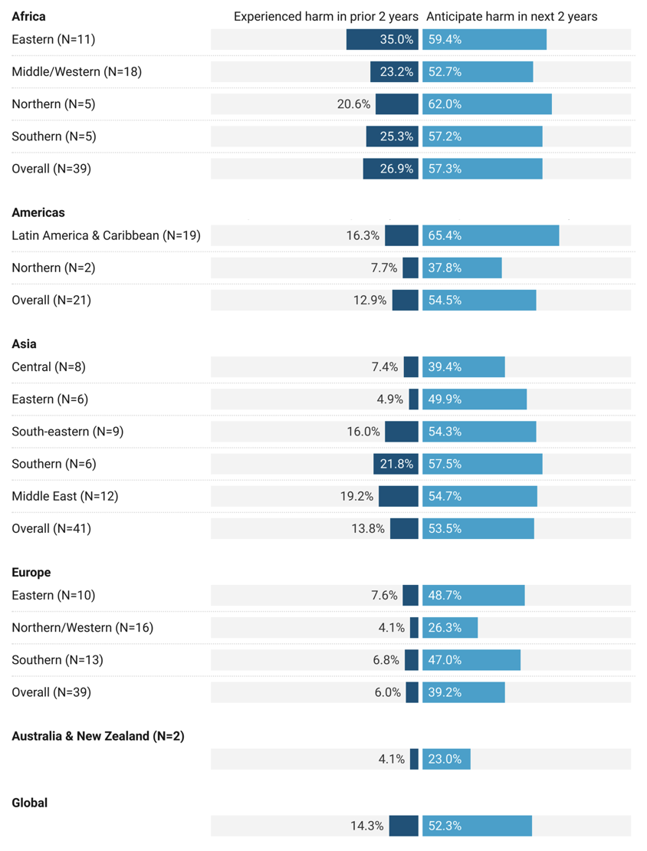
Extended Data Figure 1. Proportion of the population within each world region who experienced or anticipated harm from their drinking water in the prior or future two years, respectively.

