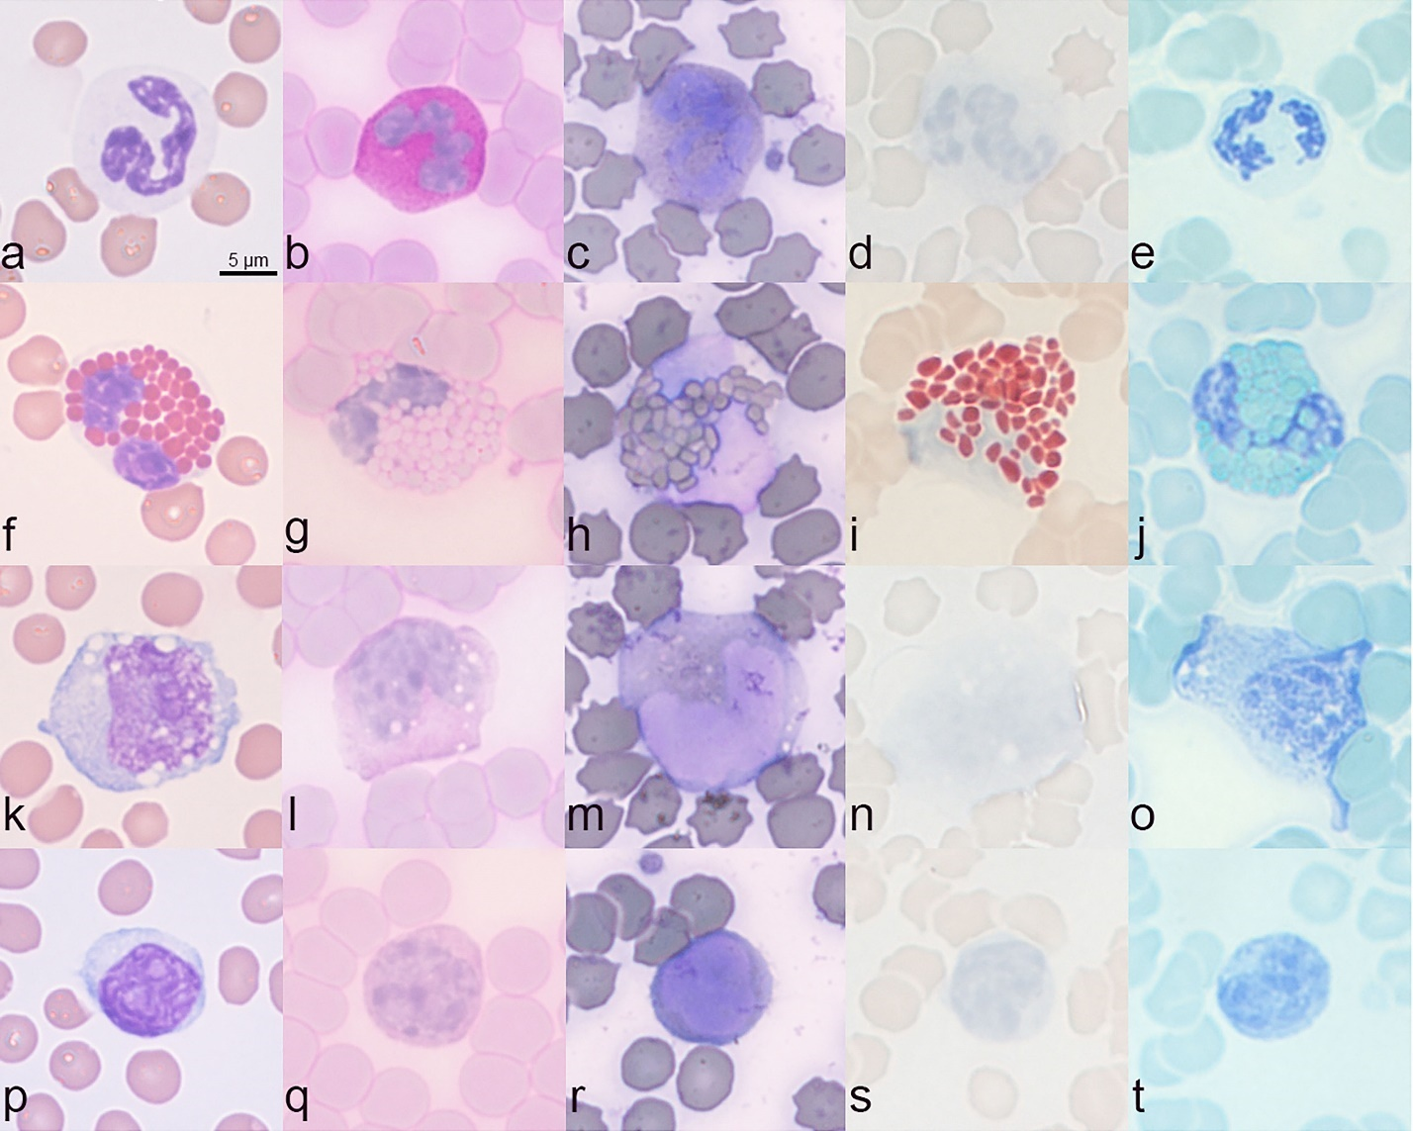
Supplementary Fig S1 Horse blood films were used as a positive control. (a) Segmented neutrophil stained with Romanovsky-Giemsa dye. (b) Strong PAS staining of a segmented neutrophil. (c) Weak SBB staining of a segmented neutrophil. (d) Negative staining for LUNA and (e) LFB in a segmented neutrophil. (f) Eosinophil stained with Romanovsky-Giemsa dye. (g) Negative or weakly positive PAS staining of an eosinophil. (h) Negative or weakly positive SBB staining of an eosinophil. (i) Strong granular staining of an eosinophil for LUNA (bright red‑orange) and (j) for LFB (bright blue‑green). (k) Monocyte stained with Romanovsky-Giemsa dye. (l) Negative or weakly positive PAS staining of a monocyte. (m) Negative or weakly positive SBB staining of a monocyte. (n) Negative staining for LUNA and (o) for LFB in a monocyte. (p) Lymphocyte stained with Romanovsky-Giemsa dye. (q) Negative staining of lymphocyte for PAS, (r) SBB, (s) LUNA, (t) LFB.

