SUPPORTING INFORMATION FOR
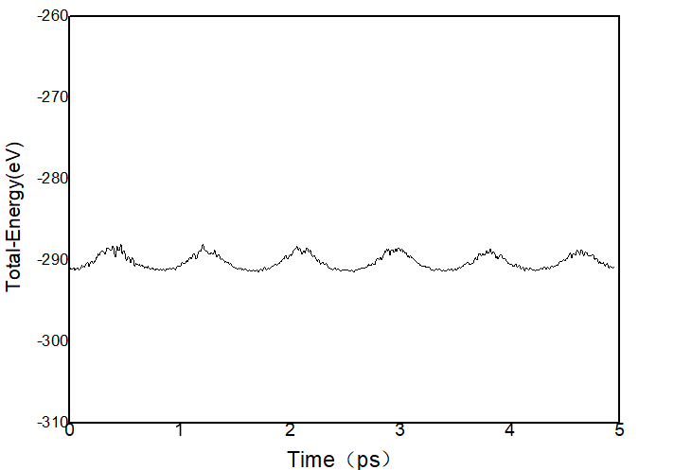 | 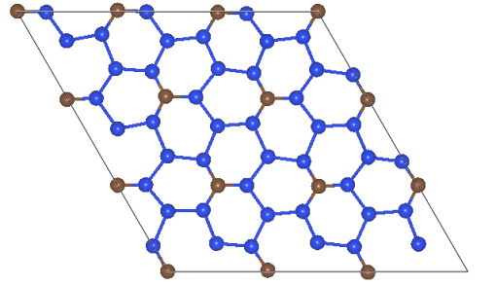
(a)
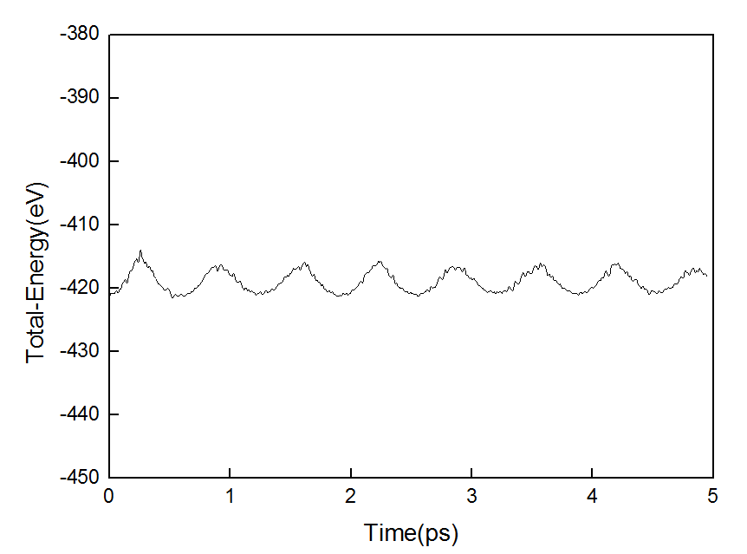 | 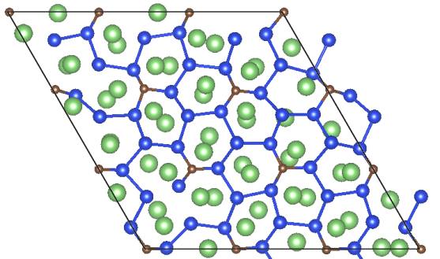
(b)
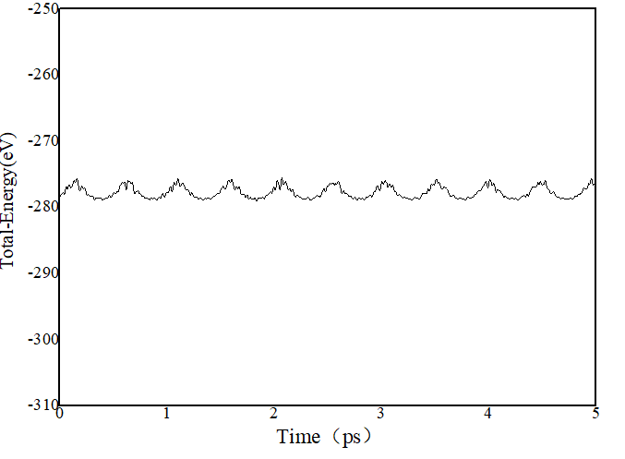 | 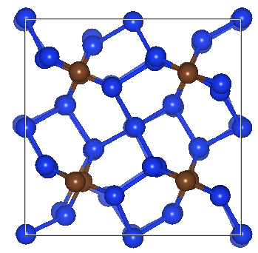
(c)
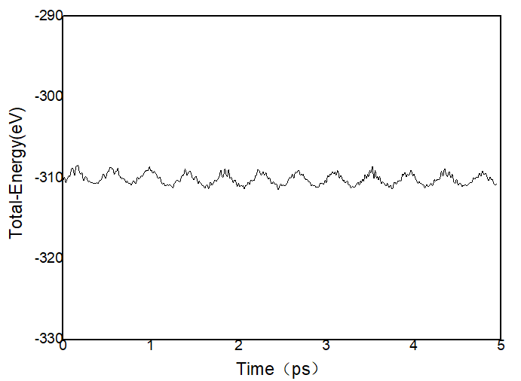 | 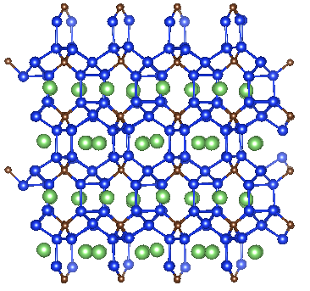
(d)
Figure S1. AIMD simulations of (a)2D Si₅C, (b) 2D Li₆Si₅C , (c)3D Si₅C, (d)3D Li₂Si₅C, The brown, blue, and green balls represent C, Si, and Li, respectively.

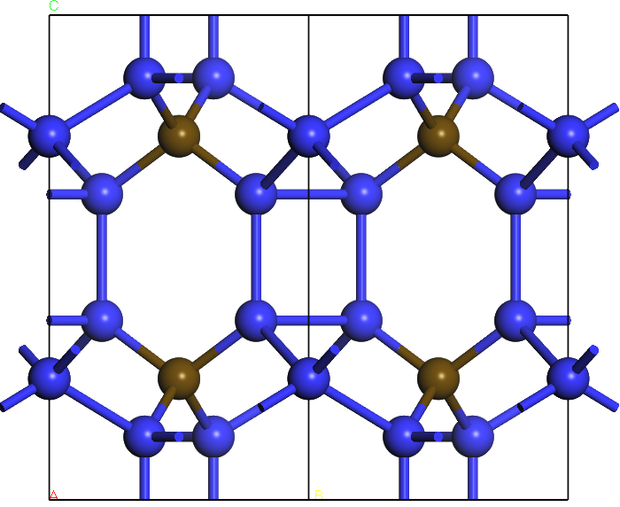 | 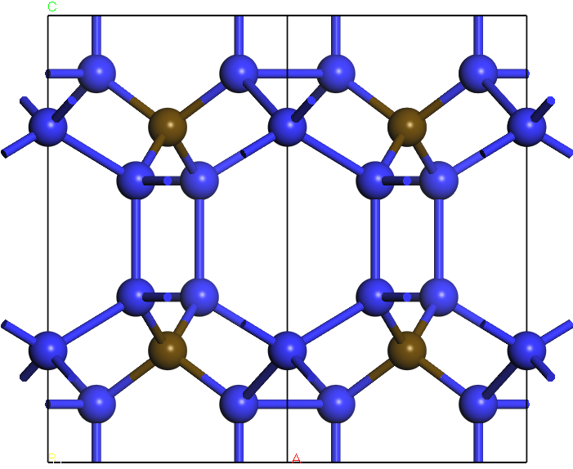 | 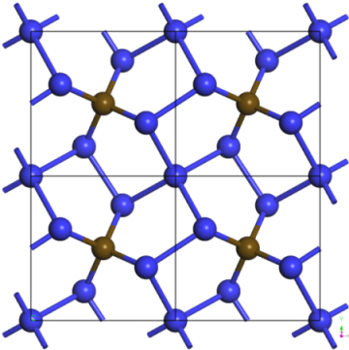
(a) | (b) | (c)
Figure S2 The views of 3D Si₅C along (a) axis a, (b) axis b, (c) axis c (2×2×1supercell)

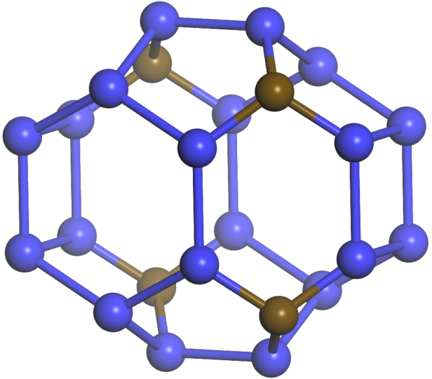 | 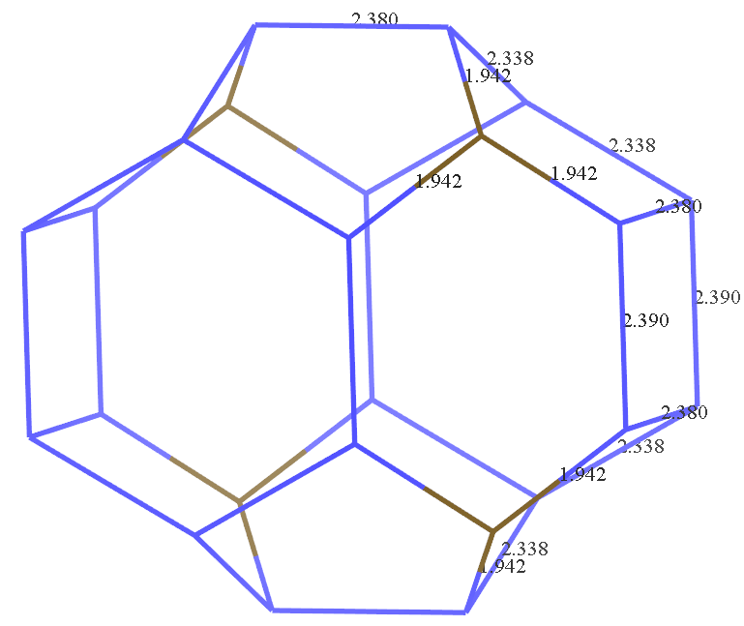
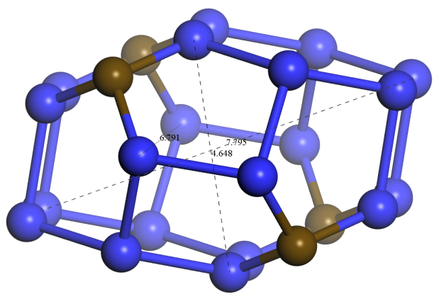 | 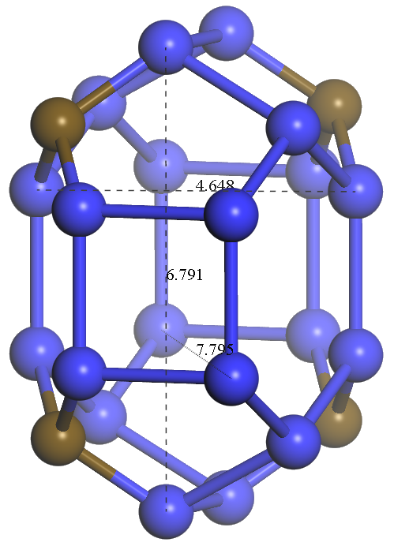
Figure S3 Various side views of porous structure of 3D Si₅C

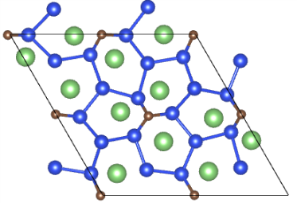 | 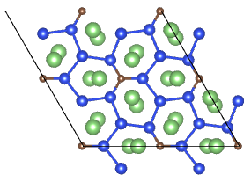 | 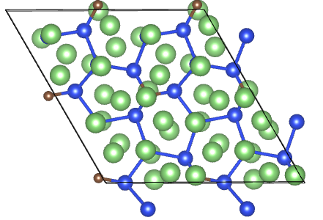
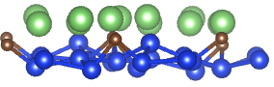 | 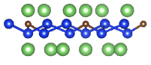 | 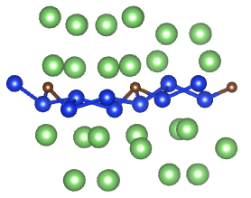
(a) | (b) | (c)
Figure S4 Top view and side view of absorbed (a) 12Li, (b) 24Li, (c) 48Li on the surface of 2D Si₅C
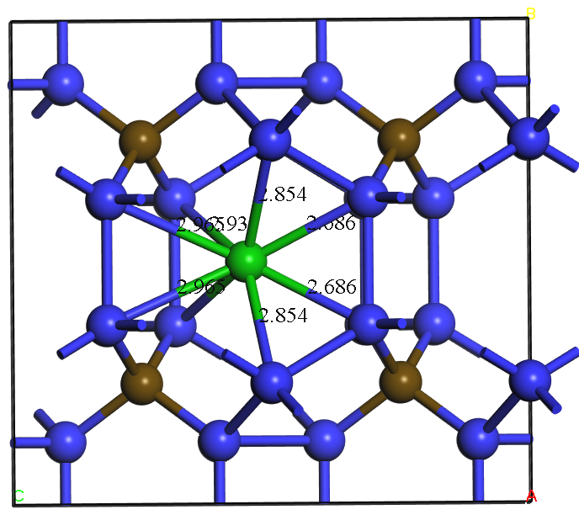 | 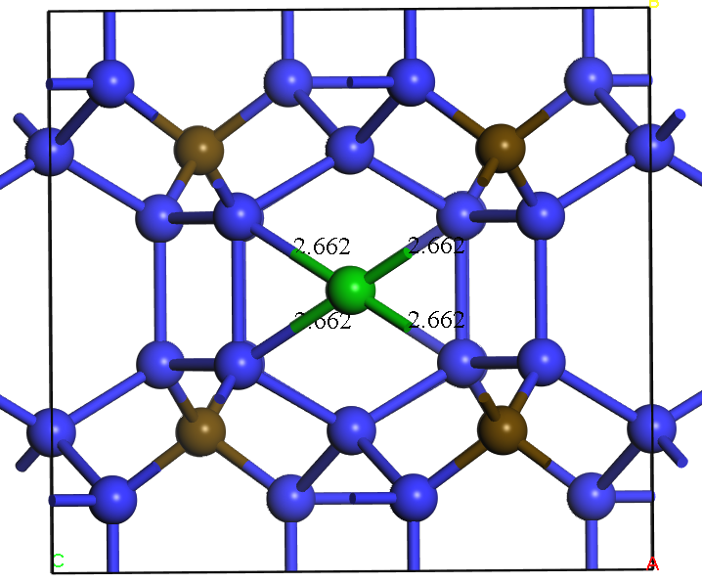
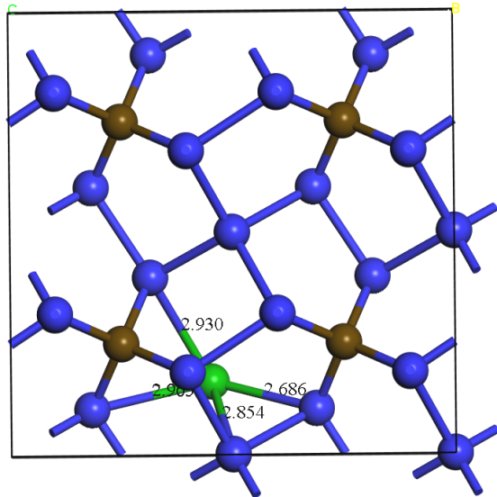 | 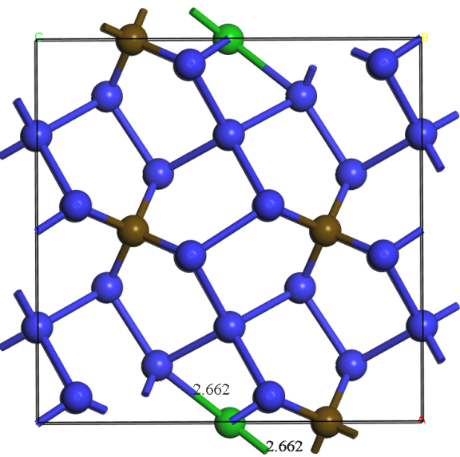
(a) | (b)
Figure S5 The views of two possible sites with single Li intercalated into 3D Si₅C along axis b and axis c (a) site-1 (b) site-2

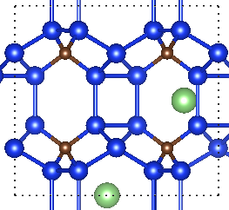 | 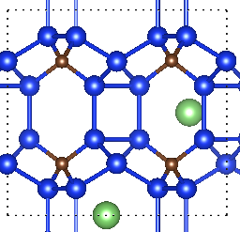 | 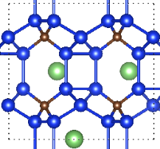 | 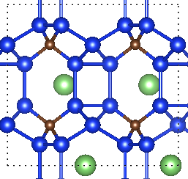
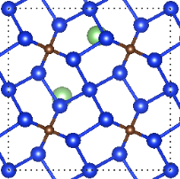 | 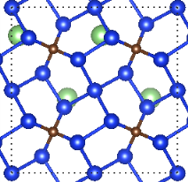 | 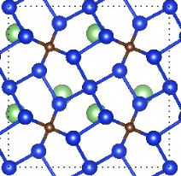 | 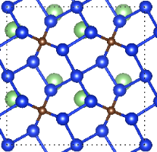
(a) Li_{0.25}Si₅C | (b) Li_{0.5}Si₅C | (c) Li_{0.75}Si₅C | (d) LiSi₅C
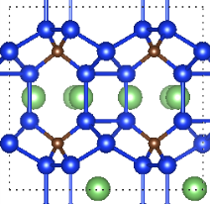 | 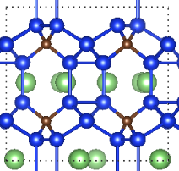 | 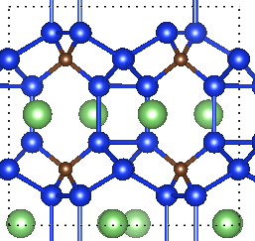 | 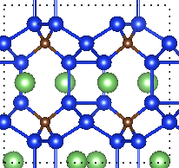
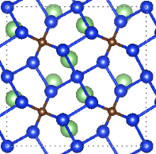 | 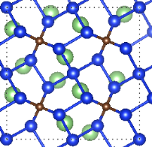 | 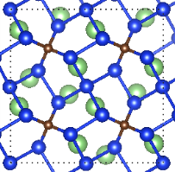 | 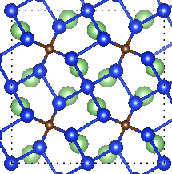
(e) Li_{1.25}Si₅C | (f) Li_{1.5}Si₅C | (g) Li_{1.75}Si₅C | (h) Li₂Si₅C
Figure S6 Top and side view of intercalated 1~8Li((a)~(h)) into 3D Si₅C (2 × 2× 1supercell)

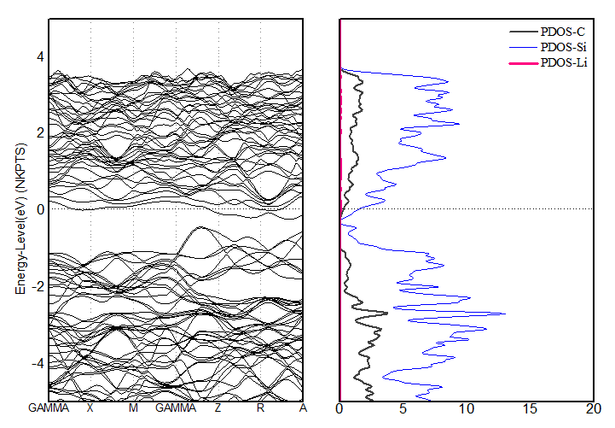 | 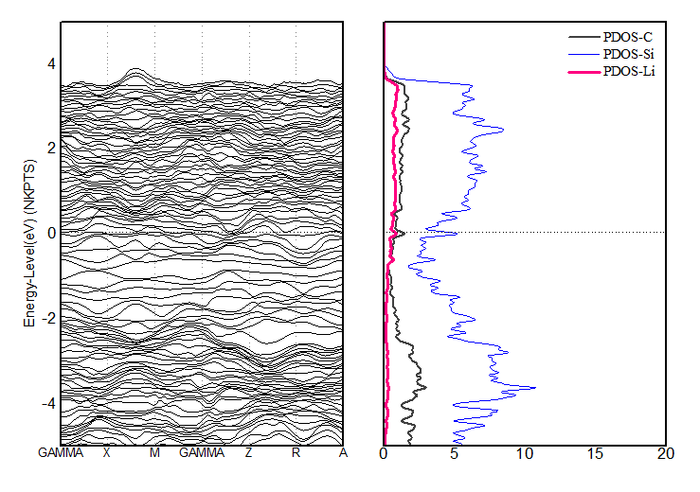
(a) | (b)
Figure S7 Band structure and DOS for the most stable configuration of 1Li-intercalated and fully Li-intercalated 3D Si₅C(a)Li_{0.25}Si₅C,(b)Li₂Si₅C.

Table S1. The structure parameters of 2D and 3D porous SiC₅
Name  (Space group) | Lattic parameter | Bond length (Å) | Bond angle（deg）
2D Si₅C  (No. 157) | a=b=6.258Å α=β=90° γ=120° | d_{Si-Si}:2.262  d_{Si−C}:1.809 | ∠_{Si-C-Si}:120; ∠_{C-Si-Si}:125  ∠_{Si-Si-Si} (bonded to Si):118  ∠_{Si-Si-Si} ( bonded to C):106
3D porous Si₅C  (No.84) | a=b=4.916 Å  c=9.181Å α=β=γ=90° | d_{Si-Si}:2.338, 2.379, 2.390  d_{Si-C}: 1.942 | ∠_{Si-C-Si}:109 (5-numbered ring); 111（6-numbered ring）  ∠_{C-Si-Si}:108,117(5–numbered ring);125(6-numbered ring)  ∠_{Si-Si-Si:}90 (4-numbered ring); 94,103 (5-numbered ring); 118,124 (6-numbered ring)

 | Table S2. the CM5 charges of Si, C, and Li and bond orders for 2D Si₅C absorbed Li
 |  | Si | C | Li | Si−C | Si−Si | Li−C | Li−Si
Si₅C |  | 0.40 | -0.59 |  | 1.25 | 0.07~1.16
 |  | -0.30
Si₅C-1Li(site-a) |  | 0.19~0.40 | -0.56 | 0.65 | 1.23~1.28 | 0.06~1.26 | 0.00 | 0.13
 |  | -0.29 | -0.60 |  |  |  |  | 0.11
Si₅C-1Li(site-b) |  | 0.24 | -0.67 | 0.72 | 1.24 | 1.19 | 0.09 | 0.10
 |  | -0.44 |  |  |  |  |  | 0.07
Si₅C-1Li(site-c) |  | 0.22~0.38 | -0.75 | 0.72 | 1.09~1.30 | 0.99 | 0.12 | 0.11
 |  | -0.48 | -0.61 |  |  |  |  | 0.07
Si₅C-24Li |  | -0.31 | -0.88 | 0.65 | 0.49 | 0.98 | 0.16 | 0.19
 |  | -0.80 |  | 0.49 |  | 0.23 |  | 0.22

Table S3. the CM5 charges of Si, C, and Li and bond orders for 3D Si₅C intercalated Li
 | Si | C (Li) | Si−C | Si-Si(C−C) | Li−C | Li−Si
Si₅C | 0.14 | -0.40 | 0.86 | 0.75~0.89
Si₅C | -0.15
Li_{0.25}Si₅C | 0.02~0.10 | -0.39 | 0.86~0.89 | 0.74~0.91 | 0.01 | 0.09
Li_{0.25}Si₅C | -0.24 | (0.64) |  |  |  | 0.06
Li₂Si₅C | -0.04~-0.59 | -0.30~ -0.52  (0.60~0.66) | 0.83~1.16 | 0.62~0.95 | 0.01~ 0.10 | 0.01~0.16

