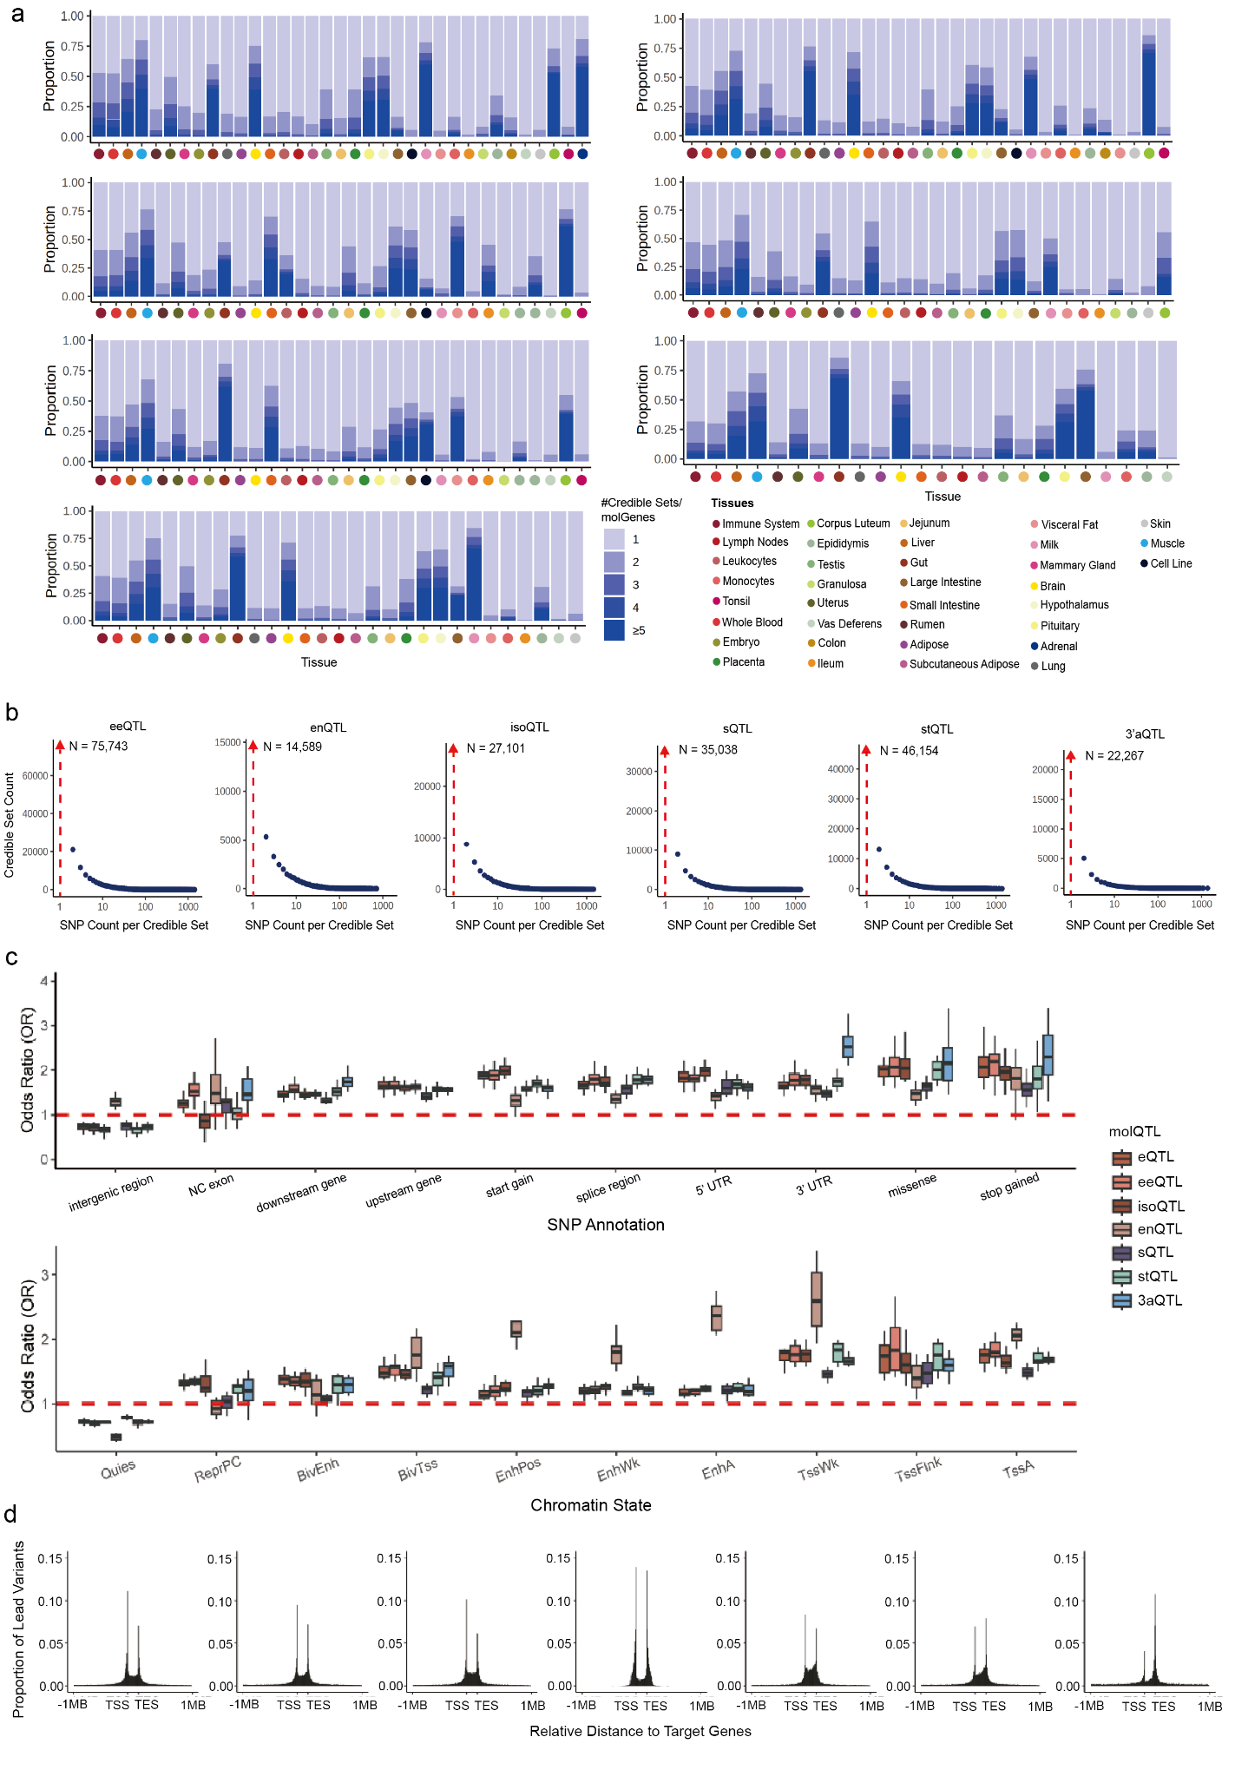
Extended Data Fig. 1 | a, The distribution of the number of fine-mapped cis-molQTL per gene across seven molQTL is shown as blue stacked bars across 35 tissues. Tissues are ordered by decreasing sample size. b, The size distribution of fine-mapped credible sets for all identified cis-molQTL across 35 tissues. The red arrow indicates count of credible sets containing only one single candidate variant. c, Functional enrichment of lead SNPs in seven molQTL with regulatory elements (top: SNP classification, bottom: chromatin states). d, Distribution of the distance to TSS regions across lead SNPs in seven molQTL.
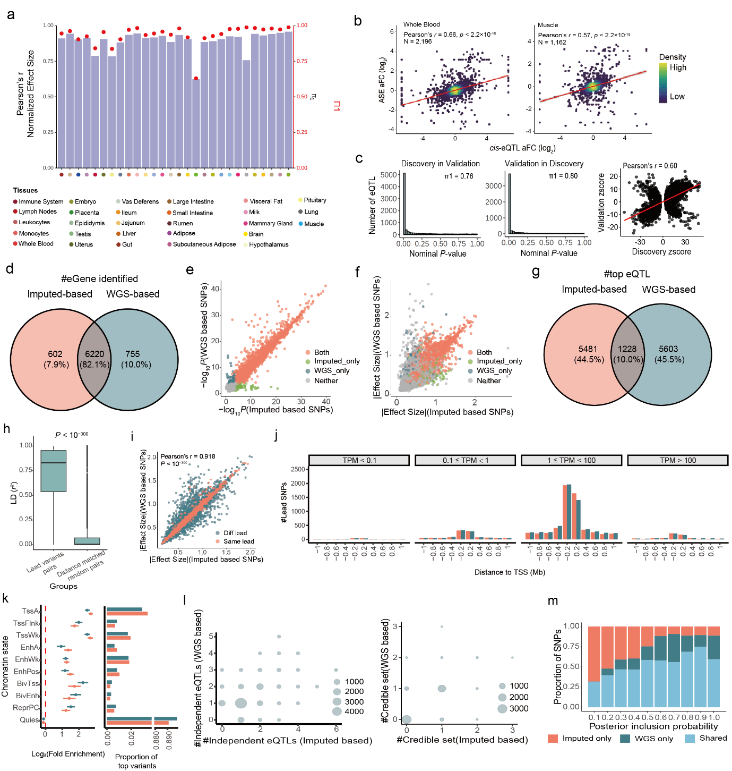
Extended Data Fig. 2 | a, Internal validation of cis-eQTL. We selected 28 tissues with sample sizes > 100 and randomly split samples into equally sized discovery and validation cohorts. eQTL mapping was performed independently in each cohort. Bars show Pearson’s correlation of normalized effect sizes between the two groups, and red dots represent Storey’s π₁ statistics, indicating the replication rate of cis-eQTL. b, Spearman’s correlation between cis-eQTL effect sizes (allelic fold change, log₂ scale) and corresponding effect sizes derived from allele-specific expression (ASE) analysis. c, External validation of cis-eQTL using an independent Holstein population (n = 99). Storey’s π₁ statistics and Spearman’s correlation were used to assess replication between external population and CattleGTEx Phase1 population in blood. d, Robustness of our approach by comparing molQTL mapping using RNA-seq imputed versus whole-genome sequencing (WGS)-called genotypes in an independent blood-tissue cohort (n = 99). Venne plot represents the overlapping of eGenes detected using imputed versus WGS–called genotypes. e, Comparison of significance (-log10 P) across different gene categories. Each point represents a gene. Genes are categorized as Both (n = 5,798): eGene detected by both WGS–called and imputed genotypes; WGS_based_only (n = 552): eGene detected only by WGS–called genotypes; Imputed_based _only (n = 1,792): eGene detected only by imputed genotypes; Neither (n = 7,935): Non-eGene in either dataset. f, Comparison of effect sizes (beta) of top variants across different gene categories. Each point represents a gene. g, Overlap of top variants using imputed versus WGS–called genotypes. h, Linkage disequilibrium (LD, r2) among lead variants of the same eGenes (n = 5,142) identified using imputed- and WGS-called. The “Distance-matched random set” contains SNP pairs with similar genomic distances as the lead variant pairs. The boxplot shows the median as the central line, the 25th–75th percentiles as the box limits, and whiskers extending 1.5× the interquartile range. Statistical significance was determined using a two-sided Student’s t-test. i, Correlation of effect sizes for lead variants of eGenes identified using imputed- and WGS-based genotypes. Same lead indicates that the shared eGenes have the same lead variant, while Diff lead indicates that the shared eGenes have distinct lead variants. P-values were calculated using the asymptotic t approximation. j, Number of top variants detected using imputed and WGS-called genotypes, plotted by distance to the TSS and stratified by median gene expression across samples. k, Functional enrichment (log2 Fold change, mean ± s.d., left) and proportion (right) of eQTL detected using WGS-called versus imputed genotypes across chromatin states. l, The left panel represents numbers of independent eQTL per gene detected using WGS-called and imputed genotypes. Point size reflects the number of eGenes with the corresponding number of independent eQTL. The right panel represents numbers of credible sets per gene detected in fine-mapping using WGS-called and imputed genotypes. Point size reflects the number of eGenes with the corresponding number of credible sets. m, Percentage of fine-mapped variants detected using WGS-called and imputed genotypes, shown across different posterior inclusion probability (PIP) thresholds
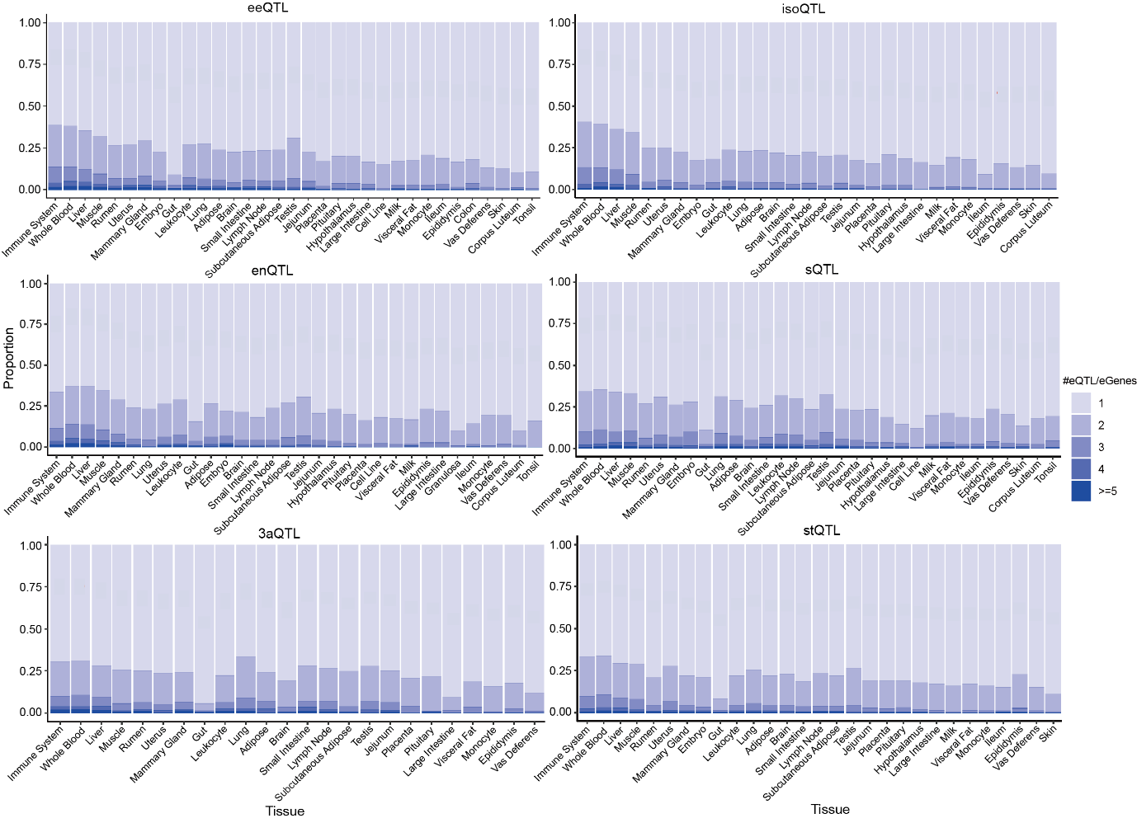
Extended Data Fig. 3 | The distribution of the number of conditionally independent cis-molQTL per gene across six molQTL is shown as blue stacked bars across 35 tissues. Tissues are ordered by decreasing sample size.

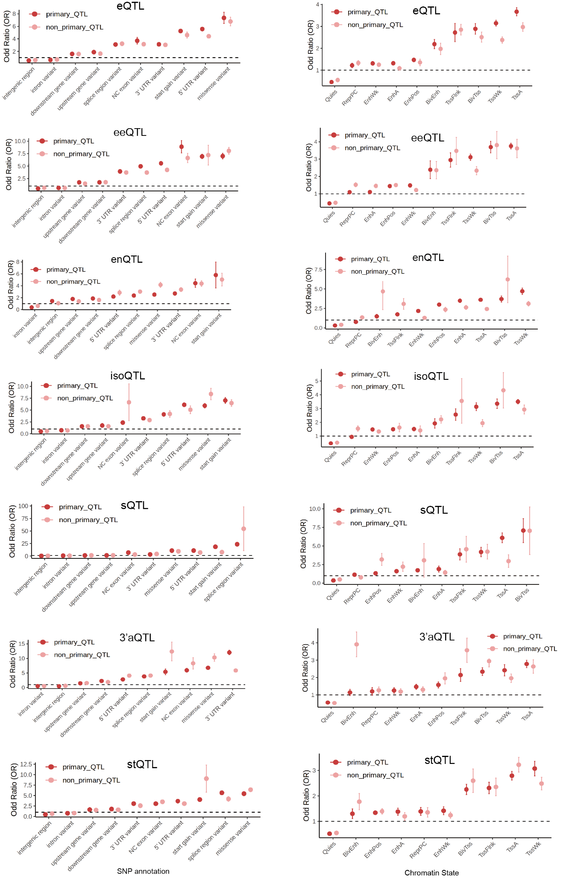
Extended Data Fig. 4 | Functional enrichment of primary and non-primary effects in six molQTL with regulatory elements (left: SNP classification, right: chromatin states).
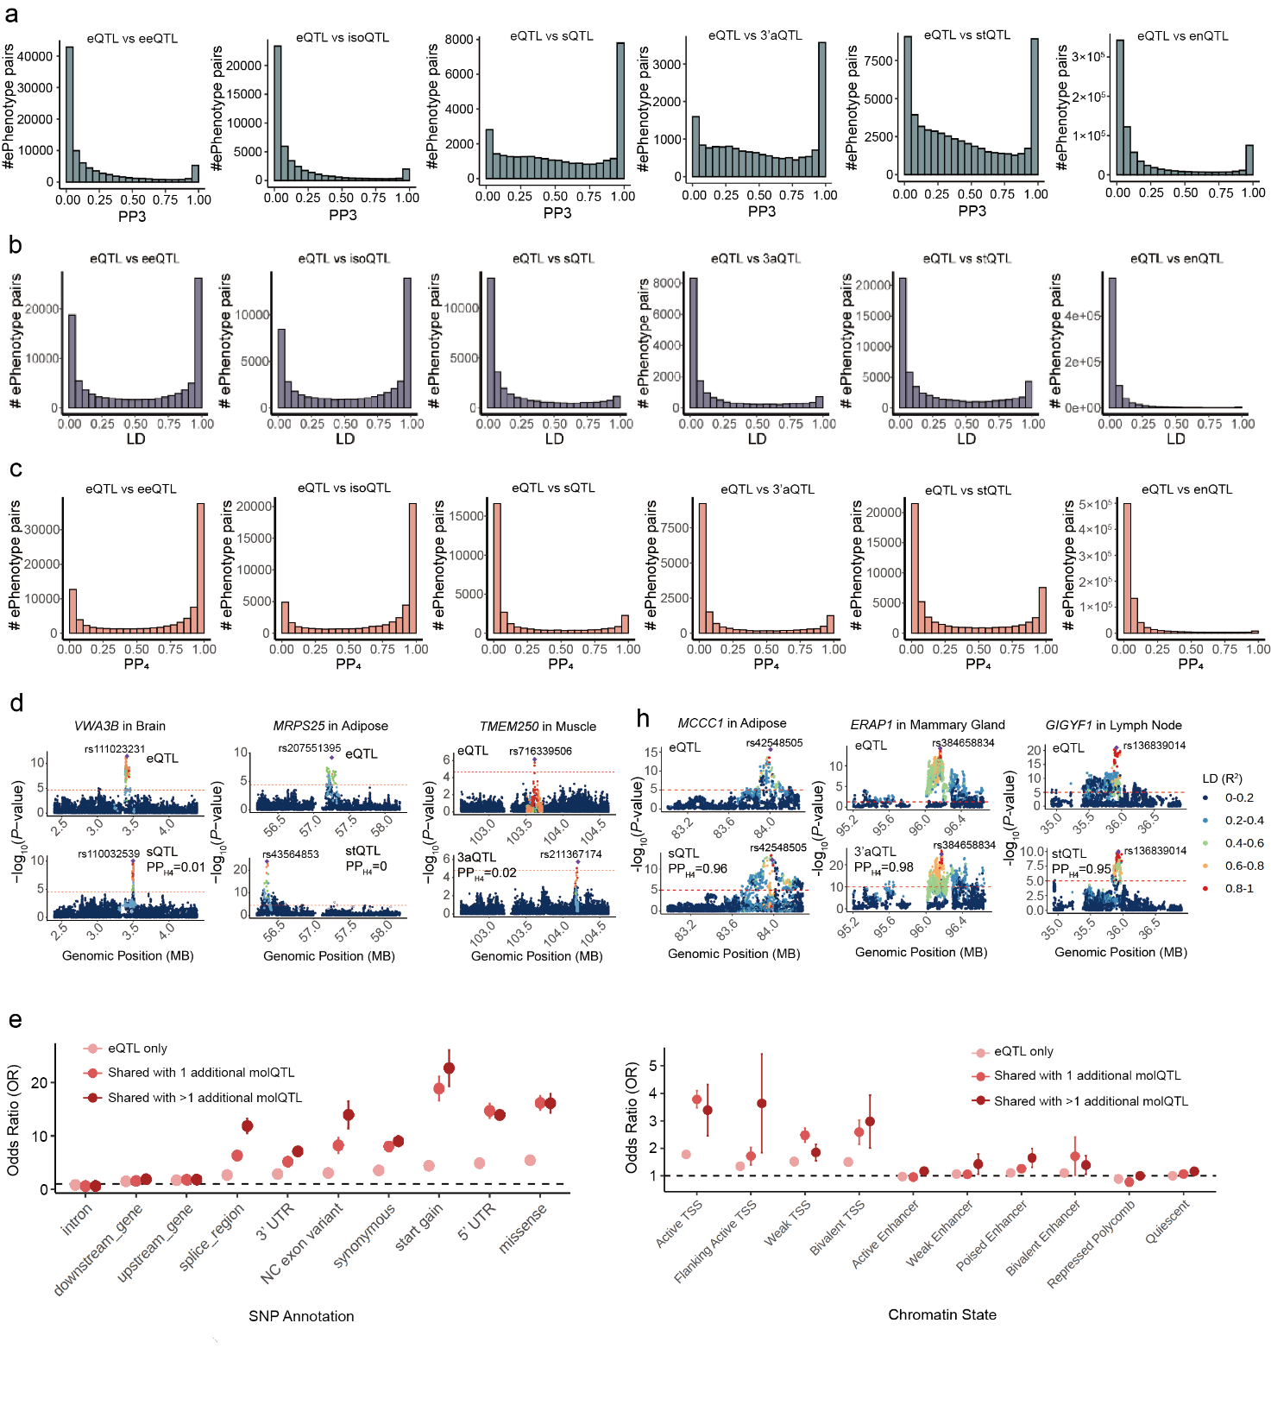
Extended Data Fig. 5 | a-c, Colocalization analyses eQTL across other six molecular phenotypes of the same molGene. PP₃: the posterior probability that the two molQTL are driven by distinct causal variants (a). PP₄: the posterior probability that the two molQTL share a single causal variant (c). LD (r²): the linkage disequilibrium of lead SNPs of two molecular phenotypes derived from the molGene (b). d, Examples of distinct signals between eQTL and other six molQTL within the same molGene. The two-sided P values of lead SNPs were calculated by the linear mixed regression model. e, Functional enrichment of pleiotropic eQTL with regulatory elements (left: SNP classification, right: chromatin states).
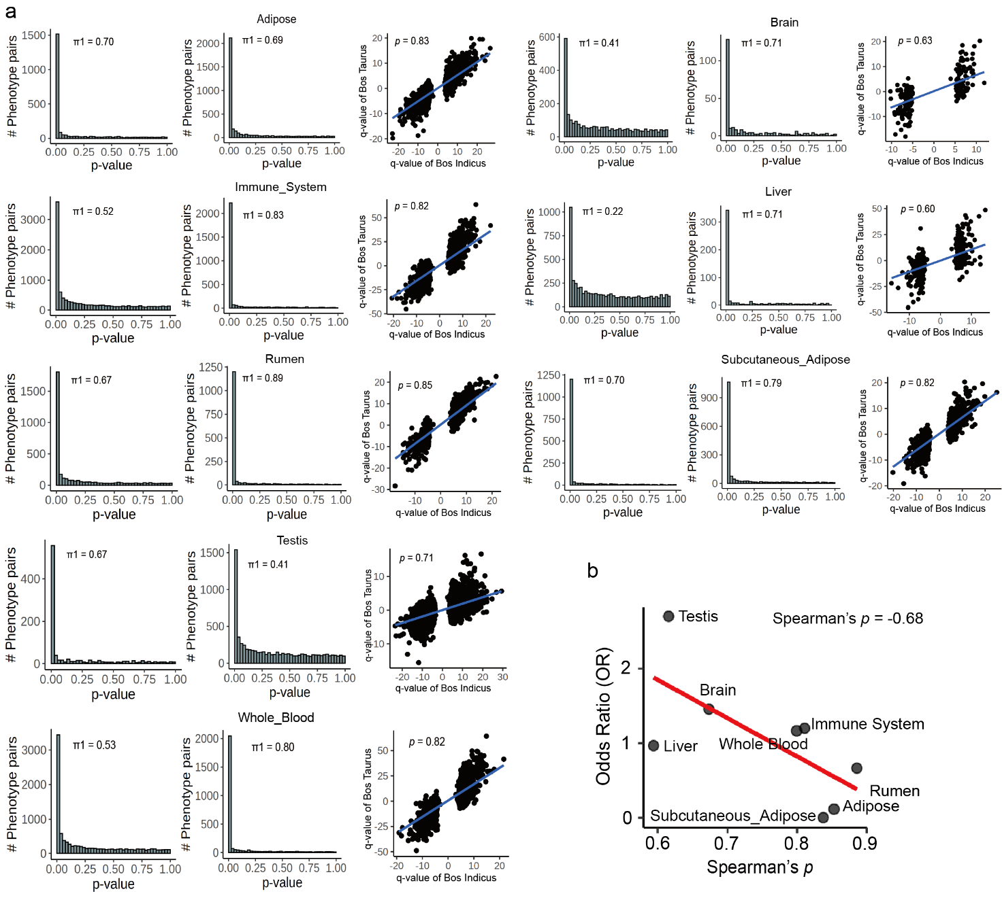
Extended Data Fig. 6 | a, Storey’s π₁ statistics implemented in the qvalue package (v2.32.0)¹¹⁹ and Spearman’s correlation were used to assess replication of effect sizes between B. taurus and B. indicus across eight tissues. In each tissue, the p-value of the eQTL of B. taurus was used as observation (left) and validation data (mid), respectively. b, Spearman’s correlation between odds ratio (OR) of enrichment between tissue-specific eQTL and strongly selected regions and spearman’s correlation of effect sizes between B. taurus and B. indicus.
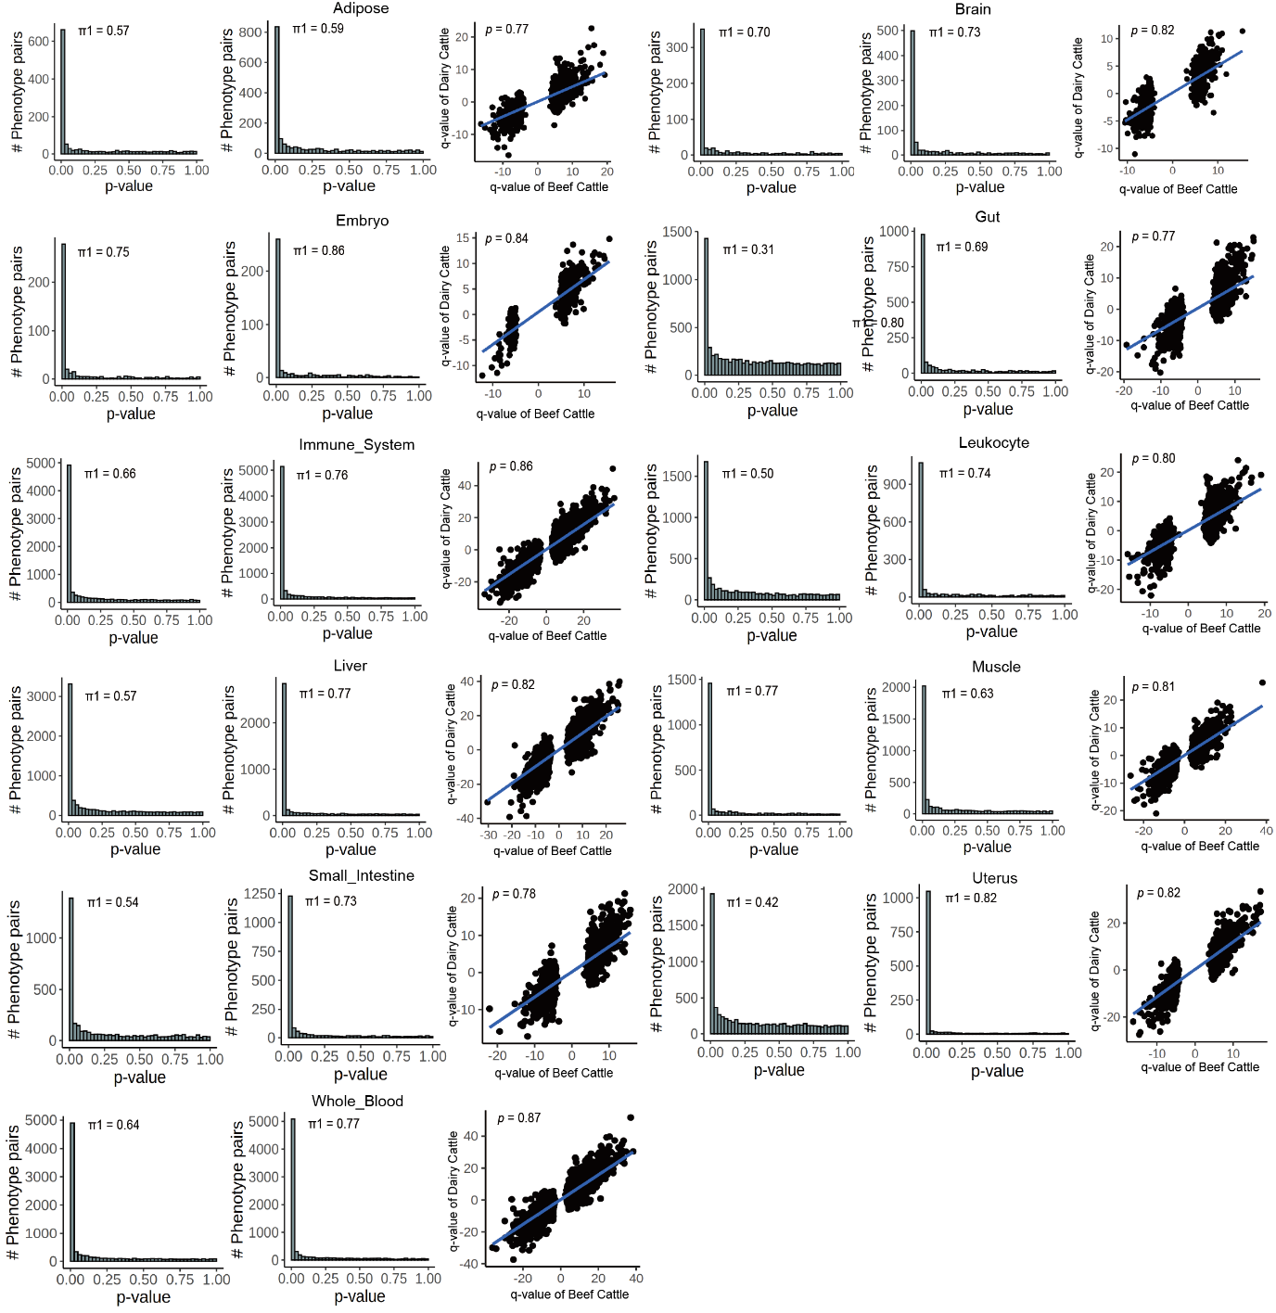
Extended Data Fig. 7 | Storey’s π₁ statistics implemented in the qvalue package (v2.32.0)¹¹⁹ and Spearman’s correlation were used to assess replication of effect sizes between dairy cattle and beef cattle across 11 tissues. In each tissue, the p-value of the eQTL of dairy cattle was used as observation (left) and validation data (mid), respectively.

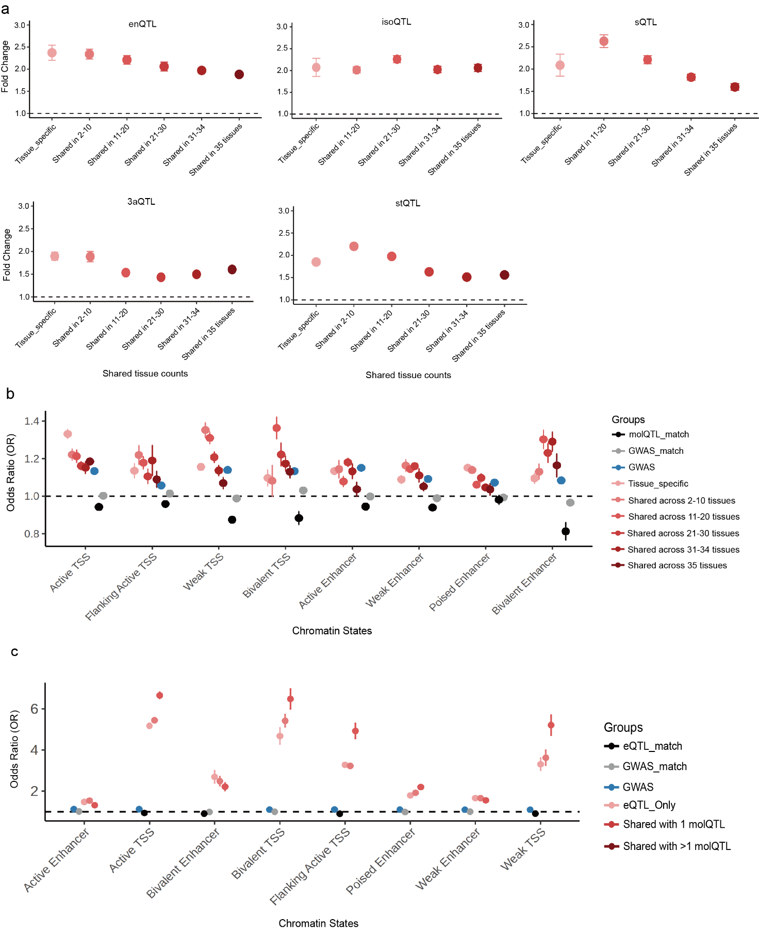
Extended Data Fig. 8 | a, Enrichment (odds ratio) of tissue specific/shared molQTL with genome-wide associations (GWAS) of 44 cattle traits using QTLenrich (v.2.0)⁵⁴. b, Functional enrichment between tissue specific/shared molQTL and regulatory elements. c, Functional enrichment between pleiotropic eQTL and regulatory elements.
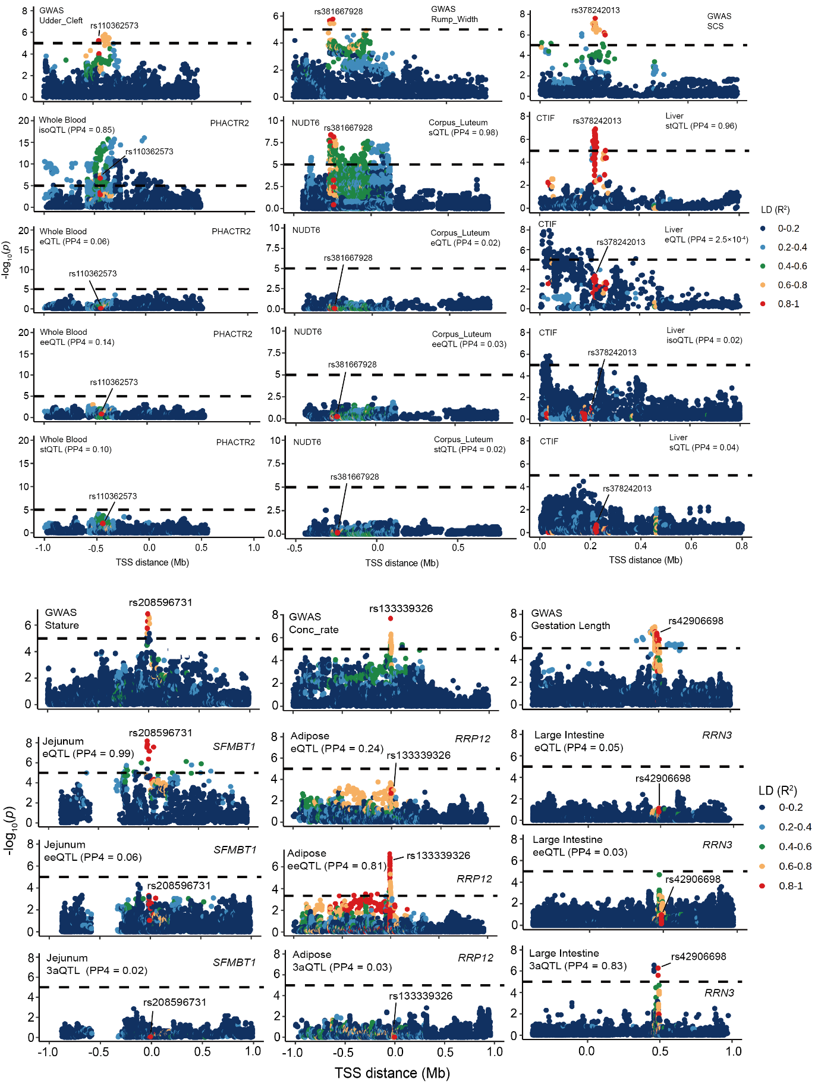
Extended Data Fig. 9 | Manhattan plots showing the -log₁₀(p) distribution of distinct colocalization between GWAS loci and each of seven molQTL, including udder cleft (GWAS) and isoQTL in whole blood across genetic variants within the locus of PHACTR2, rump width (GWAS) and sQTL in corpus leteum across genetic variants within the locus of NUDT6, SCS (GWAS) and stQTL in liver across genetic variants within the locus of CTIF, stature (GWAS) and eQTL in jejunum across genetic variants within the locus of SFMBT1, conception rates (GWAS) and eeQTL in adipose across genetic variants within the locus of RRP12 and gestation length (GWAS) and 3’aQTL in large intestine across genetic variants within the locus of RRN3. Variants are colored according to their linkage disequilibrium (LD, r²) with the lead SNP. The two-sided P values of SNPs were calculated by the linear mixed regression model.
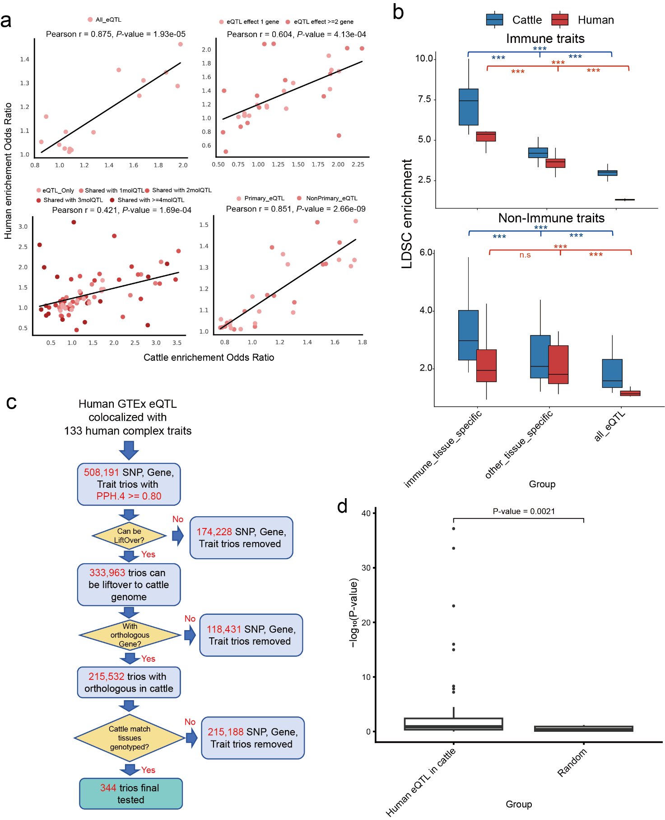
Extended Data Fig. 10 | a, Correlation between enrichment odds ratios (ORs) for different cattle eQTL groups in cattle FAANG annotations and the corresponding enrichment ORs after liftOver to the human genome in ENCODE annotations. b, Comparison of stratified LD score regression (S-LDSC) heritability enrichment of tissue-specific eQTL annotations from cattle and humans across immune versus non-immune traits. P values were calculated using two-sided unpaired t tests; P < 0.05 (), P < 0.01 (), and P < 0.001 (). c, Schematic of filtering steps and counts used to derive cattle orthologous, segregating trios from 508,191 gene–variant–trait trios obtained by colocalization between human GTEx eQTL and 133 human complex traits. Filters were applied sequentially: (1) the human variant could be lifted over from the human genome to the cattle genome; (2) the corresponding eGene had an ortholog in cattle; (3) the corresponding tissue was available in the cattle dataset; and (4) the lifted-over cattle locus harbored a segregating SNP. This yielded 344 retained trios. d, Comparison of association significance in cattle for the 344 retained trios tested using a single-variant linear mixed model versus a random set of matched orthologous loci. P values were calculated using two-sided unpaired t tests.

