Supplementary Information
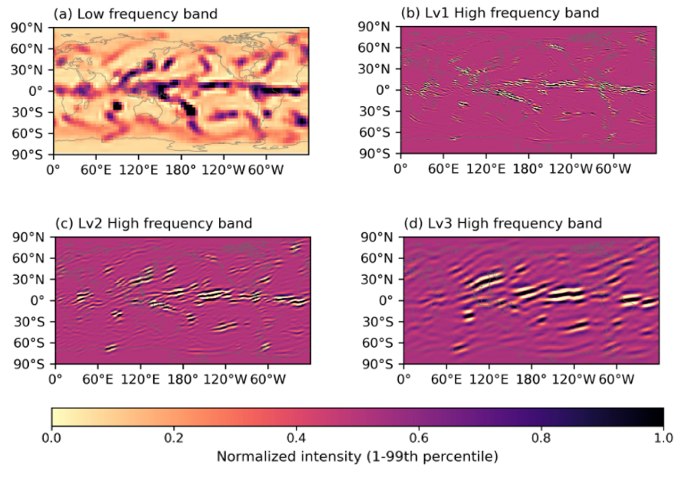
Figure S1. DTCWT band-wise decomposition results. The high-frequency visualizations correspond to the $±15°$ directional sub-bands among the six DTCWT orientations. (a) Low-frequency band at Level 1. (b) High-frequency band at Level 1. (c) High-frequency band at Level 2. (d) High-frequency band at Level 3.

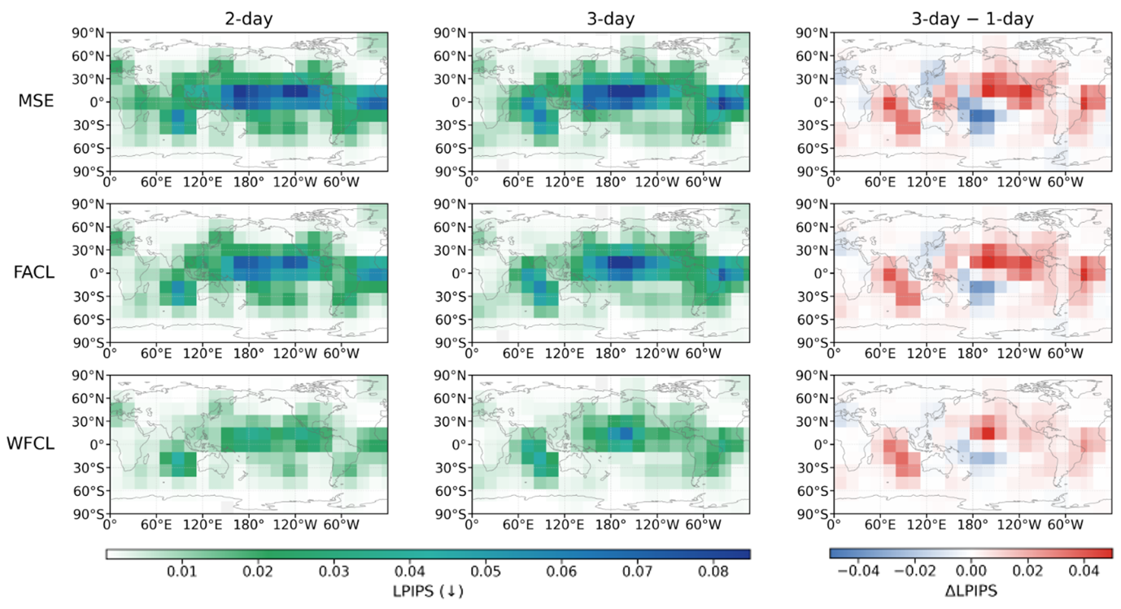
Figure S2. Global LPIPS maps for 2-day and 3-day lead precipitation forecasts across different loss functions. The rightmost panels depict the LPIPS difference between the 3-day and 1-day lead times, where positive values indicate increased perceptual error with lead time.
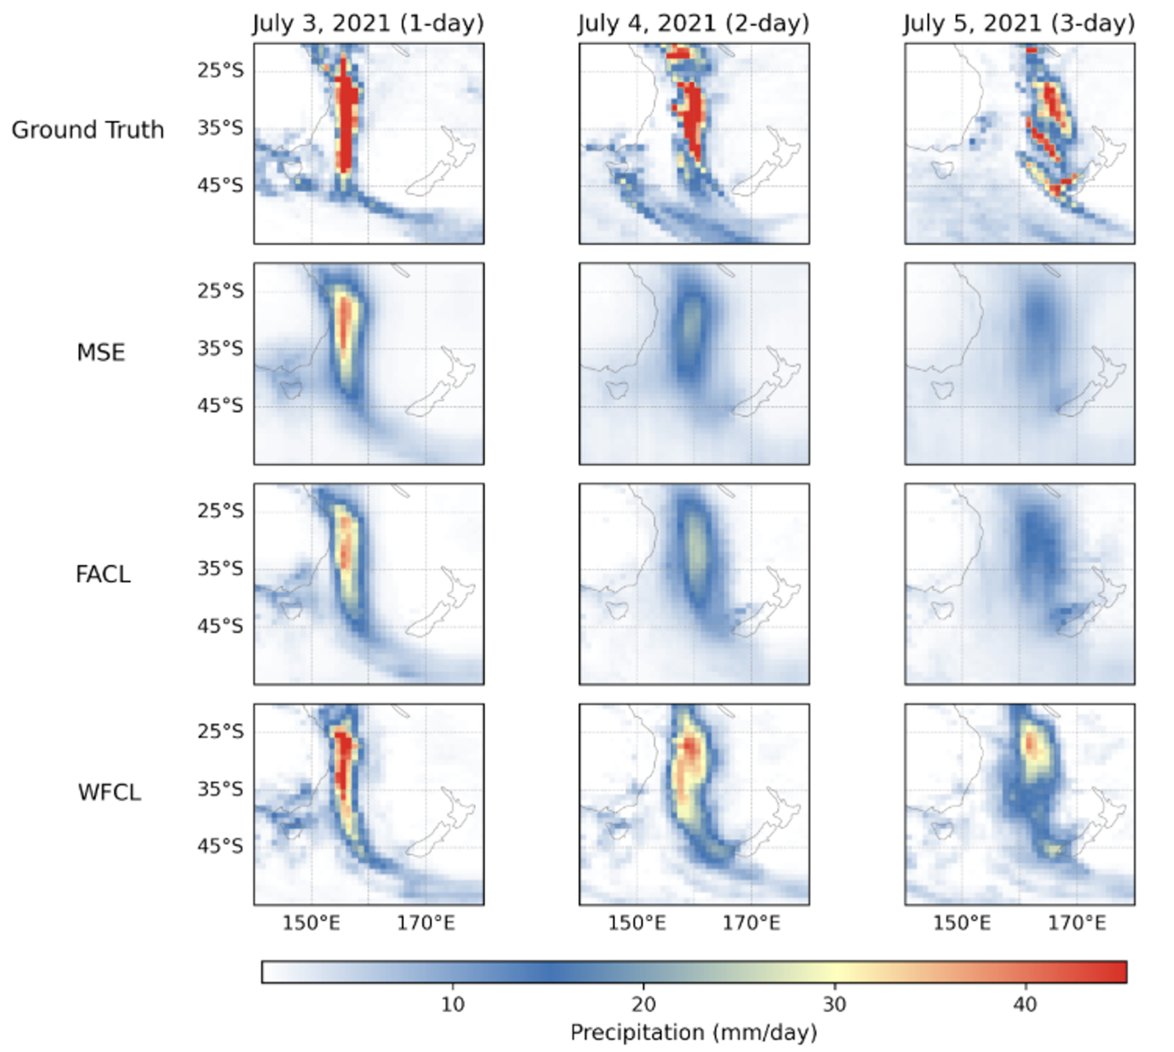
Figure S3. Comparison of predictive performance across models and lead times for a heavy precipitation event over the Tasman Sea and the western coast of New Zealand (140°E-180°E, 55°S-20°S) on 2 July 2021. Rows show the ground truth and model predictions, while columns show forecasts at increasing lead times.
Table S1. Comparison of prediction performance across DTCWT decomposition levels at a 1-day lead time. Bold values indicate the best performance for each metric. Arrows (↑, ↓) specify whether larger or smaller values represent better performance. LPC values are multiplied by 10⁴ for readability.
Loss | Perceptual / Structural |  |  | Localization | Extreme Events | Spatial Skill
Loss | LPIPS↓ | CPBD↑ | LPC(x${10}^{4})$↓ | RHD↓ | CSI-R95p↑ | FSS↑
WFCL Lv1 | 0.1351 | 86.71 | 1.14 | 2.29 | 0.1441 | 0.8682
WFCL Lv2 | 0.1122 | 88.47 | 1.15 | 1.50 | 0.1448 | 0.8812
WFCL Lv3 (Ours) | 0.1067 | 89.52 | 1.27 | 1.05 | 0.1448 | 0.8801

Supplementary Note 1. Evaluation metrics
Learned Perceptual Image Patch Similarity
The Learned Perceptual Image Patch Similarity (LPIPS) measures the perceptual distance between predicted and reference precipitation fields in a deep feature space. In this study, LPIPS was computed using a pretrained AlexNet as the feature extractor. The metric is defined by aggregating the differences between feature maps extracted from multiple convolutional layers, and can be expressed as
$$d\left(x,x_{0}\right)=\sum_{j}{\frac{1}{H_{j}W_{j}}\sum_{h, w}{{\left\|w_{j}⊙(ϕ_{hw}^{j}-ϕ_{0hw}^{j}\right\|}_{2}^{2}}} .$$
Here, $x$ and $x_{0}$ denote the predicted and reference precipitation fields, respectively, and $j$ indexes the different feature extraction layers of the pretrained AlexNet. $ϕ_{hw}^{l}$ and $ϕ_{0hw}^{l}$ represent the feature vectors at spatial location $\left(h, w\right)$ in the $j$^{th} layer for the predicted and reference fields, respectively. $H_{j}$ and $W_{j}$ correspond to the height and width of the feature map at layer $j$ and are used to normalize the spatial dimensions. The vector $w_{j}$ denotes the learned channel-wise weights that reflect the relative importance of each feature channel, and $⊙$ indicates element-wise multiplication. Finally, ${\left\|∙\right\|}_{2}^{2}$ denotes the squared L2 norm, which quantifies the perceptual discrepancy between the two precipitation fields in the feature space rather than at the pixel level.
Cumulative Probability of Blur Detection
Cumulative Probability of Blur Detection (CPBD) is no-reference sharpness metric that quantifies overall image sharpness based on the probability of blur detection at image edges. For each edge $e_{i}$, the blur detection probability $P_{BLUR}\left(e_{i}\right)$ is defined using the relative magnitude between the measured edge width $w\left(e_{i}\right)$ and the Just Noticeable Blur (JNB) width $w_{JNB}\left(e_{i}\right)$, which is determined by the local contrast around the edge, as follows:
$$P_{BLUR}=P_{BLUR}\left(e_{i}\right)=1-\exp\left(-{\left|\frac{w\left(e_{i}\right)}{w_{JNB}\left(e_{i}\right)}\right|}^{β}\right)$$
Here, $w\left(e_{i}\right)$ denotes the observed edge width at edge $e_{i}$, and $w_{JNB}\left(e_{i}\right)$ represents the reference width corresponding to the minimum level of perceptually noticeable blur, determined by the local contrast in the neighborhood of the edge. The parameter $β$ is a tuning parameter used to approximate the psychometric function of blur detection. Subsequently, the distribution $P\left(P_{BLUR}\right)$ of blur detection probabilities over all edges in the image is constructed, and the cumulative probability that blur is perceived to be below the JNB level is defined as
$CPBD=P\left(P_{BLUR}≤P_{JNB}\right)=\sum_{P_{BLUR}=0}^{P_{BLUR}=P_{JNB}}{P\left(P_{BLUR}\right)}$.
In this study, the JNB cumulative criterion was empirically set to 0.5, as precipitation fields do not exhibit clear object boundaries and their edge-strength distributions vary substantially with preprocessing and normalization. This threshold was found to better balance sensitivity to meaningful structural edges while avoiding overemphasis on spurious high-gradient noise. Accordingly, the CPBD represents the proportion of edges for which $P_{BLUR}≤0.5$, which higher CPBD values indicating a larger fraction of perceptually sharp edges in the precipitation field.
Local Phase Coherence
Local structural coherence was quantified using LPC, computed by accumulating Log-Gabor phase responses across scales and weighting them by local spectral energy. The LPC at pixel $\left(x, y\right)$ is defined as
$$LPC\left(x,y\right)=\frac{\sum_{o}{\cos\left(∠A_{o}\left(x,y\right)\right)W_{o}\left(x,y\right)}}{\sum_{o}{W_{o}\left(x,y\right)+C}},$$
where $A_{o}$ is the accumulated phase response at orientation $o$, $W_{o}$ is its energy weight, and $C$ is a stabilizing constant. LPC values in [0, 1] reflect local phase alignment, boundary sharpness, and convective organization. To summarize the degree to which such local phase alignment is consistently achieved across the domain, we employ the spatially averaged LPC. In precipitation fields, convective organization emerges from the local connectivity of cells and the continuity of rainband boundaries; these properties are governed by the coherence of neighboring local phases rather than exact pointwise agreement. Accordingly, averaged LPC is used to quantify the overall level of locally coherent structures while preserving its local interpretability. To assess the deviation from the reference, the evaluation metric is defined as the difference between the averaged LPC of the model prediction and that of the ground truth.
To assess amplitude preservation, we compute the radial amplitude ratio from 2D FFT magnitudes. After masking noise-dominated frequencies, the amplitude ratio at frequency $k$ is
$$R\left(k\right)=\frac{A_{pred}\left(k\right)}{A_{true}\left(k\right)+ε} ,$$
converted to dB and radially averaged to assess scale-dependent spectral energy retention.
Regional Histogram Divergence
Regional Histogram Divergence (RHD) is a localization-sensitive evaluation metric designed to quantify regional distributional differences between predicted and observed precipitation fields. Instead of binarizing pixel values, RHD partitions the values within each patch into multiple bins and constructs histograms by counting the frequency in each bin. The average Kullback-Leibler (KL) divergence between the predicted and observed histograms is then computed to assess regional discrepancies. Mathematically, the RHD between two sets of histograms is defined as
$RHD=\frac{1}{N_{x}N_{y}}\sum_{i=1}^{N_{x}}{\sum_{j=1}^{N_{y}}{\sum_{x∈X}{O_{i, j}^{'}\left(x\right) log\frac{O_{i, j}^{'}\left(x\right)}{F_{i, j}^{'}\left(x\right)}}}}$.
Here, $F_{i, j}^{'}$ and $O_{i, j}^{'}$ denote the predicted and observed discrete probability distributions, respectively, for the patch located at the $i$^{th} row and j^{th} column, and $X$ represents the set of histogram bins defined for each patch. In this study, non-overlapping patches of size 15 x 15 and 50 histogram bins were used, with these parameters selected empirically to balance sensitivity to localization errors and robustness to noise.
Critical Success Index-R95p
To quantitatively evaluate the performance of extreme precipitation forecasts, the Critical Success Index (CSI) was employed. In order to focus on extreme precipitation events, days corresponding to the upper 95th percentiles of the precipitation distribution over the entire period were respectively defined as extreme cases, and the CSI was computed based on these events. The CSI is defined as the ratio of hits to the total number of hits, misses, and false alarms:
$$CSI=\frac{H}{H+M+F}$$
Fraction Skill Score
The Fraction Skill Score (FSS) is a spatial verification metric that evaluates the similarity between predicted and observed spatial distributions of events exceeding a specified threshold. Rather than comparing accuracy at individual grid points, FSS assesses the fraction of grid cells exceeding the threshold within a predefined spatial window, thereby reducing sensitivity to small spatial displacement errors and enabling the evaluation of spatial coherence. In this study, a precipitation threshold of 1mm is used to define precipitation events, and the spatial window size is set to $5×5$ grid cells. These parameters are determined empirically through preliminary sensitivity experiments using different thresholds and window sizes. The FSS is defined as follows:
$$FSS=1-\frac{\sum_{i=1}^{N}{{\left(f_{i}-o_{i}\right)}^{2}}}{\sum_{i=1}^{N}{\left({f_{i}}^{2}+{o_{i}}^{2}\right)}}.$$
Here $f_{i}$ and $o_{i}$ denote the fractions of grid cells exceeding the threshold within the $i^{th}$ spatial window for the prediction and observation, respectively, and $N$ is the total number of spatial windows. The FSS ranges from 0 to 1, with values closer to 1 indicating better agreement between the predicted and observed spatial distributions.

