Supplementary Information

Integrative Transcriptomic Profiling Reveals Convergent coding and non-coding Signatures in Pediatric Bone Marrow Failure Syndromes

- Supplementary Methods for Whole-Genome Sequencing
- Clinical data of genetically defined BMF
- Supplementary Figures

- Supplementary Methods for Whole-Genome Sequencing

- Whole-Genome Sequencing, Alignment, and Variant Calling.
Library was prepared using a Illumina TruSeq DNA PCR-Free kit and sequenced on the NovaSeq6000 (Illumina). The sequencing reads were aligned to GRCh38 using Burrows-Wheeler Aligner (BWA-MEM2) (v.2.2.1) (http://bio-bwa.sourceforge.net/). Samtools (v.1.12) was used for further processing. SNVs and short indels were called using the GATK (v.4.2), while structural variant (SV) were analyzed using MANTA (v.1.6.0) and cn.MOPS (v.1.38.0). The SNVs/short indels and SVs were annotated and analyzed using Ensembl Variant Effect Predictor (v.104) and AnnotSV (v.3.1), respectively.

- Variant Filtering, Annotation, and Classification
We imported all retrieved genetic variants to the Variant interpreter (Illumina). Firstly, we applied combined filter groups including population data frequency [<0.1% or <1% by Exome Aggregation Consortium (ExAC) and Genome Aggregation Database (gnomAD Exomes)], quality metrics [Total read depth >4, variant read frequency >0.2], and variant consequences [all coding consequences]. Then we searched the causal variant using virtual panel comprising 819 genes related to IBMFS. The potential functional impacts of the retained variants were assessed using VarSome (https://Varsome.com/), HGMD (http://www.hgmd.cf.ac.uk/), and Clinvar (https://www.ncbi.nlm.nih.gov/clinvar/). The retained causal variants were confirmed by visual inspection of the BAM files. Phenotype-genotype correlations were thoroughly reviewed using Human Phenotype Ontology (https://hpo.jax.org/), and Online Catalog of Human Genes and Genetic Disorders (OMIM, https://omim.org/). If there was no causal variant remained, we repeated all process omitting virtual panel and/or filter groups.

- Clinical data of genetically defined BMF
Patient ID – G1
A one-year-old male presented with multiple café-au-lait macules and hypopigmented patches on the lower limbs, buttocks, chest, back, and chin. He was born at 36 weeks of gestation via cesarean section due to oligohydramnios, with a birth weight of 1.8 kg, and required NICU care for poor feeding during the neonatal period. Physical findings included café-au-lait spots, hypopigmented skin lesions, and a horseshoe kidney. WGS identified a homozygous splice-site variant in FANCG (NM_004629.2:c.307+1G>C), consistent with a diagnosis of Fanconi anemia. Both parents were heterozygous carriers, and the patient’s older sibling was a heterozygous carrier as well. At age 3 years, he was referred for hematopoietic stem cell transplantation due to progressive pancytopenia (WBC 6.86 × 10⁹/L, Hb 10.6 g/dL, Plt 79 × 10⁹/L, reticulocyte 1.37%). Bone marrow biopsy at age 4 years showed hypocellularity (~20%) with less than 1% blasts. He underwent a matched unrelated donor bone marrow transplantation with subsequent hematologic recovery.

Patient ID – G2
A 5-year-old female was referred for a second opinion due to persistent cytopenia and short stature. She had café-au-lait macules over the flanks, She presented with bicytopenia (WBC 3.53 × 10⁹/L, Hb 11.9 g/dL, and platelet count 86 × 10⁹/L), which revealed markedly hypocellular marrow (5% cellularity), A chromosomal breakage test was positive, supporting the diagnosis of Fanconi anemia.
WGS identified two heterozygous pathogenic variants: FANCD2 (NM_033084.4:c.3817C>T; p.Arg1273Ter) inherited from the mother, and BRCA2 (FANCD1) (NM_000059.4:c.5795_5799del; p.His1932ProfsTer11) inherited from the father. Both variants have been previously associated with autosomal recessive Fanconi anemia subtypes.
Given the biallelic involvement of different FA complementation groups, a digenic mechanism (FANCD2 + BRCA2) was considered possible, though not yet established in the literature.
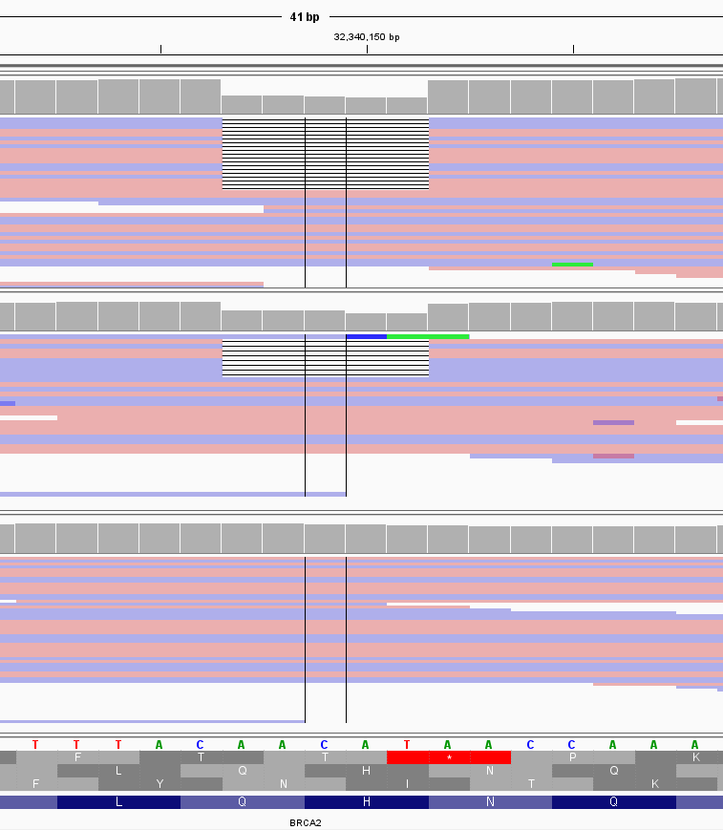
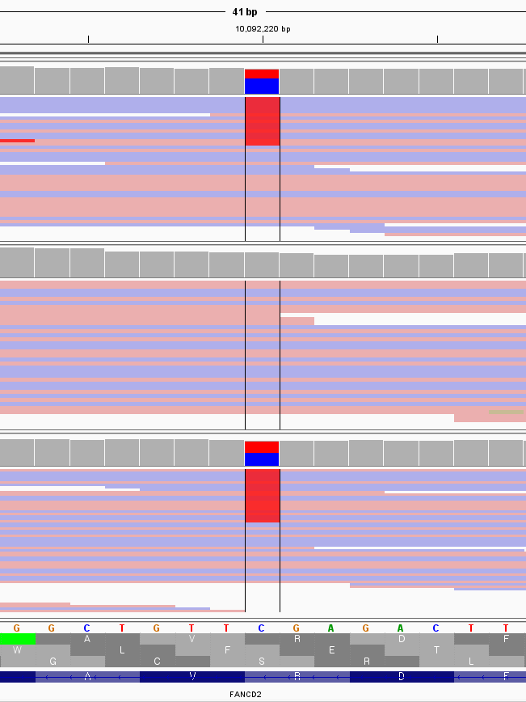

Patient ID – G3
A 7-year-old male presented with pancytopenia identified incidentally during a school health screening. Bone marrow examination showed markedly hypocellular marrow with decreased trilineage hematopoiesis, consistent with aplastic anemia. Chromosomal breakage testing confirmed the diagnosis of Fanconi anemia.Targeted sequencing revealed compound heterozygous variants in FANCA:c.3520_3522del (p.Trp1147del), inherited from the mother, and c.4168-2A>G, inherited from the father. Physical examination demonstrated short stature (3–5th percentile), multiple café-au-lait macules, a small depigmented patch on the abdomen, and prominent palmar creases, with no limb anomalies.CBC at presentation showed WBC 3.48×10⁹/L, Hb 8.1 g/dL, platelets 42×10⁹/L, ANC 420/µL, and HbF 6.5%. He underwent fludarabine–melphalan–mesna (FMM)–conditioned PBSCT at the age of 8 years but subsequently developed graft-versus-host disease and CMV pneumonitis, and died of transplant-related complications.
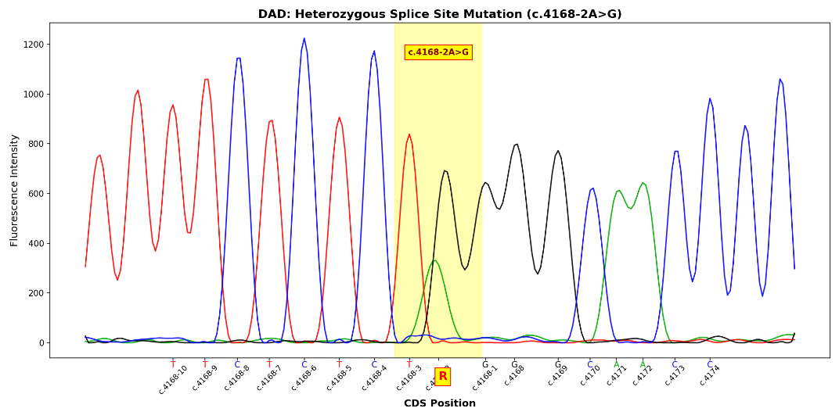
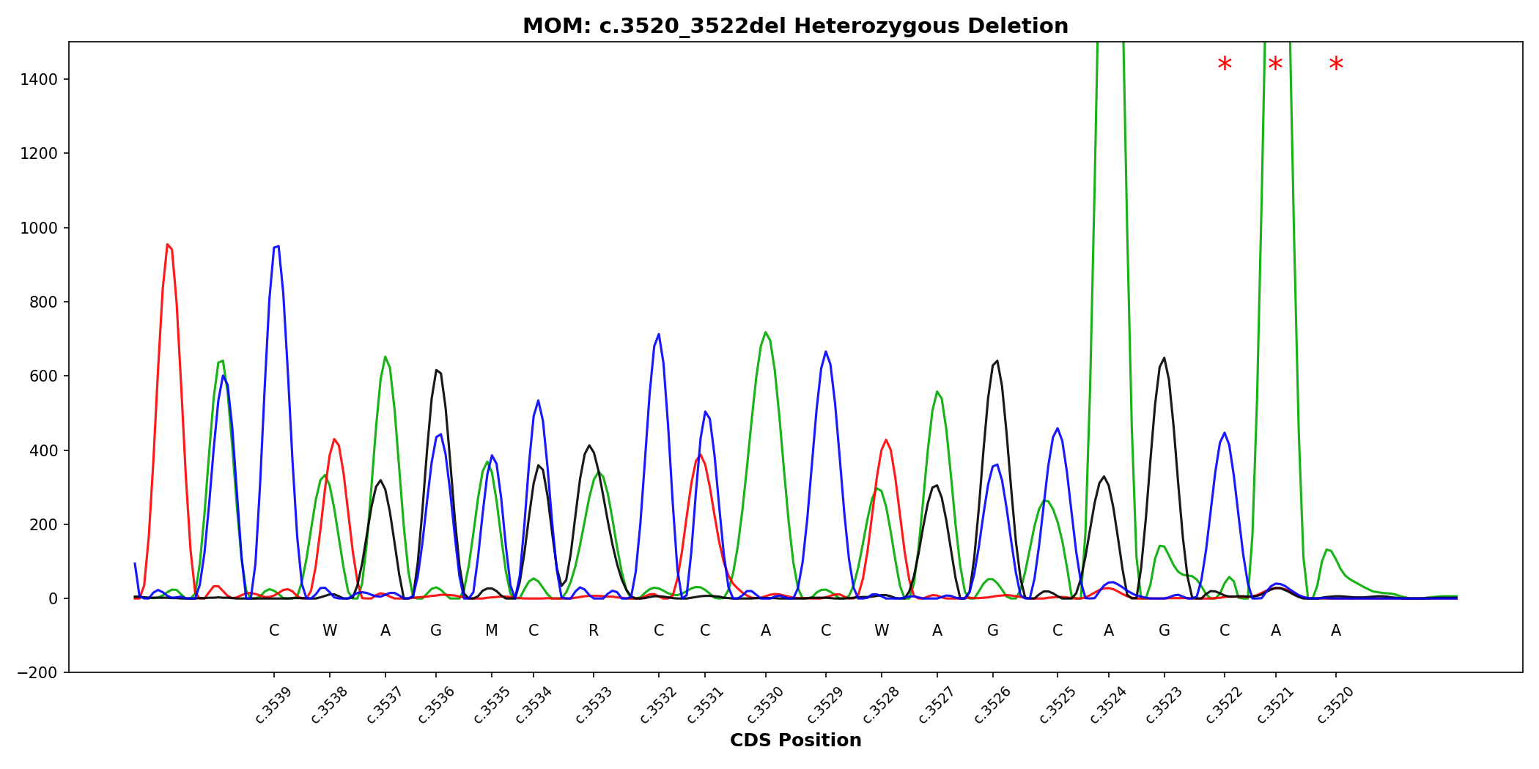

Patient ID – G4
A 7-year-old male was first noted to have thrombocytopenia (61×10⁹/L) and leukopenia (3.3×10⁹/L) during hospitalization for influenza. Follow-up testing showed further cytopenia, and bone marrow examination revealed marked hypocellularity, consistent with aplastic anemia. At follow-up, CBC showed WBC 4.55×10⁹/L, Hb 10.5 g/dL, platelets 68×10⁹/L, and reticulocytes 2.79%. PNH testing was negative, while serum erythropoietin was markedly elevated (1063 mIU/mL).
Targeted sequencing identified a heterozygous pathogenic variant in TERT (c.1892G>A; p.Arg631Gln), confirming telomere biology disorder–associated bone marrow failure.
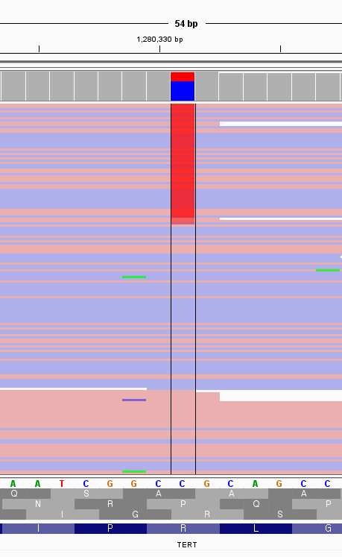

3. Supplementary Figures
Supplementary Figure 1. Distribution of detected gene biotypes across the cohort (Control, g-BMF, and u-BMF).
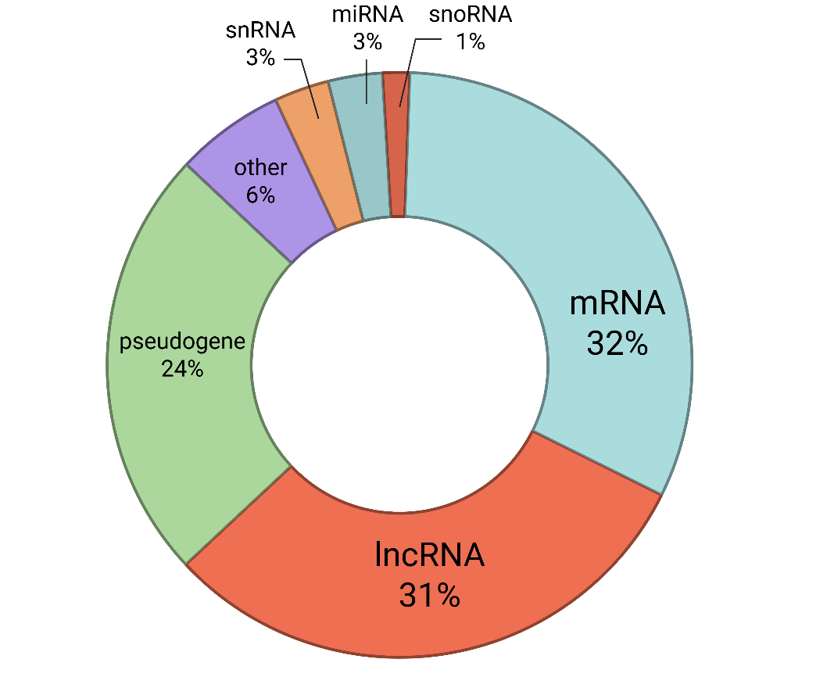
Total RNA sequencing detected 62,653 genes across all samples. Gene biotypes were annotated using GENCODE v44 and are shown as percentages of all detected genes. Abbreviations: Control, control; g-BMF, genetically defined bone marrow failure; u-BMF, genetically undefined bone marrow failure; mRNA, messenger RNA; lncRNA, long non-coding RNA; snRNA, small nuclear RNA; miRNA, microRNA; snoRNA, small nucleolar RNA. Created in https://BioRender.com
Supplementary Figure 2. PCA of RNA-seq samples across the cohort (Control, g-BMF, and u-BMF).
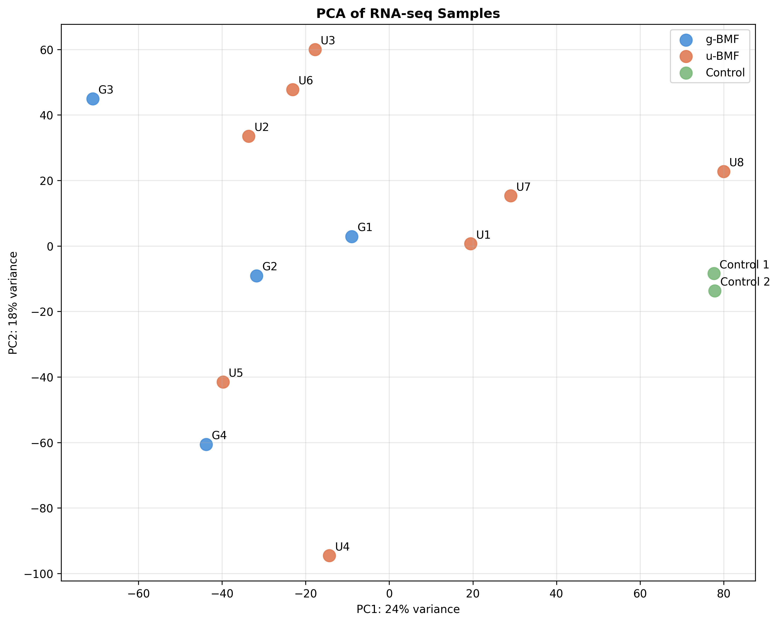
PCA was performed using VST-normalized gene expression profiles, demonstrating separation between BMF samples and Control, while g-BMF and u-BMF showed substantial overlap and intra-group heterogeneity. Abbreviations: PCA, principal component analysis; Control, control; g-BMF, genetically defined bone marrow failure; u-BMF, genetically undefined bone marrow failure; VST, variance stabilizing transformation.
Supplementary Figure 3. Representative enriched Hallmark pathways in pediatric bone marrow failure (g-BMF and u-BMF).
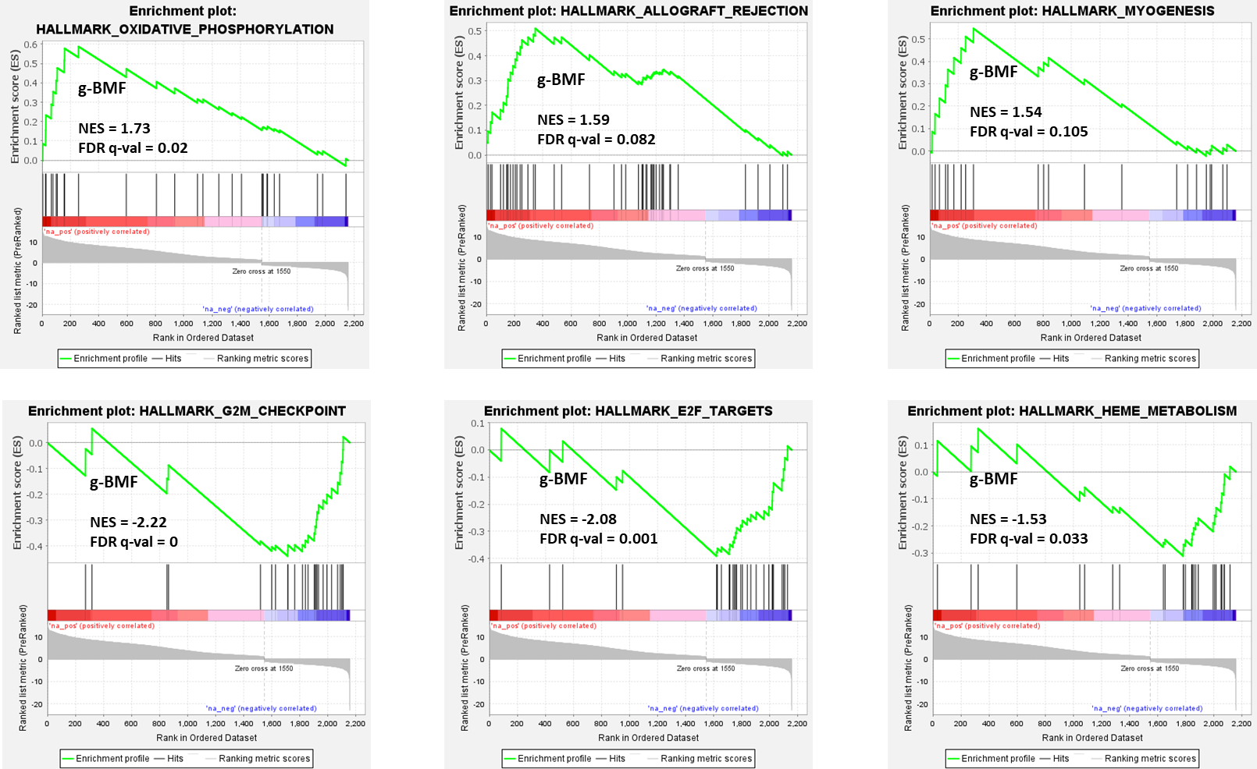
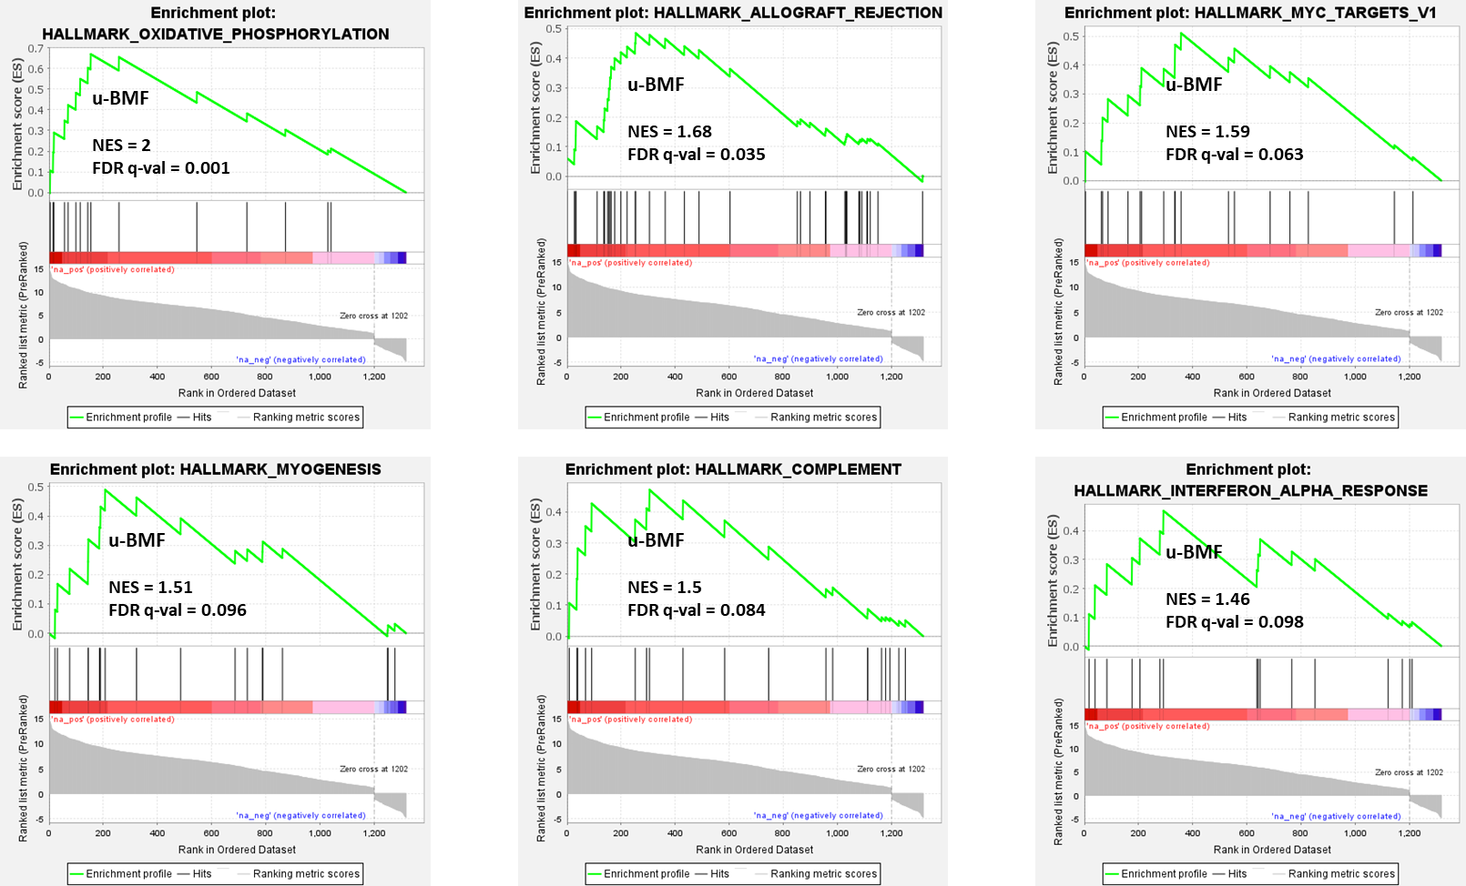

Representative Gene Set Enrichment Analysis (GSEA) plots show Hallmark pathways significantly associated with genetically defined bone marrow failure (g-BMF) and genetically undefined bone marrow failure (u-BMF) relative to controls. Positively enriched pathways include oxidative phosphorylation, allograft rejection, myogenesis, complement, and interferon-α response, indicating coordinated activation of immune- and metabolic-related programs. Negatively enriched pathways include cell-cycle–related programs such as G2M checkpoint and E2F targets. Normalized enrichment scores (NES) and false discovery rate (FDR q-values) are indicated in each panel.Abbreviations: g-BMF, genetically defined bone marrow failure; u-BMF, genetically undefined bone marrow failure; GSEA, gene set enrichment analysis; NES, normalized enrichment score; FDR, false discovery rate.

Supplementary Figure 4. RT-qPCR validation of selected DE-lncRNAs in pediatric bone marrow failure.
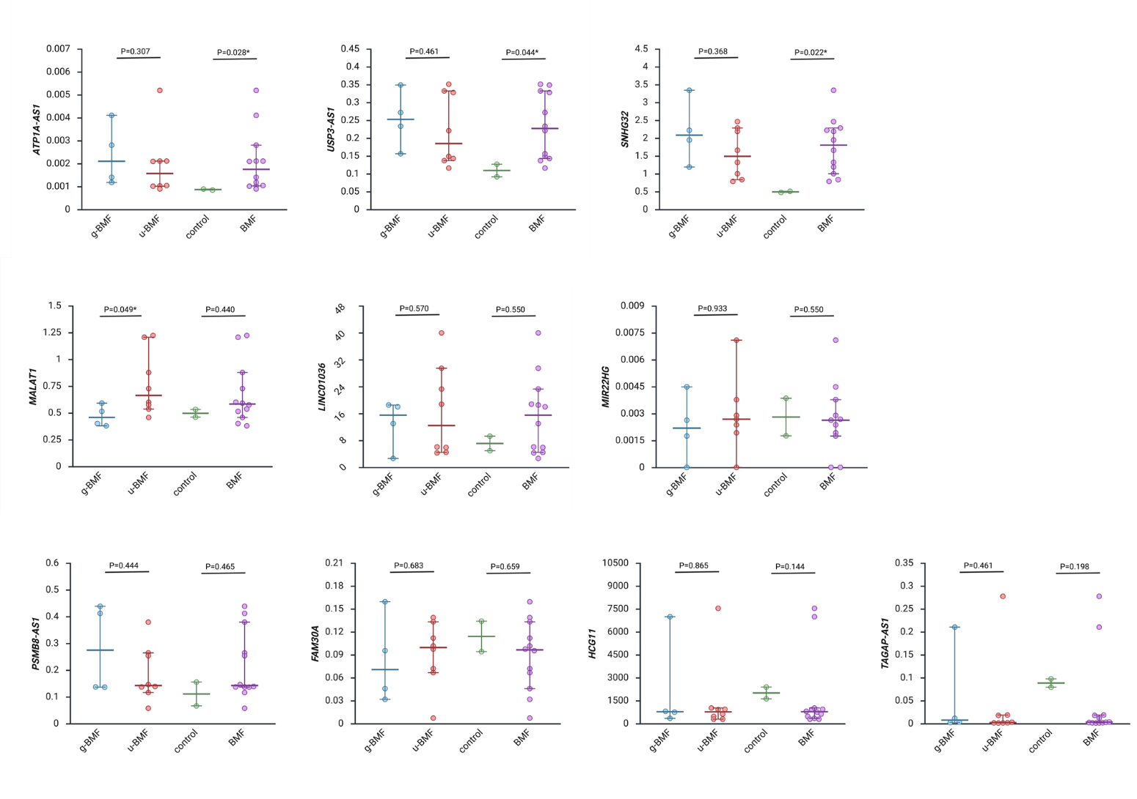
RT-qPCR was performed to validate the expression of selected DE-lncRNAs identified by RNA-seq in Control, g-BMF, and u-BMF samples. Among the tested candidates, ATP1A1-AS1, USP3-AS1, and SNHG32 were significantly upregulated in BMF relative to Control (P < 0.05), consistent with the RNA-seq results, whereas the remaining lncRNAs did not reach statistical significance. P-values for group comparisons are indicated in each panel. Abbreviations: RT-qPCR, reverse transcription quantitative polymerase chain reaction; DE-lncRNA, differentially expressed long non-coding RNA; Control, control; g-BMF, genetically defined bone marrow failure; u-BMF, genetically undefined bone marrow failure; BMF, bone marrow failure. Created in https://BioRender.com

