Title page
Guselkumab Emerges as a Superior Therapy for Inducing Clinical Remission in Crohn's Disease: A Systematic Review and Network Meta-Analysis of IL-23p19 Inhibitors and Small Molecule Drugs

Authors
Yuting Shi*; Zhenyi Tian*; Xixi He; Xiaoling Wang; Zhipeng Liu†; Xinying Wang†
*Authors share co-first authorship
†Authors share co-corresponding authors.

Affiliations
Department of Gastroenterology, Zhujiang Hospital, Southern Medical University, Guangzhou 510282, China

Correspondence
Prof. Xinying Wang MD, PhD
Department of Gastroenterology, Zhujiang Hospital, Southern Medical University
Guangzhou, 510282 China;
Telephone number: 020-62782281;
E-mail: xinyingwang06@163.com

Directory
Supplementary Table 1: Detail of search strategy. 3
Supplementary Figure 1: Risk of bias assessment 8
Supplementary Table 2: Confidence in estimates from network meta-analysis. 9
Supplementary Figure 2: Funnel plots of different outcomes in network meta-analysis. 10
Supplemetary Figure 3 : Network map for induction trials assessing secondary outcomes. 11
Supplementary Figure 4: Pair-wise meta-analysis for induction of clinical remission. 12
Supplementary Figure 5: Pair-wise meta-analysis for induction of endoscopic improvement. 13
Supplementary Figure 6: Pair-wise meta-analysis for induction of endoscopic remission. 14
Supplementary Figure 7: Pair-wise meta-analysis for induction of patient-reported outcome remission. 15
Supplementary Table 3: Indirect comparison of IL-23p19 inhibitors and small molecule drugs for the induction of clinical remission in network meta-analysis. 16
Supplementary Table 4: Indirect comparison of IL-23p19 inhibitors and small molecule drugs for the induction of endoscopic improvement in network meta-analysis. 16
Supplementary Table 5: Indirect comparison of IL-23p19 inhibitors and small molecule drugs for the induction of patient-reported outcomes remission in network meta-analysis. 17
Supplementary Table 6: Indirect comparison of IL-23p19 inhibitors and small molecule drugs for the induction of endoscopic remission in network meta-analysis. 17
Supplementary Table 7: Indirect comparison of IL-23p19 inhibitors and small molecule drugs for the induction of clinical remission in patients without biologic failure. 18
Supplementary Table 8: Indirect comparison of IL-23p19 inhibitors and small molecule drugs for the induction of clinical remission in patients with biologic failure. 19
Supplementary Table 9: Indirect comparison of IL-23p19 inhibitors and small molecule drugs for the induction of endoscopic improvement in patients without biologic failure. 20
Supplementary Table 10: Indirect comparison of IL-23p19 inhibitors and small molecule drugs for the induction of endoscopic improvement in patients with biologic failure. 21
Supplementary Table 11: Indirect comparison of IL-23p19 inhibitors and small molecule drugs for the induction of patient-reported outcomes remission in patients without biologic failure. 22
Supplementary Table 12: Indirect comparison of IL-23p19 inhibitors and small molecule drugs for the induction of patient-reported outcomes remission in patients with biologic failure. 23
Supplementary Table 13: Indirect comparison of IL-23p19 inhibitors and small molecule drugs for the induction of endoscopic remission in patients without biologic failure. 24
Supplementary Table 14: Indirect comparison of IL-23p19 inhibitors and small molecule drugs for the induction of endoscopic remission in patients with biologic failure. 24
Supplementary Table 15: Indirect comparison of IL-23p19 inhibitors and small molecule drugs for the induction of adverse events in network meta-analysis. 25
Supplementary Table 16: Indirect comparison of IL-23p19 inhibitors and small molecule drugs for the induction of serious adverse events in network meta-analysis. 25

Supplementary Table 1: Detail of search strategy.
Embase
#1 | janus kinase inhibitor'/exp OR 'jak inhibitor' OR 'janus kinase inhibitors' OR 'janus tyrosine kinase inhibitor' OR 'janus kinase inhibitor'
#2 | 'sphingosine 1 phosphate receptor'/exp OR 'sphingosine-1-phosphate receptor' OR 'sphingosine-1-phosphate receptors' OR 'sphingosine 1 phosphate receptor'
#3 | 'small molecule drugs'
#4 | tofacitinib'/exp OR 'cp 690 550' OR 'tasocitinib citrate' OR 'xeljanz'
#5 | filgotinib'/exp OR 'glpg 0634' OR 'g 146034' OR 'jyseleca'
#6 | upadacitinib'/exp OR 'abt 494' OR 'rinvoq' OR 'upadacitinib tartrate'
#7 | ivarmacitinib'/exp OR 'arq 252' OR 'shr0302' OR 'ivarmacitinib sulfate'
#8 | peficitinib'/exp OR 'asp015k' OR 'peficitinib hydrobromide'
#9 | ritlecitinib'/exp OR 'litfulo' OR 'ritlecitinib malonate' OR 'pf 06651600'
#10 | brepocitinib'/exp OR 'pf 06700841' OR 'pf 841' OR 'pf 6700841'
#11 | izencitinib'/exp OR 'jnj 8398' OR 'td 1473'
#12 | deucravacitinib'/exp OR 'bms 986165' OR 'tyk2-in-4' OR 'bms 98616501' OR 'sotyktu'
#13 | ozanimod'/exp OR 'rpc 1063' OR 'ozanimod hydrochloride' OR 'zeposia'
#14 | etrasimod'/exp OR 'pf 07915503' OR 'etrasimod arginine' OR 'velsipity' OR 'pf 7915503'
#15 | mocravimod'/exp OR 'mocravimod hydrochloride' OR 'krp203'
#16 | fingolimod'/exp OR 'bonaxon' OR 'tascenso' OR 'ro7079904'
#17 | amiselimod'/exp OR 'mt 1303' OR 'amiselimod hydrochloride'
#18 | cobitolimod'/exp OR 'dims 0150' OR 'kappaproct' OR 'cobitolimod sodium' OR 'idx 0150'
#19 | carotegrast'/exp
#20 | apremilast'/exp OR 'amg 407' OR 'otezla' OR 'cc 10004' OR 'ap 506'
#21 | interleukin 23p19 inhibitor'/exp OR 'interleukin 23 p19 inhibitor*' OR 'il23p19 inhibitor*'
#22 | interleukin 23p19'/exp OR 'interleukin 23p19' OR 'il23p19'
#23 | brazikumab'/exp OR 'brazikumab' OR 'amg 139' OR 'medi2070'
#24 | risankizumab'/exp OR 'risankizumab' OR 'risankizumab rzaa' OR 'bi 655066'
#25 | tildrakizumab'/exp OR 'tildrakizumab' OR 'tildrakizumab asmn' OR 'sch 900222' OR 'mk 3222'
#26 | mirikizumab'/exp OR 'mirikizumab' OR 'mirikizumab mrkz' OR 'ly 3074828'
#27 | guselkumab'/exp OR 'cnto 1959' OR 'guselkumab'
#28 | inflammatory bowel disease'/exp OR 'crohn disease'/exp OR 'inflammatory bowel disease' OR 'crohn disease' OR 'ibd' OR 'cd'
#29 | #1 OR #2 OR #3 OR #4 OR #5 OR #6 OR #7 OR #8 OR #9 OR #10 OR #11 OR #12 OR #13 OR #14 OR #15 OR #16 OR #17 OR #18 OR #19 OR #21 OR #21 OR #22 OR #23 OR #24 OR #25 OR #26 OR #27
#30 | #29 AND #28
Pubmed
#1 | "small molecule drugs" OR "Janus Kinase Inhibitors"[Mesh] OR "JAK inhibitors" OR "Janus Kinase Inhibitor" OR "Sphingosine-1-Phosphate Receptors"[Mesh] OR "S1P Receptor"
#2 | "tofacitinib" [Supplementary Concept] OR "tasocitinib" OR "CP-690,550" OR "Xeljanz" OR "tofacitinib citrate"
#3 | "GLPG0634" [Supplementary Concept] OR "filgotinib"
#4 | "upadacitinib" [Supplementary Concept] OR "ABT-494" OR "Rinvoq"
#5 | "ivarmacitinib" [Supplementary Concept]" OR "SHR0302"
#6 | "peficitinib" [Supplementary Concept] OR 'JNJ-54781532' OR "ASP015K"
#7 | "Ritlecitinib" OR "PF-06651600" [Supplementary Concept]
#8 | "Brepocitinib" OR "PF-06700841" [Supplementary Concept]
#9 | "izencitinib" [Supplementary Concept] OR "TD-1473"
#10 | "deucravacitinib" [Supplementary Concept] OR "BMS-986165"
#11 | "ozanimod" [Supplementary Concept] OR "RPC1063" OR "zeposia"
#12 | "etrasimod" [Supplementary Concept] OR "APD334-003"
#13 | "KRP-203" [Supplementary Concept] OR "Mocravimod hydrochloride"
#14 | "Fingolimod Hydrochloride"[Mesh] OR "Gilenia" OR "Gilenya" OR "FTY-720" OR "2-Amino-2-(2-(4-octylphenyl)ethyl)-1,3-propanediol hydrochloride"
#15 | "amiselimod" [Supplementary Concept] OR "MT-1303"
#16 | "cobitolimod" [Supplementary Concept] OR "DIMS0150"
#17 | "Carotegrast"OR "AJM300" [Supplementary Concept] OR "carotegrast methyl"
#18 | "apremilast" [Supplementary Concept] OR "CC10004" OR "Otezla"
#19 | ("Interleukin-23 Subunit p19"[Mesh]) OR (Interleukin-23 Subunit p19) OR (IL23p19) OR (IL-23p19)
#20 | (Interleukin-23 Subunit p19 inhibitor*) OR (interleukin 23 p19 inhibitor*) OR (il23p19 inhibitor*) OR (il-23p19 inhibitor*)
#21 | (brazikumab) OR (amg 139) OR (medi2070)
#22 | ("risankizumab" [Supplementary Concept]) OR (BI 655066) OR (BI-655066) OR (skyrizi) OR (risankizumab-rzaa) OR (ABBV-066)
#23 | ("tildrakizumab" [Supplementary Concept]) OR (tildrakizumab) OR (SCH 900222) OR (SCH-900222) OR (MK-3222) OR (Ilumya)
#24 | ("mirikizumab" [Supplementary Concept]) OR (mirikizumab mrkz) OR (mirikizumab) OR (LY-3074828) OR (LY3074828)
#25 | ("guselkumab" [Supplementary Concept]) OR (guselkumab) OR (Tremfya) OR (CNTO 1959) OR (CNTO-1959)
#26 | ("Inflammatory Bowel Diseases"[Mesh]) OR (Inflammatory Bowel Disease) OR (Bowel Diseases, Inflammatory) OR ("Crohn Disease"[Mesh]) OR (Crohn's Disease) OR (Crohns Disease) OR (Crohn's Enteritis) OR (Regional Enteritis) OR (Ileocolitis) OR (Ileitis, Terminal) OR (Terminal Ileitis) OR (Ileitis, Regional) OR (Regional Ileitides) OR (Regional Ileitis) OR (Enteritis, Granulomatous) OR (Granulomatous Enteritis) OR (Enteritis, Regional) OR (Colitis, Granulomatous) OR (Granulomatous Colitis) OR (IBD) OR (CD)
#27 | #1 OR #2 OR #3 OR #4 OR #5 OR #6 OR #7 OR #8 OR #9 OR #10 OR #11 OR #12 OR #13 OR #14 OR #15 OR #16 OR #17 OR #18 OR #19 OR #21 OR #21 OR #22 OR #23 OR #24 OR #25
#28 | #27 AND #26
Scopus
#1 | (("interleukin 23p19 inhibitor*" OR "il23p19 inhibitor*" ) OR ("interleukin 23p19" OR "il23p19") OR ("brazikumab" OR "amg 139" OR "medi2070") OR ("risankizumab" OR "risankizumab rzaa" OR "bi 655066") OR ("tildrakizumab" OR "tildrakizumab asmn" OR "sch 900222" OR "mk 3222") OR ("mirikizumab" OR "mirikizumab mrkz" OR "ly 3074828") OR ("guselkumab" OR "cnto 1959"))
#2 | ((( "ozanimod" OR "RPC1063" OR "zeposia" )) OR (( "small molecule drugs*" OR "Janus Kinase Inhibitors" OR "JAK inhibitors" OR "Janus Kinase Inhibitor" OR "Sphingosine-1-Phosphate Receptors" OR "S1P Receptor" )) OR (( "tofacitinib" OR "tasocitinib" OR "CP-690,550" OR "Xeljanz" OR "tofacitinib citrate" )) OR (( "GLPG0634" OR "filgotinib" )) OR (( "upadacitinib" OR "ABT-494" OR "Rinvoq" OR "(3S,4R)-3-ethyl-4-(3H-imidazo(1,2-a)pyrrolo(2,3-e)pyrazin-8-yl)-N-(2,2,2-trifluoroethyl)-1-pyrrolidinecarboxamide" )) OR (( "ivarmacitinib" OR "ivarmacitinib sulfate" OR "SHR0302" )) OR (( "peficitinib" OR 'jnj-54781532' OR "ASP015K" )) OR (( "Ritlecitinib" OR "PF-06651600" )) OR (( "Brepocitinib" OR "PF-06700841" )) OR (( "izencitinib" OR "TD-1473" )) OR (( "deucravacitinib" OR "BMS-986165" )) OR (( "etrasimod" OR "APD334-003" )) OR (( "KRP-203" OR "Mocravimod hydrochloride" )) OR (( "Fingolimod Hydrochloride" OR "Gilenia" OR "Gilenya" OR "FTY-720" OR "2-Amino-2-(2-(4-octylphenyl)ethyl)-1,3-propanediol hydrochloride" )) OR (( "amiselimod" OR "MT-1303" )) OR (( "cobitolimod" OR "DIMS0150" )) OR (( "Carotegrast" OR "AJM300" OR "carotegrast methyl" ) ) OR (( "apremilast" OR "CC10004" OR "Otezla" )))
#3 | ("inflammatory bowel disease" OR "crohn disease" OR "ibd" OR "cd")
#4 | #1 OR #2
#5 | #3 AND #4
Clinicaltrials.gov
#1 | (("interleukin 23p19 inhibitor*" OR "il23p19 inhibitor*" ) OR ("interleukin 23p19" OR "il23p19") OR ("brazikumab" OR "amg 139" OR "medi2070") OR ("risankizumab" OR "risankizumab rzaa" OR "bi 655066") OR ("tildrakizumab" OR "tildrakizumab asmn" OR "sch 900222" OR "mk 3222") OR ("mirikizumab" OR "mirikizumab mrkz" OR "ly 3074828") OR ("guselkumab" OR "cnto 1959"))
#2 | (("small molecule drugs*" OR "Janus Kinase Inhibitors" OR "JAK inhibitors" OR "Janus Kinase Inhibitor" OR "Sphingosine-1-Phosphate Receptors" OR "S1P Receptor" ) OR ("tofacitinib" OR "tasocitinib" OR "CP-690,550" OR "Xeljanz" OR "tofacitinib citrate") OR ("GLPG0634" OR "filgotinib") OR ("upadacitinib" OR "ABT-494" OR "Rinvoq" ) OR ("ivarmacitinib" OR "ivarmacitinib sulfate" OR "SHR0302") OR ("peficitinib" OR 'jnj-54781532' OR "ASP015K") OR ("Ritlecitinib" OR "PF-06651600" ) OR ("Brepocitinib" OR "PF-06700841") OR ("izencitinib" OR "TD-1473") OR ("deucravacitinib" OR "BMS-986165") OR ("etrasimod" OR "APD334-003") OR ("KRP-203" OR "Mocravimod hydrochloride" ) OR ("Fingolimod Hydrochloride" OR "Gilenia" OR "Gilenya" OR "FTY-720" ) OR ("amiselimod" OR "MT-1303") OR ( "cobitolimod" OR "DIMS0150") OR ("Carotegrast" OR "AJM300" OR "carotegrast methyl") OR ("apremilast" OR "CC10004" OR "Otezla") OR ( "ozanimod" OR "RPC1063" OR "zeposia"))
#3 | ("inflammatory bowel disease" OR "crohn disease" OR "ibd" OR "cd")
#4 | (#1 OR #2) AND #3
Cochrane Central Register of Controlled Trials
#1 | MeSH descriptor: [Interleukin-23 Subunit p19] explode all trees
#2 | MeSH descriptor: [Inflammatory Bowel Diseases] explode all trees
#3 | MeSH descriptor: [Crohn Disease] explode all trees
#4 | (Interleukin-23 Subunit p19) OR (IL23p19) OR (IL-23p19) OR (Interleukin-23 Subunit p19 inhibitor*) OR (interleukin 23 p19 inhibitor*) OR (il23p19 inhibitor*) OR (il-23p19 inhibitor*) OR (brazikumab) OR (amg 139) OR (medi2070) OR (BI 655066) OR (BI-655066) OR (skyrizi) OR (risankizumab-rzaa) OR (ABBV-066) OR (risankizumab) OR (tildrakizumab) OR (SCH 900222) OR (SCH-900222) OR (MK-3222) OR (Ilumya) OR (mirikizumab mrkz) OR (mirikizumab) OR (LY-3074828) OR (LY3074828) OR (guselkumab) OR (Tremfya) OR (CNTO 1959) OR (CNTO-1959)
#5 | (Inflammatory Bowel Disease) OR (Bowel Diseases, Inflammatory) OR (Crohn's Disease) OR (Crohns Disease) OR (Crohn's Enteritis) OR (Inflammatory Bowel Disease 1) OR (Regional Enteritis) OR (Ileocolitis) OR (Ileitis, Terminal) OR (Terminal Ileitis) OR (Ileitis, Regional) OR (Regional Ileitides) OR (Regional Ileitis) OR (Enteritis, Granulomatous) OR (Granulomatous Enteritis) OR (Enteritis, Regional) OR (Colitis, Granulomatous) OR (Granulomatous Colitis) OR (IBD) OR (CD)
#6 | (tofacitinib) OR (tasocitinib) OR (CP-690,550) OR (Xeljanz) OR (tofacitinib citrate) OR (upadacitinib) OR (ABT-494) OR (Rinvoq) OR (peficitinib) OR (JNJ-54781532) OR (ASP015K) OR (Ritlecitinib) OR (PF-06651600) OR (Ritlecitinib) OR (PF-06651600) OR (izencitinib) OR (TD-1473) OR (ozanimod) OR (RPC1063) OR (zeposia) OR (etrasimod) OR (Mocravimod hydrochloride) OR (KRP-203) OR (Fingolimod Hydrochloride) OR (Gilenia) OR (Gilenya) OR (FTY-720) OR (cobitolimod) OR (DIMS0150) OR (Carotegrast) OR (AJM300) OR (carotegrast methyl) OR (apremilast) OR (CC10004) OR (Otezla)
#7 | #1 OR #4 OR #6
#8 | #2 OR #3 OR #5
#9 | #7 AND #8 in Trials

Supplementary Figure 1: Risk of bias assessment
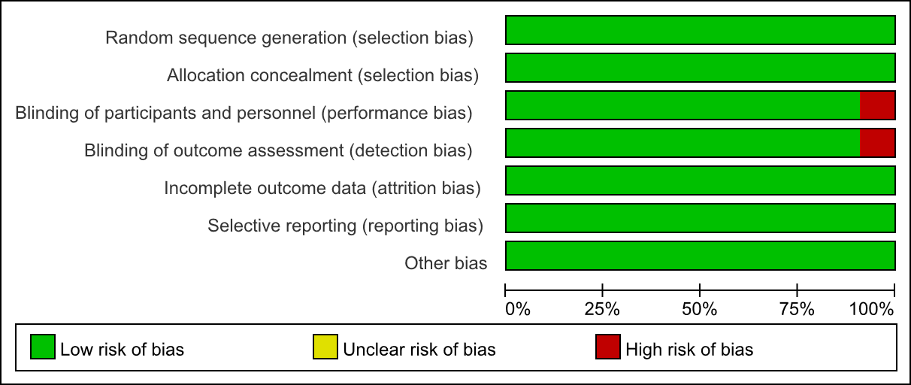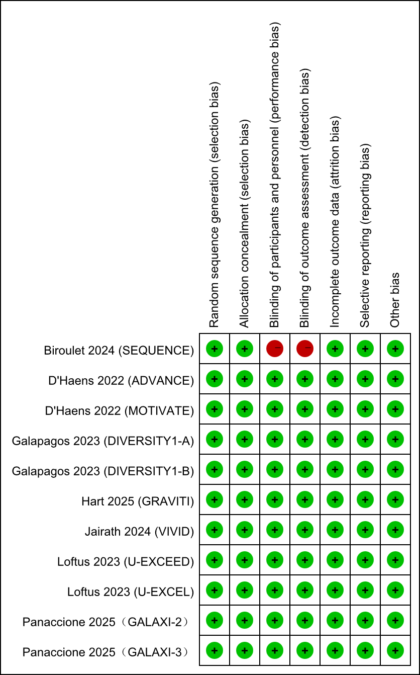

Supplementary Table 2: Confidence in estimates from network meta-analysis.
Comparison | Number of studies | Within-study bias | Reporting bias | Indirectness | Imprecision | Heterogeneity | Incoherence | Confidence rating
FIL 100mg vs FIL 200mg | 2 | No concerns | Low risk | No concerns | No concerns | Some concerns | No concerns | Moderate
FIL 100mg vs PBO | 2 | No concerns | Low risk | No concerns | Some concerns | No concerns | No concerns | Moderate
FIL 200mg vs PBO | 2 | No concerns | Low risk | No concerns | No concerns | No concerns | No concerns | High
GUS vs PBO | 2 | Some concerns | Low risk | No concerns | No concerns | No concerns | No concerns | Moderate
MIRI vs PBO | 1 | No concerns | Low risk | No concerns | No concerns | No concerns | No concerns | High
PBO vs RIS | 2 | No concerns | Low risk | No concerns | No concerns | No concerns | No concerns | High
PBO vs UPA | 2 | Major concerns | Low risk | No concerns | No concerns | No concerns | No concerns | Moderate
RIS vs UST | 1 | Major concerns | Low risk | No concerns | Some concerns | No concerns | No concerns | Moderate
FIL 100mg vs GUS | 0 | No concerns | Low risk | No concerns | No concerns | No concerns | No concerns | High
FIL 100mg vs MIRI | 0 | No concerns | Low risk | No concerns | Some concerns | No concerns | No concerns | Moderate
FIL 100mg vs RIS | 0 | No concerns | Low risk | No concerns | No concerns | No concerns | No concerns | High
FIL 100mg vs UPA | 0 | No concerns | Low risk | No concerns | No concerns | Some concerns | No concerns | Moderate
FIL 100mg vs UST | 0 | No concerns | Low risk | No concerns | No concerns | Some concerns | No concerns | Moderate
FIL 200mg vs GUS | 0 | No concerns | Low risk | No concerns | No concerns | Some concerns | No concerns | Moderate
FIL 200mg vs MIRI | 0 | No concerns | Low risk | No concerns | Some concerns | No concerns | No concerns | Moderate
FIL 200mg vs RIS | 0 | No concerns | Low risk | No concerns | No concerns | Some concerns | No concerns | Moderate
FIL 200mg vs UPA | 0 | No concerns | Low risk | No concerns | Some concerns | No concerns | No concerns | Moderate
FIL 200mg vs UST | 0 | No concerns | Low risk | No concerns | Some concerns | No concerns | No concerns | Moderate
GUS vs MIRI | 0 | No concerns | Low risk | No concerns | No concerns | Some concerns | No concerns | Moderate
GUS vs RIS | 0 | No concerns | Low risk | No concerns | Some concerns | No concerns | No concerns | Moderate
GUS vs UPA | 0 | Some concerns | Low risk | No concerns | Some concerns | No concerns | No concerns | Low
GUS vs UST | 0 | Some concerns | Low risk | No concerns | Some concerns | No concerns | No concerns | Low
MIRI vs RIS | 0 | No concerns | Low risk | No concerns | Some concerns | No concerns | No concerns | Moderate
MIRI vs UPA | 0 | No concerns | Low risk | No concerns | Some concerns | No concerns | No concerns | Moderate
MIRI vs UST | 0 | No concerns | Low risk | No concerns | Some concerns | No concerns | No concerns | Moderate
PBO vs UST | 0 | No concerns | Low risk | No concerns | No concerns | No concerns | No concerns | High
RIS vs UPA | 0 | No concerns | Low risk | No concerns | Some concerns | No concerns | No concerns | Moderate
UPA vs UST | 0 | Major concerns | Low risk | No concerns | Some concerns | No concerns | No concerns | Moderate
FIL: filgotinib. PBO: placebo. GUS: guselkumab. MIRI: mirikizumab. RIS: risankizumab. UPA: upadacitinib. UST: ustekinumab.

Supplementary Figure 2: Funnel plots of different outcomes in network meta-analysis.
IV: intravenous. SC: subcutaneous.

Supplemetary Figure 3 : Network map for induction trials assessing secondary outcomes.
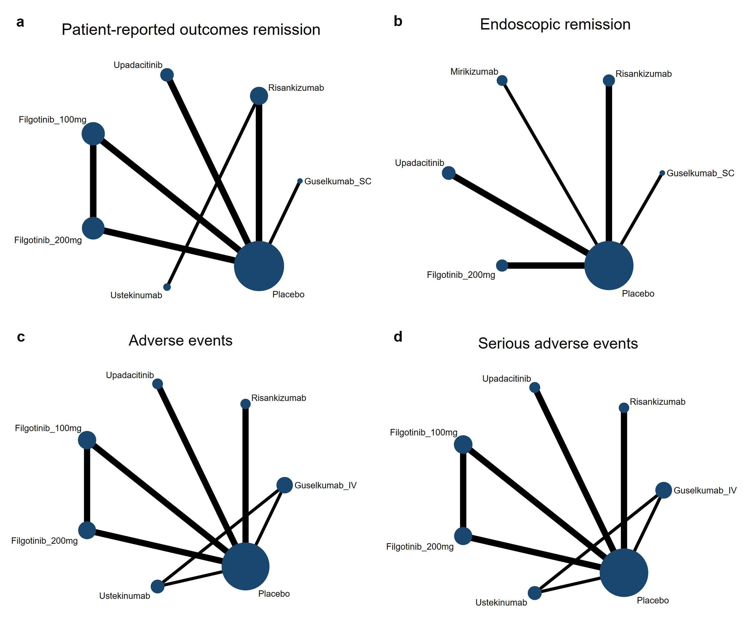
Node size (the size of the circle) corresponds to the number of study participants for each intervention, and connection size (line thickness) corresponds to the number of studies for each comparison. IV: intravenous. SC: subcutaneous.

Supplementary Figure 4: Pair-wise meta-analysis for induction of clinical remission.
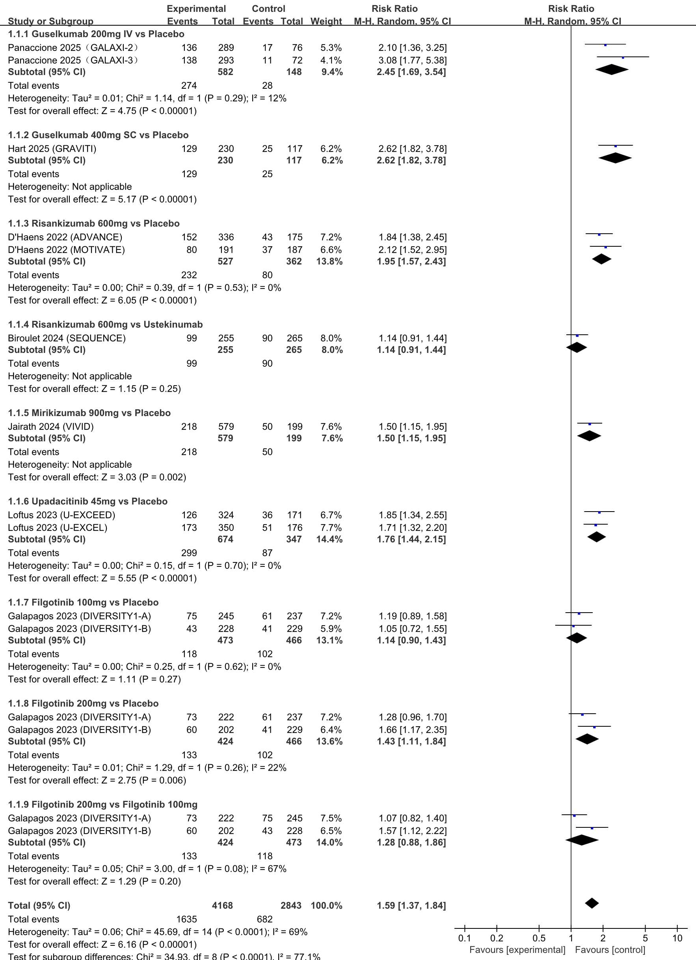

Supplementary Figure 5: Pair-wise meta-analysis for induction of endoscopic improvement.
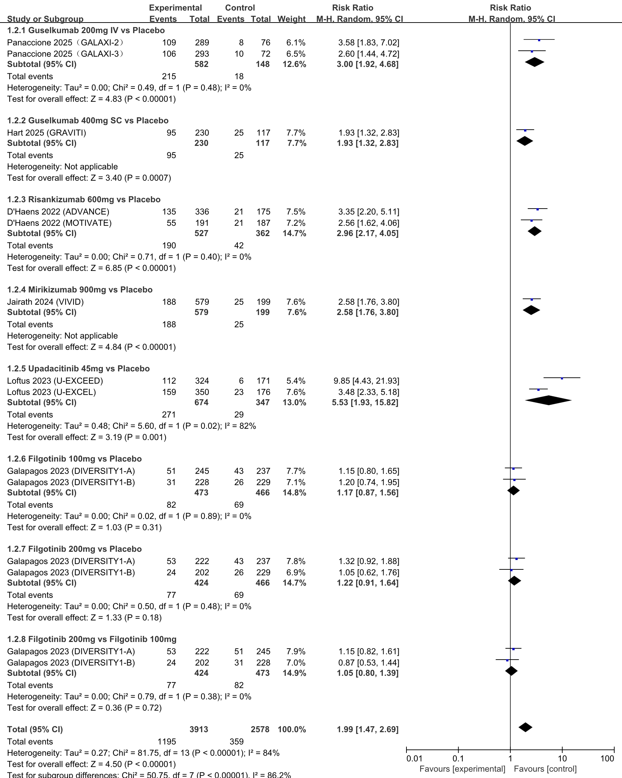

Supplementary Figure 6: Pair-wise meta-analysis for induction of endoscopic remission.
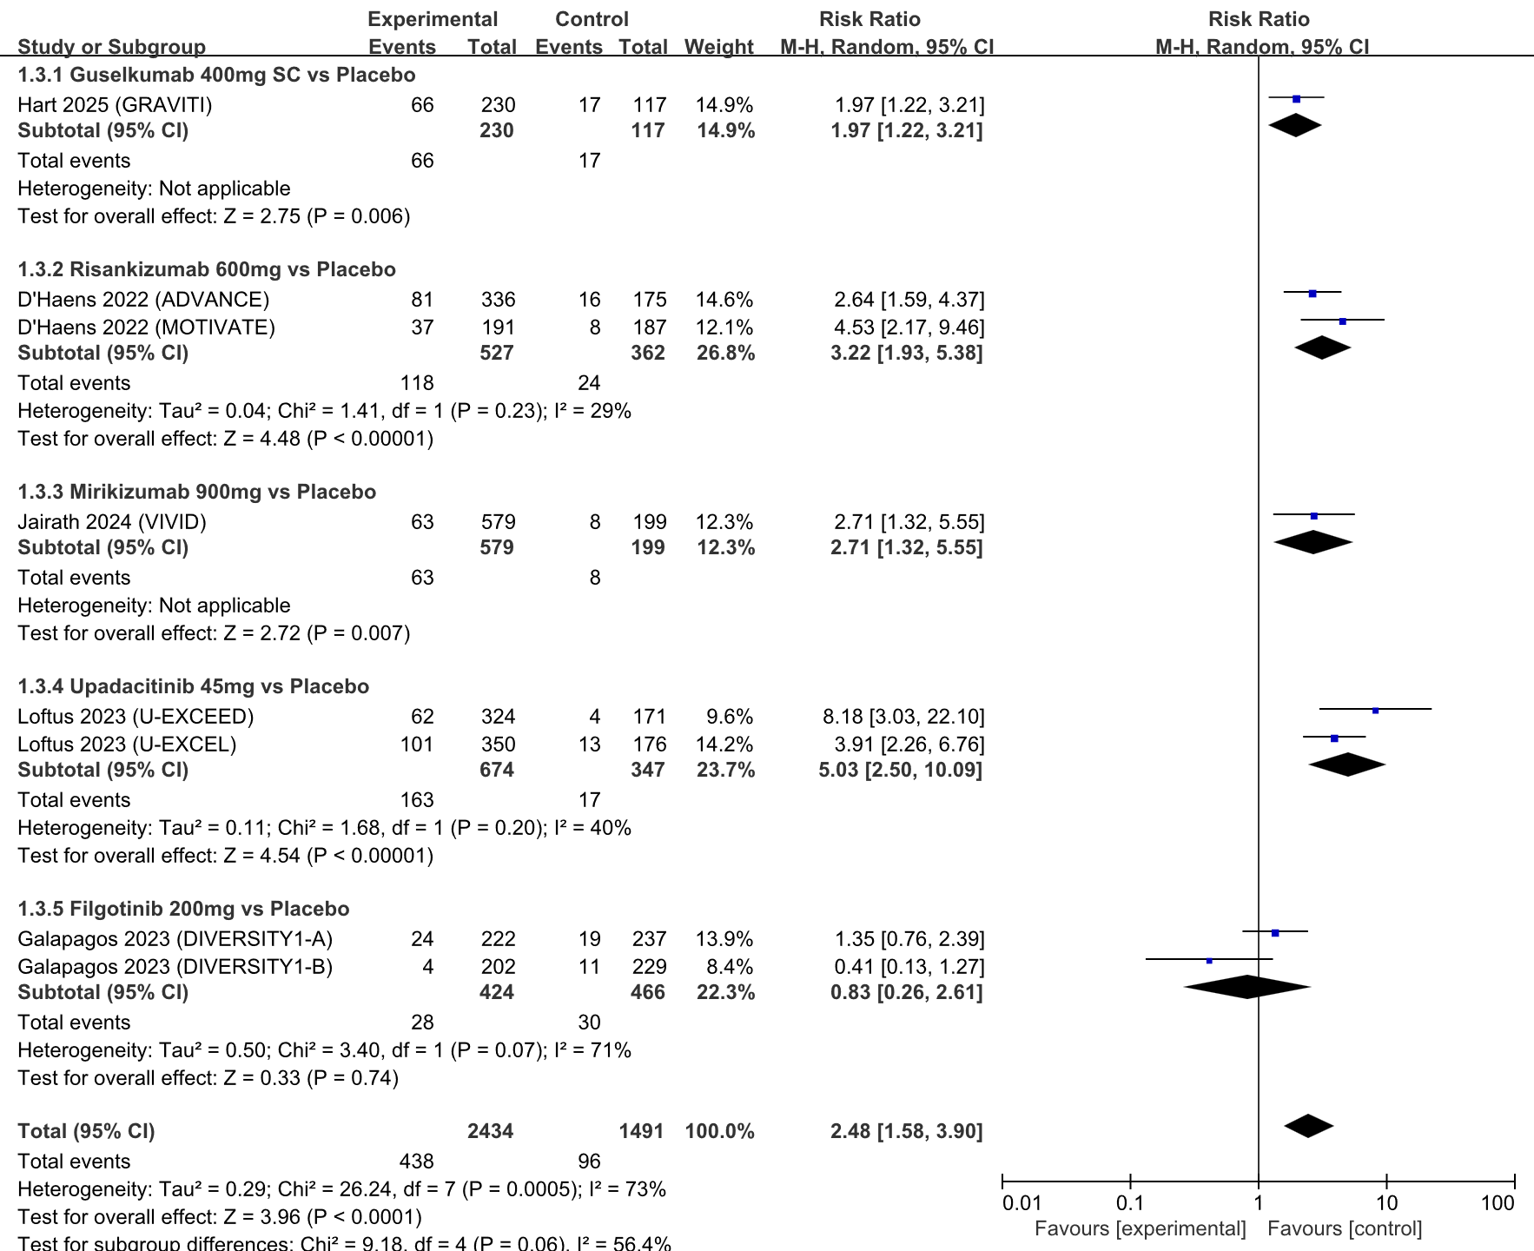

Supplementary Figure 7: Pair-wise meta-analysis for induction of patient-reported outcomes remission.
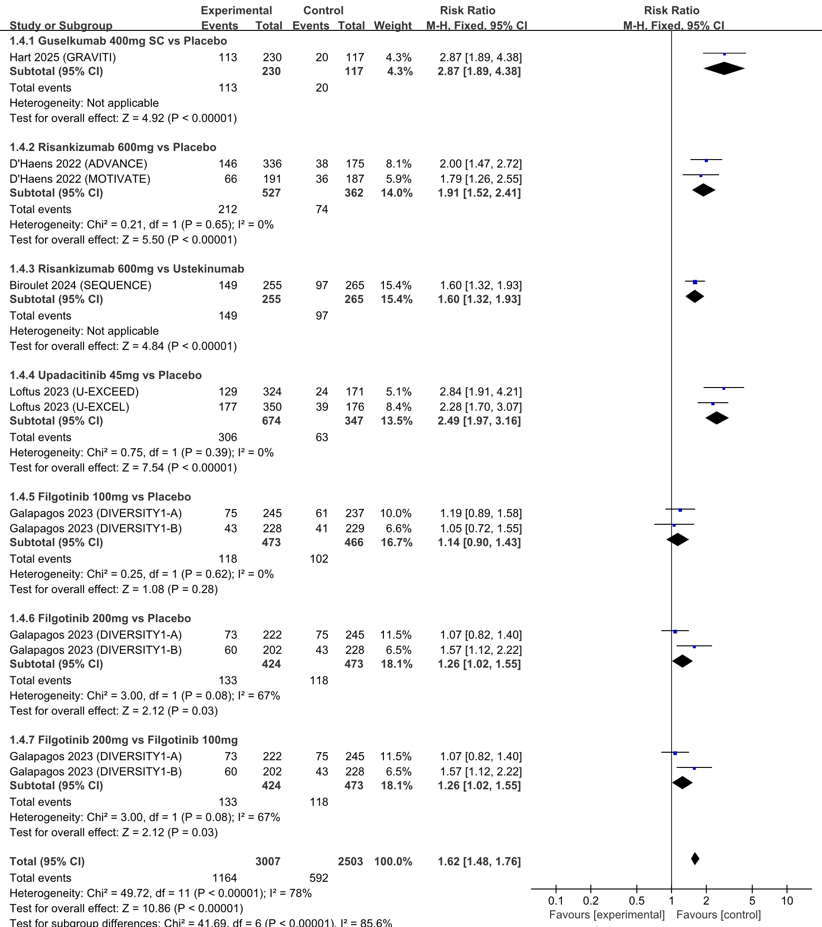

Supplementary Table 3: Indirect comparison of IL-23p19 inhibitors and small molecule drugs for the induction of clinical remission in network meta-analysis.
Guselkumab_IV | 1.08 (0.65,1.78) | 0.80 (0.53,1.21) | 0.62 (0.40,0.95) | 0.72 (0.49,1.08) | 0.47 (0.31,0.71) | 0.59 (0.39,0.88) | 0.70 (0.44,1.12) | 0.41 (0.29,0.58)
0.93 (0.56,1.53) | Guselkumab_SC | 0.74 (0.49,1.14) | 0.57 (0.36,0.90) | 0.67 (0.44,1.02) | 0.44 (0.28,0.67) | 0.54 (0.35,0.83) | 0.65 (0.40,1.05) | 0.38 (0.26,0.55)
1.25 (0.83,1.87) | 1.34 (0.88,2.06) | Risankizumab | 0.77 (0.55,1.08) | 0.90 (0.67,1.21) | 0.59 (0.43,0.81) | 0.73 (0.54,1.00) | 0.87 (0.70,1.10) | 0.51 (0.41,0.64)
1.62 (1.05,2.50) | 1.75 (1.12,2.75) | 1.30 (0.93,1.83) | Mirikizumab | 1.17 (0.84,1.63) | 0.77 (0.54,1.08) | 0.95 (0.68,1.34) | 1.14 (0.76,1.72) | 0.67 (0.51,0.87)
1.38 (0.93,2.06) | 1.49 (0.98,2.26) | 1.11 (0.83,1.49) | 0.85 (0.61,1.18) | Upadacitinib | 0.65 (0.48,0.88) | 0.81 (0.60,1.09) | 0.97 (0.67,1.41) | 0.57 (0.47,0.69)
2.12 (1.40,3.21) | 2.29 (1.49,3.53) | 1.70 (1.24,2.34) | 1.31 (0.92,1.85) | 1.53 (1.13,2.08) | Filgotinib_100mg | 1.24 (1.01,1.53) | 1.49 (1.01,2.20) | 0.87 (0.69,1.10)
1.70 (1.13,2.57) | 1.84 (1.20,2.82) | 1.37 (1.00,1.87) | 1.05 (0.75,1.48) | 1.23 (0.92,1.66) | 0.80 (0.65,0.99) | Filgotinib_200mg | 1.20 (0.82,1.76) | 0.70 (0.56,0.87)
1.42 (0.89,2.27) | 1.54 (0.95,2.49) | 1.14 (0.91,1.44) | 0.88 (0.58,1.32) | 1.03 (0.71,1.49) | 0.67 (0.45,0.99) | 0.84 (0.57,1.23) | Ustekinumab | 0.59 (0.43,0.80)
2.43 (1.73,3.43) | 2.62 (1.82,3.78) | 1.95 (1.57,2.43) | 1.50 (1.15,1.95) | 1.76 (1.44,2.15) | 1.15 (0.91,1.44) | 1.43 (1.14,1.78) | 1.71 (1.25,2.34) | Placebo
Values in each cell represent the relative treatment effect (risk ratio and 95% credible intervals) of the column-defining treatment compared to the row-defining treatment. The bold font represent statistically significant comparisons. IV: intravenous. SC: subcutaneous.

Supplementary Table 4: Indirect comparison of IL-23p19 inhibitors and small molecule drugs for the induction of endoscopic improvement in network meta-analysis.
Guselkumab_IV | 0.64 (0.34,1.21) | 0.99 (0.55,1.76) | 0.86 (0.46,1.62) | 1.46 (0.75,2.85) | 0.39 (0.22,0.69) | 0.41 (0.23,0.72) | 0.33 (0.21,0.53)
1.55 (0.83,2.92) | Guselkumab_SC | 1.53 (0.89,2.64) | 1.34 (0.73,2.45) | 2.27 (1.19,4.35) | 0.60 (0.35,1.03) | 0.63 (0.37,1.08) | 0.52 (0.34,0.79)
1.01 (0.57,1.81) | 0.65 (0.38,1.13) | Risankizumab | 0.87 (0.51,1.51) | 1.48 (0.81,2.72) | 0.39 (0.25,0.63) | 0.41 (0.26,0.66) | 0.34 (0.24,0.47)
1.16 (0.62,2.19) | 0.75 (0.41,1.37) | 1.14 (0.66,1.98) | Mirikizumab | 1.70 (0.88,3.26) | 0.45 (0.26,0.77) | 0.47 (0.27,0.81) | 0.39 (0.25,0.59)
0.68 (0.35,1.34) | 0.44 (0.23,0.84) | 0.67 (0.37,1.24) | 0.59 (0.31,1.13) | Upadacitinib | 0.27 (0.15,0.48) | 0.28 (0.15,0.52) | 0.23 (0.14,0.37)
2.57 (1.46,4.54) | 1.66 (0.97,2.83) | 2.54 (1.59,4.06) | 2.22 (1.29,3.79) | 3.76 (2.10,6.73) | Filgotinib_100mg | 1.05 (0.75,1.45) | 0.86 (0.62,1.19)
2.46 (1.38,4.38) | 1.59 (0.92,2.73) | 2.43 (1.51,3.90) | 2.12 (1.23,3.66) | 3.60 (1.91,6.77) | 0.96 (0.69,1.33) | Filgotinib_200mg | 0.82 (0.59,1.15)
3.00 (1.88,4.78) | 1.93 (1.26,2.96) | 2.96 (2.11,4.16) | 2.58 (1.68,3.97) | 4.39 (2.68,7.17) | 1.17 (0.84,1.61) | 1.22 (0.87,1.71) | Placebo
Values in each cell represent the relative treatment effect (risk ratio and 95% credible intervals) of the column-defining treatment compared to the row-defining treatment. The bold font represent statistically significant comparisons. IV: intravenous. SC: subcutaneous.

Supplementary Table 5: Indirect comparison of IL-23p19 inhibitors and small molecule drugs for the induction of patient-reported outcomes remission in network meta-analysis.
Guselkumab_SC | 0.66 (0.40,1.10) | 0.86 (0.52,1.43) | 0.40 (0.24,0.66) | 0.50 (0.30,0.82) | 0.42 (0.24,0.72) | 0.35 (0.22,0.54)
1.51 (0.91,2.49) | Risankizumab | 1.30 (0.91,1.85) | 0.60 (0.42,0.85) | 0.75 (0.53,1.06) | 0.63 (0.50,0.78) | 0.52 (0.41,0.67)
1.16 (0.70,1.92) | 0.77 (0.54,1.10) | Upadacitinib | 0.46 (0.32,0.66) | 0.58 (0.41,0.82) | 0.48 (0.32,0.73) | 0.40 (0.31,0.52)
2.51 (1.52,4.16) | 1.67 (1.18,2.37) | 2.17 (1.51,3.10) | Filgotinib_100mg | 1.25 (0.99,1.58) | 1.05 (0.69,1.58) | 0.87 (0.68,1.12)
2.01 (1.22,3.31) | 1.33 (0.95,1.88) | 1.73 (1.22,2.45) | 0.80 (0.63,1.01) | Filgotinib_200mg | 0.84 (0.55,1.26) | 0.70 (0.55,0.89)
2.40 (1.39,4.17) | 1.60 (1.28,2.00) | 2.07 (1.36,3.15) | 0.96 (0.63,1.45) | 1.20 (0.79,1.81) | Ustekinumab | 0.84 (0.60,1.17)
2.87 (1.86,4.45) | 1.91 (1.49,2.44) | 2.48 (1.92,3.19) | 1.14 (0.89,1.47) | 1.43 (1.13,1.82) | 1.20 (0.86,1.67) | Placebo
Values in each cell represent the relative treatment effect (risk ratio and 95% credible intervals) of the column-defining treatment compared to the row-defining treatment. The bold font represent statistically significant comparisons. IV: intravenous. SC: subcutaneous.

Supplementary Table 6: Indirect comparison of IL-23p19 inhibitors and small molecule drugs for the induction of endoscopic remission in network meta-analysis.

Guselkumab_SC | 1.69 (0.51,5.52) | 1.37 (0.33,5.74) | 2.60 (0.76,8.88) | 0.46 (0.13,1.63) | 0.51 (0.20,1.30)
0.59 (0.18,1.94) | Risankizumab | 0.81 (0.22,2.98) | 1.54 (0.53,4.45) | 0.27 (0.09,0.85) | 0.30 (0.15,0.62)
0.73 (0.17,3.06) | 1.23 (0.34,4.51) | Mirikizumab | 1.89 (0.50,7.23) | 0.33 (0.08,1.32) | 0.37 (0.13,1.09)
0.39 (0.11,1.32) | 0.65 (0.22,1.88) | 0.53 (0.14,2.02) | Upadacitinib | 0.18 (0.05,0.59) | 0.20 (0.09,0.43)
2.18 (0.61,7.78) | 3.68 (1.18,11.47) | 2.99 (0.76,11.86) | 5.67 (1.70,18.87) | Filgotinib_200mg | 1.11 (0.47,2.60)
1.97 (0.77,5.06) | 3.33 (1.62,6.85) | 2.71 (0.92,7.97) | 5.13 (2.32,11.32) | 0.90 (0.39,2.12) | Placebo
Values in each cell represent the relative treatment effect (risk ratio and 95% credible intervals) of the column-defining treatment compared to the row-defining treatment. The bold font represent statistically significant comparisons. IV: intravenous. SC: subcutaneous.

Supplementary Table 7: Indirect comparison of IL-23p19 inhibitors and small molecule drugs for the induction of clinical remission in patients without biologic failure.
Guselkumab_IV | 0.81 (0.41,1.60) | 0.82 (0.42,1.59) | 0.60 (0.32,1.11) | 0.53 (0.30,0.94) | 0.46 (0.26,0.82) | 0.49 (0.28,0.88) | 0.39 (0.23,0.64)
1.24 (0.63,2.45) | Guselkumab_SC | 1.01 (0.54,1.90) | 0.74 (0.41,1.32) | 0.65 (0.38,1.11) | 0.57 (0.33,0.97) | 0.61 (0.36,1.04) | 0.48 (0.30,0.75)
1.22 (0.63,2.39) | 0.99 (0.53,1.86) | Risankizumab | 0.73 (0.42,1.29) | 0.65 (0.38,1.09) | 0.56 (0.33,0.95) | 0.60 (0.36,1.02) | 0.47 (0.30,0.73)
1.67 (0.90,3.11) | 1.35 (0.76,2.42) | 1.37 (0.77,2.41) | Mirikizumab | 0.88 (0.56,1.39) | 0.77 (0.48,1.21) | 0.82 (0.52,1.30) | 0.64 (0.45,0.92)
1.90 (1.07,3.37) | 1.53 (0.90,2.61) | 1.55 (0.92,2.60) | 1.13 (0.72,1.79) | Upadacitinib | 0.87 (0.58,1.29) | 0.93 (0.63,1.39) | 0.73 (0.55,0.96)
2.18 (1.22,3.90) | 1.76 (1.03,3.03) | 1.78 (1.06,3.01) | 1.31 (0.82,2.07) | 1.15 (0.77,1.72) | Filgotinib_100mg | 1.07 (0.82,1.40) | 0.84 (0.63,1.12)
2.03 (1.14,3.63) | 1.64 (0.96,2.82) | 1.66 (0.98,2.80) | 1.22 (0.77,1.93) | 1.07 (0.72,1.60) | 0.93 (0.71,1.21) | Filgotinib_200mg | 0.78 (0.59,1.04)
2.60 (1.57,4.30) | 2.10 (1.33,3.31) | 2.12 (1.37,3.29) | 1.55 (1.08,2.23) | 1.37 (1.04,1.81) | 1.19 (0.89,1.58) | 1.28 (0.96,1.70) | Placebo
Values in each cell represent the relative treatment effect (risk ratio and 95% credible intervals) of the column-defining treatment compared to the row-defining treatment. The bold font represent statistically significant comparisons. IV: intravenous. SC: subcutaneous.

Supplementary Table 8: Indirect comparison of IL-23p19 inhibitors and small molecule drugs for the induction of clinical remission in patients with biologic failure.
Guselkumab_IV | 1.48 (0.68,3.21) | 0.79 (0.47,1.35) | 0.60 (0.33,1.10) | 0.87 (0.51,1.51) | 0.44 (0.24,0.81) | 0.69 (0.39,1.25) | 0.69 (0.39,1.24) | 0.42 (0.26,0.67)
0.67 (0.31,1.46) | Guselkumab_SC | 0.54 (0.28,1.04) | 0.41 (0.20,0.84) | 0.59 (0.30,1.16) | 0.30 (0.14,0.61) | 0.47 (0.23,0.95) | 0.47 (0.23,0.94) | 0.28 (0.15,0.52)
1.26 (0.74,2.15) | 1.87 (0.96,3.63) | Risankizumab | 0.76 (0.48,1.20) | 1.10 (0.76,1.60) | 0.56 (0.35,0.88) | 0.87 (0.57,1.34) | 0.87 (0.70,1.10) | 0.53 (0.41,0.68)
1.66 (0.91,3.05) | 2.46 (1.20,5.08) | 1.32 (0.84,2.08) | Mirikizumab | 1.45 (0.91,2.32) | 0.73 (0.43,1.26) | 1.15 (0.69,1.93) | 1.15 (0.69,1.92) | 0.70 (0.47,1.02)
1.15 (0.66,1.98) | 1.70 (0.87,3.33) | 0.91 (0.63,1.32) | 0.69 (0.43,1.10) | Upadacitinib | 0.50 (0.31,0.81) | 0.79 (0.51,1.24) | 0.79 (0.51,1.23) | 0.48 (0.36,0.63)
2.27 (1.23,4.18) | 3.36 (1.63,6.96) | 1.80 (1.14,2.85) | 1.37 (0.79,2.35) | 1.98 (1.23,3.19) | Filgotinib_100mg | 1.57 (1.12,2.22) | 1.58 (0.94,2.63) | 0.95 (0.64,1.40)
1.44 (0.80,2.59) | 2.14 (1.05,4.33) | 1.14 (0.74,1.76) | 0.87 (0.52,1.45) | 1.26 (0.81,1.96) | 0.63 (0.45,0.89) | Filgotinib_200mg | 1.00 (0.62,1.63) | 0.60 (0.43,0.85)
1.44 (0.81,2.57) | 2.14 (1.06,4.31) | 1.14 (0.91,1.44) | 0.87 (0.52,1.44) | 1.26 (0.81,1.95) | 0.63 (0.38,1.06) | 1.00 (0.62,1.62) | Ustekinumab | 0.60 (0.43,0.84)
2.39 (1.49,3.83) | 3.54 (1.92,6.55) | 1.90 (1.48,2.43) | 1.44 (0.98,2.11) | 2.09 (1.58,2.75) | 1.05 (0.72,1.55) | 1.66 (1.17,2.35) | 1.66 (1.18,2.33) | Placebo
Values in each cell represent the relative treatment effect (risk ratio and 95% credible intervals) of the column-defining treatment compared to the row-defining treatment. The bold font represent statistically significant comparisons. IV: intravenous. SC: subcutaneous.

Supplementary Table 9: Indirect comparison of IL-23p19 inhibitors and small molecule drugs for the induction of endoscopic improvement in patients without biologic failure.
Guselkumab_IV | 0.79 (0.40,1.57) | 1.61 (0.73,3.53) | 0.93 (0.47,1.84) | 1.31 (0.66,2.62) | 0.47 (0.25,0.88) | 0.54 (0.29,1.00) | 0.41 (0.25,0.68)
1.26 (0.64,2.51) | Guselkumab_SC | 2.03 (0.95,4.34) | 1.18 (0.61,2.25) | 1.66 (0.86,3.20) | 0.59 (0.33,1.07) | 0.68 (0.38,1.22) | 0.52 (0.33,0.82)
0.62 (0.28,1.37) | 0.49 (0.23,1.05) | Risankizumab | 0.58 (0.27,1.23) | 0.82 (0.38,1.75) | 0.29 (0.14,0.59) | 0.34 (0.17,0.67) | 0.25 (0.14,0.46)
1.07 (0.54,2.13) | 0.85 (0.44,1.63) | 1.73 (0.81,3.68) | Mirikizumab | 1.41 (0.73,2.72) | 0.50 (0.28,0.91) | 0.58 (0.32,1.03) | 0.44 (0.28,0.69)
0.76 (0.38,1.52) | 0.60 (0.31,1.17) | 1.22 (0.57,2.63) | 0.71 (0.37,1.37) | Upadacitinib | 0.36 (0.20,0.65) | 0.41 (0.23,0.74) | 0.31 (0.19,0.50)
2.13 (1.14,3.98) | 1.69 (0.94,3.04) | 3.42 (1.69,6.92) | 1.98 (1.10,3.56) | 2.80 (1.54,5.07) | Filgotinib_100mg | 1.15 (0.82,1.61) | 0.87 (0.61,1.25)
1.86 (1.00,3.46) | 1.47 (0.82,2.64) | 2.98 (1.48,6.01) | 1.73 (0.97,3.09) | 2.44 (1.35,4.40) | 0.87 (0.62,1.22) | Filgotinib_200mg | 0.76 (0.53,1.09)
2.44 (1.47,4.06) | 1.93 (1.22,3.07) | 3.93 (2.15,7.17) | 2.28 (1.44,3.60) | 3.21 (2.01,5.13) | 1.15 (0.80,1.65) | 1.32 (0.92,1.88) | Placebo
Values in each cell represent the relative treatment effect (risk ratio and 95% credible intervals) of the column-defining treatment compared to the row-defining treatment. The bold font represent statistically significant comparisons. IV: intravenous. SC: subcutaneous.

Supplementary Table 10: Indirect comparison of IL-23p19 inhibitors and small molecule drugs for the induction of endoscopic improvement in patients with biologic failure.
Guselkumab_IV | 0.43 (0.15,1.28) | 0.59 (0.23,1.52) | 0.72 (0.24,2.17) | 1.50 (0.54,4.18) | 0.26 (0.10,0.72) | 0.23 (0.08,0.64) | 0.22 (0.09,0.53)
2.30 (0.78,6.82) | Guselkumab_SC | 1.37 (0.65,2.89) | 1.65 (0.64,4.27) | 3.47 (1.48,8.10) | 0.61 (0.27,1.38) | 0.53 (0.23,1.23) | 0.51 (0.27,0.98)
1.69 (0.66,4.31) | 0.73 (0.35,1.54) | Risankizumab | 1.21 (0.55,2.63) | 2.54 (1.32,4.87) | 0.45 (0.24,0.82) | 0.39 (0.21,0.74) | 0.37 (0.26,0.54)
1.40 (0.46,4.23) | 0.61 (0.23,1.57) | 0.83 (0.38,1.81) | Mirikizumab | 2.10 (0.87,5.06) | 0.37 (0.16,0.86) | 0.32 (0.14,0.77) | 0.31 (0.15,0.62)
0.66 (0.24,1.85) | 0.29 (0.12,0.67) | 0.39 (0.21,0.76) | 0.48 (0.20,1.15) | Upadacitinib | 0.18 (0.08,0.37) | 0.15 (0.07,0.33) | 0.15 (0.09,0.25)
3.78 (1.40,10.21) | 1.64 (0.73,3.70) | 2.24 (1.22,4.12) | 2.70 (1.16,6.30) | 5.68 (2.74,11.79) | Filgotinib_100mg | 0.87 (0.53,1.44) | 0.84 (0.51,1.36)
4.32 (1.57,11.88) | 1.88 (0.81,4.32) | 2.56 (1.36,4.84) | 3.09 (1.30,7.35) | 6.50 (3.06,13.80) | 1.14 (0.70,1.88) | Filgotinib_200mg | 0.96 (0.57,1.61)
4.52 (1.90,10.76) | 1.96 (1.02,3.77) | 2.68 (1.87,3.86) | 3.24 (1.62,6.46) | 6.80 (3.96,11.71) | 1.20 (0.74,1.95) | 1.05 (0.62,1.76) | Placebo
Values in each cell represent the relative treatment effect (risk ratio and 95% credible intervals) of the column-defining treatment compared to the row-defining treatment. The bold font represent statistically significant comparisons. IV: intravenous. SC: subcutaneous.

Supplementary Table 11: Indirect comparison of IL-23p19 inhibitors and small molecule drugs for the induction of patient-reported outcomes remission in patients without biologic failure.
Guselkumab_SC | 0.85 (0.41,1.78) | 0.70 (0.36,1.36) | 0.44 (0.23,0.83) | 0.47 (0.25,0.89) | 0.37 (0.21,0.65)
1.17 (0.56,2.46) | Risankizumab | 0.82 (0.46,1.47) | 0.51 (0.30,0.89) | 0.55 (0.32,0.96) | 0.43 (0.27,0.69)
1.42 (0.73,2.77) | 1.21 (0.68,2.17) | Upadacitinib | 0.62 (0.40,0.97) | 0.67 (0.43,1.04) | 0.52 (0.37,0.74)
2.29 (1.21,4.33) | 1.95 (1.12,3.38) | 1.60 (1.03,2.50) | Filgotinib_100mg | 1.07 (0.82,1.40) | 0.84 (0.63,1.12)
2.13 (1.12,4.03) | 1.81 (1.05,3.14) | 1.49 (0.96,2.33) | 0.93 (0.71,1.21) | Filgotinib_200mg | 0.78 (0.59,1.04)
2.72 (1.54,4.81) | 2.32 (1.45,3.71) | 1.91 (1.36,2.68) | 1.19 (0.89,1.58) | 1.28 (0.96,1.70) | Placebo
Values in each cell represent the relative treatment effect (risk ratio and 95% credible intervals) of the column-defining treatment compared to the row-defining treatment. The bold font represent statistically significant comparisons. IV: intravenous. SC: subcutaneous.

Supplementary Table 12: Indirect comparison of IL-23p19 inhibitors and small molecule drugs for the induction of patient-reported outcomes remission in patients with biologic failure.
Guselkumab_SC | 0.59 (0.30,1.15) | 0.98 (0.49,1.98) | 0.34 (0.17,0.72) | 0.54 (0.27,1.11) | 0.37 (0.18,0.74) | 0.33 (0.18,0.61)
1.70 (0.87,3.35) | Risankizumab | 1.67 (1.10,2.54) | 0.59 (0.37,0.94) | 0.93 (0.60,1.44) | 0.63 (0.52,0.76) | 0.56 (0.43,0.73)
1.02 (0.51,2.06) | 0.60 (0.39,0.91) | Upadacitinib | 0.35 (0.21,0.58) | 0.55 (0.34,0.89) | 0.37 (0.24,0.59) | 0.33 (0.24,0.46)
2.90 (1.39,6.03) | 1.70 (1.06,2.72) | 2.84 (1.72,4.71) | Filgotinib_100mg | 1.57 (1.12,2.22) | 1.07 (0.64,1.77) | 0.95 (0.64,1.40)
1.84 (0.90,3.76) | 1.08 (0.70,1.67) | 1.81 (1.12,2.91) | 0.63 (0.45,0.89) | Filgotinib_200mg | 0.68 (0.42,1.09) | 0.60 (0.43,0.85)
2.72 (1.35,5.49) | 1.60 (1.32,1.93) | 2.67 (1.69,4.23) | 0.94 (0.57,1.56) | 1.48 (0.92,2.38) | Ustekinumab | 0.89 (0.64,1.24)
3.05 (1.64,5.69) | 1.79 (1.37,2.34) | 2.99 (2.17,4.14) | 1.05 (0.72,1.55) | 1.66 (1.17,2.35) | 1.12 (0.81,1.56) | Placebo
Values in each cell represent the relative treatment effect (risk ratio and 95% credible intervals) of the column-defining treatment compared to the row-defining treatment. The bold font represent statistically significant comparisons. IV: intravenous. SC: subcutaneous.

Supplementary Table 13: Indirect comparison of IL-23p19 inhibitors and small molecule drugs for the induction of endoscopic remission in patients without biologic failure.
Risankizumab | 1.08 (0.39,3.00) | 1.57 (0.67,3.72) | 0.60 (0.26,1.36) | 0.44 (0.24,0.80)
0.92 (0.33,2.55) | Mirikizumab | 1.45 (0.52,4.07) | 0.55 (0.20,1.50) | 0.41 (0.18,0.93)
0.64 (0.27,1.50) | 0.69 (0.25,1.93) | Upadacitinib | 0.38 (0.16,0.88) | 0.28 (0.15,0.52)
1.68 (0.73,3.84) | 1.82 (0.67,4.96) | 2.64 (1.14,6.14) | Filgotinib_200mg | 0.74 (0.42,1.32)
2.26 (1.24,4.12) | 2.45 (1.08,5.59) | 3.56 (1.92,6.61) | 1.35 (0.76,2.39) | Placebo
Values in each cell represent the relative treatment effect (risk ratio and 95% credible intervals) of the column-defining treatment compared to the row-defining treatment. The bold font represent statistically significant comparisons. IV: intravenous. SC: subcutaneous.

Supplementary Table 14: Indirect comparison of IL-23p19 inhibitors and small molecule drugs for the induction of endoscopic remission in patients with biologic failure.
Risankizumab | 0.90 (0.19,4.21) | 1.81 (0.70,4.65) | 0.11 (0.03,0.38) | 0.26 (0.15,0.46)
1.11 (0.24,5.22) | Mirikizumab | 2.01 (0.40,10.16) | 0.12 (0.02,0.74) | 0.29 (0.07,1.22)
0.55 (0.21,1.43) | 0.50 (0.10,2.51) | Upadacitinib | 0.06 (0.02,0.23) | 0.14 (0.07,0.31)
9.32 (2.63,33.07) | 8.37 (1.35,51.98) | 16.83 (4.34,65.35) | Filgotinib_200mg | 2.43 (0.78,7.50)
3.84 (2.16,6.82) | 3.45 (0.82,14.50) | 6.94 (3.27,14.72) | 0.41 (0.13,1.27) | Placebo
Values in each cell represent the relative treatment effect (risk ratio and 95% credible intervals) of the column-defining treatment compared to the row-defining treatment. The bold font represent statistically significant comparisons. IV: intravenous. SC: subcutaneous.

Supplementary Table 15: Indirect comparison of IL-23p19 inhibitors and small molecule drugs for the induction of adverse events in network meta-analysis.
Guselkumab_IV | 0.87 (0.57,1.33) | 1.25 (0.83,1.89) | 1.00 (0.66,1.52) | 0.98 (0.65,1.49) | 0.98 (0.71,1.37) | 1.03 (0.73,1.45)
1.14 (0.75,1.74) | Risankizumab | 1.43 (1.03,1.99) | 1.15 (0.82,1.60) | 1.13 (0.81,1.57) | 1.13 (0.73,1.73) | 1.18 (0.93,1.49)
0.80 (0.53,1.21) | 0.70 (0.50,0.97) | Upadacitinib | 0.80 (0.58,1.11) | 0.79 (0.57,1.09) | 0.79 (0.52,1.20) | 0.82 (0.66,1.03)
1.00 (0.66,1.51) | 0.87 (0.63,1.21) | 1.25 (0.90,1.72) | Filgotinib_100mg | 0.98 (0.78,1.24) | 0.98 (0.64,1.50) | 1.02 (0.81,1.29)
1.02 (0.67,1.54) | 0.89 (0.64,1.24) | 1.27 (0.92,1.76) | 1.02 (0.81,1.29) | Filgotinib_200mg | 1.00 (0.65,1.53) | 1.04 (0.83,1.32)
1.02 (0.73,1.41) | 0.89 (0.58,1.36) | 1.27 (0.83,1.94) | 1.02 (0.67,1.56) | 1.00 (0.65,1.53) | Ustekinumab | 1.04 (0.73,1.49)
0.97 (0.69,1.38) | 0.85 (0.67,1.08) | 1.22 (0.97,1.53) | 0.98 (0.78,1.23) | 0.96 (0.76,1.21) | 0.96 (0.67,1.37) | Placebo
Values in each cell represent the relative treatment effect (risk ratio and 95% credible intervals) of the column-defining treatment compared to the row-defining treatment. The bold font represent statistically significant comparisons. IV: intravenous. SC: subcutaneous.

Supplementary Table 16: Indirect comparison of IL-23p19 inhibitors and small molecule drugs for the induction of serious adverse events in network meta-analysis.
Guselkumab_IV | 0.92 (0.38,2.23) | 1.98 (0.81,4.86) | 2.63 (1.09,6.33) | 2.10 (0.86,5.14) | 1.98 (1.03,3.83) | 2.06 (0.94,4.53)
1.09 (0.45,2.64) | Risankizumab | 2.15 (1.19,3.89) | 2.86 (1.63,5.01) | 2.28 (1.27,4.11) | 2.16 (0.89,5.21) | 2.24 (1.49,3.36)
0.51 (0.21,1.24) | 0.46 (0.26,0.84) | Upadacitinib | 1.33 (0.74,2.37) | 1.06 (0.58,1.94) | 1.00 (0.41,2.45) | 1.04 (0.68,1.60)
0.38 (0.16,0.91) | 0.35 (0.20,0.61) | 0.75 (0.42,1.34) | Filgotinib_100mg | 0.80 (0.53,1.19) | 0.75 (0.31,1.81) | 0.78 (0.53,1.15)
0.48 (0.19,1.17) | 0.44 (0.24,0.79) | 0.94 (0.51,1.73) | 1.25 (0.84,1.88) | Filgotinib_200mg | 0.94 (0.39,2.31) | 0.98 (0.64,1.50)
0.50 (0.26,0.97) | 0.46 (0.19,1.12) | 1.00 (0.41,2.44) | 1.33 (0.55,3.18) | 1.06 (0.43,2.58) | Ustekinumab | 1.04 (0.47,2.27)
0.49 (0.22,1.07) | 0.45 (0.30,0.67) | 0.96 (0.62,1.48) | 1.28 (0.87,1.88) | 1.02 (0.67,1.56) | 0.96 (0.44,2.11) | Placebo
Values in each cell represent the relative treatment effect (risk ratio and 95% credible intervals) of the column-defining treatment compared to the row-defining treatment. The bold font represent statistically significant comparisons. IV: intravenous. SC: subcutaneous.

