Manuscript title
Short-Lived Success: Repeated Peroxide-Peracetic Acid-Based Foam Disinfection Selects for Carbapenem-Resistant Enterobacterales in Hospital Sinks Drains

Shireen M Kotay¹, Aubrey E Hetzler¹, Sharvari Narendra¹, Kevin K Chau^{2,3}, Salvador Castañeda-Barba¹, Nicole Stoesser^{2,3,4}, Amy J Mathers^{1,5#}

Supplemental materials
Table S1. Comparison of sink-drain CPE abundance at baseline and post-treatment endpoint (D35) across PPAA-foam treatment regimens
Treatment group | Baseline (D-3) mean ± SD (log₁₀ CFUml⁻¹) | Baseline median (IQR) | D35 mean ± SD (log₁₀ CFU ml⁻¹) | D35 median (IQR) | Adjusted p value† (Interpretation)
T3 (3-day interval) | 7.55 ± 0.91 | 7.37 (0.44) | 7.39 ± 0.27 | 7.51 (0.54) | 1.00  (Not significant)
T5 (5-day interval) | 7.37 ± 1.09 | 7.33 (0.40) | 6.70 ± 2.02 | 7.57 (2.12) | 1.00  (Not significant)
T7 (7-day interval) | 7.23 ± 1.53 | 7.23 (0.59) | 7.08 ± 1.90 | 7.52 (0.44) | 1.00  (Not significant)
Control (No treatment) | 7.06 ± 0.21 | 7.42 (1.08) | 7.98 ± 0.56 | 8.03 (0.87) | 0.004 (Significant)
† Wilcoxon signed-rank test comparing baseline (D–3) and D35 within each treatment group, with Bonferroni correction for multiple testing.

Table S2. Carbapenemase-producing Enterobacterales strains used to inoculate experimental sinks. List of isolates spiked into experimental sinks, including species, carbapenemase genotype, source, and date of isolation.
Isolate | Species | AMR gene harbored | Source | Isolation date
CAV1492 | Serratia marcescens | bla_{KPC-2} | Patient | Dec-2011
CAV7026 | Citrobacter freundii | bla_{KPC-2} | Hospital Sink Drain | Oct-2017
CAV7297 | Enterobacter asburiae | bla_{KPC-2} | Hospital Sink Drain | Dec-2017
CAV7640 | Enterobacter adelaidei | bla_{NDM-1} | Hospital Sink Drain | Apr-2018
CAV7887 | Escherichia coli | bla_{NDM-1} | Hospital Sink Drain | Nov-2018
CAV7023 | Klebsiella michiganensis | bla_{KPC-2} | Hospital Sink Drain | Oct-2017
CAV9733 | Klebsiella pnuemoniae | bla_{KPC-3} | Wastewater | May-2023
CAV7420 | Phytobacter diazotrophicus | bla_{KPC-3} | Hospital Sink Drain | Jan-2018
CAV7307 | Phytobacter ursingii | bla_{KPC-3} | Hospital Sink Drain | Dec-2017

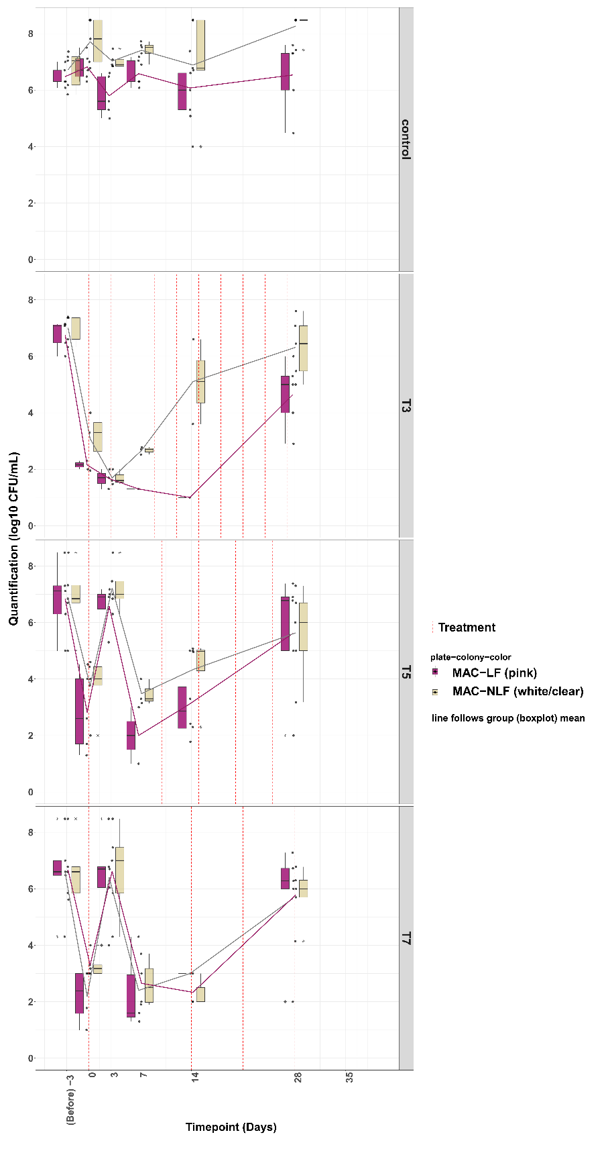
Supplemental Figure S1. Quantitative culture of Gram-negative bacilli from experimental (SinkLab) sink-drains. MacConkey agar cultures showing longitudinal counts of lactose-fermenting (LF) and non-lactose-fermenting (NLF) Gram-negative bacilli across treatment groups.

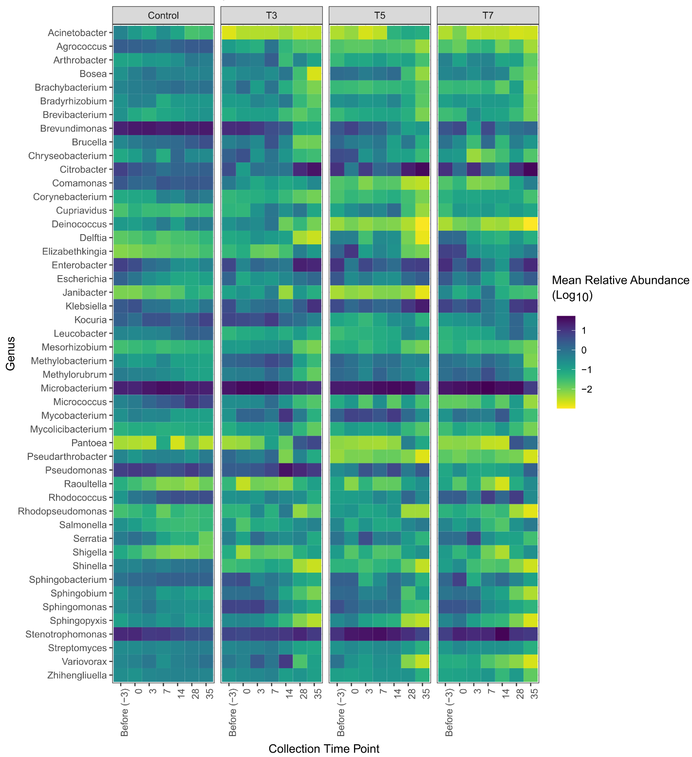
Supplemental Figure S2. Temporal dynamics of the top 20 bacterial genera in experimental sink-drains. Heatmap showing log transformed mean relative abundance across the sampling timepoints, stratified by treatment interval (Control, T3, T5 & T7).

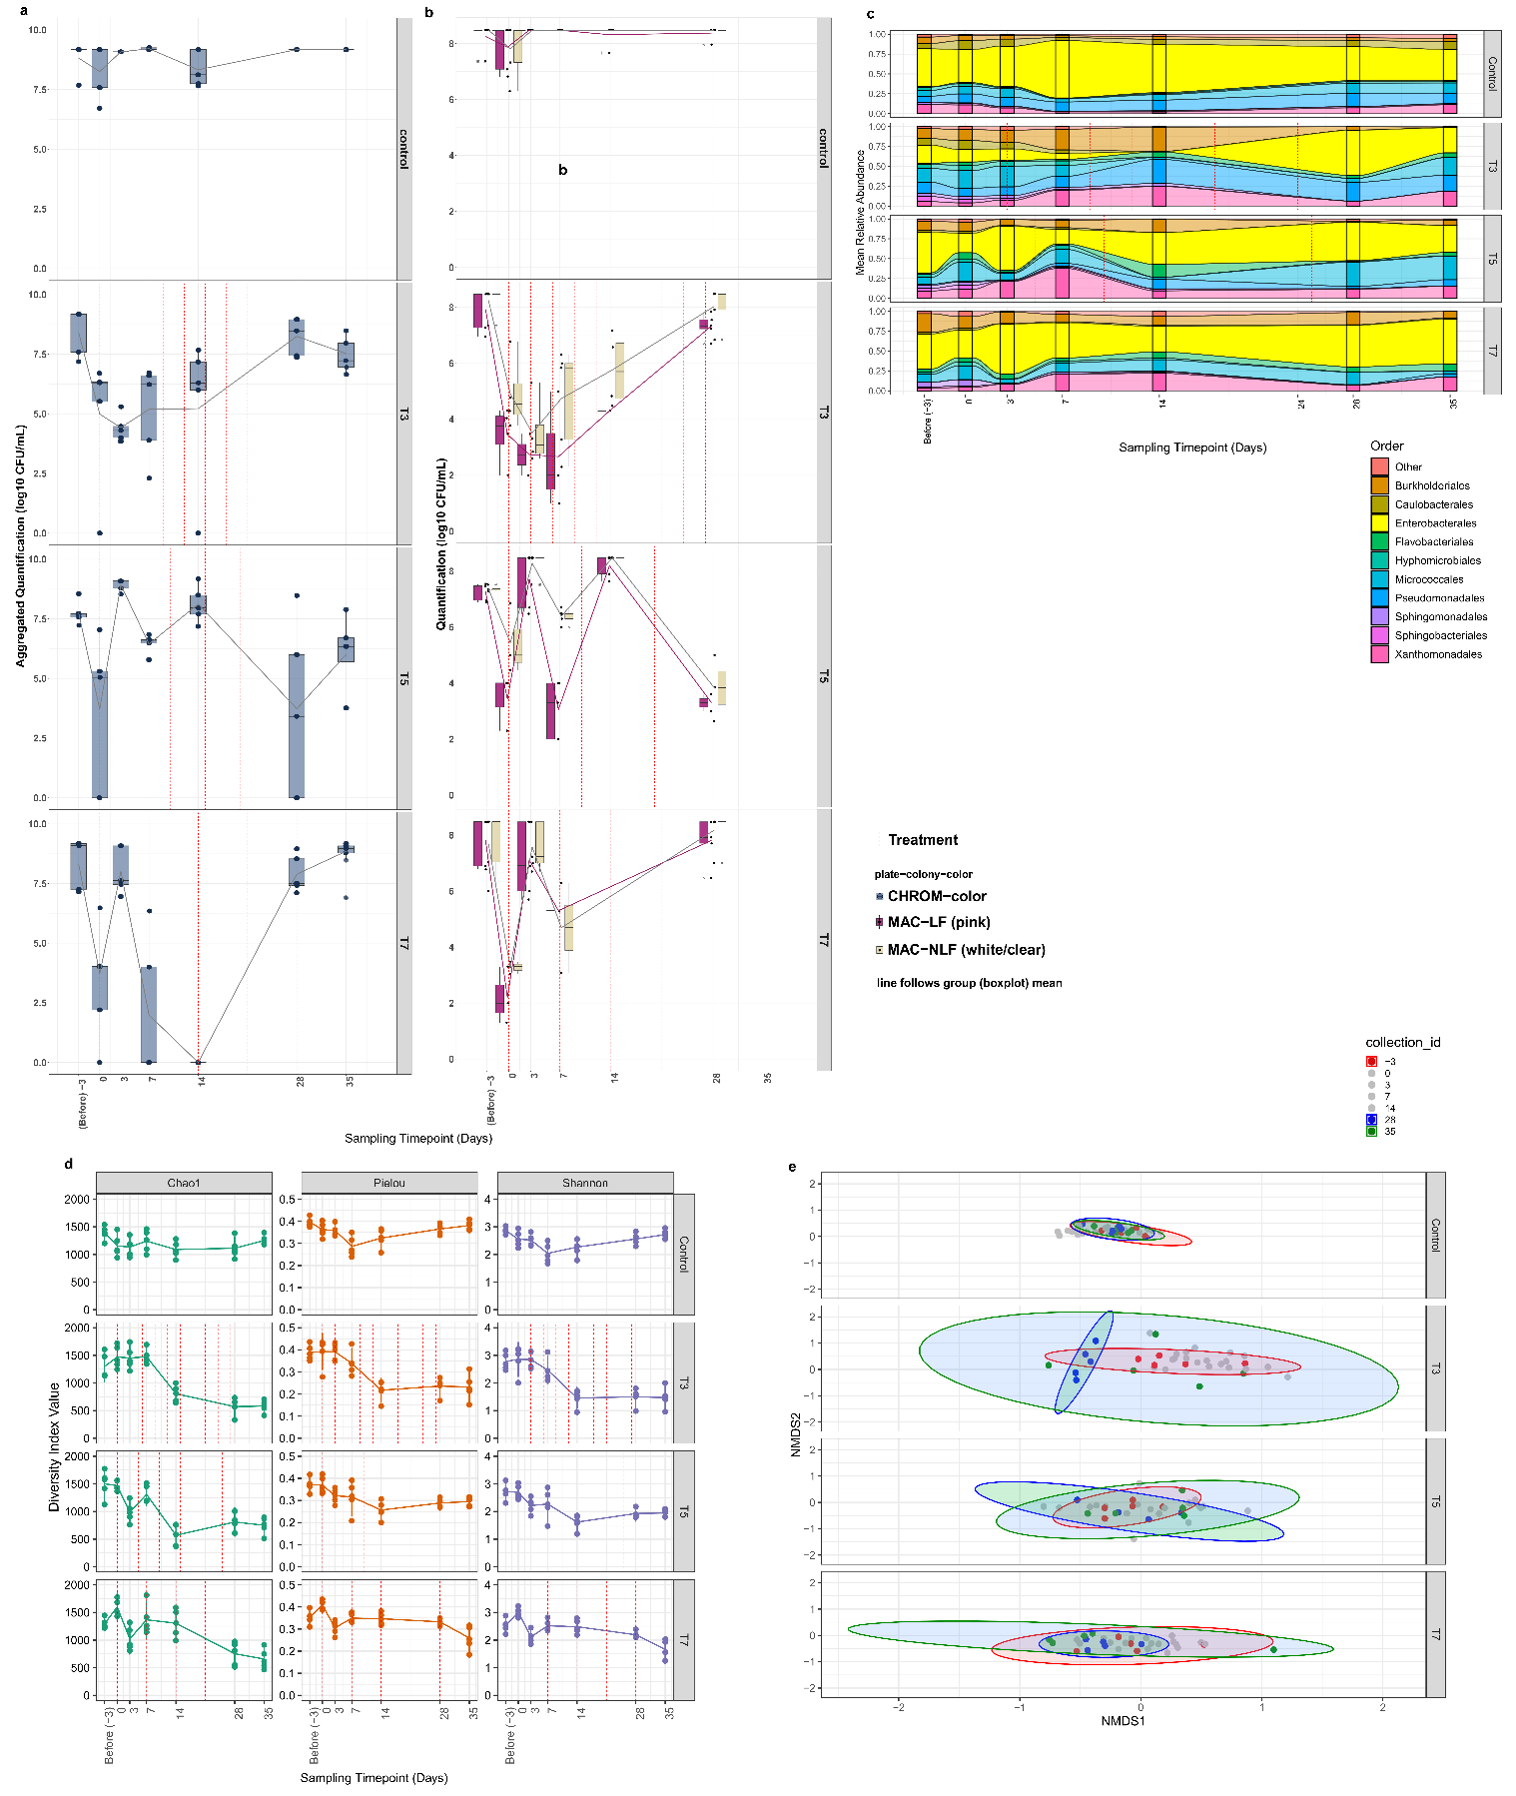
Supplemental Figure S3. Effect of PPAA-foam treatment on bacterial populations in experimental (SinkLab) sink-traps. Quantitative culture results for experimental (Sinklab) sink-traps for a) carbapenem-producing Enterobacterales (CPE) and b) Gram-negative bacilli. Cultures were performed on selective chromogenic agar and MacConkey agar respectively and for the latter, counts estimated for both lactose-fermenters (LF) and non-lactose-fermenters (NLF). c) Order-level relative abundance profiles of major bacterial orders in sink-traps over time and across treatment groups; d) Alpha-diversity indices for sink-trap microbiomes over time and across treatment groups and, E) Non-metric multidimensional scaling (NMDS) ordination based on Bray–Curtis dissimilarities at the genus-level comparing baseline (D-3) to post-treatment timepoints (D28, D35).

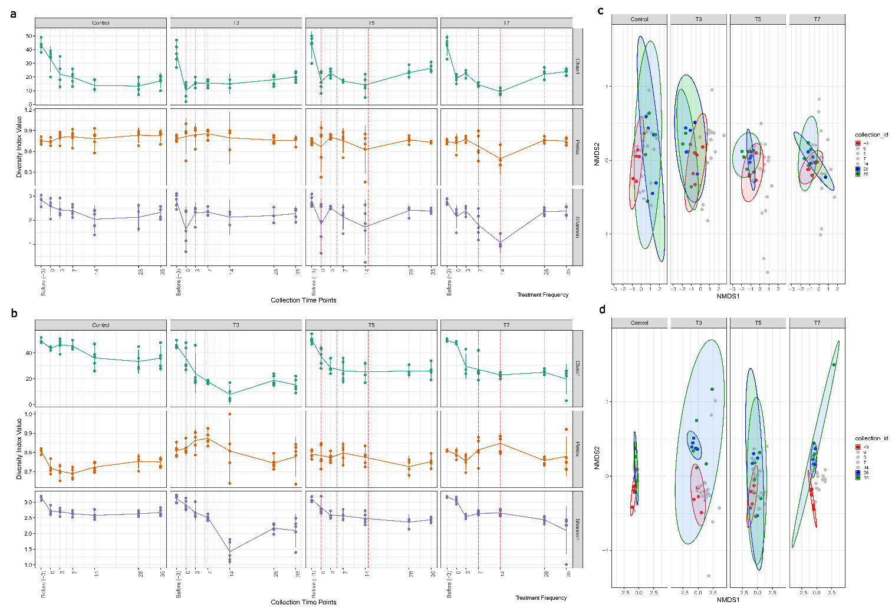
Supplemental Figure S4. Resistome responses to PPAA-foam treatment in experimental (SinkLab) sink-drains and sink-traps. Change in alpha-diversity indices of AMR gene families for a) sink-drain and b) sink-trap across the treatment groups. Non-metric multidimensional scaling (NMDS) plots showing Bray–Curtis dissimilarities at the AMR gene family-level for c) sink-drain and d) sink-trap resistomes, comparing baseline (D-3) with post-treatment (D28, D35).
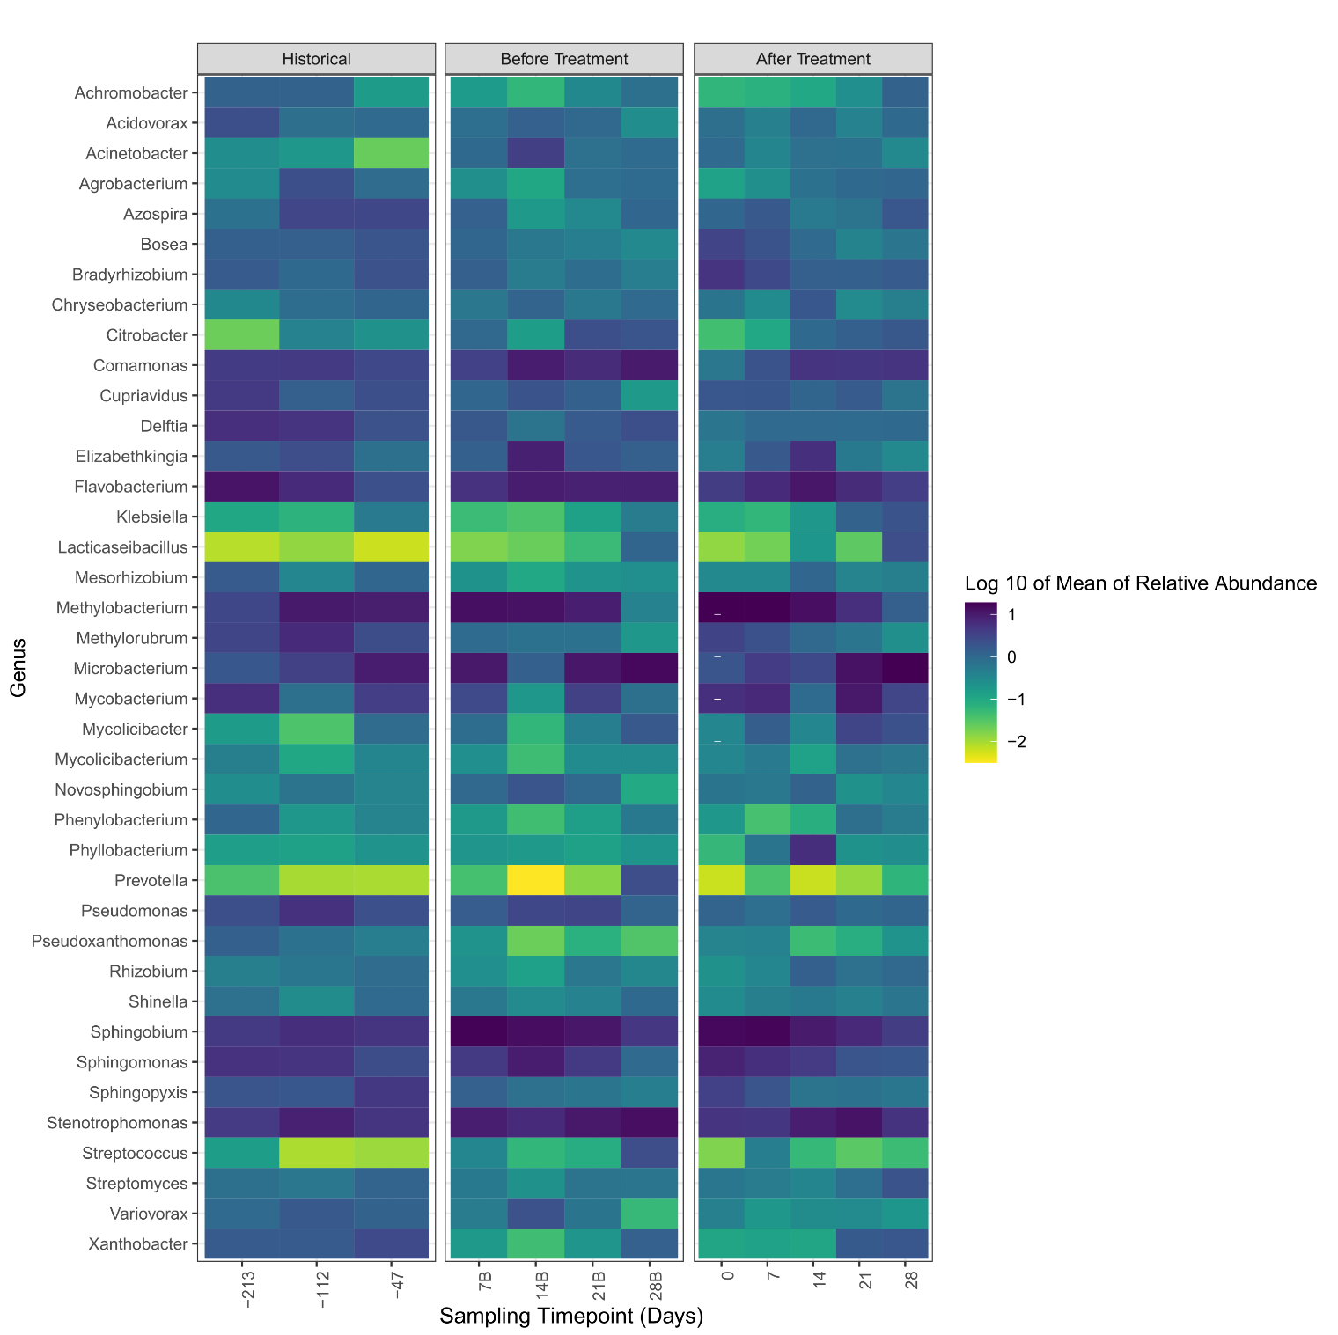
Supplemental Figure S5. Temporal patterns in the top 20 bacterial genera in hospital sink drains. Heatmap profile of the log transformed mean relative abundance across historical, immediately before-treatment and after-treatment the sampling timepoints.
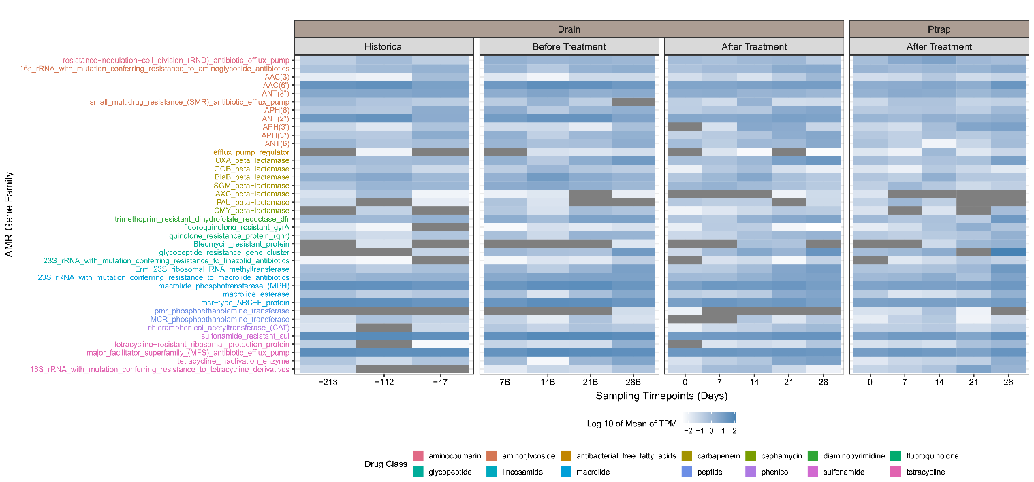
Supplemental Figure S6. Shifts in dominant AMR gene families in hospital sink-drains and sink-traps. Heatmap of the changes in mean abundance (TPM) of the top 20 AMR gene families across treatment groups for sink-drains and sink-traps.

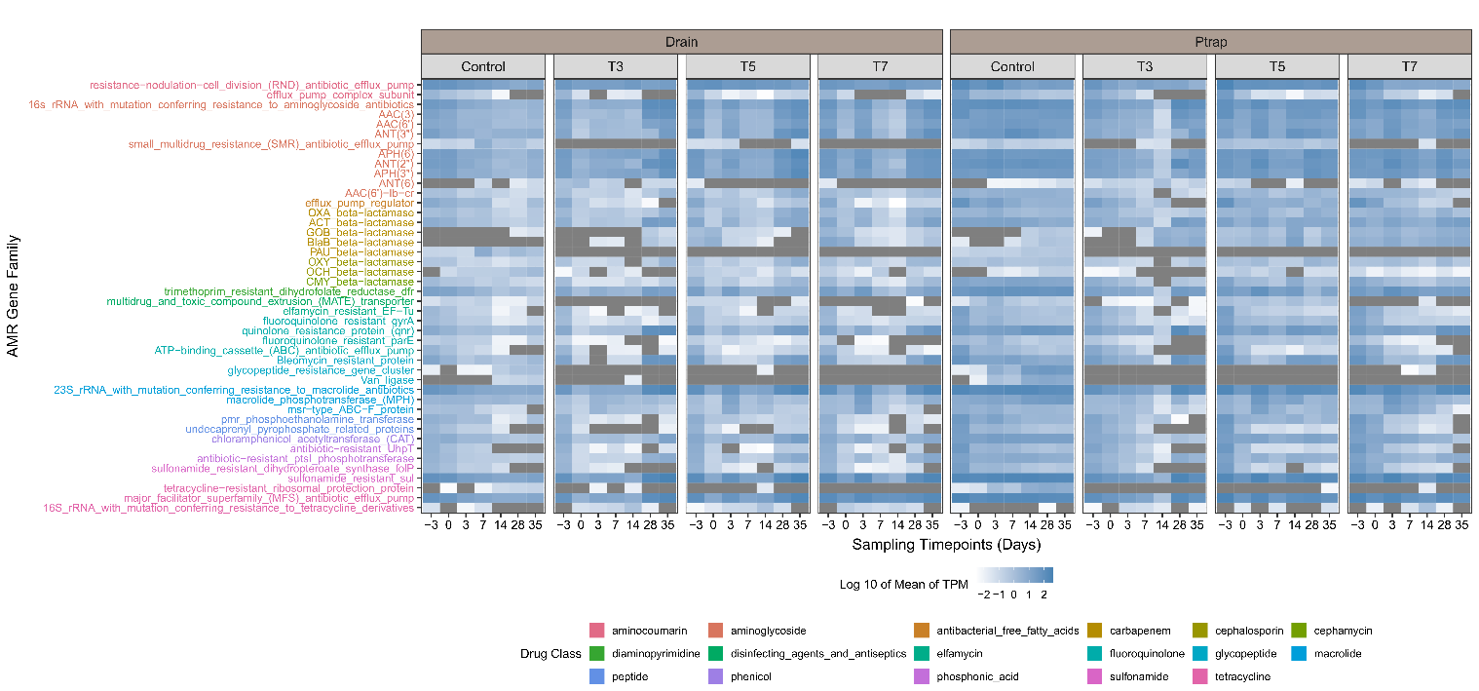
Supplemental Figure 7. Shifts in dominant AMR gene families in experimental sink-drains and sink-traps. Heatmap of the top 20 AMR gene families (TPM) across the treatment groups in the sink-drains and sink-traps.

