Supplementary Information: Evaluating spatiotemporal patterns of transmission to demonstrate malaria elimination: a case study from Bhutan

Figure S1. Likelihood of two cases being within the same transmission chain based on timing of notification (x-axis) and geographical distance (y axis), with scenarios including δ values of a.) 0.1, b.) 0.05, c.) 0.01
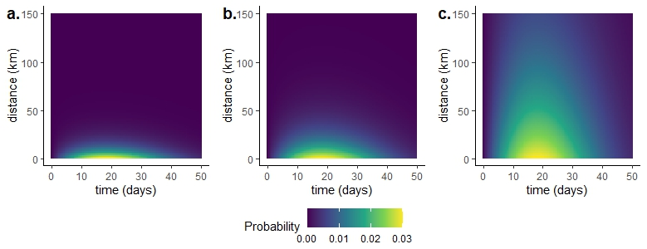
Figure S2. Seasonal patterns of malaria cases reported per month
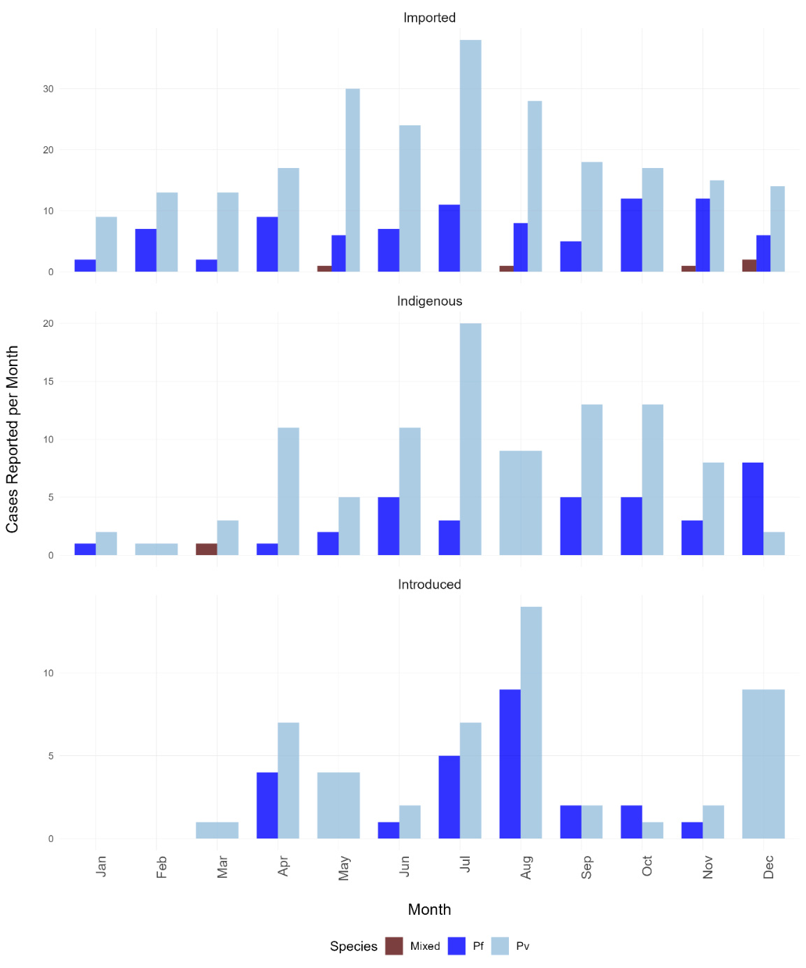

Figure S3. Estimated R_{C} values for all scenarios assessed for a.) P. falciparum and b.) P. vivax
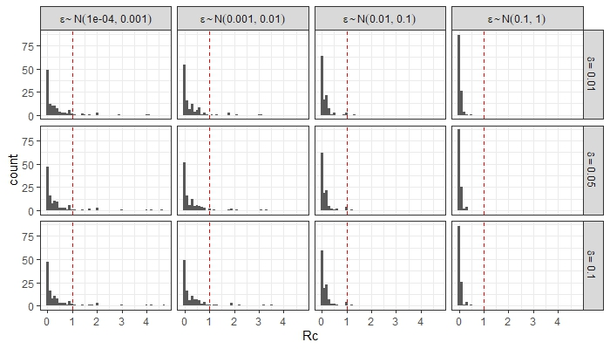
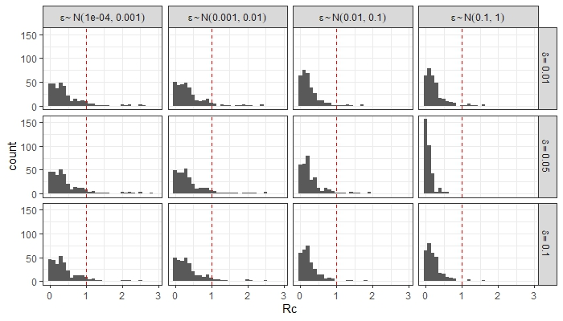

Figure S4. Posterior median and lower and upper limits of 95% credible intervals for predicted spatial intensity
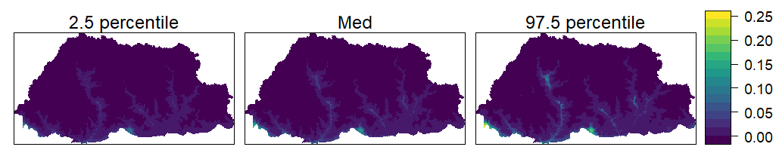

Table S1. Reported occupations of malaria cases
 | Species | Occupation | N (%)
 | Overall | Labourer | 184 (34.5%)
 |  | Farmer | 173 (32.5%)
 |  | Student/Trainee | 61 (11.4%)
 |  | Government/Military | 39 (7.3%)
 |  | Dependent/Unemployed | 29 (5.4%)
 | P. falciparum | Farmer | 50 (34.7%)
 |  | Labourer | 43 (29.9%)
 |  | Government/Military | 16 (11.1%)
 |  | Student/Trainee | 14 (9.7%)
 |  | Dependent/Unemployed | 7 (4.9%)
 | P. vivax | Labourer | 136 (35.4%)
 |  | Farmer | 123 (32%)
 |  | Student/Trainee | 47 (12.2%)
 |  | Dependent/Unemployed | 23 (6%)
 |  | Government/Military | 22 (5.7%)
 | Mixed | Labourer | 5 (83.3%)
 |  | Farmer | 1 (16.7%)

Table S2. Parameter and dataset combinations with model fit statistics
Model | DIC
Spatial random effect only | 1125
Elevation | 1084
Temperature | 1048
Precipitation | 1216
Distance from hydropower plant | 1465
Distance from India border | 1332
All covariates (except spatial) | 1009

Table S3. Posterior fixed effect estimates for final multivariate model
Variable | 2.5% | Median | 97.5%
Elevation | 0.001 | 0.003 | 0.005
Temperature | 0.000 | 0.000 | 0.001
Precipitation | 0.983 | 1.425 | 1.86
Distance to hydropower plant | 0.029 | 0.046 | 0.063
Distance to India border | -0.003 | 0.007 | 0.018

