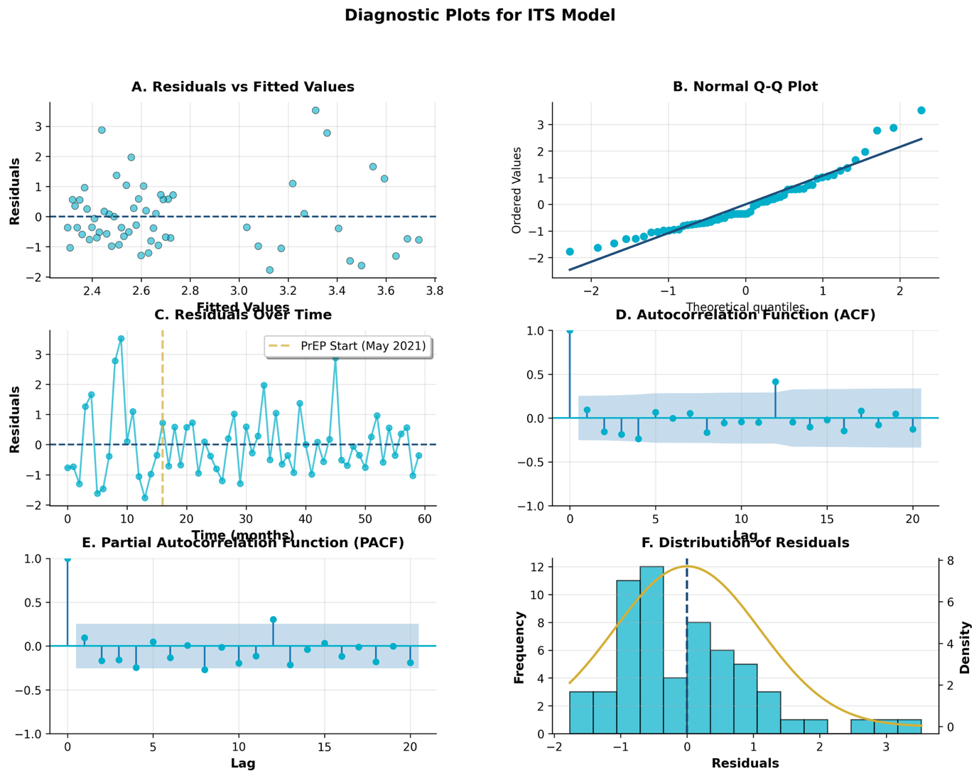
Fig. S1. Diagnostic plots for ITS model validity. Note: (A) Residuals vs fitted values showing random scatter without systematic patterns. (B) Normal Q-Q plot indicating acceptable normality with minor tail deviations. (C) Residuals over time showing no temporal trends; vertical line marks PrEP initiation (May 2021). (D) Autocorrelation function with all lags within 95% confidence bounds. (E) Partial autocorrelation function confirming no significant serial correlation. (F) Histogram of residuals approximating normal distribution.

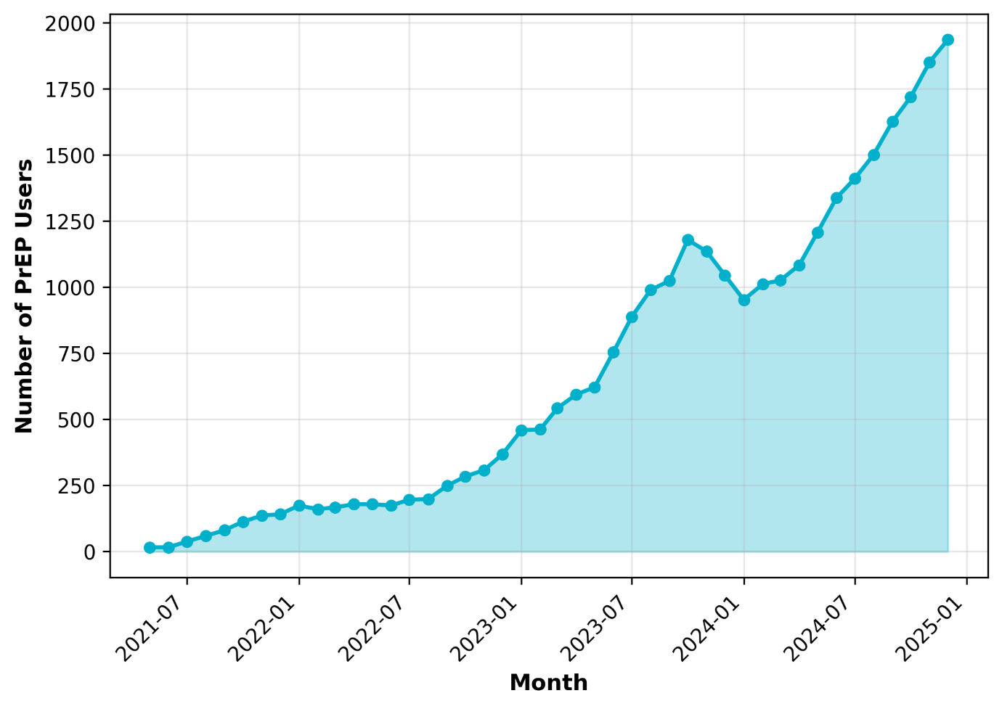
Fig. S2. Growth in PrEP users among GBMSM in Kazakhstan, May 2021–December 2024. Note: The graph shows cumulative current PrEP users over time, demonstrating sustained programme scale-up with a temporary plateau in 2023 followed by accelerated growth in 2024.

Table S1: Alternative Model Specifications

Part A: Model Coefficients
Model Specification | Observations | β₀ (SE) | β₁ (SE) | β₂ (SE) | β₃ (SE)
Primary Linear | 60 | 3.734 (0.611)*** | -0.047 (0.065) | -0.254 (0.750) | 0.037 (0.067)
Quadratic Time | 60 | 3.715 (0.622)*** | -0.039 (0.074) | -0.393 (0.753) | 0.070 (0.095)
Lag-Adjusted (3mo) | 57 | 3.734 (0.623)*** | -0.047 (0.067) | -0.345 (0.762) | 0.039 (0.069)
Testing Volume Control | 60 | 19.765 (1.799)*** | 0.053 (0.030)† | -0.056 (0.424) | -0.028 (0.029)

Part B: Model Fit Statistics
Model Specification | R² | Adjusted R² | AIC | Durbin-Watson
Primary Linear | 0.127 | 0.080 | 190.3 | 1.80
Quadratic Time | 0.130 | 0.067 | 192.1 | 1.81
Lag-Adjusted (3mo) | 0.130 | 0.080 | 183.1 | 1.75
Testing Volume Control | 0.663 | 0.638 | 135.2 | 1.70
Note: SE = standard error. Significance: ***p<0.001; **p<0.01; *p<0.05; †p<0.10. All models estimated using ordinary least squares with Newey-West HAC robust standard errors. DW statistics between 1.7–2.0 indicate acceptable autocorrelation. Testing volume control model includes log(testing volume) as additional covariate, substantially improving fit (R² increases from 0.127 to 0.663) while intervention parameters maintain beneficial direction, indicating positivity reduction is not merely a testing artefact.
Table S2. Interrupted Time Series Analysis of Alternative Outcomes

Part A: Descriptive Statistics
Outcome Measure | Pre-PrEP Implementation | Post-PrEP Implementation | Absolute Change | Relative Change
Test Positivity Rate (%) | 3.38 ± 1.62 | 2.51 ± 0.87 | -0.87 pp | -25.7%
Diagnosis Rate (per 1,000 GBMSM) | 0.34 ± 0.09 | 0.51 ± 0.10 | +0.17 per 1,000 | +50.0%
Late Diagnosis Rate (%) | 15.65 ± 11.64 | 15.78 ± 7.83 | +0.13 pp | +0.8%
Note: Values are mean ± standard deviation. Pre-PrEP: January 2020–April 2021 (n=16 months); Post-PrEP: May 2021–December 2024 (n=44 months). pp = percentage points.

Part B: ITS Model Results
Outcome Measure | β₂ (Level Change) | 95% CI | p-value | β₃ (Slope Change) | 95% CI | p-value | R²
Test Positivity Rate (%) | -0.254 | (-1.728, 1.220) | 0.761 | +0.037 | (-0.095, 0.169) | 0.598 | 0.127
Diagnosis Rate (per 1,000) | +0.052 | (-0.017, 0.121) | 0.134 | -0.004 | (-0.009, 0.001) | 0.116 | 0.437
Late Diagnosis Rate (%) | -8.418 | (-19.509, 2.673) | 0.134 | -0.710 | (-1.713, 0.293) | 0.163 | 0.057
Note: β₂ represents immediate level change at intervention; β₃ represents change in monthly slope. All models estimated using segmented regression with Newey-West robust standard errors.

Table S3: Power Analysis Details
Parameter | Value
Sample size (n) | 60
Number of predictors | 3
Alpha level | 0.05
R² | 0.127
Adjusted R² | 0.080
Cohen's f² | 0.145
Effect size category | Small
Achieved power | 66%
Required power | 80%
Power deficit | -14%
Note: Cohen's f² calculated as R²/(1-R²). Effect size categories: small (0.02), medium (0.15), large (0.35). Counterfactual analysis achieved 95% power by testing cumulative effects across all 44 post-intervention months rather than decomposing into discrete parameters.

