Supplementary Materials

Directed Evolution of Gram-Negative Klebsiella michiganensis M5al for Desiccation Tolerance and Survivability of a Spray Dry Encapsulation Process
Authors: Benjamin M. Arbaugh^{1,†}, Emily M. Makeev¹, Matthew L. Cope-Arguello², Tiffany M. Lowe-Power², Tina Jeoh^{1,*}
¹ Biological and Agricultural Engineering, University of California Davis, Davis, CA, U.S.A.
² Plant Pathology, University of California Davis, Davis, CA, U.S.A.
†Current: IFF, Inc. Palo Alto, CA, U.S.A.
*Corresponding author: ORCID ID 0000-0002-0727-4237, One Shields Ave., Davis, CA, tjeoh@ucdavis.edu

Selection controls for Klebsiella isolates
A spray drying encapsulation method was used to select for Klebsiella isolates with increased desiccation tolerance. Given the inherently non-sterile nature of the spray drying process (see Figure S2) specific selection controls were incorporated to ensure that only Klebsiella isolates were selected during the encapsulation process.

Morphology of plated colonies from cell cultures, feeds, and powder releases
Colony morphology served as the primary indicator for selecting Klebsiella isolates. Representative morphologies of both the formulated wildtype and selected-for K. michiganensis M5al-Tn7Gm from dilution plates are shown in Figure S1 below. Only colonies with the expected morphology were picked for screening and sequencing to confirm Klebsiella identity, followed by repassaging through the directed evolution experiment.
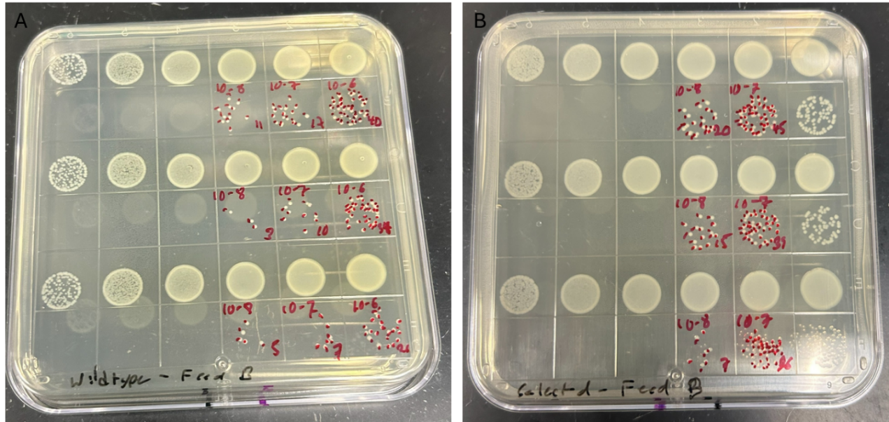
Figure S1: Typical colony morphology of formulated K. michiganensis M5al isolates from dilution plating. (A) dilution plate of wildtype K. michiganensis M5al. (B) dilution plate of selected-for K. michiganensis M5al-Tn7Gm. Note the uniform colony morphology and coloration of both the wildtype and selected-for isolates.

Antibiotic controls
The wildtype Klebsiella michiganensis M5al strain was genetically modified by introducing a gentamicin resistance cassette via a miniTn7 construct (Choi et al., 2005). This construct stably integrated into the bacterial chromosome, resulting in the creation of a new Tn7-Gm marked strain, designated as K. michiganensis M5al-Tn7Gm. This modified strain served as the parental strain for subsequent directed evolution experiments. Before the implementation of transformation and gentamicin-based selection controls, low-level bacterial contamination presented a recurring challenge during dilution plating and colony selection following spray drying operations.
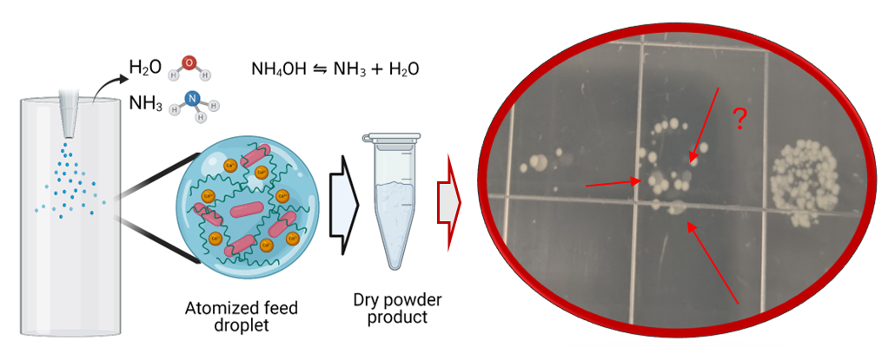
Figure S2: Microbial contaminants from spray drying. The spray drying process is inherently nonsterile. Dilution plating for spray drying survival revealed low levels of bacterial contaminants that were distinguishable from the target K. michiganensis M5al colonies by their unique morphologies and coloration, contrasting with the uniform appearance of colonies depicted in Figure S1. These contaminants were controlled in subsequent experiments through the use of gentamicin.
These contaminants, illustrated in Figure S2 above, typically appeared at the lowest dilution levels. They were distinguishable from the target K. michiganensis M5al colonies by their unique morphologies and coloration, contrasting with the uniform appearance of colonies depicted in Figure S1. The introduction of gentamicin, both in the LB shake flask broth and on the agar plates used for dilution plating, significantly reduced contamination rates when working with the K. michiganensis M5al-Tn7Gm strain. This antibiotic selection ensured that only the gentamicin-resistant strain grew, streamlining colony isolation and improving the specificity of the selection.

PCR Protocol for irp1 gel screens for confirmation of Klebsiella identities and images
Throughout the experiment, and prior to full genome sequencing, populations of isolates were picked and screened for the presence of the irp1 gene to confirm their identity as Klebsiella via a +/- gel screen. After confirmation of Klebsiella identity, the isolates were pooled and set aside as population checkpoints (t1-t5) for genetic sequencing; pooling of populations typically occurred prior to major changes in drying parameters.
The following PCR reaction setup and thermocycling conditions were used during the directed evolution experiment for the amplification of the irp1 gene. PCR reactions were prepared using a 1× master mix containing 80 mM Tris-SO₄, 20 mM (NH₄)₂SO₄, 2 mM MgSO₄, 5% glycerol, 5% DMSO, 0.06% IGEPAL CA-630, 0.05% Tween 20, 0.2 mM dNTPs, and 25 units/mL OneTaq DNA Polymerase (pH 9.2 at 25 °C). Template DNA and primers were added to the master mix according to standard concentrations. Amplification of template DNA was performed using the following thermocycling protocol shown below in Table S1. Initial denaturation was at 94 °C, followed by 32 cycles of denaturation at 94 °C, annealing at 61 °C, and extension at 68 °C. Final extension was at 68 °C, before a hold at 12 °C.
Table S1: Thermocycler settings used for the amplification of irp1. Initial denaturation was at 94 °C, followed by 32 cycles of denaturation at 94 °C, annealing at 61 °C, and extension at 68 °C. Final extension was at 68 °C, before a hold at 12 °C.
- Initial denaturation at 94 °C for 4 minutes
- 32 cycles of:
a. Denaturation at 94 °C for 30 seconds
b. Annealing at 61 °C for 45 seconds
c. Extension at 68 °C for 4 minutes
- Final extension at 68 °C for 5 minutes
- Hold at 12 °C for 5 minutes
Representative gels of irp1 PCR screen shown below in Figure S3. Selected colonies for which irp1 was confirmed were pooled together and passaged through the next round of encapsulation. Colonies negative for the irp1 gene were discarded. All amplified PCR products were run on gels alongside a positive control from the wildtype K. michiganensis M5al, and a negative water-only and/or LB media control.
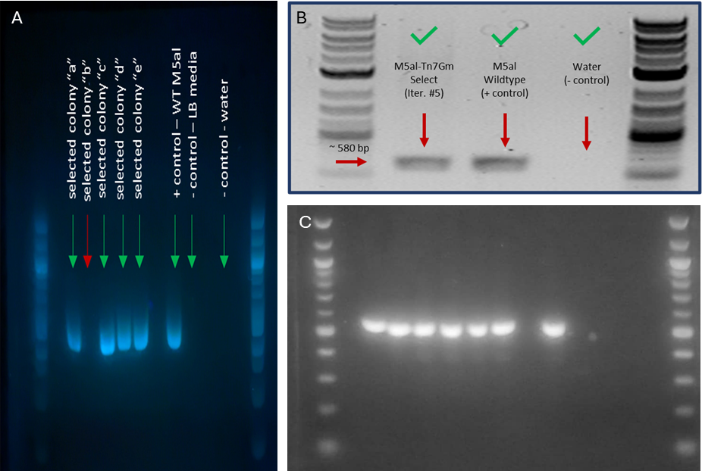
Figure S3: PCR gel screens for presence of irp1. The amplified irp1 gene has a length of ~580bp. The presence of irp1 was used to select for K. michiganensis M5al-Tn7Gm isolates with increased spray dry survival. Panels A, B, and C show representative gel images that were taken during the directed evolution experiment. DNA was extracted from picked colonies at intermediate checkpoints in the selection experiment. Selected colonies for which irp1 was confirmed were pooled together and passaged through the next round of encapsulation. Colonies negative for the irp1 gene, such as ‘selected colony “b”’ in panel A, were discarded. All amplified PCR products were run on gels alongside a positive control from the wildtype K. michiganensis M5al, and a negative water-only and/or LB media control. All DNA ladders shown are 100bp DNA ladders from New England Biolabs.

Sequencing of genomic DNA
Isolates from population checkpoints in the directed evolution experiment were sequenced using Illumina short-read sequencing. The DNA sequences from each of the checkpoints were aligned to the K. michiganensis M5al reference genome (GCA_00163315.1) (Bao et al., 2013) using the breseq analysis pipeline in polymorphism mode (Deatherage & Barrick, 2014). A high percentage of the aligned reads, as high as 95.4% from the final population checkpoint (t5), were mapped to the reference genome. This result strongly confirms that the selected isolates present in the sequenced populations were derived from the wildtype K. michiganensis M5al strain.

Breakdown of dLog10CFU/g error propagation for spray dried samples
The calculation of propagated error for the dLog₁₀ CFU/g values of spray dried powders is shown in Table S2. This error accounts for the variability in dilution plating measurements, moisture content of the powders, and solids content of the feeds. The dLog₁₀ CFU/g is the log-transformed value of the ratio of the CFU/g in the powder to the initial CFU/g in the feed. Calculation factors in error from measurement of CFU/g in powder, CFU/mL in formulated feed, moisture content (w.b.) of spray dried powders and solids content (w.b.) of formulated feeds.
Table S2: Calculation of propagated error in spray dried powders. Calculation factors in error from measurement of CFU/g in powder, CFU/mL in formulated feed, moisture content (w.b.) of spray dried powders and solids content (w.b.) of formulated feeds.
Error propagation in spray dried powders
Variable | Description | Equation
$$e$$ | averaged biological replicates | $$\frac{f_{1}+f_{2}+…+f_{n}}{n}$$
$$s_{e}$$ | propagated error (over all biological replicates) | $$\frac{1}{n}\sqrt{\left(s_{f_{1}}^{2}+s_{f_{2}}^{2}+…+s_{f_{n}}^{2}\right)}$$
$$f$$ | $$dLog10\frac{{\left[\frac{CFU}{g}\right]}_{powder \left(dry\right)}}{{\left[\frac{CFU}{g}\right]}_{feed (dry)}}$$ | $$\log_{10}\left(\frac{x}{y}\right)$$
$$x$$ | $${\left[\frac{CFU}{g}\right]}_{powder \left(dry\right)}$$ | $$\frac{a}{1-α}$$
$$y$$ | $${\left[\frac{CFU}{g}\right]}_{feed \left(dry\right)}$$ | $$\frac{b}{β}$$
$$a$$ | measured powder $\frac{CFU}{g}$ | measured
$$α$$ | measured powder moisture content (w.b.) | measured
$$b$$ | measured feed$\frac{CFU}{mL}$ | measured
$$β$$ | measured feed solids content | measured
$$s_{f}$$ | propagated error (single biological replicate) | $$\sqrt{{\left(\frac{df}{dx}\right)}^{2}{\left(s_{x}\right)}^{2}+{\left(\frac{df}{dy}\right)}^{2}{\left(s_{y}\right)}^{2}}$$
$$\frac{df}{dx}$$ | partial derivative of $f$ w.r.t. $x$ | $$\frac{1}{\ln\left(10\right)}\frac{1}{x}$$
$$\frac{df}{dy}$$ | partial derivative of $f$ w.r.t. $y$ | $$-\frac{1}{\ln\left(10\right)}\frac{1}{y}$$
$$s_{x}$$ | propagated error in ${\left[\frac{CFU}{g}\right]}_{powder (dry)}$ | $$\sqrt{{\left(\frac{dx}{da}\right)}^{2}{\left(s_{a}\right)}^{2}+{\left(\frac{dx}{dα}\right)}^{2}{\left(s_{α}\right)}^{2}}$$
$$\frac{dx}{da}$$ | partial derivative of $x$ w.r.t. $a$ | $$\frac{1}{1-α}$$
$$\frac{dx}{dα}$$ | partial derivative of $x$ w.r.t. $α$ | $$\frac{a}{{\left(1-α\right)}^{2}}$$
$$s_{a}$$ | std dev of powder $\frac{CFU}{g}$ | measured
$$s_{α}$$ | std dev of powder moisture content (w.b.) | measured
$$s_{y}$$ | propagated error in ${\left[\frac{CFU}{g}\right]}_{feed (dry)}$ | $$\sqrt{{\left(\frac{dy}{db}\right)}^{2}{\left(s_{b}\right)}^{2}+{\left(\frac{dx}{dβ}\right)}^{2}{\left(s_{β}\right)}^{2}}$$
$$\frac{dy}{db}$$ | partial derivative of $y$ w.r.t. $b$ | $$\frac{1}{β}$$
$$\frac{dy}{dβ}$$ | partial derivative of $y$ w.r.t. $β$ | $$-\frac{b}{β^{2}}$$
$$s_{b}$$ | std dev of feed CFU/mL | measured
$$s_{β}$$ | std dev of feed solids content | measured

Spray drying parameters for directed evolution experiment
A range of spray drying parameters were used during this work which impacted both the survival of the K. michiganensis M5al wildtype and selected-for strains. The spray drying parameters were initially carried over from prior spray drying and encapsulation work involving CLAMs (Arbaugh et al., 2022) and were later changed to vary the selection pressure in the directed evolution experiment. The drying parameters were also varied in order to improve the quality of powders and to compensate for day-to-day variation due to ambient environmental conditions.

Parameters established from prior work
A prior study with Klebsiella variicola (Arbaugh et al., 2022) established a set of low temperature drying parameters which were optimized to maximize cell viability immediately post drying. From this study, an inlet temperature between 135 °C, pump rate setting of 30 %, and a resultant outlet temperature in the mid 40s to low 50s °C were targeted. These were used in the first pass through the encapsulation system and adjusted accordingly as parameters were optimized for survival, selection pressure, and powder quality as the experiment went on. These parameters are provided in Table S3.

Spray drying parameters used in this study
The following table highlights the drying parameters including inlet temperature settings, pump rates, and resultant outlet temperatures. Descriptions of conditions and batch IDs for runs where conditions were applied are also included.
Table S3: Complete table of spray drying parameters used in this study. Table includes inlet temperature settings, pump rates, and resultant outlet temperatures for each batch during the directed evolution experiment.
Inlet T (°C) | Pump Rate | Outlet T (°C) | ID | Description
135 | 30% | Mid 40s-low 50s | BMA001p013 | First pass, low temp outlet, low powder quality,
150 | 30% | 60 – 70 | BMA001p015
120 | 20% | 45-50 | BMA001p016
130 | 45% | 45-50 | BMA001p018, 019, 024, 025
135 | 50% | 40-45 | BMA001p021, 022, 027, 028, 029, 030, 031, 038 | Initial passes in selection experiment before change in process parameters
135 | 45% | 42-44 | BMA001p039
140 | 50% | 45-48 | BMA001p040
145 | 45% | 46-53 | BMA001p041, 042, 046, 048, 052, 054, 059 | Re-optimized drying conditions for powder quality
155 | 45% | 49-53 | BMA001p062, 064
170 | 30% | 63-70 | BMA001p066, p068
165 | 30% | 67-83 | BMA001p070, 072, 074, 078, 080
150 | 30% | 59-73 | BMA001p086, 088, 098, 100, 102
150 | 45% | 58-63 | BMA001p104, 106, 108, 114, 116, 120 | Final optimized drying conditions, targeting 60C in the outlet

Recorded drying conditions during the directed evolution experiment
During the directed evolution experiment, drying parameters, including inlet temperatures, pump rate settings, min and max outlet temperatures, solids content of feeds and moisture content of dried powders, and ambient relative humidity and air temperature, were recorded. The inlet temperature and pump rate settings, shown in panel A of Figure S4 below, were the primary control of selection pressure. To increase selection pressure, inlet temperature was increased, and pump rate was decreased. Early passes through the directed evolution process are boxed in green, while later passes are boxed in red. As selection pressure increased, so did outlet temperature, as shown in panel B. Interestingly this did not have a significant impact on the moisture content of the resultant powders, but the water activity as indicated by the powder quality decreased. Interestingly, the later stage runs in which the inlet temperature and pump rate were held constant at 155 °C and 30 % the outlet temperature increased, likely due to a downward trend in recorded relative humidity, highlighting the need for same day spray drying controls to account for variation in ambient drying conditions.
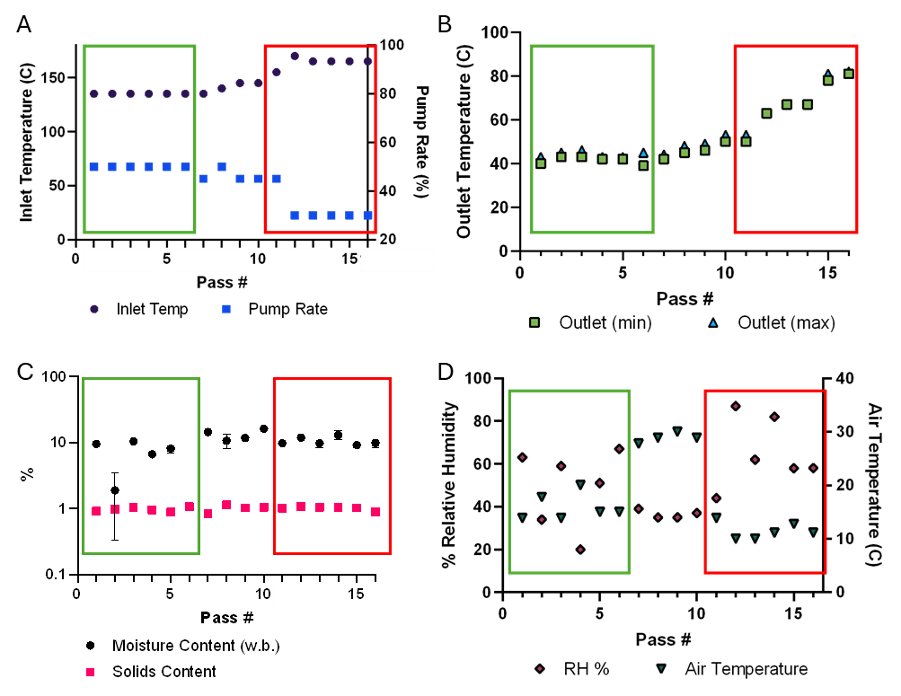
Figure S4: Drying parameters and conditions during directed evolution experiment. (A) Inlet temperature and pump rate settings used on Buchi B-290 spray dryer to select for Klebsiella isolates with increased survival of the CLAMs encapsulation process. As the experiment went on, the inlet temperature was increased, while the pump rate setting was decreased to increase the selection pressure. (B) Resultant outlet temperatures recorded. Target outlet temperatures increased as desired selection pressure increased. (C) Solids content of feed and resultant moisture content of powder held constant throughout experiment. (D) Recorded ambient conditions that impact drying. The directed evolution experiment took place over the course of several months, during which the ambient air temperature and relative humidity varied significantly. These variations impacted drying conditions throughout the experiment. Points boxed in green represent the early passes, 1-6, through the directed evolution experiment, while points boxed in red represent the later passes, 11-16. Figure generated using GraphPad Prism Software.

Impact of ambient relative humidity on survival and powder quality
The lab scale Buchi B-290 spray drier that was used in this study does not have a dehumidifier. Therefore the atmospheric conditions, as shown above in panel D of Figure S4, can have an impact on drying and survival. This may have contributed to the high variance in the batch-to-batch survival of the wildtype and K. michiganensis M5al-Tn7Gm parent strain that was observed.
During this study, the decision was made to adjust spray drying parameters to maintain powder quality as the drying air conditions changed. This resulted in changes in drying conditions from batch-to-batch which required same-day, same drying condition controls. The standard deviation of WT survival is greater than the selected population, indicating that the wildtype is more susceptible to slight variations in the drying process relative to the selected isolates.
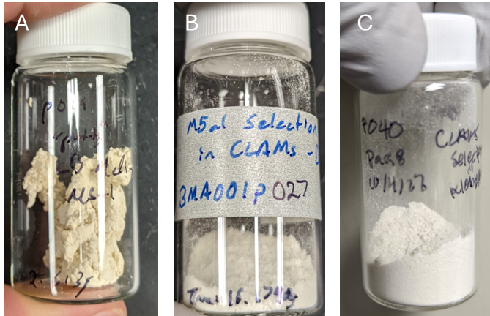
Figure S5: Impact of different processing parameters on powder quality throughout directed evolution experiment highlighting importance of optimizing for powder quality. (A) Powder produced using initial set of drying parameters carried over from prior work. Powder was initially dry and fluffy but yellowed and clumped during storage to form chunks. (B) and (C) Powders produced during directed evolution experiment with white floury consistency stayed white during storage and were easy to collect. Later drying parameters optimized to target powders of this quality.

K. michiganensis M5al spray dry survival benchmarks
The objective of the directed evolution experiment was to enhance the spray dry survival of selected-for Klebsiella isolates; therefore, it was necessary to establish survival benchmarks of the wildtype and parental strains before initiating the directed evolution process.

Initial work with K. michiganensis M5al wildtype strain
The first pass through the encapsulation system with the wildtype strain used the parameters established in previous work with K. variicola (Arbaugh et al., 2022). The parameters used in that study were described previously. The wildtype K. michiganensis M5al was spray dried under these conditions either encapsulated in CLAMs or unencapsulated as-is in whole broth. The results of the initial spray drying trials are shown in Figure S6. Panel A shows the measured CFU/g of the dry product as measured by dilution plating. Panel B shows the calculated dLog10 CFU/g dry weight of the powders. Panel C shows the resultant sticky powder/syrup that was produced when drying the whole broth without any added excipients, while panel D shows the flour-like powder produced with the CLAMs-encapsulated powders. After this trial it was determined that spraying whole broth alone was not a viable option for K. michiganensis M5al grown in LB media, from both a recovered CFU/g as well as a powder quality perspective.

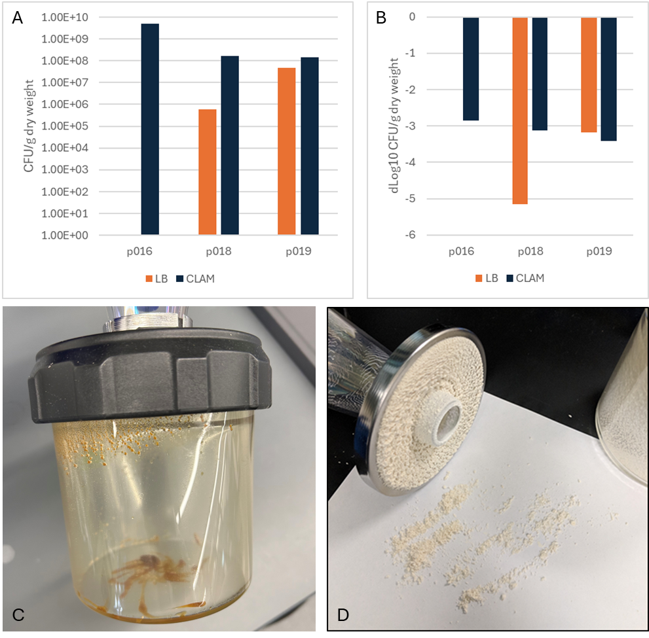
Figure S6: Initial trials using the wildtype K. michiganensis M5al. Panel A shows the measured CFU/g of the dry product as measured by dilution plating. Panel B shows the calculated dLog10 CFU/g dry weight of the powders. Panel C shows the resultant sticky powder/syrup that was produced when drying the whole broth without any added excipients, while panel D shows the flour-like powder produced with the CLAMs-encapsulated powders. After this trial it was determined that spraying whole broth alone was not a viable option for K. michiganensis M5al grown in LB media, from both a recovered CFU/g as well as a powder quality perspective.

K. michiganensis M5al-Tn7Gm parental strain survival baseline
Biological replicates of the parental K. michiganensis M5al-Tn7Gm encapsulated in spray dried CLAMs were used to establish a baseline for spray dry survival of K. michiganensis M5al during spray drying. The results of these encapsulations are shown in Figure S7 below. Measured CFU/g dry solids of both the feed and powder are given, as well as calculated dLog10 CFU/g. On average, the parental strain lost about 5 log10 CFU/g prior to the directed evolution experiment.
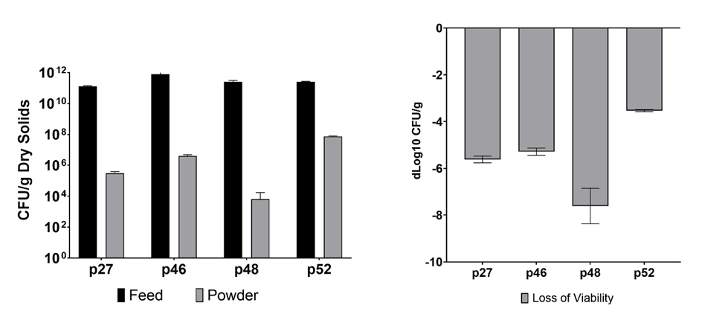
Figure S7: Individual replicates of baselines for spray drying K. michiganensis M5al-Tn7Gm. Left: measured CFU/g dry solids in feed and powder for biological replicates of spray dry encapsulation in CLAMs. Right: calculated dLog10 of loss (feed to powder) of viability for all replicates. Error bars for biological replicates are from calculated propagated error for each run. Graphs generated using GraphPad Prism software.

Early passes of directed evolution
During the early passes of directed evolution the fitness of passaged populations increased rapidly from -5.62 dLog₁₀ CFU/g to -2.91 dLog₁₀ CFU/g. During this time drying conditions were held constant.

Table of passes 1-6 of selection
Table S4: Early passes of directed evolution of K. michiganensis M5al-Tn7Gm encapsulated in cross-linked alginate microcapsules. Measured values of CFU/g from viability plating and dLog₁₀ CFU/g from loss of viability calculations. Reported error values from dLog₁₀ column are propagated error.
Selection Pass | Feed CFU/g | Error | Powder CFU/g | Error | dLog₁₀ CFU/g | Error
1 | 1.25E+11 | 1.74E+10 | 3.01E+05 | 8.94E+04 | -5.62 | 0.14
2 | 1.85E+11 | 1.52E+10 | 8.69E+05 | 2.17E+05 | -5.33 | 0.11
3 | 1.59E+11 | 8.13E+09 | 3.16E+06 | 4.93E+05 | -4.70 | 0.07
4 | 2.44E+11 | 5.77E+10 | 5.85E+07 | 1.08E+07 | -3.62 | 0.13
5 | 2.13E+11 | 3.08E+10 | 8.62E+07 | 1.81E+07 | -3.39 | 0.11
6 | 4.32E+11 | 2.21E+11 | 5.37E+08 | 9.47E+07 | -2.91 | 0.24

Diminishing returns of selection with improved drying conditions
After the initial increase in spray drying survival, there appeared to be a plateau in dLog₁₀ survival. Figure S8 shows the calculated dLog₁₀ survival over the course of the directed evolution experiment. The color of the markers indicate the drying conditions used as selection pressure. Panel B compares early passes of selection to later passes.
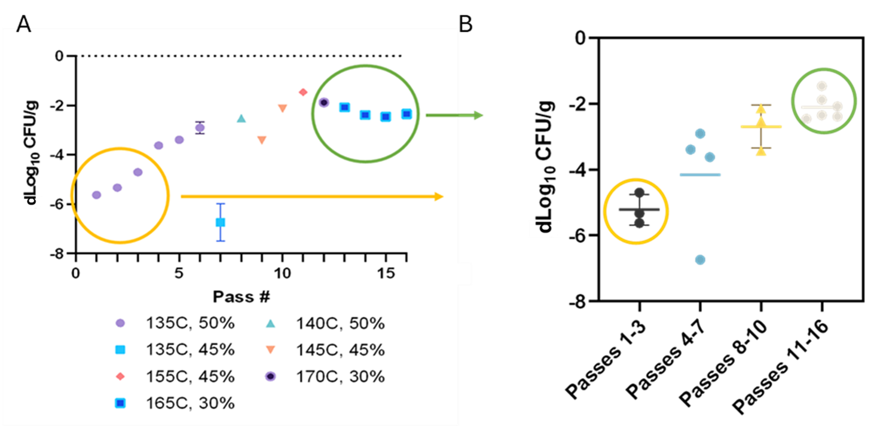
Figure S8: Comparison of K. michiganensis M5al-Tn7Gm survival through the directed evolution experiment. Panel A shows survival of each individual pass, while panel B shows differences in survival between groups of passe corresponding to different checkpoints in selection.

Table of passes 7-16 of selection
Values of CFU/g measured in the feed and powder during passes 7-16 are shown in Table S5 below. Calculated dLog₁₀ CFU/g and propagated error are also given.
Table S5: Selection passes 7-16 with increasing selection pressure. Measured values of CFU/g from viability plating and dLog₁₀ CFU/g from loss of viability calculations.
Selection Pass | Feed CFU/g | Error | Powder CFU/g | Error | dLog₁₀ CFU/g | Error
7 | 3.44E+10 | 4.21E+09 | 6.34E+03 | 1.10E+04 | -6.735 | 0.754
8 | 2.26E+11 | 2.13E+10 | 6.84E+08 | 1.06E+08 | -2.518 | 0.079
9 | 3.16E+11 | 2.70E+10 | 1.20E+08 | 1.21E+07 | -3.420 | 0.057
10 | 5.62E+11 | 1.04E+11 | 4.08E+09 | 3.07E+08 | -2.139 | 0.087
11 | 8.95E+11 | 1.48E+11 | 3.07E+10 | 8.68E+09 | -1.465 | 0.142
12 | 8.61E+11 | 7.58E+10 | 1.12E+10 | 1.39E+09 | -1.884 | 0.066
13 | 6.39E+11 | 2.31E+11 | 5.29E+09 | 8.62E+08 | -2.082 | 0.173
14 | 9.36E+11 | 1.31E+11 | 3.83E+09 | 5.50E+08 | -2.388 | 0.087
15 | 9.43E+11 | 9.98E+10 | 3.29E+09 | 9.65E+08 | -2.458 | 0.135
16 | 8.18E+11 | 1.37E+11 | 3.67E+09 | 1.55E+09 | -2.349 | 0.198

Paired parental and selected K. michiganensis M5al-Tn7Gm isolates
Given the changes to early spray drying conditions, the selected-for isolates were compared with the wildtype strain under the newly optimized conditions. Relative performance of paired wildtype and selected isolates (same day) are shown below in Table S6.
Table S6: Paired parental and selected-for side by side data for figure 3. Drying conditions varied throughout the experiment as drying parameters were optimized for powder quality control, so wildtype controls were run alongside selected isolates. The recorded drying conditions, as well as measured dlog₁₀ loss for selected and parental isolates and difference in loss values are reported.
Rep | Inlet | Pump | Outlet | dLog₁₀ Select | dLog₁₀ Parental | Select - Parental
A – p62&64 | 155 | 45% | 53-50 | -1.465 | -2.791 | 1.325
B – p66&68 | 170 | 30% | 63-70 | -1.884 | -3.148 | 1.263
C – p78&80 | 165 | 30% | 81-82 | -2.349 | -3.762 | 1.413
D – p86&88 | 150 | 30% | 60-72 | -1.645 | -2.432 | 0.788
E – p114&p116 | 150 | 45% | 60-63 | -2.132 | -4.287 | 2.155

Impact of set parameters on outlet temperature, powder quality, mc of powders
Compared to the set of drying parameters used in the wildtype baseline study, the conditions in the side-by-side parental v. selected-for isolates varied significantly as drying conditions changed during the study. This impacted the measured log₁₀ loss on a batch-to-batch basis, which necessitated day of controls. In general, the higher outlet temperatures were the result of lowered pump rates and higher inlet temperatures. And increased outlet temperatures result in higher log₁₀ loss profiles in the parental isolates. The trend was similar, but less pronounced in the selected-for isolates.

pH of cultured and formulated cells
The pH of cells at time of harvest over time, as well as the resultant formulation pHs increased over time. This increase is shown below in Figure S9.

Figure S9: Influence of selection on the pH of cell culture measured at time of harvest. Through the first 10 passes of the selection experiment the pH of the cell culture at time of harvest gradually increased from around pH 6 to pH 7. This appeared to have minimal impact on the measured pH of the formulated feed, but it was an early indication that the directed evolution experiment may be impacting the cellular metabolism of the K. michiganensis M5al-Tn7Gm selected-for strain.

Growth curves of wildtype and selected-for isolates
Reduced lag times (1-2 hours) and faster growth to stationary phase were observed in growth curves conducted side by side with wildtype K. michiganensis M5al and selected-for K. michiganensis M5al-Tn7Gm isolates. On average cultures of selected isolate inoculated at the same time reached higher titers (CFU/mL) at harvest (stationary phase). Growth curves are shown in Figure S10.
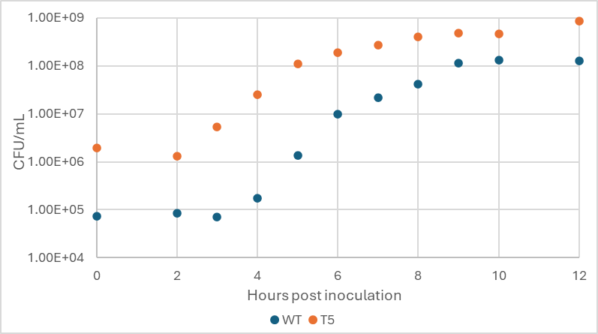
Figure S10: Growth curves of wildtype K. michiganensis M5al and the selected-for population of K. michiganensis M5al-Tn7Gm samples at the final checkpoint, t5, during the directed evolution experiment.

Filtered breseq results of directed evolution experiment
The breseq pipeline was run in polymorphism mode to analyze the final population checkpoint, t5. Predicted mutations already present in the parental strain were removed. Evidence, sequence ID, position, mutation, frequency, annotation, gene, and description of predicted mutations generated by the breseq analysis. A total of 55 mutations were identified in the selected-for population that were not present in the parental strain of K. michiganensis M5al-Tn7Gm. As shown in Table S7.

Table S7: Filtered breseq results of K. michiganensis M5al-Tn7Gm coding sequences following directed evolution. The breseq pipeline was run in polymorphism mode to analyze the final population checkpoint, t5. Predicted mutations already present in the parental strain were removed. Evidence, sequence ID, position, mutation, frequency, annotation, gene, and description of predicted mutations generated by the breseq analysis. A total of 55 mutations were identified in the selected-for population. Shading indicates frequency of occurrence. Individual genes with single or multiple mutations that occur at a frequency of greater than 50% within the sequenced population are shown in green, mutations with frequencies of 25-50% are in pink, and with 0-25% are in blue.
Predicted mutations
evidence | seq id | position | mutation | freq | annotation | gene | description | source
RA | LWKU01000001 | 1,649,684 | Δ1 bp | 100% | coding (1225/2652 nt) | A6A30_07560 → | phosphoenolpyruvate carboxylase | t5
RA | LWKU01000004 | 1,023,864 | (T)_{8→7} | 100% | coding (1515/2799 nt) | A6A30_22985 ← | zinc chelation protein SecC | t5
RA | LWKU01000004 | 1,705,759 | C→T | 100% | H12Y (CAT→TAT) | A6A30_26195 → | hypothetical protein | t5
RA | LWKU01000003 | 1,405,097 | C→A | 100% | intergenic (+40/-203) | A6A30_17875 → / → A6A30_17880 | RNA polymerase sigma factor RpoD/transcriptional regulator | t5
RA | LWKU01000001 | 771,653 | A→G | 48.10% | D146G (GAT→GGT) | pcnB → | polynucleotide adenylyltransferase | t5
RA | LWKU01000001 | 771,391 | C→T | 54.70% | R59C (CGC→TGC) | pcnB → | polynucleotide adenylyltransferase | t5
RA | LWKU01000004 | 610,483 | A→T | 25.00% | A13A (GCT→GCA) | A6A30_21065 ← | hypothetical protein | t5
RA | LWKU01000004 | 610,489 | C→A | 29.50% | S11S (TCG→TCT) | A6A30_21065 ← | hypothetical protein | t5
RA | LWKU01000004 | 610,501 | A→C | 26.20% | L7L (CTT→CTG) | A6A30_21065 ← | hypothetical protein | t5
RA | LWKU01000004 | 610,504 | T→C | 25.40% | P6P (CCA→CCG) ‡ | A6A30_21065 ← | hypothetical protein | t5
RA | LWKU01000004 | 610,505 | G→T | 25.20% | P6Q (CCA→CAA) ‡ | A6A30_21065 ← | hypothetical protein | t5
RA | LWKU01000004 | 610,506 | G→C | 25.20% | P6A (CCA→GCA) ‡ | A6A30_21065 ← | hypothetical protein | t5
RA | LWKU01000004 | 610,510 | A→G | 24.70% | D4D (GAT→GAC) ‡ | A6A30_21065 ← | hypothetical protein | t5
RA | LWKU01000004 | 610,512 | C→T | 24.20% | D4N (GAT→AAT) ‡ | A6A30_21065 ← | hypothetical protein | t5
RA | LWKU01000003 | 771,889:1 | +A | 46.20% | noncoding (785/2925 nt) | A6A30_14855 ← | 23S ribosomal RNA | t5
RA | LWKU01000004 | 610,539 | Δ1 bp | 49.20% | intergenic (-18/-74) | A6A30_21065 ← / → A6A30_21070 | hypothetical protein/DNA-invertase | t5
RA | LWKU01000004 | 610,543:1 | +G | 48.20% | intergenic (-22/-70) | A6A30_21065 ← / → A6A30_21070 | hypothetical protein/DNA-invertase | t5
RA | LWKU01000001 | 56,231 | A→T | 5.20% | R485W (AGG→TGG) | A6A30_00295 → | peptide permease | t5
RA | LWKU01000001 | 56,231 | A→T | 5.20% | *481R (TGA→AGA) | A6A30_00300 ← | deoxyribodipyrimidine photo-lyase | t5
RA | LWKU01000001 | 57,743 | G→T | 5.90% | intergenic (-72/+131) | A6A30_00300 ← / ← A6A30_00305 | deoxyribodipyrimidine photo-lyase/hypothetical protein | t5
RA | LWKU01000001 | 61,457 | T→G | 6.50% | L426L (CTT→CTG) | A6A30_00320 → | potassium-transporting ATPase subunit B | t5
RA | LWKU01000001 | 610,964 | G→A | 14.30% | G245E (GGA→GAA) | A6A30_02805 → | beta-ketoacyl-ACP synthase II | t5
RA | LWKU01000001 | 628,716 | C→G | 10.50% | F158L (TTC→TTG) | A6A30_02875 → | hypothetical protein | t5
RA | LWKU01000001 | 969,198 | C→A | 5.70% | V273V (GTG→GTT) | A6A30_04360 ← | phosphopentomutase | t5
RA | LWKU01000001 | 1,266,143 | C→A | 8.90% | A73E (GCA→GAA) | A6A30_05710 → | hypothetical protein | t5
RA | LWKU01000001 | 1,420,522 | T→A | 5.90% | intergenic (-421/-186) | A6A30_06460 ← / → A6A30_06465 | outer membrane receptor protein/lytic transglycosylase F | t5
RA | LWKU01000001 | 1,607,915 | A→C | 5.50% | P249P (CCT→CCG) | A6A30_07365 ← | GntR family transcriptional regulator | t5
RA | LWKU01000001 | 1,729,168 | A→C | 6.40% | E83D (GAA→GAC) | A6A30_07940 → | formate dehydrogenase accessory protein FdhE | t5
RA | LWKU01000001 | 1,856,902 | T→G | 6.70% | L180R (CTG→CGG) | uhpT → | antiporter | t5
RA | LWKU01000001 | 1,901,257 | A→T | 6.20% | E31V (GAA→GTA) | A6A30_08750 → | transcriptional regulator | t5
RA | LWKU01000001 | 2,087,139 | C→A | 15.50% | D19Y (GAT→TAT) | A6A30_09545 ← | inner membrane protein YhjD | t5
RA | LWKU01000001 | 2,165,439 | T→A | 6.90% | intergenic (+45/+204) | A6A30_09905 → / ← A6A30_09910 | leucine ABC transporter subunit substrate-binding protein LivK/acetyltransferase | t5
RA | LWKU01000001 | 2,165,447 | G→C | 6.90% | intergenic (+53/+196) | A6A30_09905 → / ← A6A30_09910 | leucine ABC transporter subunit substrate-binding protein LivK/acetyltransferase | t5
RA | LWKU01000001 | 2,165,475 | T→G | 5.60% | intergenic (+81/+168) | A6A30_09905 → / ← A6A30_09910 | leucine ABC transporter subunit substrate-binding protein LivK/acetyltransferase | t5
RA | LWKU01000001 | 2,313,782 | T→G | 16.00% | D196A (GAC→GCC) | A6A30_10675 ← | acetyl-CoA carboxylase biotin carboxylase subunit | t5
RA | LWKU01000001 | 2,371,761 | A→C | 5.60% | L58R (CTT→CGT) | A6A30_10945 ← | LPS export ABC transporter periplasmic protein LptC | t5
RA | LWKU01000003 | 143,510 | A→T | 5.10% | P317P (CCT→CCA) | A6A30_12110 ← | transcriptional regulator | t5
RA | LWKU01000003 | 663,498 | G→T | 9.90% | intergenic (-60/+36) | A6A30_14395 ← / ← upp | uracil permease/uracil phosphoribosyltransferase | t5
RA | LWKU01000003 | 759,434 | A→C | 8.40% | S432R (AGC→CGC) | A6A30_14800 → | ATP-dependent RNA helicase SrmB | t5
RA | LWKU01000003 | 883,914 | A→T | 9.70% | S151C (AGT→TGT) | A6A30_15400 → | hypothetical protein | t5
RA | LWKU01000003 | 886,895 | G→T | 6.40% | intergenic (+172/-12) | A6A30_15420 → / → A6A30_15425 | alkylhydroperoxidase/NrdH-redoxin | t5
RA | LWKU01000003 | 1,342,351 | A→C | 5.00% | intergenic (-22/+121) | A6A30_17595 ← / ← A6A30_17600 | hypothetical protein/TonB system transport protein ExbD | t5
RA | LWKU01000004 | 707,888 | A→C | 13.80% | H213P (CAT→CCT) | A6A30_21555 → | phytanoyl-CoA dioxygenase | t5
RA | LWKU01000004 | 1,072,111 | T→G | 7.90% | V1569G (GTA→GGA) | A6A30_23150 → | polyketide synthase | t5
RA | LWKU01000004 | 1,102,000 | G→T | 9.80% | S270Y (TCC→TAC) | A6A30_23265 ← | helix-turn-helix transcriptional regulator | t5
RA | LWKU01000004 | 1,206,348 | T→A | 12.60% | intergenic (+202/+43) | A6A30_23785 → / ← A6A30_23790 | trans-aconitate 2-methyltransferase/GNAT family acetyltransferase | t5
RA | LWKU01000004 | 1,218,994 | T→A | 16.00% | M81L (ATG→TTG) | A6A30_23850 ← | hypothetical protein | t5
RA | LWKU01000004 | 1,219,026 | T→A | 9.30% | Q70L (CAG→CTG) | A6A30_23850 ← | hypothetical protein | t5
RA | LWKU01000004 | 1,295,973 | C→A | 5.80% | E356D (GAG→GAT) | A6A30_24255 ← | hypothetical protein | t5
RA | LWKU01000006 | 15,234 | A→C | 9.30% | L240R (CTG→CGG) | A6A30_26475 ← | glutathione ABC transporter permease | t5
RA | LWKU01000006 | 15,288 | A→C | 17.20% | I222S (ATT→AGT) | A6A30_26475 ← | glutathione ABC transporter permease | t5
RA | LWKU01000006 | 81,510 | T→G | 6.10% | I186L (ATT→CTT) | moaA ← | cyclic pyranopterin phosphate synthase | t5
RA | LWKU01000006 | 96,164 | A→C | 6.00% | intergenic (+82/+23) | A6A30_26830 → / ← proY | kinase inhibitor/proline-specific permease ProY | t5

Supplemental References
Arbaugh, B. M., Rezaei, F., Mohiti-Asli, M., Pena, S., Scher, H. B., & Jeoh, T. (2022). A Strategy for Stable, On-Seed Application of a Nitrogen-Fixing Microbial Inoculant by Microencapsulation in Spray-Dried Cross-linked Alginates. ACS Agricultural Science & Technology, acsagscitech.2c00107. https://doi.org/10.1021/acsagscitech.2c00107
Bao, G., Zhang, Y., Du, C., Chen, Z., Li, Y., Cao, Z., & Ma, Y. (2013). Genome Sequence of Klebsiella oxytoca M5al, a Promising Strain for Nitrogen Fixation and Chemical Production. Genome Announcements, 1(1), e00074-12. https://doi.org/10.1128/genomeA.00074-12
Choi, K.-H., Gaynor, J. B., White, K. G., Lopez, C., Bosio, C. M., Karkhoff-Schweizer, R. R., & Schweizer, H. P. (2005). A Tn7-based broad-range bacterial cloning and expression system. Nature Methods, 2(6), 443–448. https://doi.org/10.1038/nmeth765
Deatherage, D. E., & Barrick, J. E. (2014). Identification of Mutations in Laboratory-Evolved Microbes from Next-Generation Sequencing Data Using breseq. In L. Sun & W. Shou (Eds.), Engineering and Analyzing Multicellular Systems (Vol. 1151, pp. 165–188). Springer New York. https://doi.org/10.1007/978-1-4939-0554-6_12

