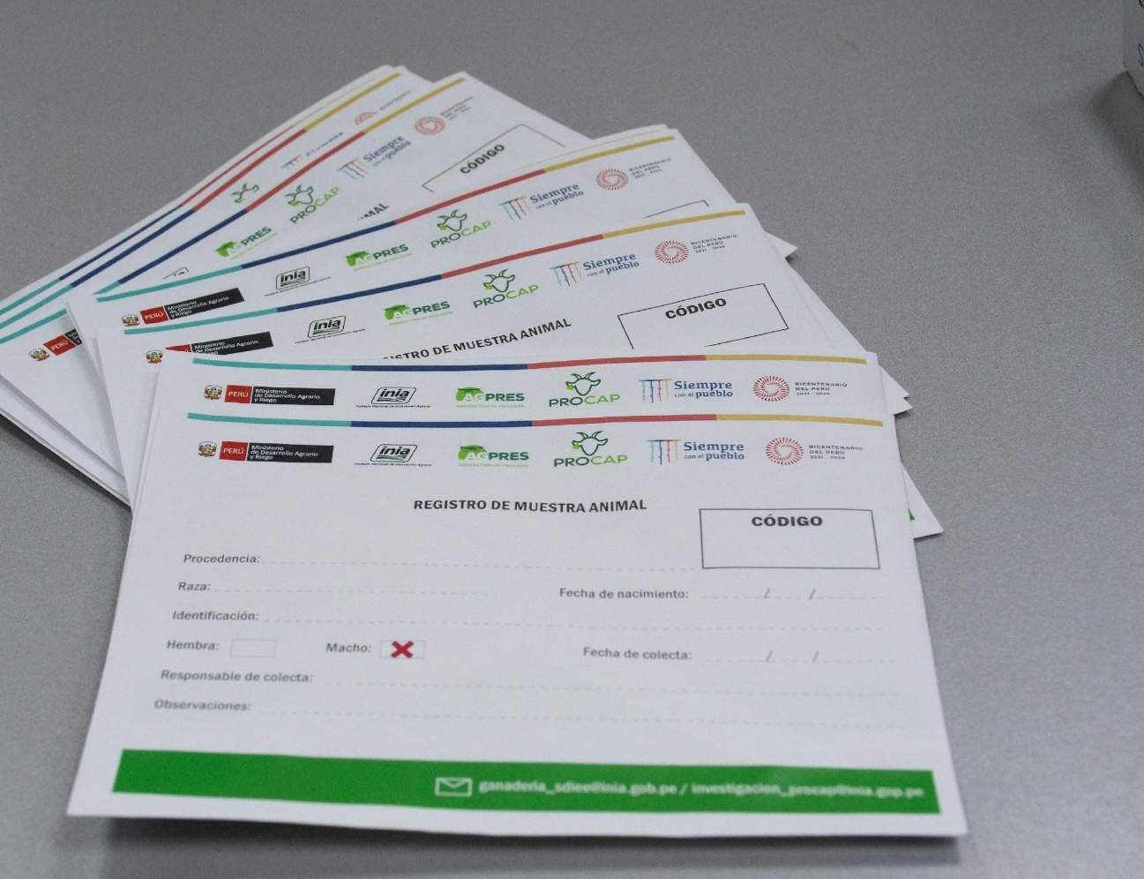

Supplementary Figure S1. Field sample labeling format used during collection.

Supplementary Figure S2. Representation of the Multiple Correspondence Analysis (MCA) of 60 Cattle – Igenity Beef
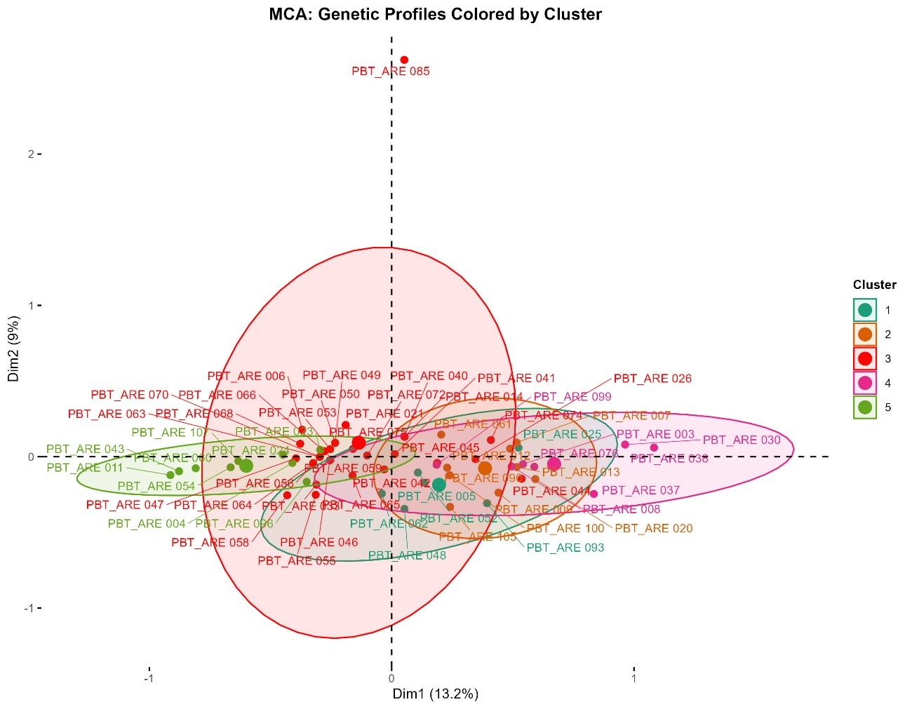
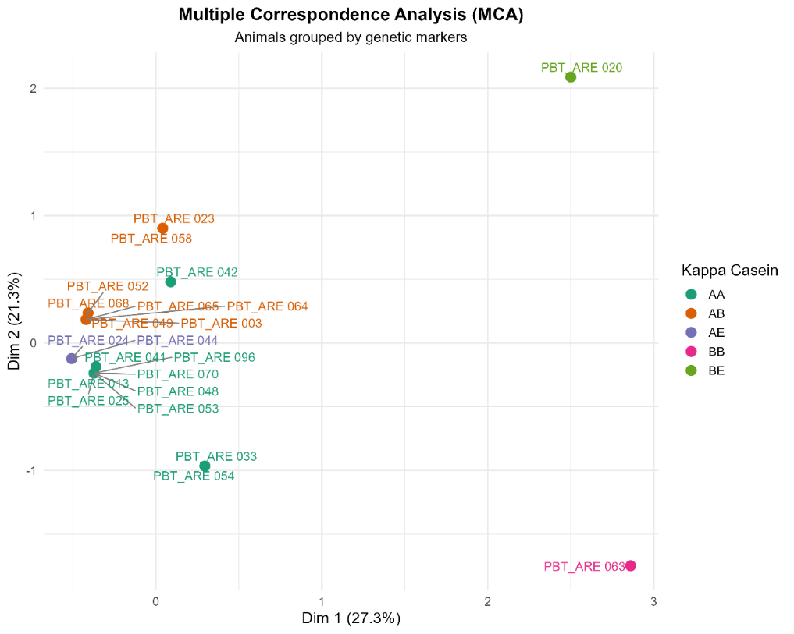
Supplementary Figure S3. Multiple Correspondence Analysis (MCA) of Genetic Profiles – Igenity Basic

