Supplementary file 1

Table S1: List of terms used to identify relevant providers with the CQC
provider alliance | alliance
together | federation
federated | gp federation
provider | collective
consortium | collaborative
network | unity
united | health partnership
association | cooperative
co-operative | cluster
hub | primary care network
pcn | care alliance
health alliance | medical group
gp group | practice group
primary care group | networks
CIC | Community Interest Company
Ltd | Limited
LLP | Limited Liability Partnership
PLC

Table S2: Data extraction form. Data extraction was performed online using Microsoft Forms
Question | Response type | Notes
Name of the provider | Free text
Date of assessment | Date
Assessment type | - First or second assessment  - Third assessment  - Discrepancy resolution | Select one
Do you think this might be a duplicate or have a similar name to another | yes/no
Initials of extractor | Free text
Website for the organisation | URL (text)
Does this organisation provide NHS care? If it is a care home then tick 'no | yes/no | If no, exclude from list and go no further
Does this organisation provide primary medical services | yes/no | If no, exclude from list and go no further
Does this organisation provide GP services (ie. NOT EXCLUSIVELY pharmacy, optometry, dentistry, physiotherapy) | yes/no | If no, exclude from list and go no further
Is this organisation a small-scale practice provider? ie. a single group practice that is clearly less than 100,000 patients? If yes, the form will be completed. | yes/no | If yes, exclude from list and go no further
Number of patients served according to the website of the provider only | Raw number / not specified
What broad activities does this provider do for its associated practices? | Categories  - Core GP services, including home visits  - Out of hours services, including extended access  - Emergency care / urgent care centres / walk-in centres  - Enhanced primary care services - dermatology, minor surgery, physiotherapy, inclusion  - At-scale back-office support - any non-clinical service provided to more than one practice. HR, training, estates, research, population health management, etc.  - Psychosocial interventions, eg. smoking cessation, counselling, link workers, social prescribing  - Diagnostic services eg. phlebotomy, radiology  - Vaccination hub  - Intermediate care services, frailty hubs, virtual wards, community emergency response teams  - No information at all available | Select many
What is the form of this provider? Click all that apply. If you can't find it, try a Companies House or Mutuals Public Register search. If you still don't know then tick 'not sure / unknown' | - Primary Care Network  - Federation  - (Super)partnership  - Community Interest Company  - Private limited company  - Company limited by guarantee  - Limited Liability Partnership  - Other provider alliance model  - Not sure / unknown  - Registered Society  - Other (free text) | Select many
Is this organisation a Primary Care Network? | yes/no
Is this organisation an NHS trust? | Yes/no  If yes, specify if Acute, Community, Mental Health, Ambulance or Other
Does the provider serve only one ICB and its directly neighbouring ICBs? (this is the definition of 'contiguous geographical area') | yes/no
Which Integrated Care Boards are associated with this organisation, according to the website? Copy them as a list separated on new lines. | Multiple choice for the 42 ICBs
Geographical area served | Free text
List of practices associated | Free text | Copy them as a comma separated list/ If not obvious, write “Not Provided”.
Associated Primary Care Networks | Free text | Copy them as a comma separated list/ If not obvious, write “Not Provided”.
Is there a discrepancy between the total number of practices and the practices that are individually named on the website? | yes/no
Free text comments |  | For any comments about the organisation for discussion later
Overall, do you think this provider would meet our inclusion criteria | - Include  - Exclude  - Unsure

Figure S1: Data extraction decision tree
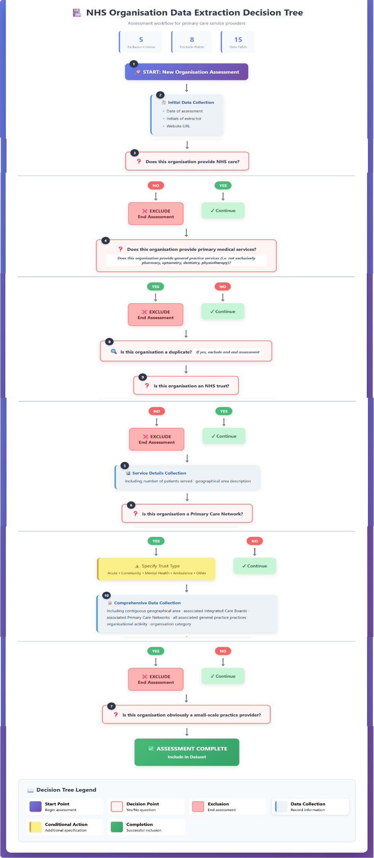

Figure S2: Screenshot 1 of 2 of review web application
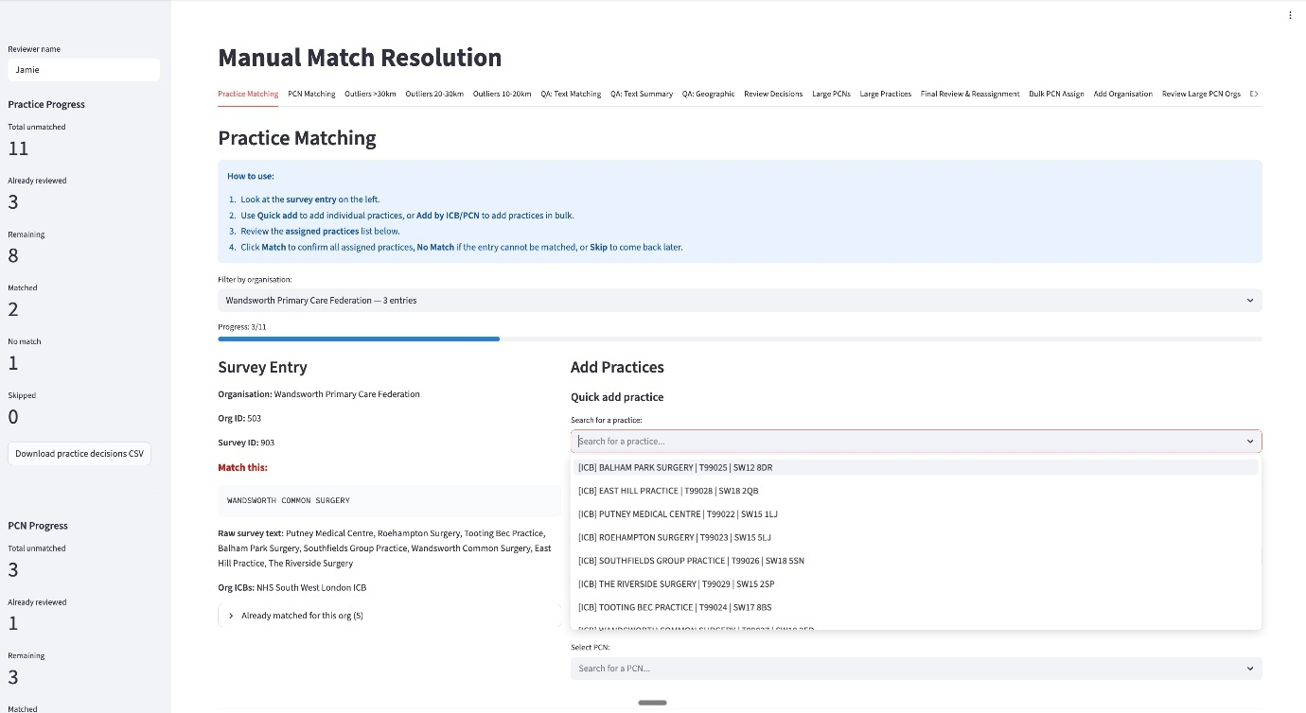

Figure S3: Screenshot 2 of 2 of review web application
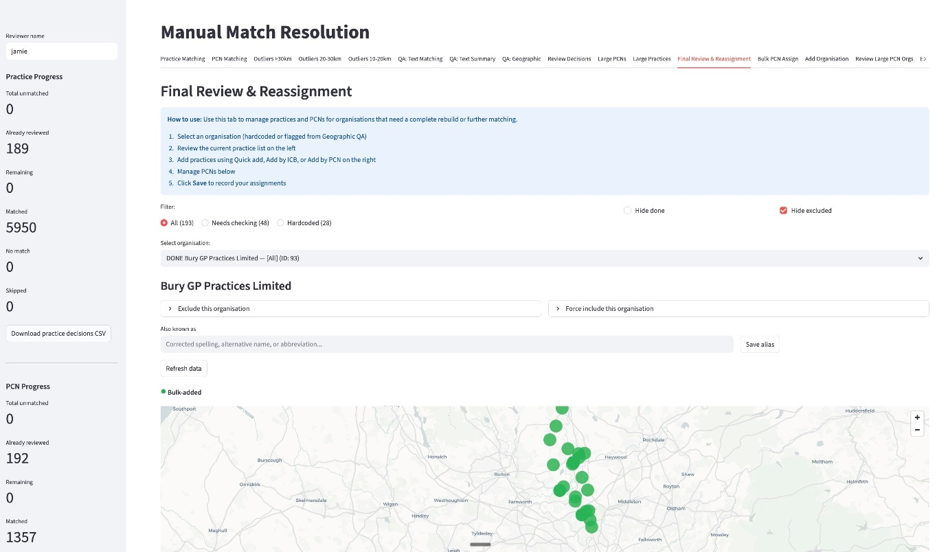

Table S3: Text matching of practices and PCN names from at-scale general practice provider websites to English GP practices
Stage | Input | Method
1. Text normalisation and data cleaning | Free-text practice names from proforma | Common names removed, e.g. ‘medical practice’, ‘surgery’, ‘partners’. Long lists of practices split up into lists of practices.
2. ICB-constrained fuzzy text matching | Names from stage 1 | Jaro-Winkler (JW) string distances computed between each name and all practices in the organisation’s ICB. Matched if there is a strong match. Ties are broken by geographic proximity to organisational centroid (i.e. the centroid of the coordinates of all currently associated practices)
3. Geographic fuzzy matching | Remaining unmatched names from stage 2 | All practices within 50 km of organisation searched regardless of ICB. Matched only if there is a close match.
4. Care Quality Commission (CQC) directory lookup | Remaining unmatched names from stage 3 | Fuzzy text matching against CQC location name, alternative name, and provider name fields. Matched CQC entry’s coordinates used to identify the nearest GP practice within 2km.
5. Large language model matching | Remaining unmatched names from stage 4 | Unmatched names sent to a large language model (GPT-5) with the organisation’s ICB and PCN context. Model returns best match from candidate list.  Prompt example:  You are an expert at matching NHS GP practice names. Match the survey name to the correct official practice name.  SURVEY NAME TO MATCH: "Brixton Road Medical Ctr"  CANDIDATE PRACTICE NAMES (choose ONLY from this list of 5 closest matches):  - Brixton Road Medical Centre  - Brixton Health Centre  - Brixworth Medical Centre  - Brixton Surgery  - Brixton Road Group Practice  MATCHING RULES:  Common abbreviations: MC/Med Ctr = Medical Centre, Surg = Surgery, HC = Health Centre, Grp = Group, Prac = Practice  - Ignore: 'The', 'Dr/Drs', word order differences, punctuation  - Consider typos and spelling variations  - If multiple could match, pick the closest spelling  - If NONE of these candidates are a good match, respond NO_MATCH  RESPOND IN EXACTLY THIS FORMAT: MATCH: [exact name from list OR NO_MATCH] CONFIDENCE: [HIGH/MEDIUM/LOW] REASON: [brief explanation, max 15 words]
6. Manual review | Remaining unmatched names from stage 5, presented in custom-built web application for matching to GP practice database | Trained reviewer selects correct match or confirms no match, with free-text notes.

Table S4: Availability of NHS payments data by Integrated Care Board (ICB)
14 months from April 2024 to May 2025 were considered for analysis.
Months of available data (out of 14 months) | Number of ICBs
14 | 33
13 | 3
12 | 3
10 | 1
9 | 1
8 | 1

Table S5: Missing data table

Variable | Count of missing data | Percentage of missing data (%)
At-scale general practice providers
Provider size by survey collection | 81 | 49.09
Provider size by linked practices | 0 | 0
Number of linked practices | 0 | 0
Income Deprivation Score | 0 | 0
Proportion Patients of White Ethnicity | 0 | 0
Average Population Density (people per sq. km) | 0 | 0
Proportion Patients Aged ≤ 4 years | 0 | 0
Proportion Patients Aged ≥ 65 years | 0 | 0
Emergency and Urgent Care | 8 | 4.85
At scale back-office support | 8 | 4.85
Enhanced Services | 8 | 4.85
Core General Practice | 8 | 4.85
Intermediate Care | 8 | 4.85
Psychosocial Care | 8 | 4.85
Out of Hours Work | 8 | 4.85
Diagnostic Services | 8 | 4.85
Vaccination Hubs | 8 | 4.85
Federation OR Alliance | 0 | 0
Super partnership | 0 | 0
Primary Care Network | 0 | 0
Other organisational structure | 0 | 0
Integrated Care Board | 0 | 0
General practices in England
Practice list size | 94 | 1.49
Income Deprivation Score | 119 | 1.89
Proportion Patients of White Ethnicity | 119 | 1.89
Average Population Density (people per sq. km) | 119 | 1.89
Proportion Patients Aged ≤ 4 years | 94 | 1.49
Proportion Patients Aged ≥ 65 years | 94 | 1.49
Integrated Care Board | 105 | 1.66

