Appendix A. Supplementary Data
The following is the Supplementary data to this article.
Table A.1. Reliability statistics for the 13‑item perceived‑impact questionnaire.
Reliability Statistics
Cronbach's Alpha | Cronbach's Alpha Based on Standardized Items |  | N of Items
0.820 | 0.818 | 13

Table A.2. Item-total and reliability diagnostics for the 13-item perceived‑impact questionnaire.
Item-Total Statistics
 | Scale Mean if Item Deleted | Scale Variance if Item Deleted | Corrected Item-Total Correlation | Squared Multiple Correlation | Cronbach's Alpha if Item Deleted
Daily life | 35.92 | 94.24 | 0.505 | 0.319 | 0.805
Physical health | 37.95 | 97.179 | 0.447 | 0.288 | 0.81
Mental health | 36.87 | 93.489 | 0.446 | 0.356 | 0.81
Children's schooling/education | 36.45 | 86.101 | 0.641 | 0.5 | 0.792
Work/Job | 36.83 | 89.827 | 0.541 | 0.37 | 0.801
Religious gathering | 37.6 | 93.384 | 0.458 | 0.331 | 0.809
Local transportation | 35.74 | 93.877 | 0.499 | 0.356 | 0.805
Energy supply | 35.32 | 100.05 | 0.387 | 0.407 | 0.814
Drinking water supply | 35.16 | 101.037 | 0.391 | 0.328 | 0.814
Food supply | 36.25 | 89.808 | 0.588 | 0.395 | 0.797
Damage to the house | 37.68 | 93.275 | 0.532 | 0.36 | 0.803
Damage to farming land | 37.87 | 97.571 | 0.379 | 0.226 | 0.814
Damage to non-farming land | 35.71 | 103.457 | 0.153 | 0.129 | 0.831

Table A.3. Communalities for extracted component(s), indicating the proportion of variance in each of the 13 perceived‑impact items explained by the retained factor.
 | Extraction
Daily life | 0.354
Physical health | 0.286
Mental health | 0.311
Children's schooling/education | 0.567
Work/Job | 0.418
Religious gathering | 0.319
Local transportation | 0.380
Energy supply | 0.254
Drinking water supply | 0.252
Food supply | 0.489
Damage to the house | 0.383
Damage to farming land | 0.210
Damage to non-farming land | 0.037
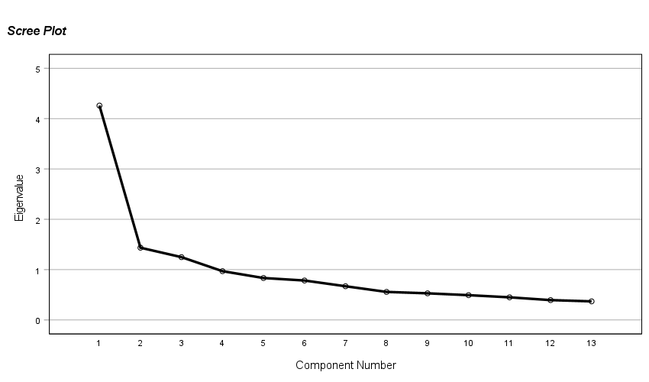
Fig. A.1. Scree plot illustrating the distribution of eigenvalues generated from the Principal Component Analysis of the 13‑item perceived‑impact questionnaire. The y‑axis represents the eigenvalues, indicating the proportion of variance explained by each component, while the x‑axis lists the component numbers in descending order of extracted variance. The sharp decline in eigenvalues after the first component demonstrates a clear inflection point, supporting the retention of a single dominant underlying factor in accordance with the Kaiser criterion (eigenvalues ≥ 1) and the elbow test.

Table A.4. Component matrix derived from principal-component analysis of the 13-item perceived‑impact questionnaire.
Component Matrix^{a*} | Component
Component Matrix^{a*} | 1
Daily life | 0.753
Physical health | 0.699
Mental health | 0.647
Children's schooling/education | 0.619
Work/Job | 0.617
Religious gathering | 0.595
Local transportation | 0.565
Energy supply | 0.558
Drinking water supply | 0.535
Food supply | 0.504
Damage to the house | 0.502
Damage to farming land | 0.458
Damage to non-farming land | 0.192
Extraction Method: Principal Component Analysis.
a. 1 components extracted.
Note: ^{a*} The principal component analysis yielded a single extracted component. Consequently, all factor loadings presented in the table reflect the contribution of each item to this singular underlying latent construct.

